THE CARDIOVASCULAR SYSTEM
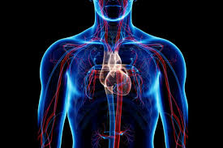
INTRODUCTION TO PHYSIOLOGY
(Bailey, 2019)
Student Name: Selina Shafiq
Student Number: 2028762
Module: Introduction to Physiology
Module Code: BMHP5003_BIRM
Assignment: Individual Academic Poster Presentation
Lecturer: Rachel Rivers
INTRODUCTION
This poster will explain the importance of the Cardiovascular System, and how it is structured and functions in the human body. There will be discussions in relation to the connections between the body functioning also the related anatomy and detailed physiology. There are many ways that health problems may occur within the human body instigated within the cardiovascular system, which can be prevented using the right form of treatment and management. There will be talks on how these health problems arise and how they can be prevented or improved with the use of appropriate treatment and consideration. THE CARDIOVASCULAR SYSTEM
LUNGS
These are one of the main organs in the human body, the lungs bring oxygen in to the human body and sends carbon dioxide out of the body. The exchange of gas happens here.

PULMONARY VEIN
This vein brings the oxygenated blood back in from the lungs to the left atrium of the heart
PULMONARY ARTERY
This artery transports deoxygenated blood from the right side of the heart to the lungs for it to be oxygenated

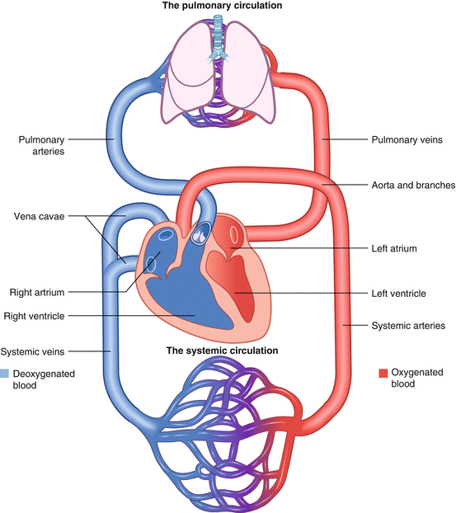
AORTA
This is the main artery as well as the largest artery that oxygenates blood from the heart to the whole body.

SUPERIOR VENA CAVA
This is a large vein that brings deoxygenated blood from the top part of to the right side of the heart for the blood to be oxygenated

INFERIOR VENA CAVA
This is a large vein that brings the deoxygenated blood from the lower part of the body back to the right side of the heart to be oxygenated

B (Buckley, 2021)
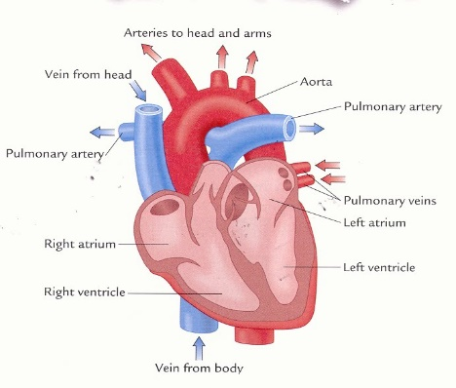
The Cardiovascular System focuses on the functions of the heart, blood vessels and blood. This system is vital for ensuring blood is transported within the body. The heart is an important organ within the human body, its primary focus is that it acts as a pump forcing blood supply through the body.
There are three types of blood vessels:
- Arteries
- Veins THE HEART
- Capillaries (Barlow,u.d)
(Kohli, 2021)
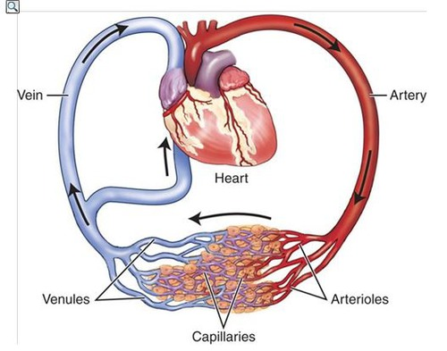
The veins focus on bringing blood supply back to the heart from the body. Arteries on the other hand focus on carrying the blood further from the heart to the body. Similar to this concept the capillaries are different in their role, these are small vessels that detach themselves from the arteries once delivering blood supply to all tissue within the body.
The heart is split into two main chambers, atria and ventricles which consist of two components each. Between the two a concept namely the septum, which is similar to a wall, separates the atria and ventricles. The valves control the blood flow throughout the chambers.
The heart is a key factor when analysing the human body, its main primary function is to flow and allocate blood to the tissue within the body using closed vessels. As a result of this, the blood then provides nutrients to the cells within the body. Without the function of flowing blood, the body would in essence lack the working capacity of the cells and tissue, leading to malfunction of the body and evidently dying.
(Gorane, 2022) (Encyclopedia and services, 2022)
HEALTH ISSUES
The Cardiovascular System is a major system within the human body that can be triggered and can lead to many causes of common diseases. Cardiovascular diseases are generally known to be severe and possibly leading to life threatening.
The four most common and generally associated diseases are:-
- HEART ATTACKS
A heart attack occurs as a result of a heart muscle having a lack of blood supply. This is caused in short as a potential blockage, an artery which has had a tear due to stress and a requirement for additional oxygen. Those that are potentially highly affected by this are individuals who have high blood pressure, high blood cholesterol and those that smoke. Although heart attacks are inevitable an individual can participate in regular activity, maintaining their weight, following through with a healthy diet, quitting smoking, and undergoing cardiac treatment.
- STROKES
A stroke is medically recognised as a lack of blood supply to the brain which results in very limited blood supply. The limited blood supply ultimately leads to the death of the cells located within the brain. Symptoms of a stroke are difficult to determine however those more prone to strokes are individuals who have multiple symptoms such as high blood pressure, diabetes, heart disease, smoking, older age. The more concerning symptoms that develop quickly and can become life threatening immediately are numbness in the arms, legs, or face, feeling a loss of balance similar to dizziness, headaches, vision issues and weakness in either right or left side down. Unlike other diseases, stroke symptoms develop suddenly and can become life threatening almost immediately. Although it is a serious and common disease there are factors that can decrease the risk of having a stroke by attending undergoing therapy, medications that can overtime lower high blood pressure or even undergoing surgery to have a stent put into the body to prevent blood clots from forming.

- HEART FAILURE
Heart failure is where the heart is restricted and as a result fails in pumping enough blood to flow for the body to naturally function. The main symptoms of this can vary some include shortness of breath, swelling on the body, confusion, higher heart rate, a continuous cough and wheezing. Compared to other conditions this type of condition does not have an immediate cure but there are treatments that can eventually assist in managing and decreasing the symptoms for example dietary changes, medical procedures that can input medical devices which act as an aid, diuretics to decrease the swelling/edema.
- ARRHYTHMIA
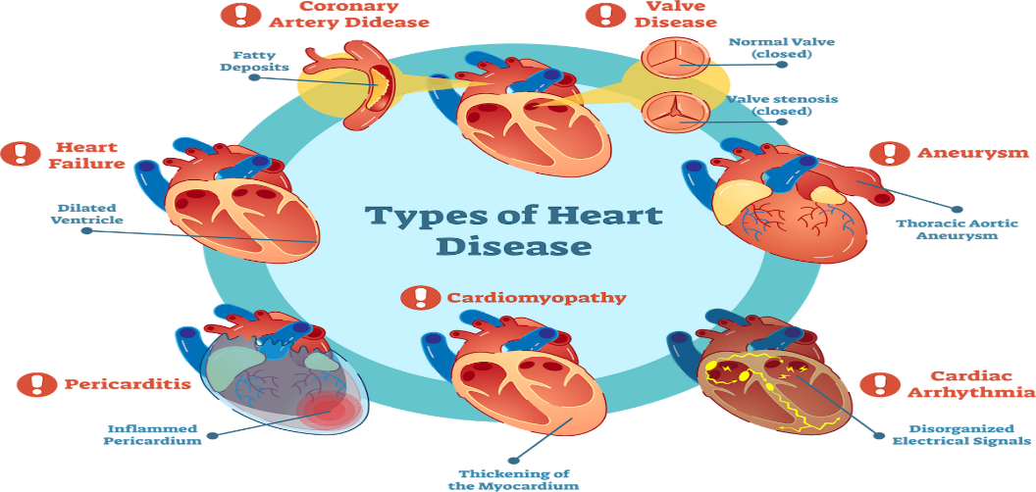
Arrhythmia is also a major condition that can be instigated within the heart, this is where the heart beats at an uncommon and abnormal pace. This type of heartbeat is distinctive as it could possibly beat visibly slower or faster than an average person. Symptoms again can become sudden and major ones which include being lightheaded, faster and slower heartbeat, fainting, shortness of breath and sweating. Those at higher risk of arrhythmia are patients with high cholesterol, previous heart diseases/family history of them, high blood pressure, alcohol users and so forth. In patients where the heartbeats are dangerous either by beating to fast or slow or that the rhythm is very unusual and unpredictable, doctors may introduce a pacemaker device which in essence will restore and maintain a regular heartbeat.
(Kohli, 2021)

(Axelrod, 2020)

BIBLIOGRAPHY/REFERENCES
Aaronson, P.I., Ward, J.P. and Connolly, M.J., 2020. The cardiovascular system at a glance. John Wiley & Sons. (Accessed: 19 October 2022)
Axelrod, D. (2020) What is heart disease? and other heart disease questions - healthcentral, Health Central . Available at: https://www.healthcentral.com/condition/heart-disease (Accessed: October 21, 2022).
Bailey, R. (2019) Circulatory system: Pulmonary and systemic circuits, ThoughtCo. ThoughtCo. Available at: https://www.thoughtco.com/circulatory-system-pulmonary-and-systemic-circuits-3999090 (Accessed: October 17, 2022).
Buckley, G. (2021) Circulatory system - the definitive guide, Biology Dictionary. Available at: https://biologydictionary.net/circulatory-system/ (Accessed: October 19, 2022).
Encyclopedia, M. and services, H.,( 2022). heart and vascular services: medlineplus medical encyclopedia. [online] medlineplus.gov. available at: <https://medlineplus.gov/ency/article/007459.htm> (Accessed: 20 October 2022)..
Gorane, J. (2022) 7 structural and functional difference between arteries veins and capillaries - CBSE class notes online, Classnotes123. Available at: https://classnotes123.com/difference-between-arteries-veins-and-capillaries/ (Accessed: October 20, 2022).
Matthews, B.E. (no date) Circulatory system, Encyclopædia Britannica. Encyclopædia Britannica, inc. Available at: https://www.britannica.com/science/circulatory-system (Accessed: October 19, 2022).
Kohli, P. (2021) Cardiovascular system: Function, organs, diseases, and more, Medical News Today. MediLexicon International. Available at: https://www.medicalnewstoday.com/articles/cardiovascular-system#anatomy (Accessed: October 21, 2022).
Wei, J.Y., 1992. Age and the cardiovascular system. New England Journal of Medicine, 327(24), pp.1735-1739 (Accessed: 19 October 2022)

