Games Architecture and Mechanics
Assessment 2
Nathan Willis (2103532)
2024
Contents
Operations Research 2
Vector distance 2
Plane class 2
Spheres 2
Collision detection 2
Operations Implementation 2
Vectors 2
Planes 2
Spheres 2
Operations Testing 2
Code 2
Header files 2
panes.h 2
sphere.h 2
vectors.h 2
Source files 2
Main.cpp 2
planes.cpp 2
sphere.cpp 2
vectors.cpp 2
References 2

Operations Research

Vector distance
The method for finding the distance between 2 points was specified in the brief. First you subtract one vector from the other, putting one vector in terms of the other, then take the resultant vector and calculate its length via the Pythagorean theorem (taking the square root of the sum of all its components squared).
I also needed to get a cross product of 2 vectors. As the 2 vectors I needed the cross product for originate at the same point I didn’t need the angle or the cosine function just the equation:
c_{x} = a_{y}b_{z} − a_{z}b_{y}
c_{y} = a_{z}b_{x} − a_{x}b_{z}
c_{z} = a_{x}b_{y} − a_{y}b_{x}
Where a b and c are vectors.[1]

Plane class
To define a plane 3 non-colinear points are required. Meaning 3 points that it is impossible to have a straight-line pass through. From there you can find the equation of the plane in the form:
AX + BY + CZ -d =0 [2]
So, by inserting one of the points that define the plane into the equation’s x, y, z and d values and by using these values, if you put a fourth point in the equation you can check to see if the result is 0 and if it is you know the point lies on the plane.
To determine the distance of a point from a plane you put the coefficients of the equation of the plane into the equation:
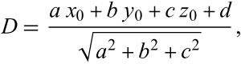
Where D is distance. [3]

Spheres
The creation of a sphere is simple, as every point on the exterior of the shape has an equal distance from its centre. So, you just need to specify this distance and the x y and z components of the centre point.

Collision detection
Using the method specified in the brief to find the distance between 2 points and then subtracting the sum of the radii of the spheres is sufficient to measure the distance between 2 spheres. Entering the x y and z coordinates of a point into the equation of the plane works to determine whether the point lies on the plane or not and doing the same with the centre point a sphere and subtracting the radius and seeing if the point is zero or less works for sphere to plane collision.

Operations Implementation

Vectors
A vector requires x y and z components. I made 3 constructors. A default constructor that initialised all member variables at 0, a parametrised constructor, allowing the user to enter their own member variables and a copy constructor allowing a copy of member variables from one object to another.

Planes
I implemented the same constructors as with I did with the vectors class, with some changes the parametrised constructor calls the check function which assigns values to . I also implemented the following member functions:
The yZero function to set the plane to y = 0 by setting the 3 vector points to:
(0,0,0) (1,0,1) and (4,0,-4)
3 non-colinear points that align with y = 0.

An info function that prints the vector components
A normal function to get the normalised vector to the plane by getting the cross product of the 2 vectors made from one of the points to the other 2, the reason this works is because the 2 vectors have the same origin point.
A function to assign the coefficients of the equation of the plane to the member variable.
distance function gets the distance of a point from a plane by using the equation:
[3]

a check function to checks 3 points are colinear a
I overloaded the check function, the secondary function checks if the point lies on the plane and if not how far above or below it is by calling the distance function.
I implemented 5 member variables:
point is an array of vectors with length 3 to contain the 3 points that define the plane.
normnorm is a vector that contains the normalised plane normal.
equationCoEff is a vector that contains the coefficients to the equation of the plane.
d is a double that holds the d component of the above equation.
invalid is a Boolean value that holds whether the plane is valid or invalid.

Spheres
For the implementation of spheres, I just made the class inherit from the vectors class and implemented a radius variable “r” and some new member functions:
sphCollision and sphDistance to determine if there are 2 spheres colliding and return the distance. By using the point-to-point distance
plnCollision and plnDistance to determine if there is a sphere and plane colliding and return the distance. By using the point to plane distance function and subtracting the radius.
getVol function to get the volume of a sphere using the equation:
4/3*π*r³
And a copy function to copy the x y and z components of the centre point over to a member of the vectors class.

Operations Testing

Menu tests:
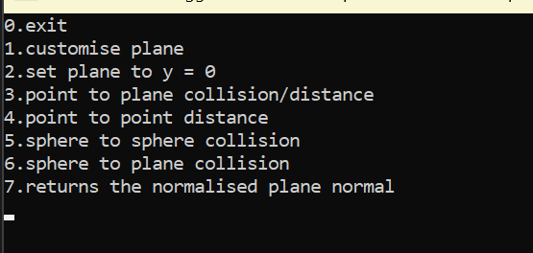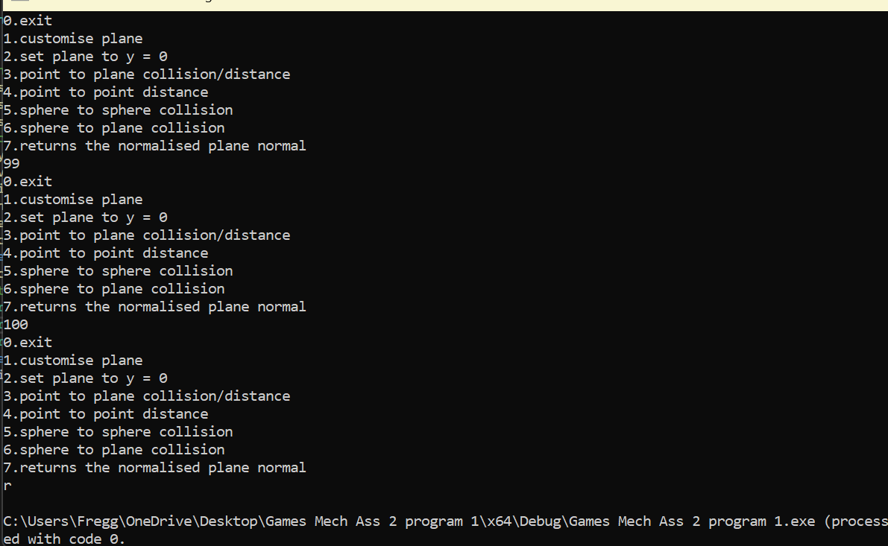
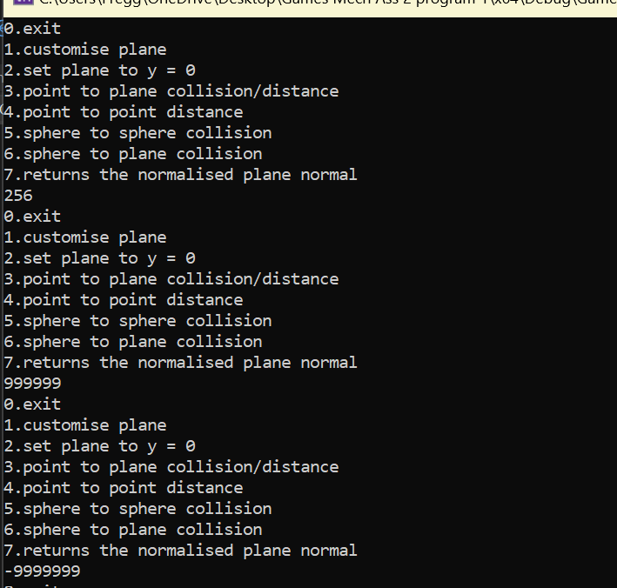
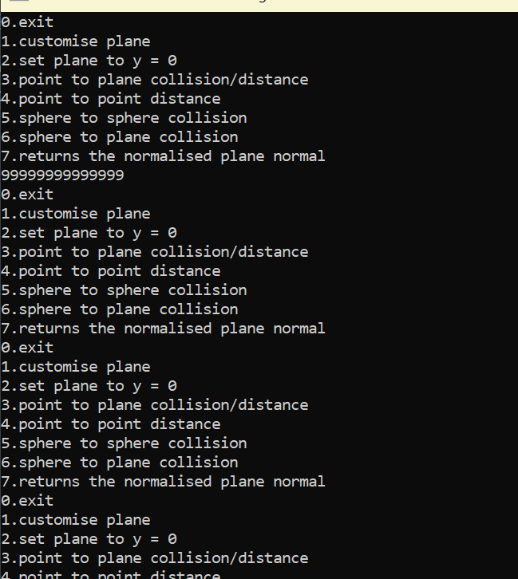
Menu behaves as expected with the exception of very large numbers and I don’t know how to fix this.

Vectors tests:
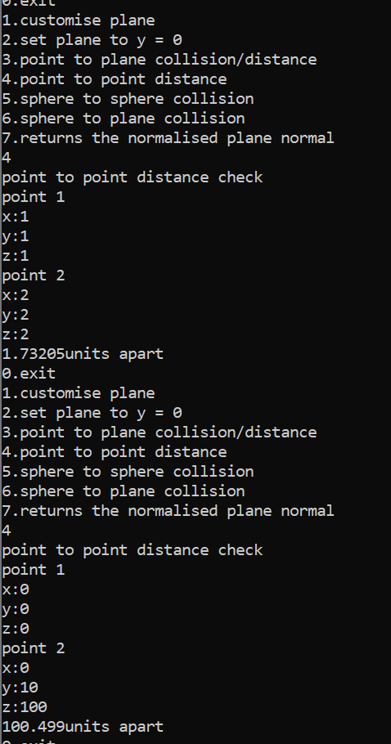
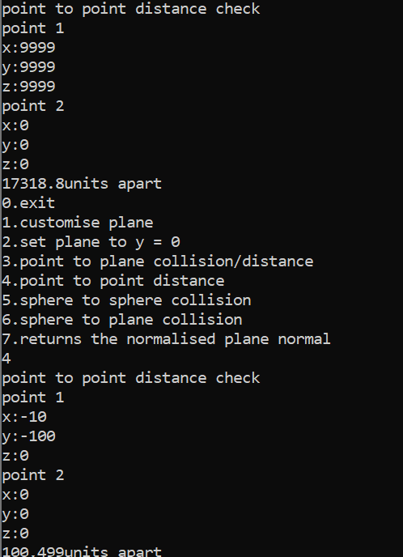
Accurate and behaves as expected, forgot to put a space before units.

Planes tests:

Plane entry:
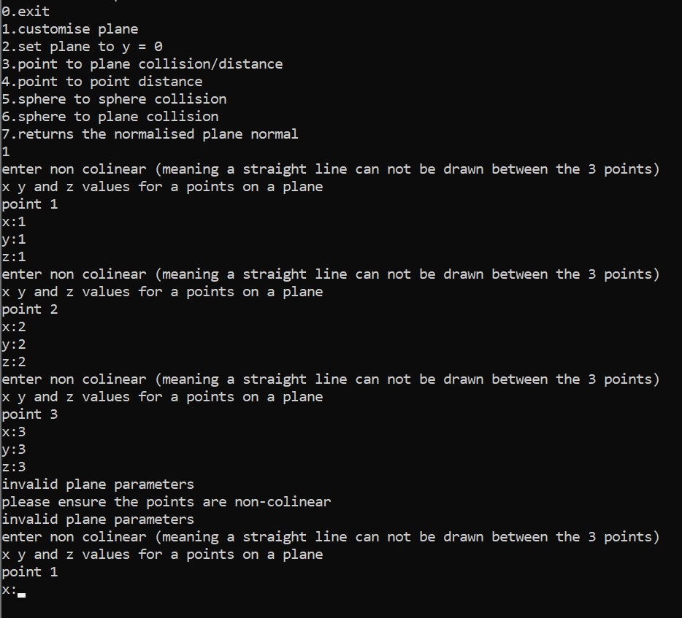
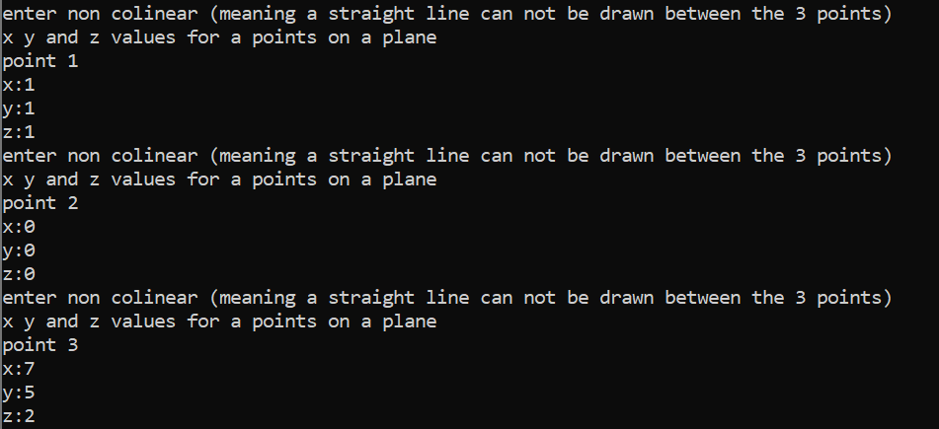
Allows non-colinear points, disallows non-colinear points. Shouldn’t have put the cout statement in the check function as it prints “invalid plane parameters” too many times.

Plain to point collision/distance:
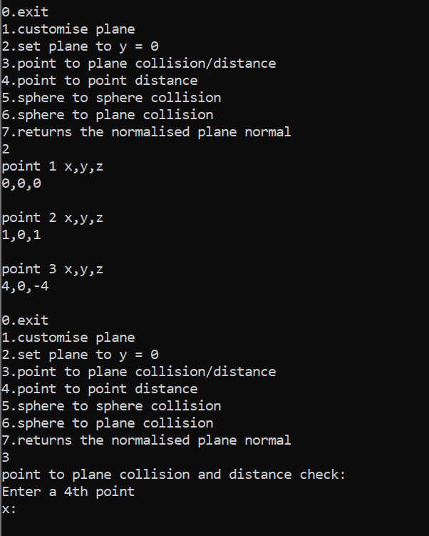
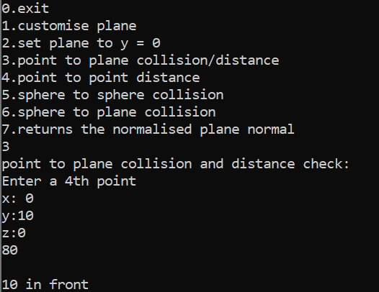
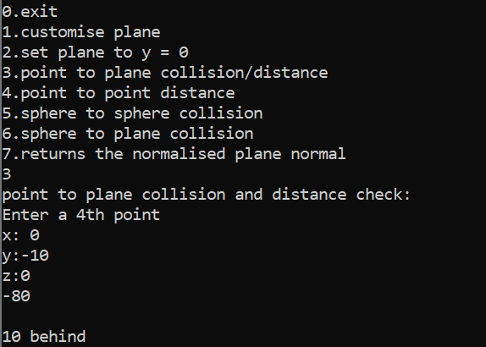
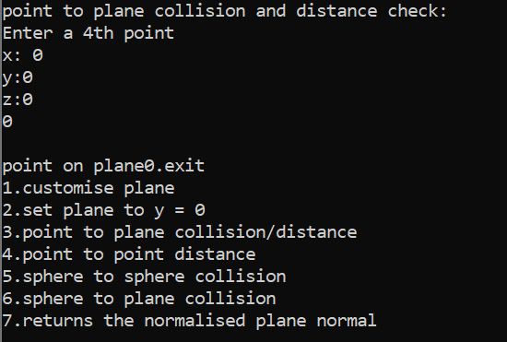
Forgot an endl after “point on plane” and I didn’t remove a test print of the d value, that’s what that 0 is.
std::cout << total - d << "\n\n";
if (total - d == 0) {
std::cout << "point on plane";
}
else if (total - d > 0) {
In this snippet I should’ve commented out the cout statement.
Test with different planes:
Plane z = 0:
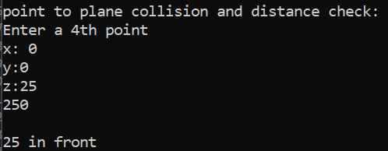
Plane x = 1:
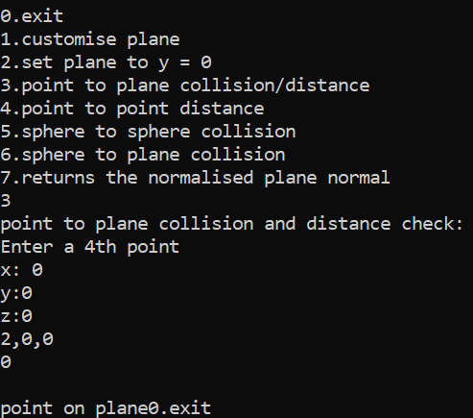
Not working as expected
I fixed this problem by switching the method previously used to:
void planes::equationGet() {
vectors tempVec[3];
tempVec[1].subt(tempVec[1], point[1], point[0]);
//tempVec[2].subt(tempVec[1], point[2], point[0]);
tempVec[2].x = point[2].x - point[0].x;
tempVec[2].y = point[2].y - point[0].y;
tempVec[2].z = point[2].z - point[0].z;
tempVec[2].info();
equationCoEff.x = (tempVec[1].y * tempVec[2].z) - (tempVec[1].z * tempVec[2].y);
equationCoEff.y = (tempVec[1].x * tempVec[2].z) - (tempVec[1].z * tempVec[2].x);
equationCoEff.z = (tempVec[1].x * tempVec[2].y) - (tempVec[1].y * tempVec[2].x);
equationCoEff.info();
d = equationCoEff.x * point[0].x + equationCoEff.z * point[0].z - equationCoEff.y * point[0].y;
}
Which uses the same method as can be found here[4]
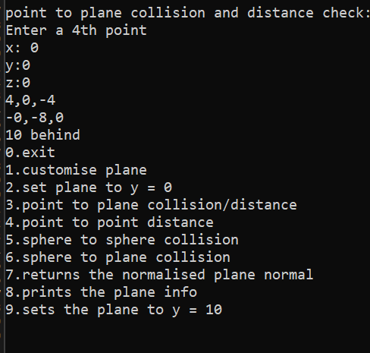

Code

Header files

planes.h
#pragma once
#include "vectors.h"

class planes {

public:
// Constructors
planes(vectors x, vectors y, vectors z);
planes(planes& p2);
planes(void);
//functions
void yZero(); // sets the plane to y = 0
void vectIn(vectors x, vectors y, vectors z); // assigns the 3 points of the plane
void info(); // prints the x y and z values of points 1 2 and 3
void normal(); // gets the normalised vector to the plane
void equationGet(); // gets the coefficients of the equation of the plane
void check(vectors v1); // checks if the point lies on the plane and if not how far above or bellow it is
double distance(vectors v1); // gets the distance of a point from a plane
bool check(); // checks if 3 points are colinear
//vectors
vectors point[3]; // 3 points defining the plane
vectors normnorm; // normalised vector normal to the plane
vectors equationCoEff; // equation coefficients
double d; // d value of equation
bool invalid = 0; // whether the plane is valid or invalid depending on whether the 3 points are colinear
};

sphere.h
#pragma once
#include "vectors.h"
#include "planes.h"

class sphere : public vectors {
public:
// Constructors
sphere(double i, double j, double k, double l);
sphere(sphere& vA);
sphere(void);
// Functions
void makeCopy(vectors& v1); // copies the coordinates of the center of the sphere into an object with class vectors
double getVol(); // returns the volume of the sphere
double sphDistance(sphere s2); // returns the distance between 2 spheres
double plnDistance(planes p1); // returns the distance between a sphere and a plane
bool sphCollision(sphere s2); // checks for collisions with spheres
bool plnCollision(planes p1); // checks for collisions with planes

double r;

};

vectors.h
#pragma once

class vectors {

public:
// Constructors
vectors(double i, double j = 1, double k = 1);
vectors(vectors& vA);
vectors(void);

// Functions
void zero(); // zeros x y and z
void info(); // prints x y and z
void scale(double s); // scales a vector by a scalar amount
void mult(vectors vA); // multiplies the x y and z values by the x y and z values of another vector
void norm(); // normalises a vector
void norm(vectors& vB); // normalises a vector parsed through
void absVal(); // gets the absolute values of x y and z
void subt(vectors& vA, vectors& vB); // subtract the x y and z values by the x y and z values of another vector
void subt(vectors& vA, vectors& vB, vectors& vC); // same as the function above but returns the result to a third vector
void copy(vectors& vA); // copies one vector to another
void cross(vectors vA, vectors vB); // does the cross product of 2 vectors
double leng(); // gets the length of a vector
double leng(vectors vB); // gets the length of a vector parsed through
double getScalarvAB(vectors vA, vectors vB); // gets the distance between 2 points
double getSqrScalarvAB(vectors vA, vectors vB); // gets the square of the distance between 2 points
double sum(); // returns the sum of the x y and z values
bool lineCheck(vectors vA, vectors vB); // checks if 2 vectors are on the same line

// Variables
double x;
double y;
double z;
};

Source files

Main.cpp
#include <iostream>
#include "vectors.h"
#include "planes.h"
#include "sphere.h"

int main() {
using namespace std;
int userIn; // user input
vectors points[4]; // array of 4 vectors
planes uPlane; //user plane
sphere sph[2]; // 2 spheres
do { // loops the selection menu
cout << "0.exit\n1.customise plane\n2.set plane to y = 0\n3.point to plane collision/distance\n4.point to point distance\n5.sphere to sphere collision\n6.sphere to plane collision\n7.returns the normalised plane normal\n";
cin >> userIn;
switch (userIn) {
case 0:
break;
case 1:
do {
for (int i = 0; i < 3; i++) {
cout << "enter non colinear (meaning a straight line can not be drawn between the 3 points)\nx y and z values for a points on a plane\npoint " << i + 1 << "\nx:";
cin >> points[i].x;
cout << "y:";
cin >> points[i].y;
cout << "z:";
cin >> points[i].z;
}
uPlane.vectIn(points[0], points[1], points[2]); // assigns the 3 defining points of uPlane to the 3 vectors the user just entered
if (uPlane.check()) { // checks if the 3 points form a valid plane
cout << "please ensure the points are non-colinear" << endl;
}
} while (uPlane.check()); // loops while the 3 points do not form a valid plane
break;
case 2:
uPlane.yZero(); // sets the plane to y = 0
uPlane.info(); // prints the plane information
break;
case 3:
if (!uPlane.check()) { // if the plane is valid
cout << "point to plane collision and distance check:\nEnter a 4th point\nx: ";
cin >> points[3].x; // user enters x y and z values
cout << "y:";
cin >> points[3].y;
cout << "z:";
cin >> points[3].z;
uPlane.check(points[3]); // checks if the point lies on the plane
}
else {
cout << "first create a plane" << endl;
}
break;
case 4:
cout << "point to point distance check\n";
for (int i = 0; i < 2; i++) {
cout << "point " << i + 1 << endl;
cout << "x:";
cin >> points[i].x;
cout << "y:";
cin >> points[i].y;
cout << "z:";
cin >> points[i].z;
}
cout << points[0].getScalarvAB(points[0], points[1]) << "units apart" << endl; // gets a scalar value for the distance between 2 points
break;
case 5:
cout << "sphere collision and distance check" << endl;
for (int i = 0; i < 2; i++) {
cout << "sphere " << i + 1 << endl;
cout << "x:";
cin >> sph[i].x;
cout << "y:";
cin >> sph[i].y;
cout << "z:";
cin >> sph[i].z;
cout << "radius:";
cin >> sph[i].r;
}
if (sph[0].sphCollision(sph[1])) { // checks sphere collision
cout << "2 spheres collide\n" << endl;
}
else {
cout << sph[0].sphDistance(sph[1]) << " units apart" << endl; // gets sphere distance
}
break;
case 6:
if (!uPlane.check()) { // if the plane is valid
cout << "sphere to plane collision and distance check" << endl;
cout << "x:";
cin >> sph[0].x;
cout << "y:";
cin >> sph[0].y;
cout << "z:";
cin >> sph[0].z;
cout << "radius:";
cin >> sph[0].r;
if (sph[0].plnCollision(uPlane)) { //checks plane collision
cout << "collision\n" << endl;
}
else {
cout << sph[0].plnDistance(uPlane) << " units apart" << endl; // gets plane distance
}
}
else {
cout << "first create a plane" << endl;
}
break;
case 7:
if (!uPlane.check()) { // if the plane is valid
uPlane.normal();
uPlane.normnorm.info();
}
else {
cout << "first create a plane" << endl;
}

break;
default:
break;
}
} while (userIn != 0);
return 0;
}

planes.cpp
#include "planes.h"
#include <iostream>

// Constructors
planes::planes(vectors v1, vectors v2, vectors v3) {
point[0] = v1;
point[1] = v2;
point[2] = v3;
invalid = check();
if (!invalid) {
equationGet();
normnorm.zero();
}
}

planes::planes(planes& p2) {
point[0] = p2.point[0];
point[1] = p2.point[1];
point[2] = p2.point[2];
invalid = p2.invalid;
equationCoEff = p2.equationCoEff;
d = p2.d;
normnorm = p2.normnorm;
}

planes::planes(void) {
for (int i = 0; i < 3; i++) {
point[i].zero();
}
invalid = 1;
equationCoEff.zero();
d = 0;
normnorm.zero();
}

// Functions

void planes::yZero() {
for (int i = 0; i < 3; i++) {
point[i].y = 0;
}
point[0].x = 0;
point[0].z = 0;
point[1].x = 1;
point[1].z = 1;
point[2].x = 4;
point[2].z = -4;
}

void planes::vectIn(vectors x, vectors y, vectors z) {
point[0] = x;
point[1] = y;
point[2] = z;
}

void planes::info() {
for (int i = 0; i < 3; i++) {
std::cout << "point " << i + 1 << " x,y,z\n" << point[i].x << "," << point[i].y << "," << point[i].z << "\n" << std::endl;
}
}

void planes::normal() {
vectors tmpVec[2];
tmpVec[0].subt(tmpVec[0], point[1], point[0]);
tmpVec[1].subt(tmpVec[1], point[2], point[0]);
normnorm.cross(tmpVec[0], tmpVec[1]);
normnorm.norm();

}

void planes::equationGet() {
vectors tmpVec[2];
tmpVec[0].subt(tmpVec[0], point[1], point[0]);
tmpVec[1].subt(tmpVec[1], point[2], point[0]);
equationCoEff.cross(tmpVec[0], tmpVec[1]);
d = -(equationCoEff.sum());
}
void planes::check(vectors v1) {
vectors tmpVec[3];
double total;
tmpVec[0].subt(tmpVec[0], point[1], point[0]);
tmpVec[1].subt(tmpVec[1], point[2], point[0]);
tmpVec[2].cross(tmpVec[0], tmpVec[1]);
vectors equation(tmpVec[2]);
equationCoEff.copy(equation);
tmpVec[2].mult(tmpVec[1]);
d = -(tmpVec[2].x + tmpVec[2].y + tmpVec[2].z);
//std::cout << "\n" << d << "\n";
equation.mult(v1);
total = equation.sum();
std::cout << total - d << "\n\n";
if (total - d == 0) {
std::cout << "point on plane";
}
else if (total - d > 0) {
std::cout << distance(v1) << " in front" << std::endl;
}
else {
std::cout << distance(v1) << " behind" << std:: endl;
}
}

double planes::distance(vectors v1) {
vectors tempVec[2];
double numerator, denominator;
tempVec[0].copy(equationCoEff);
tempVec[1].copy(equationCoEff);
tempVec[0].mult(v1);
numerator = tempVec[0].sum() + d;
if (numerator < 0) {
numerator *= -1;
}
tempVec[1].mult(tempVec[1]);
denominator = tempVec[1].sum();
denominator = sqrt(denominator);
if (denominator == 0) {
return 0;
}
return numerator / denominator;
}

bool planes::check() {
vectors checkA(point[0]);
vectors checkB(point[1]);
vectors checkC(point[2]);
checkA.subt(checkB, checkA);
checkA.subt(checkC, checkA);
//dont remember why i put this here
//interferes with negative inputs but might be important
//no issues from removal yet
//checkC.absVal();
//checkB.absVal();
//
if (checkB.lineCheck(checkB, checkC)) {
std::cout << "invalid plane parameters" << std::endl;
return 1;
}
return 0;
}

sphere.cpp
#include "sphere.h"
#include <iostream>

// Constructors
sphere::sphere(double i, double j, double k, double l) {
x = i;
y = j;
z = k;
r = l;
}
sphere::sphere(sphere& vA) {
x = vA.x;
y = vA.y;
z = vA.z;
r = vA.r;
}

sphere::sphere(void) {
x = 0;
y = 0;
z = 0;
r = 0;
}
// Functions

void sphere::makeCopy(vectors& v1) {
v1.x = x;
v1.y = y;
v1.z = z;
}

double sphere::getVol() {

return 4./3. * 3.1415 * r * r * r;

}

double sphere::sphDistance(sphere s2) {
vectors sph[2];
makeCopy(sph[0]);
s2.makeCopy(sph[1]);
double rAndR = r + s2.r;
double centerD = getScalarvAB(sph[0], sph[1]);
return centerD - rAndR;
}

double sphere::plnDistance(planes p1) {
vectors sph;
makeCopy(sph);
double centerD = p1.distance(sph);
return centerD - r;
}

bool sphere::sphCollision(sphere s2) {
vectors sph[2];
makeCopy(sph[0]);
s2.makeCopy(sph[1]);
double rAndR = r + s2.r;
double centerD = getScalarvAB(sph[0], sph[1]);
double actD = centerD - rAndR;
if (actD <= 0) {
return 1;
}
return 0;
}
bool sphere::plnCollision(planes p1) {
vectors sph;
makeCopy(sph);
double centerD = p1.distance(sph);
double actD = centerD - r;
if (actD <= 0) {
return 1;
}
return 0;
}

double r;

vectors.cpp
#include <iostream>
#include "vectors.h"
#include <cmath>

// Constructors
vectors::vectors(double i, double j, double k) {
x = i;
y = j;
z = k;

}
vectors::vectors(vectors& vA) {
x = vA.x;
y = vA.y;
z = vA.z;
}

vectors::vectors(void) {
x = 0;
y = 0;
z = 0;

}

// Functions
void vectors::zero() {
x = 0;
y = 0;
z = 0;
}

void vectors::info() {
std::cout << x << "," << y << "," << z << std::endl;

}
void vectors::scale(double s) {
x *= s;
y *= s;
z *= s;

}
void vectors::mult(vectors vB) {
x *= vB.x;
y *= vB.y;
z *= vB.z;

}
void vectors::norm() {
if (leng() != 0) {
scale(1 / leng());
}
else {
scale(0);
}
}

void vectors::norm(vectors& vB) {
x = vB.x;
y = vB.y;
z = vB.z;
norm();

}

void vectors::absVal() {
if (x < 0) {
x *= -1;
}
if (y < 0) {
y *= -1;
}
if (z < 0) {
z *= -1;
}
}

void vectors::subt(vectors& vA, vectors& vB) {
vA.x = vA.x - vB.x;
vA.y = vA.y - vB.y;
vA.z = vA.z - vB.z;

}
void vectors::subt(vectors& vA, vectors& vB, vectors& vC) {
vA.x = vB.x - vC.x;
vA.y = vB.y - vC.y;
vA.z = vB.z - vC.z;

}
void vectors::copy(vectors& vA) {
x = vA.x;
y = vA.y;
z = vA.z;

}

void vectors::cross(vectors vA, vectors vB) {
x = vA.y * vB.z - vA.z * vB.y;
y = vA.z * vB.x - vA.x * vB.z;
z = vA.x * vB.y - vA.y * vB.x;

}
double vectors::leng() {

return sqrt(x * x + y * y + z * z);
}
double vectors::leng(vectors vB) {

return sqrt(vB.x * vB.x + vB.y * vB.y + vB.z * vB.z);
}
double vectors::getScalarvAB(vectors vA, vectors vB) {
subt(vA, vB);
double scalar;
scalar = vA.x * vA.x + vA.y * vA.y + vA.z * vA.z;
scalar = sqrt(scalar);

return scalar;
}

double vectors::getSqrScalarvAB(vectors vA, vectors vB) {
subt(vA, vB);
double scalar;
scalar = vA.x * vA.x + vA.y * vA.y + vA.z * vA.z;

return scalar;
}

double vectors::sum() {
return x + y + z;
}

bool vectors::lineCheck(vectors vA, vectors vB) {
double sum;
vA.norm();
//vA.info();
vB.norm();
//vB.info();
vA.subt(vA, vB);
sum = vA.sum();
if (sum < 0.000001 && sum > -0.000001) {
//std::cout << "Colinear" << std::endl;
return 1;
}
else {
//std::cout << "Non-Colinear" << std::endl;
return 0;
}

}

References

[1] “Cross product,” Math is Fun Advanced, https://www.mathsisfun.com/algebra/vectors-cross-product.html (accessed Jan. 8, 2024).
[2] “Online help,” Equation of a Plane - 3 Points - Maple Help, https://www.maplesoft.com/support/help/maple/view.aspx?path=MathApps%2FEquationofaPlane3Points (accessed Jan. 8, 2024).
[3] “Point-plane distance,” from Wolfram MathWorld, https://mathworld.wolfram.com/Point-PlaneDistance.html (accessed Jan. 8, 2024).
[4] “Online calculator. equation of a plane,” Studying of mathematics online, https://onlinemschool.com/math/assistance/cartesian_coordinate/plane/ (accessed Jan. 8, 2024).

