

Assessment 1 – Reading Task Template
PART 1: Upload your photo of your A3 in-class notes here:
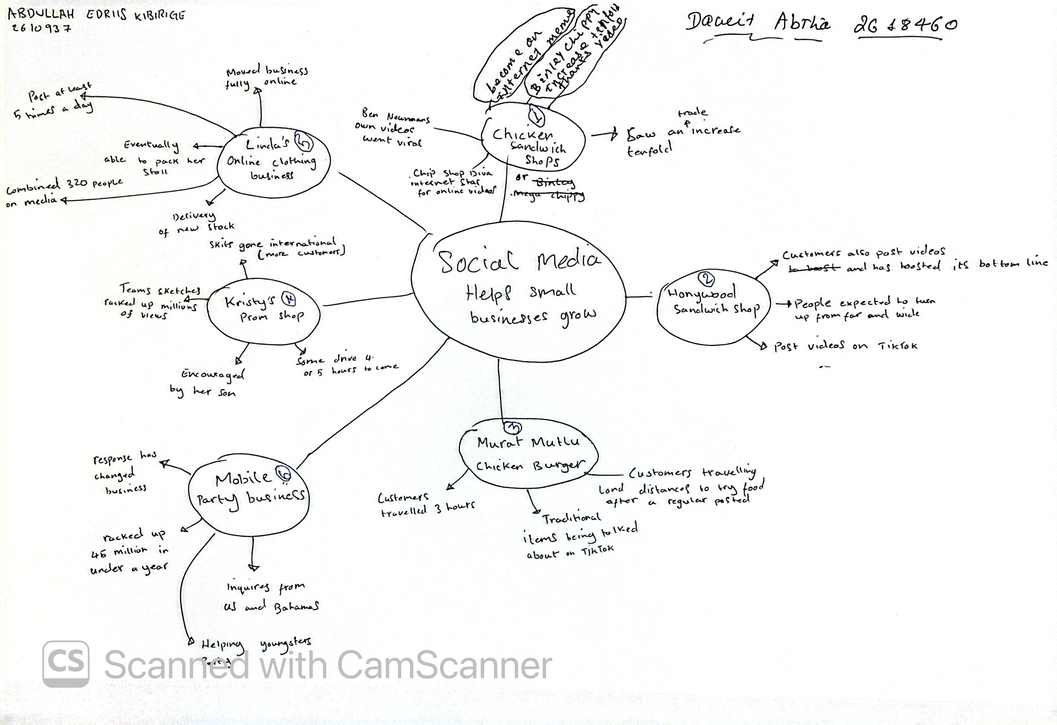

PART 2:
- Answer every question below in 1-3 full sentences.
- Use your own words. Do not use generative AI to answer these questions.
- Include a specific detail from the text when asked.
REMINDER
- The main idea is the overall message of the whole text.
- A key point helps to explain the main idea.
- A specific detail or example from the text shows that the key point is true.

- What is the main idea of the whole text?

The main question and idea that begs us all to notice and pay attention to, is how social media can help small businesses attract customers, make their businesses grow, and how to increase their sales.

- What is one key point that supports the main idea, and which specific example from the text shows this?

One key point that supports the main idea from the extract is “Binley Mega Chippy… trade increase tenfold thanks to social media”. This goes without a fact to show how social media can help further sponsor and popularize any person’s business.

- What is a different key point that supports the main idea, and which specific example from the text shows this?

Another key point that supports the main idea is “In Essex… number of businesses… boost… after going viral”. This provides further evidence to show how social media can and has helped several businesses to scale upwards by going viral.

- Which part of the text do you think is most important, and why?

The part of the text that I think is more important is Linda’s clothing business. It demonstrates how moving a business online can widen its reach. It says in the extract, “ She started posting on the platform during the pandemic and, after 46 years selling clothes on markets in Essex… has moved the business fully online and ships outfits across the UK and even Australia”. This also shows how a 20 year old went 46 yrs without having a wider reach of customers but after them many years, she was able to transform her business online. This tells us that its never too late for any business owner to transfer selling online.

Reflection:
- What did you find difficult in this task (including in-class components), and why was it difficult?

Although all the key details were on the mind map, I took a while processing how to answer the questions and whether to be to the point or to broaden my language/vocabulary.

- What helped you with this difficulty, and how did it help you?

What helped me with this difficulty was being able to just start writing and figuring out what’s next, word by word. Also, the mind map helped reasonably well by allowing me to choose from various points.

