

Student name: Alketa Lata
Student ID: 2510172

Module name: Introduction to Health and Social Care
Module code: LCHS4003
Lecturer name: Mark Kane
Content page

Element 1 …………………………………………………………Page
Community Mental Health Services: Key Milestones

Community Mental Health Services
• Support that fits into daily life
• Helps manage long‑term or complex mental health needs
• Provides psychological therapies, trauma‑informed care, and physical health support
• Builds confidence and coping skills
• Prevents crises through early, ongoing help
• Works with families, GPs, and local organisations
• Creates a strong community support network
(NHS England 2023).

1. Build Strong, Multidisciplinary Teams
Bringing together professionals from diverse backgrounds—such as psychologists, social workers, and nurses ensures that care is tailored to individual needs. This collaborative approach has been shown to improve outcomes and reduce hospital admissions (NHS England, 2019).
2. Ensure Fair and Timely Access for All
Addressing funding and resource gaps across different regions is essential. Making mental health services accessible to everyone, especially underserved communities, improves overall mental health (World Health Organisation, 2022).
3. Focus on Early Intervention
Proactive outreach and early support can catch mental health issues before they escalate, helping people get the right care sooner and easing pressure on acute services (Mental Health Foundation, 2021).
Community in Health and Social Care
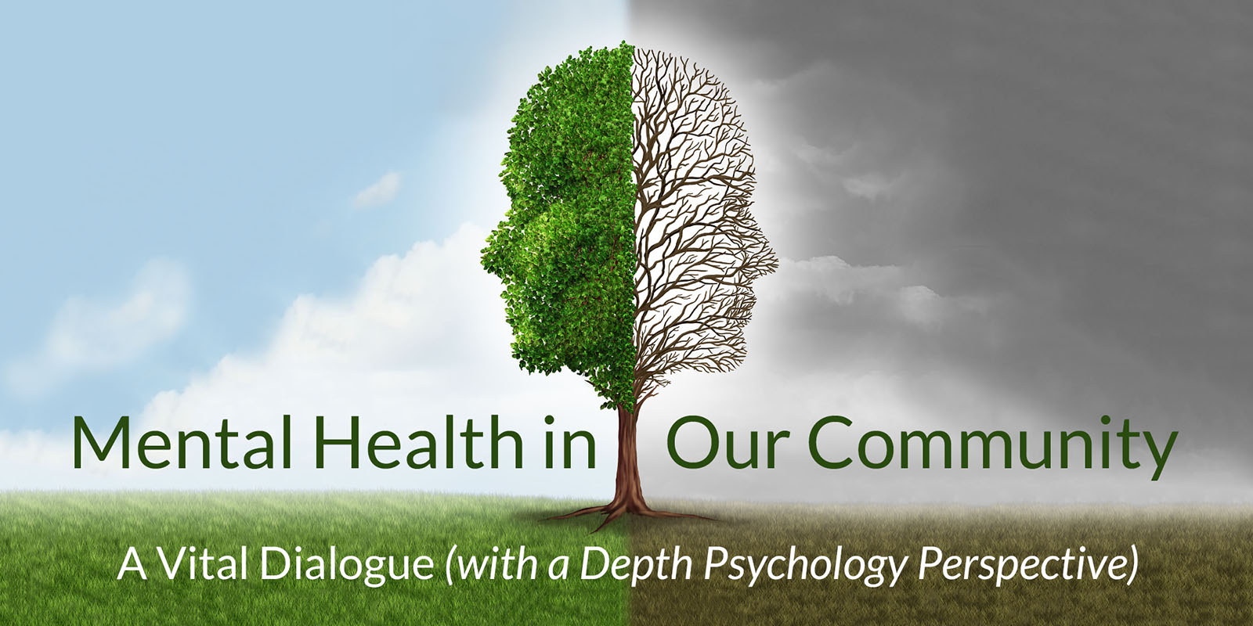


Element

References
Mental Health Foundation (2021). Prevention and Mental Health. [online] www.mentalhealth.org.uk. Available at: https://www.mentalhealth.org.uk/explore-mental-health/a-z-topics/prevention-and-mental-health.
NHS England (2019a). NHS England» NHS Long Term Plan to Tackle Major Killer Conditions and save up to Half a Million Lives. [online] England.nhs.uk. Available at: https://www.england.nhs.uk/2019/01/long-term-plan/.
NHS England (2019b). NHS England,» The Community Mental Health Framework for Adults and Older Adults. [online] England.nhs.uk. Available at: https://www.england.nhs.uk/publication/the-community-mental-health-framework-for-adults-and-older-adults/.
North (2025). Community Mental Health Transformation Programme. [online] North London NHS Foundation Trust. Available at: https://www.northlondonmentalhealth.nhs.uk/community-mental-health-transformation-programme/.
RC PSYCH ROYAL COLLEGE OF PSYCHIATRISTS. (n.d.). The Community Mental Health Framework for Adults and Older Adults | Royal College of Psychiatrists. [online] Available at: https://www.rcpsych.ac.uk/improving-care/nccmh/service-design-and-development/community-framework.
Transformation Partners in Health and Care. (2024). New Models of Community Mental Health Programme - Transformation Partners in Health and Care. [online] Available at: https://www.transformationpartners.nhs.uk/programmes/mental-health-transformation/support-for-adults/new-models-of-community/.
World Health Organisation (2022). World Mental Health report: Transforming Mental Health for All. [online] www.who.int. Available at: https://www.who.int/publications/i/item/9789240049338.

Table of contents: Essay
This assignment explores the essential role of community antenatal midwifery in delivering maternity care, focusing on how effective communication, good administrative skills, and collaboration contribute to positive outcomes for mothers and babies. Community antenatal midwifery means delivering maternity care outside hospitals, in GP practices and clinics, making care more accessible to pregnant women. Midwives in these settings offer health checks, screening, education, and support during pregnancy. They also monitor well-being, identify risks, and refer to specialists as needed. National guidelines stress early intervention NICE (2021) recommends spotting issues early to improve outcomes, and the NMC (2025) highlights that personalised, compassionate care empowers women to be confident and involved in decisions. Effective communication is crucial in community antenatal care. It ensures that women receive clear, accurate information about their pregnancy and care options so they can participate confidently in their own care. Good communication helps midwives explain screening, discuss risks, and support informed decisions—improving outcomes for mothers and babies. Building trust through communication also means that women are more likely to share their concerns, allowing care to meet their needs (NICE, 2021). For women with language barriers or complex social circumstances, strong communication helps reduce inequalities and improve their experience. For instance, using plain language and visual aids with a non-English-speaking woman ensures she understands her ultrasound appointment (NICE, 2008). If communication is unclear or too technical, misunderstandings may occur, leading to missed information or lost opportunities for care. Communication also underpins teamwork among professionals, preventing misunderstandings and ensuring continuity (NICE, 2021). Good administrative and organisational skills are essential for community midwives. These skills mean keeping accurate records, managing appointments, and coordinating care, which is vital for safety and smooth service (NMC, 2025). However, high caseloads, staff shortages, and outdated IT systems can make administration challenging, increasing the risk of errors or delays (NICE, 2021). Solutions include recruiting more midwives, upgrading IT, and providing training in digital and organisational skills. Central appointment systems and admin support can also help ease the workload. Good organisation allows midwives to plan workloads, track appointments, and follow up on care. Even with strong effort, heavy caseloads may lead to missed risks or delayed follow-up, especially for women with complex needs. Good records help all professionals stay up to date and coordinate care. Still, poor organisation or systemic issues can lead to missed appointments, delayed referrals, or incomplete documentation, risking patient safety. Achieving robust organisation requires both individual skill and adequate resources (NMC, 2025). Collaboration is a cornerstone of community antenatal midwifery. Working with GPs, social workers, and other teams means women get coordinated, holistic care (NICE, 2023). Teamwork enables quick information sharing, early risk recognition, and effective care planning. For example, if a midwife finds a woman is experiencing housing instability, collaboration ensures extra support and regular check-ups (Royal College of Midwives, 2023). But collaboration can face challenges—heavy workloads, organisational differences, or incompatible IT systems can all make teamwork difficult (WHO, 2022). Addressing these barriers means establishing clear protocols, integrating digital systems, and holding regular team meetings. Training in interprofessional communication and data protection helps teams share information safely, while care coordinators can support women with complex needs. When collaboration is strong, it reduces duplication, improves decisions, and strengthens continuity of care, leading to safer and better outcomes (NICE, 2023). In summary, effective communication, strong organisation, and collaborative working are essential for safe, person-centred maternity care in the community. These elements help midwives promote positive outcomes, reduce inequalities, and ensure high-quality care. Community antenatal midwifery is a vital part of modern health and social care, and an ongoing commitment to these standards supports the safety and well-being of mothers and babies. In conclusion, community antenatal midwifery plays a crucial role in supporting safe and effective maternity care. Effective communication enables informed decision-making and builds trust, while strong administrative skills ensure organised and accurate care delivery. Collaborative working between midwives and other professionals promotes early risk identification, continuity of care, and holistic support for women (NICE, 2021; NMC, 2025). By prioritising these elements, community midwifery services enhance the quality of life for mothers and babies, reduce inequalities, and contribute to safer outcomes across the healthcare system. An ongoing commitment to high standards in communication, administration, and teamwork is essential to the continued success of community antenatal midwifery.

References
National Institute for Health and Care Excellence (2021). Overview | antenatal care | guidance | NICE. [online] www.nice.org.uk. Available at: https://www.nice.org.uk/guidance/NG201.
Health (2023). The Care Quality Commission (Maternity and Newborn Safety Investigation Programme) Directions 2023. [online] GOV.UK. Available at: https://www.gov.uk/government/publications/the-care-quality-commission-maternity-and-newborn-safety-investigation-programme-directions-2023.
Sharples, R. (2023). RCM urges Government to take the opportunity to improve maternity care - Royal College of Midwives. [online] Royal College of Midwives. Available at: https://rcm.org.uk/media-releases/2023/07/rcm-urges-government-to-take-opportunity-to-improve-maternity-care/.
Dayyani, I., Lou, S. and Jepsen, I. (2021b). Midwives’ Provision of Health Promotion in Antenatal Care: a Qualitative Explorative Study. Women and Birth, [online] 35(1). doi:https://doi.org/10.1016/j.wombi.2021.01.010.

Homer, C., Wilson, A. and Davis, D. (2020). Editorial: Words matter; Language Matters. Women and Birth, 33(2), pp.105–106. doi:https://doi.org/10.1016/j.wombi.2020.02.003.

‌

