

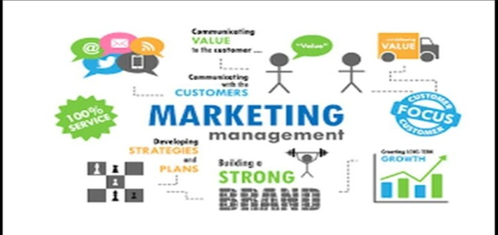

Assignment 2
Subject Name: Marketing Management
Subject Code: LCMB7024
Company Name: Bang & Olufsen
Lecturer: Dr Laila Maazouz
Course: MBA
Term: 1

Student Name: Manali Dipakbhai Shiroya
Student Number: 2427830
Submission Deadline: 28 April 2025
Word Count: 2568

Table of Contents
1. Introduction 2
2. Brand Extension 3
2.1 Brand Overview 3
2.2 Unique Selling Proposition (USP) 4
2.3 Market Research and Opportunity 4
2.4 Strategic Fit 6
3. Segmentation, Targeting, and Positioning (STP) 6
3.1 Segmentation 7
3.2 Targeting 8
3.3 Positioning 9
4. Customer Persona 9
4.1 Demographic Information 9
4.2 Psychographic Information 10
5. 7P Marketing Mix 11
5.1 Product 11
5.2 Price 12
5.3 Place 13
5.4 Promotion 14
5.5 People 15
5.6 Process 15
5.7 Physical Evidence 16
6. Conclusion 17
References 18

1. Introduction
Bang & Olufsen (B&O) is internationally recognised for its innovative acoustic technology, high-end design, and craftsmanship. B&O has established itself as a luxury brand that caters to discerning consumers who seek both functionality and form, with a rich heritage that is anchored in innovation and aesthetics (MarketLine Advantage, 2024). This report investigates the creation of a new brand extension: Bang & Olufsen Electric Bicycles (e-Bikes) in response to the increasing demand for sustainable urban mobility and the integration of technology and lifestyle.
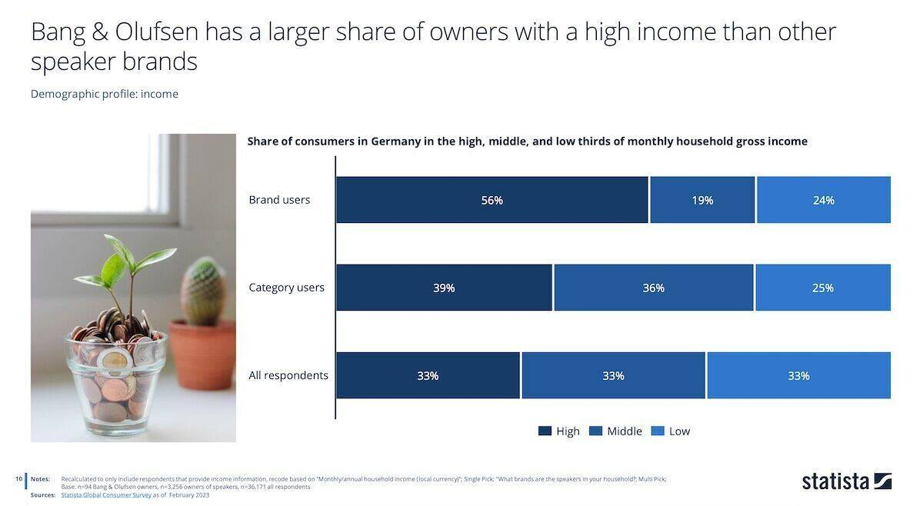
Source: https://www.wuv.de/Themen/Marke/45-Prozent-Wachstum-Wie-Bang-Olufsen-der-Umschwung-gelang
While entering the dynamic and rapidly expanding electric mobility market, this brand extension is consistent with B&O's core identity, which combines sophisticated engineering with premium design (MarketLine Advantage, 2024). Our objective is to revolutionise urban commuting by introducing an e-Bike that not only performs at the highest level but also offers a distinctive sensory experience through the integration of smart connectivity and aural elements.
This report commences with a conceptual overview of the e-Bike and its brand alignment, subsequently detailing the development of the brand extension. It presents a 7P marketing formula, establishes a consumer persona, and discusses the segmentation, targeting, and positioning (STP) strategy to guarantee a comprehensive market approach.

2. Brand Extension

2.1 Brand Overview
Bang & Olufsen (B&O), a Danish icon in premium audio-visual craftsmanship, is on the brink of extending its design philosophy and technological excellence into the electric mobility sector with the introduction of Bang & Olufsen Electric Bicycles (e-Bikes). B&O, which is recognised for its ability to combine exceptional sound engineering with high-end aesthetics, generated USD 375.7 million in revenue in FY2024 (MarketLine Advantage, 2024).
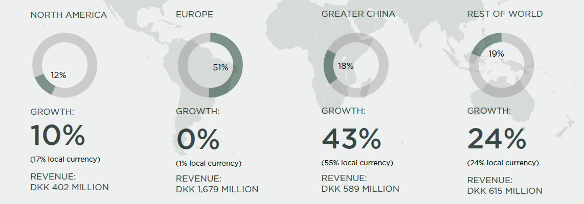
Source: https://seekingalpha.com/article/4187709-bang-and-olufsen-turn-up-the-bass-and-the-share-price
This revenue was generated through a diverse range of products, including speakers, home entertainment solutions, and sound systems. B&O's extensive distribution network, which includes 387 monobrand stores and more than 2,300 multibrand points of sale worldwide, is well-positioned for expansion into adjacent lifestyle markets (MarketLine Advantage, 2024).
This proposed e-Bike brand extension is consistent with B&O's core values of luxury, innovation, and sensory experience (MarketLine Advantage, 2024). It capitalises on the company's strengths in product design and technology to address the increasing demand for sustainable urban mobility among consumers (Heineke et al., 2023). The concept is not merely transportation; it is a multisensory commuting experience that combines Scandinavian design, integrated smart technologies, and B&O's renowned acoustic excellence.

2.2 Unique Selling Proposition (USP)
The B&O e-Bike is distinguished by its combination of premium craftsmanship, intelligent connectivity, and immersive audio. A minimalist yet luxurious frame design, embedded B&O sound systems for ambient aural experiences, and app-controlled smart features for navigation and diagnostics are all part of the bicycle's vision as a lifestyle accessory that redefines commuting.
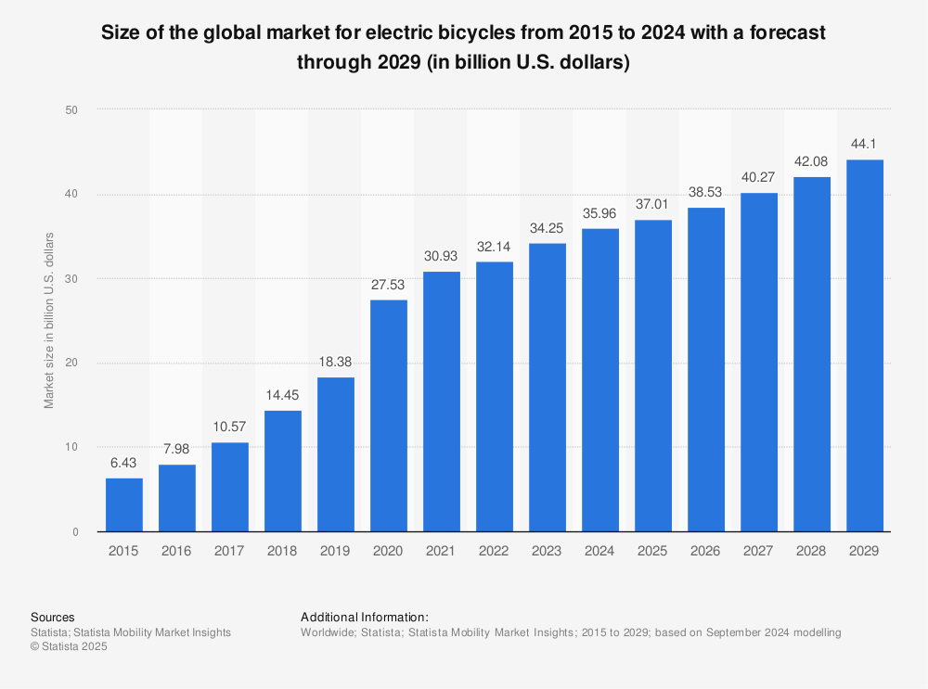
Source: https://www.statista.com/statistics/674381/size-global-market-electric-bicycles/
The unique selling proposition is the provision of a mobile luxury platform that is not merely a mode of transportation, but rather a platform that is appealing to brand-conscious consumers who prioritise both sustainability and prestige (Aeberhard et al., 2020).

2.3 Market Research and Opportunity
The decision to enter the e-bike market is supported by robust global trends. 35% of individuals in 28 countries ride a bicycle at least once per week. The highest rates of bicycle usage were observed in India (67%), China (66%), and the Netherlands (65%) (Ipsos, 2022). These figures illustrate a resilient cycling culture in critical international markets, particularly in urban centres where B&O already has a substantial retail presence.
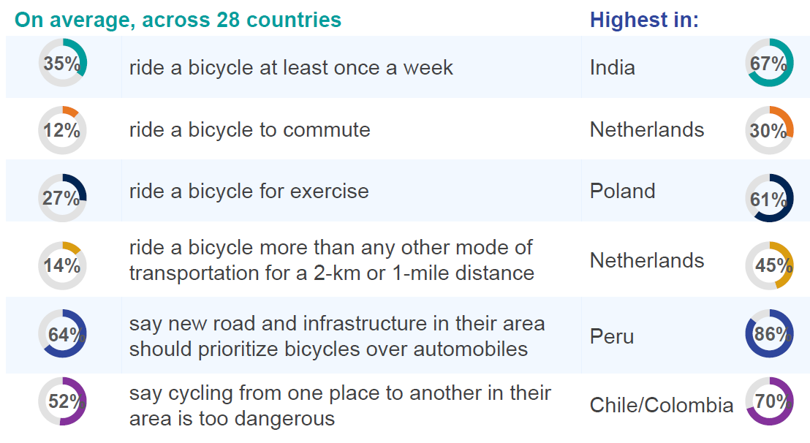
Source: Ipsos (2022) Cycling across the world
Additionally, 86% of global respondents concur that cycling is a critical factor in the reduction of carbon emissions, while 80% regard it as a solution to urban congestion (Ipsos, 2022). These statistics are in close alignment with B&O's strategic emphasis on sustainable innovation, which further boosts the alignment of the brand extension with emerging consumer values (Bang & Olufsen, 2025).
In the context of short-distance transportation, bicycles are the primary mode of commuting for distances under 2 kilometres for 14% of the global population. The Netherlands (45%), China (33%), and Japan (27%) are pioneering this trend (Ipsos, 2022). B&O has the opportunity to capitalise on the micro-mobility segment by providing a solution that seamlessly integrates premium identity with practical utility, a demand that is readily apparent in mature urban markets (D’Acunto, 2024).
Product ownership trends serve to further reinforce the transformation in consumer behaviour. 42% of global respondents personally own a bicycle, 28% ride for exercise, and 16% use bicycles to commute to work or education (Ipsos, 2022). Furthermore, the demand for public bicycle-sharing systems and e-mobility alternatives is on the rise, particularly in European and Asia-Pacific cities (EEA, 2024).

2.4 Strategic Fit
B&O's present strategy focusses on "Luxury Timeless Technology," a long-term development vision that prioritises product innovation, connected lifestyles, and experience-based branding. This strategy is in alignment with the introduction of an e-Bike, notably within the "On-the-Go" and "Flexible Living" categories, which accounted for 24.7% and 17.9% of total revenue, respectively, in FY2024 (Ipsos, 2022). The demographic that e-bikes are designed to target is precisely the mobile lifestyles and urban consumers that these segments cater to.
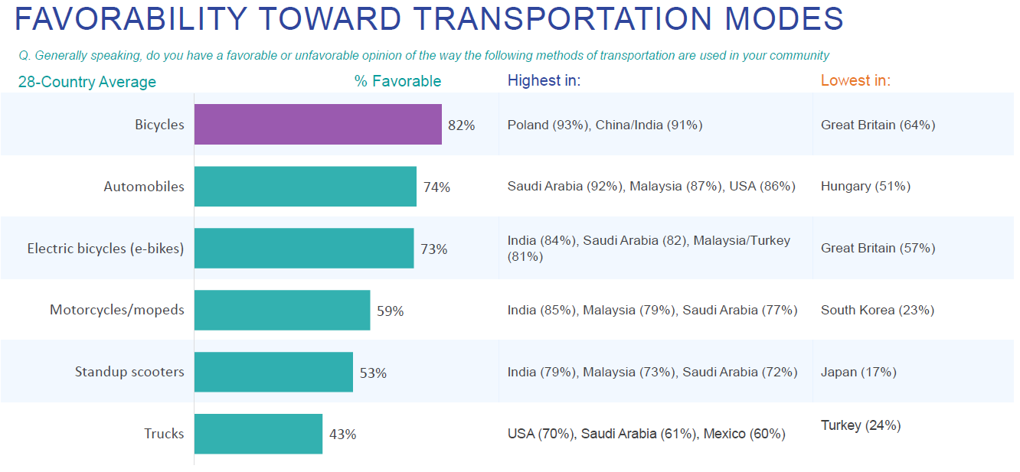
Source: Ipsos (2022) Cycling across the world
Additionally, the European consumer electronics and e-commerce markets provide an advantageous environment for this endeavour (Ipsos, 2022). B&O will be able to expand e-Bike sales through both physical and digital channels as the online retail market is anticipated to grow at a 13.8% CAGR and Europe's consumer electronics retail sector is projected to reach USD 406 billion by 2027.

3. Segmentation, Targeting, and Positioning (STP)

3.1 Segmentation
Urban professionals with medium to high household income and a preference for premium, well-designed products comprise the core consumer segment, which is characterised by a demographic of individuals aged 25 to 49. These individuals are more likely to reside in major metropolitan areas and be part of communities that prioritise education and career development.
Across 28 countries, 35 percent of adults ride a bicycle at least once per week (Ipsos, 2022). This figure increases to 67 percent in India, 66 percent in China, and 65 percent in the Netherlands, all of which are markets with robust cultural and infrastructural support for cycling. These observations indicate that a substantial number of potential users are already acclimated to incorporating bicycles into their daily routines.
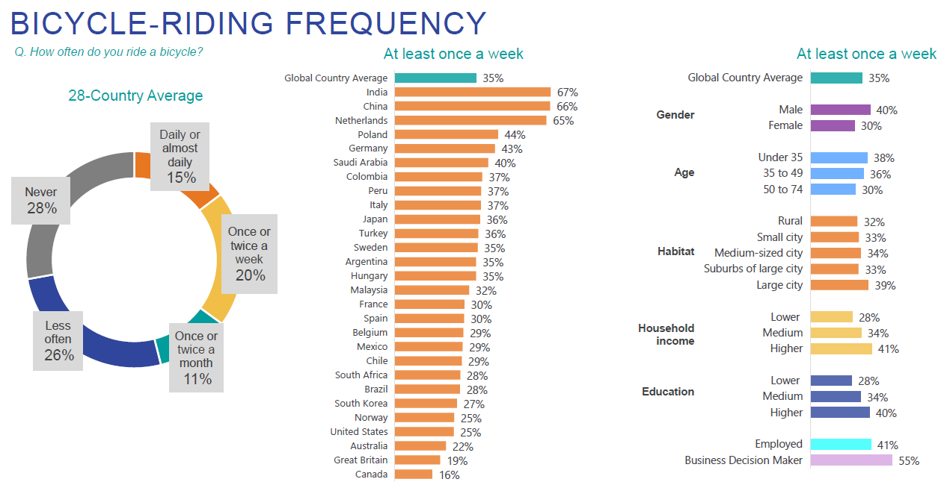
Source: Ipsos (2022) Cycling across the world
From a geographical perspective, the Netherlands, China, Japan, and Germany present ideal market opportunities for the brand (Ipsos, 2022). A bicycle is the primary mode of transportation for 45 percent of individuals in the Netherlands, which is significantly higher than the global average of 14 percent, for distances of two kilometres or less.
Behaviourally, the ideal user is one who frequently cycles for commuting or leisure, actively pursues sustainable alternatives to vehicle travel, and responds to well-branded, lifestyle-driven product experiences. It is worth noting that 73 percent of global respondents have a favourable opinion of electric bicycles, with approval rates increasing to 85 percent in India, 79 percent in Malaysia, and 77 percent in Saudi Arabia (Ipsos, 2022).

3.2 Targeting
With this segmentation in place, Bang & Olufsen will implement a focused targeting strategy that emphasises affluent urban professionals and forward-thinking commuters in global cities with established or swiftly expanding cycling infrastructure (Banister, 2018; Popan, 2019). These consumers are not only environmentally motivated but also exceedingly brand-conscious. They are prepared to pay a premium for products that provide both utility and prestige and appreciate technology that seamlessly integrates into their lifestyles.
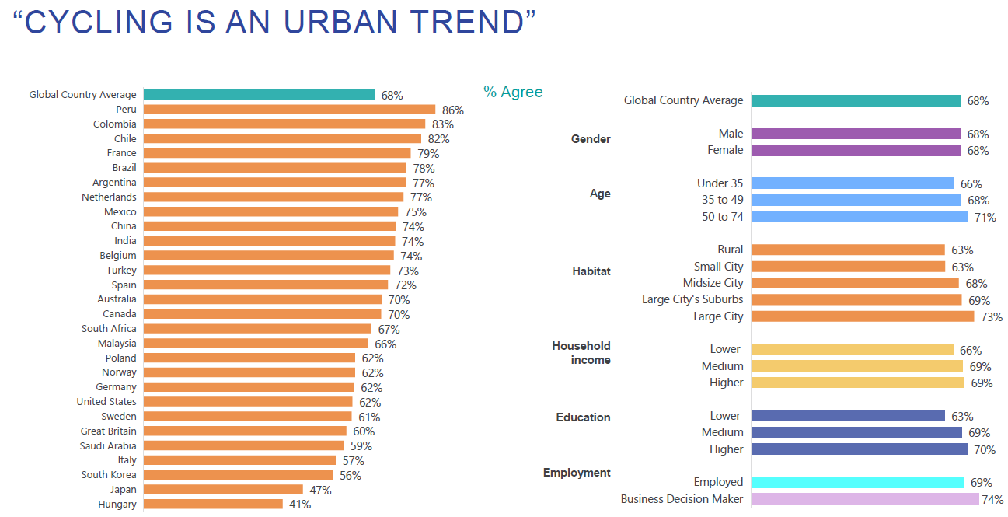
Source: Ipsos (2022) Cycling across the world
Metropolitan residents are considerably more inclined to engage in cycling than their rural counterparts (Ipsos, 2022). Furthermore, individuals with higher levels of education and income are more likely to own bicycles, suggesting a significant overlap with Bang & Olufsen's current consumer base and brand community (MarketLine Advantage, 2024). This demographic is optimally adapted for a product that combines performance, design, and intelligent connectivity—features that elevate the mundane experience of commuting to a level of luxury.

3.3 Positioning
Bang & Olufsen will present its e-Bike as a premium electric mobility experience that surpasses conventional cycling. The product will embody the brand's most distinctive attributes: advanced electric engineering, immersive sound technology, and Scandinavian aesthetics (MarketLine Advantage, 2024).
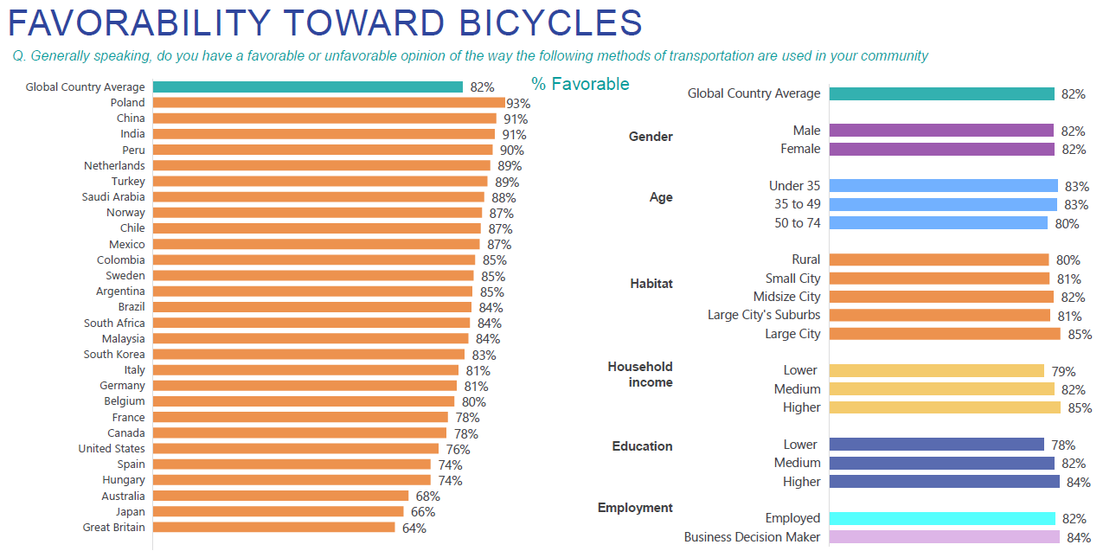
Source: Ipsos (2022) Cycling across the world
It will serve as a representation of intelligent urban living, developed for users who desire more than just efficiency; they seek distinction, sentiment, and identity in each product they employ. The e-Bike will not only offer silent, zero-emission transportation, but it will also enhance daily commutes by incorporating features such as a lightweight, minimalist frame design, intuitive app integration, and built-in Bang & Olufsen audio.

4. Customer Persona

4.1 Demographic Information
A male or female urban professional between the ages of 30 and 45 is the optimal customer for Bang & Olufsen's electric bicycle. They are typically found in large cities or metropolitan areas where cycling infrastructure is well-developed and active commuting is both feasible and encouraged.
A particularly active demographic is represented by individuals under 35, as 40% of men and 30% of women in this age group report that they ride a bicycle at least once a week (Ipsos, 2022). In contrast to rural areas, individuals residing in large cities exhibit a higher level of engagement with cycling as a daily activity, with 38% of city residents utilising bicycles on a weekly basis.
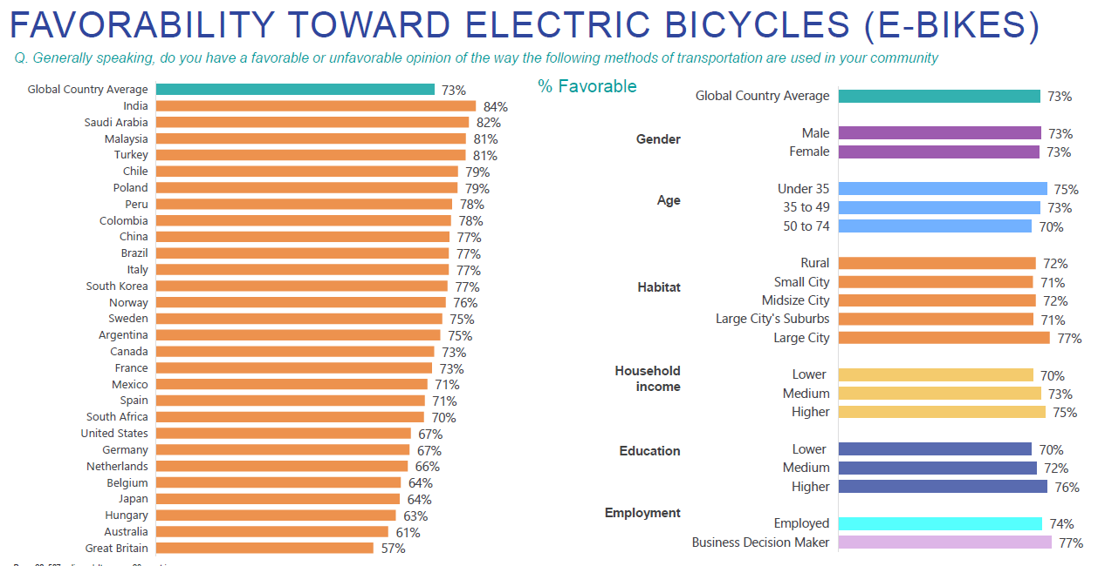
Source: Ipsos (2022) Cycling across the world
This consumer is typically classified as a medium to high-income individual and possesses a university degree or higher. Individuals with higher levels of educational attainment have a higher frequency of cycling. Approximately 38% of adults with higher education ride a bicycle at least once a week (Ipsos, 2022).

4.2 Psychographic Information
The target consumer is profoundly environmentally aware and design-conscious from a psychological perspective. They prioritise sustainability, technological integration, and premium aesthetics in their product selections. This individual is not solely driven by function; they also pursue emotionally rewarding experiences through their product purchases.
86% of global respondents consider cycling to be a critical solution to urban traffic congestion, while 80% regard it as a means of reducing carbon emissions (Ipsos, 2022). This emphasises the increasing environmental awareness that influences the mobility decisions of urban populations.
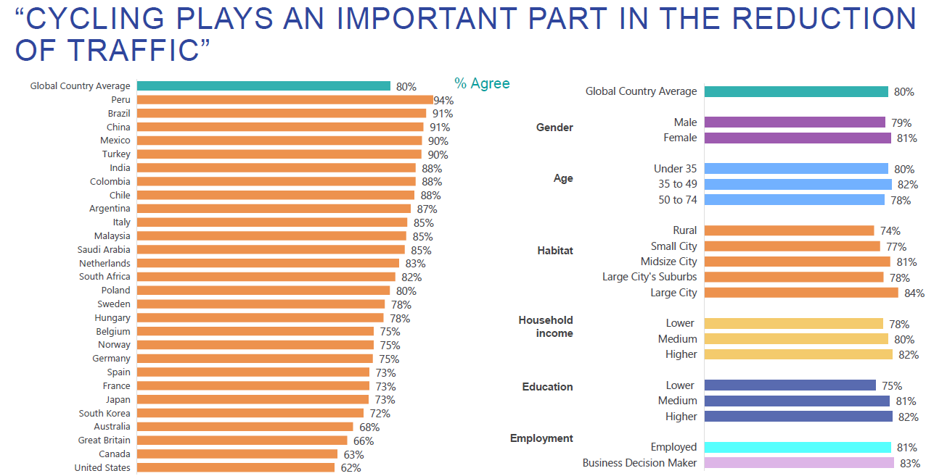
Source: Ipsos (2022) Cycling across the world
The ideal consumer is likely to be someone who utilises technology on a daily basis, values convenience, and appreciates brands that seamlessly integrate form and function. They regard cycling as a lifestyle choice that reflects their values and aspirations, in addition to a transportation method.

5. 7P Marketing Mix

5.1 Product
As a high-end e-mobility solution that integrates sustainable transportation with the brand's legacy of Scandinavian design and superior audio quality, the Bang & Olufsen Electric Bicycle will be introduced. The e-Bike will be furnished with advanced digital connectivity, a lightweight and minimalist frame, and integrated B&O sound systems, drawing on Bang & Olufsen's expertise in premium speakers, televisions, and wearable audio devices (MarketLine Advantage, 2024).
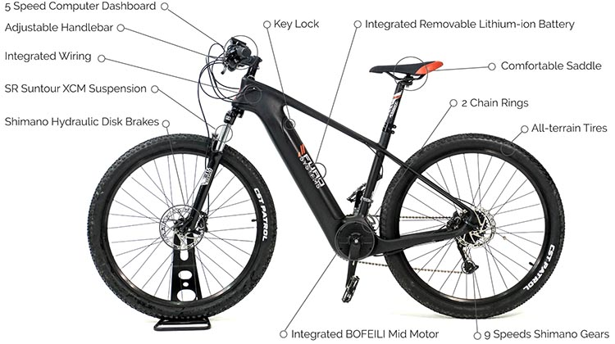
Source: https://electricbikeblog.com/furosystems-carbon-e-bikes/
The concept is consistent with the company's "On-the-Go" product category, which is already responsible for 24.7% of its revenue (DKK640 million in FY2024) and is designed for consumers who prioritise performance and design in their mobile lifestyles (MarketLine Advantage, 2024).

5.2 Price
The Bang & Olufsen e-Bike will be priced according to a premium strategy that is indicative of its technological integration and brand equity. The e-Bike is anticipated to be priced between €3,500 and €6,000, in accordance with B&O's position in the luxury electronics sector (MarketLine Advantage, 2024), where products such as the Beosound Edge and Beovision Harmony are priced at several thousand euros. In addition to demographic targeting, this pricing is also justified by the prestige of the brand.
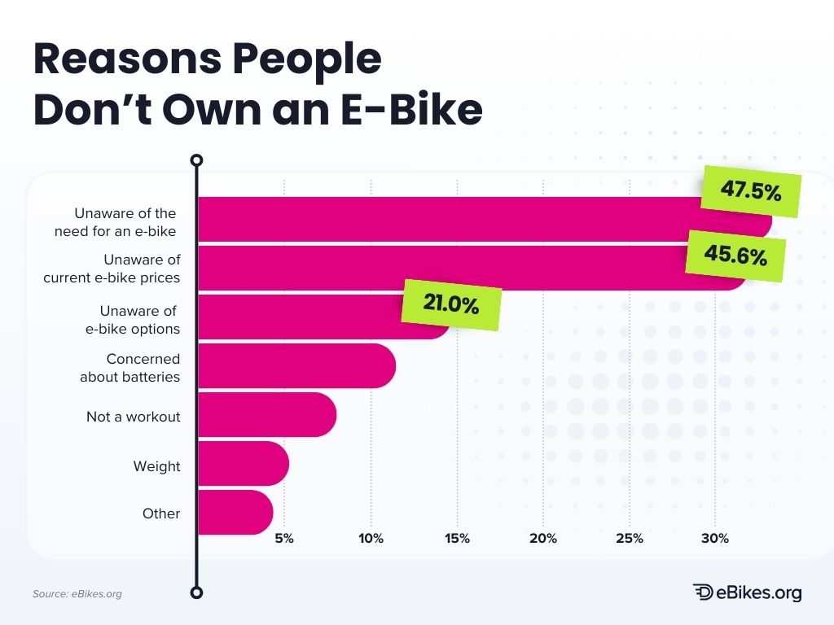
Source: https://ebikes.org/general/e-bike-market-insights/
The highest rates of bicycle ownership and usage are observed among individuals in high-income households (Ipsos, 2022). Specifically, 46% of high-income earners own a bicycle, while 40% of lower-income groups do. This suggests a substantial potential for a customer base that is quality-oriented and price-inelastic, and is willing to pay a premium for mobility products that are technologically advanced and sustainable.

5.3 Place
Bang & Olufsen maintains an extensive global retail presence, which encompasses 387 monobrand stores and 2,317 multibrand points of sale, in addition to a direct-to-consumer e-commerce platform (www.bang-olufsen.com) (MarketLine Advantage, 2024). The e-Bike will be initially introduced in countries with a high level of cycling penetration and a supportive infrastructure.
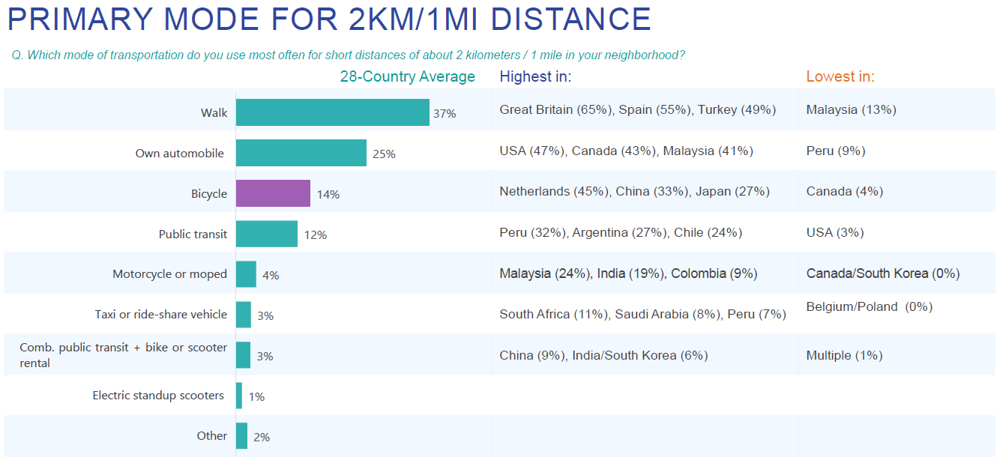
Source: Ipsos (2022) Cycling across the world
In terms of the percentage of adults who use bicycles for short commutes under two kilometres, the Netherlands (45%), China (33%), and Japan (27%), according to Ipsos, are among the greatest (Ipsos, 2022). Furthermore, it is worth noting that a significant number of adults in India and China, 67% and 66%, respectively, ride bicycles on a weekly basis, indicating considerable demand in these regions. The early implementation will focus on these nations, particularly those with dense urban centres and sustainability mandates.

5.4 Promotion
Bang & Olufsen's brand will be reinforced as an arbiter of elegance, innovation, and sensorial delight through a promotional strategy that emphasises both functionality and lifestyle. Product storytelling will be integrated into marketing initiatives that focus on technological integration, design, and sustainability.
Visual storytelling, influencer marketing, and partnerships with other luxury brands will be the primary focus of the campaigns (Romo, García-Medina and Romero, 2017). This approach has been demonstrated to be effective in B&O's previous collaborations with Supreme, Balenciaga, and Williams Racing (MarketLine Advantage, 2024).
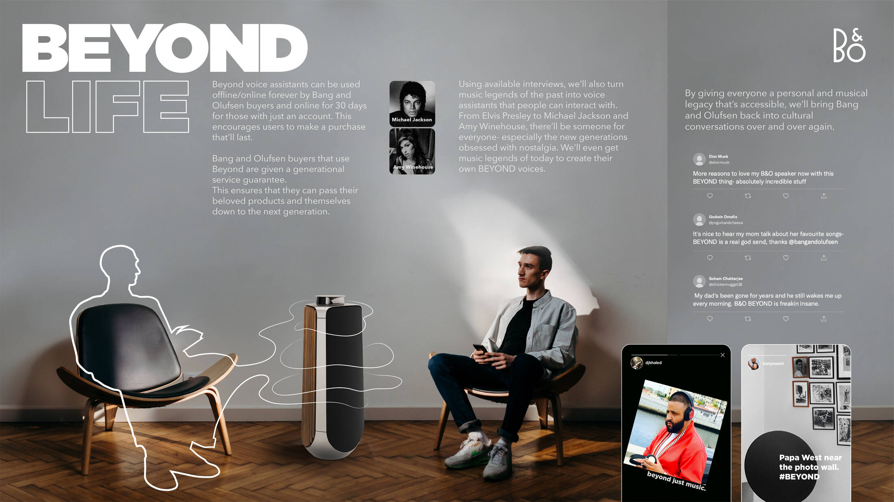
Source: https://www.adsoftheworld.com/campaigns/beyond-0507eca1-fa25-42ad-82f3-a3a747352dff

5.5 People
Bang & Olufsen is known for its curated in-store experience, which is complemented by staff that are trained in product storytelling and personalised service (MarketLine Advantage, 2024). In order to reinforce a premium purchasing experience, personnel will be prepared to provide in-depth technical demonstrations, customisation guidance, and after-sales support for the e-Bike.

5.6 Process
The consumer experience will be designed to ensure a seamless interaction, regardless of whether it occurs in-store or online. B&O has already implemented a sophisticated e-commerce system and has made significant investments in personalisation tools (MarketLine Advantage, 2024).
An interactive online portal will enable customers to customise the features of their e-Bike, including colour, accessories, and connectivity options. In metropolitan regions, customers can anticipate white-glove delivery and in-home setup services following their purchase, which will further enhance the perception of exclusivity (Scott et al., 2024).
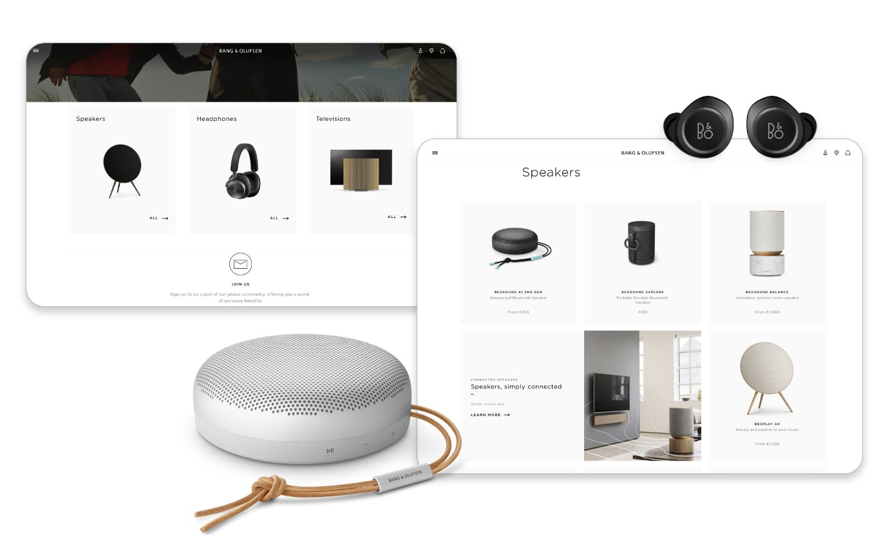
Source: https://commercetools.com/customer-stories/bang-olufsen

5.7 Physical Evidence
Bang & Olufsen's identity will be reflected in the physical product by means of a distinctive frame silhouette that features the B&O insignia, minimalist aesthetics, and high-quality materials. The e-Bike will project elegance and functionality in urban settings, just as its speaker systems, such as the Beosound Emerge and Beolab 28, exemplify sculptural design (MarketLine Advantage, 2024).
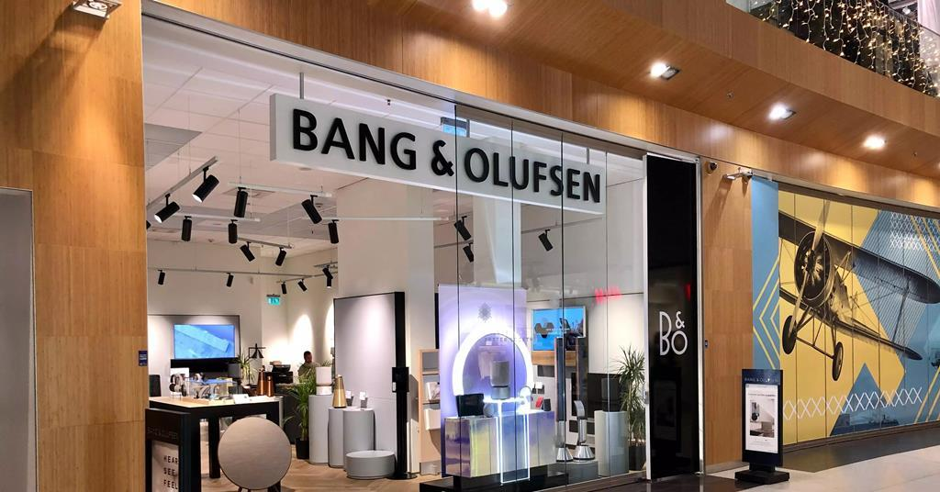
Source: https://www.telcotitans.com/deutsche-telekomwatch/bang-and-olufsen-withdraws-from-more-than-700-t-mobile-us-stores/7306.article
The Bang & Olufsen lifestyle ecosystem will be further embraced by consumers through the use of branded accessories, including helmets, saddlebags, and locks, in addition to a functional and aesthetically pleasing in-store presentation.

6. Conclusion
The Bang & Olufsen Electric Bicycle is a logical progression of the brand's dedication to premium experiences, aesthetics, and innovation. This expansion into the e-mobility sector is both strategic and opportune, as it is in accordance with global sustainability trends and the growing demand for smarter, greener urban commuting solutions among consumers.
The e-Bike is a strong strategic fit for Bang & Olufsen's future development, as evidenced by global market data and changing lifestyle values. The brand is well-positioned to dominate and enter the emerging premium electric bicycle market by utilising a robust 7P marketing blend, a compelling customer persona, and targeted segmentation.

References
Aeberhard, M. et al. (2020) 'Marketing management of luxury providers,' in Tourism, hospitality & event management, pp. 109–155. https://doi.org/10.1007/978-3-030-59893-8_5.
Bang & Olufsen (2025) 'What is Sustainable Design?' Bang & Olufsen, 1 January. https://www.bang-olufsen.com/en/us/story/sustainable-design (Accessed: April 18, 2025).
Banister, D. (2018) 'Beyond mobility: planning cities for people and places,' Transport Reviews, 39(3), pp. 418–419. https://doi.org/10.1080/01441647.2018.1462272.
D’Acunto, D. (2024) The future of E-Mobility: Investigating the Role of Electric Mobility for Consumers and Industries. Springer Nature.
EEA (2024) Bike sharing systems in European cities. https://www.eea.europa.eu/en/circularity/sectoral-modules/product-lifespans/availability-of-bike-sharing-systems-in-european-cities-intensity-of-use (Accessed: April 18, 2025).
Heineke, K. et al. (2023) Shared mobility: Sustainable cities, shared destinies. https://www.mckinsey.com/industries/automotive-and-assembly/our-insights/shared-mobility-sustainable-cities-shared-destinies (Accessed: April 18, 2025).
Ipsos (2022) Cycling across the world. https://www.ipsos.com/sites/default/files/ct/news/documents/2022-05/Ipsos%20-%20Cycling%20Across%20the%20World-2022.pdf.
MarketLine Advantage (2024) Bang & Olufsen AS.
Popan, C. (2019) Bicycle Utopias: Imagining Fast and Slow Cycling Futures.
Romo, Z.F.G., García-Medina, I. and Romero, N.P. (2017) 'Storytelling and social networking as tools for digital and mobile marketing of luxury fashion brands,' International Journal of Interactive Mobile Technologies (iJIM), 11(6), p. 136. https://doi.org/10.3991/ijim.v11i6.7511.
Scott, M.A. et al. (2024) 'Investigating the effects of customer traits on preference for last‐mile delivery service attributes: When the product introduces a task,' Transportation Journal, 63(2), pp. 127–151. https://doi.org/10.1002/tjo3.12003.
Wang, J. (2024) 'Study on the Relationship between Digital After-sales Service of Charging Pile and Purchasing Intention of Major Customers Based on the TAM Model---A Case Study of GK Corporation,' Deleted Journal, 8(1), pp. 19–44. https://doi.org/10.54254/2977-5701/8/2024077.

