Dewi Sant
  - Who was Saint David?
St. David or, Dewi Sant, is most known as the patron saint of Wales. From preaching to miracles, St. David has left a substantial impact on Wales and is a key symbol of cultural heritage and pride. This essay will be exploring the history of the saint, his religious significance, and continued legacy within Wales. There will be a focus on the religious and historical impact he left behind. In this essay there will be a focus on the hagiography written by Rhygyfarch. There will be discussion into the events he recorded about the life of St. David, and the symbolism associated with him, and the churches related to the Saint and more specifically St Davids Cathedral.
Born around the years 500CE-520CE near St Bride’s Bay in Pembrokeshire, his father was Sant, or Sand, a prince of Ceredigion, and St. Non, a nun reported by some sources to be the daughter of Cynir, or Cynyr, Ceinfarfog. According to the writings of Rhygyfarch, St David was conceived as the result of rape. Despite the nature of the conception of St. David, his birth is surrounded by miraculous events. Rhygyfarch states that it was revealed to St. Patrick in Dyfed, where he planned to devote himself to God, that this place was not assigned to him, ‘[…] but to a son who is not yet born, nor will be born until thirty years have first passed.’ Further on, according to Rhygyfarch’s ‘Life of St David’ at the location of St. David’s conception, lays a small meadow, at this site Rhygyfarch claims a small miracle where ‘[…] at the moment she conceived, there appeared two large stones that had not been seen before, one at her head and the other at her feet; for the land, rejoicing at his conception […]’. The events surrounding the birth of St. David are almost messianic in nature, they depict his coming as divine. Rhygyfarch, later describes an event where St. Non visits a church, whilst pregnant with St. David, to hear the preaching of St. Gildas. When St. Non entered the church Gildas lost the ability to preach, whilst maintaining the ability to speak in normal conversation. Gildas expelled the congregation, to see if he could regain his ability to preach. When the parishioners left, St. Non remained, hidden in the church ‘with an intense thirst for the Word of life, to assert the privilege of her great offspring.’ This continues a series of connections between St. David and other Welsh saints that sanctify his saintly status.
The most famous miracle attested to St. David is one where a hill formed beneath him as he preached to a crowed allowing them to see and hear him clearly, whilst he preached it is said that a white dove landed upon his shoulder. This dove is present in many further depictions of the saint.
He was asked to preach, and he did not reject the decision of the council. they ordered him to ascend the built-up heap of clothes, but he refused. Instead, he ordered the boy recently raised from the dead to place a handkerchief under his feet. Standing on it, he explained the Gospel and the law as if from a trumpet. Before everyone’s eyes a snow-white dove, sent from heaven, settled on his shoulders and remained there as long as he preached.
The white dove could represent the presence of God with him whilst he preached. The comparison of his voice to a trumpet evokes the imagery of the ‘Trumpets of Heaven’ from the Book of Revelation signalling the announcement of God’s kingdom. This follows the theme of parallels between stories of St. David and stories from The Bible. Rhygyfarch states at the location of this miracle now lays a church, this is a common theme in locations associated with St. David’s life. Such as the place of his birth at the clifftop where St. Non’s Chapel now lies. This shows the importance of St. David as a religious figure.
An examination into the context of Rhygyfarch’s writings and the history of the writer is important in determining the quality of the information it contains. Rhygyfarch ap Sulien, was lived from 1056/57-1099, he was part of a family that ruled the clas of Llanbadarn during the eleventh century. His father was the bishop of St Davids, tying his family history to his work on St. David. It must be noted that Rhygyfarch was born over four hundred years after the death of St. David, this affects the reliability to his account of events. The work of Rhygyfarch contains references to miracles and revelations by God; this, and the writer’s ties to the church, reveals that aspects of the text are to be analysed carefully, accounting for a level of unreliability in finer details regarding historical events. However, the accounts of miracles can provide insight into the mythos around St. David, and his veneration as a saint.
St. David died in Mynyw, Dyfed on the 1st of March. Scholars have been able to calculate the year of his death due to text in Rhygyfarch’s Life of St David, stating:
My brothers, persevere in those things that you have learned from me, and have seen with me; on Tuesday, 1 March, I shall enter the way of the fathers;111 farewell in the lord, for I shall go away; we shall not see each other any more in this world.
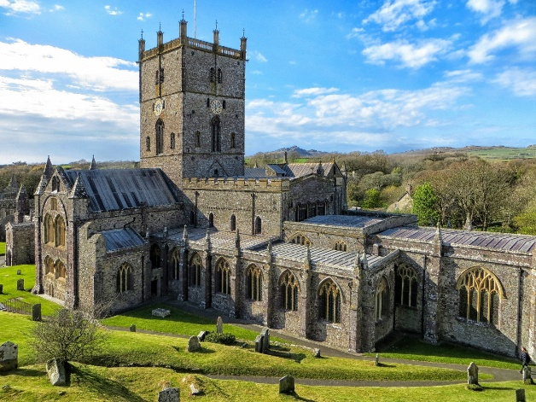
Scholars have been able to attribute the stated day of the week to work out the year St. David died, usually placed in either 589 CE or 601 CE.
St. David is highly venerated throughout Wales, from his place of birth in Ceredigion and his monastic education at Henfynyw and then in Carmarthenshire. St. David and his followers moved along the countryside founding churches. Through plotting the distribution of churches in dedication to St. David, E.G. Bowen identified two groups of the cult of St. David: north and south. He believed the northern group to have expanded from Llanddewibrefi, the southern sect expanding from St Davids.
St David’s Cathedral was founded in the sixth century; it is the burial site of St. David. The current church is assumed to be the fourth iteration of the building. The original monastic church was destroyed by a fire in 645, the second in 1088 and the third in 1171 and 1172.When Pope Calixtus II canonised St. David in 1131 the church was devoted to him in conjunction with St. Andrew, the patron saint of the previous church.
Figure 112
This essay has been to discuss the life and veneration of St. David after his death, through the lens of Rhygyfarch’s hagiography of St. David, exploring the religious and cultural significance of St. David. Rhygyfarch speaks of miracles that surround his life and the sites of these miracles where they are memorialised by churches and chapels. The following of St. David has been traced through Wales and the churches he founded show the spread of his veneration. The discussion of St. David’s life and religious importance is key in understanding the history of the man regarded as the patron saint of Wales.

Encyclopædia Britannica, ‘Saint David | Biography & Facts | Britannica’, Www.britannica.com (Encyclopædia Britannica, 1998) <https://www.britannica.com/biography/Saint-David> [accessed 31 December 2025].
J Wyn Evans, Jonathan M Wooding and Heather James, St David of Wales: Cult, Church and Nation, Boydell and Brewer eBooks (Boydell & Brewer, 2007), (p. 111) <https://doi.org/10.1515/9781846155963> [accessed 20 December 2025].
Ibid (p. 113).
Ibid (p. 113).
Encyclopædia Britannica, ‘Saint David | Biography & Facts | Britannica’, Www.britannica.com (Encyclopædia Britannica, 1998) <https://www.britannica.com/biography/Saint-David> [accessed 31 December 2025].
J Wyn Evans, Jonathan M Wooding and Heather James, St David of Wales: Cult, Church and Nation, Boydell and Brewer eBooks (Boydell & Brewer, 2007), (pp. 145-147) <https://doi.org/10.1515/9781846155963> [accessed 20 December 2025].
Bible Gateway, ‘Bible Gateway Passage: Revelation 8-11 - New Revised Standard Version, Anglicised’, Bible Gateway, 2025 <https://www.biblegateway.com/passage/?search=Revelation%208-11&version=NRSVA> [accessed 2 January 2026].
J Wyn Evans, Jonathan M Wooding and Heather James, St David of Wales: Cult, Church and Nation, Boydell and Brewer eBooks (Boydell & Brewer, 2007), (p. 147) <https://doi.org/10.1515/9781846155963> [accessed 20 December 2025].
Ibid (p. 117).
Ibid (p. 90).
Ibid (p.151).
Pixabay and David Lloyd, Photograph of St David’s Cathedral, Pixabay, 8 March 2019 <https://pixabay.com/photos/st-davids-st-davids-cathedral-4041250/> [accessed 4 January 2026].
J Wyn Evans, Jonathan M Wooding and Heather James, St David of Wales: Cult, Church and Nation, Boydell and Brewer eBooks (Boydell & Brewer, 2007), (p. 41) <https://doi.org/10.1515/9781846155963> [accessed 20 December 2025].
Philip A Robson, Bell’s Cathedrals (anboco, 2016).

