University Of Wales Trinity St David
School of Engineering
Electronic Ignition & Fuel Injection Systems
Kieran Dellow
2102899
Motorsport Engineering BEng
6/4/2022
Vehicle / Motorsport Technology
ACHA4010

Contents
1.0 – Introduction 2
2.0 – Test Procedure 3
3.0 – Test Results and signal waveforms 4
3.1 – ECU Static Voltage Testing 4
3.2 – Engine component testing during warmup 5
3.3 – Component Resistance Testing Vs Factory Resistance 5
3.4 – Scope Patterns 7
4.0 – Reasons for choice of test equipment 12
5.0 – Safe working practices adopted while carrying out test 13
6.0 – NTC2 Graph 14
7.0 – System differences & Waveform analysis 15
7.1 – Scope pattern analysis 17
8.0 – Modifications 22
9.0 – Conclusion 24
References 24

– Introduction
Electrical ignition and fuel injection systems are a key component in any drivetrain, as without it, they engine will never run. Over the past century, these systems have vastly improved and been overhauled, for an engine to run more efficiently, using other variables such as RPM and Altitude, to vary elements such as timing and volume of fuel, in order to make the engine run as efficiently as possible in a given environment.
Testing these systems is very important, as the engine may still run, even if one of the elements of the system is not working. This would cause the engine to run inefficiently, defeating the objective almost entirely. Various readings will be taken during the practical investigation to analyse these variables in different environments stated below:
- Ignition on, engine not running
- Engine cranking (from cold)
- Engine warm-up
- Acceleration
- Deceleration
- Idle speed (engine at operation temperature)

2.0 – Test Procedure
To test voltages of each system, a dedicated diagnostics centre was used, measuring voltages of different pins within the control systems. These pins gave readings for each environment as stated above.
Two systems were tested with this same procedure, a Bosch LE3-jetronic system, and a Bosch Motronic System. Both of these systems are very similar, but they still have some key differences in capabilities, the main one being the ECU control of the ignition timing. The LE3 system is independent of computer control, and injector operation is separate, where as the Motronic system controls both ignition and the fuel. These differences between the systems should reflect in the results and the analysis of said results.
The testing procedure started with taking readings without ignition, which gave results for everything used beforehand to the start-up process of the engine. Results were taken for each set of pins, with varying voltages, ranging from no signal at all, to 12V. With ignition turned on, the throttle potentiometer could also be tested for its resistance, along with the mass airflow sensor, the injectors, and rotary idle valve, all with a multi-meter.
This exact process was then repeated for ignition on without the engine cranking, which gave more results as expected, as there are more electronics being used with ignition turned on. Now that testing had concluded for static environments, the engine was then cranked, results were taken, and this again, gave more results than previous tests. Engine temperature was also measured through an NTC2 plug, along with cold crank pulse-injection (flood prevention).
Engine warm-up was then tested, which again, sent voltages to pins which were beforehand dormant. Then this process was repeated for the engine accelerating, decelerating, and idling afterwards, at operating temperature. This was important as if the idling was tested at cold, pins that operate the fans for example wouldn’t show any results, as this only activates after a certain temperature to reduce load on the engine when available.

3.0 – Test Results and signal waveforms

3.1 – ECU Static Voltage Testing
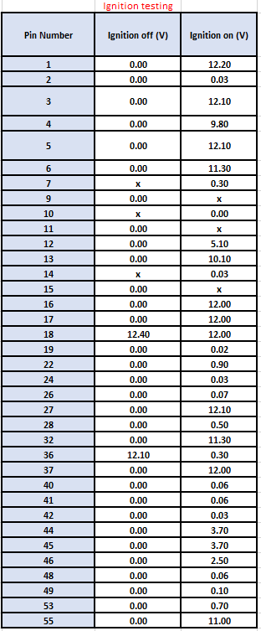
Voltages were taken with the ignition off, using the digital multimeter, for each pin on the LE3 system, with any blocked out, or any pins without voltages for either test, not being included in Table 1. This process was then repeated with the ignition turned on, giving more data, as there are more components active now.

Table 1: Ignition Testing

3.2 – Engine component testing during warmup
Once the static engine tests had concluded, components within the engine were tested which included:
- NTC2 voltages and resistance
- Injection on time resistance and voltages
- Rotary idle valve keying ratios
- Tank Vent valve, and Lambda sensor switching
These components were tested during the warm-up phase of the testing procedure, as they would give different values depending on the engine temperature.
The engine temperature was tested using the oscilloscope again, removing the oil dipstick, and replacing it with a temperature gauge, in order to as accurately as possible, raise the engine temperature in 10°C increments. This began at 18.2°C, the temperature of the engine before cranking, at which point injector timing was calculated. Temperatures were then raised to 20°C, at which point all of the above stated components were tested. This process was then repeated after the engine was brought up another 10°C.
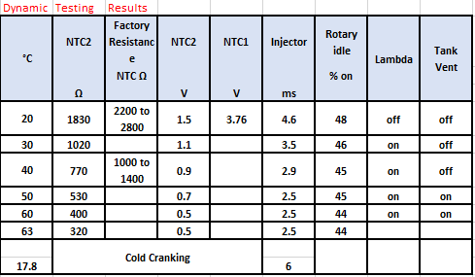
Table 2: Dynamic Testing Results

3.3 – Component Resistance Testing Vs Factory Resistance
Components can degrade over time; therefore, it is important to check and service/replace components from time to time. They can lose resistance and wear out just from use, from oxidation, or from water damage for example. The next stage of the testing procedure was to check the throttle potentiometer resistance, the mass airflow sensor’s resistance, and the injector valves resistance. These values were then compared against manufacturers specifications.
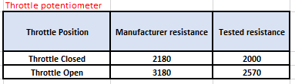
Table 3: Throttle potentiometer resistances
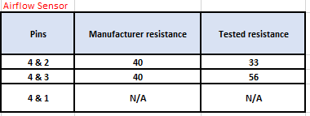
Table 4: Airflow sensor resistances
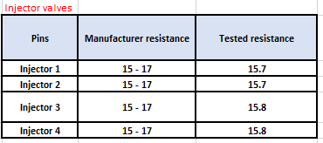
Table 5: Injector valves’ resistances

3.4 – Scope Patterns
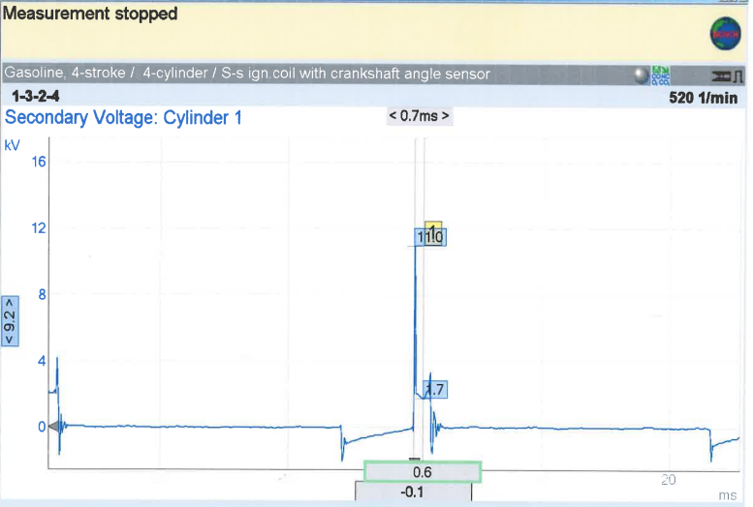
Figure 1: Secondary voltage
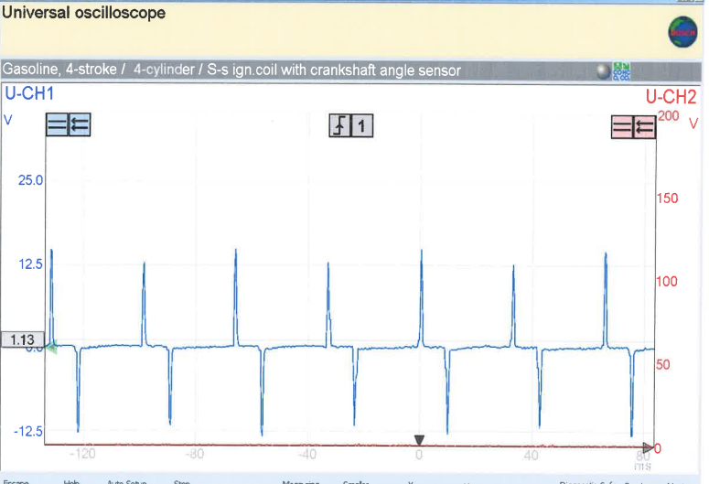
Figure 2: Crankshaft signal
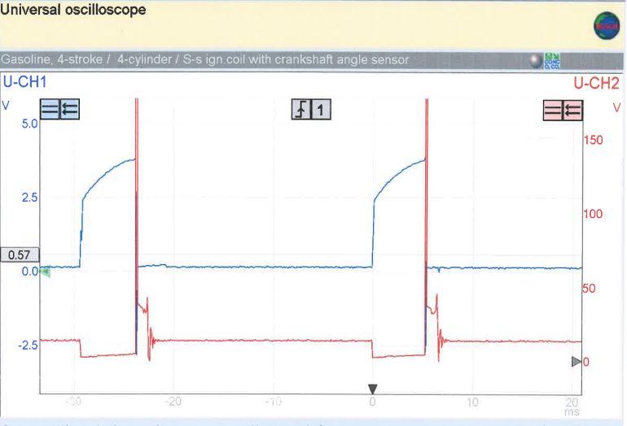
Figure 3: Pin 4 Spark advance signal + Pin 1 primary
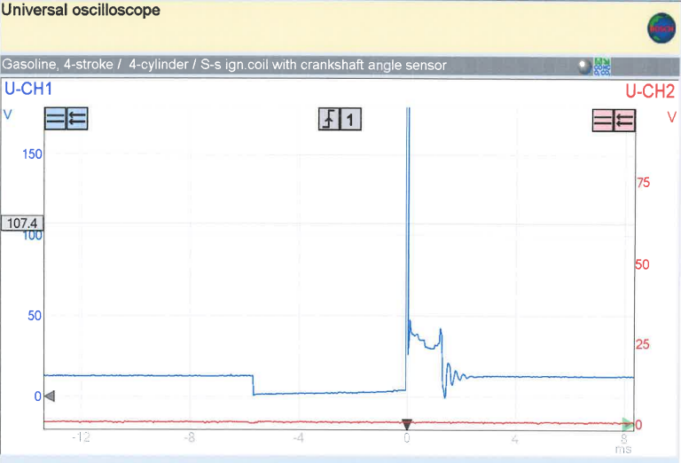
Figure 4: Pin 1 primary
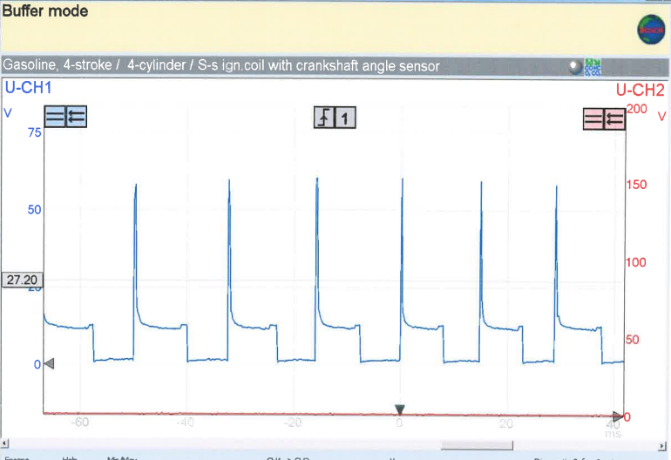
Figure 5: Pin 3 Acceleration
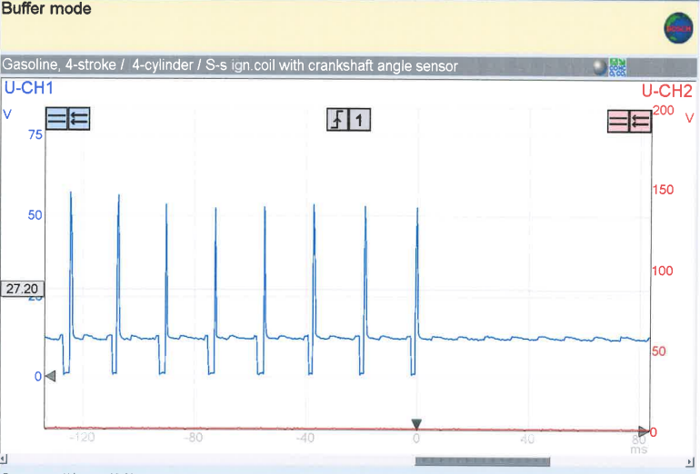
Figure 6: Pin 3 Deceleration
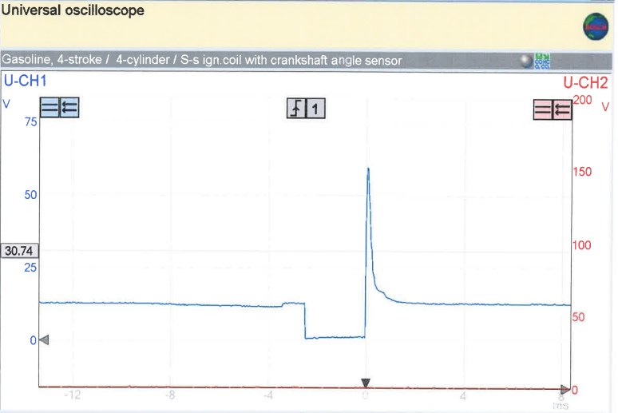
Figure 7: Pin 3 Injector Idle
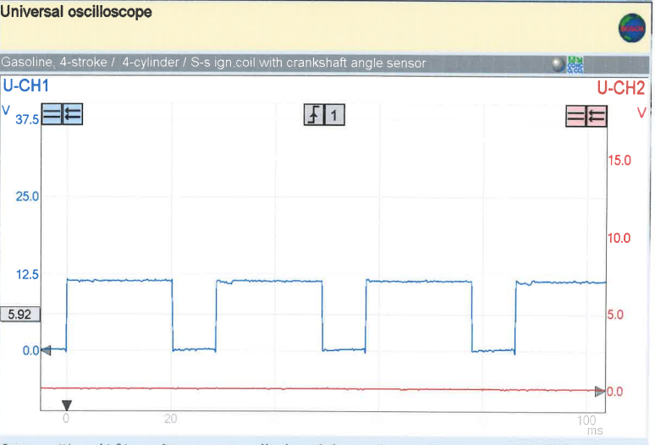
Figure 8: Pin 5 Speed reference for fuel ECU
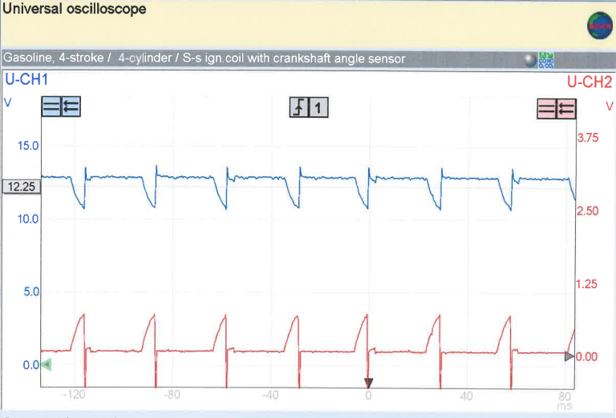
Figure 9: Pin 3 Supply + Pin 2 Earth

4.0 – Reasons for choice of test equipment
An oscilloscope was used during the tests, and this was because they are highly accurate, have hundreds of uses on the electronics within an engine, and are also very precise with their voltage readings. Oscilloscopes are an extremely useful tool, as they can be used to graph and create a visual indication of voltage signals such as injector retardation and advancement. This allows the user to Make small adjustments within the system for either performance benefits, or efficiency benefits, and sometimes even both. The oscilloscope allows the user to spot problems, such as bad injection timing, that would otherwise be indistinguishable to the human eye until it escalates into a larger problem, at which point it may be too late. The oscilloscope could also be used to check temperatures of the engine during testing, which was the case while the engine was in its warm-up phase.
A multi-meter was also used within the testing, as it is a fast, reliable way to acquire results for voltages and resistance. This can also be used to check pins within an engines electronic control unit, to see at what stage a certain component switches on to aid the system.
Both of these are very useful pieces of equipment to have to diagnose an engine with some sort of fault, as there is no consistent way of diagnosing without these electronics to detect them, before the problems grows and becomes a mechanical problem for instance. An exhaust extraction system was also used to remove harmful and toxic gases during the testing session.

5.0 – Safe working practices adopted while carrying out test
Safety was a priority while taking results on a running engine, so precautions were taken, and a brief was given beforehand, so that the procedures could be carried out safely and without injury.
The correct PPE was worn during the test sessions, which included a pair of steel toe cap boots, to prevent injury from any heavy falling objects. Safety goggles were also worn to prevent any injuries to the eyes, which could become very serious when working around combustion engines, as it is a highly pressurized system. A dustcoat was also worn to prevent any unwanted stains on clothing, and also acted as another layer of protection if anything goes wrong during testing.
Inspections of both engines were carried out beforehand to reduce the risk of anything within the engine failing , which could lead to projectiles
Wire cages covered any parts that were moving that could be a possible hazard to health, such as the crankshaft, and the fan. This highly reduced risk during the testing process, which in turn increased how efficiently results could be taken.
Standing clear of the engine while cranking, idling, accelerating, and decelerating also decreased the risk of injuries. Measures were taken to prevent any risk of shock from any pins or wires, therefore the multimeter cables were held by only the insulating rubber handles.
As mentioned before, an exhaust extraction system removed all exhaust gases, which could otherwise cause serious harm over time, and even just being around exhaust gases could cause light-headedness, which could increase risk of injuries.
Exhaust fumes can quickly reach harmful concentrations, particularly from cold or intermittently run engines (when run indoors without exhaust ventilation). Don't rely on catalytic converters to run engines safely indoors. They are less effective when exhaust gases are relatively cool, eg from vehicles idling for long periods or used intermittently for short periods. Catalytic converters do not remove toxic oxides of nitrogen. (Health and Safety Executive Gov, 2022)
Following COSHH (Control Of Substances Hazardous to Health) regulations, extraction fans were required to be turned on before any sort of engine testing while running, and turned off when not needed.
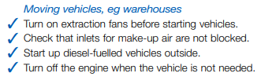
Any long hair was recommended to be tied back to reduce risk of getting caught in moving components such as the fan or flywheel.
All members of the group were also required to fill out a risk assessment quiz in order to enter the workshop, to make sure they are competent while working in high-risk environments such as around a running engine.
Both engines required two keys as a safety precaution, so that the engine could not be started by accident, further reducing risks of injury. The procedure was also made very clear before anyone had entered the workshop, in order to reduce the time spent in the workshop, therefore further reducing risk.

6.0 – NTC2 Graph
Graphing the NTC2 resistances at different temperatures is a simple way of visualising changes in resistance over temperature, which can be used to limit currents to other devices when necessary.
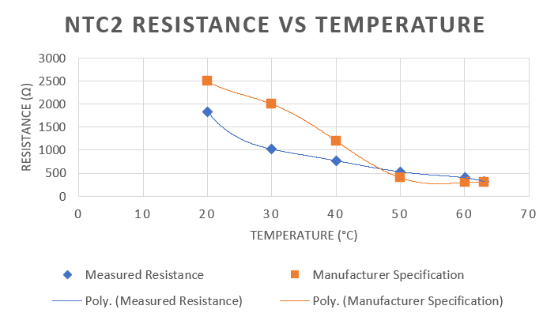
Figure 10: NTC2 Resistance VS Temperature
Looking at the measured values for resistance, it is consistently lower than the manufacturer specification, but is still on a negative trend, as expected. Looking at the trendlines after the intersection, it is clear to see that there are some discrepancies within the specified resistance values. This is most likely due to the creation process of the NTC2 plug, and also the degradation of the plug over its lifetime.
NTC plugs are thermistors, which means there is an open circuit between two sides of the thermistor itself, which could be a reason why the measured values are different to that of the manufacturer specification.
Usually, thermistor failure is caused by an open circuit due to mechanical separation between the resistor element and lead material. This can happen as a result of improper handling, thermal mismatch, or heat damage. Another common reason thermistors fail is simply aging. Over time the thermistor circuit becomes less accurate and displays incorrect temperatures. In this case, its easiest to choose a replacement. (TGC Company, 2022)

7.0 – System differences & Waveform analysis

Looking at results in Table 1, and comparing values to the Motronic data, it can be determined that the LE3 system had more pins with signals during the static voltage testing.
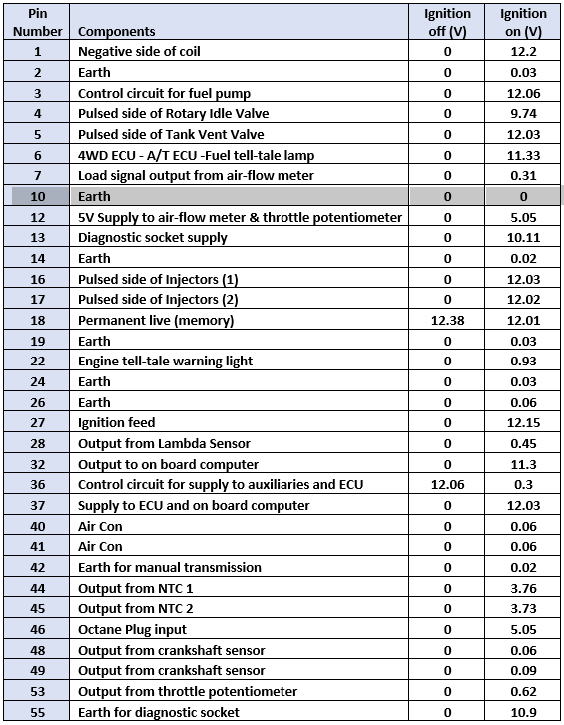
Table 6: Motronic ECU Static Voltage Testing
While Table 1 has 35 pins total showing signal in the static tests, the Motronic data from table 6 only shows 33 pins, which suggests that the LE3 system is more advanced, requiring more pins at start-up. With this being said, this is only a very minimal difference, and may in fact be because the Motronic system doesn’t require as many separate pins for the same system essentially.
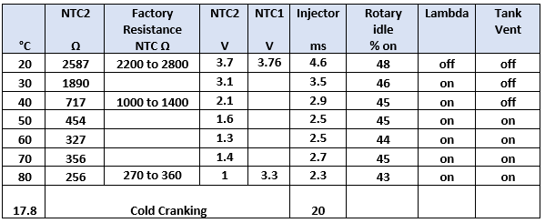
Table 7: Motronic Dynamic Testing
In table 7, comparing datapoints such as the injection time to that of table 2’s injection time, there are clear differences in cold cranking, with the LE3 system taking almost 4 times less, than the Motronic system. Another observation is that the measured resistance of the LE3 NTC2 plugs were lower than that of the Motronic system, which could be due to erosion over time, or high usage.
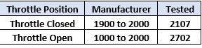
Table 8: Motronic throttle potentiometer resistance
In Table 3, the evidence is clear that the resistance of the tested component has reduced by around 17% overall, when comparing to the manufacturer’s specification in table 8, for the throttle potentiometer resistance. This could lead to inaccurate readings of throttle, which could snowball into larger issues such as running the engine lean or rich, which can lead to detonation, or unburnt gases exiting the exhaust.
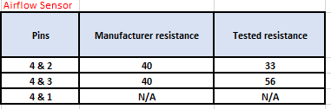
Table 9: Motronic Airflow sensor resistance
Comparing the LE3 data to the Motronic data, there is no noticeable difference, though mechanically, there could be different designs, while incorporating the same components and resistances. This in turn could have a large impact on performance, or the reaction of other components.
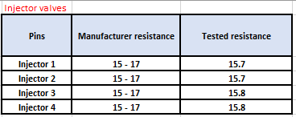
Table 10: Motronic injector valve resistance
Along with the mass airflow sensor for both systems, the injector valve resistances for both the LE3 system and the Motronic system are identical. This is most likely due to there being do major issues with the original setup. If the resistance of the injector valves works perfectly with the rest of the system, there is no real reason to change these values.

7.1 – Scope pattern analysis
Variables such as the dwell time, peak voltage, and burn time after ignition, are constantly changing throughout RPMs, due to ignition advancement and retardation.
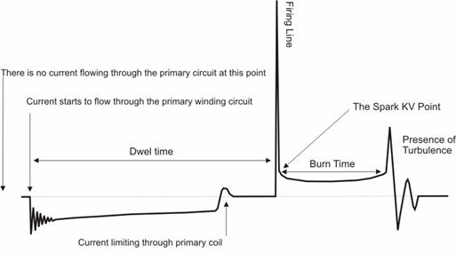
(Autoditex, 2020) Figure 11: Secondary ignition graph
As seen above in figure 11, these variables are likely to change throughout different RPMs.
Comparing Figure 11 to Figure 1, there are clear similarities between the two, though on a smaller scale than Figure 11.
As seen in figure 2, the voltage peaks at around 11kV, which is too large a jump from a 12v signal from the battery, so it needs to be stepped up through a Kettering coil, and the primary windings are shown above in Figure 4. From this point, the peak voltage in Figure 4 can be used as a baseline in Figure 1, which allows for the 11kV peak.
Dwell timing can be visualised in Figure 5, as the engine accelerates and raises RPM, the dwell time between firing lines decreases, advancing the ignition. This is important, as without ignition advancement, the air/fuel mixture may not be fully burned, before the cycle repeats, so ignition timing needs to be advanced in order to get more of the mixture burnt.
When comparing Figure 5 (acceleration) to Figure 7 (Idling), there are clear differences between the two again. In Figure 7, there is a much shorter burn time, as there is much less load on the engine, therefore a less powerful burn is needed, along with the fact that it is at idling RPM, therefore doesn’t need any sort of ignition advancement or retardation.
Figure 2 shows a crankshaft signal, which determines the ignition timing, negating the need for manual distributor timing altogether.
The PCM uses the signal from the crankshaft position sensor to determine at what time to produce the spark and in which cylinder. The signal from the crankshaft position is also used to monitor if any of the cylinders misfire. If the signal from the sensor is missing, there will be no spark and fuel injectors won't operate. (Samarins, 2018)
In Figure 2, the waveform signal is constant, therefore it is reasonable to assume no cylinders are misfiring. If there was a cylinder misfiring, there would be no peak voltage for said cylinder in the cycle. This makes the crankshaft sensor a very useful tool when diagnosing an engine that may be misfiring.

8.0 – Modifications
When looking at the years that both LE3 and the Motronic 4.1 were used, it is clear to see that there has been major improvements to both systems when comparing them to more modern engines and electronic control systems.
Newer designs could include features such as coil-on-plug ignition, which would make it easier for the spark plugs themselves to receive voltage.
Essentially, COP systems replace four different parts in the car: distributor caps, distributor rotors, distributor shafts, and spark plug wires. (Automotive Training Centres, 2022)
Replacing four components could reduce risk of malfunctioning, as there are fewer moving parts. This would in turn most likely reduce costs of maintenance, being a simpler system.
COP systems also prevent engine failures as catastrophic as a simpler system such as the one seen on the LE3 system and Motronic system. This is because if one of the coils fails, only that cylinder has the possibility of misfiring, whereas if a distributor fails, there is a possibility none of the cylinders fire, depending on how far back the root of the problem goes.
COP systems have been known to improve spark energy, Chrysler stating that its COP ignition system can deliver up to 28% more spark energy than earlier systems. This in turn reduces chances of misfiring with lean mixtures, as they require more energy to full combust.

Stratified charge ignition would also be a beneficial modification for the system, this has numerous benefits including:
- Higher compression ratios, which translates into more power
- Increased combustion efficiency due to better fuel distribution throughout the combustion chamber
- Cooling effect of the pressurized fuel, while leads to the ability to use a lower octane fuel, leading to lower costs for the user
- Higher power during lower RPMs
The principle behind stratified charge engines is to have a readily ignitable mixture in the vicinity of the spark plug, and a weaker (possibly non-ignitable) mixture in the remainder of the combustion chamber. The purpose of this arrangement is to control the power output of the engine by varying only the fuel supply without throttling the air, thereby eliminating the throttling pressure drop losses. The stratification of the charge can be obtained by division of the combustion chamber to produce a pre-chamber that contains the spark plug. (Sciencedirect, 2022)
For stratified charge operation, the fuel is injected when the cylinder pressure is in the range 3–10 bar, and these pressures make the spray less divergent than with homogenous operation, which has injection when the gas pressure is about 1 bar. (Sciencedirect, 2022)
Stratified injection could benefit the efficiency and power output of the engine, while not over-complicating the electronics of the system.

Introducing preventative components such as knock sensors and oil pressure sensors could decrease the likelihood of an engine failure down the line. Knock sensors detect preignition and detonation, which could be damaging to the engine. While full blown knocking can usually be heard by listening to the engine for a tapping sound, a knock sensor can notify the user before any major damage is done. This sensor works by “listening” for irregular vibrations and sound coming from the engine block, and then sends a signal to the ECU, which then takes the signal and determines whether or not the ignition timing should be altered. This in turn makes the engine more reliable, and less prone to failure.

9.0 – Conclusion
From the results take and the similarities and differences drawn from said results, it is clear to conclude that both systems have their benefits, yet both are superseded by modern day technology. The era that both of these systems were most widely used in was the 1980s-1990s. Since then, engine control systems have vastly improved in efficiency, simplicity, performance, reliability, and cost. For example, the LE3 system is mainly analog, therefore could be seen as less reliable and accurate than the Motronic system, which is predominantly digital. These differences have been observed by manufacturers over the past 3 decades, and the benefits have been transferred and built into designs seen today, for example being able to plug a laptop straight into an OBD2 port inside the car and have a fault code in seconds essentially.

References
Autoditex, 2020. Secondary ignition. [Online]
Available at: https://autoditex.com/page/secondary-ignition-33-1.html
[Accessed 17 4 2022].
Automotive Training Centres, 2022. Intro coil plug ignition systems. [Online]
Available at: https://www.autotrainingcentre.com/blog/intro-coil-plug-ignition-systems-interested-auto-mechanic-training/#:~:text=A%20coil%20on%20plug%20(COP,spark%20plugs%20to%20receive%20voltage.
[Accessed 18 4 2022].
Health and Safety Executive Gov, 2022. Vehicle exhaust emissions. [Online]
Available at: https://www.hse.gov.uk/mvr/mechanical-repair/exhaust.htm#:~:text=Vehicle%20exhaust%20fumes%20can%20irritate,lead%20to%20coughing%20and%20breathlessness.
[Accessed 19 4 2022].
Samarins, 2018. Crank sensor. [Online]
Available at: https://www.samarins.com/glossary/crank_sensor.html
[Accessed 17 04 2022].
Sciencedirect, 2022. Stratified charge engines. [Online]
Available at: https://www.sciencedirect.com/topics/engineering/stratified-charge-engines
[Accessed 18 4 2022].
TGC Company, 2022. Faulty thermistor symptoms. [Online]
Available at: https://www.tgccompany.com/faulty-thermistor-symptoms/#:~:text=Usually%2C%20thermistor%20failure%20is%20caused,thermistors%20fail%20is%20simply%20aging.
[Accessed 19 4 2022].

