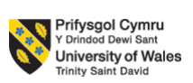

Student Name: Gabriel Alexandru

Student ID: 2218133

Module Code: LCLM6005

Module Name: Independent Project

Module Leaders: Md Kalam and Samuel Ofori

Assignment Title: Component 1: Portfolio (including 3 elements)

Acknowledgement
I, Gabriel Alexandru, understand that I am solely responsible for the content of this dissertation and its use of copyrighted materials. All copyright infringements and issues are solely the responsibly of myself as the author of this dissertation and not University of Wales Trinity Saint David, its programs, or libraries.

Gabriel
______________________________ ___alexandru____________________
Signature gabriel of Author Date10-12’-2025

Abstract
This study explored the problem of day-by-day customer turnover that increased at Mercedes-Benz UK. The first chapter included the research background, which indicates that the UK luxury automotive market suffers customer defection due to the lack of satisfaction with the services, high maintenance charges, perceptions of prices and digital experience expectations.
The second chapter literature review provided a critical review of available literature on what drives customer churn in the automotive sector. This chapter described service quality failures, perceived poor value of money, operational challenges, and shifting mobility trends. The chapter combined both theoretical models, like Expectation Confirmation Theory (ECT) and SERVQUAL, to describe the difference between customer expectations and the service-performance gap. It ends with a conceptual framework and literature gaps, related to the daily turnover trends and customer experience deficiencies.
The third chapter methodology described the qualitative mono-method research design, which is based on the research onion. The study was conducted using interpretivism, an inductive approach and a case study strategy where primary qualitative data was gathered using semi-structured interviews with eight customers of Mercedes-Benz UK who were chosen using a purposive approach. Key findings were obtained with the help of thematic analysis, whereas ethical issues and constraints of the research were taken into account.
The fourth chapter results and discussion revealed six themes of the interview, indicating that service delays, high ownership costs, inadequate digital interaction, insufficient personalised follow-ups and ineffective communication significantly decrease customer trust, contentment and loyalty in the long run. These are areas that undermine the efficiency of operation, the financial performance and stability of the markets.
The last chapter suggested evidence-based measures, such as tailor-made CRM systems, better after-sales service, and better communication channels (digitally). This chapter concluded that to lower the turnover of customers and ensure long-term retention, it is necessary to address these factors at Mercedes-Benz UK.

Table of Contents
Element 1: Dissertation document 9
Chapter 1: Introduction 9
1.1 Research title 9
1.2 Background of the Study 9
1.3 Research Problem Statement 9
1.4 Research Aim and Objectives 9
1.5 Research Questions 10
1.6 Justification and Rationale of the Study 10
1.7 Scope of the Study 11
1.8 Brief Research design 12
Chapter 2: Literature reviews 13
2.1 Chapter Introduction 13
2.2 Factors Influencing Customer Turnover in the Automotive Industry 13
2.2.1 Service quality issues 13
2.2.2 Pricing, Cost Perception and Value for Money 13
2.3 Impact of Customer Turnover Rate on the Business Operation 14
2.3.1 Financial impact on business operation 14
2.3.2 Impact on Brand performance and market position 15
2.3.3 Operational impact due to the customer turnover 15
2.4 Recommendation for reducing customer turnover and enhancing long-term retention and loyalty in the automobile industry 16
2.4.1 Strengthening Service Quality and After-sales Excellence 16
2.4.2 Implementing Personalised Customer Relationship Management (CRM) Systems 16
2.4.3 Establishing the Digital Customer Experience 17
2.5 Theoretical application 17
2.5.1 Expectation Confirmation Theory (ECT) 17
2.5.2 Service Quality Models (SERVQUAL) 18
2.6 Conceptual framework 19
2.7 Literature Gap 19
2.8 Chapter Summary 20
Chapter 3: Methodology 21
3.1: Chapter introduction 21
3.2 Research Design 21
3.3 Research philosophy 21
3.4 Research approach 22
3.5 Research strategy 22
3.6 Methodological choice 22
3.7 Time horizon 23
3.8 Data collection 23
3.9 Sampling technique 23
3.10 Data analysis 23
3.11 Research ethics 24
3.12 Research Limitations 24
3.13 Research timeline 25
3.14 Chapter summary 25
Chapter 4: Results and Discussion 26
4.1 Chapter introduction 26
4.2 Presentation of Data and Result (Primary Data) 26
4.2.1 Results of Primary Data 26
4.3 Interpretation of Results 29
4.4 Discussion and comparison of the Findings in Relation to the Literature 32
4.5 Practical and Theoretical Implications of the Findings 34
4.6 Chapter Summary 35
Chapter 5: Recommendations, Conclusion and limitations of the research 36
5.1 Recommendations 36
5.2 Conclusions 36
5.3 Linking with objectives 37
5.4 Limitations of the research 38
Element 2: Research Process Reflection 39
Element 3: Methodology poster 41
Reference list 42
Appendix: Interview Transcript 50

List of Figures
Figure 1: Customer retention rate in the UK automotive industry 9
Figure 2: Research structure 10
Figure 3: Customer loyalty rate in the UK automobile industry 12
Figure 4: Traits of Expectation Confirmation Theory (ECT) 15
Figure 5: Aspects of Service Quality Models 16
Figure 6: Conceptual framework 17
Figure 7: Research onion 19

List of Table
Table 1: Research timeline 25

Element 1: Dissertation document

Chapter 1: Introduction

1.1 Research title
Investigating the Issue of Customer Turnover Day-by-Day: A Case Study of Mercedes-Benz UK.

1.2 Background of the Study
The UK automotive market size is estimated at 1,082.9 thousand in 2024 and is projected to increase to 1,734.9 thousand in 2033 with a compound annual growth rate (CAGR) of 5.38% between 2025 and 2033 (Imarc, 2024). The premium brands like Mercedes-Benz are securing their business growth in this large environment. The UK division posted a 20% year-on-year rise in new car registrations through the agency model in late 2024 and registered a 29% growth in its private-retail channel (Turner, 2024). Despite that, Mercedes-Benz is facing challenges in maintaining its customer engagement rate. The automotive and transportation industry has a customer retention rate of approximately 83% across the industry (Shopify, 2022). This indicates that close to 17% of the customer base changes their provider, which is a problem for luxury automobile brands, where the value of the customer and the longevity of the relationship are the basis of profitability (Shopify, 2022). The increasing market volumes, changing consumer mobility trends, such as electrification, subscription plans, and high competition pressure, are creating issues for Mercedes-Benz. As a result, the customer turnover rate is increasing in this brand.

1.3 Research Problem Statement
Mercedes-Benz UK has a good brand image, and its sales are currently rising. Despite that, the business experiences the threat of customer turnover, as more clients switch to other companies like BMW, Audi, and Tesla. Service dissatisfaction, price perception, digital experience gap and changing preferences of mobility have created this problem (Rizvi et al., 2023). Available studies offer limited quantitative data on the daily customer defection trends in the luxury automotive sector of the UK market. This deficiency hinders the capacity of Mercedes-Benz UK to predict customers' behaviour and to implement data-driven customer retention tactics, which can keep the company competitive and profitable over the long term.

1.4 Research Aim and Objectives
Research aim
This research aims to investigate the issue of customer Turnover day by day at Mercedes-Benz UK.

Research objectives
- To analyse relevant theoretical frameworks related to customer turnover rate and customer loyalty in the context of marketing and consumer relationship management.
- To examine the key factors for increasing customer turnover rate at Mercedes-Benz UK.
- To analyse the impact of the customer turnover issue on the business operation of Mercedes-Benz UK.
- To suggest evidence-based recommendations to Mercedes-Benz UK to reduce customer turnover and enhance long-term retention and loyalty.

1.5 Research Questions
- What theoretical frameworks are related to customer turnover and customer loyalty within the context of marketing and consumer relationship management?
- What are the key factors contributing to customer turnover at Mercedes-Benz UK?
- What is the impact of the customer turnover issue on the business operation of Mercedes-Benz UK?
- How can Mercedes-Benz UK reduce customer turnover and enhance long-term retention and loyalty?

1.6 Justification and Rationale of the Study
Customer retention is widely known as more expensive than customer acquisition. In the case of the automotive and transportation industry, its average customer retention rate is approximately 83%, which means that this industry loses approximately 17% of its customers every period (Shopify, 2022). Customer satisfaction is a key factor in the UK automotive market. A survey reveals that 90% of dissatisfied automotive customers switch their brand to another organisation instead of remaining loyal (Orangutan.UK, 2025). As a result, the total customer satisfaction index (UKCSI) of the automotive industry stood at 79.5 /100 in July 2025 (Institute of Customer Service, 2024). This situation indicates that there is little significant opportunity to enhance the customer experience in the sector.
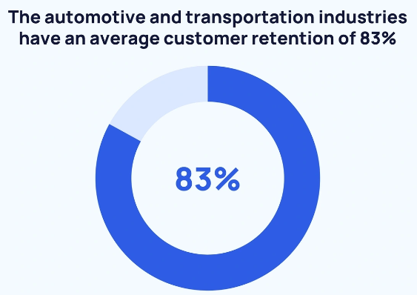

Figure 1: Customer retention rate in the UK automotive industry
(Source: Shopify, 2022)
Considering this situation, the present study on the day-by-day turnover of customers of Mercedes-Benz UK is relevant. This research addresses the gap in terms of customer retention research on daily turnover trends, and not only annual turnover. Along with that, this research is highly significant because it allows Mercedes-Benz UK to adopt specific retention measures, which will enhance customer loyalty and ensure profit preservation. This automotive brand needs to improve its customer retention strategy by understanding customers’ need, which this study has portrayed by gathering authentic information. A strong customer base is the primary aspect of every organisation to get competitive advantages (Gong et al., 2023). In this way, Mercedes-Benz UK can mitigate the concerned issue to hold a strong competitive position in the UK automobile industry.

1.7 Scope of the Study
The present research is devoted to the investigation of the key factors for customer turnover in Mercedes-Benz UK. The concerned research is based on a primary quantitative approach, which helped to gather real-time data regarding the issues of Mercedes-Benz UK. Additionally, this study is concerned with recent turnover trends rather than loyalty over the long run of several years. The existing research has been used to provide the primary findings with an analysis and interpretation strength. However, the research cannot be applicable to every luxury automotive brand because this study offered different customer retention strategies for enhancing customer experience and satisfaction in the Mercedes-Benz UK setting.

1.8 Brief Research design
This research project contains five chapters to complete the study authentically and achieve the research aim and objectives properly. The detailed research structure is portrayed in the figure below.
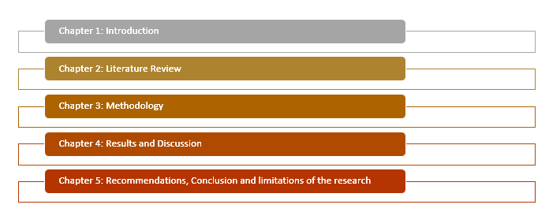

Figure 2: Research structure
(Source: Author)

Chapter 2: Literature reviews

2.1 Chapter Introduction
This chapter will provide information on customer turnover in the automotive industry with particular reference to the case of Mercedes-Benz UK. Customer retention is becoming more important as a long-term competitiveness factor; research interest is mounting in discovering the causes of increasing customer turnover. The literature will discuss the concept of customer churn, the factors that affect customers to drop a brand and the theoretical underpinnings that substantiate customer loyalty and behaviour. This chapter will investigate the operational and financial implications of customer turnover. Also, the chapter will assess the best practices and strategies employed in the luxury automotive industry to improve customer experience and reduce churn. The chapter will reveal the major gaps in the body of literature and preconditions the investigation of the particular issues of the automobile industry in the UK through a critical analysis of these themes.

2.2 Factors Influencing Customer Turnover in the Automotive Industry

2.2.1 Service quality issues
Service quality issues are the prime factor for customer turnover in the automobile industry. Gulzari et al., (2022) have stated that most of the automobile industry failed to provide quality services to customers after purchasing vehicles, which leads to customer dissatisfaction. Moreover, the service quality issue includes poor after-sales support, delay in car delivery and lack of communication with customers. As a result, it was identified that 90% of customers in the UK switch their brands due to service quality issues (S&P Global Mobility, 2025). Therefore, the automotive industry needs to improve service quality to reduce customer turnover. On the other hand, Marcos and Coelho (2022) have argued that the lack of communication with customers and mechanical issues in the vehicles reduce customers' trust and willingness to repurchase products from the brand. Therefore, the service quality issue is a serious factor that influences customers to leave their desired automobile brand.

2.2.2 Pricing, Cost Perception and Value for Money
Pricing strategy in the automobile industry influences customers’ decision-making process. The inflation rate in the UK luxury automobile industry increased by 3.6% which created issues for middle-class people to buy luxury cars (ONS, 2024). Due to the high inflation rate, people from the middle class cannot afford luxury cars, which reduces the customer engagement rate in the UK automobile industry. As per the viewpoint of Hamzah and Pontes (2022), the maintenance cost is high in the luxury car brands, which provides poor value for money and encourages customers to switch brands. In this way, the luxury automobile industry of the UK is facing customer turnover issues effectively. High inflation and maintenance costs for luxury vehicles are creating several challenges for this industry in retaining customers for a long time. On the other hand, Sharma and Mitra (2024) have claimed that poor quality service received is not equal to the premium price and results in cognitive dissonance and subsequent turnover. Thus, pricing can be a strategic strength and weakness based on the expectations of the customers and the market conditions.

2.3 Impact of Customer Turnover Rate on the Business Operation

2.3.1 Financial impact on business operation
Customer turnover rate creates serious consequences and leaves a negative impact on the financial performance. According to Songur (2024), a lack of customer engagement rate reduces the selling rate, which decreases financial performance. It was observed that the customer loyalty rate in the luxury automobile industry is decreasing, and the 51.1% customer loyalty rate has been reduced in the automobile industry as of 2024 (S&P Global Mobility, 2025).
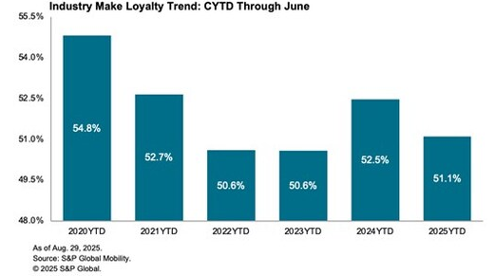

Figure 3: Customer loyalty rate in the UK automobile industry
(Source: S&P Global Mobility, 2025)
The declining rate indicated that customers are frequently switching their brands, which creates a negative impact on the financial performance of automotive organisations. On the contrary, Sachdeva et al., (2023) have contradicted that, each customer turnover rate in the luxury brands not only represents lost margin on next selling but also lost lifetime value. Lifetime value includes brand loyalty, cross-sales, and after-sales service maintenance. Therefore, customer turnover rate is a serious issue that damages business operations, creating a negative financial impact.

2.3.2 Impact on Brand performance and market position
As per the study by Adiguzel and Sonmez Cakir (2022), a high customer turnover rate creates difficulties in market positions for premium brands. However, customers generally switch their brands to try something new if they feel disappointed with their existing brands. It was noticed that UK customers prefer to switch their brands not only for price or service issues, but also to try new services. As a result, the premium automaker brands face issues in engaging customers for a long time, which enhances competitive pressure and destroys market position. On the other hand, Kridiawan and Wang (2023) have narrated that, due to a high customer turnover rate, organisations lost their market shares and brand reputation. As a result, premium automaker brands invest more in Customer Acquisition Costs (CAC), which increases business operations costs. Hence, brand performance can be damaged due to a high customer turnover rate.

2.3.3 Operational impact due to the customer turnover
The automobile industry faces different operational issues due to a high customer turnover rate. In accordance with Keith et al., (2022), due to the high customer turnover rate, the automobile industry may face challenges in maintaining dealership networks and supply planning, as well as after-sales operations. This industry may face challenges in analysing customers’ demand due to unpredictable demand. As a result, this situation can lead to under- or over-stocking of a certain model. On the other hand, DeCampos et al., (2022) have proposed that due to the customer turnover rate, the automobile industry faces challenges in modifying its business operation based on the customers' preferences for existing customers. As a result, the automobile industry lost its control over the business operation. Therefore, from the above discussion, it can be stated that these issues need to be solved in the premium automaker industry to execute business operations smoothly and hold a strong competitive position in the market.

2.4 Recommendation for reducing customer turnover and enhancing long-term retention and loyalty in the automobile industry

2.4.1 Strengthening Service Quality and After-sales Excellence
Service quality improvement is necessary in the high-end automotive business, where reliability and professionalism expectations are significantly greater. As per the opinion by Gupta and Raman (2022), enhancing the excellence in after-sales service, increasing the accuracy of diagnostic tests, and ensuring clear lines of communication may generate customer satisfaction in the long term and enhance brand trust. A well-trained employee base can work successfully to deliver seamless services to customers.
On the contrary, Sikombe (2025) has argued that operational costs can be enhanced for staff training and investment in digital tools to track the services. These costs can cause a financial strain in the short term on dealerships, particularly small franchises. Despite these, this strategy can provide long-term advantage to improve customer loyalty, repeat buying and quality of services, a very important strategic point to reduce customer turnover rate.

2.4.2 Implementing Personalised Customer Relationship Management (CRM) Systems
According to Hu and Basiglio (2023), personalised CRM systems can help automakers gain clearer insight into the customer purchasing patterns, their service history, preferences, and churn risk. One-to-one communication, such as reminders, personal promotions, and loyalty benefits, can improve the customer experience of feeling appreciated instead of being treated as a mass customer. The customer-focused strategy will enhance the emotional attachment and the chances of retention in the long run.
Although Gupta and Raman (2022) have said that the implementation of CRM may be complicated and expensive. CRM systems can fail when customers feel that they are being ignored. Moreover, excessive dependence on digital personalisation without human interaction is no less significant to the premium automotive customers. Nonetheless, given such issues, an intelligent CRM system continues to be the key to minimising churn by means of intelligent customer interaction.

2.4.3 Establishing the Digital Customer Experience
As per the viewpoint of Valinezhad et al., (2024), to enhance digital customer experience, it is important to note that contemporary automotive customers are becoming more demanding in terms of a seamless online experience. A single digital platform provides information about vehicles, vehicle booking, live services and ownership. This can build trust and provide the possibility of proactive involvement, in particular, when a vehicle has to be owned.
Apart from that, Miguel et al., (2022) have narrated that the dealerships with insufficient resources may face obstacles due to high implementation costs, cybersecurity risks and the complex nature of technology. Moreover, not all groups of customers, especially older or less technologically advanced customers, can use digital tools, which could make them even more frustrated. However, excessive automation might also undermine individualised, human-oriented experience that should be the case in luxury automotive situations. In that case, a well-constructed and convenient digital experience is crucial to turnover minimisation and extending customer loyalty in a competitive market.

2.5 Theoretical application

2.5.1 Expectation Confirmation Theory (ECT)
The theory of Expectation Confirmation Theory (ECT) describes customer satisfaction according to the comparison of initial expectations and actual performance (Hasibuan, 2024). The UK automobile industry can follow this theory to understand customers' needs and enhance their loyalty.
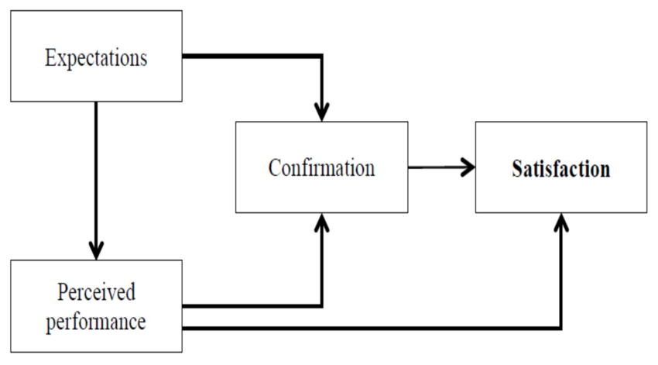

Figure 4: Traits of Expectation Confirmation Theory (ECT)
(Source: Hasibuan, 2024)
ECT can be applied in the UK automotive industry because customers who purchase premium cars like Mercedes-Benz, BMW, or Audi expect the quality of service, reliability, digital assistance, as well as long-term ownership value. Moreover, positive confirmation enhances brand loyalty when dealerships offer good timing of services. Nevertheless, in case of underperformance, such as service delays, unforeseen repair expenses or EV-related problems, negative disconfirmation increases customer turnover. In spite of that, ECT is an appropriate theory that needs to be followed to understand customers' perception and deliver quality services based on that.

2.5.2 Service Quality Models (SERVQUAL)
The SERQUAL model has been developed to measure the quality of services offered by service firms in five dimensions (Nguyen, 2022). These dimensions are reliability, responsiveness, assurance, empathy and tangibles.
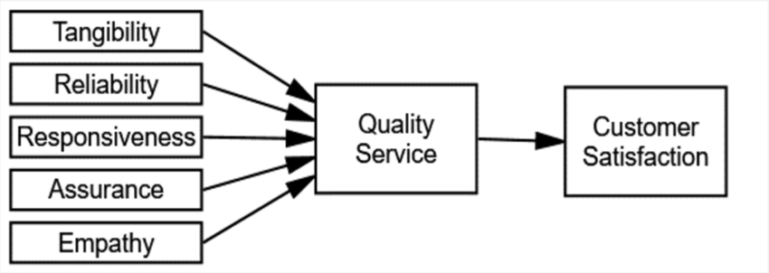

Figure 5: Aspects of Service Quality Models
(Source: Nguyen, 2022)
The SERVQUAL model can be followed by the UK automobile industry, as the level of interaction with the dealerships plays a major role in customer satisfaction and retention (Aprilianto et al., 2024). Dependability and responsiveness are directly associated with the servicing and repair accuracy of the vehicle, as well as the speed of communication, which is essential in high-end brands. Trust needs assurance and empathy, particularly in advising customers on the high-priced repairs or EV transition suggestions. The tangibles are also important since contemporary clean service centres with modern impressions enhance the perception of professionalism. Though it can simplify complicated processes of automotive services, this is the basic limitation of this model.

2.6 Conceptual framework
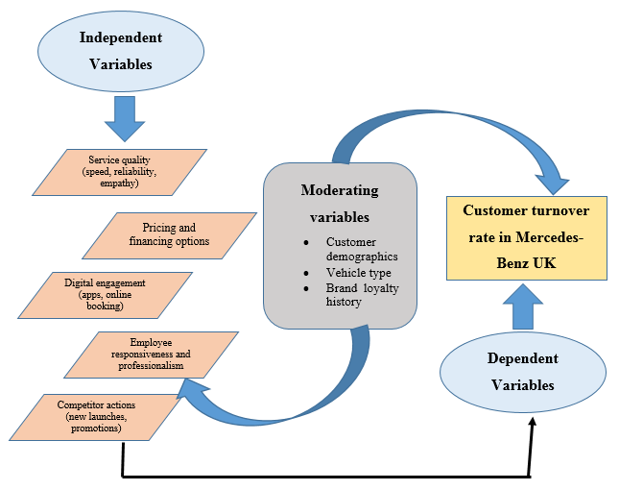

Figure 6: Conceptual framework
(Source: Author)
Based on the framework, it can be stated that poor service quality and a high pricing strategy are responsible for the customer turnover rate in the automobile industry. However, strong employee training and technological implementation can address the issue of customer turnover by analysing customer demographics and launching different types of vehicles as per the customer demand. In this way, brand loyalty can be developed in the UK automobile industry. Therefore, the dependent and independent variables are linked to each other.

2.7 Literature Gap
The existing literature has provided vast information on the customer turnover in the automobile industry. Very little literature has provided adequate information on the factors that are primarily responsible for customers’ turnover rate in the automobile industry. Along with that, strategies for mitigating the issue of customer turnover rate have not been mentioned in the existing literature gap. This has created a literature gap in this study, which the current research will address.

2.8 Chapter Summary
It can be concluded that different factors are responsible for customer turnover in the automobile industry. These factors include service quality issues, product delivery delay, and high prices in after-purchase maintenance. Due to the high customer turnover rate, the UK automobile industry is facing different issues such as operational impact, financial impact and competitive pressure. In that case, the brands which make premium cars need to establish different strategies that have been mentioned in this chapter.

Chapter 3: Methodology

3.1: Chapter introduction
This chapter will illustrate the research methods used to collect data on customer turnover day by day at Mercedes-Benz UK. The research method will be described by following the research onion, which is an essential strategy that allows researchers to collect and complete the research logically.

3.2 Research Design
The concerned research has been designed by following the research onion framework. Research Onion is a strategic framework developed by Saunders to ensure all aspects of the research design are aligned with the overall research aims and objectives (Seuring et al., 2022).
.

Figure 7: Research onion
(Source: Seuring et al., 2022)

3.3 Research philosophy
Research philosophy is the first layer of the research onion, and it shapes the entire research process. There are four categories of research philosophy, such as positivism, interpretivism, pragmatism and realism (Mbanaso et al., 2023). This research has followed the interpretivism philosophy to interpret the research elements. Through this philosophy, this research has produced high validity data on the customer turnover rate at Mercedes-Benz UK. The key benefit of interpretivism philosophy is that it allows researchers to gather detailed qualitative data in the research (Bergmann, 2023). On the other hand, interpretivism philosophy depends on the researcher's interpretation, which can provide biased information. This is the basic limitation of this philosophy.

3.4 Research approach
The research approach is a strategic plan that helps researchers conduct research authentically. Deductive, abductive and inductive are the three categories of research approach (Mbanaso et al., 2023). The Inductive approach has been followed in this research to analyse qualitative data authentically. However, by following the concerned approach, this study uncovered unexpected findings on the customer turnover rate at Mercedes-Benz UK. This approach has been applied in this research to predict the complexity of real-world phenomena. The key advantage of the inductive approach is that it allows researchers to achieve research objectives by collecting real-time data (Yuwono and Rachmawati, 2023). Although there is a chance of subjective findings and uncertainty in the research approach due to the researcher's own bias, this is a disadvantage of the inductive approach.

3.5 Research strategy
This is the overall strategy to collect data in the research and answer the research questions (Mtisi, 2022). Based on the research onion, there are different kinds of research strategies present. The current study has pursued the case study research strategy. The key benefits of this research strategy are that it helps researchers to do an in-depth investigation on a single case (Lavarda and Bellucci, 2022). Therefore, the current study has followed the case study research strategy to understand the complex phenomena in the real-world context, such as Mercedes-Benz UK. Thus, this study has developed authentic research findings by identifying the reasons for customer turnover in the specific automobile brand. However, the mentioned research strategy does not apply to the wider population, which is the key limitation.

3.6 Methodological choice
Methodological choice refers to the decision-making strategy to complete the research authentically (Mtisi, 2022). The current research was collected through a mono method followed by Qualitative data. The mono method has been followed in this research because this methodological choice offers simplicity and feasibility in the research. Moreover, through the mono method, this study collected in-depth data on the reasons for customer turnover at Mercedes-Benz UK. The primary benefit of the qualitative data is that it helps to maintain consistency in the research and requires limited resources to complete the research authentically (Denny and Weckesser, 2022). Though there is a limitation in the mono method. The core limitation of qualitative data is its inability to quantify the findings and to measure the impact using statistical analysis.

3.7 Time horizon
Time horizon is a timeframe of the research where researchers cover all the research activity within the mentioned time frame (Hunziker and Blankenagel, 2024). According to the research onion, there are two types of time horizon, namely cross-sectional and longitudinal. This research completed the entire research by following the cross-sectional time horizon to collect data at a certain point in time. The cross-sectional time horizon allows researchers to collect data quickly at a low cost, and these are the key benefits of this time horizon (Hunziker and Blankenagel, 2024). On the contrary, the key limitations of the cross-sectional time horizon are that it is unable to design definitive cause-and-effect due to measuring the exposure and research outcome at the same time.

3.8 Data collection
The data collection process is an essential aspect of the research to maintain research credibility by collecting data from authentic sources. The data collection method is divided into two types, namely primary and secondary (Khoa et al., 2023). Primary and secondary data also have two categories, such as qualitative and quantitative. The primary qualitative data was collected by semi-structured interviews with customers of Mercedes-Benz UK through open-ended questions. The primary benefits of a semi-structured interview are that it offers flexibility and opportunity for in-depth research, leading to authentic qualitative data. On the contrary, the limitation of semi-structured interviews is that they are time-consuming and create difficulties in collecting qualitative information in the research due to biased responses to interview questions.

3.9 Sampling technique
Sampling technique is generally followed in the research to identify the right participants for the research (Haruna, 2023). However, purposive sampling has been followed to identify the interview participants. This sampling method allows researchers to identify the right participant who knows the situation, and this is the advantage of this sampling technique. On the other hand, there is a chance of bias in this sampling, which is a limitation.

3.10 Data analysis
The primary qualitative data have been analysed through thematic analysis based on the semi-structured interview findings. Thematic analysis is a process to analyse qualitative data by creating necessary themes (Naeem et al., 2023). In the data analysis, themes have been developed according to the interview findings to gather authentic research findings. The key benefits of thematic analysis are that it helps to provide a clear structure to analyse complex qualitative information. On the other hand, thematic analysis relies on the researcher's perspective, which leads to superficial analysis. These are the basic limitations of thematic analysis.

3.11 Research ethics
In this research, research ethics have been maintained properly. A consent form was provided to participants to ensure that they participated in the research of their own. Additionally, it was ensured by the researcher that participants could withdraw their names whenever required. Additionally, privacy was maintained for research data or information and participants’ personal information. The Data Protection Act 2018 of the UK was followed to avoid data theft or breach.

3.12 Research Limitations
Primary qualitative data requires much time and cost to collect data appropriately. Additionally, participants can withdraw their name at any time, which is responsible for developing incomplete research findings (Denny and Weckesser, 2022). These are the core limitations of this research. Additionally, the other limitation of this research is that the quantitative data have not been used, which could help in this research to measure the responses numerically.

3.13 Research timeline
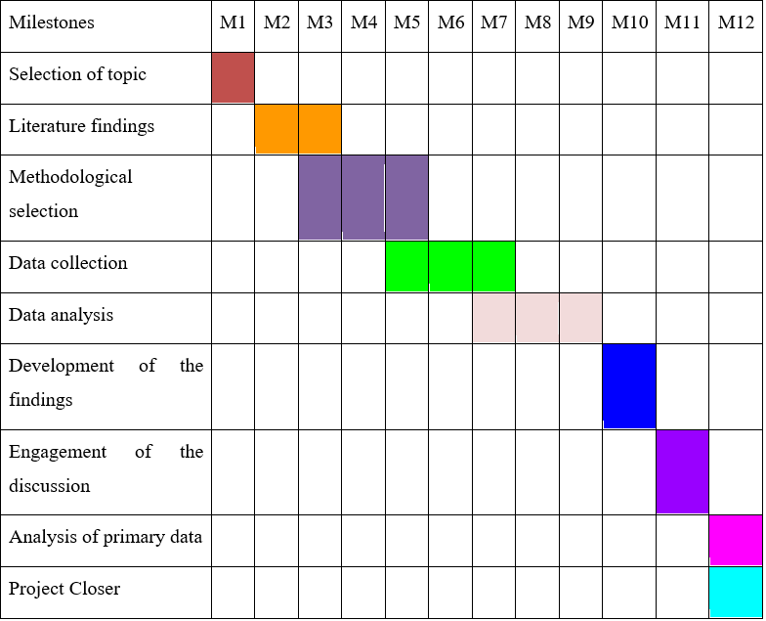

Table 1: Research timeline
(Source: Author)

3.14 Chapter summary
It can be concluded that this research followed the research onion framework to complete the research authentically and develop reliable research findings. Furthermore, research ethics were maintained to avoid any unethical activity in the research and to complete the research accurately.

Chapter 4: Results and Discussion

4.1 Chapter introduction
This chapter will cover the primary data results and findings. The interview transcript will be provided in this chapter, where customers’ responses will be gathered regarding Mercedes-Benz UK. Along with that, a comparison of primary data findings and literature review will be illustrated in this chapter. Furthermore, practical and theoretical interpretations of the findings will be portrayed in this section.

4.2 Presentation of Data and Result (Primary Data)
The primary data has been gathered by interviewing the Mercedes-Benz” customers. In this research, a semi-structured interview was conducted among 8 customers. A semi-structured interview is a qualitative research method that combines a predetermined set of open-ended questions (Paoli, 2023). The interview transcript is portrayed in the appendix portion [Refer to Appendix].

4.2.1 Results of Primary Data
Q1: What challenges, if any, have influenced you to consider switching from Mercedes-Benz to another automotive brand?
Based on the interview, it was found that customer 1 switched their brand due to service delay, and Mercedes-Benz failed to provide quality services to the customer. Along with that, customer 2 said that the high maintenance cost influenced them to switch their brand. Customer 3 got frustrated as they failed to access the online services from Mercedes-Benz UK. Apart from that, customers 4, 5, and 6 shared that they switched their brand due to inconsistent service, poor digital facilities, and high after-sales service costs. These are the primary service facilities of the automobile industry, like Mercedes-Benz, which need to be provided to customers. In that case, these are the primary reasons for customers to switch their brands from Mercedes-Benz. Apart from that, customer 7 felt underappreciated by generic communication and left their brand and engagement for a long time. Every organisation is responsible for interacting with its staff and understanding their issues to engage customers in the long term. Additionally, Customer 8 answered in the interview that long wait time in vehicle repair is the main concern for switching their brand. Therefore, there are several reasons present for which customers are switching their brands from Mercedes-Benz. These reasons include high price, delay in product delivery, lack of communication and huge wait time for repairing vehicles, which reduced the customer satisfaction rate effectively.
Q2: How would you evaluate the service quality, pricing structure, and digital interaction provided by Mercedes-Benz UK, and in what ways have these factors shaped your satisfaction or dissatisfaction?
In this interview, Customer 1 said that Mercedes-Benz UK offers inconsistent service and the price for the vehicles is extremely high, which influences customers to switch brands. However, due to high prices, all economic groups of customers cannot afford the vehicles from this brand. Customer 2 justified that occasionally they got good services from Mercedes-Benz UK, but the poor online communication facilities created difficulties for this customer to interact with the brand and express their needs. In this way, these factors shaped customer dissatisfaction towards their brand. On the other hand, customer 3 proposed that the high price for product servicing has reduced their satisfaction level. Therefore, this customer pricing structure enhanced dissatisfaction. Furthermore, customer 4 stated that high prices and poor internet service are the key factors for dissatisfaction. In that case, the pricing strategy and its service quality are both factors that influence the customer turnover rate. Besides, Customer 5 and 6 claimed that the online services of Mercedes-Benz UK are not good enough, and the online interaction of these brands is poor. Due to these factors, customers felt undervalued and lost interest in engaging with this brand for a long time. Customer 7 also agreed that the poor digital communication of Mercedes-Benz UK lowered customer trust, and customer 8 said that the delayed delivery of products lowered customer trust. Hence, pricing structure, digital interaction and service quality are major factors for customer turnover rate in Mercedes-Benz UK.
Q3: How do you think problems such as service delays, high maintenance costs or poor communication affect your trust and long-term relationship with the brand?
According to the interview question, customer 1 narrated that the service delay had broken their trust and customer 1 showed that they are not interested in making a long-term commitment with this brand. Customer 2 claimed that high maintenance costs affected their relationship with the brand. Mercedes-Benz UK is a premium automobile manufacturer. The products of this brand are already costly. In that case, customers reduce their interest in engaging with this brand for a long time due to the high maintenance cost. Customer 3 justified that the communication gap with this brand decreased their trust. Customers failed to solve their doubts and queries due to a lack of communication. Customer 4 illustrated that high expenses for maintaining the vehicles are challenging. The high expenses have reduced customers’ confidence and made them frustrated. In this way, customers’ confidence was reduced, which affected the long-term relationship with Mercedes-Benz UK. Apart from that, customer 5 claimed that the lack of consistency in communication created issues and damaged confidence. Customer 6 also admitted that Mercedes-Benz has high maintenance costs that do not attract all economic group customers. In addition to that, customer 7 shared that they experienced fake updates on the online site, which was not acceptable and lowered customers’ trust. Customer 7 also shared that the lack of communication opportunities and the pricing strategy of Mercedes-Benz UK are the primary causes for the customer turnover rate. People cannot get appropriate services from this brand, which damages brand value and enhances the customer dissatisfaction rate.
Q4: Based on your experience, how do you think such negative customer experiences might influence the operational performance or market position of Mercedes-Benz UK?
Negative customer experience damages market position and impacts operational efficiency effectively. Customer 1 said that, due to negative customer experience, organisations face competitive pressure and challenges in managing customer loyalty. Due to a lack of customer loyalty, automobile brands face high customer turnover and do not get a competitive advantage to hold a strong position. Customer 2 claimed that service delay is another factor for negative customer experience, and the service delay is evidence of poor service in the automobile industry. Customer 3 shared that inconsistent service from Mercedes-Benz UK decreases sales and affects brand position. Based on the semi-structured interview, it can be stated that the lack of sales growth is challenging for the automobile industry. Besides, customer 4 justified that service failures reduce customer trust and increase turnover rate. Customer 5 portrayed that the lack of communication between customers and the organisation reduces customers' trust and confidence to purchase products. Along with that, customer 6 stated that poor after-sales service decreases repeat purchase and customer trust, which affects business operation negatively. Apart from that, customer 7 stated that poor service facilities not only reduce customers' trust but also pose challenges for maintaining a strong position in the competitive market. Customer 8 also prioritised that the lack of customer satisfaction rate enhances competitive pressure and reduces brand value. Hence, based on the interview responses, it can be stated that poor customer service develops a negative customer experience that damages the operational efficiency of Mercedes-Benz UK.
Q5: What improvements in after-sales service, pricing transparency or customer communication would make you more likely to stay with Mercedes-Benz?
Customer 1 claimed that a strong communication tool needs to be implemented by Mercedes-Benz UK to understand customers' perspectives and provide quick after-sales services to influence customers to stay loyal to this brand. In this interview, customer 2 justified that a regular pricing update is necessary on Mercedes-Benz UK's website to share all the details regarding the product price to enhance customers' trust. Additionally, customer 3 started the transparent cost breakdown from the organisation to increase customers' trust. Therefore, Mercedes-Benz UK needs to improve their services to stay loyal and enhance the customer engagement rate. Customer 4 claimed that lower maintenance costs can be useful to build a strong, trustworthy relationship with Mercedes-Benz UK. High maintenance cost was the prime reason for the customer turnover rate. Customer 5 shared that transparent information on the product can improve relationships with this brand. Customer 6 justified that a proper communication channel and a lower pricing range can be useful to stay loyal to Mercedes-Benz UK. Apart from that, Customers 7 and 8 also claimed that proper communication channels and better after-sales services are mandatory for customers to influence them to engage with Mercedes-Benz UK for the long term.
Q6: What specific digital or personalised services could Mercedes-Benz UK introduce to enhance your satisfaction and loyalty?
Customer 1 claimed that the service track application can improve customer satisfaction and loyalty. Through the service track, customers can track new updates and maintenance services properly. Customer 2 proposed that e-reminders can be useful to make customers special by sending reminders regarding the sales service and any updated products. Customer 3 also stated that the active automation system can be useful for them to develop a strong trust in brands. In this way, customers can interact with Mercedes-Benz UK whenever required, and this is essential for building a trustworthy relationship. Besides these, customer 4 claimed that one-on-one live chat with the brand can be beneficial to get 24*7 service, which is an essential part of strong communication. Furthermore, customer 5 said that Mercedes-Benz UK must develop a customer portal where all the product prices need to be disclosed for transparency and to develop customers' trust. Customer 6 stated that the mentioned automobile industry can send follow-up messages to their customers to interact with them at all times. This approach can influence customers to purchase their vehicles from Mercedes-Benz UK. Customers 7 and 8 also suggested online tools to enhance customer loyalty and satisfaction rate. This includes virtual assistance tools, mobile applications and loyalty rewards. In this way, Mercedes-Benz UK can easily increase customers' loyalty and satisfaction rate.

4.3 Interpretation of Results
Based on the Six Questions asked to 8 different Customers of Mercedes-Benz, UK, it can be interpreted as follows:
Q1: What challenges, if any, have influenced you to consider switching from Mercedes-Benz to another automotive brand?
The responses indicate that the customers believed that they could change to flee the service issues associated with Mercedes-Benz due to cost and communication. Some customers complained that it lost their confidence in the brand because of delays, slow service and unreliable after-sales service. Others were very worried about high maintenance costs and expensive repairs that may come as a surprise, which made it a burden financially and made them feel less valued. Turnover was also affected by digital problems when one customer experienced that the booking system was unreliable. The sense of not being valued or getting impersonal messages also led to poor levels of emotional attachment. All in all, the findings indicate that low service quality, an increase in the ownership expenses, underdeveloped digital platforms, and the absence of personalised interaction were the primary issues that forced the customers to look elsewhere in the automotive brands.
Q2: How would you evaluate the service quality, pricing structure, and digital interaction provided by Mercedes-Benz UK, and in what ways have these factors shaped your satisfaction or dissatisfaction?
The responses demonstrate that customers are generally not satisfied with the quality of services, prices and online communication at Mercedes-Benz UK. Most of the customers have complained that the service quality is not always consistent, and that they have good service in some instances but poor service in other instances. One of the greatest dissatisfaction factors was high prices, since the majority of the customers believed that the cost of servicing and repairs was high and not worth the value they received. Online communication too was a matter of concern, as some of the customers have expressed that online communication was incomprehensible, unreliable or frustrating. Difficulties in booking systems and waiting time also lowered brand loyalty. Other effects included the customers of the company developing low trust and overall satisfaction due to weak digital tools and a lack of online support. In general, the findings indicate a tendency toward dissatisfaction due to the prohibitive cost, the lack of consistency in service delivery and malfunctioning digital systems, which constituted the factors of adverse customer experience.
Q3: How do you think problems such as service delays, high maintenance costs or poor communication affect your trust and long-term relationship with the brand?
The answers indicate that the problem of delays in services, high maintenance rates, and inadequate communication significantly decreases trust in customers and commitment to the Brand in the long term by Mercedes-Benz. Most customers said that they were confused about the brand due to the delays in service provision, and this undermined their loyalty. The issue of high maintenance costs was repeatedly presented and mentioned as one of the biggest frustrations, and several customers stated that such expenses have prompted them to consider abandoning the brand. Poor communication was also revealed as a critical issue, whereby most customers believed that ambiguous or inconsistent updates decreased their trust. Certain customers said that they felt out of touch with the brand due to the lack of transparency and clear information. Generally, the findings indicate that in cases where service is slow, cost is high, and communication is poor, customers lose their confidence and would not consider a long-term relationship with Mercedes-Benz.
Q4: Based on your experience, how do you think such negative customer experiences might influence the operational performance or market position of Mercedes-Benz UK?
According to the responses, negative customer experiences significantly affect the operational performance as well as the market position of Mercedes-Benz UK. It was found that bad service and delays damage the reputation of the brand and decrease customer loyalty among many customers. Various customers described that recurring services and inability to engage them lower the customer confidence, which may translate into fewer repeat customers and less long-term interaction. Other customers reported that such issues accelerate customer turnover, which puts a company under competitive pressure and impacts the company in terms of maintaining a high market position. Some observed that customer discontent and lack of trust can negatively affect sales and cause a negative image of the brand in the high-end market. In general, the findings indicate that in the case of negative customer experiences, operational efficiency is reduced, customer loyalty is decreased, and the brand is exposed to a greater risk of competition.
Q5: What improvements in after-sales service, pricing transparency or customer communication would make you more likely to stay with Mercedes-Benz?
The answers indicate that the customers prefer to be communicated with more, have their services served faster, and their prices made less ambiguous to remain loyal to Mercedes-Benz. This is the commentary that was made by several customers who felt that they would feel more appreciated and less frustrated when faster after-sales services and prompt updates are provided. The necessity to provide clear pricing, particularly clear cost breakdowns and affordable maintenance fees, was raised by several customers because high and ambiguous prices undermine trust now. Better communication was also stated several times, as customers wanted to be informed periodically, get specific service schedules and more individual messages rather than generic information. Personalised communication and improved follow-up after the service were also mentioned as preserving confidence in the brand among some of the customers. On the whole, the findings indicate that customers prefer to stay loyal to the brand when the latter offers prompt and efficient after-sales services, transparent and reasonable pricing, and constant and tailored feedback that helps them feel informed and valued.
Q6: What specific digital or personalised services could Mercedes-Benz UK introduce to enhance your satisfaction and loyalty?
The answers demonstrate that the customers desire more innovative, individualised and quality digital services to become satisfied and loyal to Mercedes-Benz UK. Most of the customers indicated that a service tracking application and better booking systems would simplify their experience and make it more transparent. Some of the customers said that they would feel special and appreciated with custom-made e-reminders, specialised offers and individual maintenance tips. Others said that it would create more trust and confidence through such tools as live chat, virtual assistance and a detailed customer portal with clear pricing. Some customers also commented that the online service history, proactive notifications, and additional functionalities in the mobile app will make long-term engagement more robust. Rewarding loyalty and updating the automatic services were also found to be appealing. In general, the findings reveal that the customers are expecting digital tools that are personalised, easy to use and informative, since these systems would facilitate the interactions and make them feel more loyal to the brand.

4.4 Discussion and comparison of the Findings in Relation to the Literature
The discussion and comparison of the findings in relation to the Literature are as follows:
RQ1: What theoretical frameworks are related to customer turnover and customer loyalty within the context of marketing and consumer relationship management?
The results of the study are in line with the existing theories of the research. It demonstrates that in the case of underperformance of Mercedes-Benz UK against the expectations of the customers, customers walk away, leaving a trend similar to that of the Expectation Confirmation Theory. The focus on the ineffective after-sales service and responsiveness is equal in its effect as the churn drivers to the SERVQUAL dimension of reliability and responsiveness. The study also rings the bells of relationship-marketing concepts that loyalty is safeguarded by trust and commitment, in that, when trust is diminished, then turnover increases (Khattak et al., 2022). The suggestion of personalised CRM and improved digital touchpoints is due to the recent industry efforts, where CRM and digital experience decrease churn when done properly. In general, the empirical themes of the study, failures in service, high maintenance costs and digital gaps are similar to the wider body of churn research, which applies touchpoint failures to an increasing defection risk. In the dissertation, these results are presented in the conclusion and results.
RQ2: What are the key factors contributing to customer turnover at Mercedes-Benz, UK?
According to the study, the primary cause of customers losing Mercedes-Benz UK was failures in service quality, expensive maintenance and ownership costs, poor digital touchpoints and insufficient personalised CRM. These empirical themes are consistent with the literature, which has associated churn with low after-sales service and low perceived value as postulated by service quality and expectation-confirmation viewpoints (Hematabadi et al., 2024). The evidence presented in the research that responsiveness and reliability are the determinants of defections is reminiscent of the works of SERVQUAL, whereas issues of price and lifetime cost can be found in the value perceptions in the premium car markets (Park and Hai, 2024). The findings on digital gaps and ineffective personalised follow-up indicate new literature findings that CRM and smooth digital experiences decrease churn when used effectively. Nonetheless, the research puts context-specific spin: routine defection trends and customer feedback highlight real-life dealership and cost pain points that project previously theoretical assertions on expectation violation and service quality into pervasive dealer life.
RQ3: What is the impact of the customer turnover issue on the business operation of Mercedes-Benz, UK?
This study indicates that customer turnover decreases the revenue and lifetime value of Mercedes-Benz UK. This reduces profitability and increases the price of acquiring new buyers. The analysis also revealed that churn destroys brand position and competitive pressure, thus compelling high expenditure on marketing and acquisition (Jahan and Shahria, 2022). The findings also had operational problems. It means that dealers are exposed to an uncertain demand, supply planning becomes more difficult, and the after-sales operations are negatively affected in case the customers leave. These empirical findings are consistent with the literature that attributes churn to financial distress, forfeited lifetime value and destroyed market share (Mirza et al., 2021). The literature also provides reasons that led to these outcomes through service failures and cost perceptions, and it is this that defines the study's focus on the quality of the after-sales and pricing. On balance, the local, day-to-day evidence provided in the research supports the current research by demonstrating how daily defections cause financial and operational damage within a high-end carmaker in a short period of time.
RQ4: How can Mercedes-Benz, UK, reduce the customer turnover and enhance long-term retention and loyalty?
The study’s recommendations for improving after-sales service, personalised CRM and enhanced digital touchpoints are, in most aspects, similar to the academic literature on churn reduction in high-end auto markets. Reliability of service and reduced ownership costs deal with the problem of expectation breach leading to defections, as expectation-confirmation (SERVQUAL) and expectation-confirmation studies predict. Personalised CRM has been demonstrated to raise emotional attachment and the ability to identify churn risk. The literature cautions that it is expensive to implement and requires human contact in high-end buying groups (Parihar and Yadav, 2022). Digital platforms provide active, convenient experiences of ownership that minimise friction, but research warns of excessive automation and disparities between customer groups. The current study provides a practical twist by illustrating the churn patterns and dealer pain points daily (Naeem et al., 2025). It implies that Mercedes-Benz UK needs to combine strategic digital resources with enhanced dealer service and after-sales pricing based on value to reduce the number of defections per day and increase long-term commitment.

4.5 Practical and Theoretical Implications of the Findings
The results provide evident practical and theoretical consequences for Mercedes-Benz UK and luxury automotive churn researchers. In practice, it is necessary to respond to the failures in service quality by implementing changes in operations immediately. To enhance reliability and responsiveness, dealers are recommended to standardise service procedures, reduce the lead times in repairs and train employees (Chakraborty and Altekar, 2021). Enhancing these areas will reduce daily defections driven by poor after-sales service and restore confidence among high-value customers. The study evidence reveals that easier and speedier service interactions reduce the risk of brand switching by customers. There are direct commercial implications of high maintenance and ownership costs (Delivand et al., 2021). In practice, Mercedes-Benz UK needs to reconsider the prices of regular servicing, provide transparent information about the total cost of ownership, and experiment with value packages or loyalty offers to repeat customers (Arık et al., 2022). Unexpected repair bills can be reduced, and cost transparency can be increased to reduce churn due to perceived low value. The data provided in the dissertation shows that cost shocks are a common causative factor of daily turnover.
The gaps in digital experience indicate the pressing points of investment. In practice, one conveniently located online centre where reservations are made, service recordings are kept, active reminders are issued, and online service is provided will reduce friction. Nevertheless, the research cautions against the complete automation of premium customers; digital devices are to be used as an addition, but not a substitute for personalised human interaction (Kiani and Nazari, 2024). Having a mixed digital-human model will prove to be more successful in keeping customers who prefer to be both convenient and treated individually.
Absence of personalised follow-up negates emotional connections with the brand. In practice, a focused CRM based on service and ownership information to send personalised messages, specific offers and timely check-ins can help increase commitment and identify churn risks in time. The study concludes that individual contact enhances perceived care and minimises short-term defections (Al Ali, 2021). In theory, the findings support and further develop Expectation Confirmation Theory and SERVQUAL in a daily churn situation. They demonstrate that the violation of expectation in the moment of expectation is caught in time and repaired or added results in fast negative confirmation and an instant churn (Osano and Lutego, 2022). This augments the prediction of ECT but gives it granularity by recording day-by-day triggers. Dimensions of reliability and responsiveness in SERVQUAL help to develop strong predictors of short-term defection, which implies that a model of quality of service operationalised in terms of time needs to place more emphasis on time-related failures when using it in a premium auto market.
Lastly, the research notes the interplay of theory and practice, such as interventions should be based on operational fixes, price transparency, digital redesign and personalised CRM. The study indicates to the researchers that the models of churn in the future must consider the daily data of events and the hybrid digital-human relationship variables as a better predictor and deterrent of defections in luxury brands (Pandey et al., 2025).

4.6 Chapter Summary
This chapter discussed the main data obtained through interviews of eight customers of Mercedes-Benz UK and how their answers can be integrated with the literature. The results indicated that customers were most likely to be dissatisfied and turn over because of service delay, high maintenance expenses, poor communication and weak digital systems, as the primary sources of customer dissatisfaction. These matters decreased trust, damaged long-term relations and weakened the market position of the brand. As seen during the discussion, the findings have validated other theories like Expectation Confirmation Theory and SERVQUAL. The practical steps that the brand should undertake to increase the quality of service, price transparency, online experience and personalised CRM to decrease churn and enhance customer loyalty have also been explained in the chapter.

Chapter 5: Recommendations, Conclusion and limitations of the research

5.1 Recommendations
- Establishing a customised customer relationship system
Mercedes-Benz UK can establish personalised CRM services to improve the customer retention rate. In that case, this organisation can arrange a customer loyalty programme to encourage customers to engage with this brand in the long term. In addition to that, Mercedes-Benz UK can establish a one-to-one communication channel to interact with customers to know their demands. Strong communication between the organisation and customers is important to know their needs (Hu and Basiglio, 2023). In this way, the concerned automobile brand in the UK can reduce customer turnover rate and can hold a strong position in the UK automobile industry.
- Improving after-sales services
The premium automaker brand needs to provide quality after-sales services at a low cost to attract customers from different economic backgrounds. The maintenance cost of after-sales service is high in the premium automobile industry, and for this reason, customers switch their brands (Rane et al., 2023). As a result, Mercedes-Benz UK is facing a high customer turnover issue. Therefore, this luxury brand can provide one free after-sales service or can reduce the cost for maintenance service to enhance the customer engagement rate and increase the brand value in the competitive industry.
- Implementing digital communication channels
Mercedes-Benz UK can implement a 24*7 customer care service to solve any small issues instantly. In that case, this organisation can use their official website or other social media platforms like Facebook, Instagram and can develop mobile applications to interact with customers. Thus, customers will feel valued and can change their perspectives on switching brands. In this way, UK customers can show their willingness to purchase vehicles and can refer others to be engaged with this premium brand in the long run. This strategy can be beneficial for Mercedes-Benz UK to address the issue of the high customer turnover rate.

5.2 Conclusions
This independent research project has given an in-depth analysis of the increasing problem of customer turnover in Mercedes-Benz UK, which has presented the multifaceted nature of service quality, perception of price, and digital experience mismatch, and changing mobility preferences. However, by incorporating the information found in literature and the primary qualitative data, the research established that service dissatisfaction and enormous maintenance expenses are the most common factors that make customers switch to rival brands like BMW, Audi, and Tesla. The analysis also indicated that a growth in churn will directly harm the financial performance, stability in the market and operational efficiency.
The research onion approach provided the methodological approach that ensured the structured investigation, and the application of interpretivism and the use of qualitative interviews resulted in original and context-specific information. The use of ECT and SERVQUAL offered good theoretical support, which helped in strengthening the importance of expectation management and consistency of quality of the services in attaining customer loyalty. Recommendations based on evidence, such as the improved after-sales service, individual CRM systems, and better digital touchpoints, became the keys to overcoming the turnover problem and reinforcing retention in the long term. In that case, this research would help to better understand the dynamics of the luxury automotive market regarding the churn phenomenon daily, which is a significant gap in the existing literature.

5.3 Linking with objectives
RO1: To analyse relevant theoretical frameworks related to customer turnover rate and customer loyalty in the context of marketing and consumer relationship management
The current research has used different theories, such as the Expectation Confirmation Theory (ECT) and the SERVQUAL model. These theories helped in this research to examine the relationship between customers and the organisation. According to these theories, it was observed that an organisation can enhance their brand loyalty by increasing customer satisfaction rate, understanding different perspectives and providing quality services. In this way, the first objective has been met.
RO2: To examine the key factors for increasing the customer turnover rate at Mercedes-Benz UK
The qualitative observations showed that service quality failures, high maintenance rates, digital experience and absence of personalised follow-ups are the biggest contributors to churn. These considerations were in line with the literature trends in the UK automotive industry, which proved their relevance and effectiveness. Thus, the second objective has been met in this research.
RO3: To analyse the impact of the customer turnover issue on the business operation of Mercedes-Benz UK
The study identified that a high customer turnover rate develops financial instability in the organisation, decreases lifetime value, and enhances competitive pressure. Along with that from the primary data, it was observed that due to the high customer turnover rate, the automobile industry faces challenges in business operation, which includes poor supply chain management and dealership. In this way, the findings have met the third research objective.
RO4: To suggest evidence-based recommendations to Mercedes-Benz UK to reduce customer turnover and enhance long-term retention and loyalty
The research offered practical recommendations regarding enhancing after-sales service, using custom CRM systems, and improving the digital customer experience to achieve better long-term relationships. Despite that, this research provided a few recommendations to reduce customer turnover and enhance long-term retention and loyalty. Therefore, the research findings have met the fourth research objective.

5.4 Limitations of the research
This research has provided versatile information on the reasons for the customer turnover rate in Mercedes-Benz UK. The research was based on a primary qualitative approach, with semi-structured interviews. Therefore, the sample size was small in this research, which limits the generalisability of the results to the overall group of customers of Mercedes-Benz. The purposive sampling method also subjected the research to researcher bias since respondents were chosen according to subjective considerations. The lack of time did not allow for the inclusion of a longitudinal element, which prevented observing the turnover trends at various times. Lastly, the company records were not easily accessible, which implied that the study used the predominantly customer-based perspectives instead of data triangulation with organisational performance variables. Future studies should consider these limitations to ensure increased validity and reliability.

Element 2: Research Process Reflection
This essay aims to describe research experience by following a reflective model. In that case, Kolb’s Learning Cycle will be followed. This is a reflective model and has four stages to describe the personal experience (Vince, 2022). This is a holistic approach that helps to describe experience accurately.
Concrete Experience is the first stage of this model that describes the initial stage of the experience (Meijer et al., 2022). I was excited while conducting this research because I gathered new information on the exact customer turnover rate in Mercedes-Benz UK. Along with that, I knew the process of conducting the research. I set the research aim and objective initially as per the mentioned deadline. I communicated with my supervisor clearly whenever required and conducted an interview to collect real-time information on the research topic. The overall experience was good as I was excited to complete the research authentically.
Reflective Observation is the second stage of Kolb's model to reflect on the experience. I gathered existing data regarding the customer turnover rate in the automobile industry from authentic journal articles. In this way, I have completed the literature review. However, I faced difficulties sometimes in time management as my time management skills are not good enough. Apart from that, I communicated clearly with my supervisor whenever required, as I have a strong communication ability. After discussing all the necessary processes of the research, I interviewed to analyse the reason for customer turnover from Mercedes-Benz UK. I realised that authentic information is necessary to develop sound research findings to maintain research credibility.
Abstract Conceptualisation is the third stage of this reflective model that involves making sense of the experience (Henríquez et al., 2025). After completing the research, I realised that the lack of service facilities and the high price of the product, as well as maintenance costs, are the primary reasons for the constant customer turnover rate from Mercedes-Benz UK. However, I have poor research skills, and I faced challenges in finding accurate information on this automobile brand, which I need to improve for better research. Due to a lack of time management and research skills, I became anxious, which decreased my performance. Although my strong communication and team working abilities allowed me to complete the research properly by following each step.
Active Experimentation is the last stage of the concerned reflective model that illustrates new implications in new situations (Henríquez et al., 2025). After completing the research, I decided to utilise my skills and knowledge in future to conduct another research perfectly. Along with that, I have decided to improve my shortcomings to perform well in my academic career. In that case, I will improve my time management ability by following the Pomodoro Technique. I will improve my research skills through note-taking. Thus, I can conduct my research authentically.
It can be concluded that Kolb’s reflective model helps to portray experience appropriately. I will improve the weaknesses that I have identified through this model to work better in the future. In this way, I can progress in my academic career.

Element 3: Methodology poster
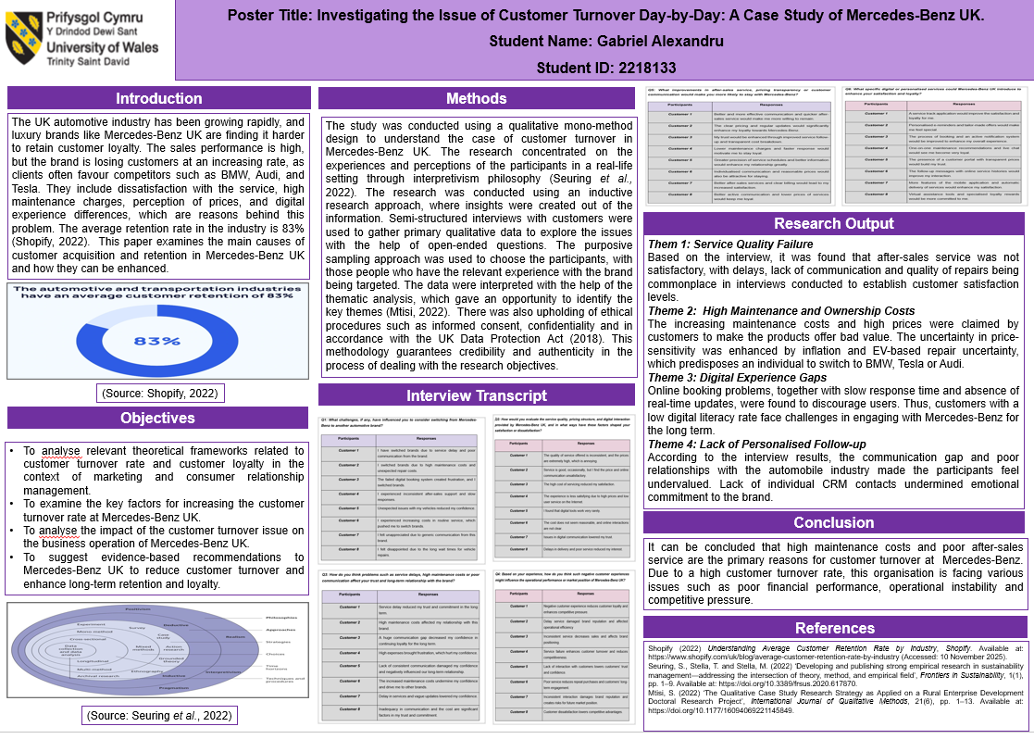

Reference list
Adiguzel, Z. and Sonmez Cakir, F. (2022) ‘Examining the effects of strategic orientation and motivation on performance and innovation in the production sector of automobile spare parts’, European Journal of Management Studies, 27(2), pp. 131–153. Available at: https://doi.org/10.1108/ejms-01-2022-0007. [Accessed on: 5th Dec 2025]
Al Ali, A. (2021). The impact of information sharing and quality assurance on customer service at UAE banking sector. International Journal of Technology Innovation and Management (IJTIM), 1(1), pp.01-17. Available at: https://www.journals.gaftim.com/index.php/ijtim/article/download/10/6 [Accessed on: 5th Dec 2025]
Aprilianto, A., Puspasari, M.A. and Suzianti, A. (2024) ‘Service blueprint design at automotive dealers with integration of Servqual method and Kano Model’, AIP Conference Proceedings, 2860(87), pp. 20–80. Available at: https://doi.org/10.1063/5.0221653. [Accessed on: 5th Dec 2025]
Arık, K., Gezer, M. and Tayalı, S.T. (2022). Bibliometric analysis of scientific studies published on game customer churn analysis between 2008 and 2022. Journal of Politics, Economy and Management, 5(1), pp.55-75. Available at: https://dergipark.org.tr/en/pub/jopem/issue/70865/1112009 [Accessed on: 5th Dec 2025]
Bergmann, J. (2023) ‘Research Philosophy, Methodological Implications, and Research Design’, Studien zur Migrations- und Integrationspolitik, 41(11), pp. 57–89. Available at: https://doi.org/10.1007/978-3-658-42298-1_3. [Accessed on: 5th Dec 2025]
Chakraborty, D. and Altekar, S. (2021). What drives people to use grocery apps? The moderating & mediating role of customer involvement and trust. Indian Journal of Marketing, 51(11), pp.23-37. Available at: https://www.indianjournalofentrepreneurship.com/index.php/ijom/article/view/166734 [Accessed on: 5th Dec 2025]
DeCampos, H.A., Rosales, C.R. and Narayanan, S. (2022) ‘Supply chain horizontal complexity and the moderating impact of inventory turns: A study of the automotive component industry’, International Journal of Production Economics, 245(7), pp. 108–377. Available at: https://doi.org/10.1016/j.ijpe.2021.108377. [Accessed on: 5th Dec 2025]
Delivand, M.C., Moghadam, M.B., Shamami, N. and Taghipour, M. (2021). Investigating the effective factors in measuring customers' credibility with a combined approach of data mining and multidisciplinary decision making. Journal of Military Operations Research, 1(1), pp.2. Available at: https://www.researchgate.net/profile/Drmohammad-Taghipour/publication/ [Accessed on: 5th Dec 2025]
Denny, E. and Weckesser, A. (2022) ‘How to do qualitative research?’, BJOG: An International Journal of Obstetrics & Gynaecology, 129(7), pp. 1166–1167. Available at: https://doi.org/10.1111/1471-0528.17150. [Accessed on: 5th Dec 2025]
Gong, Y., Xiao, J., Tang, X. and Li, J. (2023) 'How Sustainable Marketing Influences the Customer Engagement and Sustainable Purchase Intention? The Moderating Role of Corporate Social Responsibility', Frontiers in Psychology, 14(1128686), pp. 34–80. Available at: https://doi.org/10.3389/fpsyg.2023.1128686. [Accessed on: 5th Dec 2025]
Gulzari, A., Wang, Y. and Prybutok, V. (2022) 'A green experience with eco-friendly cars: A young consumer electric vehicle rental behavioural model', Journal of Retailing and Consumer Services, 65(65), pp. 102–877. Available at: https://doi.org/10.1016/j.jretconser.2021.102877. [Accessed on: 5th Dec 2025]
Gupta, R. and Raman, S. (2022) ‘After-sale service experiences and customer satisfaction: An empirical study from the Indian automobile industry’, Research in Transportation Business & Management, 45(7), pp. 100–873. Available at: https://doi.org/10.1016/j.rtbm.2022.100873. [Accessed on: 5th Dec 2025]
Hamzah, M.I. and Pontes, N. (2022) 'What drives car buyers to accept a rejuvenated brand? The mediating effects of value and pricing in a consumer-brand relationship', Journal of Strategic Marketing, 32(2), pp. 1–23. Available at: https://doi.org/10.1080/0965254x.2022.2129749. [Accessed on: 5th Dec 2025]
Haruna, S. (2023) ‘A Phonological Study of Consonants and Vowels Phonemic Merger in Hausa’, British Journal of Multidisciplinary and Advanced Studies, 4(3), pp. 45–59. Available at: https://doi.org/10.37745/bjmas.2022.0196. [Accessed on: 5th Dec 2025]
Hasibuan, A.Q.R. (2024) ‘Perception of Social Media Use on Home Industry Product Promotion: Expectations-Confirmation Theory (ECT) Perspective’, UPI YPTK journal of business and economics, 9(1), pp. 37–41. Available at: https://doi.org/10.35134/jbe.v9i1.253. [Accessed on: 5th Dec 2025]
Hematabadi, H.R., Hakimpour, H., Mahmoodzadeh, M. and Rezaeifar, H. (2024). Investigating and modeling the impact of online banking marketing interaction management (ORM) on the loyalty of electronic banking customers using structural equations and PLS partial least squares technique. International Journal of Nonlinear Analysis and Applications, 15(11), pp.185-195. Available at: https://ijnaa.semnan.ac.ir/article_8436.html [Accessed on: 5th Dec 2025]
Henríquez, V.V., Rabanal, I.C. and Abásolo, J.S. (2025) ‘Applying Kolb’s experiential learning cycle for deep learning: A systematic literature review’, Social Sciences & Humanities Open, 12(6), pp. 102–960. Available at: https://doi.org/10.1016/j.ssaho.2025.102096. [Accessed on: 5th Dec 2025]
Hu, L. and Basiglio, A. (2023) ‘A multiple-case study on the adoption of customer relationship management and big data analytics in the automotive industry’, The TQM Journal, 36(9), pp. 1–21. Available at: https://doi.org/10.1108/tqm-05-2023-0137. [Accessed on: 5th Dec 2025]
Hunziker, S. and Blankenagel, M. (2024) ‘Cross-Sectional Research Design’, Springer eBooks, 21(6), pp. 187–199. Available at: https://doi.org/10.1007/978-3-658-42739-9_10. [Accessed on: 5th Dec 2025]
Imarc (2024) UK Automotive Market Size, Share & Industry Statistics 2032, Imarcgroup.com. Available at: https://www.imarcgroup.com/uk-automotive-market (Accessed: 10 November 2025).
Institute of Customer Service (2024). UK Customer Satisfaction Index (UKCSI), Institute of Customer Service. Available at: https://www.instituteofcustomerservice.com/research-insight/ukcsi/ (Accessed: 10 November 2025).
Jahan, N. and Shahria, G. (2022). Factors affecting customer satisfaction of mobile banking in Bangladesh: a study on young users' perspective. South Asian Journal of Marketing, 3(1), pp.60-76. Available at: https://www.emerald.com/insight/content/doi/10.1108/sajm-02-2021-0018/full/html [Accessed on: 5th Dec 2025]
Keith, D.R., Naumov, S., Rakoff, H.E., Sanches, L.M. and Singh, A. (2022) 'The effect of increasing vehicle utilisation on the automotive industry', European Journal of Operational Research, 317(3), pp. 45–80. Available at: https://doi.org/10.1016/j.ejor.2022.10.030. [Accessed on: 5th Dec 2025]
Khattak, K.N., Ahmed, M., Iqbal, N., Khan, M.A., Imran and Kim, J. (2022). A conceptual model of factors influencing customer relationship management in global software development: a client perspective. Applied Sciences, 12(15), pp.7851. Available at: https://www.mdpi.com/2076-3417/12/15/7851 [Accessed on: 5th Dec 2025]
Khoa, B.T., Hung, B.P. and Brahmi, M.H. (2023) 'Qualitative Research in Social Sciences: Data collection, Data Analysis and Report Writing', International Journal of Public Sector Performance Management, 12(1/2), pp. 187–209. Available at: https://doi.org/10.1504/ijpspm.2023.132247. [Accessed on: 5th Dec 2025]
Kiani, M.S. and Nazari, L. (2024). Investigating Effective Factors in Attracting Customers of Sports Venues by Combining Marketing and New Technologies. Journal of Cyberspace Studies, 8(2), pp.265-284. Available at: https://jcss.ut.ac.ir/article_98038.html [Accessed on: 5th Dec 2025]
Kridiawan, Y. and Wang, G. (2023) ‘A Systematic Literature Review On Customer Retention In The Automobile Or Automotive Industry’, Cakrawala Repositori IMWI, 6(4), pp. 937–948. Available at: https://doi.org/10.52851/cakrawala.v6i4.436. [Accessed on: 5th Dec 2025]
Lavarda, R. and Bellucci, C. (2022) ‘Case Study as a Suitable Method to Research Strategy as Practice Perspective’, The Qualitative Report, 27(2), pp. 539–554. Available at: https://doi.org/10.46743/2160-3715/2022.4296. [Accessed on: 5th Dec 2025]
Marcos, A.M.B. de F. and Coelho, A.F. de M. (2022) ‘Service quality, customer satisfaction and customer value: holistic determinants of loyalty and word-of-mouth in services’, The TQM Journal, 34(5), pp. 957–978. Available at: https://doi.org/10.1108/tqm-10-2020-0236. [Accessed on: 5th Dec 2025]
Mbanaso, U.M., Abrahams, L. and Okafor, K.C. (2023) ‘Research Philosophy, Design and Methodology’, Research Philosophy, Design and Methodology, 1(1), pp. 81–113. Available at: https://doi.org/10.1007/978-3-031-30031-8_6. [Accessed on: 5th Dec 2025]
Meijer, M.W., Brandhuber, T., Schneider, A. and Berberat, P.O. (2022) ‘Implementing Kolb´s Experiential Learning Cycle by Linking Real Experience, Case-Based Discussion and Simulation’, Journal of Medical Education and Curricular Development, 9(2), pp. 1–5. Available at: https://doi.org/10.1177/23821205221091511. [Accessed on: 5th Dec 2025]
Miguel, P.M. de, De-Pablos-Heredero, C., Montes, J.L. and García, A. (2022) ‘Impact of Dynamic Capabilities on Customer Satisfaction through Digital Transformation in the Automotive Sector’, Sustainability, 14(8), p. 4772. Available at: https://doi.org/10.3390/su14084772. [Accessed on: 5th Dec 2025]
Mirza, F., Younus, S., Waheed, N. and Javaid, A. (2021). Investigating the impact of product-related and service quality attributes on repurchase intention: Role of customer characteristics and customer satisfaction. International Journal of Research in Business and Social Science, 10(3), pp.24-35. Available at: https://search.proquest.com/openview/2d74abe1694e0dfb94ab6e631e3b3405/1?pq-origsite=gscholar&cbl=2032017 [Accessed on: 5th Dec 2025]
Mtisi, S. (2022) ‘The Qualitative Case Study Research Strategy as Applied on a Rural Enterprise Development Doctoral Research Project’, International Journal of Qualitative Methods, 21(6), pp. 1–13. Available at: https://doi.org/10.1177/16094069221145849. [Accessed on: 5th Dec 2025]
Naeem, M., Amin, M.S. and Ali, S. (2025). From Knowledge to Growth: Investigating Intellectual Capital’s Impact on Financial Sustainability in Emerging Economies. Journal of Management & Social Science, 2(2), pp.333-346. Available at: http://www.rjmss.com/index.php/7/article/view/146 [Accessed on: 5th Dec 2025]
Naeem, M., Ozuem, W., Howell, K. and Ranfagni, S. (2023) ‘A step-by-step Process of Thematic Analysis to Develop a Conceptual Model in Qualitative Research’, International Journal of Qualitative Methods, 22(1), pp. 1–18. Available at: https://doi.org/10.1177/16094069231205789. [Accessed on: 5th Dec 2025]
Nguyen, P.-H. (2022) ‘Automotive Service Quality Investigation Using a Grey-DEMATEL Model’, Computers, Materials & Continua, 73(3), pp. 4779–4800. Available at: https://doi.org/10.32604/cmc.2022.030745. [Accessed on: 5th Dec 2025]
ONS (2024) CPI WEIGHTS 07.1.1A : NEW CARS, Ons.gov.uk. Office for National Statistics. Available at: https://www.ons.gov.uk/economy/inflationandpriceindices/timeseries/cjxn/mm23 (Accessed: 26 November 2025).
Orangutan.UK (2025) Automotive Sector | Orangutan, Orangutan.uk. Available at: https://orangutan.uk/automotive-sector (Accessed: 10 November 2025).
Osano, F.J. and Lutego, D. (2022). Effect of pricing strategies on customer retention among small-scale metal mechanics and fabrication: A case study of Mwanza City, Tanzania. International Journal of Engineering, Business, and Management, 6(1), pp.18-28. Available at: https://www.academia.edu/download/80771543/IJEBM_03_jan._feb._2022.pdf [Accessed on: 5th Dec 2025]
Pandey, A.K., Shukla, P., Sharma, P. and Tripathi, P. (2025). Leveraging AI in Human Resource Management (HRM) Practices for the Hospitality Sector: Issues and Challenges. Digital Disruption in Hospitality, AI, and Emerging Technologies, pp.103-114. Available at: https://www.emerald.com/insight/content/doi/10.1108/978-1-83608-796-020251006 [Accessed on: 5th Dec 2025]
Paoli, S.D. (2023) ‘Performing an Inductive Thematic Analysis of Semi-Structured Interviews With a Large Language Model: An Exploration and Provocation on the Limits of the Approach’, Social Science Computer Review, 42(4), pp. 1–15. Available at: https://doi.org/10.1177/08944393231220483. [Accessed on: 5th Dec 2025]
Paoli, S.D. (2023) ‘Performing an Inductive Thematic Analysis of Semi-Structured Interviews With a Large Language Model: An Exploration and Provocation on the Limits of the Approach’, Social Science Computer Review, 42(4), pp. 1–15. Available at: https://doi.org/10.1177/08944393231220483 [Accessed on: 5th Dec 2025]
Parihar, V. and Yadav, S. (2022). Comparative analysis of different machine learning algorithms to predict online shoppers' behaviour. International Journal of Advanced Networking and Applications, 13(6), pp.5169-5182. Available at: https://www.researchgate.net/profile/Veena-Parihar/publication/ [Accessed on: 5th Dec 2025]
Park, I.J. and Hai, S. (2024). Bump up daily positive affect and perseverance-promoting vigor at work day by day! The moderating effects of relational conflict. Baltic Journal of Management, 19(5), pp.583-600. Available at: https://www.emerald.com/insight/content/doi/10.1108/BJM-07-2024-0345 [Accessed on: 5th Dec 2025]
Rane, N., Choudhary, S. and Rane, J. (2023) ‘Metaverse for Enhancing Customer Loyalty: Effective Strategies to Improve Customer Relationship, Service, Engagement, Satisfaction, and Experience’, Social Science Research Network, 21(3), pp. 1–20. Available at: https://doi.org/10.2139/ssrn.4624197. [Accessed on: 5th Dec 2025]
Rizvi, S.W.H., Agrawal, S. and Murtaza, Q. (2023) ‘Automotive industry and industry 4.0-Circular economy nexus through the consumers’ and manufacturers’ perspectives: A case study’, Renewable and Sustainable Energy Reviews, 183(3), pp. 113–517. Available at: https://doi.org/10.1016/j.rser.2023.113517. [Accessed on: 5th Dec 2025]
S&P Global Mobility (2025) Automotive Brand Loyalty Rates Show Mixed Results, according to S&P Global Mobility, Prnewswire.com. Cision PR Newswire. Available at: https://www.prnewswire.com/news-releases/automotive-brand-loyalty-rates-show-mixed-results-according-to-sp-global-mobility-302541019.html (Accessed: 26 November 2025).
Sachdeva, N., Rathore, A.K., Sondhi, N. and Bamel, U. (2023) ‘Manifestation of customer value co-creation behaviour in the automobile industry: a perspective from Twitter analytics’, Electronic Commerce Research, 6(9), pp. 78–98. Available at: https://doi.org/10.1007/s10660-023-09740-2. [Accessed on: 5th Dec 2025]
Seuring, S., Stella, T. and Stella, M. (2022) ‘Developing and publishing strong empirical research in sustainability management—addressing the intersection of theory, method, and empirical field’, Frontiers in Sustainability, 1(1), pp. 1–9. Available at: https://doi.org/10.3389/frsus.2020.617870. [Accessed on: 5th Dec 2025]
Sharma, J. and Mitra, S.K. (2024) ‘Developing a used car pricing model applying Multivariate Adaptive regression Splines approach’, Expert Systems with Applications, 236(6), pp. 121277–121277. Available at: https://doi.org/10.1016/j.eswa.2023.121277. [Accessed on: 5th Dec 2025]
Shopify (2022) Understanding Average Customer Retention Rate by Industry, Shopify. Available at: https://www.shopify.com/uk/blog/average-customer-retention-rate-by-industry (Accessed: 10 November 2025).
Sikombe, S. (2025) ‘Investigating after-sales service, customer satisfaction and word-of-mouth nexus: evidence from a branded car dealership’, International Journal of Business Forecasting and Marketing Intelligence, 10(2), pp. 199–213. Available at: https://doi.org/10.1504/ijbfmi.2025.145289. [Accessed on: 5th Dec 2025]
Songur, A. (2024) ‘The Impact of Automobile Features on Co-Creation: The Mediating Role of Customer Engagement’, Alanya Akademik Bakış, 5(8), pp. 45–98. Available at: https://doi.org/10.29023/alanyaakademik.1469867. [Accessed on: 5th Dec 2025]
Turner, A. (2024) Mercedes-Benz UK reports 20% growth in car sales under new agency model, Am-online.com. AM-online. Available at: https://www.am-online.com/news/mercedes-benz-uk-reports-20-growth-in-car-sales-under-new-agency-model (Accessed: 10 November 2025).
Valinezhad, B., Rousta, A., Asayesh, F. and Moshabaki Esfahani, A. (2024) 'Customer Experience Management to gain a Competitive Advantage in the Iranian Automotive Industry', Management Strategies and Engineering Sciences, 6(1), pp. 169–180. Available at: https://doi.org/10.61838/msesj.6.1.18. [Accessed on: 5th Dec 2025]
Vince, R. (2022) ‘Reflections on “Behind and Beyond Kolb’s Learning Cycle”’, Journal of Management Education, 46(6), pp. 983–989. Available at: https://doi.org/10.1177/10525629221114040. [Accessed on: 5th Dec 2025]
Yuwono, M.A. and Rachmawati, D. (2023) ‘Combined Methods. Can This Solve the Differences Between Deductive and Inductive Methods in Qualitative Research?’, Moroccan Journal of Quantitative and Qualitative Research, 5(3), pp. 11–60. Available at: https://doi.org/10.48379/IMIST.PRSM/mjqr-v5i3.45541. [Accessed on: 5th Dec 2025]

Appendix: Interview Transcript
Q1: What challenges, if any, have influenced you to consider switching from Mercedes-Benz to another automotive brand?

Participants | Responses
Customer 1 | I have switched brands due to service delay and poor communication from the brand.
Customer 2 | I switched brands due to high maintenance costs and unexpected repair costs.
Customer 3 | The failed digital booking system created frustration, and I switched brands.
Customer 4 | I experienced inconsistent after-sales support and slow responses.
Customer 5 | Unexpected issues with my vehicles reduced my confidence.
Customer 6 | I experienced increasing costs in routine service, which pushed me to switch brands.
Customer 7 | I felt unappreciated due to generic communication from this brand.
Customer 8 | I felt disappointed due to the long wait times for vehicle repairs.

Q2: How would you evaluate the service quality, pricing structure, and digital interaction provided by Mercedes-Benz UK, and in what ways have these factors shaped your satisfaction or dissatisfaction?

Participants | Responses
Customer 1 | The quality of service offered is inconsistent, and the prices are extremely high, which is annoying.
Customer 2 | Service is good, occasionally, but I find the price and online communication unsatisfactory.
Customer 3 | The high cost of servicing reduced my satisfaction.
Customer 4 | The experience is less satisfying due to high prices and low user service on the Internet.
Customer 5 | I found that digital tools work very rarely.
Customer 6 | The cost does not seem reasonable, and online interactions are not clear.
Customer 7 | Issues in digital communication lowered my trust.
Customer 8 | Delays in delivery and poor service reduced my interest.

Q3: How do you think problems such as service delays, high maintenance costs or poor communication affect your trust and long-term relationship with the brand?

Participants | Responses
Customer 1 | Service delay reduced my trust and commitment in the long term.
Customer 2 | High maintenance costs affected my relationship with this brand.
Customer 3 | A huge communication gap decreased my confidence in continuing loyalty for the long term.
Customer 4 | High expenses brought frustration, which hurt my confidence.
Customer 5 | Lack of consistent communication damaged my confidence and negatively influenced our long-term relationship.
Customer 6 | The increased maintenance costs undermine my confidence and drive me to other brands.
Customer 7 | Delay in services and vague updates lowered my confidence.
Customer 8 | Inadequacy in communication and the cost are significant factors in my trust and commitment.

Q4: Based on your experience, how do you think such negative customer experiences might influence the operational performance or market position of Mercedes-Benz UK?

Participants | Responses
Customer 1 | Negative customer experience reduces customer loyalty and enhances competitive pressure.
Customer 2 | Delay service damaged brand reputation and affected operational efficiency
Customer 3 | Inconsistent service decreases sales and affects brand positioning.
Customer 4 | Service failure enhances customer turnover and reduces competitiveness.
Customer 5 | Lack of interaction with customers lowers customers’ trust and confidence.
Customer 6 | Poor service reduces repeat purchases and customers’ long-term engagement.
Customer 7 | Inconsistent interaction damages brand reputation and creates risks for future market position.
Customer 8 | Customer dissatisfaction lowers competitive advantages.

Q5: What improvements in after-sales service, pricing transparency or customer communication would make you more likely to stay with Mercedes-Benz?

Participants | Responses
Customer 1 | Better and more effective communication and quicker after-sales service would make me more willing to remain.
Customer 2 | The clear pricing and regular updates would significantly enhance my loyalty towards Mercedes-Benz.
Customer 3 | My trust would be enhanced through improved service follow-up and transparent cost breakdown.
Customer 4 | Lower maintenance charges and faster response would motivate me to stay loyal.
Customer 5 | Greater precision of service schedules and better information would enhance my relationship greatly.
Customer 6 | Individualised communication and reasonable prices would also be attractive for staying.
Customer 7 | Better after-sales services and clear billing would lead to my increased satisfaction.
Customer 8 | Better active communication and lower prices of services would keep me loyal.

Q6: What specific digital or personalised services could Mercedes-Benz UK introduce to enhance your satisfaction and loyalty?

Participants | Responses
Customer 1 | A service track application would improve the satisfaction and loyalty for me.
Customer 2 | Personalised e-reminders and tailor-made offers would make me feel special.
Customer 3 | The process of booking and an active notification system would be improved to enhance my overall experience.
Customer 4 | One-on-one maintenance recommendations and live chat would see me become very loyal.
Customer 5 | The presence of a customer portal with transparent prices would build my trust.
Customer 6 | The follow-up messages with online service histories would improve my interaction.
Customer 7 | More features of the mobile application and automatic delivery of services would enhance my satisfaction.
Customer 8 | Virtual assistance tools and specialised loyalty rewards would be more committed to me.

