

Student name: ALEFESH ABRAHA
Student ID:2516691

Module name introduction health and social care
Modul code 4003
Lecturer name: Sam Parker

Content page

Element 1 …………………………………………………………….. page
Explanation of the chosen healthcare service
It is a very important healthcare service. Without this service, many patients would die or risk to die.
A brief history. It started in 18th century. Liverpool was the first city to have horse-drawn ambulances. But ambulances were not required. British Red Cross started a service for wounded soldiers during WW I. By WW II, automotive vehicles were used. After the NHS was introduced ambulance service became required.
Current functioning of the service
In 21st century we have bicycle ambulance to move in the heavy traffic areas. We also have a modern “Advanced Medical Priority Dispatch Service”.
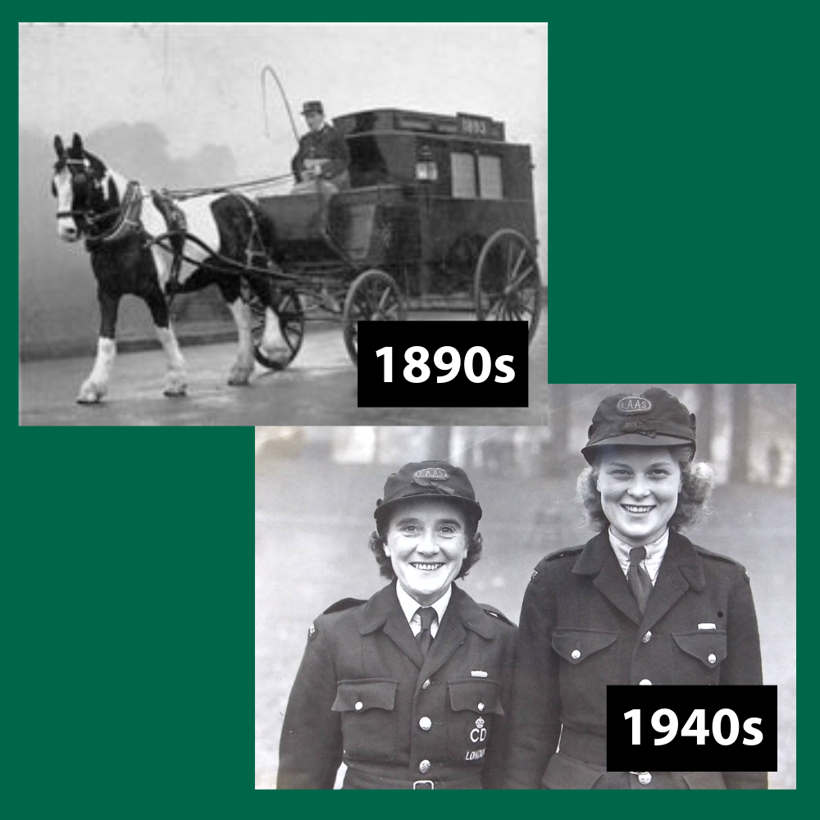
https://www.londonambulance.nhs.uk/wp-content/uploads/2025/03/LAS-History-Early-Years-Square.png
References
History of the Ambulance | liverpoolmedicalinst
Our history - a timeline - London Ambulance Service NHS Trust

Two challenges faced by the service
1. Delayed Hospital Handovers
2. Workforce Shortages and Staff Pressures

Ambulance service

Element 2
Community mental health services

Investigate the origins of the service and explore the historical context that shaped its development • Critically evaluate how the service functions today. • Discuss its significance in enhancing the quality of life of service users.

References

