Impact of current challenges on the human resource department relating to recruitment and retention

Name: Adrian Grigore
Student id: 2127381
Lecturer's name: Helen Evans
Module code: 5005

Table of Contents
Introduction and Background 3
Literature review 4
Challenges faced by the hospitality sector 4
Impact of Challenges on business performance 5
Solutions to deal with challenges 6
Pestle Analysis 6
Political Factor 6
Economic Factor 7
Social Factor 8
Technological Factor 9
Legal Factor 9
Environmental Factor 9
Conclusion and Recommendations 9
References 11

Introduction and Background
Business performance is defined as the indicator of commercial effectiveness, that is, the ability of the division or organisation to attain the goal and anticipated outcomes of the business (AlMuhayfith, and Shaiti, 2020). Commercial effectiveness consists of revenue or sales, quality, timelines, and cost, which are considered useful metrics for analysing the company.
This research proposal is based on INTERCONTINENTAL HOTEL GROUP, which is marked as the IHG Resorts & Hotels. It is a British multinational hospitality organisation which is headquartered in Windsor, England. The InterContinental Hotel Group (IHG) was established on 15th April 2003 (InterContinental Hotel Group, 2023). The selected organisation is listed on the New York Stock Exchange and London Stock Exchange. At the present time, the business has 325000 numbers of employees, and in the year 2022, it has 6,028 hotels and 884,820 rooms.
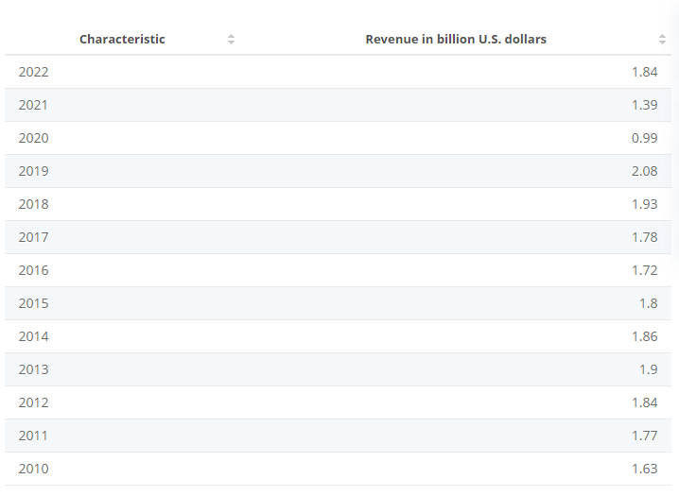
Figure 1: Revenue of IHG
(Source: Statista, 2023)
It has been seen that the UK-based multinational hotel IHG generated 1.84 billion US dollars in revenue in the year 2022. The above statistics highlight an increase in revenue from the year 2021, when its revenue was 1.39 billion US dollars (Statista, 2023). The InterContinental Hotel Group own many well-known hotel brands, such as Holiday Inn, InterContinental, Holiday Inn Express, Crowne Plaza, Candlewood Suites, Staybridge Suites and Hotel Indigo. In the year 2019, the selected organisation generated the highest revenue, which amounted to 2.08 billion US dollars (InterContinental Hotel Group, 2023).
STRENGTH  - Global Presence  - Skilled and experienced professionals  - Occasion Wise Brand Portfolio  - Strong digital outlook  - Strategic Partnership | WEAKNESS  - Weak IT Security  - No economic brand of hotel
OPPORTUNITIES  - Increased in International Tourist travel.  - The fragmented branded market of hotels  - Technology advancement | THREATS  - Global Crisis  - High Competition  - Increased dependence on Intermediaries  - Sharing economy in the sector  - Market instability due to unprecedented events

Literature review

Challenges faced by the hospitality sector.
As per the view of Gursoy, and Chi, (2020) there are numerous challenges which are faced by the hospitality sector. The key challenge faced by the sector is the rising operational cost. This challenge is faced by the organisation due to Brexit because, after this economic crisis, the hospitality industry has to increase the wages of the workers so that they can attract them from different countries. This has resulted in higher prices for the guest of the hotels decline in the service level (Yusoff, et al. 2020). For example, due to Brexit, the IHG was facing the issue of employee retention as there was poor management in the business because of a shortage related to the workforce. Thus, that's why the organisation needs to increase the wage of the worker so that there is effective management in the business.
It has been critically argued by Djajasinga, et al. (2021) that another challenge faced by the hospitality industry at the time of inflation is an increase in the cost of supply and food. Due to this, all the hotels and resorts in the UK have increased the prices of their menu, and it has become very difficult for them to manage the prices. Because of the increase in cost, most people can't afford to go to hotels. Thus, the industry has faced a decline in sales. The inflation has caused the retention issue in the hospitality sector as with the increase in the cost of supply and food, it becomes difficult for the sector to offer higher wages to the workforce.
Mass cancellations of bookings and accommodation are also disputing which hospitality industry is facing at the time of Covid-19. Many of the events and bookings have been cancelled due to Covid-19, which has caused losses for the hospitality sector. They are not earning any penny, but still, they have to pay salaries to their workforce (Kansakar, Munir, and Shabani, 2019). Due to Covid-19, there was a lockdown in the UK, and because of this, the hospitality industry was not able to recruit and retain employees. Apart from this, there was a lack of training as, at the time of Covid-19, the HR of the company was not able to provide training to the employees (Martínez-Martínez, et al. 2019).

Impact of Challenges on business performance
The impact of challenges such as rising operational costs, increases in the cost of the supply and food, as well as mass cancellations of accommodation and bookings, is negative on the performance of the business. As per the view of Baum, (2019) the impact of these challenges was negative on business performance because the rise in the operating cost maximises the profitability of the organisations. Due to this, the business needs to increase the prices of its services, which results in decreased profitability that also outcome in decreasing the performance of the company (Alonso, et al. 2020).
The impact of the increase in the cost of the supply and food is negative on the business performance in the hospitality industry because it increases the inventory holding cost of the organisations. It has been argued by Thams, et al. (2020) that the impact of mass cancellations of accommodation and bookings is negative on the performance of the business. For example, due to this, the demand forecast accuracy of the IHG has been highly affected because of the cancellations.

Solutions to deal with challenges
According to Dashper, (2020) to deal with the challenge of mass cancellations of accommodation and bookings, the hospitality industry needs to set a flexible policy for cancellation so that the guest who is planning vacations doesn't have a fear of non-refund. This might help the organisation in dealing with the challenge. To deal with the challenge related to the increase in the cost of the supply and food, the organisations in the hospitality industry need to talk with the suppliers so that they can offer the best quality products at fewer prices (Ali, et al. 2021). The suppliers can facilitate the IHG with the purchasing and planning. It has been critically opposed by Legrand, Chen, and Laeis, (2022) that to solve the challenge of rising operational cost, the organisation needs to enhance the efficiency of the employees.

Pestle Analysis

Political Factor
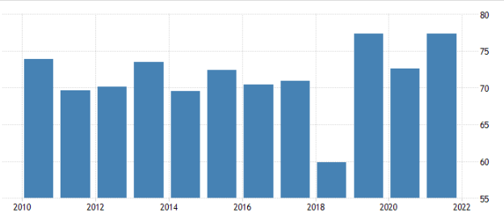
Figure 2: UK’s Political Stability
(Source: Trading Economics, 2023)
The political stability of the UK is stable, as identified from the above-mentioned figure. The UK’s political stability in 2021 was 0.54. The low or controlled corruption and the effectiveness of the government policies reflected that the UK is politically stable and also the government of the country is performing well. The UK falls under the most powerful country due to its political stability (Trading Economics, 2023). However, Brexit had created uncertainty in previous years. In 2020 the UK was able to deal with Brexit for the economic prosperity of the nation. Political stability has a positive impact on IHG as there is less government intervention and high support of the administration.

Economic Factor
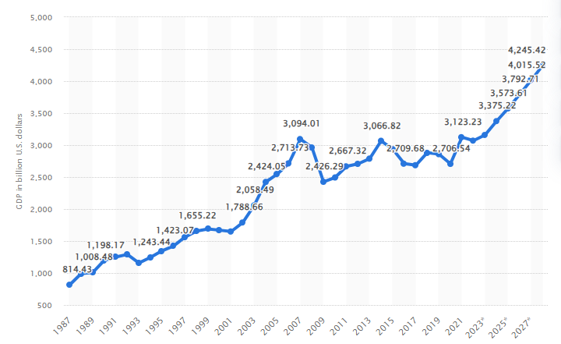
Figure 3: GDP of the UK
(Source: Statista, 2023)
The above statistic reflects that the GDP of the UK in 2022 was 3,070.6 billion US dollars which put the economy of the UK in the 6th place globally. UK’s per capita in 2019 was approximately 41030 US dollars and 20th maximum per capita globally (Statista, 2023). The key rationale behind the achievement of the UK's economy is diversity. The UK market is so assorted, which offers equivalent opportunity to all organizations to flourish and grow. The economic factor also has a positive impact on the IHG as they have many opportunities for expansion and growth in the UK market, which also assists in increasing profitability.

Social Factor
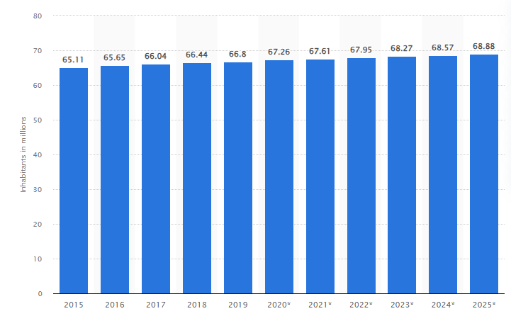
Figure 4: UK’s Total Population
(Source: Statista, 2023)
The total population of the UK in 2022 was 67.95 million, and it is projected that the population of the country will be 68.88 million by the end of 2025. The population of the UK is increasing rapidly because birth is increasing the mortality rate of the nation (Statista, 2023). This creates chances for business to fulfill the needs of the individuals. The United Kingdom is considered the major purchaser market globally. The UK is also well known for its education system because every year it keeps on changing with the updated or latest information. This has a positive impact on the selected organization as they can recruit educated people in the business, which will assist in increasing their service quality and sales.

Technological Factor
The UK is considered the most technologically advanced country in the world. In the UK, London is a great hub for technological and financial institutions. In the nation, organisations are mainly focused on implementing latest technologies so that they can offer the best services and effective solutions to their consumers (How and What, 2023). Technological advancement offers multiple opportunities for the organisation operating in the UK. The technological factor has a positive impact on IHG as this facilitates them to understand the needs of the customers with the help of social media channels and digital marketing.

Legal Factor
The UK is famous for its advanced legal system and for its strong tradition of civil liberties. It is considered the world leads in civil liberties and human rights. In the UK, it is significant for every organisation to implement The Employment Act of 1996, which assists in protecting the employees rights (How and What, 2023). This has a positive impact on InterContinental Hotel Group as it assists them in having the maximum level of employee satisfaction.

Environmental Factor
It has been analysed that economic activities impact a lot on the environment. However, the selected country has also made imperative enhancements in reducing the negative impact on the nation (How and What, 2023). The government, charities, newspapers, and local councils of the UK have taken multiple initiatives in order to decrease the negative collision of economic growth on the environment. Thus, this has a positive impact on IHG as they can focus on sustainability which can result in attracting tourists.

Conclusion and Recommendations
From the overall proposal, it has been concluded that business performance analyses how an organisation execute its daily functions by developing the strategies that result in the effectiveness of the entity. The selected organisations operate in the Hospitality industry. IHG manages, franchises, leases and owns Hotels and Resorts. IHG is UK based multinational hotel which had produced profits of 1.84 billion US dollars in the year 2022. The key strength of IHG is that it has a global presence with a skilled and experienced workforce, which assists them in attaining their goals as well as also in terms of earning the maximum amount of profit. It has also been concluded that rising operating costs, increases in the cost of food and supply chain as well as mass cancellation of booking and accommodation are the disputes which the selected sector is facing at the time of Brexit, Covid-19, and inflation. The collision of these challenges is negative on the performance of the business as it has decreased the profitability of the hospitality industry. It has also been concluded that the collision of macroeconomic aspect is positive on the selected business.
In order to deal with the challenges faced by the InterContinental Hotel Group, certain recommendations have been mentioned below:
- It has been recommended that IHG should offer rescheduling bookings to the customers, which will help the organisation to not face the loss that can be faced due to cancellation. The rescheduling of the booking can be done on the hotel website. The guest will be able to change the dates on their own (El-Gohary, 2020). This will facilitate IHG to solve the challenge faced by them related to mass cancellations of accommodation and bookings.
- It has also been suggested that IHG should focus on training the staff so that they can have effective inventory management, which will facilitate them in managing the inventory. The effective management of the inventory will result in decreasing the cost of the supply chain, and thus, this will help IHG in mitigating the challenges faced by them, which are related to the increase in the cost of food and the supply chain (Jones, and Wynn, 2019).
- It has been recommended that InterContinental Hotel Group should embrace technology. The implementation of the innovative and latest software can imperatively reduce the operational costs of the business (Darvishmotevali, et al. 2020). The latest software and advanced technology could relieve the workforce of manual tasks. This could facilitate the organisation in eradicating the challenge faced by them, which is related to rising operational costs.

References
Ali, B.J., Gardi, B., Jabbar Othman, B., Ali Ahmed, S., Burhan Ismael, N., Abdalla Hamza, P., Mahmood Aziz, H., Sabir, B.Y., Sorguli, S. and Anwar, G., 2021. Hotel service quality: The impact of service quality on customer satisfaction in hospitality. Ali, BJ, Gardi, B., Othman, BJ, Ahmed, SA, Ismael, NB, Hamza, PA, Aziz, HM, Sabir, BY, Anwar, G. (2021). Hotel Service Quality: The Impact of Service Quality on Customer Satisfaction in Hospitality. International Journal of Engineering, Business and Management, 5(3), pp.14-28.
AlMuhayfith, S. and Shaiti, H., 2020. The impact of enterprise resource planning on business performance: With the discussion on its relationship with open innovation. Journal of Open Innovation: Technology, Market, and Complexity, 6(3), p.87.
Alonso, A.D., Kok, S.K., Bressan, A., O’Shea, M., Sakellarios, N., Koresis, A., Solis, M.A.B. and Santoni, L.J., 2020. COVID-19, aftermath, impacts, and hospitality firms: An international perspective. International journal of hospitality management, 91, p.102654.
Baum, T., 2019. Does the hospitality industry need or deserve talent. International Journal of Contemporary Hospitality Management.
Darvishmotevali, M., Altinay, L. and Köseoglu, M.A., 2020. The link between environmental uncertainty, organizational agility, and organizational creativity in the hotel industry. International journal of hospitality management, 87, p.102499.
Dashper, K., 2020. Mentoring for gender equality: Supporting female leaders in the hospitality industry. International Journal of Hospitality Management, 88, p.102397.
Djajasinga, N.D., Sulastri, L., Sudirman, A., Sari, A.L. and Rihardi, E.L., 2021, June. Practices in Human Resources and Employee Turnover in the Hospitality Industry. In 2nd Annual Conference on blended learning, educational technology and Innovation (ACBLETI 2020) (pp. 113-117). Atlantis Press.
El-Gohary, H., 2020. Coronavirus and halal tourism and hospitality industry: Is it a journey to the unknown?. Sustainability, 12(21), p.9260.
Gursoy, D. and Chi, C.G., 2020. Effects of COVID-19 pandemic on hospitality industry: a review of the current situations and a research agenda. Journal of Hospitality Marketing & Management, 29(5), pp.527-529.
How and what, 2023. Pestle Analysis. [Online]. <Accessed Through: https://www.howandwhat.net/pestel-analysis-uk/>. [Accessed On 7th June 2023].
InterContinental Hotel Group, 2023. About IHG. [Online]. <Accessed Through: https://www.ihgplc.com/en >. [Accessed On 7th June 2023].
Jones, P. and Wynn, M.G., 2019. The circular economy, natural capital and resilience in tourism and hospitality. International Journal of Contemporary Hospitality Management.
Kansakar, P., Munir, A. and Shabani, N., 2019. Technology in the hospitality industry: Prospects and challenges. IEEE Consumer Electronics Magazine, 8(3), pp.60-65.
Legrand, W., Chen, J.S. and Laeis, G.C., 2022. Sustainability in the hospitality industry: Principles of sustainable operations. Taylor & Francis.
Martínez-Martínez, A., Cegarra-Navarro, J.G., Garcia-Perez, A. and Wensley, A., 2019. Knowledge agents as drivers of environmental sustainability and business performance in the hospitality sector. Tourism management, 70, pp.381-389.
Statista, 2023. GDP of the UK. [Online]. <Accessed Through: https://www.statista.com/statistics/263590/gross-domestic-product-gdp-of-the-united-kingdom/>. [Accessed On 7th June 2023].
Statista, 2023. Revenue of IHG. [Online]. <Accessed Through: https://www.statista.com/statistics/273254/revenue-of-the-intercontinental-hotels-group/>. [Accessed On 7th June 2023].
Statista, 2023. Total Population of UK. [Online]. <Accessed Through: https://www.statista.com/statistics/263754/total-population-of-the-united-kingdom/>. [Accessed On 7th June 2023].
Thams, A., Zech, N., Rempel, D. and Ayia-Koi, A., 2020. An initial assessment of economic impacts and operational challenges for the tourism & hospitality industry due to COVID-19 (No. 2/2020). IUBH Discussion Papers-Tourisms & Hospitality.
Trading Economics, 2023. Political Stability of UK. [Online]. <Accessed Through: https://tradingeconomics.com/united-kingdom/political-stability-and-absence-of-violence-terrorism-percentile-rank-upper-bound-of-90percent-confidence-interval-wb-data.html>. [Accessed On 7th June 2023].
Yusoff, Y.M., Nejati, M., Kee, D.M.H. and Amran, A., 2020. Linking green human resource management practices to environmental performance in hotel industry. Global Business Review, 21(3), pp.663-680.

