University of Wales Trinity Saint David
Wales Institute of Science and Art


Material Selection Report
ACHA4001
Engineering Technical Report
Harry Rogers
2205525
10/04/2024

Contents
Contents 1
1. Introduction 2
2. Component design specification 3
2.1. OEM part 3
2.2. New part 0
3. Material selection 0
3.1. Type 316L stainless Steel 0
3.2. 6061 T6 aluminium alloy 1
3.3. 6AL4V titanium 1
4. Manufacturing process selection 2
5. Conclusion 3
6. References 4

Introduction
This technical report will aim to design an aftermarket replacement to a KTM duke 890R front spindle. It will investigate what is needed of the front spindle, what it is designed to do and in what environment. It will then be possible to look at what improvements can be made and how they can be achieved using different materials and manufacturing techniques. By the conclusion of the report, in improved knowledge of design specifications, material selection and manufacturing processes relating to metallic components will be achieved.

Component design specification

OEM part
In order to create a design specification an aftermarket front spindle, first it is important to understand what it needs to do, what conditions it will be used in, how it can be manufactured and how much it needs to cost. This was done by first looking at the existing spindle. The table below give details of the existing spindles and specifications. These specification gave an initial understanding of the part to improve upon it. The spindle has then been drawn in to Solid works and an engineering drawing produced to give accurate dimensions of the part.
Table 1
OEM spindle
material | Material coating | Material tensile strength (MPa) | Weight  (grams) | Cost  GBP
EN 8 mild steel | Hard anodized | 370 | 564 | £35-£60
Figure 1 photo of the OEM spindle and an engineering drawing including dimensions.
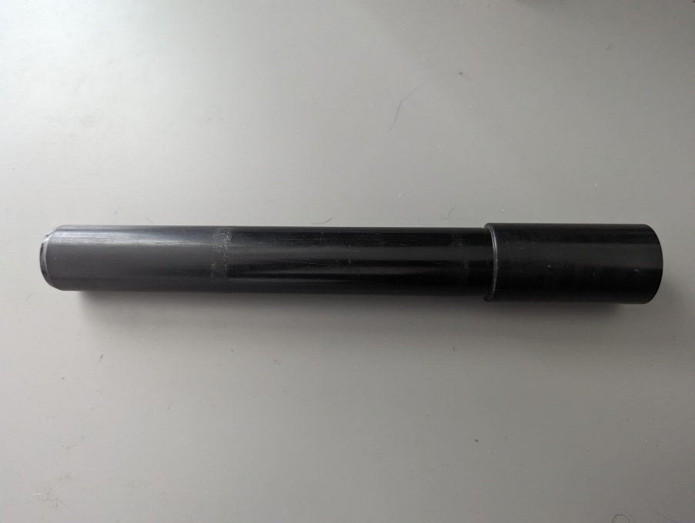
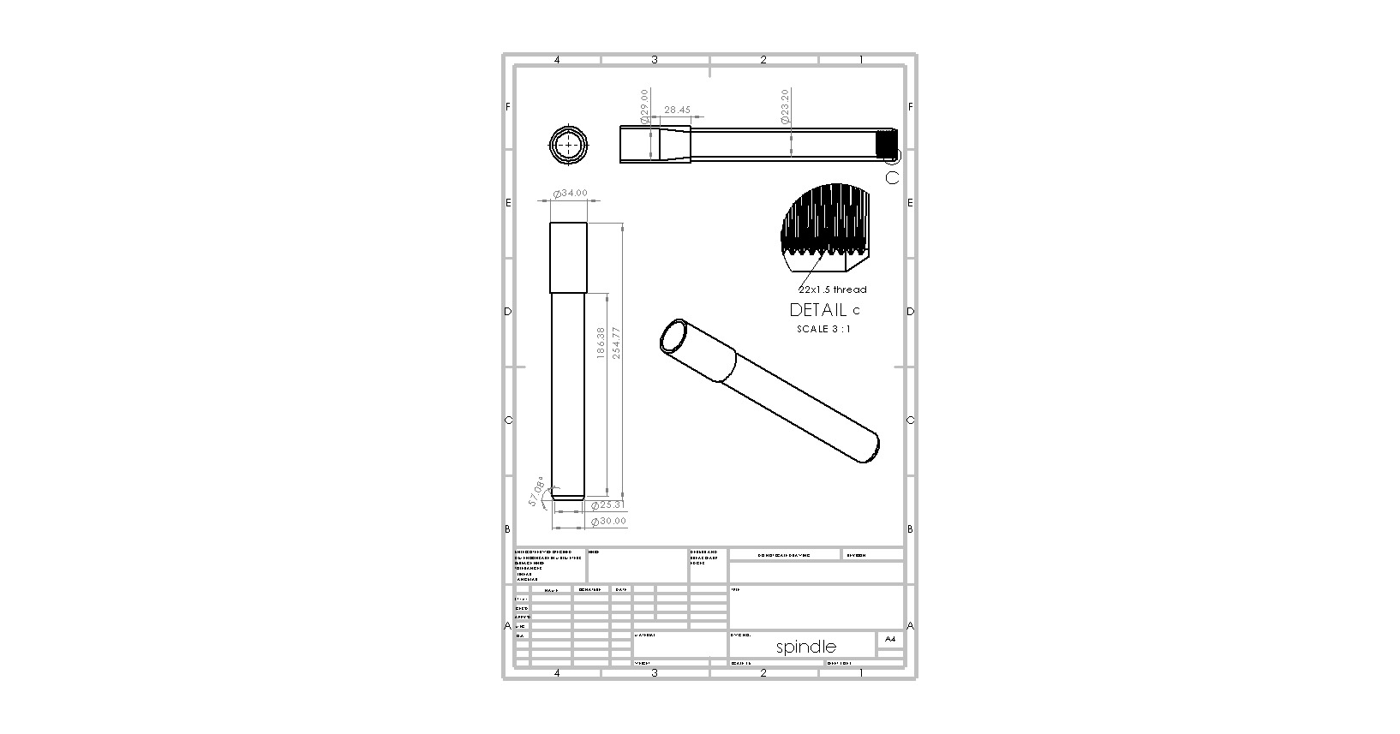

New part
Given the specifications from the OEM part, it was then possible to look at designing an aftermarket replacement. The goal of this replacement will be function identically to the original, but at a lighter weight and improved corrosion resistant. Reducing the weight of this part would improve the overall weight of the bike. This would lead to an improved power to weight ratio and will improve potential lap times. Due to this part being located at the wheel axle, it would also decrease the unsprung mass of the front suspension further improving suspension performance (Dixon, 1916).
Table 2 Design specification
KTM 890 front spindle |  | Requirements | Reason
1 | performance | The part must locate and fix the front wheel to the fork lowers securely  The part must be as strong, or stronger than the OEM part  The part must be simple to remove and install so the wheel can be removed  The part must not fracture, sheer or bend under the common loads the bike experience | This part must meet all the criteria highlighted in order to do its job effectively. It it is unable to perform any of these tasks, it will have to be redesigned.
2 | environmental consideration | The part must be resistance to corrosion  The part must not have a large variation in material properties as temperatures change | It must be corrosion to allow it to perform properly in all conditions. Corrosion on this could cause the spindle to seize inside the wheel, which would hinder wheel removal.  The part must be resistant to temperature changes as a lot of heat cab build up in the fork dropouts and wheel hub during road and track use due to braking. the part must perform as intended despite this.
3 | cost | the part will be designed as an upgrade to the OEM so it can cost more but a realistic market price must still be achievable. | Due to this part being an aftermarket upgrade, it can cost more than an OEM part.  the cost must be kept low to make sure the bike is possible to produce at a reliable price.
4 | life expectancy | the part must be more durable than the OEM as it is intended use on track will make for more harsh usage. | Due to the harsher environment it is used in, that part has to be stronger and more resilient to cope with this.  if the part wears out or fails prematurely, it will mean the cost of replacing it will lower potential profits
5 | weight | must weight less that the OEM part (564g) without sacrificing strength and longevity. | the part must weigh as little as possible to keep the overall weight of the motorbike as low as possible. It is also unsprung mass due it its location, so if it is excessively heavy it will have a negative impact on suspension performance.
6 | manufacturing | must be simple and cost effective to manufacture | keeping the design simple will keep the cost down per unit.
7 | appearance | the part must be appealing to customers. | if the part looks good to the customer it will be easier to market and sell

Material selection

There are many possible materials that could be used to create a spindle for this bike. Different materials will give vastly different characteristics and ultimately affect the overall performance of the product. There are many important considerations that must be made such as the mass, hardness / ductility, corrosion resistance and ease of manufacturing. These considerations often allow multiple different materials to suit a situation, all having benefits and compromises. Table below outlines the specifications of 3 possible metals that would be suitable alternatives, compared to the OEM material.
Table 3
material | material tensile strength (MPa) | Material  Density  (Kg/M³) | weight of spindle (g) | cost per Kg (£) | Material supplier
EN 8 steel | 370 | 7850 | 564 | 5.76 | themetalstore.co.uk
Type 316L stainless steel | 485 | 8000 | 583 | 11.74 | metalswarehouse.co.uk
6061 T6 aluminium alloy | 310 | 2700 | 196 | 4.03 | 1stchoicemetals.co.uk
6AL4V titanium | 1050 | 4430 | 312 | 31 | titane-services.eu

All the material properties and spindle weights gathered in table 3 were collected from (Dassault Systèmes, 1993)
Looking at Table 3, it is clear that EN 8 steel is a good option for an OEM material as it has a high tensile strength for its weight at a lower cost than other materials. It does however outline that there are better materials for the task if cost is less of an obstacle.

Type 316L stainless Steel
316L stainless steel has been looked at as alternative due to its higher tensile strength at a relatively similar weight. AZoM (2004) says It is also more corrosion resistant than the EN 8, negating the need for a coating to prevent resting over time. This would be an ideal material to use if durability and longevity were the most desired improvements. AZoM go on to say that it is more difficult to machine than EN8 due to its tendency to work-harden and is also roughly double the cost in material compared to EN8.

6061 T6 aluminium alloy
6061 T6 is an option as it is much less dense than EN8 making for a much lighter spindle. It is also very corrosion resistant. It is also a good option for anodizing in many different colours which adds appeal to potential buyers. It does however have a lower tensile strength, meaning the wall thickness would have to increase to obtain the desired strength. (Gabrian, 2019). A downside to aluminium is that it Is susceptible to weakening over prolonged periods of stress. This would make it necessary to strengthen the spindle further with more material (Hong et al., 2023)

6AL4V titanium
Titanium is a good option for a spindle as it has a very high tensile strength compared to its weight. This allow the part to have a greater overall strength, meaning it could have material removed to make it even lighter. Titanium is also very corrosion and temperature resistant, hence its common use in marine applications, making it an idea choice for an aftermarket spindle. The biggest downside of titanium is its cost. It would be 6 times more expensive than EN 8 steel in material costs. This means it would make for a stronger and lighter spindle but would be a much more expensive product (MatWeb, 2020).
For the reasons outlines above, titanium would be the best choice to meet the requirements of the design specification. It can be made stronger, lighter and more corrosion resistant. It would also be more expensive to make, but this acceptable as product will be an after-market upgrade for racing and track riding.

Manufacturing process selection
The manufacturing process of making the spindle are similar with all the metals looked at. The most common way of processing them would be to machine them from a bar of material. This would involve cutting the shape and features on a lathe. Steel, stainless steel and aluminium would be very similar ot machine as they all have similar machining properties. Titanium would be more difficult to machine due to its poor thermal conductivity, hardness, and low modulus of rigidity. Its hardness also requires the use of Cubic Boron Nitride (CBN) and Poly Crystalline Diamond (PCD) cutting tools in order to machine it (Evans, 2012). This further increases the cost of the spindle to the end user.
Machining would be the most cost-effective way to make the spindle for the customer. it allow for tight dimension tolerances. it is also quick to produce identical parts which aids in quality control and ensures the spindle lasts as long as it’s designed to.

Conclusion
in conclusion, an aftermarket spindle can be made from a verity of materials and work effectively. If the product just needs to be more corrosion resistant to deal with harsher climates, stainless steel would be a very good option. It makes for a stronger spindle with added corrosion resistance without adding to much weight or cost to the product. For use in a performance track or race bike, titanium stands out as the best option. It has the corrosion resistance of the stainless steel while also being %50 lighter and %50 stronger. The major downside to titanium is the increase in cost of material and manufacturing. These negatives make it unrealistic as an OEM option, but in a race application where marginal gains are important, it is by far the best material.

References
AZoM (2004) Stainless Steel - Grade 316L (UNS S31603), AZoM.com.
Dassault Systèmes (1993) ‘solidworks’, Dassault Systèmes [Preprint].
Dixon, J.C. (1916) Tires, suspension, and handling. 2nd edn. Society of Automotive Engineers.
Evans, R. (2012) Machining Titanium Alloy - an overview | ScienceDirect Topics, www.sciencedirect.com.
Gabrian (2019) 6061 Aluminum: Get to Know its Properties and Uses - Gabrian, Gabrian.
Hong, T. et al. (2023) ‘Mechanical Properties of 6061 Aluminum Alloy under Cyclic Tensile Loading’, Crystals, 13(8), p. 1171. Available at: https://doi.org/10.3390/cryst13081171.
MatWeb (2020) MatWeb - The Online Materials Information Resource, MatWeb .

