Managing People
Name of the Student: Iulia Flita
Student ID:2027759

Slide 1



Slide 2

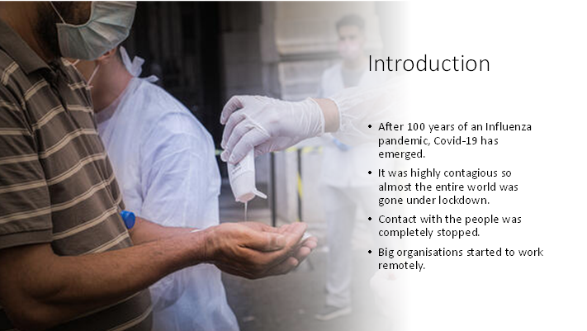

According to Allas et. al., (2020), the UK was affected severely by the pandemic and the death toll reached around 1.85 lakhs. Around 7.6 million jobs in the UK were put at risk due to the lockdown. This presentation will discuss the importance of flexible working and how it successfully implements diversity and inclusion in work. The role of HR to promote diversity and inclusion in relation to flexible working will also be discussed.

Slide 3

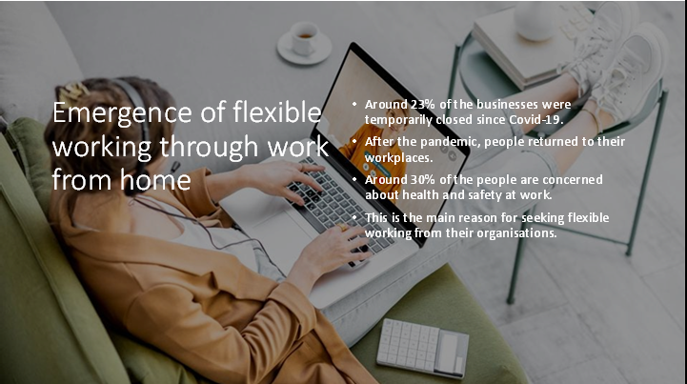

Only a minority of the people from the UK have gotten work from home facilities. The number is around eight million. According to Allas et. al., (2020), fear of contagion has affected the employees riding in the public vehicle. Even sometimes, sudden restrictions on travelling prevent them from travelling to foreign countries.

Slide 4

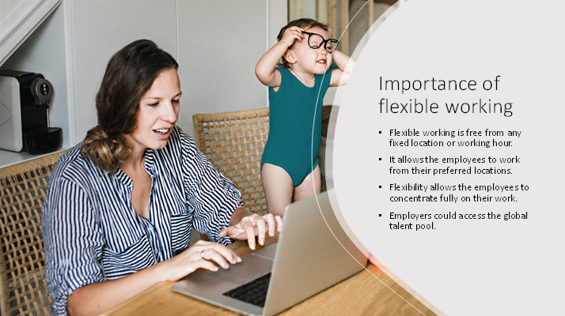

According to ‌Press (2021), it has several other benefits also such as it reduces the office space cost and retaining most of the employees. The employees work happily so give their best affecting the company's revenue and profit positively. They also could maintain their work-life balance improving their health.

Slide 5

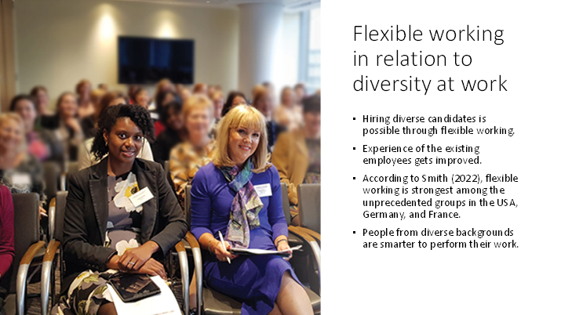

According to Grissom (2018), homogeneity refers to the enemy of creativity so a diverse team in the workplace is needed to be established so that groupthink is promoted. Hiring diverse people will add a fresh perspective to the team.

Slide 6

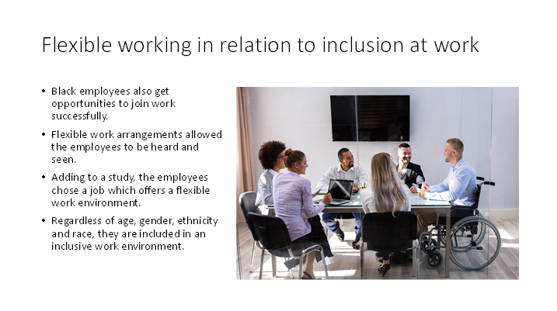

The employees feel included through direct and transparent communication even in remote working systems then they feel connected. According to ‌Smith (2022), this system gives rise to a good work culture allowing the employees to perform their best.

Slide 7

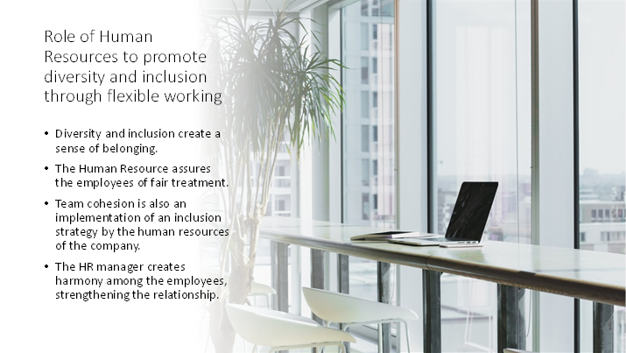

According to ‌David (2020), the role of HR is important as he could build confidence among the employees by motivating them. Thus, organisational efficiency is also improved along with employee-wellbeing.

Slide 8

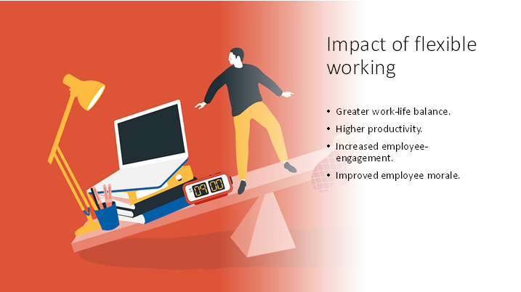

The stress of working could be reduced by flexible working that eventually improved employee morale. According to ‌David (2020), retention of valuable staff is also higher than it definitely impacts positively. According to a survey, 35% of the employees prioritise flexible working to get a prestigious position in the workplace. Even the same study has exposed that 30% of the employees left their jobs because of the less flexibility at their workplace. Diverse people could work because of flexible working facilities and they also perform better than a less diverse company.

Slide 9

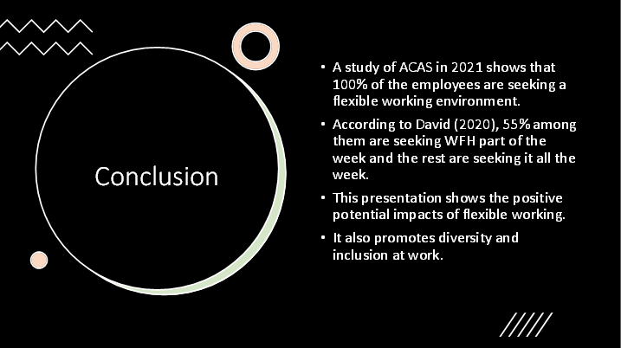

It also encourages people to take part in the organisation's decision-making process. The role of HR is important as he is the only person who promotes inclusion and diversity in the workplace by hiring people from different social groups.

Slide 10

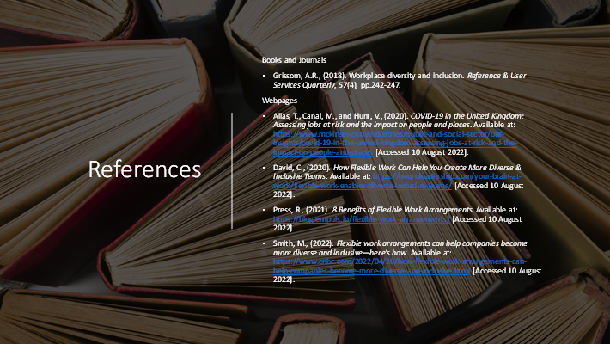

References
Books and Journals
Grissom, A.R., (2018). Workplace diversity and inclusion. Reference & User Services Quarterly, 57(4), pp.242-247.
Webpages
Allas, T., Canal, M., and Hunt, V., (2020). COVID-19 in the United Kingdom: Assessing jobs at risk and the impact on people and places. Available at: https://www.mckinsey.com/industries/public-and-social-sector/our-insights/covid-19-in-the-united-kingdom-assessing-jobs-at-risk-and-the-impact-on-people-and-places [Accessed 10 August 2022].
‌David, C., (2020). How Flexible Work Can Help You Create More Diverse & Inclusive Teams. Available at: https://neuroleadership.com/your-brain-at-work/flexible-work-enables-diverse-inclusive-teams/ [Accessed 10 August 2022].
‌Press, R., (2021). 8 Benefits of Flexible Work Arrangements. Available at: https://blog.empuls.io/flexible-work-arrangements/ [Accessed 10 August 2022].
‌Smith, M., (2022). Flexible work arrangements can help companies become more diverse and inclusive—here’s how. Available at: https://www.cnbc.com/2022/04/20/how-flexible-work-arrangements-can-help-companies-become-more-diverse-and-inclusive.html [Accessed 10 August 2022].

