
developing A Promotional campaign to relaunch the doha to cardiff route with qatar airways to support inbound tourism to wales

June 1, 2020
University of Wales Trinity Saint David Olivia Griffiths

Client: Jayne Miller (Sales Executive at Qatar Airways)
jmiller@uk.qatarairways.com
(Furloughed due to COVID19 – Tutor Aware)
Tutor acting as client/industry expert:
Jacqui Jones – Programme Director Jacqui.jones@uwtsd.ac.uk

Table of Contents
1.0 Executive Summary 2
2.0 Introduction 3
3.0 Methodology 5
4.1 Internal Audit of route (SWOT) 6
4.2 External Audit of route (PESTEL) 7
4.3 Competitor Analysis 9
4.4 Visit Wales Strategy 11
5.0 COVID19 Impacts on industry 12
6.0 Promotional Material – Video 13
7.0 Conclusions and Recommendations 14
8.0 References of report 16
9.0 References (Video) 18
10.0 Appendices 21

Link to video created for use as marketing material for relaunch of route:
https://1drv.ms/v/s!AoppxT4BKB5GkEs3bNSVNGsSw-0q

The client will be sent a copy of report and video once submitted to Turnitin.

1.0 Executive Summary

The report outlines the reasons for a joint campaign of Qatar Airways and The Welsh Government (which owns Visit Wales and Cardiff Airport) to relaunch the route connecting Cardiff and Doha.
The report had to be altered from the Bid Pitch and Project Initiation Document due to the impacts of COVID19 and the furlough of the client, however a new project was agreed prior to the furloughing.
The research methods used throughout were an internal and external audit consisting of a SWOT and PESTLE analysis as well as primary research through analysing figures from reports published by Cardiff Airport, Bristol Airport and Visit Wales as well as secondary research which looked at news items, interviews and reports.
The key findings were that there is no partnership between The Welsh Government in promoting Qatar Airways and the route was not mentioned in the 2020-2025 Visit Wales Strategy. It was found that COVID19 will heavily impact inbound tourism to the UK and Wales and so a relaunch can be used as a way to begin the recovery of the financial impacts the pandemic has brought on.

Recommendations were found that included:
- Creating a joint campaign linking Qatar Airways and The Welsh Government is needed to help increase visitor numbers to Wales
- Cardiff Airport has opportunities to compete with Bristol Airport but needs to utilise these opportunities soon in order to increase the public’s awareness
- It is possible to sell Wales as a business destination and not just as a tourist destination
- Partnerships between luxury hotels and business facilities will help increase business tourism to Wales

2.0 Introduction

The original project agreed by the client, Jayne Miller, Sales Executive at Qatar Airways based at Cardiff Airport was to undertake primary research to evaluate the public’s knowledge of the route the airline offers and ways in which to overcome this lack of communication in the form of marketing material such as a promotional video. Due to COVID19, the project had to be altered as well as research methods that were intended to be used. This report will cover the impacts COVID19 has had on the industry and promotional material will be created as a way of relaunching the route to help the airline and Visit Wales recover from the loss of passengers and tourists due to the pandemic.

This report will investigate the lack of partnership between Visit Wales (owned by the Welsh Government) and Qatar Airways. Qatar Airways started their Doha to Cardiff route in May 2018 with five flights a week. In the first twelve months of the airline flying to and from Cardiff Airport, occupancy was at 55% with 82,000 passengers (Business Live, 2019). Passenger figures have increased from its inaugural year, however there is still room to increase these figures. Due to flying to Qatar Airways’ hub airport, the route has huge potential to bring visitors from all over the world to Wales. The airport located in Doha, handles 30 million passengers a year, soon to be 50 million with 360,000 flights a year (Dohahamadairport, 2020).
The route currently features marketing of ‘Wales to the World’ which focuses on outbound tourism for UK residents to travel to Doha with the potential to the connect onto other flights through the hub airport.
Cardiff Airport was taken over by the Welsh Government in 2013 for £52 million after a decline in passenger numbers (Evans, 2019). Since the buyout, the number of passengers at the airport has risen from 2013 by 65%, to 1.7m annually. However, despite this increase in passenger numbers, it made a pre-tax loss of £6.6m in 2017/18 (BBC News, 2019).

Visit Wales is the Welsh Government’s team to promote Welsh tourism and assist the tourism industry across the country. The current Visit Wales strategy will be analysed with recommendations put forward from this research.
There is currently no link between Visit Wales and Qatar Airways and this report will aim to provide a plan for a promotional campaign for a joint relaunch of the route to market Wales to a worldwide audience through Qatar Airways as either a holiday or business destination as well as its quick connections to the rest of the UK.

3.0 Methodology

The research methods that will be used to undertake this report will consist of primary and secondary research in the form of internal and external audits. The internal audit will analyse the controlled aspects such as a SWOT analysis and the external audit will look at a PESTLE of the relaunch of the route.
Primary research will be undertaken by analysing data and figures that have been published by the government as well as airline reports to allow a thorough understanding. Research will mainly consist of analysing data such as visitor numbers to Wales from the rest of the UK and beyond. Passenger figures from Cardiff Airport will also be looked at as well as those projected in their masterplan for the period to 2040.
Competitor analysis is being undertaken to assess where Wales falls in line with competition and how this can be improved upon to increase passenger numbers at Cardiff Airport and reduce the number of people travelling to Bristol and further afield to fly.
The strategy published by Visit Wales will also be analysed in order to assess how they target inbound travel from the outside the UK. Secondary research will be used by looking at news reports and interviews on the industry to allow a greater depth of understanding.

4.0 Findings

4.1 Internal Audit of route (SWOT)

A SWOT analysis has been undertaken to look in depth at the internal and controllable factors of the Doha to Cardiff route.
Strengths  - World’s best airline  - Busiest commercial airport in Wales  - Quick connections to rest of UK  - Cheap flight prices  - Large customer base due to flying from a hub airport  - High number of routes available through Doha | Weaknesses  - Only five flights a week  - Limited connections for business travellers at Cardiff  - Current lack of business facilities and partnerships at airport  - Lack of promotional media and therefore, awareness of the route  - Lack of public transport to airport  - Remote location
Opportunities  - Cheaper than flying into LHR or other major airports in UK  - Soon to be new four-star hotel on site  - Link with ICC and Celtic Manor  - Create better business facilities and check in at CWL  - Increase flight numbers per week  - Increase tourism/passenger numbers after COVID19 | Threats  - Other competitor airports  - Lack of passenger numbers  - Pandemics
The analysis shows that although there are a number of weaknesses and threats, they can all be improved with financial investment through marketing or investing in the airport.
A lack of connections for business travellers from Cardiff Airport is linked to the fact there is currently only five flights per week operating on the route. Therefore, people wanting to travel from Wales to Qatar, or further through the hub airport have limited times available to them. With an increase in demand through passenger figures and an increase in flights per week, this issue will be resolved. The lack of business facilities at the airport are due to be overcome with one of the opportunities listed, a new four-star hotel opening at the airport which will feature conference and business facilities. A link between the route/airline with major hotels would provide great benefit to that of the hotel as well as encouraging flights into Cardiff by promoting that Wales does have the capabilities to host a luxury holiday or business needs.
Qatar Airways has been voted the world’s best airline, and so this is a major selling point which can be used to market the route. Many of the strengths and opportunities are only available to CWL and not their competitor of Bristol which needs to be fully utilised in a way to stand out from its competition and really capture the market.

4.2 External Audit of route (PESTEL)

A PESTLE analysis was undertaken to examine the external factors which may influence the success of the route.
Political  - Qatar blockade  - Devolution/ Welsh independence  - Passenger duty charge  - Brexit | Environmental  - Climate change  - Attitudes to flying may change due to increase in environmental awareness
Social  - Pandemics  - Changes of behaviour  - Awareness of climate change so less travel  - More domestic travel | Technological  - Digital inflight to sell new product/relaunch  - Market online (website and social media)  - New technologies at airport  - Use VR and AR to sell Wales/the route
Economic  - Less disposable income  - Rise in fuel/slots  - Stock market/shares  - UK Government investing less due to COVID19 recovery  - Cardiff Airport investing less due to COVID19 recovery  - Qatar Airways investing less due to COVID19 recovery | Legal  - Regulations for airline  - Paris Climate Agreement

The economic section heavily revolves around the recovery of the industry due to COVID19. It must be appreciated that there will be less investment in the coming years whilst the government, businesses, residents and visitors all recover financially from the pandemic. However, with the route already in place, no major investment needs to be undertaken to relaunch it, other than a marketing rebrand. This will hopefully bring in new passengers which will outweigh the costs incurred by this relaunch.
Technology is ever changing and this can be used as an advantage to sell and promote the relaunch through having a video demonstrating all Wales has to offer as a tourist and business destination on the inflight entertainment as well as new technologies at airports. It can also be shown online through social media, websites and using virtual and augmented reality to really bring the experience to life.

4.3 Competitor Analysis

As the closet airport to Cardiff Airport, it is important to see Bristol Airport as a competitor. Bristol Airport published a masterplan in 2006 detailing their aims for the period until 2030. This plan included an expansion of passenger numbers as they were constrained to a limit of only six million passengers a year which was then extended to ten million passengers a year in 2011 (Bristol Airport, 2006). Passenger numbers have increased to over eight million passengers per year, and forecasts originally indicated that demand will reach ten million passengers per year by 2021. They then began the process of planning to expand their facilities to reach capacity of 12 million passengers per year (Bristol Airport, 2018).
However, in February 2020 the expansion plans to increase passenger capacity by two million a year were rejected by councillors on the grounds of climate change, much like the expansion of London Heathrow. More than 8,000 people objected the expansion, and a three-day protest with dozens of activists was held by Extinction Rebellion (The Guardian, 2020). More than 8.6 million passengers used Bristol Airport in 2018 which was an increase of 6.2% equating to over 400,000 additional passengers, and a ninth consecutive year of growth (International Airport Review, 2019).
Qatar Airways deciding to use Cardiff Airport as their gateway to the South East did not sit well with Bristol Airport who had been seeking a Gulf-based airline. The airport calls itself “a world-leading regional airport serving the South-west and Wales,” and claims it handles more Welsh people than Cardiff Airport (The Independent, 2017). However, Chief Executive of Qatar Airways, Akbar Al Baker, insisted he would be proved right in opting for Cardiff instead of Bristol stating that he would be the "facilitator" in bringing further investment into Wales using the new service (BBC news, 2017).
Bristol Airport currently focus on short-haul and domestic routes with carriers such as TUI and Ryanair with constant investment and expansion aims to fully maximise potential of the airport. It is estimated that around 1.2 million people cross the border from Wales to fly from Bristol Airport (Wales Online 2018).

Cardiff Airport
The White Paper report in 2003 explained that although it was expected that Cardiff Airport claw back an increased share of Welsh traffic, airports in England will continue to have a significant role in meeting the needs of air travellers from Wales (Department for Transport, 2003). In 2018, 1.6 million passengers used Cardiff Airport, which was an increase of 8% from the previous year. The Welsh Government and Cardiff Airport released their Masterplan for the period up to 2040. The masterplan looked at forecasted passenger numbers, which can be seen below.
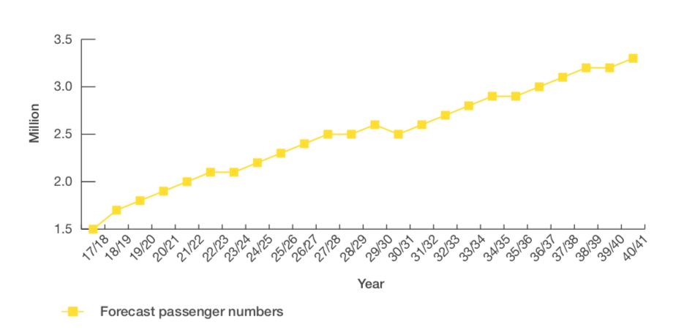
(Welsh Government, 2018).
They explain how the forecasted growth estimate that the airport could receive 2.5 million passengers annually by 2030 then increasing to 3.3 million by 2040. Their plans include a new passenger terminal, new cargo terminal as well as improving access to the airport. This will be done with new roads, pedestrian and cycle access as well as public transport links improving such as bus and train links.
The aim is to increase capacity and therefore attract new airlines. Cardiff Airport is able to expand its runway and boundaries if needed, due to its location, which is something that Bristol Airport are unable to do although recommended in the Government’s White Paper report in 2003 (Department for Transport, 2003). This works in favour for Cardiff Airport, allowing the potential to attract longer haul carries than Bristol Airport.
The airport is also opening a four-star hotel which will feature business and conference facilities in a bid to attract business travellers. Other opportunities to attract the business traveller would be to work in partnership with hotels that already offer fantastic conference facilities on a larger scale such as the five-star Celtic Manor Resort. Marketing a link with Cardiff Airport and Celtic Manor could attract new clientele which previously would have travelled through larger airports into the UK and then travelled via road to Celtic Manor.
To compete with Bristol Airport, Cardiff Airport need to market themselves as a competitor to attract some of the 1.2 million people travelling from Wales to Bristol as well as people in the South East who currently do not see Cardiff Airport as a viable option. With modernisation and new transport links to make it easier for passengers from all over the UK, this will help to increase the publics decision to travel through Cardiff Airport rather than competitor airports.

4.4 Visit Wales Strategy

The current 2020-2025 Visit Wales strategy outlines one of their aims as ‘Better connectivity, including a globally-connected Cardiff Airport’.
The strategy explains how they are making best use of new and more efficient digital marketing and social media opportunities to grow the international market of visitors to Wales as well as harnessing tactical opportunities as they arise (Visit Wales, 2020). The Doha to Cardiff route is not mentioned in the strategy specifically and with it being the only long-haul flight from Cardiff, this needs to be addressed to ensure long term sustainability of the route.
In the 2015-2020 Visit Wales strategy it was outlined that their key focus is to work with the new ‘Welsh Government Aviation Team’, as well as VisitBritain, to develop a Route Development strategy for Wales whilst working in partnership with Visit Britain (Welsh Government, 2016). This relaunch of the route along with the media campaign will help to ensure that Visit Wales fully utilise all available ways of promoting the airline, the capabilities of the airport as well as what Wales as a destination has to offer visitors from all over the world.
The video created also fits with the thematic years that Visit Wales has adopted. The year of 2020-2021 being ‘The Year of the Outdoors’. All attractions featured in the video are of outdoor attractions and everything that is unique to Wales. New marketing videos could also be created to work for each thematic year Visit Wales introduce.
Creating a partnership between Qatar Airways and major luxury hotels and business convention centres (such as a luxury executive transfer between the airport and Celtic Manor Resort and the ICC) will enable Visit Wales to market Wales as a world-class venue for business travellers and the higher spend traveller looking for luxury.

5.0 COVID19 Impacts on industry

COVID19 is having a major impact on all industries worldwide. Many airlines across the world have gone into administration due to the impacts, such as Flybe, who were one of the main airlines to serve Cardiff Airport.
As well as the financial impacts of the pandemic, which the full extent are not currently known, there is a chance that social trends may change over the next few years with less international travel due to a loss of earnings and therefore, disposable income, as well as confidence in the airline industry. In a report published by the Welsh Government, in 2018 visitors to Wales spent £6.3billion with over ten million overnight stays from visitors within the UK and 941,000 from visitors overseas (Welsh Government, 2020). With over 130,000 people, which equates to 9.5% of the total workforce in Wales employed in the tourism industry, recovery is highly important to reduce the number of redundancies in the tourism and aviation industry.
There is a risk that a number of tourist attractions which were forced to close, may never reopen their doors again due to loss of earnings during the period of closure. This promotional video is key to offering worldwide advertising to those attractions and helping to minimise these impacts.
Therefore, it is vital to create a joint campaign to relaunch the Doha to Cardiff route to help encourage visitors from all over the world to travel through the hub airport directly into Wales and show exactly what Wales has to offer all types of visitors.

6.0 Promotional Material – Video

The purpose of creating a video was to show everything on offer with the route and the potential of what Visit Wales could do if they worked with Qatar Airways through joint campaigns and promotions. The intention is to put a spin on the already used ‘Wales to the World’ campaign which can be seen throughout Cardiff Airport, and begin marketing ‘The World to Wales’ to encourage inbound travel to the UK.
Visit Wales acknowledged that a video created by Surf Snowdonia when it first opened showed the potential of how many viewers a successful video can have and how fast it can reach the intended audience. It was this reason that it was decided a video showing the connections the airline can offer travellers in Wales would be created.

A link to the video can be found at the beginning of this report.

The video includes clips from over thirty sperate YouTube videos which all demonstrate the beauty Wales has to offer in terms of coast lines, world famous mountains and visitor attractions as well as the benefits of flying into Cardiff Airport with Qatar Airways.
The music played throughout was used to portray excitement and ensure the viewer felt in an upbeat mood which suited the rapid short clips. The video aims to show potential passengers that as well as visiting as a tourist for leisure purposes, Wales and the airline offer great business options and these will be further developed through the new 4 stars on site hotel. It explains how major cities in the UK can also be reached through landing at Cardiff Airport in less than four hours and so can be used to connect to the whole of the UK, and so with more competitive rates through flying into Cardiff, they can still reach locations across the UK if needed.

7.0 Conclusions and Recommendations

From the research and analysis undertaken throughout this report, it is concluded that a partnership is needed between the Welsh Government (who own both Visit Wales and Cardiff Airport) and Qatar Airways. A partnership would mean that a relaunch of the route through new promotional marketing material would increase passenger numbers entering through Cardiff Airport and would benefit visitor attractions, hotels and businesses across Wales.
The 3-and-a-half-minute video was designed to help promote the relaunch of the route with the aim of increasing passenger numbers over the next five years. The video was designed to show what Wales has to offer as well as Qatar Airways. It was designed to be used on in-flight entertainment on all Qatar Airways planes alongside other destination videos as well as on social media platforms, the Qatar Airways and Visit Wales/Visit Britain website. A twenty second shortened version with no audio would also be advised to be created to show on display screens at airports that Qatar Airways fly from as well as in locations across Qatar. It is hoped that this video, along with other marketing material, will help increase passenger numbers either as tourists or business travellers.
Other recommendations are as follows:
- As well as a full marketing relaunch, another recommendation would be to use the new four-star hotel due to open at the airport as a business check-in for passengers. The hotel is already planned to have business and conference facilities so this separate check-in service would suit the business traveller and is already successfully used at other airports across the world.
- A luxury transfer between the airport and Celtic Manor Resort, ICC and St Davids Spa and Hotel would help target the higher paying traveller and also help increase exposure of these hotels worldwide and provide a hassle-free trip for passengers.
- Target the business market as well as family market through promotional material which shows what Wales has to offer in both aspects
- Use the relaunch as a way of recovering the Welsh tourism industry from the financial impacts of COVID19 due to low cost involved with potentially high return.
Visit Wales should be utilising the opportunities that Qatar Airways are bringing to the country and a partnership could help provide a longer-term guarantee that the airline will continue its route.

This project suffered setbacks due to COVID19 and the furlough of the client in which it was originally intended for.
Although the reduced interaction with the client could not have been prevented, a number of measures could have been undertaken by the writer to help minimise the impacts and limit the amount of alterations to the original project. These would have been to potentially foreseen difficulties earlier on in the year when news started to come out about COVID19 and so could have agreed a project before which would have worked despite the client being furlough earlier on.

8.0 References of report

BBC News. 2017. Qatar Boss 'Faith In Cardiff Air Route'. [online] Available at: <https://www.bbc.co.uk/news/uk-wales-41469143> [Accessed 28 May 2020].
BBC News. 2019. Cardiff Airport To Be Loaned More Taxpayers' Cash. [online] Available at: <https://www.bbc.co.uk/news/uk-wales-politics-50127123> [Accessed 28 May 2020].
Bristol Airport, 2006. Bristol International Airport Master Plan 2006 To 2030.
Bristol Airport, 2018. Your Airport: Your Views Towards 2050.
Business Live. (2019). First year passenger figures for Qatar Airways' Cardiff to Doha route. [online] Available at: https://www.business-live.co.uk/economic-development/how-many-passengers-flew-first-16701011 [Accessed 20 May. 2020].
Department for Transport, 2003. The Future Of Air Transport. [online] London: Department for Transport, pp.76-102. Available at: <https://assets.publishing.service.gov.uk/government/uploads/system/uploads/attachment_data/file/685595/6046.pdf> [Accessed 26 May 2020].
Dohahamadairport.com. 2020. Our Airport | Hamad International Airport. [online] Available at: <https://dohahamadairport.com/about-us/our-airport> [Accessed 26 May 2020].
Evans, F., 2019. 'Millions Wasted' On 'Vanity Project' Airport. [online] BBC News. Available at: <https://www.bbc.co.uk/news/uk-wales-politics-49023188> [Accessed 26 May 2020].
International Airport Review. 2019. CEO Of Bristol Airport Believes 2019 Was The Turning Point For Aviation. [online] Available at: <https://www.internationalairportreview.com/article/109555/ceo-bristol-airport/> [Accessed 26 May 2020].
The Guardian. 2020. Plan To Expand Bristol Airport Rejected After Climate Protests. [online] Available at: <https://www.theguardian.com/uk-news/2020/feb/11/plan-to-expand-bristol-airport-rejected-after-climate-protests> [Accessed 30 May 2020].
The Independent. 2017. Is This Britain's Unlikeliest New Transport Hub?. [online] Available at: <https://www.independent.co.uk/travel/news-and-advice/cardiff-airport-doha-qatar-airways-gateway-to-the-world-auckland-bali-australia-a7699521.html> [Accessed 22 May 2020].
Visit Wales, 2020. Priorities For The Visitor Economy 2020 – 2025.. [online] Available at: <http://Priorities for the visitor economy 2020 – 2025.> [Accessed 16 May 2020].
Walesonline. 2018. Cardiff Airport's Nearest Rival Bristol Reports Big Increase In Welsh Passengers. [online] Available at: <https://www.walesonline.co.uk/business/business-news/cardiff-airports-nearest-rival-bristol-14146380> [Accessed 18 May 2020].
Welsh Government, 2016. Partnership For Growth: Strategy For Tourism 2013-2020. [online] Available at: <https://gov.wales/sites/default/files/publications/2019-07/partnership-for-growth-strategy-for-tourism-2013-to-2020-strategy-progress-review.pdf> [Accessed 28 May 2020].
Welsh Government, 2018. CARDIFF AIRPORT 2040 MASTERPLAN. [online] Available at: <https://www.cardiff-airport.com/uploads/Masterplan%20Report%20FINAL%20JUNE19%20lower_compressed%20%281%29.pdf> [Accessed 28 May 2020].
Welsh Government, 2020. Priorities For The Visitor Economy 2020 – 2025. [online] Available at: <https://gov.wales/sites/default/files/publications/2020-01/welcome-to-wales-priorities-for-the-visitor-economy-2020-to-2025-summary.pdf> [Accessed 28 May 2020].

9.0 References (Video)
Airport Traveller, 2019. Doha Airport Tour 2019. [video] Available at: <https://www.
youtube.com/watch?v=83rTzHUbEyE> [Accessed 24 May 2020].
All The Stations, 2017. Heart Of Wales Line - Episode 32, Day 54 - Swansea To Shrewsbury. [video] Available at: <https://www.youtube.com/watch?v=C_LFtdH2YkQ&t=252s> [Accessed 30 May 2020].
Around The World 4K, 2017. London In 4K. [video] Available at: <https://www.youtube.com/watch?v=X8zLJlU_-60> [Accessed 28 May 2020].
Booking.com. 2020. ★★★★★ The Celtic Manor Resort, Newport, UK. [online] Available at: <https://www.booking.com/hotel/gb/celticmanor.en-gb.html> [Accessed 30 May 2020].
Cardiff Airport, 2015. The Airport, Series 1 Episode 1. [video] Available at: <https://www.youtube.com/watch?v=mMjEeq5WH9s> [Accessed 28 May 2020].
CufflinkssHD, 2017. Rhossili Bay | Gower Peninsula | DJI Phantom 3 Professional. [video] Available at: <https://www.youtube.com/watch?v=79_brjTCAxw> [Accessed 28 May 2020].
Dreamy Travel Story, 2019. PORTMEIRION WALES Is ITALY In UK | Where To Travel In Wales 2019 | How To Travel In UK 2020. [video] Available at: <https://www.youtube.com/watch?v=MusbztlgfPw> [Accessed 28 May 2020].
Expedia, 2015. Liverpool Vacation Travel Guide | Expedia. [video] Available at: <https://www.youtube.com/watch?v=ojrHLXj8GJA> [Accessed 24 May 2020].
Expedia, 2020. Birmingham, Wolverhampton And Warwickshire, UK Vacation Travel Guide | Expedia. [video] Available at: <https://www.youtube.com/watch?v=Yd75ADasBoo&t=41s> [Accessed 30 May 2020].
Five on the Move, 2019. Aerial View Of Conwy Castle In North Wales, U.K.. [video] Available at: <https://www.youtube.com/watch?v=bb-ZQOoDUWI> [Accessed 26 May 2020].
Fly Drive Explore, 2016. A Day Out At St Fagans, Cardiff - The National History Museum Of Wales. [video] Available at: <https://www.youtube.com/watch?v=GdC-TEVNH9Y> [Accessed 30 May 2020].
Golfbreaks, 2018. Golfbreaks' Review Of: Coldra Court Hotel At The Celtic Manor Resort (Newport). [image] Available at: <https://www.youtube.com/watch?v=nzoQY0oDX34> [Accessed 30 May 2020].
Guinness Six Nations, 2013. RBS 6 Nations: Team Behind The Team -- Millennium Stadium. [video] Available at: <https://www.youtube.com/watch?v=_59DiFRDk0k> [Accessed 30 May 2020].
Guinness Six Nations, 2020. Extended Highlights: Wales V France | Guinness Six Nations. [video] Available at: <https://www.youtube.com/watch?v=bsZVIFfG5l0> [Accessed 30 May 2020].
Harinarayan, 2018. Amazing Wales [4K]. [video] Available at: <https://www.youtube.com/watch?v=O0-JTcOEpNQ&list=LLbHrG5jWm0gBVvkRmCpA5Kg&index=9&t=127s> [Accessed 30 May 2020].
Hold Tight Riders, 2017. Zip World Fforest Coaster - Mounted Onride Footage - UK's Only Alpine Coaster!. [video] Available at: <https://www.youtube.com/watch?v=gvHCPrzbVqc&t=174s> [Accessed 30 May 2020].
M3GA, 2017. Caernarfon Castle: Breathtaking Aerial View. [video] Available at: <https://www.youtube.com/watch?v=3Li9d5w7Mss> [Accessed 28 May 2020].
N125AS, 2013. Airbus A330-300 Qatar Airways Take Off. [video] Available at: <https://www.youtube.com/watch?v=47Cu1-uVXIs> [Accessed 28 May 2020].
NOVA, 2019. Velocity 2 At Zip World, POV Mix. [video] Available at: <https://www.youtube.com/watch?v=zpZnY4mLTlw> [Accessed 30 May 2020].
Qatar Airways, 2016. George Calombaris In Doha's Hamad International Airport - Qatar Airways. [video] Available at: <https://www.youtube.com/watch?v=MKPm0ShLtOM&list=PLPRzM4WEgNXPRFbfblDFT6YvT_W_s73uX&index=1> [Accessed 28 May 2020].
Qatar Airways, 2016. Introducing Qsuite - Qatar Airways New Business Class. [video] Available at: <https://www.youtube.com/watch?v=_yhZDsctiZg> [Accessed 24 May 2020].
Roberts, G., 2018. Pembrokeshire Coast Drone Movie 4K HD. [video] Available at: <https://www.youtube.com/watch?v=0DG0sPcB8Ac&t=104s> [Accessed 30 May 2020].
Roberts, J., 2017. Anglesey | North Wales | 4K. [video] Available at: <https://www.youtube.com/watch?v=bsZVIFfG5l0> [Accessed 28 May 2020].
Ryan, 2018. Pembrokeshire 4K Drone Tour. [video] Available at: <https://www.youtube.com/watch?v=fIXJja9agpc&t=86s> [Accessed 30 May 2020].
Smith, J., 2017. Pen Y Fan Via Drone. [video] Available at: <https://www.youtube.com/watch?v=TrSN6SpNPk0> [Accessed 30 May 2020].
St Davids Hotel & Spa HD, 2015. Welcome To The St David's Hotel & Spa In Cardiff HD. [video] Available at: <https://www.youtube.com/watch?v=uj5GhsrAJvg> [Accessed 26 May 2020].
The Planet D, 2016. The Steam Train Up Mt Snowdon In Wales. [video] Available at: <https://www.youtube.com/watch?v=Y1O8-4_j8gQ> [Accessed 24 May 2020].
Timsvideochannel1, 2017. The Ffestiniog Railway - Part 1 - Porthmadog To Tan Y Bwlch. [video] Available at: <https://www.youtube.com/watch?v=GWD--ZfPUxw> [Accessed 30 May 2020].
Tusdestinos, 2013. Cardiff, Visit Wales, United Kingdom UK / Wales Travel / Turismo Gales / City Tour Ciyscape Tourism. [video] Available at: <https://www.youtube.com/watch?v=Xfit3tly3FQ> [Accessed 30 May 2020].
ZipworldUK, 2019. Zip World Velocity 2 - The WORLD's FASTEST Zip Line. [video] Available at: <https://www.youtube.com/watch?v=9fSNsrvWyJc> [Accessed 26 May 2020].

10.0 Appendices

Minutes of meetings between client (Jayne Miller)

Location: Cardiff Airport
Present: Olivia Griffiths, Jayne Miller, Dee Jones
When: 10th February 2020 11am-1.30pm
Purpose: Present draft BID pitch, Decide original topic, title, research methods and the projects aims and objectives. Next meeting was organised for two weeks later at Morgan’s Hotel, Swansea to discuss progress.

Location: Morgan’s Hotel, Swansea
Present: Olivia Griffiths, Jayne Miller, Dee Jones
When: 27th February 2020 11am- 1pm
Purpose: Review BID pitch and PID. Client update on industry and business due to COVID19. Discuss how project may be affected and ways to overcome this.

Location: Via phone call
Present: Olivia Griffiths and Jayne Miller
When: 14th April 2020
Purpose: Review current situation and discuss new topic ideas, title, research methods and advice were given from client of who to contact for prices and strategies of North Wales if needed.

Regular email communication between Olivia Griffiths and Jayne Miller from January 2020 until 15th April when client was furloughed. Emails discussed and reviewed progress and communicated any questions and feedback.
Email showing client satisfied with reviewed project

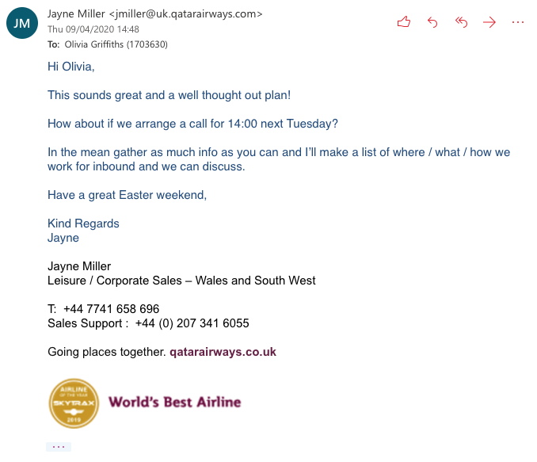

Gantt Chart before COVID19 impacted
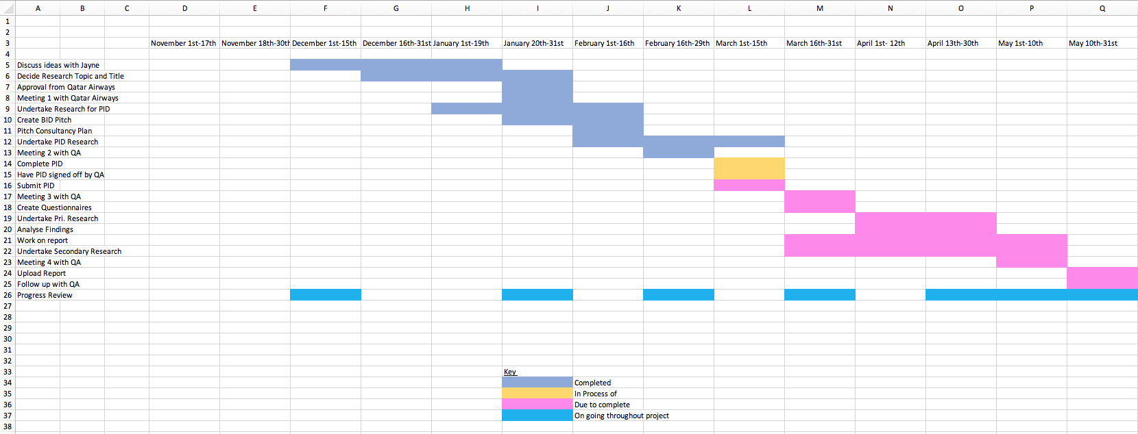
Reviewed Gantt chart at end of assignment 

