Qualification: CIPD Diploma in Applied Human Resources

Module Name: Understanding Employment Law

Title: Employment Law

Word Count: 4760 words

Student Name: Rachel Thomas
Student Number: 1201576
CIPD Membership Number: 55478540

By signing below, I confirm that the work/evidence presented is my own, unaided work. I understand the regulations pertaining to candidate malpractice and the action that may be taken as a result.

Signed: RMThomas
Date: 27 April 2020

Employment Law

Part One

HR professionals are more obliged to take account of legal requirements in different jurisdictions when carrying out aspects of their roles. CIPD (2020a) acknowledges that employment law regulates professional relationships between employers and employees, governing what employers can expect from employees, what employers can ask employees to do, and employees’ rights at work.

A dictionary definition given is “a set of laws that deal with the rights of employees and the responsibilities of employers” (Cambridge University Press, 2020). Legislation are put in place to provide guidance to employers on what is expected of them, and to ensure that employees feel that they are treated fairly in the workplace.

In the UK, employment law is categorised as ‘civil law’, resolving disputes between two parties, the claimant and the respondent. CIPD (2019a) identifies ‘claimant’ as an employee, a former employee, or an unsuccessful job applicant. Claimants will use the court system to allege that the ‘respondent’ (their current or former employer) has caused detriment and has done so in contravention of law. Most employment disputes will be resolved in an Employment Tribunal.

Daniels (2019) explains how Employment Tribunals date from the 1960s and were initially created to deal with appeals by employers against training levies under the Industrial Training Act 1964. In 1998, they were renamed to Employment Tribunals. Over time, jurisdiction has been extended with notable additions such as: claims for statutory redundancy payments in 1965, unfair dismissal introduced by the Industrial Relations Act 1971, and various types of discrimination in employment in the Equality Act 2010. There are now over 80 types of claim that can be brought to an employment tribunal (Shackleton, 2005).

The civil court system is hierarchical in structure. Most employment law cases are first heard in an Employment Tribunal. Should the outcome lead to an appeal, which firstly must be based on a point of law, it is referred to the Employment Appeal Tribunal. Any further appeal is directed to the Court of Appeal and then to the Supreme Court. When a higher court makes a ruling on a point of legal practice, that then becomes a binding precedent which all the lower courts must observe when similar cases are brought before them (Legal Dictionary, 2016).
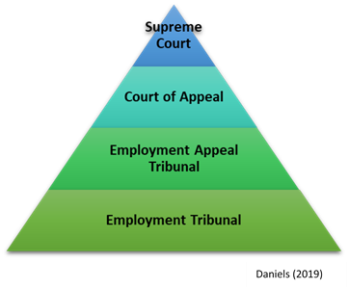

Employment Tribunals only have jurisdiction to hear claims arising from employment in the UK (Gov.uk, 2015). When claimants wish to pursue claims against their employer, they inform the Advisory, Conciliation and Arbitration Service (ACAS) of their intentions. ACAS contact the employer (respondent) to discuss details of the claim, with a view of facilitating an out of court settlement. Should these attempts fail, the claimant can pursue their claim.
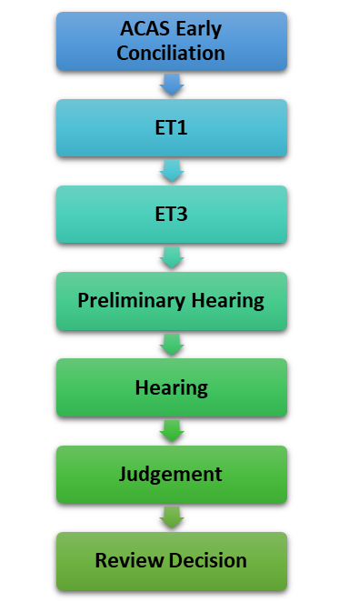
A claimant makes a claim to the Employment Tribunals (ET) by completing an ET1 form, lodging this at the ET within three months of the alleged incident occurring. The relevant regional office of the ET receives the claim to the tribunal and a copy is sent to the respondent. The respondent is also sent an ET3 form outlining its defence of the claim, which they are to complete and return within 28 days. Once this has elapsed, the case will be listed for a hearing in the ET. Should this not be returned, the claimant will automatically win.

A preliminary hearing addresses points that need resolving before a full hearing can take place. At this point, the Employment Judge can strike out a claim, and order a deposit to be paid by the claimant, should the claim be unlikely to succeed. ACAS have a statutory duty to try to facilitate a settlement prior to a hearing.

The ET will send directions to both parties which they must comply with. A case file is reviewed by the Employment Judge prior to the hearing. Once evidence has been presented, and witnesses have been heard, a judgement can be reached. A decision will always be confirmed in writing to both parties.

There is great debate surrounding employment law. The arguments in favour of extensive employment law aim to enhance social justice (CIPD, 2017). These include:
- Balancing the power between employers and employees
- Deterring employers from exploiting their power unreasonably
- Minority groups need protection and encouragement to achieve equality
- Trade unions would be powerless without legal support
- Encourages people to stay in the UK to work

The main arguments against employment regulation are economic (Chance, 2009). It is believed that it will:
- Raise unemployment and slows economic growth
- Raise costs for employers and makes our economy less competitive internationally
- Deter inward investment
- Reduce employment opportunities for minority groups

Employment Tribunals can have damaging effects to an organisation; should cases reach this stage, considerable organisational costs are incurred, as well as reputational damages (Taylor & Wilkinson, 2016). HR managers should therefore gain and maintain good working knowledge of legislation. Employment law can affect and influence a wide range of HR decisions, policies and practices, consequently impacting on the time taken to make decisions – 20% on average, according to a CIPD survey (2002).

Part Two

When employees start employment with a new employer, the employer will provide them with a contract of employment, setting out terms of conditions of employment (ACAS, 2020a). A contract of employment is made up of three type of terms (Gov.uk, 2020a):

Expressed terms – expressly written or established within the contract i.e. salary, working hours, annual leave entitlement, sick pay and notice periods.

Statutory rights – regardless of whether this information is included in the contract of employment, an individual is entitled to them i.e. the right to an itemised payslip and minimum levels of holidays. Do not necessarily need to be included in the contract.

Implied terms – what has turned into the ‘norm’.

Taylor and Wilkinson (2016) outline five major conditions that must be in place in order for a contract of employment to exist:
- An unconditional offer
- An unconditional acceptance of the offer
- An intention to form a legal relationship (that is, not an informal agreement between friends and family members)
- Consideration (payment or payment in kind)
- Certainty (that is clarity about the main terms and conditions).

In law, there is no requirement to provide a contract of employment, however under the Employment Rights Act 1996, there is an obligation for employers to provide a written statement of terms and conditions. An amendment to the Employment Rights Act Regulations 2019 brought in on 06 April 2020, provides further details that are a requirement to include in this document, for example, details of all possible benefits an employee will receive and any training they may receive. As of 06 April 2020, an employer must provide a written statement of terms of conditions for workers as well as employees, outlining the differences to be provided on day one of employment (ACAS, 2020b).

Recruitment and selection are important aspects of the HR function, not only to refresh the organisational establishment but in terms of law and possible legal consequences. When an employer is recruiting and selecting staff, they need to make sure that they treat everyone who applies for a job equally and fairly, but also that they are seen as doing so.
The law permits people who have a range of ‘protected characteristics’ to claim compensation should they suffer from unfair discrimination (Gov.uk, 2020b). Should a claim of discrimination be made, the claimant must be able to provide evidence that they have been discriminated against because of one of nine protected characteristics set out within the Equality Act 2010.

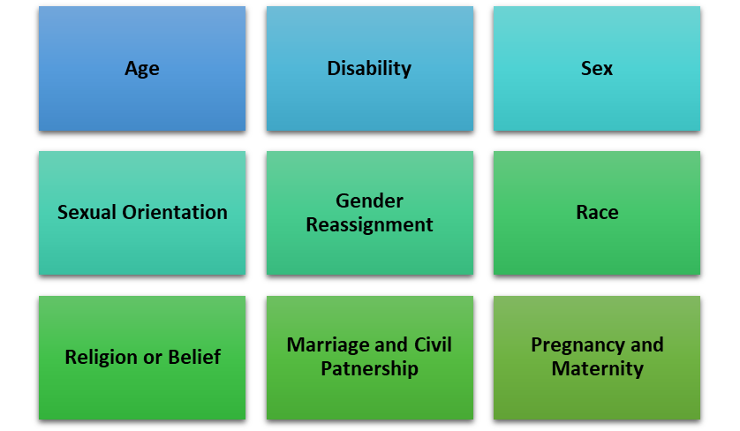

Once an individual has satisfied a tribunal that they do fall under one of the nine protective characteristics, they must justify that they have been discriminated against because of that protective characteristic (CIPD, 2018a). Discrimination can take many forms:

The Equality Act 2010, employers are permitted to take positive action in respect of discrimination. If an employer reasonably thinks that either:
- Persons who share a protected characteristic suffer a disadvantage connected to the characteristic
- Persons who share a protective characteristic have needs that are different from the needs of persons who do not share it; or
- Participation in an activity by persons who share a protected characteristic is disproportionately low (Personnel Today, 2020).

Amphlett and Raval (2018) explain that employers are encouraged to take any action which is proportionate means of achieve a legitimate aim of:
- Enabling or encouraging persons who share the protected characteristic to overcome or minimise the disadvantage
- Meet the needs identified
- Enable or encourage persons to participate – targeting areas for advertising

Employers can defend their actions should there be an occupational need whereby a certain protected characteristic is required to carry out the role, for example a female patient requesting a female carer, or an objective justification where there is a proportionate means of achieving a legitimate aim (CIPD, 2018b).

The employer can be liable for discrimination claims if it itself discriminates against an employee, an applicant or an ex-employee. A member of staff could also directly be liable should they discriminate against another employee. Vicarious liability occurs when an employer acts on behalf of employees, unless the employer took reasonable steps to prevent the employee from doing the discriminatory act or it wasn’t done in the course of employment (ESPHR, 2020).

Should an employee or employer be successful in a discrimination claim, they can receive a declaration which is publicly accessible declaring that they have been subject to discrimination, a recommendation for future practices, and compensation awarded to the individual under the Vento bands.
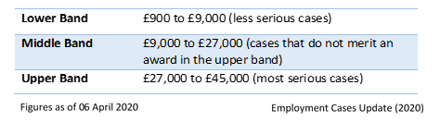

Trade Union membership is another ground that a claim unfair treatment can be made. It is unlawful to refuse to employ someone based on their membership, you cannot subject anyone to a detriment because of their membership and they cannot be dismissed because of their Trade Union membership, covered by the Trade Union and Labour Relations Consolidation Act, 1992.

Part Three

As part of organisational changes, an employer may be required to make changes to a contract of employment: a need to change hours of work due to restructure, or due to changes in the product or service being provided. Should changes be required, an employer must consult with the employee in the first instance.

When an employee signs a contract of employment, this becomes a legal agreement between two parties, therefore and employer can not unilaterally vary that contract (CIPD, 2020b). The employer may end up facing claims of constructive dismissal or damages for loss while still in employment.

Springer (2016) recognises that many employers write flexibility into their contracts of employment from the start, giving discretion to make changes later, without gaining consent from the employee. The right to vary the terms of a contract must be clear and unambiguous, any ambiguity will be construed against the employer. Employers must exercise flexibility in a contract in accordance with the mutual trust and confidence built with the employee.

In accordance with employment rights, an employee that has two-years’ service is entitled to receive a severance payment when they are made redundant from employment (Chandler, 2003). Redundancy can be defined as the “termination of employment because of the disappearance of the need for the job” (Farlex, 2020). According to the Employment Rights Act 1996, employees are regarded as redundant if their dismissals are associated with one of the below:

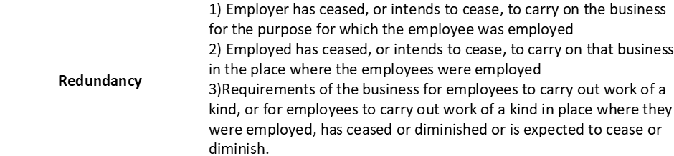

According to Trade Union and Labour Relations Act 1992, consultations should take place for change of contracts and when redundancy is happening. The length of consultation process will vary depending on number of employees this will be affecting (Daniels, 2019). The aim is to agree to proposed changes and understand upcoming processes. Consultation should take place with Trade Unions or elected representatives.

During such discussions, employees should be provided with justification: why the changes are taking place and reasons for redundancy, numbers and description of each type, total number of redundancies, proposed selection methods and why they do not meet this criteria, procedures and a redundancy pay calculator (CIPD, 2020c).

If no agreement is made, however the employee works in accordance to the proposed changes for a significant period with no protest, it can be interpreted that the employee has accepted these changes by their actions. Should the employee disagree with the changes, and no effort is made to adopt the new changes, the options available to the employer include termination of current contract for potentially fair reasons under ‘some other substantial reason’ and offer a new contract under the new terms – strong risk of unfair dismissal claim from employee.

Even though there is no legal obligation to ask for volunteers for redundancy, many organisations will, whereby the terms of the redundancy are enhanced, to encourage volunteers and reduce the number of compulsory redundancies. When determining the length of consultation, volunteers are still counted in the number of redundancies (CIPD, 2019b).

It is important to emphasise that selection of redundancy must be fair and must be objective. Organisations must use at least two assessors who know the employees taking into consideration: length of service, attendance records, disciplinary records and qualifications to make their decisions.

During this process, there will be the potential for individual jobs to be made redundant. At this stage, employers must consult with the individual, detailing reasons for redundancy, and to invite for a meeting to discuss. When the decision to dismiss has been communicated, the employee has rights to appeal. Should the employee have been employed for two-years, they will be entitled to statutory redundancy payment and notice payment, unless they have been offered suitable alternative employment and refused it.

Transfer of Undertakings Regulations 1981 (TUPE) ensures that employees do not lose out when the identity of their employer changes, protecting them from dismissal or redundancy when a business transfer takes place. TUPE applies where:
- A business, part of a business or part of another type of employing organisation is merged with or taken over by another employer
- The contract to provide a service is either lost by one provider and won by another, or otherwise outsource/insourced by an organisation (Taylor & Wilkinson, 2016).
Key employment rights/legal duties that apply in TUPE include formal consultation with employees prior/during/after transfer, continuity of service and pension. Failure to inform and consult could result in the employer having to pay 13 weeks’ pay per affected employee.

Organisations are required to provide information of resources to be transferred to buyer/new service provider at least 28 days before transfer date, to include: names and ages of employees, details of statement of particulars and any other agreements, and details of disciplinary action, grievances or legal action in last two years.

There can be no dismissal or variation of contractual terms as a result of a TUPE transfer, unless there is an economic, technical or organisational (ETO) reason for changes.

Dismissal is automatically classed an unfair if the reason for dismissal is the transfer itself. An employee that has been dismissed immediately before the transfer for a reason relating to the transfer will be classed as unfair dismissal.

Part Four

Working Time Regulations 1998 (WTR) relates to health and safety. A ‘worker’ is defined to “include anyone who have entered into or works under (or where the employment has ceased, worked under):
- A contract of employment
- Any other contract, whether expressed or implied” (Legislation.gov.uk, 2020a)

UK weekly working hours are limited to an average of 48 hours, and the working day to an average of 8 hours (CIPD, 2020d). Individuals carrying out roles that require them to work over these hours can opt-out, by providing written confirmation.

Taylor and Wilkinson (2016) summarise other fundamental rights within the WTR:
- Four week’s paid annual leave per year in addition to eight statutory bank holidays
- 20 minutes’ rest in any period of work lasting six hours or more
- 11 hours’ rest in any one 24-hour period
- 24 hours’ rest in any seven-day period
- Night workers are limited to eight hours work in any one 24-hour period and have rights to free, regular checks
- Special provisions that restrict working time of young workers (16-18 years-old)

Unauthorised deductions apply to all workers, not just employees (Upcraft, 2020). Lawful deductions occurs when authorised by legislation and contract, or written agreement. Employees have the right to an itemised pay statement (Phillips, 2020). Employee’s with one month’s continuous service are entitled to a guarantee payment of a maximum £29 daily for 5 days, if they are not provided with work when they would normally expect to work (Gov.uk, 2020c).

As of 06 April 2020, holiday pay is calculated as an average of pay earned in the last 52 weeks, to include: overtime, shift allowances, commission, bonus and performance related pay (Gov.uk, 2020d).

Employees are eligible for flexible working if they have 26 weeks continuous employment, changing: hours, times or location, different to their contract of employment (Lawrite, 2020). All other entitlements will be changed to reflect this.

Employees cannot get sick pay and holiday pay at the same time; however, employees accrue holidays as normal when off sick. Taking holidays whilst on sick - sick leave will be paused, and holiday pay will be issued. (ACAS, 2020c). There is no legal requirement for an employer to have a sick-pay scheme, however employers are required to pay Statutory Sick Pay (SSP) - if been sick for four or more consecutive days and average earnings of at least equal to the lower earnings limit. SSP is claimed for days would normally work and will be paid for maximum 28 weeks in any 12-month period (Gov.uk (2020e).

National Minimum Wage is the minimum salary per hour, that an employer can pay based on age. National Living Wage is for those aged over 25 (due to increased outgoings) which added to the NMW. There is no legal obligation to pay ‘Living Wage’, however in cities such as London where the cost of living is higher, employers may opt to p.
The Work and Families Act 2006 covers maternity, paternity, and adoption. Maternity protection covers a woman through periods of antenatal care, care at work during her pregnancy, and maternity leave. For Occupational Maternity leave (OML), an employee must notify their employer no later than the end of the 15th week before expected week of confinement (EWC) that she is pregnant, due-date and start date of OML (CIPD, 2020e). Employers have 28 days to notify individual of the end date of maternity leave. An employee has 28 days to notify employer should maternity leave be automatically triggered by pregnancy-related absence four weeks before EWC (ACAS, 2020d).

“A pregnant woman is protected against dismissal on the grounds of her pregnancy, discrimination on the grounds of her pregnancy or any other detrimental treatment relating to the pregnancy” (Daniels, 2019). An employee is entitled to Statutory Maternity Pay where she meets eligibility criteria: 26 weeks continuous employment up to and including 15th week before EWC and have average earnings of at least the lower earnings limit for National Insurance during eight-week period ending 15th week before EWC. SMP is payable for 39 weeks: the ‘earnings related rate’ for first 6 weeks, followed with ‘prescribed rate’ for remainder period.

Occupational Paternity leave (OPL) is only available to employees, continuously employed by their employer for a period of not less than 26 weeks ending with qualifying week, and be either the child’s father or spouse, civil partner or partner of child’s mother. An employee must give 28 days’ written notice to employer stating EWC and length of leave required. Paternity leave is for 7 or 14 continuous days. Leave must be taken within 56 days of birth. All employment rights are protected while on Paternity leave (Gov.uk, 2020f).

Parents adopting children are permitted to take leave on same basis as parents of newly born children. With adoption, parents choose which is going to take maternity leave and be paid SMP and which will take benefits associated with paternity (CIPD, 2020f).

Additionally, employees can take time off to deal with family emergencies (unpaid) and up to four months’ unpaid parental leave (Taylor & Wilkinson, 2016).

Part Five

The Health and Safety at Work Act 1974 is the primary piece of legislation covering occupational health and safety in the UK. This Act forms part of the criminal law. The Act contains the following general statement: “It shall be the duty of every employer to ensure, as far as is reasonably practicable, the health, safety and welfare at work of all his employees” (Taylor & Wilkinson, 2016).

There are certain health and safety laws that are implied on an employer through statute that they must comply with. These are:
- Safe and adequate plant and equipment
- Safe premises and/or place of work
- Competent and safe fellow employees
- A safe system of work. (HSE, 2020a)

Health and safety require the contribution of the employer and employee together. The laws implied on an employee through statute are:
- Reasonable care for health and safety of themselves and others
- Cooperate with employer as is necessary to enable health and safety requirements to be met
- Requirement to use personal protective equipment (PPE) where provided
- To follow appropriate systems of work laid down by the employer
- To inform the employer of any serious or imminent dangers to health and safety and to inform of any shortcomings

The Act requires that all workplaces with more than five employees, have in place a written health and safety policy (CIPD, 2019c). Risk assessments play a central part in health and safety law and are the primary focus for auditors and courts. Risk assessments involve identifying areas of health and safety hazards and taking the appropriate steps to eliminate potential risks.
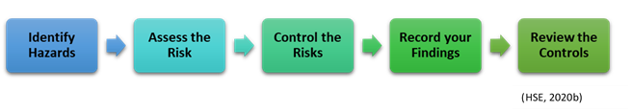

Failure to address health and safety issues and the requirements set out, can lead to potential claims of negligence against the employer or employee, an employee may resign and place a constructive dismissal claim, there could be criminal action or personal injury claims as a result of non-compliance (Citizens Advice, 2020b).

The Equality Act 2010 is the major piece of legislation that protects employees against discrimination in the workplace. The Act replaces 9 major pieces of legislation, and 100 pieces of smaller legislation, harmonising the reasoning why discrimination may take place. The consolidation of this information makes more straightforward to bring a claim of discrimination to an Employment Tribunal (Equality and Human Rights Commission, 2020).

The Equality Act 2010 provides protection to:
- employees – who have the most protection of statutory rights in relation to employment law
- workers
- job applicants – protection from discriminatory recruitment practices
- ex-employees – should a discriminatory reference be provided to their new employer; they could have potential for a discriminatory claim against previous employer

Disability is one of the most common claims against employers under the Equality Act 2020. An individual must prove, with the use of a three-stage test, that they have a “physical or mental impairment that has a substantial and long-term adverse effect of a person’s ability to carry out normal day-to-day activities” (Legislation.co.uk, 2020b). A long-term effect is classed as anything that is going to last for a period of 12 month and longer. In recent years, claims for mental health have overtaken claims for physical impairments. Should an individual suffer from cancer, HIV or MS, they are deemed disabled and do not need to provide evidence.

All contracts of employment contain implied terms. Possible collective agreements with Trade Unions for example, can be expressly incorporated or incorporated by implication. Statutory implied terms to include National Minimum Wage. Implied terms can be established through ‘custom and practice’, this is hard to evidence, however repetitive processes such as bonuses each year, would encourage the individual to expect this and therefore is an implied term to the contract. The court system can establish implied terms, whereby the relationship between both parties is considered. Workplace policies, procedures and handbooks can influence implied terms whereby terms are set out which could have implications on the contract of employment.

Implied terms that are influenced by law expected by the employer: providing wages and work, health and safety, give effective support when dealing with sensitive subjects i.e. bullying. Implied terms expected from the individual: obey all reasonable instructions, co-operate with employees, duty of fidelity and to take care in their duties.

These rights are implied into all contracts of employment as the law recognises that they are necessary in order for the employment relationship to work.

Part Six

CIPD (2020g) explains that dismissal occurs when a contract of employment is terminated with or without notice, a fixed-term contract ends without renewal, or employees leave with or without notice, when they are entitled to do so due to the employer’s conduct in accordance with the Employment Rights Act (ERA) 1996.

Dismissal does not account for all circumstances a termination of contract occurs. If an employee simply wishes to leave the organisation by submitting their resignation, it is not dismissal. However, if they feel like that forced into terminating their contract by their employer, this could be classed as constructive dismissal whereby a claim can be made. Resignations must be a written submission (Cabrelli, 2016).

Section 98 of the ERA 1996, lists five potentially fair reasons for dismissal, whereby an individual can be dismissed on only one of these reasons:

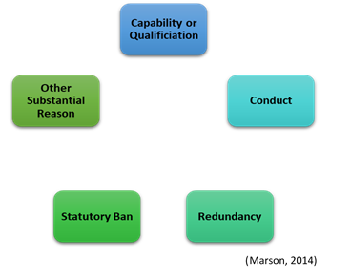

Employers can justify their reasoning as to why they have dismissed employees on these grounds:

An important part of demonstrating that a dismissal has been reasonable, is demonstrating that the procedure for carrying out the dismissal has been fair (Daniels, 2019). The Employment Act 2002 introduced a statutory dismissal and disciplinary procedure and statutory grievance procedure, ACAS Code of Practice, to reduce the number of claims being brought to Employment Tribunal.

Not all situations require dismissal of an employee, in these situations disciplinary warnings are given. The law does not set out what warnings are to be given; however, ACAS guidelines suggest the following levels of warnings:
- Formal written warning (remains on employee record for 6 months)
- Final written warning (remains on employee record for 12 months)
- Dismissal

BrightHR (2020) identify an additional two actions that are not covered by the ACAS Code: no further action – lack of information/evidence to support the claim, and verbal warning – informal in first instance, followed by formal backed with documentation, can prevent problems arising in future.

Should an employee be accused of negative behaviour i.e. misconduct or gross misconduct due to their behaviour, summary dismissal is issued, where their contract is terminated immediately without prior warning or notice. Tribunals may determine this action as ‘procedurally unfair’, if their contract does not outline this as a potential action (Gov.uk, 2020g). Alternatively, the individual should be suspended on full pay until an investigation is carried out. It is important to follow a fair procedure as per other disciplinary matters.

Employers often include suspension as part of the process. Employment Tribunals have been increasingly critical of employers who take this approach, questioning whether full consideration has been made whether it is essential to do so (Gordon Turner Employment Lawyers, 2020).

The ERA 1999, gives workers the right to be accompanied by a fellow worker or trade union representative to formal disciplinary or grievance hearings that:
- Give a formal warning to a worker by the employer
- Taking of some other action to a worker in relation to a disciplinary
- Gives confirmation of a warning or other action that has been taken (Chamberlain, 2012).

Should the employers conduct breach the contract of employment, the employee can terminate the contract of employment and claim constructive dismissal. Citizens Advice (2020) confirms the employee must evidence that there was a fundamental breach to the contract by the employer, causing them to resign with no significant delays.

There are situations whereby a dismissal is automatically unfair, and therefore the one/two-year qualifying period to bring a claim, is not necessary, these include:
- The employee’s pregnancy or any maternity related issues
- Asserting a statutory right
- Asserting the right to be paid in accordance with the National Minimum Wage Act 1998

The code sets out three stages that should be followed when addressing a grievance:

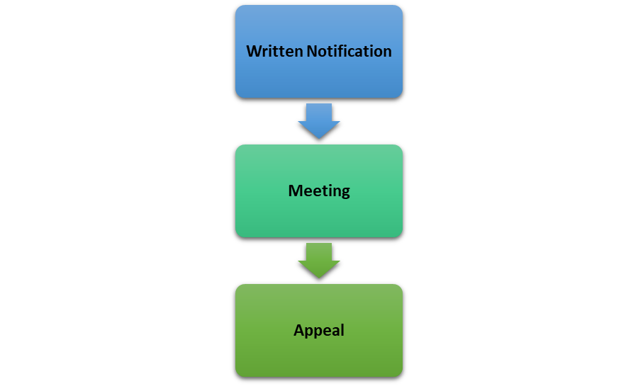

Whistleblowing is the act of disclosing information about wrongdoing in the workplace (Unison, 2020). The Public Interest Disclosure Act 1998 provides legal protection from detriment and unfair dismissal for individuals who disclose information to expose acts concerning:
- A criminal offence
- A failure to comply with legal obligations
- A miscarriage of justice (legally)
- Compromised health and safety arrangements
- Something to cause environmental damage (Taylor & Wilkinson, 2016).

Claims of whistleblowing must be made in public interest with reasonable belief and evidence and cannot use the usual grievance procedure. For disclosures to be protected by law, workers must make them to the right people, following the right procedures and not for personal gain.

Reference List

ACAS. (2020a) What an Employment Contract is. Available at: https://www.acas.org.uk/what-an-employment-contract-is (Accessed: 26 April 2020)

ACAS. (2020b) What must be written in an Employment Contract. Available at: https://www.acas.org.uk/what-must-be-written-in-an-employment-contract (Accessed: 26 April 2020)

ACAS. (2020c) Checking Sick Pay. Available at: https://www.acas.org.uk/checking-sick-pay/sick-pay-and-holiday-pay (Accessed: 25 April 2020)

ACAS. (2020d) Your Maternity Leave, Pay and Other Rights. Available at: https://www.acas.org.uk/your-maternity-leave-pay-and-other-rights/taking-maternity-leave (Accessed: 25 April 2020)

Amphlett, J. and Raval, A. (2018) ‘Is Age Discrimination ever Justified?’. People Management. 07 March. [Online] Available at: https://www.peoplemanagement.co.uk/experts/legal/age-discrimination-justified (Accessed: 27 April 2020)

BrightHR (2020) What are Formal and Informal Warnings at Work?. Available at: https://www.brighthr.com/articles/employee-conduct/warnings (Accessed: 25 April 2020)

Cabrelli, D. (2016) Employment Law in Context: Text and Materials. 2nd edn. Oxford: Oxford University Press.

Cambridge University Press (2020) Employment Law Definition. Available at: https://dictionary.cambridge.org/dictionary/english/employment-law (Accessed: 22 April 2020)

Chamberlain, L. (2012) ‘The Right to be Accompanied at Disciplinary and Grievance Hearings: Nine Things to Remember’. Personnel Today. 23 August. [Online] Available at: https://www.personneltoday.com/hr/the-right-to-be-accompanied-at-disciplinary-and-grievance-hearings-nine-things-to-remember/ (Accessed: 25 April 2020)

Chance, M. (2009) ‘Why Employment Law is Bad for the Economy’. The Telegraph. 23 September. [Online] Available at: https://www.telegraph.co.uk/comment/personal-view/6222110/Why-employment-law-is-bad-for-the-economy.html (Accessed: 22 April 2020)

Chandler, P. (2003) Waud’s Employment Law: The Practical Guide. 14th edn. London: Kogan Page.

CIPD (2002) Employment Law. Survey Report. London: Chartered Institute of Personnel and Development.

CIPD (2017) Employment Regulation in the UK: Burden or Benefit? Survey Report. [Online] Available at: https://www.cipd.co.uk/Images/employment-regulation-in-the-UK_2017-burden-or-benefit_tcm18-21622.pdf (Accessed: 22 April 2020)

CIPD (2018a) Tribunal Claims, Settlement and Compromise Q&As. 26 July. [Online] Available at: https://www.cipd.co.uk/knowledge/fundamentals/emp-law/tribunals/questions (Accessed: 26 April 2020)

CIPD (2018b) Disability Discrimination Q&As. 01 October. [Online] Available at: https://www.cipd.co.uk/knowledge/fundamentals/emp-law/disability-discrimination/questions (Accessed: 27 April 2020)

CIPD (2019a) Employment Law in the UK: The Court System. 28 June. [Online] Available at: https://www.cipd.co.uk/knowledge/fundamentals/emp-law/about/court-system (Accessed: 22 April 2020)

CIPD (2019b) Redundancy Q&As. 05 November. [Online] Available at: https://www.cipd.co.uk/knowledge/fundamentals/emp-law/redundancy/questions (Accessed: 27 April 2020)

CIPD (2019c) Health and Safety at Work. 27 September. [Online] Available at: https://www.cipd.co.uk/knowledge/fundamentals/emp-law/health-safety/factsheet (Accessed: 27 April 2020)

CIPD (2020a). Employment Law. Available at: https://www.cipd.co.uk/knowledge/fundamentals/emp-law (Accessed: 22 April 2020)

CIPD (2020b). Contracts of Employment. Available at: https://www.cipd.co.uk/knowledge/fundamentals/emp-law/terms-conditions/contracts-factsheet (Accessed: 26 April 2020)

CIPD (2020c). Redundancy: An Introduction. 23 April. [Online] Available: https://www.cipd.co.uk/knowledge/fundamentals/emp-law/redundancy/factsheet (Accessed: 26 April 2020)

CIPD (2020d). Working Hours and Time off Work. Available at: https://www.cipd.co.uk/knowledge/fundamentals/emp-law/working-time/factsheet (Accessed: 25 April 2020)

CIPD (2020e). Maternity, Paternity and Adoption Rights. 16 April. [Online] Available at: https://www.cipd.co.uk/knowledge/fundamentals/emp-law/maternity-paternity-rights/factsheet#6279 (Accessed: 25 April 2020)

CIPD (2020f). Maternity, paternity, shared parental and adoption leave and pay Q&As. 01 April. [Online] Available at: https://www.cipd.co.uk/knowledge/fundamentals/emp-law/maternity-paternity-rights/questions (Accessed: 25 April 2020)

CIPD (2020g). Dismissal. Available at: https://www.cipd.co.uk/knowledge/fundamentals/emp-law/dismissal#11243 (Accessed: 25 April 2020)

Citizens Advice (2020) Claiming Constructive Dismissal. Available at: https://www.citizensadvice.org.uk/work/leaving-a-job/dismissal/claiming-constructive-dismissal/ (Accessed: 25 April 2020)

Citizens Advice (2020b) Employment Tribunals – Claims for Breach of Contract. Available at: https://www.citizensadvice.org.uk/work/problems-at-work/employment-tribunals-from-29-july-2013/making-an-employment-tribunal-claim-is-it-worth-it/employment-tribunals-claims-for-breach-of-contract/ (Accessed: 27 April 2020)

Daniels, K. (2019) Induction to Employment Law – Fundamentals for HR and Business Students. 5th edn. London: Kogan Page.

Employment Cases Update (2020) New Vento Bands from 06 April 2020. Available at: https://www.employmentcasesupdate.co.uk/site.aspx?i=ed40696 (Accessed: 27 April 2020)

Equality and Human Rights Commission. (2020) Your Rights Under Equality Act 2010. Available at: https://www.equalityhumanrights.com/en/advice-and-guidance/your-rights-under-equality-act-2010 (Accessed: 27 April 2020)

ESPHR (2020) Discrimination. Available at: https://esphr.co.uk/resources/subject/Discrimination (Accessed: 27 April 2020)

Farlex. (2020) Definition of ‘Redundancy’. Available at: https://legal-dictionary.thefreedictionary.com/redundancy (Accessed: 26 April 2020)

Gordon Turner Employment Lawyers (2020) Suspension from Work. Available at: https://www.gtemploymentlawyers.co.uk/suspension-from-work.html (Accessed: 25 April 2020)

Gov.uk (2015) The Employment Tribunals Rules of Procedure 2013. 22 May. [Online] Available at: https://assets.publishing.service.gov.uk/government/uploads/system/uploads/attachment_data/file/429633/employment-tribunal-procedure-rules.pdf (Accessed: 22 April 2020)

Gov.uk (2020a) Employment Contracts. Available at: https://www.gov.uk/employment-contracts-and-conditions/written-statement-of-employment-particulars (Accessed: 26 April 2020)

Gov.uk (2020b) Discrimination: Your Rights. Available at: https://www.gov.uk/discrimination-your-rights (Accessed: 26 April 2020)

Gov.uk (2020c) Lay-off and Short-time Working: Guarantee Pay. Available at: https://www.gov.uk/lay-offs-short-timeworking/guarantee-pay (Accessed: 25 April 2020)

Gov.uk (2020d) Holiday Entitlement. Available at: https://www.gov.uk/holiday-entitlement-rights/holiday-pay-the-basics (Accessed: 25 April 2020)

Gov.uk (2020e) Statutory Sick Pay. Available at: https://www.gov.uk/statutory-sick-pay (Accessed: 25 April 2020)

Gov.uk (2020f) Paternity Pay and Leave. Available at: https://www.gov.uk/paternity-pay-leave (Accessed: 25 April 2020)

Gov.uk (2020g) Dismissing Staff. Available at: https://www.gov.uk/dismiss-staff/fair-dismissals (Accessed: 25 April 2020)

HSE. (2020a) Health and Safety at Work etc Act 1974. Available at: https://www.hse.gov.uk/legislation/hswa.htm (Accessed: 27 April 2020)

HSE. (2020b) Managing Risk and Risk Assessments at Work. Available at: https://www.hse.gov.uk/simple-health-safety/risk/steps-needed-to-manage-risk.htm (Accessed: 27 April 2020)

Lawrite (2020) Employment Law Guide – Flexible Working. Available at: https://www.employmentlaws.co.uk/guide/flexible_working_rights.html (Accessed: 25 April 2020)

Legal Dictionary. (2016) Case Law. 28 April. [Online] Available at: https://legaldictionary.net/case-law/ (Accessed: 22 April 2020)

Legislation.gov.uk (2020a) The Working Time Regulations 1998. Available at: http://www.legislation.gov.uk/uksi/1998/1833/regulation/2/made (Accessed: 25 April 2020)

Legislation.gov.uk (2020b) Equality Act 2010. Available at: http://www.legislation.gov.uk/ukpga/2010/15/section/6?view=plain (Accessed: 27 April 2020)

Marsh, J. (2014) Beginning Employment Law. Abingdon: Routledge.

Personnel Today. Positive Action. Available at: https://www.personneltoday.com/equality-diversity/discrimination/positive-action/ (Accessed: 27 April 2020)

Phillips, G. (2020) Employment Law 2020. Guildford: College of Law Publishing.

Shackleton, J.R. (2005) ‘Regulating the Labour Market’, in Booth, P. (ed) Towards a Liberal Utopia?. London: Chartered Institute of Personnel and Development.

Springer, C. (2016) ‘Varying Contracts of Employment: What are the Risks for Employers?’. Personnel Today. 10 November. [Online] Available at: https://www.personneltoday.com/hr/variation-of-contract-of-employment-risks-for-employers/ (Accessed: 26 April 2020)

Taylor, S. and Wilkinson, K. (2016) ‘Employment Law’, in Taylor, S. and Woodhams, C. (ed) Human Resource Management: People and Organisation. 2nd ed. London: Chartered Institute of Personnel and Development.

Unison. (2020) Whistleblowing. Available at: https://www.unison.org.uk/get-help/knowledge/disputes-grievances/whistleblowing/ (Accessed: 27 April 2020)

Upcraft, K. (2020) ‘Deductions from Wages and Attachment of Earnings’. XpertHR. [Online] Available at: https://www.xperthr.co.uk/employment-law-manual/deductions-from-wages-and-attachment-of-earnings/20357/ (Accessed: 25 April 2020)

