

Report of my team working and communication

Name: Keila Vargas
Student number: 1906502
Lecturer: Christopher Mafuva
Date: 6th January 2020

Tables of contents

1.0…………………………………………. Introduction
2.0……………………………Types of communication
2.1……………………. Verbal communication
2.2………………Non-Verbal communication
3.0……………. Theories of communication
3.1…………...Shannon-weaver model of communication
3.2………...Berol’s model of communication
3.3……. Schramm’s model of communication
4.0………………………………...Conclusion
5.0……………………………….Appendices

- Introduction
This report explains the importance of concept of team working, how does it work with their respect definitions.
The meaning of team working is relating with a group with undetermined members inside which their objective and propose is sharing ideas and have the same commitment for obtain best results and manage it with the best form without any discordance between them. There are some of obstacles into this common goal such as inexperience of the leader at time to arrange and influence on each component due to non-communication for this reason need of a group efficacy and a exist levels of trust that members feel safe to contribute offer ideas.

-Maund.A, Schriek. M and Tinkler, R (2017) Certificate in Higher education: Skills for the Workplace Student Yearbook, pp.4-7.

On the other hand, we have Communication is another topic that we mustn’t be ignore because it will determinate interaction between the team, normally we adapt skills to communicate effectively, it is transmitter who will generate, encoding, the message toward receive the person who will be a decode, as we know between these two points there are a interference transform as a noise in some cases. In this part appeared verbal and nonverbal communication
-Maund.A, Schriek. M and Tinkler, R (2017) Certificate in higher Education: Skills for the Workplace Student Yearbook, pp. 45-46. -Reference wrote as my own words from my notes made in class.
In this part I am going to write base to my workplace, and I applied this section of communication to explain the important to have this two skills of verbal and nonverbal communication each day because I have to be able to communicate with people around me because I work as a cleaner into office and need to talk with security man if need something or ask. But if I don’t appeal to talk and just show face expressions, they can’t know what pretend to say or transmit even can be mess
2.0 Types of communication

Exist divers group members among to team performance compromised improving abilities to a great communicate it is where intervene two types of communication in, Verbal and nonverbal know the benefits and challenges of each one with different opinions and point of view, whoever in some occasion this models can be successful or harmful will depend of the actual situation and people who are around there. As the most important criteria we have to cited interpersonal skills which will requirements for a future solutions talking to leader in some cases, if one day we are not feel with energy at time to keep an conversation applying by ourselves tool and want to opt to any of this types of communication

  - Verbal communication
Have a correct verbal communication is applicable in both different kind as a formal and informal into a conversation can be conform by group or between two components is necessary on any type of workplace or situation is essential to a daily life express words and know what saying on the correct moment for this reason we must be able to share information between individuals or as a team for a respect smooth operation.

Maintain clarity of speech as a interpersonal conflict ,one example that I would like to express on my workplace is when I need more product of cleaning or my boss need me for replace to another person we need to talk and express our thoughts and needs otherwise any of us can solve the concerns depends on the tone of the speaker and how, me or my boss say the things on the correct way

2.2 Nonverbal communication
Nonverbal communication we don’t need words but it can bring problem at time to transmit the message just visually because we just show through body language where, in this case we have to learn to read it without confusion and don’t take it nothing personal but it can’t express what you really mean and contradict the message, in many situation we have to trust our instinct for haven’t a wrong idea of the other person it depend of our physical behavior, sign emotions even the facial emotions can be interpreter differently by every person and are the same across cultures eye contact in this specific case of non-verbal communication emotions are of special importance because they have meanings in there, and transmit us the message in a different way helping us to improve and manage stress developing on emotional awareness

-Segal, J etc. al. (2019) Non verbal communication. Available at: https://www.helpguide.org/articles/relationships-communication/nonverbal-communication.htm ( Accessed: 04th January 2020).

I have done some of this examples already explain before on my professional area, as a cleaner for example when in the morning I woke up without moods to say hello and I just express my facial gestures or simple smile, but then honestly makes me feel that it's not polite at all for this reason I avoid doing that because is a little bite rude, not talk, and more when I start working in the morning and is the principal word that must say. Whoever in the case of know quickly the reaction of the person is a hundred percent security because not all person can be hide their gestures or expressions

3.0 Theories of communication

In theories of communication there are a pyramid where is compose by Societal: which include History, political and sociology
Institutional and group: Sociology and cultural anthropology
Interpersonal: Sociology and phycology
Intrapersonal: Reflection where look into oneself and evaluate strengths and weaknesses, with the objective to improve each area of weaknesses
Finally, inside this section there are three principal models of communication that I am going to explain then one by one.
Theorical speaking about communication there are a diversity of types and theory definitions respect this topic but the thig that we have to know is our interpersonal skills into this world of communication, for this reason there are some subtopics as a sociology cultural respect to learn about the world around us and know that all is necessary for use on different ambient and situation and we have to be able to use all this tool for a better compressible obtain knowledge and daily learning.
All of this theme are including on the pyramid of communication based in building groups around the world.

3.1Shannon-Weaver model of communication
This specific Model participle sender who makes the message send it through the channel as a medium used toward to the encoder who receive the message, on this part is where interfere the noise as a discrepancies into a conversation don’t allowing heard or understand what they say

This model was created by an American Mathematician and it represented conversations where the main trouble is the noise behind all activity this can be disturbs and disagreements because one person can heard wrong the message and act doing another complete thing different at the correct order

-Businesstopia (2018) Shannon weaver Model of communication. Available at: https://www.businesstopia.net/communication/shannon-and-weaver-model-communication (Accessed: 04th January 2020)

For this model I experimented the same action with the following sequences on in working one day, One month ago I remembered one person took holidays and my boss decided to call me by phone for tell me this action and if I was available to replace this shift for one week, but the thing was when we was talking, he was in a noise place maybe outside where there was a traffic with tremendous stressful around, and I couldn’t heard him so I just declined and on the next day he already selected another person for occupied it
  - Berol’s Model of Communication
This model was designed to improve technical communication is known because is not specific between others because there is lack of feedback without this symbol of confirmation on a questions for a second or clear repeat times the ask what the person have said but whoever there isn’t noise around them but it doesn’t utile because we haven’t understood the problem to solve and putting emphasize on coding and decoding of the message for an efficient communication. Participated for components, Sender, who created the message to send where including general knowledge, attitudes and communication skills then would be the message express the body language constitute all elements like content, structure code and treatment, then coming the channel which is transported the message where it consist for each tastes, finally the receiver got all information mentioned before. Basically, this point is extending all principal topics for understand well each one with more carefully at time to develop more than one

-Juneja, P, (2015) Berol’s Model of communication. Available at: https://www.managementstudyguide.com/berlo-model-of-communication.htm (Accessed: 03 January 2020)
Applying on my professional area one day I received a message voice by WhatsApp of my partner of job where he was telling me about another place of job near to my house in this part I decided to called him for a better communication and get information about it .
  - Schramm’s Model of Communication
Wilber Schramm created this model in 1954 is the process of communication but on majority of time the recipient must be able to understand what the sender wants to transmit, normally this conversation being a disaster for lack of information and without receive feedback from the principal person for this reason this model considered a model with any information and interest between two or a group people because just one or few people speak into the conversation and the rest are in complete silence this case is not a two-way process
There are Sender and receiver and before word mentioned must interpreter in the desired for the sender without give a feedback being a incomplete action to communicate
-Not author (2019) Moodle university of wales saint David. Available at: https://moodle.uwtsd.ac.uk/course/view.php?id=7030 (Accessed: 05th January 2020)
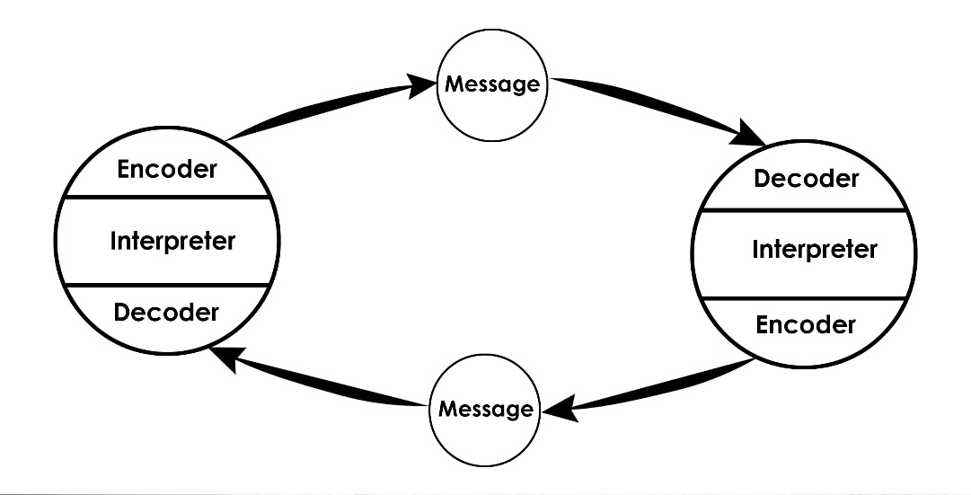

This technique can be used on a workplace when the boss decided to contact with one of the employers inside the local but when he found him ,this person ignore him absolutely in all that the boss wants transmit with the follow conversation, in this case can brings concerns at time to feel ignored or rejected towards other person thinking if the conversation is not comfortable or interest.

- Conclusion
In conclusion of this report of team working and communication assessment have a lot of discomforts and challenges, since trust is difficult to achieve on this society, at time to talk about speak or express on a communication. Nowadays people are not able to keep a long conversation for this reason I elaborated this deep report including verbal and nonverbal communication submitted with the types.
As I mentioned before exist way to communicate by phone with the risk of have interferences. Also, there are body movement where express all our gestures and intention to do on the follow time, one example of smile can be affected display for happiness or another face emotion as a frustration or similar and desire to do something but not always is applied because not all are able to hide their thoughts and need to another ways to express what they feel at this moment.
Talking about the main conversation have to know how to send the correct message through the channel which will be the transport for transmit some indicates for a better compression and any misunderstanding this will be the goal and objective for any type of situation depend of each members inside in.
Finally according to this content talked before on each topic, need to get knowledge before say something incorrect for a enhance each day without leave inconclusion things and themes unknown is the best form to develop by ourselves although day by day we learn something new and usable to practice.

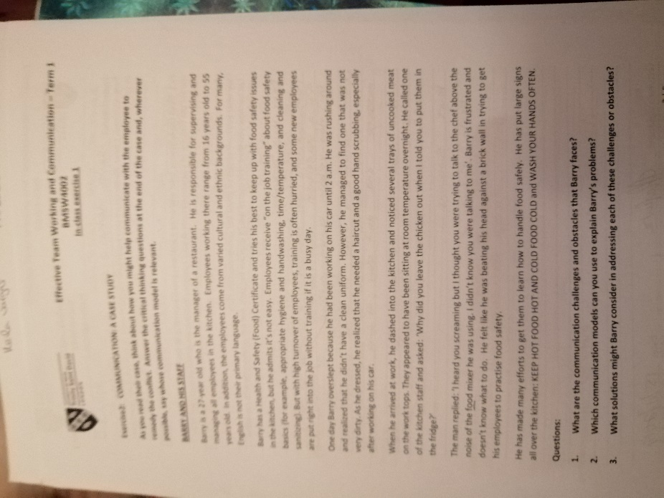
- Appendices


