University Of Wales Trinity Saint David
Institute of engineering



Engineering technical report
Workshop and practice (ACHA4011)

Rhys-Tom Williams
2302363
December 2023
1.Contents Page

- Contents……………………………………………………………………………………………………………(2)
- Introduction………………………………………………………………………………………………………(4)
- Chapters……………………………………………………………………………………………………………….
  - Health & Safety with Risk Assessments………………………………………………………..(5)
  - Engineers Role in Society……………………………………………………………………………..(7)
  - Problem Solving……………………………………………………………………………………..……(8)
  - Team Structure……………………………………………………………………………………..……..(9)
  - Personal Development Plan……………………………..………………………………………….(11)
- Conclusion………………………………………………………………………………………………….….…(12)
- References………………………………………………………………………………………………….…….(13)
- Appendix………………………………………………………………….…………………..………………….(14)

Table 1 – Abbreviations……………………………………….……………………………………………………(3)

Abbreviations | Meaning
PPE | Personal Protective Equipment
EN | European Standard
ISO | International Organization for Standardization
Boundary spanning | team's efforts to manage links with external stakeholders
Boundary buffering | team's efforts to deal with external requests
Table 1

2.Introduction

This technical report will consist of an analysis of an engineer’s job role in his work environment.
It’s always important to consider the right precautions when an engineer is conducting a task as there are many different areas and severity of risk that are involved In their job role. Of course, this is dependant of their assigned role but the saftey precautions and the assessment of the risks involved are always relevant to an engineer. Therefore, this will be discussed in my report.
Other factors such as their importance to society and their skills on planning or conducting work in a group will be discussed in this report a these are the factors of what defines an engineer.
After the discussion there will be a conclusion written on all the factors gathered from each chapter to summarise the true meaning of what is meant by the term engineer.

3.1 Chapter 1

The matter of health and saftey always needs to be evaluated and never underestimated in the workplace. No engineer should ever think it’s appropriate think when they ‘apply their skills and knowledge to the best of their ability, things are safe enough’ (HS 2006) as this is what causes accidents in the workshop.
To apply the understanding of health and safety in the workshop its best to give an activity to fully analyse them. When conducting an engine strip procedure there are many factors to consider due to the many heavy, sharp, and small constituent parts that make up an engine.
When disassembling engine, tools are required to take constituents parts off but it’s important to remember that specific tools can ‘cut materials’ which also implies they ‘will cut people’ (HS 2006). This implies that the correct PPE is required when completing these tasks. Also tasks such as lifting the engine head off the engine block is dangerous due to the weight of the component. This means considerations of ‘material handling’ (HS 2006) are needed to be implemented to the engineer. Its also stated that ‘20% to 25% of all disabling occupational injuries result from materials handling’ (HS 2006) which further proves the importance of safety implications. Because of all the potential dangers are common among many tasks they published the first legislation which was the ‘Health & Safety at Work Act in 1974’ (HS 2014) which has all the correct working conditions for any engineer when conducting any task. For example, the task for taking the engine head off the engine block would cover ‘Manual Handling Operations Regulations 1992’ (MHO 2023) and the appropriate footwear when handling will come under ‘EN ISO 20345:2011’ (SF 2023).
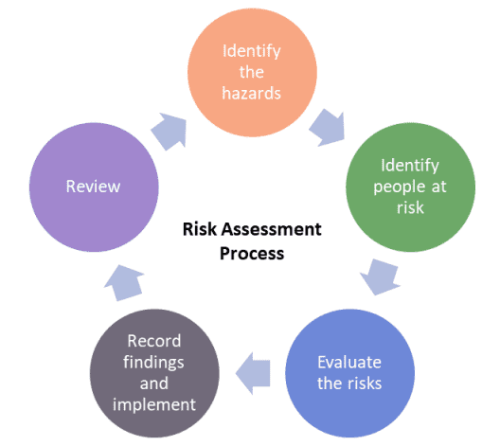
As we discuss the safety precautions in place for a safe workspace for an engineer it’s also important to plan and to evaluate the job and its risks. This is called a risk assessment. A shown on the right, these are the steps in creating a risk assessment. ‘risk assessments are crucial to preventing accidents’ (RA 2023) and help seek out any hazards there might be with the workplace.
(RA 2022)
There is another way to conduct a risk assessment but not to seek for hazards but to calculate the risks involved with the job. This is called a risk assessment matrix. To conclude on a risk box for the activity of disassembling an engine you will need to weigh up the likelihood of an injury and the
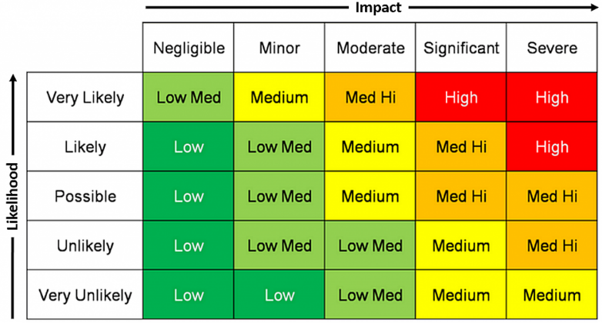
severity of that injury. If the parts were to fall on your feet or you mishandle a heavy engine component its likely you will get an injury via disassembly, but the severity of the injury won’t be extremely high most of the time due to the nature of its disassembly. Therefore, you would expect to see an injury in this region in black.
(2023 ARMS Reliability)

3.2 Chapter 2

Another part of being an engineer is the role that they play in society. Companies place a code of conduct on their engineers to ensure that they act in a way which supports the society of operations and the engineers’ reputation. Code of conduct must always be followed by an engineer, but some companies interpret them in different manners.
When comparing how either different championships or teams expect engineers to treat others, Mercedes F1 demand their engineers not to use any ‘Discrimination of any kind, including racism, homophobia, sexism’ (MF 2023). His is to generate a sustainable workplace for all the engineers. Moving on to a different championship the Porsche Carrera cup require for all the engineers to follow a similar responsibility, for them to never ‘express themselves or behave in an insulting, offensive or abusive way’. (PC 2023) When comparing both championships, it’s clear that they both have the same intensions but F1 teams and the championship want to be further announced about their sustainability for all engineers and other workers due to their higher platforms.
The Porsche Carrera cup further add that an offence will lead to an engineer to be ‘excluded by the Series Organiser from the Series or may be suspended or disqualified by the Race Director’ (PC 2023). The championship wants to continue with a sustainable working environment for all engineers and not to create any tension or unfairness in its working environment. F1 teams and the championship will treat the situation similarly by suspension or disqualification if the engineers are not to act in a manner the organisations did not intend them too.

3.3 Chapter 3

There are possibilities of errors / problems during production or during a project for an engineer. Therefore, there needs to be a conclusive way that that problem can be fixed in an efficient manner. Issues can occur in either one of these steps,
- An issue found during development.
- An issue found once on market.
- A supplier issue in the production process.
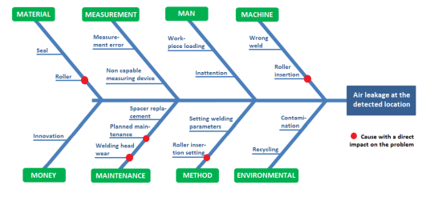
1)This method is called the Ishikawa diagram application. The problem in the production line can easily be plotted as the red dot therefore it is easy to conclude on where the problem is coming from. This will be beneficial when the product is in the prototype stage before it goes on the market.
(PS 2022)
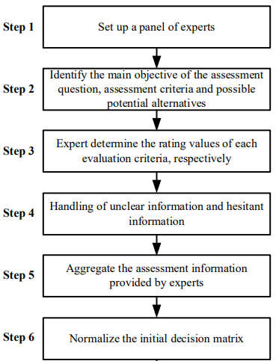
2)A possible approach to dealing with a sold faulty appliance is to offer a callout to all clients on your existing product and offer a fix or a solution to the problem. This might damage the brands reputation if completed but this would mean no client will have a faulty product from the manufacture which will not put off new clients in the future.
3)If the supplier is at fault and unable to deliver the raw materials or deliver your product there must be an option for a response to this. Methods such as execution flow chart method as shown in the diagram is a great way to overcome problems with suppliers not being able to meet expectations. These diagrams are an example of how a flow diagram works. When a problem occurs then it is stated as NO on the diagarm. This is where the second option of supplier or transportation type will reroute the production process. This makes it easy for the process to be manipulated if there were an error to occur on the original production plan.
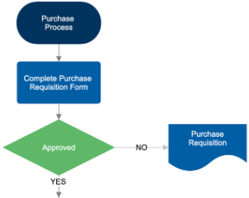
(SI 2013)

(FD 2023)

3.4 Chapter 4

Now another important factor for an engineer is the consideration of team structure. I once worked in a team for the purpose of a group assignment in school. This assignment was to set up a successful business idea. To do this we conducted a skills audit to conclude on every candidate’s strength to allocate them a role in the team. Once we all had our roles, we individually completed our tasks that we needed to do to create a successful business. The work was conducted on OneDrive open access file so we can see the progress of each candidate. To keep in close contact as a team we conducted one meeting per week to catch up and talk about the work we have completed towards the business and how to improve our innovations. This team structure was effective as we would always keep in close contact and keep our moral high with the weekly meetings. The problems that I experienced is the lack work conducted by other group members as we would only have one meeting a week to talk about our work. Another key problem with this structure is that we didn’t set deadlines for a task to be submitted into the file, this again led to a slow rate if work completed. We also had no plan when communicating to suppliers which led us create problems when resourcing material for our business.
As I will be part of more group tasks and projects soon it’s important for me to understand a few team structure techniques that lead to a successful outcome. A method the team and I should have used is ‘Team boundary work’. This technique is used so a team can always be one step ahead of their next decision. Decisions I will have to make using this method are,
- Finding boundaries over barriers (barriers are about avoiding problems and boundaries are about making responsibilities)
- Figure out how to create my best work first.
- Evaluate my team members situation by putting myself in their shoes.
- Make agreements that help drive the team forwards.
- Give based on long term benefits not short term.
Here is what the method looks like when we apply it to our team.
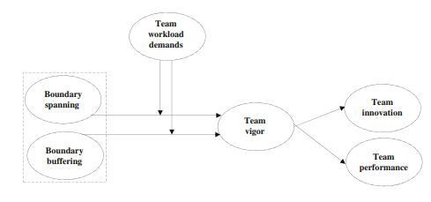
(TW 2022)

Step one involves spanning and buffering and are very important steps to take as they ‘are positively related to team innovation and team performance’ (TW 2022) which makes these points a priority to start my team around.
The following step feeds into the first as it’s all about having ‘members work interdependently to utilize various resources, such as expertise, equipment, and money, to yield meaningful outcomes’ (TW 2022)
The last step before branching for our teams innovative and performance focus its about Team vigor. This is the ‘physical, social, psychological, or organizational aspects of the team's tasks. It’s important to me and my team members as it again does well to ‘motivate team members by helping them collectively achieve their work goals and team tasks’. (TW 2022)

3.5 Chapter 5

Degree – Bachelor of Engineering (with honours) – Beng(Hon)
Previous Qualifications – GCSEs, A Level
Previous experiences – Part of Arden motorsport YRDA, attended test days with Praga cup at Silverstone, raced in different championships in Rotax go karts, buying cars to fix and then sell on.
Long time goal ( 5 to 10 years)
- To have travelled to each race with an F1 team.
- To be a mechanic on one of the cars.
- To still have my car selling business doing well.

Short time goal (0 to 5 years)
- Get my degree at UWTSD.
- Join an F1 team.
- To grow my car selling business.

Goal | Objective | Resources required | Measurement | Target date
To Join an F1 team | Become a mechanic for a driver’s car | Need to finish my degree | To keep involved with the race team at UWTSD | 2026/ 2027
To complete my degree | Hand in all assignments on time | Need to be aware of all hand in dates | Make sure the work is finished to a high quality | Every assignment due date
Go to a race weekend with team MCR | Keep working with the team | Need to be committed to put in extra hours to get the car ready to race | I will need to keep contributing to the team members and cars performance | By the end of 2024
To keep buying and selling cars | Buy more cars and repair them in my free time to sell | I will need to have create time to keep ruining the car business | I will repair the cars on the weekend and after some weekdays to get ready to sell | By the end of 2024

4. Conclusion

Based on the reaserch I have conducted, I have concluded the meaning of being an engineer is a person who seeks perfection in their work whilst following their job roles brief carefully. They will approach a project or business model with strategy to ensure their work is finished in the correct manner so that society will continue to value their input to every individual’s lives. They also don’t tolerate failure in their work as they are always one step ahead of any potential failure threat in their plans by inventing a substitute method to ensure there is no reduction in the rate of work carried out. It’s also clear that an engineer is someone who thinks critically about the threat involved in their tasks, therefore they always evaluate the risks and take precautions to put their health as their main priority.

5.References
(2023 ARMS Reliability)
Matrix from - https://www.armsreliability.com/page/resources/blog/beyond-the-risk-matrix
(HS 2006)
Information from - https://hsseworld.com/wp-content/uploads/2020/10/Safety-and-health-for-engineers.pdf
(HS 2014)
Information from- https://librarysearch.uwtsd.ac.uk/discovery/fulldisplay?docid=cdi_unpaywall_primary_10_1093_occmed_kqu084&context=PC&vid=44WHELF_UWTSD:44WHELF_UWTSD_VU1&lang=en&search_scope=Search_ELEC&adaptor=Primo%20Central&tab=Everything&query=any,contains,%22health%20and%20safety%20legislations%22,AND&mode=advanced&pfilter=lang,exact,eng,AND&offset=0
(SF 2023)
Information from – https://www.xamax.co.uk/blog/safety-footwear-ratings.html#:~:text=The%20safety%20footwear%20standards%20in,against%20a%20200%20joule%20impact.
(MHO 2023)
Information from –
https://www.hse.gov.uk/msd/backpain/employers/mhor.htm#:~:text=Manual%20Handling%20Operations%20Regulations%201992,by%20hand%20or%20bodily%20force%22.
(RA 2023)
Information from - https://brownssafetyservices.co.uk/blog/why-risk-assessments-so-important/#:~:text=Proper%20risk%20assessments%20are%20crucial,amongst%20both%20employees%20and%20managers.
(RA 2022)
Picture from - https://howletthealthsafetyservices.co.uk/why-are-risk-assessments-important/
(PC 2023)
Information from - https://www.carreracup.se/app/uploads/2023/03/Official-PCCS-Sporting-Technical-Regulations-2023-Edition-02.pdf
(MF 2023)
Information from - https://www.mercedesamgf1.com/community-guidelines-and-reporting
(PS 2022)
Information from - https://www.actamechanica.sk/pdfs/ams/2022/01/05.pdf
(SI 2013)
Information from - https://www.proquest.com/docview/2779554107?accountid=130472&parentSessionId=0tQHiJyNd3rTaLbfcbcaM2fieiv8UlrYs3UVWrq67qU%3D&pq-origsite=primo
(FD 2023)
Diagram from - https://www.smartdraw.com/flowchart/flowchart-maker.htm
(TW 2022)
Information and diagram from - https://web-s-ebscohost-com.ezproxy.uwtsd.ac.uk/ehost/pdfviewer/pdfviewer?vid=0&sid=a527a712-460d-4152-9741-146c16125103%40redis

6.Appendix
Word count = 2305

