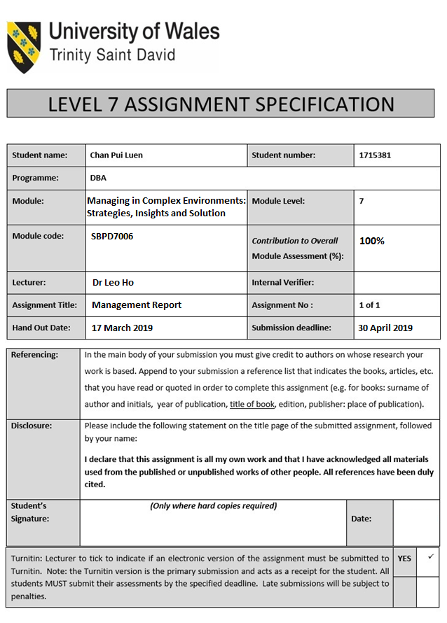



Module:
Managing in Complex Environments: Strategies, Insights and Solutions
(SBPD7006)

Lecturer: Dr Leo Ho

Assignment Title:
Business Management Report – Samsung Electronics in People Management Strategies

by

Student Name: Chan Pui Luen, Paul
Student Number: 1715381

Word Count: 7,000 words
17 March 2019

Executive Summary
This is the business management report for the international electronics company of Samsung Electronics Company Limited (“Samsung”) on their people management strategic analysis. Business Management Report – Samsung Electronics in People Management Strategies is the report topic for the DBA module of Managing in Complex Environments: Strategies, Insights and Solutions (module code SBPD7006). The report has three parts in Part a, b and c. In the Part a) Critique of Samsung and literatures related to their people management. Understand Samsung and their business challenges in related to people management. Part b) Analysis the strength and limitation of Samsung in the different alternative suggestions and it carry out the sustainable competitive advantage; and Part c) Analysis of Samsung related to their people management strategies. And then analyse the root cause of those issues for Samsung further development in short term, mid-term and long term management strategies.
The business trend in the electronics products industry is under the complex environment in the fast changing world. The product life cycle, the new technology and the innovative functions are directing the corporates, especially the high technology and innovation company like Samsung. And the customers always look for the high quality and safety products. Samsung is one of the world’s largest manufacturers of electronics products. They produce a wide range of electronics products in different business areas all over the world. The management of Samsung is very important to allocate the resources on each segment in the company and the people management to achieve their goals by strategies, insights and solutions.

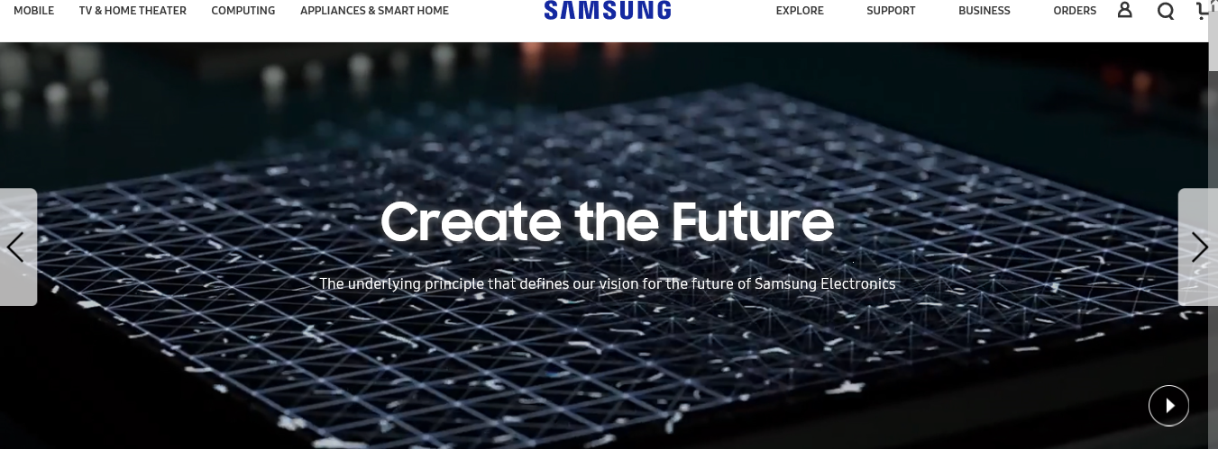
Samsung – Create the Future. Source: Samsung Electronics Homepage
(https://www.samsung.com/us/aboutsamsung/home/ )

Samsung has spent USD 14.857 billion on R&D and they were the second largest amount invested in R&D in the world and only behind Amazon.com in year 2017. However, the R&D budget of Samsung was efficiently as they have spent 7% of their total revenues on R&D in year 2017.
Samsung know R&D is important to their business growth and sustain their successful in the market. The amount spent on R&D is a huge number investment that resulted in their developing the largest patent portfolio amount their key competitors. Samsung has granted total 15,499 patents in the United States during year 2014 to year 2016. Nowadays Samsung’s patent portfolio is one of the strongest portfolios in the high technology industry. Both R&D spending and the patent portfolio are the factors to indicate the competitive advantages of Samsung.
Samsung has the mobile phone product Galaxy Note 7 crisis in year 2016. Samsung has recalled the mentioned phone products and they have a huge negative impact on the performance of sales and profit in this mobile segment in year 2016. The trend of sales performance on Samsung mobile phone products segment, it was growing slow from year 2013 to year 2017 and it dropped in year 2018.
The sales and profit of Samsung semiconductor segment was outperformed in this few years. Since from the low level in year 2013 and then the profit was claiming up on every year from year 2014 to year 2017 and further increased in year 2018.
Samsung has the successful products in high technology and innovative functions by R&D. The mobile phones segment and the semiconductors segment are the Samsung core businesses. The resources allocation and the people management strategies in R&D Department are also important to sustain their competitive advantages.
The business management report will carry out a strategic internal and an external analysis using the SWOT analysis to Samsung and it provide the sustainable competitive advantage of the company. And then it will share the recommendation to advise the company on the strategic in short term, mid-term and long term by using Management by Objectives for the people management in R&D Department. The business management of Samsung by using people management will focus on R&D Department for managing work in effectiveness and managing changes.

Table of Contents Page
Executive Summary ………………………………………………………… 3
Introduction ………………………………………………………… 6
Background ...……….……………………………………………… 8
The Samsung Products ...…….………………………………………… 8
The Samsung Market ………………………………………………… 8
The Key Market Competitors ………………………………………………… 9
Financial Analysis ………………………………………………………… 10
The SWOT Analysis ………………………………………………………… 12
Strengths ………………………………………………………… 12
Weaknesses ………………………………………………………… 12
Opportunities ………………………………………………………… 12
Threats ………………………………………………………… 12
The Competitive Advantages ………………………………………………… 13
Recommendations ………………………………………………………… 14
R&D Department in People Management Strategies ………………………… 14
Management by Objectives ………………………………………………… 15
Apply the Motivation Theories with Management by Objectives ………... 16
Mid-Term Strategy ………………………………………………………… 18
MTS Support Strategy in R&D Department ………………………………… 18
Long Term Strategy in R&D Department ………………………………… 21
Conclusions ………………………………………………………………… 24
References ………………………………………………………………… 25
External Links ………………………………………………………………… 26

Introduction
Part a) Understand Samsung and their business challenges in related to people management. Critique of Samsung and literatures related to their people management.
Samsung is the world leading electronics products manufacturing company. The company is the South Korean company established in 1969 and listed in Korea Stock Exchange in 1975. Samsung provides a wide range of electronics products in the market and they have the major product segments in the Consumer Electronic segment of home electric appliances; the Information Technology and Mobile Communications segment of smartphones and computers; and the Device Solutions segment in semiconductors and LCD & OLED display panel.
Samsung has more than 320,000 employees located at 73 countries (Africa, China, European countries, Japan, Korea, Latin and North America countries and Southeast Asia countries…etc.) around the world. The R&D expenditure was KRW16.8 trillion in year 2017. (Figure 1)

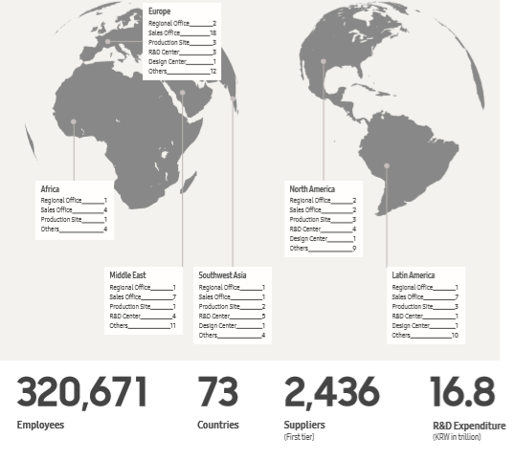
Figure 1. Samsung Electronics Sustainability Report 2018 Page. 7

The company vision of Samsung is “Vision 2020 - Inspire the World, Create the Future”. First Samsung has their Mission statement to “inspire the world with their innovative technologies, products and design that enrich people’s lives and contribute to social prosperity by creating a new future.” (Figure 2) The goal of the vision is to become a beloved brand, an innovative company and an admired company. And the second is Strategic Direction for their vision, Samsung dedicate their effort to creativity and innovation, shared value with their partners and their employees.
The Samsung management philosophy is they devote their human resources and technology to create superior products and services, thereby contributing to a greater global society.
The Philosophy and goals of Samsung are:
- Core Elements of Management - To basis Human resources and technologies.
- Company Objectives with inner goals - To create the best products and services.
- Company Objectives - To make the contribution to the society.
Samsung has five business principles translated into action plan guidelines to establish the Samsung Global Code of Conduct to guide all of their employees. Their business principles are:
- Comply with laws and ethical standards.
- Maintain a clean organizational culture with high integrity.
- Respect customers, shareholders and employees.
- Care for the environment, heath and safety of all.
- Be a socially responsible corporate citizen.

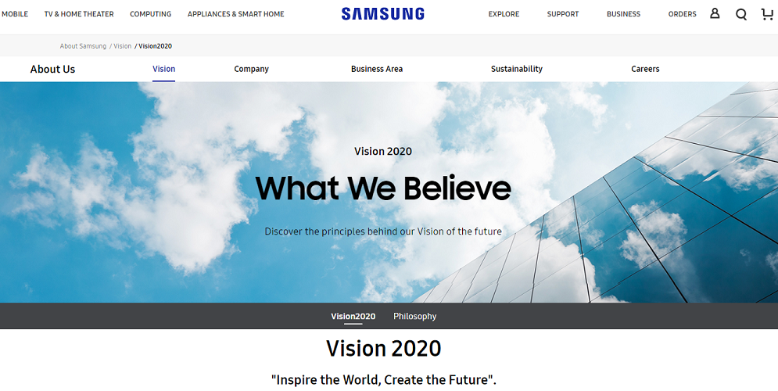
Figure 2. Samsung Vision. Source: Samsung Electronics Company Limited homepage (https://www.samsung.com/us/aboutsamsung/vision/vision2020/ )

Samsung drive their sustainable growth and define their way forward, they are guided by their core values, which are instrumental to the way their employees conduct business. The core value of Samsung are People, Excellence, Change, Integrity and Co-prosperity:
Their core value of People: Samsung is dedicated to giving their employees a wealth of opportunities to reach their full potential.
Their core value of Excellence: The entirety of their endeavours is driven by unyielding passion for excellence and an unfaltering commitment to develop the best possible products and services in the market.
Their core value of Change: The change is constant, and innovation is critical to their survival.
Their core value of Integrity: Operating in an ethical manner that ensures fairness, respect for all stakeholders and complete transparency.
Their core value of Co-prosperity: Their business cannot be successful unless it creates prosperity and opportunity for employees in every local and global community in which they operate.

Background
The background of Samsung introduce their products in different segments, their market in different countries and their key market competitors in their core product segments.

The Samsung Products
Samsung provides a wide range of electronics products in the market cover all the world. They have four major business divisions for different product segments: Consumer Electronics, Information Technology and Mobile Communications, Device Solutions and Harman.
The Consumer Electronics (“CE”) division produce the home electric appliances. It includes digital TVs, monitors, air conditioners, refrigerators and washing machines.
The Information Technology and Mobile Communications (“IM”) division make the high technology communication devices and computers. It includes mobile phones, smartphones and communication systems and computers.
The Device Solutions (“DS”) division manufacture the high technology electronics components and parts. It includes the semiconductor businesses (“SEMI”) such as DRAMs, static RAMs, flash memory and display drivers. And the display panel business (“DP”) such as LCD and OLED display panels.
The Harman division includes the products such as connected car systems, audio and visual products, enterprise automation solutions.
Samsung is looking forward to exploring the new business areas such as healthcare and automotive electronics to continue their journey through history of innovation. And Samsung is welcome to have a new challenges and opportunities with joy.

The Samsung Market
Samsung has 217 operation hubs located 72 countries around the world in year 2017. The headquarters of Samsung are located in Suwon, South Korea. They have 15 Regional offices, 55 Sales offices, 39 Production sites, 35 R&D Centres, 7 Design Centres and 66 other offices are located in the countries of Africa, China, Europe, Japan, Korea, Latin and North America and Southeast Asia…etc. over the world.
America is their largest single market, accounting for 30% of sales; Europe contributes about 25%; while China makes another 20% and South Korea 10%. Other countries across Asia and Africa make up the remaining 15%. (Hoover’s 2018)
Samsung uses a direct sales force that operates from offices located in more than 50 countries. Their products for the consumer market (electronics, appliances) are sold through major retailers worldwide. Other Samsung products, such as the LCD and OLED panels made by Samsung Display, are sold to OEMs. The chips made by Samsung Semiconductor are sold directly as well as through their distributors.

The Key Market Competitors
The key market competitors of Samsung are Apple, HTL, Huawei, Intel, LG Electronics, Microsoft, Philips Electronics, QUALCOMM and Sony…etc. Most of their competitors are the large global corporates are from China, Japan, South Korea and the United States.
And those companies like Apple and Huawei are the top competitors to Samsung smartphone products. Intel and QUALCOMM are the top competitors to Samsung semiconductor products. The Samsung products are highly competitive in the market. The competitive characteristics of several different locations and products. The competition in most of Samsung products is based primarily on technology, price, customer services and on the products performance and quality.

Financial Analysis
According to the Samsung financial highlights from year 2013 to year 2015, the figures in Figure 3 below are showing the trend of each Samsung major product segments in operating profit.
The performance of the operating profit by segment in Information technology and Mobile communication (“IM”), the trend is from the high level for amount KRW 25 trillion in year 2013 and continuously goes downward from year 2013 to year 2015 for amount of KRW 10.1 trillion. And then maintain a slow improvement from year 2015 to year 2017 for the amount of operating profit was KRW 11.8 trillion which only increased 16.8% in financial two years. The performance of the operating profit by the Semiconductor products (“SEMI”) in Device Solutions segment, the trend is from the low level of amount KRW 6.9 trillion in year 2013 and then it was gradually increasing for the amount KRW 8.8 trillion to KRW 13.6 trillion from year 2014 to year 2016 and then it was increased dramatically for the amount of KRW 35.2 trillion in year 2017. (Figure 3)
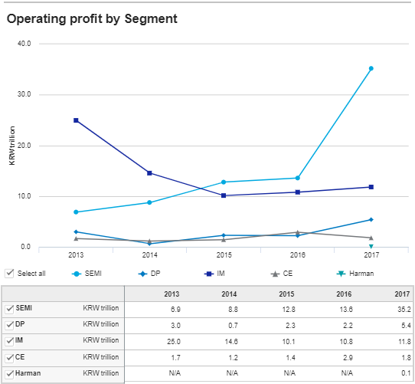
Figure 3. The operating profit by Segment 2013 – 2017
(Source: https://www.samsung.com/global/ir/financial-information/fiancial-valuation-snapshot/ )

The Performance in the Fourth Quarter of 2018
Based on Samsung management information of earning release of the fourth quarter of 2018, the figures in Figure 4 below are showing the latest performance on each Samsung major product segments in sales and operating profit.
The performance of the sales and the operating profit by segment in IM, the trend of the performance was still going downward, and the sales of Mobile products performed even worst was 7% dropped year-over-year for amount KRW 96.52 trillion.
The performance of the sales and the operating profit by segment in SEMI, the trend of the performance was still having a strong growth in 16% and the sales of SEMI of the memory products performed even better and it was 20% increased for amount KRW 72.38 trillion compared with year 2017. (Figure 4)
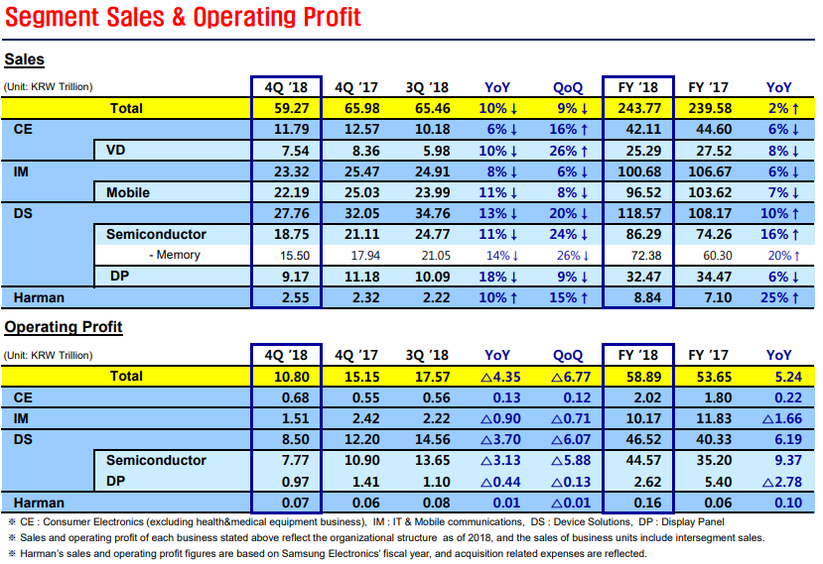
Figure 4 Samsung Electronics Official Earning Release Q4 2018

The SWOT Analysis
Part b) Analysis the strength and limitation of Samsung in the different alternative suggestion and it carry out the sustainable competitive advantage.
This business management report is using SWOT analysis to evaluate Samsung competitive position by identify their strengths, weaknesses, opportunities and threats. Then based on the identify the factors of strengths, weaknesses, opportunities and threats to build the SWOT analysis diagram of Samsung. (Figure 5) After the SWOT analysis, this report carry out the sustainable competitive advantages of Samsung.

Strengths
The successful outcome of the company is supported by the internal attribution and resources. Samsung is one of the biggest market leaders in electronics products in the world. Samsung provides a wide range of electronics products in the market and they have the major product segments in the Consumer Electronic segment of home electric appliances; the Information Technology and Mobile Communications segment of smartphones and computers; and the Device Solutions segment in semiconductors and LCD & OLED display panel. The Samsung employees are professional and innovative, so that Samsung can be the market leader to produce the high technology and innovation electronics products.

Weaknesses
The weakness internal factors work against the company success. Samsung is focused their businesses in Europe, the United States and Korea. They are not well known and not active company in China and Asian countries. Most of the Samsung businesses are reply on mobile phones products and semiconductor products. The new Samsung products of the Harman business grow slowly.

Opportunities
The external factors can use for the company’s advantage. Samsung should consider gaining the economics of scale to the new market in China and Asian countries due to the high demand on those related products from those countries. The joint ventures consider in the China and Asian countries. The diversification of develop the new related products in high technology and advanced products for attracting the new customers and keeping the existing customers. The products diversification of the unrelated products development in the new market like healthcare and automotive electronics products.

Threats
The Threat factors can work against the successful outcome. The Government restrictions on the high technology products using in their countries. The increasing of tax rate in the European countries and the United States. The new technology of high technology products replace the existing Samsung electronics products. The new brand replacement products.

Strengths | Weaknesses
• The market leader in electronics products. | • Not well known and company not active in China and Asian countries.
• A wide range of products in electronics products. | • The businesses are reply on Europe and the United States.
• The innovation and sustainable products. | • The businesses are reply on electronics products.
• The professional and innovative employees. | • The new products of Harman business grow slowly.
Opportunities | Threats
• The new market in China and Asian countries. | • The Government restrictions.
• The diversification to develop the new related products. | • The increasing of tax rate in the European countries and the United States.
• The diversification of the unrelated products in the new market. | • The current products replace by new technology products.
• The joint ventures consideration in the new market in China and Asian countries. | • The new brand replacement products.
Figure 5. The SWOT Analysis diagram of Samsung
The Competitive Advantages
Samsung has spent USD 14.857 billion on R&D and they were the second largest amount invested in R&D in the world and only behind Amazon.com in year 2017. However, the R&D budget of Samsung was efficiently as they have spent 7% of their total revenues on R&D in year 2017. Samsung know R&D is important to their business growth and sustain their successful in the market. The amount spent on R&D is a huge number investment that resulted in their developing the largest patent portfolio amount their key competitors. Samsung has granted total 15,499 patents in the United States during year 2014 to year 2016. Nowadays Samsung’s patent portfolio is one of the strongest portfolios in the high technology industry. Both R&D spending and the patent portfolio are the factors to indicate the competitive advantages of Samsung.
Samsung has the sustainable competitive advantages in their electronics products of semiconductors and mobile phones products in the United States, Europe and Korea. It is because their businesses are based in Korea and cover the United States and Europe. Their products are high technology and advance that manufacture by their innovative and professional employees. The innovative and professional employees are the company valuable resources and they are one of the keys to make the company successful. On the other hand, Samsung is a customer focused company. They always build a good relationship with their customers. The loyalty customers are also one of the keys to make more profit to the company.

Recommendations
Part c) Analysis of Samsung related to their people management strategies. And then analyse the root causes of those issues for Samsung further development.
Samsung is one of the biggest electronics company in the world. Samsung has the sustainable competitive advantage in their electronics products in the world because of their businesses based cover the United State, Europe and Korea. Their products are high technology and advance by their innovative and professional staff. The innovative staff members are one of the keys to make the company success. Samsung is a customer focused company to build a good relationship with their customers. The loyalty customers are one of the source to make profit to the company as well.
After the business analysis of Samsung to carry out the strength and the limitation using SWOT analysis and also the financial analysis. The corporate strategy in people management to recommend Samsung to establish the market growth by the semiconductors and mobile phones segments by R&D. And the R&D Department focus on the semiconductors and mobile phones in the product development and further the market development. And Samsung always looks forward to exploring the new business areas such as healthcare and automotive electronics to continue their journey through history of innovation. And Samsung is welcome to have a new challenges and opportunities with joy.

People Management Strategies in R&D Department
R&D Department assist the company’s market development strategy and the product development strategy for the market growth to develop and launch the company current products in new market segments. The market development strategy targets new customers in currently targeted segments in the new market segments. Samsung products are highly competitive in the market. The competition in most of Samsung products is based primarily on technology, price and customer services.
The trend of Samsung product segments from the analysis, the core product segments are mobile segment and semiconductor segment. The trend of sales performance on Samsung mobile phone products segment, it was growing slow from year 2013 to year 2017 and it dropped in year 2018. The sales and profit of Samsung semiconductor segment was outperformed in this few years. Since from the low level in year 2013 and then the profit was claiming up on every year from year 2014 to year 2017 and further increased in year 2018.
This report introduces the Mid-Term Strategy to apply into Management by Objectives process to Samsung management for people management in R&D Department. This is the five years term renewable strategy process for their short term and mid-term.
In short term, the resources allocation in R&D should remain the proportion on the core product segments in mobile phone and semiconductor as same as last year because the R&D budget of Samsung was efficiently in year 2017. For the mobile segment, the products should consider the new smartphone technology and 5G network communications technology. For the semiconductor segment, the products should consider high technology and low cost products.
In mid-term, R&D Department should consider the most profitable and high demand products in the semiconductor segment first. They can put more R&D resources to develop the semiconductor products to further increase the market share. The resource in R&D Department for mobile segment should focus on the new technology and 5G network communication technology on mobile devices which should not limit to the smartphone or smartwatch products only.
In long term, R&D Department should consider the diversification of develop the new related products in high technology and innovation products for attracting the new customers and keeping the existing customers. The products diversify the unrelated products development in the new market like healthcare and automotive electronics products.
The establishment of the market growth for Samsung in R&D Department that they can follow the trend of their product performance by using the people management strategy to develop the high technology and innovation electronic products to achieve the market development and the product development. This report recommends the people management of Samsung R&D Department on their short term, mid-term and long term strategies by using the Management by Objectives process.

Management by Objectives
This report recommends Samsung to use the people management approach on Management by objectives (“MBO”) process. Many successful companies have used MBO. The management at the computer company Hewlett-Packard (HP) has said that it considers the policy a huge component of its success. (Packard 2007)
MBO is the modern management objectives process to set the organization’s objective. It was introduced by Peter Drucker in 1954. MBO is the process to define objectives within an organisation. The management of the organization can communicate to the employees and then decide how to achieve each objective step by step. This process can allow managers to take work and complete it step by step in good productive work environment. This process can help the employees to see their achievement on each objective which reinforce a sense of achievement in a positive work environment. An important part of MBO is the measurement and comparison of the employee’s actual performance with the standard set. Ideally, when the employees have been involved in the process of goal setting and they followed the action on the process. They are most likely to fulfil their responsibilities. The system of MOB can be described as a process, the manager and the subordinate jointly identify the common goals in the organisation and the process define on each employee’s major areas of responsibility in terms of the results expected of the organisation employee. The process can measure the contribution of each employee as operating guides. (Drucker 1954)
Refer to the MBO diagram below as paradigm, the managers set up the mission and the strategy with the organisation goals. The top management manager set up the goals based on an analysis that the organisation can be accomplished within a specific period. The organisation can appoint a project manager to monitor and control activities of the various departments. The contribution of each manager to the organisation goal should be clearly stated even if the process cannot be done or not desirable. Refer to the MBO diagram below, there have five steps of MBO Process:
- Set Organisational goal
- Cascade objectives to the employees
- Monitor progress
- Evaluate performance
- Reward performance

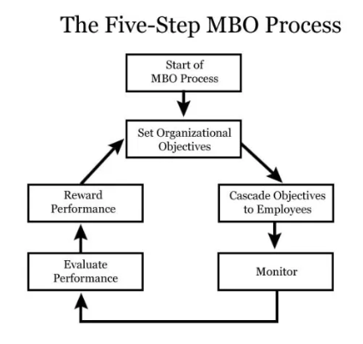
Figure 6. Management by Objective process diagram (Source: The Five-Step MBO diagram)
The core of MOB is the process for introducing the organisation goals set up by the management and manage their employees that both the employee and the organisation strive to achieve and work to meet the organisation goals accordingly.
The principle of MBO is to have the expected responsibilities to the employees. The employees have to understand clear on their roles. Therefore, they can know how their work related to achieve the organization’s goals. MBO also have an important role to meet the personal goals of each employee.
The benefit of MBO process is to have the motivation of employees that increase the employee job satisfaction and commitment. Through the involvement of employees that increase the employee empowerment with better communication and coordination. Through monitoring and goal review process to help all employees in the organisation to maintain harmonious relationships and can solve problems.

Apply the Motivation Theories with Management by Objectives
The factors of employee motivation are applied by the classical management motivation theories like Maslow’s hierarchy of needs, The Two-factor theory of motivation and the Motivational theory of Theory X and Theory Y …etc. The employee’s performance measurement refers to the management strategy in the Balanced Scorecard or the Management by Objectives Process to measure the efficiency and the employee’s performance by the employee motivation to see the result on employee job satisfaction and staff retention in the organization.
The literature review on the relationship between employee motivation and employee’s performance, that the employee motivation has a positive impact on the employee’s performance as well as organization’s performance. The increase of the employee motivation drive to increases the employee productivity as well as job satisfaction on staff retention for the organization. (Alnasrallah 2016, Bernanthos 2018, Dartey-Baah 2010, Springer 2011) The employee motivation, employee’s performance and employee job satisfaction are related to the organization’s performance and the organization’s strategy management in visions, strategies and objectives.
The employee motivation has a positive impact on the employee’s performance. The increase of employee motivation drives to increase of the employee productivity as well as job satisfaction on staff retention for the organization. The employee motivation can be improved by social support, job enrichment, leadership influence and employee training and development. (Alnasrallah 2016)
The motivation is one of the main factors that direct impact on the employees’ performance. The employee motivation, job satisfaction and sense of loyalty are the result of a large number of factors directly related to the employees’ perception of job and working environment. In the European Employee Index, there have the seven factors reputation, senior management, immediate superior, co-operation, daily work, total remuneration and development that the organization and the manager can pull in order to improve motivation. (Viorel et al 2009) Motivational management aims the constitution of a positive, dynamic emotional environment as a background to particular objectives and duties. (Lazaroiu 2015) Applying the motivation factors in MOB is Achievement, Challenging work, Recognition and Responsibility.
The Samsung R&D Department objective process below to MOB with motivation theories,
- Vision and Goals with Core Values
- Mid-Term Strategy
- Staff communications sessions
- Manager Training program

Apply the five steps of MBO Process into Samsung objective process,
- Set Organisational goal:
Samsung’s Vision and Goals statement share to their employees together with the core values of Samsung in People, Excellence, Change, Integrity and Co-prosperity which is set up by the Samsung top management.
The factors of motivation: Recognition and Responsibility.
- Cascade objectives to the employees:
Mid-Term Strategy (‘MTS’) is set up by the top management and then each Business and Function Unit to set up their own MTS support strategy.
The factors of motivation: Challenging work and Responsibility.
- Monitor progress:
The first staff and department communications session are update the performance of their division and their department as well. The department head will encourage their staff members to achieve their division MTS support strategy after update the MTS result. The department heads will remind their staff members that their involvement is very important and appreciate the good performance teams and staff members.
The factors of motivation: Challenging work and Recognition.
- Evaluate performance:
Senior Managers program & Junior Managers program are including the Samsung’s elements: Vision, Mission, Core Values and MTS. The Core Values and MTS are the most important parts in the training program to let the managers to have the way to share and achieve.
The factors of motivation: Challenging work, Recognition and Responsibility.
- Reward performance:
The second staff and department communications sessions are the company’s annual performance in returns and MTS result to the employees. The department heads will share the achievements of their divisions and their departments. The achievement items of the department will get the reward in the BEST staff awards and the INNOVATIVE staff awards to their teams and staff members. The department heads will on behalf of the top management to appreciate to all the staff members involvement. Finally, the department heads will share the MTS review for next year and the MTS review support strategy of their Business Unit and Function Unit.
The factors of motivation: Achievement, Recognition and Responsibility.

Mid-Term Strategy
The recommendation to the Mid-Term people management strategy to introduce to Samsung’s management to set up the Mid-Term Strategy (‘MTS’). This MTS was a five years business plan and followed by the objective process to have an annual review process and MTS Refresh on another five years set up review process. The MTS plan concern the areas are cover Geographical area, Target customers, and Risk management. And then each of the Business and Function Unit (including all departments in the company like Marketing Department, R&D Department, Operations Department and Human Resources Department…etc.) required to set up their own MTS support strategy to follow by the Samsung’s MTS.

MTS Support Strategy in R&D Department
The R&D Department is one of the important internal function units in Samsung. The General Manager of the R&D Department with all product segment department heads in R&D Department have set up the MTS support strategy to propose to the top management and then let our R&D staff members to achieve. The support strategy includes: Support the Business and Function Units MTS support strategy, Fit for Growth, Effective Cost Management and Risk Management & Internal Control.
Support the Business Units and the Function Units MTS support strategy that including Project Management Excellence, Strengthen Business Transacting Capabilities, deploy resources to support Business and Function Units in flexible and agile manner. We treat the other Business and Function Units as internal customers and we focus on fostering of customer focus culture and striving for business partnership with internal customers.
- Emphasize team spirit and support mentality, especially across different divisions or departments.
- Strengthen bilateral communicate well with our external and internal customers.
- Be helpful, proactive, cooperative and supportive.
Fit for Growth that R&D Division has the Centralization and Re-Engineering programs to align resources with MTS goals.
Effective Cost Management which is enhancing transactions capabilities and supporting Business and Function Unit’s MTS remain the key focus, our division will set up the effort in efficiency improvements and re-engineering and re-visiting the Fit for Growth strategy and effectiveness.
Risk Management & Internal Control that we required “The Right Focus, The Right Model, The Right Enforcement”. The “Right” requirements as below,
- Strengthen staff members’ sensitivity and awareness of the risks and timely escalation to department and division heads where appropriate.
- Institutionalise the risk-based approach in control and escalation, add this element in the new development and annual reviews of the existing operational policy and procedures to make sure that effective and balanced control measures and management oversight processes are built in.
- Arrange regular training activities of briefing for staff of all levels to tune the right mind set and foster the right culture in control and risk management.

Staff Communications Sessions
The staff communications sessions are one of the objective process. The management communications sessions and the department communications sessions.
The top management will hold the management communications sessions with senior management including all Business and Function Units division heads and department heads twice a year. The propose of these two communication sessions are different functions.
The first management communications session, it will hold after the company half year financial report announcement. To update the bank half year performance and review each Business and Function Unit MTS support strategy progress.
The second management communications session, it will hold after the company annual financial report announcement. The top management report the bank whole year performance in returns and MTS result and award the Business and Function Units which achieve the MTS and then review the next financial year MTS.
The department communications sessions will be held by the department heads to their departments right after both management communications sessions. The first department communications session, the department heads will update the performance of their division and their department as well. The department head will encourage their staff members to achieve their division MTS support strategy after update the MTS result. The department heads will remind their staff members that their involvement is very important and appreciate the good performance teams and staff members.
The second department communications session, firstly, the department heads will share the company’s annual performance in returns and MTS result to their staff members. And then the department heads will share the achievements of their divisions and their departments. The achievement items of the department will get the reward in the BEST staff awards and the INNOVATIVE staff awards to their teams and staff members. The department heads will on behalf of the top management to appreciate to all the staff members involvement. Finally, the department heads will share the MTS review for next year and the MTS review support strategy of their Business Unit and their Function Unit.

Manager Training Program
The manager training program is one of the objective processes of the company. There will have the senior manager training program and the junior manager training program for different grading managers. The training program is based on their grading to design the program content to fit for their working function. In both training programs are include the Samsung’s elements: Vision, Mission, Core Values and MTS. The Core Values and MTS is the most important parts in the training program to let the managers to have the way to share and achieve.
The senior manager training program which is for the senior manager grade or above managers to join. Most of them are the department heads or the team heads of their Division. The training mainly is strategy management, coaching and leadership.
The junior manager training program which is for the manager grade staff members. The training mainly is team building, sharing working experience and staff motivation.

The Long Term Strategy in R&D Department
In long term, the good communications with their employees on their vision is “Vision 2020 - Inspire the World, Create the Future”. First Samsung has their Mission statement to “inspire the world with their innovative technologies, products and design that enrich people’s lives and contribute to social prosperity by creating a new future.” The goal of the vision is to become a beloved brand, an innovative company and an admired company. The R&D Department should consider the diversification of develop the new related products in high technology and innovation products for attracting the new customers and keeping the existing customers.
And the second is Strategic Direction for their vision, Samsung dedicate their effort to creativity and innovation, shared value with their partners and their employees. The products diversify the unrelated products development in the new market like healthcare and automotive electronics products Samsung is looking forward to exploring the new business areas to continue their journey through history of innovation. And Samsung is welcome to have a new challenges and opportunities with joy.
In the R&D Department, most of the employees are high educated and professional in their working area. Some of them have more than one company working experiences. They are willing to learn the things in the department and share their experience. Most of the staff members in R&D Department are the professional employees. They have a high education background and they are productive in their profession working area. However, they are not only seeking for job security and they also want to have job satisfaction in work. Therefore, one of the Company concerns is staff retention and motivation. Final, Samsung can share their great result to their employees with the staff awards and bonus.

Conclusions
The Business Management Report – Samsung Electronics in People Management Strategies. Samsung is one of the world’s largest manufacturers of electronics products. The company is the South Korean company established in 1969 and listed in Korea Stock Exchange in 1975. Samsung provides a wide range of electronics products in the market all over the world. The report is carrying out a strategic internal and an external analysis using the SWOT analysis and provided the sustainable competitive advantage of the company.
Samsung has the sustainable competitive advantage in their electronic products in European countries, the United States and Korea. It is because their businesses are based in Korea and cover Europe and the United States. Their products are high technology and advance in manufacture by their innovative and professional employees.
The business management report carry out a strategic internal and an external analysis using the SWOT analysis to Samsung and it provide the sustainable competitive advantage of the company. And then it share the recommendations to advise the company on the strategic in short term, mid-term and long term by using Management by Objectives for the people management in R&D Department. The business management of Samsung by using people management will focus on R&D Department for managing work in effectiveness and managing changes.
The recommendation advises to Samsung on their people management strategic in R&D department in short term, mid-term and long term
The market development and the product development. The market development strategy is recommended for Samsung due to high demand of the semiconductor products in China and Asian countries. Samsung can access the new market segments and increase the products market share to gain the economics of scale. The risk is the government policies in those new market countries.

References

Alnasrallah, Y. 2016, “Employee Motivation and Performance”, International Journal of Scientific & Engineering Research, 7(1).

Bernanthos, B. 2018, “Employees’ Performance in Islamic Banking”, European Research Studies, vol. 21, no. 1, pp 1-42.

Dartey-Baah, K. 2010, “Job Satisfaction and Motivation: Understanding its impact on employee commitment and organizational performance”, Academic Leadership (15337812), 8, 4, Education Source, EBSCOhost, viewed 15 July 2018.

Clark, K. B., Fujimoto, T., & Cook, A. 1991, “Product development performance: Strategy organization, and management in the world auto industry”, Boston, MA: Harvard Business School Press, pp. 121-161.

Li, H., & Atuahene-Gima, K. 2001, “Product innovation strategy and the performance of new technology ventures in China”, Academy of management Journal, 44(6), 1123-1134.

Choe, S. & Mozur, P. 2017, “Samsung Galaxy Note 7 Crisis Signals Problems at Korea Inc”, The New York Times, 24 Jan 2017, ISSN 24727149.

Drucker, P. 1954, “Management by objectives and self-control”, Practice of Management.

Hoover’s. 2018, “Samsung Electronics Co., Ltd., Profile.” A D&B Company, 23 Sep 2018.

Lazaroiu, G. 2015, “EMPLOYEE MOTIVATION AND JOB PERFORMANCE”, Linguistic and Philosophical Investigations, vol. 14, pp. 97-102.

Maheshwari, S. 2016, “Samsung’s Response to Galaxy Note 7 Crisis Draws Criticism”, The New York Times, 12 Oct 2016, ISSN 24727149.

Packard, D. 2007, “HP Way”, Bloomsbury Business Library – Management Library, 35.

“Samsung Electronics Co., Ltd.: Technology and Communications – Company Profile, SWOT & Financial Analysis 2016”, GlobalData plc, London.

“Samsung Electronics Co., Ltd. 2019”, Fort Mill: Mergent.

Springer, G J. 2011, “A Study of Job Motivation, Satisfaction, and Performance among Bank Employees”, Journal Of Global Business Issues, 5,1, pp. 29-42, Business Source Complete, EBSCOhost, viewed 15 July 2018.

Viorel, L, Aurel, M, Virgil, M, & Stefania, P. 2009, “EMPLOYEES MOTIVATION THEORIES DEVELOPED AT AN INTERNATIONAL LEVEL”, Annals Of The University Of Oradea, Economic Science Series, 18, 4, pp. 324-328, Business Source Complete, EBSCOhost, viewed 15 July 2018.

External Links

Samsung Electronics Company Limited homepage (https://www.samsung.com/us/ )

Samsung Electronics Earning Releases Fourth Quarter 2018 (https://images.samsung.com/is/content/samsung/p5/global/ir/docs/2018_4Q_conference_eng.pdf )

Samsung Electronics Financial Highlights 2013 - 2017
(https://www.samsung.com/global/ir/financial-information/financial-valuation-snapshot/ )

Samsung Electronics Sustainability Report 2018
(https://images.samsung.com/is/content/samsung/p5/global/ir/docs/SustainabilityReport2018_en.pdf )

Smartphone trends affecting the product lifecycle, Ingram Micro Commerce & Lifecycle Services, Katie Wild, 8 June 2018
(https://www.ingrammicroservices.com/blog/mobile-device-smartphone-lifecycle/ )

SWOT analysis of Samsung (6 Key Strengths in 2019), Strategic Management Insight, Ovidijus Jurevicius, 10 January 2019
(https://www.strategicmanagementinsight.com/swot-analyses/samsung-swot-analysis.html/ )

