Vehicle Tech 2 – Vehicle Structure & Aero


Bonded aluminium chassis with glass fibre body

Found in most Lotus models, the aluminium chassis is a more rudimental way of making a chassis. For example in the Lotus Exige Sport 350 they use a central extruded aluminium tub on top of a ladder frame structure. This allows for a lightweight structure with greater torsional rigidity.
When paired with a glass fibre body this makes the car much lighter than most cars whilst staying stronger than most cars their weight. The lightweight construction also allows for a lower centre of gravity.
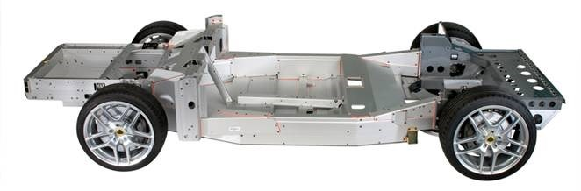
Pros :
- Lightweight
- Greater torsional rigidity
- Simpler and cheaper to make
Cons :
- Not so good in crash protection

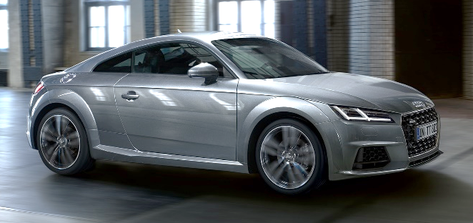
Steal monocoque

Most mainstream production cars have a steal monocoque chassis which merges both the body panels, chassis, and tub all in one big structure. These are a lot heavier in comparison to the bonded aluminium chassis, so most car makers are using both steal and aluminium to make it a bit lighter, but the overall concept stays the same.
With this example of an Audi TT the conventional steel floorplan is borrowed from the VAG MQB parts bin which is shared with the Volkswagen Golf and the Seat Leon for example. Then Audi have stamped the body sides and roof frames from aluminium, like most of the body panels. All this makes it around 50kg lighter than the generation before.

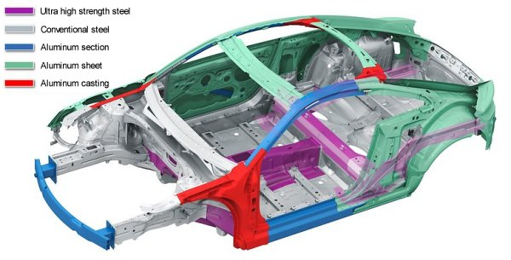
Pros :
- Better in crash protection
Cons :
- Uses more metal to make as torsionally stiff
- Heavier than the bonded aluminium chassis with glass fibre body
- More expensive and complicated to make

Aerodynamics

Efficient aerodynamics are now a major factor in car design, influencing fuel economy, and range. Its even got to the stage that the 2019 BMW X5 is now more aerodynamically efficient than the McLaren F1 supercar from the 1990’s.
Aerodynamics can affect a cars performance in many different ways. The performance of a car can be majorly effected by the way a car cuts through the air. A car will have a higher top speed the better it can cut through the air instead of slamming into the air and creating a lot of drag. This is usually measured out in Drag Coefficient (Cd) which currently makes the 2019 Mercedes Benz A class saloon the most aerodynamic production car on sale according to motoringresearch.com.
Drag will also effect a cars fuel efficiency as the better the car can cut through the air, the less fuel you need to use to go anywhere. For example the claimed combined MPG (Miles Per Gallon) for a Seat Leon FR 5 door Hatchback with the 1.5 TSI EVO DSG is 43.5 MPG, where for a similarly sized Seat Ateca FR SUV with the same engine and gearbox the claimed combined MPG is 39.2 MPG, both on the new WLTP test cycle. Drag will also effect the cars range as if both those Seats above had the same sized fuel tanks full, and the same weight, the lower Leon would travel much further than the taller Ateca.
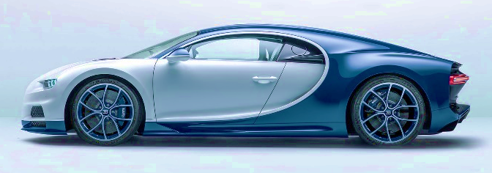


Aerodynamic Car vs Un-Aerodynamic Car

References

Lotus website:
https://www.lotuscars.com/exige-sport-350
Lotus chassis image:
https://www.carmagazine.co.uk/car-news/industry-news/lotus/extreme-dieting-how-lotus-saved-207kg-from-its-cars-in-2016/
Audi TT chassis image and info
https://www.autozine.org/Archive/Audi/new/TT_Mk3.html
Jaguar F-pace aero pic
https://www.autocar.co.uk/car-news/new-cars/aerodynamics-why-virtual-testing-better-wind-tunnel
Cd car Ratings
https://www.motoringresearch.com/car-news/most-aerodynamic-new-cars-2018/
Seat MPG claims
https://configurator.seat.co.uk/seat-cc/desktop-desktop-006_DEFAULT-en-normal.view?msk=1

