Assignment 2: Project Management & Innovation
BSc(Hons): Applied Computing ACCA5033 Changemakers: Creativity and Value Creators Tutor: Fahad Ahmed
Jairo Rukeni Do Nascimento Ambrosio (2413052)
Table of Contents
Introduction 2
Task 1 3
Project Management & Planning: Language Learning Software 3
Project Scope 3
Proposed Solution 3
Required Technologies & Resources 3
Programming Frameworks: 3
Databases 4
Artificial Intelligence & NLP resources 4
Infrastructure 5
Human Resources 5
Time & Schedule (Summary) 5
Project Graphs 6
Constraints 9
Task 2 11
Innovation 11
Question 1: PEST and SWOT Considerations for a Technology Company 11
PEST Analysis 11
SWOT Analysis 12
Question 2: Development, Deployment, Maintenance, and Evolution of the Project 13
Core Concepts 13
Methods and Development Practices 13
Tools and Technical Architecture 13
Deployment within a Large Organisation 14
Ethics, Privacy, and Compliance 14
Maintenance and Evolution 14
Project Reflection 16
Conclusion 17
References 18

Introduction

This is a report of the planning of development of a Language Learning Application and Online Service named Glossion. A programming that combines adaptive AI tutoring spaced repetition, and speech scoring. This report covers the project scope, timeline, development method, design artifacts, market and enterprise analysis, and a reflective plan for skills and societal impact.

Task 1

Project Management & Planning: Language Learning Software
Project Scope
This Project aimed to develop, design and launch a language learning software that responds the ever-growing demand for accessible, interactive, and adaptive language acquisition tools [1].

Proposed Solution
The solution has leveraged AI-driven natural language processing (NLP) to provide speech recognition, pronunciation correction, and contextual vocabulary training. Gamified modules will encourage consistent practice, while cloud-based storage has certainly enabled synchronization across devices. The system did also integrate collaborative features such as peer-to-peer practice and community forums [2].

Required Technologies & Resources


Programming Frameworks:
Python (for NLP): Python is a versatile programming language supporting web development, data science, AI, automation, and education, offering readability, scalability, extensive libraries, and strong community support.

JavaScript & React (Web): Java is a dynamic, versatile programming language enabling interactive web applications, client-side scripting, server-side development, and cross-platform solutions with extensive frameworks and libraries.
React is a powerful JavaScript library enabling dynamic user interfaces, component-based architecture, efficient rendering, and scalable web application development [3][4].
Kotlin & Swift (Mobile): Kotlin is a modern, concise, statically typed language offering null safety, Java interoperability, and cross-platform support for Android development.
Swift is Apple’s modern programming language, offering safety, speed, readability, interoperability, and cross-platform support for iOS, macOS, and beyond[1][8].

Databases
Firebase: Firebase provides cloud-based backend services, including authentication, databases, hosting, analytics, and real-time synchronization for scalable cross-platform applications.
PostgreSQL: is a robust, open-source relational database offering scalability, security, JSON support, and analytics for educational language learning applications.

Artificial Intelligence & NLP resources
TensorFlow: TensorFlow is an open-source machine learning framework enabling deep learning, NLP, and scalable AI models for adaptive language learning applications.
spaCy: Is an open-source Python library for advanced natural language processing, offering fast, efficient tokenization, parsing, and named-entity recognition, and speech recognition APIs [1][2][8].

Infrastructure
Cloud hosting: AWS, Azure.
CI/CD pipelines
Version Control: GitHub.
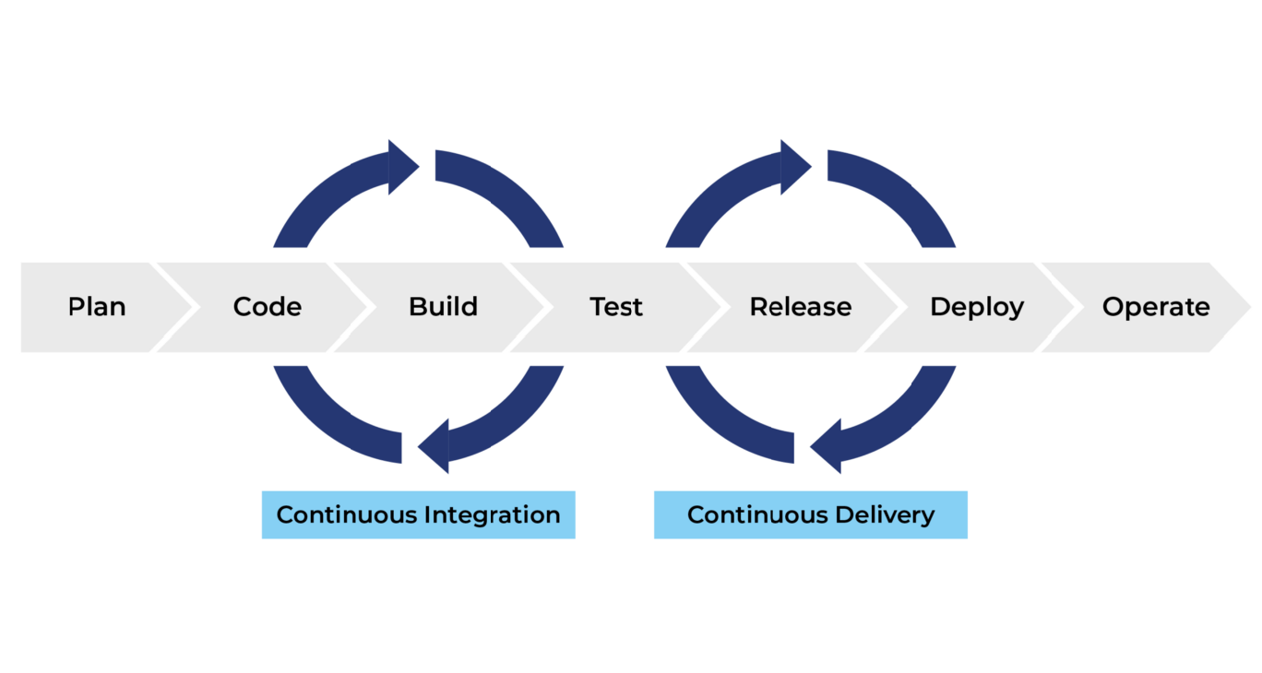

Human Resources
Project management, software engineers, linguists, UX/UI designers, and QA testers. These collection of resources and tools make technical feasibility and scalability possible while supporting agile development practices [1][2][3].

Time & Schedule (Summary)
- Month 1 – Initiation & Planning
  - Requirements gathering, stakeholder interviews, feasibility analysis, scope definition.
  - Project charter, requirements specification, risk register.
  - Approval of scope and resource allocation.
- Month 2–3 – Design & Prototyping
  - System architecture design, UI/UX wireframes, prototype development.
  - Design documentation, prototype demo.
  - Prototype validated by stakeholders.
- Month 4 – Core Development
  - Implementation of NLP modules, database integration.
  - Functional modules with unit testing results.
  - Completion of core system functionality.
- Month 5 – Integration & Testing
  - System integration
  - Test reports, bug fixes
  - UAT approval for deployment readiness.
- Month 6 – Deployment & Closure
  - Final deployment
  - Deployed application, user manuals, closure report.
  - Formal project handover and closure.

Project Graphs
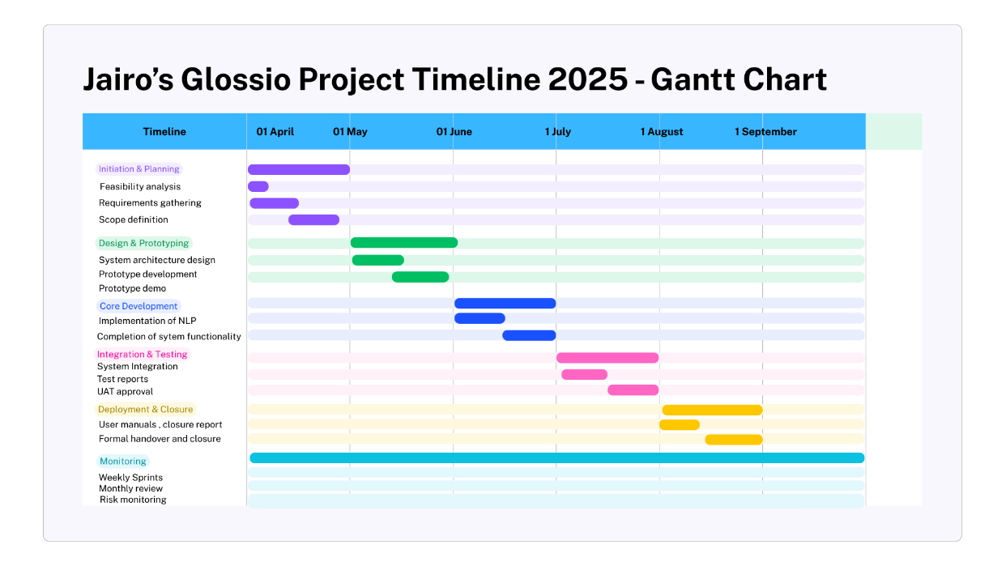
Figure 1 Gantt Chart

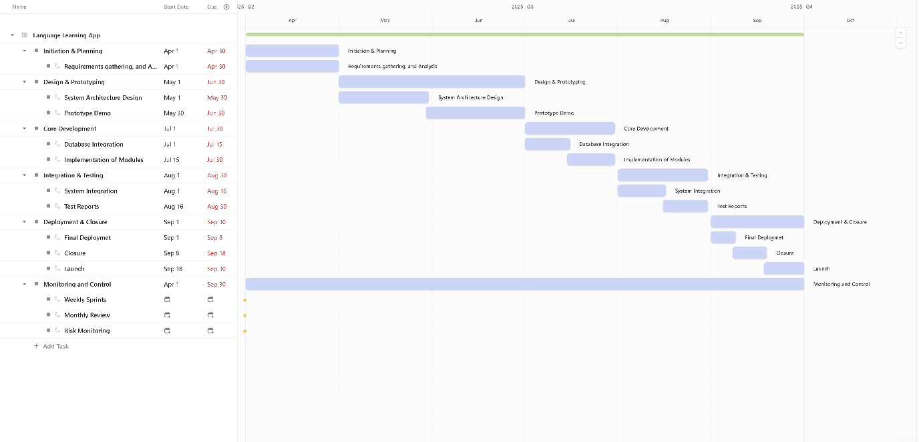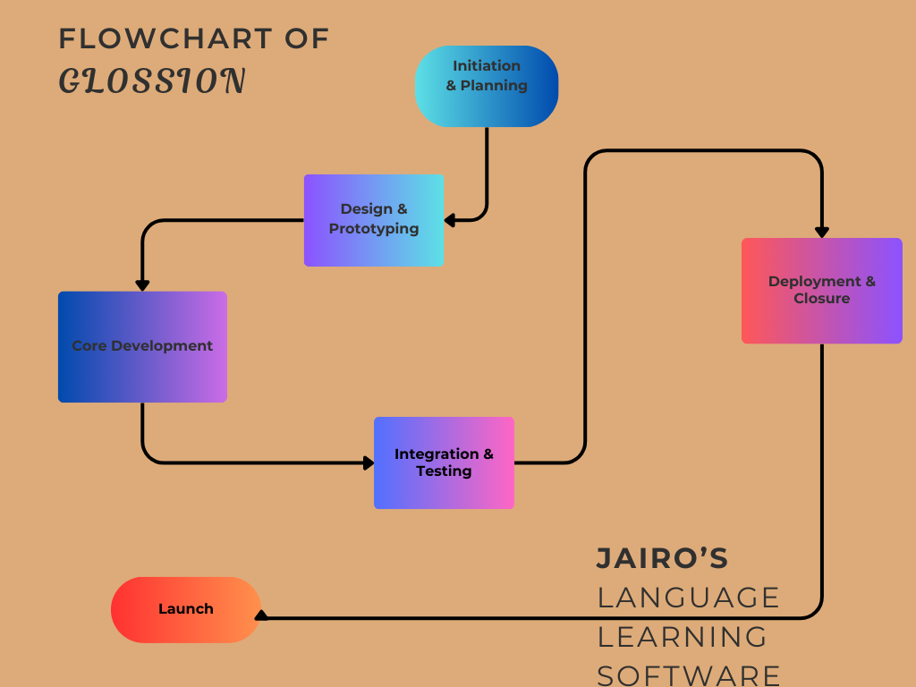
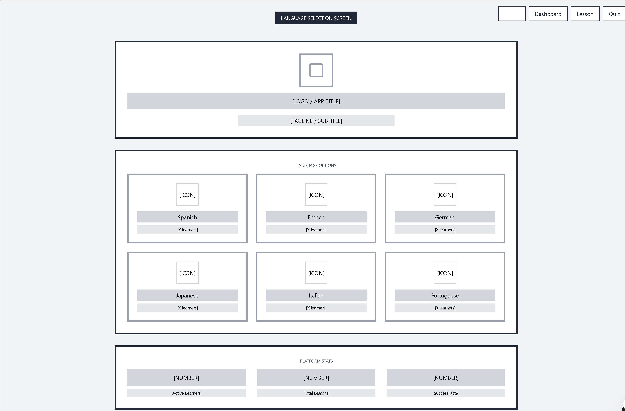
Constraints
Project constraints are the boundaries and limitations that shape planning, execution, and delivery:
- Scope: Defines project boundaries; controls feature delivered within release.
- Time: Six-month deadline; delays cascade, requiring strict milestone adherence.
- Cost: Budget limits advanced AI; open-source tools reduce financial strain.
- Quality: Usability, accessibility, reliability ensured through iterative testing cycles.
- Resources: Skilled linguists, developers scarce; optimize allocation and collaboration effectively.
- Risk: AI delays, adoption issues, privacy concerns require mitigation strategies.

Task 2

Innovation

Question 1: PEST and SWOT Considerations for a Technology Company
To contextualise the proposed language learning software project, a PEST and SWOT analysis is presented using Duolingo as an example of a large technology-driven language learning company. While Duolingo is used illustratively, the considerations are broadly applicable to similar educational technology organisations.

PEST Analysis
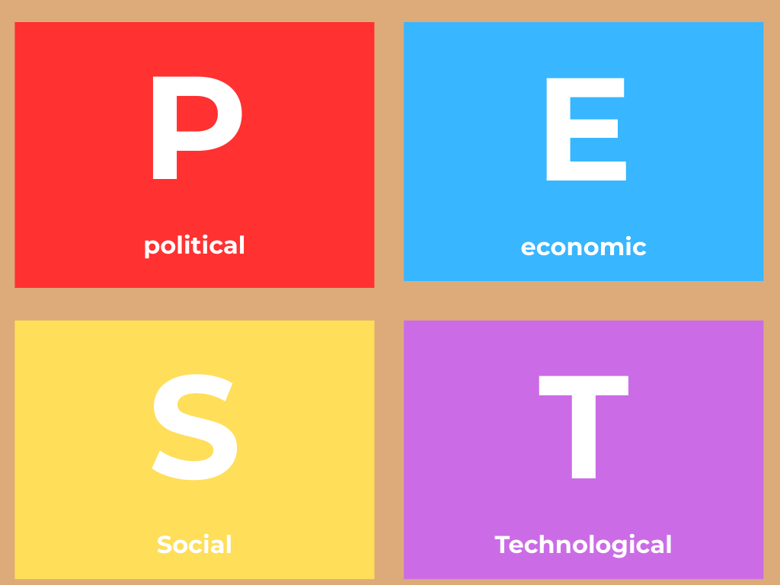
Political and Legal Factors
Language learning software companies operate across multiple jurisdictions and must comply with international data protection and education regulations. In Europe, the General Data Protection Regulation places strict requirements on how learner data are collected, processed, and stored. These regulations are particularly relevant where automated systems personalise learning pathways or evaluate learner performance. Automated decision-making that significantly affects learners must be explainable and subject to human oversight. Additionally, accessibility legislation requires platforms to be usable by learners with disabilities, influencing interface design and content delivery.
Economic Factors
Economic conditions influence both individual subscriptions and organisational learning and development budgets. During economic uncertainty, demand for affordable and scalable digital learning tools may increase, as organisations seek cost-effective training solutions. However, high development and infrastructure costs associated with data-driven personalisation and advanced media content can pressure profitability.
Social Factors
There is growing societal emphasis on lifelong learning, multilingualism, and remote education. At the same time, learners are increasingly concerned about digital surveillance, fairness, and the ethical use of automated systems. Trust and transparency are therefore essential for sustained adoption.
Technological Factors
Advances in machine learning, speech processing, and immersive media enable more engaging and adaptive language learning experiences. However, rapid technological change creates challenges related to system complexity, staff skills, and long-term maintainability.

SWOT Analysis
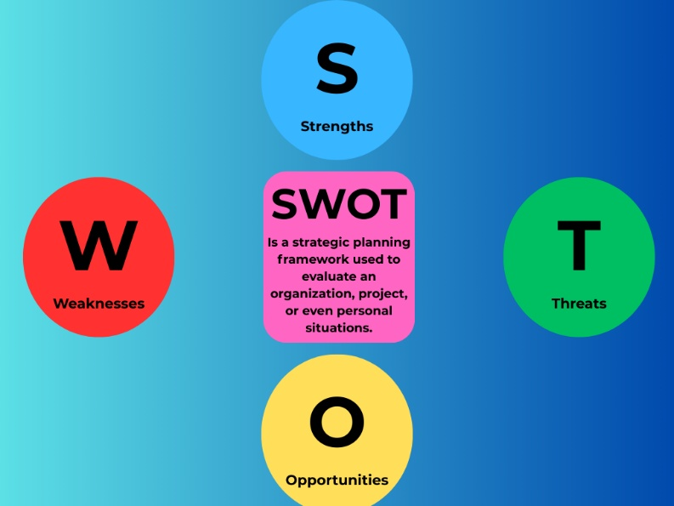
Strengths
Key strengths include scalable cloud-based delivery, data-driven personalisation, and high learner engagement through interactive content. Large user bases allow continuous improvement of learning models.
Weaknesses
Weaknesses include reliance on automated assessment, which may disadvantage learners with non-standard accents or speech patterns, and limited transparency in algorithmic decision-making. These issues raise ethical and pedagogical concerns.

Opportunities
Opportunities exist in integrating contextual learning environments, workplace-focused language training, and partnerships with educational institutions to support certification and credibility.
Threats
Threats include increasing regulatory scrutiny of automated systems, public concern about algorithmic bias, and competition from open-source or low-cost alternatives.
Legal and Ethical Considerations
Ethically, the use of automated learner modelling raises concerns around bias, explainability, and learner autonomy. Research highlights the risk of reinforcing inequalities if adaptive systems are not carefully audited and governed (Holmes, Bialik, and Fadel, 2021) [11]. Legally, failure to comply with data protection and accessibility standards can result in reputational and financial harm.

Question 2: Development, Deployment, Maintenance, and Evolution of the Project
The proposed project is an adaptive language learning software platform designed for deployment within a large organisation, such as a multinational enterprise or public sector body.

Core Concepts
The project is grounded in adaptive learning theory, which suggests that learning outcomes improve when instructional content dynamically responds to learner performance and behaviour (Durlach and Lesgold, 2012) [8]. It also draws on communicative and contextual language teaching principles, emphasising authentic language use rather than isolated drills.

Methods and Development Practices
An iterative development approach would be adopted, enabling close collaboration between software engineers, language educators, and ethics specialists. Short development cycles allow rapid feedback and continuous pedagogical refinement.
Learning interactions across web and mobile clients would be captured using standardised learning activity tracking and stored in a central learning record repository. Learning analytics derived from this data can inform content updates and personalised learning pathways. However, analytics are used to support educators and learners rather than to replace human judgement, aligning with best practice in learning analytics research (Siemens and Long, 2011) [9].

Tools and Technical Architecture
The platform would use a modular, service-based architecture hosted on secure cloud infrastructure. Front-end applications would deliver interactive lessons, while back-end services manage learner profiles, analytics, and content delivery. Automated language feedback tools, such as speech analysis, would prioritise privacy-preserving or on-device processing where possible to reduce data exposure.
To manage intelligent components, structured operational practices for machine learning systems are essential. These include version control for models, continuous performance monitoring, and systematic testing for bias and degradation over time (Amershi et al., 2019) [10].

Deployment within a Large Organisation
Deployment would integrate with existing organisational learning systems and identity management platforms. Clear governance structures define responsibility for content quality, data protection, and ethical oversight. Dashboards provide learning and development managers with aggregated insights into engagement and skill progression, supporting evidence-based decision-making.

Ethics, Privacy, and Compliance
Ethical governance is embedded throughout the system lifecycle. This includes documentation explaining how adaptive decisions are made, regular audits for demographic and linguistic bias, and human review for high-stakes outcomes. Data minimisation, pseudonymisation, and clearly communicated consent mechanisms are applied in line with data protection principles.

Maintenance and Evolution
Continuous evaluation is critical. Controlled experiments and learner outcome analysis are used to assess pedagogical effectiveness and system fairness over time. Telemetry and monitoring tools detect technical or educational regressions early.
Long-term evolution is supported through partnerships with universities or assessment bodies, enabling peer-reviewed evaluation and alignment with recognised language proficiency frameworks. Such collaboration increases credibility and supports sustainable adoption, as highlighted in educational technology research (Luckin et al., 2016) [12].

Task 3

Project Reflection

This reflection outlines how I will use a language-learning platform project to build technical, pedagogical and ethical skills, how those skills can benefit society, and the main risks with concrete mitigation steps.
How I intend to develop new skills
I will use the project to gain practical expertise in adaptive learning system design, including learner modelling, item sequencing and evidence-based evaluation methods, by implementing and testing personalized learning pathways in real classrooms and workplace pilots. I will also learn production-grade machine learning operations practices such as reproducible pipelines, model versioning and continuous monitoring so that models remain reliable and auditable in production environments. Finally, I will develop immersive content creation skills for three-dimensional interactive scenarios, including scenario scripting, user interaction design and multimodal feedback for spoken practice, by building prototype environments and running iterative user tests. These combined skills will let me move from research prototypes to robust learning products that are pedagogically sound and operationally sustainable [5].
How the project and new skills could contribute to society
The project aims to deliver equitable access to practical language skills by offering adaptive pathways that match individual needs and by providing low-bandwidth and non-immersive alternatives for learners without high-end hardware. Research on immersive environments shows that contextualized practice can increase motivation and support vocabulary retention when scenarios are well designed and repeated, which supports workforce readiness in sectors such as healthcare and customer service. By partnering with community organisations and public institutions, the platform can support migrants, adult learners and under resourced schools with subsidised licences and tailored curricula, thereby improving employability and social inclusion. In addition, by publishing evaluation results and pedagogical findings, the project can contribute to the broader evidence base on effective digital language instruction [6].
Risks and challenges and how to reduce them
A primary risk is algorithmic unfairness in speech scoring and recommendation systems that could disadvantage speakers with nonstandard accents or minority dialects. To reduce this risk, I will adopt formal bias assessment procedures, publish model documentation and include human review for high-stakes decisions, following the literature on algorithmic bias in education. A second risk is data privacy and regulatory compliance when collecting voice and performance data; I will apply privacy-by-design principles, minimise personally identifiable information, use local processing for audio where feasible and document retention policies to meet legal obligations. A third risk is operational fragility: models can degrade and immersive assets can be costly to maintain. I will mitigate this by implementing robust machine learning operations pipelines with automated testing, monitoring for model drift and staged deployments to enable safe rollouts and rapid rollback if problems occur. Finally, there is a risk that immersive novelty does not translate into real-world transfer; I will address this by designing scaffolded practice with repeated exposures and by measuring transfer through controlled experiments and workplace performance indicators [7].

Conclusion

Overall, this project represents a meaningful opportunity to develop new skills while contributing positively to society. It encourages responsible innovation by combining technical development with ethical awareness and educational impact. By acknowledging and actively addressing its risks, the project can evolve into a sustainable and socially valuable language learning solution.

References
[1] Asana, “6 Project Constraints: Manage Them for Project Success,” Mar. 2025. [Online]. Available: https://asana.com/resources/project-constraints
[2] M. H. Al-Khresheh, “The Cognitive and Motivational Benefits of Gamification in English Language Learning: A Systematic Review,” Open Psychology Journal, vol. 18, 2025. [Online]. Available: https://openpsychologyjournal.com/VOLUME/18/ELOCATOR/e18743501359379/FULLTEXT/
[3] S. A. Triantafyllou, C. Georgiadis, and T. Sapounidis, “Gamification in education and training: A literature review,” International Review of Education, vol. 71, pp. 483–517, 2025.
[4] D. Zhao, “The impact of AI-enhanced natural language processing tools on writing proficiency,” Education and Information Technologies, vol. 30, pp. 8055–8086, 2025.
[5] A. Mohebbi, “Enabling learner independence and self-regulation in language education using AI tools: A systematic review,” Cogent Education, vol. 12, no. 1, 2025.
[6] J. H. Woo and H. Choi, “Systematic Review for AI-based Language Learning Tools,” arXiv preprint, 2021.
[7] M. E. Nenni, F. De Felice, C. De Luca, and A. Forcina, “How artificial intelligence will transform project management in the age of digitization: a systematic literature review,” Management Review Quarterly, vol. 75, pp. 1669–1716, 2025.

[8] FinModelsLab, “Language Learning App PESTEL Analysis,” 2025. [Online]. Available: https://finmodelslab.com/products/language-learning-app-pestel.
[9] Emergen Research, “Language Learning App Market Size, Growth Outlook 2034,” Oct. 31, 2025. [Online]. Available: https://www.emergenresearch.com/industry-report/language-learning-app-market.
[10] Business Research Insights, “Language Learning Application Market Size, Share & Growth From 2025 To 2034,” 2025. [Online]. Available: https://www.businessresearchinsights.com/market-reports/language-learning-application-market-102456.
[11] Spherical Insights, “Language Learning Application Market Size, Growth, Outlook,” Apr. 2025. [Online]. Available: https://www.sphericalinsights.com/reports/language-learning-application-market.
[12] Data Insights Market, “Market Projections for Language Learning Application Industry 2025-2033,” 2025. [Online]. Available: https://www.datainsightsmarket.com/reports/language-learning-application-1453934.

