PSYCHOLOGY FOR HEALTH AND SOCIAL CARE
UNIVERSITY OF WALES TRINITY SAINT DAVID
CAMPUS: Oval ( London)
LEVEL 4 PROGRAMME:CERTIFICATE IN SKILLS FOR THE WORKPLACE
(HEALTH AND SOCIAL CARE) TERM 3
ACADEMIC YEAR :19/20
STUDENT NAME: Jennifer Oluwakemi Laguda
STUDENT NUMBER: 1907297
LECTURER NAME: Diya Ganguly.

THE INFLUENCE OF PSYCHOLOGY IN THE HEALTH AND SOCIAL CARE ENVIRONMENT

INTRODUCTION

The main point of this reflective essay is to analyse and explain how psychology affects our lives from infancy stage to elderly stage.
In this essay I’m going to explain and talk about the different life stage s we all encounter in our life. I’m going to concentrate on the infancy stage mainly because in my future career I would love to work with infants and young adults.
I’m going to focus on S. Freud and Piaget infancy stages then study and analyse the different theory’s and experiments.

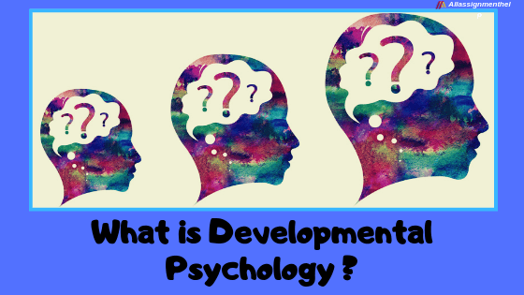

DEVELOPMENTAL PSYCHOLOGY
Developmental psychology is the scientific study that explains how and why human beings continue to change and develop different behaviour during the course of their life span .
Back in the days it was linked with infants and pre- adolescent children, this study has expanded and now includes adolescence, adult development, elderly people , and the rest of the entire lifespan.

This study concentrates and focus on the physical, cognitive, social, , perceptual, intellectual, personality and emotional growth.
There are different types of stages in a human being lifespan which are infancy, adolescents and elderly. Jonh H. Flavel (1971 )
The ages of the stages vary from psychologists to psychologist ,almost all have different ideas on every stage ; many have more than 5 stages or even less than that.
Infancy is the first years of life where the toddler grows up fast physically ( doubles the height and weight, grows teeth )learns how to walk and communication skills.
Adolescent is the transitional stage of growth and development between childhood and adulthood.
An adolescent is considered a young adult and may grow several inches in few months and might have periods of very slow growth, then have another growth spurt.
Puberty (sexual maturation) may differ from person to person it happens gradually or several signs may become visible; for boys is enlargement of testicles ,pubic hair , beards and for girls is enlargement of breast ,pubic hair and menstrual circle.
Elderly is the late stage of adulthood.
The elderly is classified in five basic stages of ageing in older adults: independence, interdependence, dependency, crisis management, and end of life.
This stage is classified as ageing or old age and it starts from age 65 until death( from some psychologists is starts earlier or later on).
In this stage, most of the people retire from their work and no longer have many responsibility of taking care of others. Physically, old age tends to affect older adults and most of the times tend to have a decline of stamina, strength, reflex of time, and the senses.
The essay will concentrate on the life span of infancy, as I have a personal interest in this sector since my future career would focus on working with kids.

I would love to learn how the studies and theories of developmental psychology work so I can understand them better than I do now.
At the moment I’m working as a nanny so this work and research is very useful and will help improve my skills so I can understand the kids I’m working with and be a better career for them.
As I mentioned earlier I will be working and analysing the infancy stage with S. Freud and Piaget theory becomes they are part of the oldest theory’s and they are soo interesting and intriguing.
PIAGET
Piaget was a psychologist of Swiss origin that is recognised in psychology for his great discoveries in child cognitive development ; His studies influenced the education of children in a positive way.

PIAGET’S COGNITIVE DEVELOPMENT STAGES

Sensorimotor | Birth to 18–24 months old | Object permanence
Proportional | 2 to 7 years old | Symbolic thought
Concrete operational | 7 to 11 years old | Operational thought
Formal operational | Adolescence to adulthood | Abstract  Concepts

N.1 Sensorimotor ( from birth to 24 months )
The Sensorimotor stage is one of the first stages of Piaget cognitive development theory and has 6 sub – stages.
1 . Reflex acts [ 0 – 1 month ]
The new born baby responds to stimulations with innate reflexes .
For example if you place your hand near their mouth they have the reflex to suck it.
2 . Primary circular reaction [ 1 – 4 months ]
The infant repeats actions that give him / her pleasure intentionally
For example the infant kick their legs and suck their hands.
3 . Secondary circular reaction [ 4 – 8 months ]
In this sub – stage the infant repeats action that makes him feel pleasure concentrating not only on his body but on objects .
4 . Co – ordinating secondary scheme [ 8 – 12 months ]
The child shows he is capable of making use of the knowledge acquired in the previous sub – stages.
For example the child will grab object and shift objects on is way to do something.
5 . Tertiary circular reaction [ 12 – 18 months ]
This stage is completely different from the previous one; in this stage the child the child explores objects by putting them apart and back together.
For example the child stocks some bricks together and then puts them back in the original form he meet them.
6 . Symbolic thoughts. [ 18 – 24 months. ]
This is one of the most important and fundamental sub – stages of the sensorimotor stage because the child can now form mental representation of objects he’s not viewing at the moment.
McLeod, S. A. (2019, April 09). Sensorimotor stage. Simply Psychology.

N.2 Proportional ( 24 months – 6 years old )
This is the second stage of Piaget’s theory in which the child learns true experience and gains knowledge . Piaget ( 1951 ).
This stage has 8 sub – stages
1 . Centration
The action of concentrating on one situation at a time ; when the child learns to concentrate on more situations at a time he becomes decenter .
In this stage the child has issues with assimilating more than one thing at a time.
2. .Egocentrism
In this stage the child thinks about his own view and doesn’t see other perspectives.
3 . Play
In this stage every child leaves in is world and play’s alone instead of others
4 . Symbolic representation
The child starts to talk and associate words with objects.
5 . Pretend play
The child pretends to be who they are not and at times they have imaginary friends.
They also go over their egocentric period and involve other kinds in their games .
6 . Animism
In this period the child this toys and objects have feelings and can talk like humans.
7. Artificialism
They believe that the some part of the geographic environment is made by a humans .
8 . Irreversibly
This is the inability to reverse the direction of a sequence of events to their starting point.

N.3 Concrete Operational
The third stage contains 6 different sub – stages that are conservation, seriation , classification, Reversibility, Decentering , Transitivity.
This stage start from 7 years and last till 11 years and focuses on the improvement of organised and rational thinking.

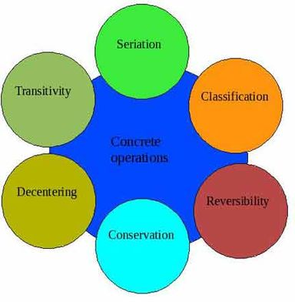

N.4 Formal Operational
The fourth stage lasts from adolescence to adulthood they learned how to make abstract thinking and imagining the consequences of what will happen in the future.

Saul McLeod ( 2018 )

SIGMUND FREUD
S. Freud was an Austrian neurologists and one of the main founders of psychoanalysis .
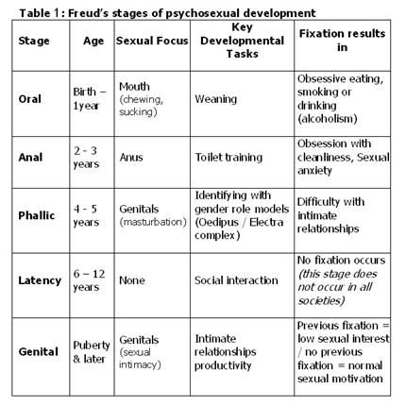

SIGMUN FREUD PSYCHOLOGICAL DEVELOPMENT

According to S. Freud psychological development happens during this psychosexual development stages which are 5.
Psychosexual Development Stages
Personality develops true the activation of human instinct.
Sex is one of the most important instinct that everyone individual has for the rest of their lives and is a biological instinct that needs to be satisfied.
The first sexual experience occurs with non sexual activities but with bodily activities such as eating and body waste.
According to Freud the first 5 years of an individual’s life are critical because they will determine the person the individual will become and the personality they will have.

The 5 stages of Psychosexual Development
Every psychosexual development stage concentrates in a different zone of the body.

Oral Stage ( from 0 – 1 year )
In the first 18 months of life the principal region of activities in the body is in the mouth of the infant
In this stage the child derives pleasure from sucking that involves tactual stimulations and sucking.
Later on when the child’s teeth grow he uses the mouth to bite and chew since the sexual drive is localised in the mouth.
This period the child is concerned on how to gain pleasure so the mother is the main character because the new born baby derives pleasure from breastfeeding.
Breastfeeding is important because it forms a relationship between child and mother .
According to S..Freud feeding is an important moment between the mother and the child because physiologically and psychologically it satisfies the child.

Anal stage ( from 2 – 3 years )
In this stage the child derives pleasure from waste functions .
The child feels pleasure in the anus when defecating then there is erotic stimulation when holding the waste .
The eliminative function gives the child a sensation of comfort and tranquility.
This stage overlaps the previous stage and gives an end to the oral stage.

Phallic stage ( from 4 – 5 years )
In this stage the reproductive organs become the main centre of arousal .
The child plays with his / her genital and feels excitement and pleasure in it .
The sexual activity is linked with urination physiologically and psychically because the child starts to identify his or her own gender .
During this stage sexual feelings start to appear and the arousal and fantasy gives pleasure to the child; this gives way to the Oedipus and Electra complex to come in.
Oedipus complex ( for males )
Oedipus was a Greek king who murdered is dad and married his mother .
This complex explains how male children have this strong attraction for the parent of the opposite sex and dislike the parents of the same sex ( the males what to get ride of their rivals for the love of god their mother ).
The Electra complex shows how the females want to own their fathers and get ride of the father.
This complexes help identify their gender since they identify them self with the parents of the sex.

Latency stage ( from 6- 12 )
In this stage the child focus is no longer on the genital area ; the child starts to concentrate on social interactions , creativity and their academics.
The child changes his attitude because wants to adapt to the social environment so he becomes more cautious about his self; the child leaves his sexual pleasure behind to manifest affection for friends and parents and concentrates his energy to excel.

Genital stage ( from puberty to adulthood 13 years onwards )
In this stage the child is becoming a young adult and the sexual feelings reappears in a stronger way.
In the adolescences period the young adult starts to concentrate on group of friends and Relationships.
The principal function of the genital stage is the one of reproduction.
Tommy Philip ( 2017 )

Psychology in the health and social care
Psychological factors may be the course of mental illness ; severe trauma suffered during childhood may compromise the future of the child that is why Freud and Piaget made this theory’s to help us understand the young one during the crucial phase in their life .
Psychology is a Behaviorism of health discipline practice and contributes healthy behaviour to the quality of life.
In young adult depression and other form of mental illness might occur and to come out of it in the healthy way depends on the environment they leave in.

Conclusion
I’ve learned how a human being develops his cognitive skills from birth to adulthood.
This will help me in my future job with kids and young adults.
The importance of health and social care and the environment contributes a lot to the healthy upbringing of a responsible adult.
BBC

References

Hall Calvin S. and Lindzey Gardner (1998), Theories of Personality, John Wiley and Sons Inc, New York.
https://www.sciencedirect.com/science/article/abs/pii/0010028571900259

McLeod, S. A. (2018, June 06). Jean piaget's theory of cognitive development.
https://www.simplypsychology.org/sensorimotor.html

Jonh H Favel (2004) University of Minnesota
https://www.sciencedirect.com/science/article/abs/pii/0010028571900259

McLeod, S. A. (2019, April 09). Sensorimotor stage.
https://www.simplypsychology.org/piaget.html

Pinterest (2017)
https://www.pinterest.com/pin/44613852536235849/

* Dr. Tommy Philip, University of Delhi, ( 2020 )
https://pdfs.semanticscholar.org/c517/fce869c806850aa79d5df4c3bc157038b963.pdf

Corrigan, P. (2005). On the Stigma of Mental Illness. American Psychological Association: Washington,
https://www.cambridge.org/core/journals/epidemiology-and-psychiatric-sciences/article/stigma-and-discrimination-limit-access-to-mental-health-care/2FA22511D1878BA80162D7FDD891C00A

.

