

The Use of Facial Recognition to Track Peoples Location Within a Building

by
Dylan Evans

Supervisor: Gordon Dickers
Second Marker: Andrew Baker

Project submitted as part of the requirements for the award of
BSc (Hons) Software Engineering

April 2020

Declaration FORM AND FORM OF CONSENT
DECLARATION

I, Dylan Evans declare that I am the sole author of this Project; that all references cited have been consulted; that I have conducted all work of which this is a record, and that the finished work lies within the prescribed word limits.

This work has not previously been accepted as part of any other degree submission.

Signed: 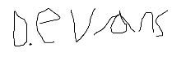

Date: 4/11/2019

FORM OF CONSENT

I Dylan Evans hereby consent that my Project, submitted in candidature for the B.Sc. Software Engineering degree, if successful, may be made available for inter-library loan or photocopying (subject to the law of copyright), and that the title and abstract may be made available to outside organisations.

Signed:

Date: 4/11/2019

ABSTRACT
This report contains the research and implementation of a facial recognition system. This facial recognition system is used to place people’s locations within a building. The author uses the language python to implement his system and has web interface running in the background to place everyone’s location on a map. The author implements his project using the feature driven development programming methodology along with the positivism philosophy.
The author made many personal discoveries which are covered throughout the report. These discoveries include how facial recognition works and how this information can be passed to a support vector machine to classify who is currently in an image, this is done using a dataset containing multiple images of people. During the project, the author hit some barriers due to the coronavirus. The author discusses within this report how he overcame these barriers and recommends any future work.
The author met his aims apart from implementing his own support vector machine, due to time constraints this wasn’t possible. Instead the author modified a pre-existing program to work with his own dataset.

Contents

Declaration FORM AND FORM OF CONSENT ii
ABSTRACT iii
Contents iv
Table of figures vii
Table of Tables viii
1 Introduction 9
1.1 Aim 9
1.2 Objectives 9
1.3 Structure of the Report 10
2 Research and Review of Literature 11
2.1 Introduction 11
2.2 What is Artificial Intelligence 11
2.3 Machine Learning 13
2.3.1 Supervised Learning 13
2.3.2 Unsupervised learning 13
2.3.3 Reinforcement learning 13
2.3.4 Steps Within Machine Learning 14
2.4 What is Facial Recognition 15
2.4.1 Methods of facial recognition 15
2.4.2 Machine Learning libraries 16
2.5 Neural Networks 17
2.5.1 Convolutional Neural Networks (CNNs) 17
2.5.2 Deep Neural Networks (DNNs) 18
2.5.3 Activation Functions 18
2.6 Ethics 19
2.7 Projects Relating to The Authors Research 19
2.7.1 Classification and recognition of dental images using a decisional tree 19
2.7.2 Generalizing Capacity of Face Database for Face Recognition 20
2.7.3 Study of Fault Diagnosis Model Based on Multi-Class Wavelet Support Vector Machines 20
2.7.4 Using Support Vector Machines to Classify Student Attentiveness for the Development of Personalized Learning Systems 21
2.8 Conclusion 21
3 Research and Development Methodology 22
3.1 Research Methodology 22
3.1.1 Philosophy 22
3.1.2 Strategy 22
3.1.3 Risks and Limitations 22
3.1.4 Validity & Reliability 23
3.1.5 Data Evaluation Methods 23
3.2 Development Methodology 24
3.2.1 Software Development Methodology 24
3.3 Resources 25
3.3.1 Software Resources 25
3.3.2 Hardware Resources 25
3.3.3 Information Resources 25
3.4 Conclusion 26
4 Design and Implementation 26
4.1 Problem Formulation 26
4.2 Requirements 26
4.3 Design 27
4.4 Implementation 27
4.4.1 Facial Recognition 28
4.4.2 Web Interface 29
4.4.3 User Guide 30
4.5 Testing 32
4.5.1 Tests Performed 32
4.5.2 Testing images 37
4.5.3 Issues 39
4.5.4 Future improvements 39
4.6 Conclusion 39
5 Evaluation 39
5.1 Introduction 39
5.2 Data Evaluation 39
5.3 Objectives and Aim 40
5.4 Future Improvements 41
5.5 Conclusion 41
6 Conclusions and Recommendations 42
6.1 Summary 42
6.2 Recommendations for Further Research/Work 42
6.3 Conclusion 43
7 Reflection 43
7.1 Introduction 43
7.2 Learning Experiences 43
7.3 Problems and their solutions 44
7.3.1 Hardware issues 44
7.3.2 Concentration Issues 44
7.3.3 Personal Circumstances Due to the Coronavirus 44
7.4 Conclusion 44
8 Bibliography 45
9 Appendices 48
9.1 CODE 48
9.1.1 Web Interface 48
9.1.2 Facial Recognition 51

Table of figures
Figure 1: Support Vector Machine Example [17] 15
Figure 2: Convolutional Neural Network Diagram[27] 17
Figure 3: License Plate CNN Example[29] 17
Figure 4: Activation Functions [33] 18
Figure 5: Nearest Neighbour Algorithm Example [40] 20
Figure 6: Map of Building 27
Figure 7:Testing Image 1 37
Figure 8:Testing Image 2 37
Figure 9:Testing Image 3 38
Figure 10:Testing Image 4 38
Figure 11: HTML Code for Map View 48
Figure 12: HTML Code for Table View 48
Figure 13: TS Code for Location Data Service 49
Figure 14: TS Code for Table View 50
Figure 15: TS Code for Map View 50
Figure 16: Code for MainProgram.py 51
Figure 17: Code for Recognise.py 52
Figure 18: Code for TrainModel.py 53
Figure 19: Code to Show EncodeImages.py 54

Table of Tables
Table 1:Tests 36

Introduction
Artificial Intelligence (AI) is a huge part of the technology industry today. It is used in a variety of different ways. AI is used to simplify tasks which are bothersome for humans to perform. The AI can simplify these tasks by using vast amounts of computing power to complete them a lot faster than humans.

Facial recognition systems are on the rise, they are being used more regularly across the industry even in devices as small as mobile phones. On the latest iPhone’s and Android phones, you can use your face to unlock your phone. People are starting to rely more on the technology as it enhances. With the user’s facial data being stored this causes ethical questions which will be covered within the authors report.

For the main outcome of this report the author will focus on using a pre trained neural network alongside a support vector machine to develop a facial recognition system using webcams/IP cameras.

Aim
The main aim of this report is the development of a facial recognition system using pre trained neural networks. The overall aim is to feed this information to a map so that the user can see where clients are within a building.

Objectives
The objectives are to:
- Research facial recognition establish an understanding of its use cases.
- Provide a literature review of AI and facial recognition
- Review facial recognition libraries to find the most suitable library.
- Code a facial recognition system to recognise people within a building on multiple webcams/IP cameras then save this data to a text file or database.
- Design a map of the building used in the facial recognition system.
- Code a program to take in the data from text file/database and display the information to a map.
- Give the program lots of facial pictures for the algorithm to match the face to a picture.
- Test the program with known and unknown faces to see if there are any errors or unintended behaviour.

Structure of the Report
The project is split into three parts the research work which the author will utilise within his implementation of the system. The research will relate to AI, facial recognition, and machine learning. The second part of the report will outline the implementation of the system and how it was created along with the structure of the algorithms and how they work. The third and final part of the report will discuss the authors findings. Within this section the author will discuss what his algorithm outputted during testing and show the problems discovered along the way. The author will then evaluate his work.
Chapter 1 discusses the overall aims and objectives of the authors project along with an introduction.
Chapter 2 will concentrate on the research and literature which will contain the authors findings within his research.
Chapter 3 will go on to discuss the research and methodologies used within the project.
Chapter 4 will discuss the design and implementation of the system.
Chapter 5 will evaluate the project and display the authors findings.
Chapter 6 will elaborate on the authors conclusions and recommendations for future work.
Chapter 7 the final chapter of the report will show a reflection of the overall work discovered and implemented within the authors project.

Research and Review of Literature

Introduction
This section of the report will cover the research for the authors project. The research includes definitions and history of Artificial Intelligence and Machine Learning. The research will then cover the ethics and definition of Facial Recognition. The section will conclude with projects relating to the authors project.

What is Artificial Intelligence
There are many different definitions of Artificial Intelligence, some have been listed below along with the authors thoughts on them:
“[The automation of] activities that we associate
with human thinking, activities such as decision making, problem solving, learning” [1].

“a branch of computer science dealing with the simulation of intelligent behaviour in computers” [2].

“The ability of a digital computer or computer-controlled robot to perform tasks commonly associated with intelligent beings” [2]

From the above definitions the author believes that the ability to hold knowledge is the main requirement for AI, and what makes the intelligence artificial is that artificial knowledge is defined whereas human knowledge have no limits. The ability to hold knowledge is like a database, but the main difference between AI and databases is that databases are mainly used for collection of data whereas AI can implement this data, AI can take the information and do something with it. The author believes that this is what makes artificial intelligence artificial.
For an AI to function correctly it needs the ability to think humanly, think rationally, act humanly and act rationally.
Within the computing industry many people have different views on what AI is. Some people see intelligence as computational and therefore the states of intelligence can be reproduced within AI. Others judge the behaviour of the AI and use that to determine the success, and the third set of people develop an environment similar to humans so that the AI can reflect human cognition, this way the AI can learn to be as close to human intelligence as possible without displaying general intelligence [3].
At the time of writing this report AI is mainly used to perform a small number of tasks at once or just one, the technology for an AGI (Artificial General Intelligence) is not quite there. According to a survey performed by Vincent C Müllet and Nick Bostrom four groups of experts reported that there is a 50% chance that an AGI would be developed by 2040 or 2050 [4].
The other type of AI which differs from AGI is known as narrow AI this type of AI can only perform a specific task and is the technology used today in computers. For example, the AI used within the Google assistant and Amazon’s Alexa is narrow AI as it can only be taught a specific task. Narrow AI can also be used within video feeds for facial recognition which the author will be utilising within his project. Later in the report the author will cover his use of facial recognition within a building.
“Can machines think” a question which jump started the AI industry asked by Alan Turing in 1950; Turing first introduced the Turing test in 1950 to investigate his question. This test consisted of a conversation between a human and a machine, the machine must be able to convince the human that it is a human in order to be considered intelligent [5].
The origin of artificial intelligence is quite troublesome to pinpoint but one major point in AI history is when science fiction writer Isaac Asimov wrote his short novel Runaround. This is where the three laws of robotics originated:
“(1) a robot may not injure a human being or, through inaction, allow a human being to come to harm.
(2) a robot must obey the orders given to it by human beings except where such
orders would conflict with the First Law.
(3) a robot must protect its own existence if such protection does not conflict with the First or Second Laws [6].”
AI is used in many different areas of the computing industry, the main areas today being personal assistants such as google assistant and Alexa. Amazon is using AI to enhance customer experience by recommending products based upon what the customers have previously ordered. Amazon also uses machine learning to best guess how much stock level they need on a given week, for example if there were a lot of birthdays coming up one week then amazon would make sure that balloons were in high stock [7].
A great example of an AI system which is taking the world by storm is Tesla with their autopilot system [8]. Tesla uses AI to control their cars making them automated, the AI system can also detect when possible collisions are about to occur and apply the brakes. Tesla is one great example which shows how far Artificial intelligence has come throughout the years.

Machine Learning
Machine learning is the ability for computers to learn without being explicitly programmed is an interpretation of a definition by A. L Samuel [9]. Machine learning algorithms are given data and not told what to do with said data. The algorithm will then analyse the information and decide what best to do with it. There are four main methods of machine learning: supervised learning, unsupervised learning, semi-supervised learning and reinforcement learning, these methods will be discussed later in the authors report.

Supervised Learning
Within supervised learning the algorithm is given data and the correct answers, it then tries to make connections between the data and correct answers to come up with an outcome [10].
Supervised learning can be used in many different approaches these include SVMs (Support Vector Machines), LR (Logistic Regression), rule-based classifiers and neural networks. These approaches are linear, but other approaches include probabilistic classifiers which include Naïve Bayes.
Supervised learning techniques use previous and current data with the aid of labels to generate outcomes. The algorithm takes the outcome and compares with the expected outcome in order to determine whether it was successful [11].

Unsupervised learning
Unsupervised learning takes in unlabelled data to find a hidden structure. The algorithm will observe all the data provided to the system by looking at things like characteristics of its observations of the data. One method of unsupervised learning is clustering. In clustering the algorithm can separate data into different clusters to distinguish them for example if an algorithm was created to work out whether someone was a man or a woman in an image the algorithm would separate the dataset into two clusters of men and women [12].
Another learning task would be anomaly detection. The algorithm would calculate what is normal and what is not. Machine learning is most useful performing tasks which humans can perform but are bothersome to perform. For example, if a factory was producing toys a camera could be taking pictures of each toy for humans to check if they are defective, the unsupervised learning algorithm could take these pictures over a few weeks and calculate what’s normal and what’s not. Using this data, the algorithm would be able to detect anomalies which in this case would be defects [13].

Reinforcement learning
Reinforcement learning works by awarding the algorithm when it makes a correct decision this is particularly useful when teaching machine learning algorithms to play games. For example, with a car racing game the algorithm can be awarded when the agent stays on the track or if it goes through checkpoints, with this information the ML algorithm can learn to navigate the track and get better as time goes on. For the agent to be efficient it must favour actions that it has been previously awarded for, but the agent can not only perform previously awarded tasks, the agent needs to explore all options to obtain the best possible method of completing its purpose [14].

Steps Within Machine Learning

- Gather data – All data required for the algorithm is gathered. In the authors case this is facial images, multiple images of different people will be gathered for the algorithm.
- Data Preparation – In this section the data is labelled for the algorithm to use. The data is then organised into sections for the algorithm to differentiate the data. In the authors case the images of different people will be stored in different folders with the folders being labelled with who the photos are of in each folder. Labelling only applies to supervised learning as unsupervised learning takes in unlabelled data.
- Choose model – Once the data is gathered and prepared a model needs to be chosen which is best fitted to the data in the dataset. In the authors case the model best fitted is a support vector machine (SVM) this SVM takes in the images and can compare the data from the dataset to the live data being provided. The SVM will then create a hyperplane in which it will use to classify the data.
- Training – This is the main chunk of the learning; this is where the algorithm takes all the data to improve the overall model by incrementally improving predictions. In the authors case a support vector machine is trained. The SVM is trained by taking in the training data and a weighting factor (C) is allocated. This weight determines how much it needs to avoid misclassifications, a high value will give smaller margins and allow for less classifications but is only recommended when the support vector machine has enough data to train, if the value is set high and the SVM doesn’t have enough data then it may not classify data at all as the margins could be too small [15]. The author decided that it would be best for a low C value of 1 to have a larger margin and allow for more misclassifications but will improve the overall accuracy of the model in the long run.
- Evaluation – In this stage the model will be evaluated to see if it’s any good. The author can evaluate his model by using different faces to check classifications. The author can also look at the confidence value which the SVM outputs to see if it’s a low confidence or high.
- Parameter Tuning – in this section data obtained from the evaluation can be used to tune parameters. In the authors case he can modify the C value to allow less misclassifications if the model is misclassifying a lot.
- Prediction – this is the final stage where the model outputs its prediction based on what it has been asked to predict. In the authors case the model’s prediction will output who it thinks is in view of the IP camera/webcam.

What is Facial Recognition
Facial recognition is on the rise and being used for many different things all the way from access control, identity confirmation, unlocking mobile phones to crime reduction. Facial recognition is a difficult problem as there are many factors which can impact it, things like facial expression, illumination and viewpoint can affect the accuracy [16].
A machine learning method known as support vector machines (SVMs) is an effective pattern recognition used within the facial recognition industry this method will be the focus of the authors research.
Facial recognition is a form of biometric recognition, biometrics are unique and a great way to authorise users in systems like access control. To utilise biometric recognition a system would need to be implemented for the recognition to take place, this would require both hardware and software. Trying to make a bank transfer of a large amount is an example of where facial recognition comes into good use, the user of the application would normally have to get a verification code sent to them or call the bank to verify their identity but with facial recognition all they need to do is look into their camera and their identity is verified.
Facial recognition is not an easy task to overcome as there are many impacting factors on the accuracy including light levels and facial expressions.

Methods of facial recognition

Support Vector Machines (SVMs)
A support vector machine (SVM) is a supervised learning classifier which can be used within facial recognition. An SVM is given labelled training data and then separates this data using a hyperplane. The algorithm takes in the data and calculates the optimal hyperplane this data can be outputted in multi-dimensional spaces an example is shown below
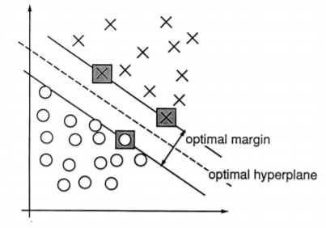
Figure 1: Support Vector Machine Example [17]
From the figure shown on the previous page the support vector machine has calculated the optimal margin and hyperplane. The hyperplanes are used for classification, the hyperplane needs to be the furthest distance possible from the training data for the margin to be functional this is called the maximum margin hyperplane. The larger the margin the less generalisation errors take place within the calculations [17]. In the authors case of face recognition, the data which will be provided to the SVM will be a 4 Dimensional BLOB (Binary Large Object).
Within the authors project the SVM will be utilised to classify recognised faces. The SVM will take a 128 vector of a face then compare it to other faces within the dataset.

Machine Learning libraries
There are many libraries that the author could use to implement the facial recognition side of the project. These libraries will be covered in this section. There are four main libraries which focus on facial recognition these libraries are TensorFlow, OpenCv2, Pytorch and Dlib.

TensorFlow
TensorFlow is developed by google and has an opensource license. The library is supported in the authors chosen language python along with others like C++ and Java. The library uses Cuda which is a framework developed by Nvidia used to utilize the compute cores on their gpu’s [18]. This framework helps improve the speed of machine learning and other tasks the author plans to use cuda as during his testing it was proven that using the cpu for facial recognition was very slow.
TensorFlow facial recognition can implement Google’s FaceNet algorithm, this algorithm takes in the images and converts them into 128 image embeddings which can then be used with support vector machines for classification [19].

OpenCv2
Opencv2 is an opensource library very similar to TensorFlow. The library is supported by python and C++. The library works best alongside Dlib which is a toolkit compiled in C++ containing many machine learning algorithms. The library works in the same way as TensorFlow by taking in the images converting them to 128 embeddings and this can then be used with an algorithm of choice. One library containing a support vector machine which can be used alongside OpenCv2 is scikit-learn. Scikit-learn is built upon NumPy which is used for large multidimensional arrays. This library is perfect for the authors case as the 128 embedding can be stored in array and used within scikit-learn [20][21][22].

Pytorch
Pytorch utilises the GPU for higher performance, in relation to facial recognition the library can be used to detect faces within images and then determine whether the faces match up with someone in the dataset. Pytorch first detects the face then calculates face feature vectors like the previous libraries 128 embeddings. The library then calculates whether the person is in the dataset by using a method known as distance measuring. Distance measuring works by comparing the keys which are stored within the dataset to the current video image being received, the key with the lowest distance will be classified as the best match for the image [23][24].

Libraries summary
In summary the libraries discussed above are all very similar and the author will take all libraries into consideration when implementing his system. From the research the author can see that using GPU over a CPU for calculations is much faster, this is due to the design of GPUs their dedicated core count for calculations is much larger than CPUs, and they can also focus on one task, that task being the calculation, whereas CPUs have to perform multiple tasks which takes up most of their workload.

Neural Networks

Convolutional Neural Networks (CNNs)
Convolutional Neural Networks originated from Yann LeCun in 1998, he took a previous paper titled Neocognitron written by Fukushima (1980) which later became Convolutional Nets, Yann LeCun adapted Neocognitron to become Convolutional Neural nets [25] [26]. Convolutional Neural Networks are used throughout image recognition. Due to the recent advancements in computing power CNNs are becoming more powerful and performance is increasing drastically.
A CNN is made up of convolutional layers, these convolutional layers transform the images they are given in an operation called convolutional operation.
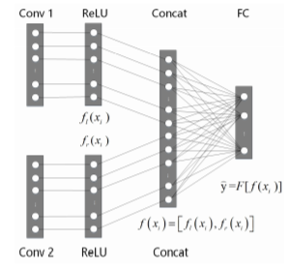
Figure 2: Convolutional Neural Network Diagram[27]
The above diagram shows the structure of a CNN. The CNN works by activating Conv 1, and Conv 2 using the ReLU activation function which will be described later in the report. [27]

Filters are used within CNNs to detect patterns for instance shapes, colours, and textures. For example, if a CNN were given a dataset of bird images it would be able to detect objects such as feathers scales and beaks. A filter is a matrix which the user decides the number of rows and columns, the values of said matrix are randomly generated. For example, if the filter were a 3x3 matrix this filter would convolve across each 3x3 block of pixels and calculate the dot product using the filter matrix. After the calculations are complete there will be a new representation of the image [28]. An example is shown below where a CNN is used to enhance the quality of a license plate:
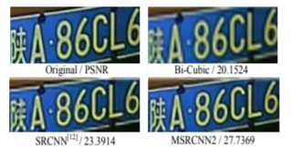
Figure 3: License Plate CNN Example[29]

Deep Neural Networks (DNNs)
Deep neural networks are made up of various nonlinear operations including neural networks with multiple hidden layers [30]. Using feature hierarchies, deep learning methods form the features by using features of lower levels to form the higher layers [31]. Hinton in 2006 proved a theory that improved results can be accomplished in deep architectures when every layer is pretrained using an unsupervised learning algorithm. After this has completed a supervised algorithm can then be used to train the network using a back-propagation algorithm to modify weights [32].

Activation Functions
Within Neural Networks activation functions are used by placing a node at the end of the Neural Network. This node determines whether the neuron will fire or not. The activation function determines the output then decides whether it should be activated “fired”. The activation function also normalises the output making sure that it is either between 1 and 0 or -1 and 1. There are many different activation functions including; Sigmoid, tanh, ReLU, leaky ReLU, Maxout and ELU. A diagram of these activation functions is shown below.
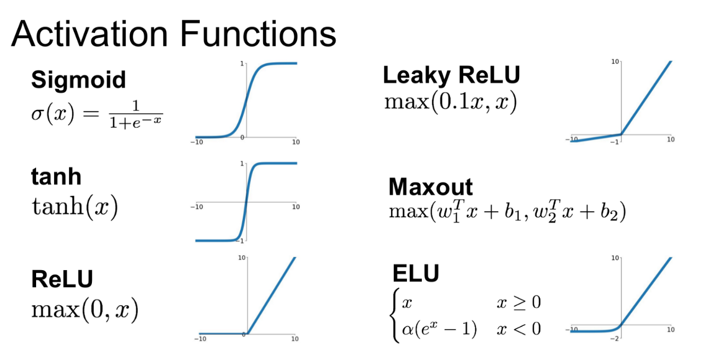
Figure 4: Activation Functions [33]
Below some descriptions of four of these activation functions can be found describing their advantages and disadvantages:

Sigmoid
Sigmoid is an accurate activation function which allows for precise predictions, if X was above 2 or below -2, the Y value (prediction) would be extremely close to 1 or 0. Although, sigmoid is expensive and can cause something known as a “vanishing gradient” this occurs when very high or very low values of X appear. When this “vanishing gradient” problem occurs the neural network can refuse to learn further or learn very slowly [34].

TanH
TanH is very similar to the sigmoid function the only difference being that it is zero centred. This makes it easier for the inputs to be modelled in a way that the values are neutral, strongly positive or negative values [34].

ReLU
ReLU is a non-linear derivative function which allows backpropagation. The ReLU is efficient and the network can converge promptly. Although when the inputs are zero or below then the network cannot allow backpropagation and cannot learn further [34].

Leaky ReLU
Leaky ReLU solves the problem within ReLU where inputs cannot be zero or below. Although the results have a low consistency when it comes to negative input values [34].

Ethics
The ethics of facial recognition and AI is a grey area and needs to be taken into consideration when in use. Phillipa Foot came up with a moral dilemma which is suited to AI “a runaway tram which he can only steer from one narrow track on to another; five men are working on one track and one man on the other; anyone on the track he enters is bound to be killed” [35]. This problem was called the trolley problem. If this problem was for example used within driverless cars what should the car do, should it stay on course and kill five people or steer away and kill one. How would an AI answer this question? It is questions such as the trolley problem which should cause developers of AI to take ethics into consideration.
Another ethical problem at present is the surveillance system being used in China “Skynet”. This system has over 20 million cameras throughout the country which are used to monitor criminals [36]. Who can access this system, and can it be used for other purposes such as spying without consent, again these questions are ethical grey areas. If this system were hacked the criminal hacking the system would have access to find anyone in china at the click of a button, huge security measures would need to be in place to prevent unauthorised users from accessing the system. The authors project has some ethical concerns around the consent of facial images, from the authors research he decided that only images of himself and freely available images on the internet would be used, this method will remove ethical concerns around consent of data, data used within the authors project will be covered later in the report.

Projects Relating to The Authors Research

Classification and recognition of dental images using a decisional tree
The project by Hicham Riri, Abdelmajid Elmoutaouakkil, Abderrahim Beni-Hssane Et Al. This project used decision trees to determine the efficiency of their treatment. The image classification was done via the use of decision trees. The project used over 400 x-ray images from a total of 50 patients. This data was then inputted into the decision tree to determine the type and profile of the patient’s oral treatment. This data was shown to be very successful with a minimum of 86.66% correct classifications.
The author found this project interesting as it uses a different approach to image recognition and was considered while documenting his research [37]. The author determined while the decision trees were a successful method of recognising images, support vector machines would be more suited as they classify facial images more efficiently. The support vector machine within the authors project will classify whether the face on the camera is similar to any within the dataset.

Generalizing Capacity of Face Database for Face Recognition
Stan Z. Li and Juwei Lu developed a face database for face recognition [38]. This project proposed the use of multiple face databases with different facial features, varying in illumination, expression, and viewpoints. They used this data alongside a method called the feature line method, this method uses the nearest neighbour classification to classify variations between features in facial data. The nearest neighbour algorithm works by storing all data based on similarities. the algorithm then checks the nearest neighbour to classify what the data is [39].
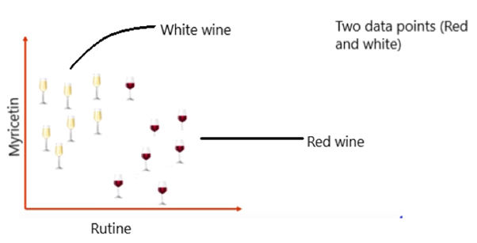
Figure 5: Nearest Neighbour Algorithm Example [40]
As shown in the example above the nearest neighbour algorithm has to determine between red and white wine using the chemicals, when a new item is added to the data set the algorithm would check to see how many neighbours it has of both wines (K value). The algorithm would then determine which K value was higher to classify the data.
The outcome of Stan Z. Li and Juwei Lu’s project was that the “use of the feature
line representation as opposed to the feature point representation improves the error rate for face recognition”[38].
The main difference between this project and the authors is the use of the Nearest Neighbour algorithm is not used within the authors but instead a support vector machine is used. The author will be providing the algorithm with many different facial features this will be discussed within the implementation section later in the report.

Study of Fault Diagnosis Model Based on Multi-Class Wavelet Support Vector Machines
The project by Peng Lv, Da-Ping Xu, and Yi-Bing Liu, used support vector machines to diagnose faults. The support vector machine took in fault diagnoses along with the data of each fault such as extraction flow and water temperature of a heat recycling system. The support vector machine then used this data to classify a fault. The data can be used to identify patterns while the machine is running to classify when a fault is occurring. The outcome of this project was that using the SVM the system was able to diagnose faults within complex systems in an optimized and simple fashion [41].
This project relates to the authors in relation to the support vector machine. The classification of data will be very similar to this project in terms of finding similarity’s within data to minimalize misclassifications.

Using Support Vector Machines to Classify Student Attentiveness for the Development of Personalized Learning Systems
The project by Manus Ross, Corey A. Graves, John W. Campbell, Et. Al uses a support vector machine to classify student attentiveness during lectures. The results of the project were proposed to be used within the teaching industry to improve teaching strategies the data can be shown to teachers/lecturers to determine whether their teaching methods are suitable. Improving teaching strategies would mean that students would be more prepared once they have finished their studies. The results from the project showed the number of attentive/inattentive students by considering actions such as raising hands or raising eyebrows, all this data was then inputted into the support vector machine to classify the data [42].

Conclusion
This chapter has covered the authors research for the Facial Recognition system. The methods used to develop the project have been discussed also the ethics have been researched and covered. The author will take into consideration all the material found within his research and use it while developing the project. The next chapter will cover the research methodology of the facial recognition system.

Research and Development Methodology

Research Methodology
This section will cover the authors chosen methodology and philosophy. The section will cover strategies and approaches used throughout the project. The report will then go on to cover the resources used throughout the project and their reliability.

Philosophy
The philosophy chosen by the author is positivism​. The reason why positivism has been chosen by the author is because this is best suited to a software development project. “Epistemology - what constitutes acceptable knowledge” [43]. From this definition the author can determine that positivism is the best choice for the authors project as the epistemology of positivism fits in well with software development.

Strategy
The strategy chosen by the author is deduction. The reasoning behind this is that it fits in well with positivism. Within deduction the author can use current existing data alongside his own to build a hypothesis. For example, if the aim of some facial recognition software was to determine facial features of a person then the hypothesis of this project would be the more data provided to the algorithm the more accurate the facial feature detection would be. The algorithm used can then be used alongside this algorithm.

Risks and Limitations
There are many risks which could affect the authors project and plans will need to be put in place to overcome them. These risks include:
- University closing down – If the university closed down the author would need to have measures in place to access all of his work from home; this can be handled by making sure work is backed up to the cloud along with other locations in order to work from home.
- Hardware failure of authors resources – If the authors hardware failed then he would need alternative arrangements to do his work on; perhaps an older machine until repairs or replacements can be made on his hardware.
- Data loss – If data were lost during production of the project then this could mean that the author would need to start over. This can be prevented by making regular backups. Data does not exist unless it is backed up in three places, a rule the author follows to keep his data safe.
- Time – If the author misses the deadline of the project then this could be a problem and time management is something which needs to be implemented within his project. The author can manage his time well by creating a Gantt chart.

Validity & Reliability

Validity & Reliability
The best way to investigate the problem of facial recognition within the authors project is to research well and make sure that all possible methods of delivery and implementation are investigated to determine the most reliable. The validity can be determined by checking does the system do what it intended to. In the authors case does the system recognise the faces correctly and display them on the map. A system can be reliable, but it doesn’t make it valid. For example, if shots from a rifle were fired consistently within one section but this section was not the section that was aimed for then this would be reliable but not valid, this is called a non-random error.
In the authors case the measurement will be the percentage of likeliness between the face in view of the camera and the faces within the dataset. This percentage will be calculated by the support vector machine, if the percentage is consistent then the data can be classified as valid.
For the authors research to be reliable he needs to back up his research comparing hypotheses with other similar projects to make sure that his outcome is correct, and the best possible outcome is reached. For the results to be reliable they need to be consistent, so repeated tests need to be performed to determine this.

Data Evaluation Methods

Data Collection
The data that the author plans to use is images of himself under different lighting, different locations and different facial expressions. The author will also use images of people available freely online. The reasoning of this data collection method is that it is the most ethical method. The minimum amount of data that the author would like to collect is 200 images. If the author does not collect this amount of data, the authors hypothesis is that the project will still be a success but not as accurate.

Data Evaluation
The author will evaluate his data by implementing a percentage value of which the face in view of the webcam/IP camera is of likeness to the images within the authors data set, once the value is high the author will know that he has enough data. The authors hypothesis is that the more data provided to the algorithm the more accurate it will be.

Development Methodology

Software Development Methodology
The software development methodology the author has decided to use is Feature Driven Development (FDD). The reason that the author has chosen this methodology is because it is good for lone developers and has a nice set of stages to easily plan and develop the project. A brief description of each stage is found below:
Stage 0: Gather Data – within this stage an accurate understanding of the system trying to be built must be established. This can be accomplished through research and speaking to users of the system to see what they need in order to operate the system.
Stage 1: Develop overall model – within this stage a rough outline of what the system will contain will be formed.
Stage 2: Build Features List – from the information obtained in stage 0 the developer can establish a list of features required within the system.
Stage 3: Plan by Feature – within this stage each features development must be planned i.e. how the feature will be implemented into the system and what technologies would be used.
Stage 4: Design by Feature – within this stage the design of the feature will be implemented, the design of the interfaces will be designed and then implemented.
Stage 5: Build by Feature – within this final stage all features required to make the design work will be implemented. Each feature is given a two-week deadline to complete, any feature which takes longer than this will be split into smaller features to adhere to the two-week deadline. The software will then be tested.

Resources

Software Resources
The software resources required for the authors project are:
- Windows 10
- Python 3.6
- PyCharm community edition (for coding the project)
Libraries within python required:
- OpenCV 2 – Open CV 2 will be used for cropping the images within the dataset to just the facial area. The OpenCV 2 library also is what controls the webcam/IP camera stream and displays them to the screen.
- Dlib – Dlib helps with the facial recognition aspect within Open CV2. Dlib uses the Nvidia cuda library to perform calculations on the GPU.
- Sklearn – Sklearn is the library which contains the support vector machine. The support vector machine is used to classify faces within the dataset by comparing them with the live video from the video feed.
- NumPy – NumPy is used for calculations and basic array cropping/splicing
- Imutuils – Imutuils is used for resizing photos in the dataset and the video feed.
- Pickle – Pickle is used to embed all the encodings into files for python to use them later in the program.
- OS – OS is used to access files within the dataset.
- Time – time is used for sleep functions within the program.

Hardware Resources
The hardware resources required within the authors project are:
- A computer
- Nvidia graphics card capable of running the cuda platform.
- Webcam
- IP camera

Information Resources
The data required within the authors project is:
- Facial images
- Pretrained neural network

Conclusion
This concludes the research and methodology section of his report. The section has covered his development and research methodologies used within the project. The section then went on to include the risks and resources within the project. The next section of this report will cover the design and implementation.

Design and Implementation

Problem Formulation
The problem outlined by the author is a requirement for a facial recognition system with the ability to map people’s locations within a building. The author will need to overcome ethical issues like consent for use of facial data.

Requirements
Below the requirements of the authors project can be found:
- The software must be able to distinguish between different faces. This requirement is an essential part of the project as without it the system will not function. This requirement will be implemented within the build by feature step within the FDD methodology discussed in the previous section.
- The software must display the location of the user based upon the location of the camera. This requirement is also an essential requirement as without the ability to see the location of a person within the building you will not be able to track their location. This will be implemented within the build by feature step within the FDD methodology discussed in the previous section.
- The facial recognition must run at a reasonable frame rate of 10 fps+. This requirement is desirable, the system will function without the ability to run at 10fps+ but it would be easier to look at the camera frames if this requirement is met. This requirement will be implemented within the build by feature step within the FDD methodology discussed in the previous section.
- The map must update in real time. This requirement is desirable as the map would function even if it had a delay of say 10 seconds, but the map would be much more functional if it was Realtime. This requirement will be implemented within the build by feature step within the FDD methodology discussed in the previous section.

- The user interface must be easy to navigate, this is a desirable requirement. The interface doesn’t have to be easy to navigate but would be a lot easier for the user of the interface if it was programmed to do so. This requirement will be implemented within the design by feature step within the FDD methodology discussed in the previous section.

Design
During the authors design of the project he decided that it was best to use an Angular web interface for the map. The author decided that angular was best for this as it is easy to formulate designs in html and CSS and also angular has a feature that the page automatically refreshes on update, this is good for the real time map which will be discussed in the authors implementation of the report. The map was designed using a freely available tool online called floorplan [44] , this map is shown below:
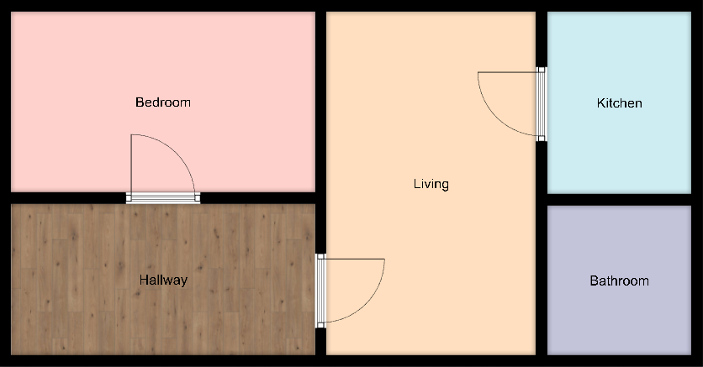
Figure 6: Map of Building
The author will discuss how this map works in the implementation section of the report. The reason why the author designed the map like this is so from the users point of view its easy to recognise where someone is within the building.
The design of the facial recognition software is handled by the OpenCV library[20].

Implementation
The authors implementation is split into two parts, the facial recognition software in python which uses libraries and boiler plate code which will be discussed in this section. The second part is the web interface which is used to display the map of the building which updates in real time.

Facial Recognition
The facial recognition implementation is split into 3 classes encodeImages, trainModel, recognise. These scripts were taken from pyimagesearch [45] and modified to work with the authors data set and the author also made these scripts object orientated for simplicity.

encodeImages
The encode image class takes in the data from the authors data set and checks each file for faces. If faces are detected in a file, the DNN then converts the face into a 128-d vector. This vector contains the encodings of the image the values contain no relevancy but can be compared by an algorithm to find similarities. Once the data has been serialised into a vector this information is stored in a pickle file. A pickle file is essentially just a file format which data can be serialised and then stored within the file data can later be deserialized.

trainModel
The embeddings were extracted in the previous class but in order to be able to recognise someone with these embeddings they need to be used to train the support vector machine within the sckit-learn library. This takes place within the train model class. The class first loads in the 128d-embeddings and attach the labels (person in image) to each 128d embedding. The support vector machine then uses these labelled embeddings to train. The training data along with the labels are then outputted to a pickle file to be used later in the program.

recognise
The recognise class starts a stream to a webcam/IP camera and then the OpenCV library detects for any faces and crops them down to the area. Once the image has been cropped this data is then encoded into a 128-d vector using the DNN. The vector is then given to the support vector machine. The support vector machine decides whether the face in the camera is of likeliness to any of the images in the dataset. The support vector machine then outputs a name either being Dylan, Hayley (the authors mum), Gordon or unknown. The author has then added some code to send this name along with the camera it is detected on to a JSON server, this will later be used by the web interface discussed in the next section.

Web Interface
The web interface is using the framework Angular. The author chose this framework for its automatic refresh when data is updated, this feature complies with one of the authors requirements of the map being Realtime. The files for this web interface are contained in the directory “src/app”. The main file is the app.compnent.html, this file links the two functions of the web interface table-view and map-view. These files are contained within 2 separate folders “src/app/map-view” and “src/app/table-view”. The way that angular works is that it requires 2 files for each component, one being the html page (view) and the other being a typescript file which contains the scripts to load the data on the page. The author has implemented an interface called location-data-service.ts located within “src/app” there is a separate class which then extends location-data-service, this file is called location-json-config.service.ts also contained within “app/src”. These two files are what gets the data from the JSON server which python sends data to. The data service works by sending http requests to the JSON server, the interface has one main function to get all items from the JSON server and receive them as a JSON object. The html files for both table view and map view then use a for each loop (*ngFor directive) to display each item in html. The table view displays the names as table items whereas the map view uses a switch statement ([ngSwitch]) on the camera location to display an image of who is currently in that room, this is done via an if statement (*ngIf).

User Guide

Install guide
- Obtain python 3.6 setup executable from:
https://www.python.org/downloads/release/python-360/
- Install python 3.6 using the setup executable obtained from the python website. Make sure the correct installer for your version of windows is downloaded.
- Install the latest version of Cmake (at the time of writing 3.17.2) make sure to select the installer and not source. This can be obtained from:
https://cmake.org/download/
- Install python libraries by running install.py this is done by double clicking on the install.py after python is installed. If this opens a python editor press F5 to run the program
- install node.js from:
https://nodejs.org/en/download/
- Press the windows key and R and a run box will appear. Type in cmd and press enter. A command prompt will appear
- Use the command cd to change directory into facerecognitonwebapp, for example if the folder is on the c drive in a folder called projects:
cd c:/projects/facerecognitonwebapp
- Once in the facerecognitonwebapp directory in the command prompt type npm install and press enter.
- Once the above command has finished type npm install @angular/cli and press enter.
- Change directory into facerecognitonwebapp/src/assets as you are already in the main directory typing cd src/assets will change directory to the correct folder.
- Once in the src/assets folder Type the command npm install json-server and press enter.

Run guide
- Open a command prompt by pressing the windows key and R then type cmd and press enter. A command prompt will appear.
- Use the command cd to change directory into facerecognitonwebapp. Eg if the folder is on the c drive in a folder called projects:
cd c:/projects/facerecognitonwebapp
- Once in the facerecognitionwebapp folder, type ng serve and press enter
- Minimise the command prompt currently open and open another command prompt by pressing the windows key and R then type cmd and press enter.
- Change directory into “facerecognitonwebapp/src/assets”, for example if the folder is on the c drive in a folder called projects:
cd c:/projects/facerecognitonwebapp/src/assets
- Once in the assets folder type json-server --watch db.json and press enter.
- Open MainProgram.py from the facialrecognitonapp folder in your editor of choice.
- Follow the comments within the file and uncomment the code block specific to your camera setup. There is a code block for a standalone webcam and a code block for a webcam and an IP camera together.
- Camera feed will now load and begin recognition
- Type in the address bar of your browser localhost:4200 and the map will appear.

Testing
Within this section the author will cover the test performed on his face recognition software to show that the software is functioning as expected. The author will also cover unexpected bugs within the software.

Tests Performed
Test Number | Description | Expected Outcome | Actual Outcome | Pass/Fail & Notes
1 | Author looks into camera 1 (bedroom) | Author’s name will appear on software and be sent to the JSON server | As Expected | PASS
2 | Author looks into camera 1 (bedroom) with headphones on | Authors name will appear on software and be sent to the JSON server | As Expected | PASS
3 | Author looks into camera 1 (bedroom) with a hat on | Author’s name will appear on software and be sent to the JSON server | The software initially detects the face as the author but then has some difficulty classifying the image as the author so unknown is displayed | FAIL – The author believes that adding images with hats will solve this problem. This will be investigated in further testing.
4 | Author looks into camera 1 (bedroom) with a hat on after adding images with him wearing a hat | Author’s name will appear on software and be sent to the JSON server | As expected. After adding images to the dataset of Dylan wearing a hat the software recognised him correctly | PASS
5 | Someone within the authors dataset looks at camera 1 (Bedroom) | Person Detected will appear on map in bedroom as a small round image | As expected | PASS
6 | Unknown person not within authors data set looks at camera 1 (Bedroom) | Unknown picture will appear on map in bedroom as a small round image of John Hammond, the author used this image as it is one of the pictures within his unknown dataset | As expected | PASS
7 | Someone within the authors dataset looks at camera 2 (Hallway) | Person Detected will appear on map in hallway as a small round image | As expected | PASS
8 | Unknown person not within authors data set looks at camera 2 (Hallway) | Unknown picture will appear on map in bedroom as a small round image of John Hammond, the author used this image as it is one of the pictures within his unknown dataset | As expected | PASS
9 | Author looks into camera 2 (Hallway) | Authors name will appear on software and be sent to the JSON server | As Expected | PASS
10 | Author looks into camera 2 (Hallway) with headphones on | Authors name will appear on software and be sent to the JSON server | As Expected | PASS
11 | Author looks into camera 2 (Hallway) with a hat on | Authors name will appear on software and be sent to the JSON server | The software initially detects the face as the author but then has some difficulty classifying the image as the author so unknown is displayed | FAIL – The author believes that adding images with hats will solve this problem. This will be investigated in further testing.
12 | Author looks into camera 2 (Hallway) with a hat on after adding images with him wearing a hat | Authors name will appear on software and be sent to the JSON server | As expected. After adding images to the dataset of Dylan wearing a hat the software recognised him correctly | PASS
13 | Author looks into camera 1 comes out of frame then Hayley (authors mum) walks into frame | Author will initially be detected then Hayley will be detected. | Dylan is initially detected when he walks out of frame and then Hayley is detected when she walks into frame, but there is an FPS drop during the change. | Partial Pass - investigation showed that this is due to the update on the JSON server and cannot be resolved. The reason for this is because the facial recognition code waits until the JSON has been updated to continue so the frames will drop while this is in progress.
14 | Author looks into camera 2 comes out of frame then Hayley (authors mum) walks into frame | Author will initially be detected then Hayley will be detected. | Dylan is initially detected when he walks out of frame and then Hayley is detected when she walks into frame, but there is an FPS drop during the change. | Partial Pass - investigation showed that this is due to the update on the JSON server and cannot be resolved. The reason for this is because the facial recognition code waits until the JSON has been updated to continue so the frames will drop while this is in progress.
15 | Partially cover face in front of camera. | Author will be detected at a lower percentage probability | As expected | PASS
Table 1:Tests

Testing images

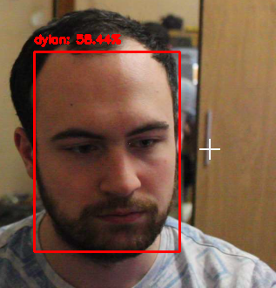
Figure 7:Testing Image 1

The image above shows the author being recognised correctly by the system.

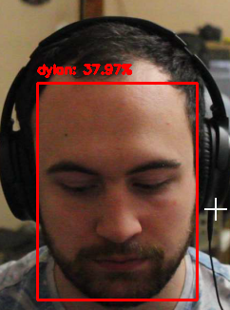
Figure 8:Testing Image 2

The image above shows the author being recognised correctly by the system while wearing headphones

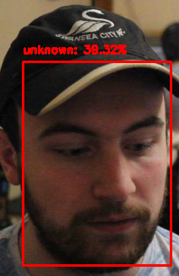
Figure 9:Testing Image 3
The image above shows the author being misclassified as unknown before adding images containing hats to the dataset.

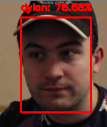
Figure 10:Testing Image 4

The image above shows the author being recognised correctly after adding images containing hats. Notice that the probability of likeliness is also higher after adding more images.

Issues
The author did face some issues during testing as shown above. To overcome these issues the author felt it would be best in future improvements to add more images to the dataset or modify images lighting and effects to help further train the algorithm to train.
The author also had an issue during testing due to the coronavirus. The author would have liked to have tested the system using more unknown faces throughout the university to see if the software would find any similarities and provide misclassifications. Due to the lockdown and social distancing measures this was not possible so the author could only test the software using people within his household.

Future improvements
If the author was to complete this project again to help improve the testing phase he could write automated tests with pre-recorded videos/images. The author could also expand upon the dataset to reduce misclassifications during the testing and deployment stage. Overall, the author is pleased with the results received during the testing phase

Conclusion
To conclude this section has covered the authors design, implementation, and requirements of the project. The next section will cover the authors evaluation.

Evaluation

Introduction
This section will summarise how the authors project meets his objectives. The section will also summarise the authors conclusions of data along with comparisons to the research of literature. The author will then conclude with a discussion on whether he expected these results and what he would do differently if the project were redone.

Data Evaluation
The data within the authors project was used efficiently for maximum accuracy. The author knows that this is true from testing which was shown in the previous section. During testing the author used a variety of faces both unknown and in his data set. The author found that the more data on one person there was the higher accuracy was received. The author also found that people with no images in the data set were picked up as unknown but also other people within the data set with a low percentage of likeliness, this is because the support vector machine can see some similarities but not enough to say with high probability. The author could improve the accuracy of the support vector machine by only allowing outputs of more than 50% likeliness otherwise output unknown, this way it would be less likely for false positives.
The literature review found that the more data provided to the algorithm the higher the accuracy and this has been proven in the authors project.

Objectives and Aim
The author believes that his aim has been met as he has a fully functional system which displays people’s location within a building using facial recognition. Below is documentation proving each objective as a success:
  - Research facial recognition establish an understanding of its use cases.
The author believes this objective to be a success as his research has allowed him to perform the tasks that he has included in his project. The authors research allowed him to decide what method was best to classify different faces. He found in his research that the best option for the algorithm was the support vector machine and this is the algorithm which was used within his project.
  - Provide a literature review of AI and facial recognition
This objective has been met as the author has a completed literature review and within this literature review AI and facial recognition have been discussed and the author strongly believes that it is this research that has made his project possible.

  - Review facial recognition libraries to find the most suitable library.
The author concluded that opencv2 was the best library to use for facial recognition as the program can be run using the gpu which vastly increases the speed of recognition compared to the cpu. This was not the only reason why he believed it was the best library, he found that the library contained multiple functions to help make the classification for the support vector machine easier which is why the author believes this objective was a success.

  - Code a facial recognition system to recognise people within a building on multiple webcams/IP cameras
Due to resource issues and time constraints this objective was not fully met. The author did not implement his own facial recognition system instead modified an existing system to make it work with his map system. The author still sees this objective as a success as the system is fully functional in terms of recognising people and placing their location within the building.

  - Take the data from the facial recognition system save the locations of each detected face to a text file or database.
The author implemented a JSON server to meet this objective. The data of people’s locations was sent from the application to the JSON server to be displayed on the web interface. The author sees this objective as fully met and a success.

  - Design a map of the building used in the facial recognition system.
To meet this objective, the author used an online floor plan creator. The author then placed this image on his web interface. From this image the author believes that this objective is met.
  - Code a program to take in the data from text file/database and display the information to a map.
The author met this objective by using the framework Angular. The author used the framework to get the data from the JSON server and then using CSS coordinates placed an image of who the facial recognition system believes to be in view of the camera.

  - Give the program lots of facial pictures for the algorithm to match the face to a picture.
The author added lots of images to his dataset for the facial recognition system to recognise him correctly. The author did not meet his initial 200 image target, but he found the amount provided was sufficient for the system to recognise the author and other people within the dataset correctly.
  - Test the program with known and unknown faces to see if there are any errors or unintended behaviour.
The author met this objective during his testing stages. He used multiple faces of people within his household to test for any errors. The software behaved as expected but also had some unintended outcomes when recognising unknown faces this was discussed during the testing. The author would also like to mention that due to the coronavirus and the social distancing measures he was not able to test the system with as many people as he may have liked.

Future Improvements
If the author were to do the project again, he would take what he has already learned and improve each aspect of the project. The author would implement his own library for the facial recognition aspect of the project instead of using opencv2. The author believes that if given the time to redo this project there would be a big improvement, the reason behind this is due to the coronavirus. The author believes that the coronavirus has limited him in terms of testing with others and getting face to face feedback from people outside of his household. During the authors research he also found other libraries like TensorFlow and Pytorch, these libraries could also be explored in the future to see if they improve results within the project. The author is particularly interested in using Googles FaceNet in the future as its implementation looks interesting and could create an improvement within the project.

Conclusion
Overall, this section of this report has shown the author that the answers are in line with his hypothesis based upon his literature review and is pleased with the outcome. This section has summarised how he has met his aims and objectives and concluded on the data received from the project. The author also touched upon what he would do if he were to repeat the project. The next section will include conclusions and recommendations based upon everything that he has done.

Conclusions and Recommendations
Within this section the author will summarise the contents of the report/project findings. The author will then bring the section to a close with some recommendations for further research/work.

Summary
The author began his project via a literature review, within this section the author uncovered some research which was helpful in creating his project. The research contained the basis of Artificial Intelligence, Machine Learning, and facial recognition. These technologies are what the author used to implement his project.
After the author completed his research he then went on to research and development methodologies, within this section the author uncovered the methodologies that he would use throughout the project. The methodologies chosen were positivism and extreme programming. This section the author also discussed risks within the implementation and how to overcome them and then went on to cover the resources required.
The design and implementation section covered the design idea for the authors project and how it was implemented. The author also covered why he chose these design ideas and technologies. Once the design stage was completed the author implemented the web interface used to view the map, the author then linked the map to a JSON server which the face recognition software then used to send the data. The section finished off with testing, this section the author used to find any potential bugs or unintended behaviours within the program. The author then went on to cover potential fixes for these bugs.
The author then concluded the project by including the evaluation which contained all the data found within the project and evaluate how successful the project was. The evaluation explained how the aims and objectives were met and left an outline for any future improvements.

Recommendations for Further Research/Work
Within the authors literature review many areas of interest were uncovered. Some of these areas were not fully investigated which in future work the author could investigate these methods more closely to see if there is a way to further improve his work. One of these areas was the k-nearest neighbour algorithm. This algorithm could have proven useful within the authors project as an alternative to the support vector machine. The authors project has endless extendibility, it could be extended to be an attendance system clocking in employees as they enter the building and clocking them out as they leave. The system could also be used as a security/safety measure to see how many people are currently in the building, this could be proven useful in an evacuation or if an employee’s location was needed, a search function could be added to the authors implementation.
The author object orientated the facial recognition system, so adding extra cameras is as easy as creating a new object. The system has endless possibilities and if this project were revisited in the future it could be extended.
The author would implement his own library for the facial recognition aspect of the project instead of using opencv2. The author believes that if given the time to redo this project there would be a big improvement, the reason behind this is due to the coronavirus. The author believes that the coronavirus has limited him in terms of testing with others and getting face to face feedback from people outside of his household. During the authors research he also found other libraries like TensorFlow and Pytorch, these libraries could also be explored in the future to see if they improve results within the project. The author is particularly interested in using Googles FaceNet in the future as its implementation looks interesting and could create an improvement within the project.

Conclusion
This section has covered the basis of the authors report and recommendations for further research, the next section will cover the reflection of the authors project.

Reflection

Introduction
Within this section the author will discuss what he has learned during the project and how it changed him as a person. The author will also discuss what went wrong and what went right and finish off with the issues he faced throughout the project.

Learning Experiences
During this project, the author has learned a lot of new skills throughout the research and development stages. The author has learned about support vector machines, an algorithm which he found very interesting which he could use for future projects. The author also expanded his knowledge on AI and machine learning, a very useful skill to have within the software development industry given the current increase in interest. The author believes that completing the project has been a challenge from start to finish, but nonetheless the author had to find ways to overcome these challenges. The biggest challenge within this project was the coronavirus. The author had to plan around it and change schedules to complete the project. The coronavirus also caused a change in the project, within the testing section the authors original plan was to test the system against multiple faces from within the university, but this was stopped due to social distancing. The author also came across time constraints where he had to scale back parts of his project including the support vector machine he intended to originally write.
With the support and guidance from the authors supervisor he was able to research enough materials to understand and complete the project. After the research was collected the author went to work on implementing the map system to link in with the facial recognition system. For this system, the author used pre-existing knowledge to implement a real time map system.
Overall, this project has changed the author by helping him develop on pre existing and new skills like time management, problem solving skills and planning skills. The author can use these skills in the future to help him within work and life and appreciates everything that he has learned.
The most challenging part for the author was by far the research stage. The author struggled to find material within the facial recognition area due to lack of available material.
If the author were to repeat this project, he would make the facial recognition a secondary aspect so that other areas with more material could be the focus area.
The project also helped the author vastly improve his problem-solving skills due to several problems he came across throughout the project. These problems will be listed in the next section along with how the author overcame them.

Problems and their solutions

Hardware issues
A fan in the authors laptop developed a fault during the project, normally this would only be a minor setback as the author could take the laptop to the shop to be replaced under warranty, but due to the coronavirus this wasn’t possible as all non-essential shops were closed, this included the place of purchase of the authors computer.
To overcome this issue the author asked for support from the university who set him up with a virtual machine which could be accessed from an old computer. This set the author back a few days due to transferring files and setting up development environments on the virtual machine, but the author soon was back on track.

Concentration Issues
Due to the coronavirus the author had to complete his project at home and the use of the university’s facilities were prohibited. This was a problem for the author as he struggled working at home due to distractions of things like tv and games console. The author found working from the university much easier due to the relaxing and distraction free environment. To overcome this the author had to remove all distractions to be able to complete his project.

Personal Circumstances Due to the Coronavirus
During the coronavirus, the author helped with collecting shopping for family members who were unable to leave home. The author did not account for this while planning for his project and therefore lost some time. To overcome this issue and the other issues mentioned in this section the author contacted the university who helped the author and arranged an extension of time due to extenuating circumstances.

Conclusion
To conclude this section the author has summarised what he has learned during the project and what could have gone better. The author has also summarised the issues he came across and how he got around them. This is the final section of the report and below the authors bibliography containing all his references can be found.

Bibliography
[1] R. Bellman, An Introduction to Artificial Intelligence: Can Computers Think? Boyd & Fraser, 1978.
[2] “artificial intelligence | Definition, Examples, and Applications | Britannica.” https://www.britannica.com/technology/artificial-intelligence (accessed Dec. 30, 2019).
[3] J. Finlay, An introduction to artificial intelligence. London: UCL Press, 1996.
[4] C. Ahmet, Artificial Intelligence: How Advanced Machine Learning Will Shape The Future Of Our World. Independently published, 2018.
[5] R. M. French, “Peeking behind the screen: the unsuspected power of the standard Turing Test,” J. Exp. Theor. Artif. Intell., vol. 12, no. 3, pp. 331–340, Jul. 2000, doi: 10.1080/09528130050111464.
[6] M. Haenlein, “A Brief History of Artificial Intelligence: On the Past, Present, and Future of Artificial Intelligence.,” Calif. Manage. Rev., vol. 61, no. 4, pp. 5–15, Aug. 2019.
[7] “What is Artificial Intelligence (AI)? — Amazon Web Services.” https://aws.amazon.com/machine-learning/what-is-ai/ (accessed Jan. 02, 2020).
[8] “Autopilot | Tesla UK.” https://www.tesla.com/en_GB/autopilot (accessed Jan. 02, 2020).
[9] A. L. Samuel, “Some studies in machine learning using the game of checkers,” IBM J. Res. Dev., vol. 44, no. 1–2, pp. 207–219, 2000, doi: 10.1147/rd.441.0206.
[10] I. Kachalsky, I. Zakirzyanov, and V. Ulyantsev, “Applying reinforcement learning and supervised learning techniques to play hearthstone,” in Proceedings - 16th IEEE International Conference on Machine Learning and Applications, ICMLA 2017, 2017, vol. 2017-December, pp. 1145–1148, doi: 10.1109/ICMLA.2017.00016.
[11] R. Saravanan and P. Sujatha, “A State of Art Techniques on Machine Learning Algorithms: A Perspective of Supervised Learning Approaches in Data Classification,” in Proceedings of the 2nd International Conference on Intelligent Computing and Control Systems, ICICCS 2018, Mar. 2019, pp. 945–949, doi: 10.1109/ICCONS.2018.8663155.
[12] H. U. Dike, Y. Zhou, K. K. Deveerasetty, and Q. Wu, “Unsupervised Learning Based On Artificial Neural Network: A Review,” in 2018 IEEE International Conference on Cyborg and Bionic Systems, CBS 2018, Jan. 2019, pp. 322–327, doi: 10.1109/CBS.2018.8612259.
[13] J. Hu, E. Zhu, S. Wang, S. Wang, X. Liu, and J. Yin, “Two-stage Unsupervised Video Anomaly Detection using Low-rank based Unsupervised One-class Learning with Ridge Regression,” in Proceedings of the International Joint Conference on Neural Networks, Jul. 2019, vol. 2019-July, doi: 10.1109/IJCNN.2019.8852022.
[14] R. S. Sutton, Reinforcement learning : an introduction. 1998.
[15] Y. M. Huang and S. X. Du, “Weighted support vector machine for classification with uneven training class sizes,” in 2005 International Conference on Machine Learning and Cybernetics, ICMLC 2005, 2005, pp. 4365–4369, doi: 10.1109/icmlc.2005.1527706.
[16] Y. Adini, Y. Moses, and S. Ullman, “Face recognition: The problem of compensating for changes in illumination direction,” IEEE Trans. Pattern Anal. Mach. Intell., vol. 19, no. 7, pp. 721–732, 1997, doi: 10.1109/34.598229.
[17] C. Cortes and V. Vapnik, “Support-Vector Networks,” Mach. Learn., vol. 20, no. 3, pp. 273–297, 1995, doi: 10.1023/A:1022627411411.
[18] “CUDA Zone | NVIDIA Developer.” https://developer.nvidia.com/cuda-zone (accessed May 05, 2020).
[19] T. Nyein and A. N. Oo, “University Classroom Attendance System Using FaceNet and Support Vector Machine,” in 2019 International Conference on Advanced Information Technologies, ICAIT 2019, Nov. 2019, pp. 171–176, doi: 10.1109/AITC.2019.8921316.
[20] “OpenCV.” https://opencv.org/ (accessed May 05, 2020).
[21] “scikit-learn: machine learning in Python — scikit-learn 0.22.2 documentation.” https://scikit-learn.org/stable/ (accessed May 05, 2020).
[22] “NumPy — NumPy.” https://numpy.org/ (accessed May 05, 2020).
[23] “PyTorch.” https://pytorch.org/ (accessed May 05, 2020).
[24] A. Nigam and P. Gupta, “A new distance measure for face recognition system,” in Proceedings of the 5th International Conference on Image and Graphics, ICIG 2009, 2009, pp. 696–701, doi: 10.1109/ICIG.2009.97.
[25] K. Fukushima, “Neocognitron: A self-organizing neural network model for a mechanism of pattern recognition unaffected by shift in position,” Biol. Cybern., vol. 36, no. 4, pp. 193–202, Apr. 1980, doi: 10.1007/BF00344251.
[26] Yann LeCun, Patrick Haffner, Leon Bottou, and Yoshua Bengio, “Object Recognition with Gradient-Based Learning,” 1998.
[27] T. Wang and L. Ye, “Matching Cost Calculation Model Based on Multi-Scale Convolutional Neural Network,” in 2019 IEEE International Conferences on Ubiquitous Computing & Communications (IUCC) and Data Science and Computational Intelligence (DSCI) and Smart Computing, Networking and Services (SmartCNS), 2019, pp. 185–189, doi: 10.1109/IUCC/DSCI/SmartCNS.2019.00059.
[28] “Convolutional Neural Networks (CNNs) explained - deeplizard.” https://deeplizard.com/learn/video/YRhxdVk_sIs (accessed Jan. 03, 2020).
[29] Y. Yang, P. Bi, and Y. Liu, “License Plate Image Super-Resolution Based on Convolutional Neural Network,” in 2018 3rd IEEE International Conference on Image, Vision and Computing, ICIVC 2018, Oct. 2018, pp. 723–727, doi: 10.1109/ICIVC.2018.8492768.
[30] Y. Bengio, “Deep learning of representations: Looking forward,” in Lecture Notes in Computer Science (including subseries Lecture Notes in Artificial Intelligence and Lecture Notes in Bioinformatics), 2013, vol. 7978 LNAI, pp. 1–37, doi: 10.1007/978-3-642-39593-2_1.
[31] J. Dean et al., “Large scale distributed deep networks,” in Advances in neural information processing systems, 2012, pp. 1223–1231.
[32] G. E. Hinton, S. Osindero, and Y. W. Teh, “A fast learning algorithm for deep belief nets,” Neural Comput., vol. 18, no. 7, pp. 1527–1554, May 2006, doi: 10.1162/neco.2006.18.7.1527.
[33] Udeme Udofia @ Medium, “Activation Functions Image.” https://miro.medium.com/max/1400/0*44z992IXd9rqyIWk.png (accessed May 08, 2020).
[34] “7 Types of Activation Functions in Neural Networks: How to Choose?” https://missinglink.ai/guides/neural-network-concepts/7-types-neural-network-activation-functions-right/ (accessed May 08, 2020).
[35] P. Foot, “The Problem of Abortion and the Doctrine of the Double Effect.”
[36] “‘Skynet’, China’s massive video surveillance network - Skynet is the Chinese government’s video surveillance system, which it claims is for tracking criminals. Under the project, more than 20 million cameras have been set up in public spaces across the country. | Abacus.” https://www.abacusnews.com/who-what/skynet-chinas-massive-video-surveillance-network/article/2166938 (accessed Jan. 04, 2020).
[37] H. Riri, A. Elmoutaouakkil, A. Beni-Hssane, and F. Bourezgui, “Classification and Recognition of Dental Images Using a Decisional Tree,” in Proceedings - Computer Graphics, Imaging and Visualization: New Techniques and Trends, CGiV 2016, May 2016, pp. 390–393, doi: 10.1109/CGiV.2016.82.
[38] S. Z. Li and J. Lu, “Generalizing capacity of face database for face recognition,” in Proceedings - 3rd IEEE International Conference on Automatic Face and Gesture Recognition, FG 1998, 1998, pp. 402–406, doi: 10.1109/AFGR.1998.670982.
[39] B. Wang, Y. Zeng, and Y. Yang, “Generalized nearest neighbor rule for pattern classification,” in Proceedings of the World Congress on Intelligent Control and Automation (WCICA), 2008, pp. 8456–8459, doi: 10.1109/WCICA.2008.4594258.
[40] “Nearest Neighbour Image Example.” https://miro.medium.com/max/1204/1*NDU4K7r-NIAt5lCN4-5EQQ.png (accessed Apr. 16, 2020).
[41] L. V. Peng, D. P. Xu, and Y. B. Liu, “Study of fault diagnosis model based on multi-class wavelet support vector machines,” in 2005 International Conference on Machine Learning and Cybernetics, ICMLC 2005, 2005, pp. 4319–4321, doi: 10.1109/icmlc.2005.1527697.
[42] M. Ross, C. A. Graves, J. W. Campbell, and J. H. Kim, “Using support vector machines to classify student attentiveness for the development of personalized learning systems,” in Proceedings - 2013 12th International Conference on Machine Learning and Applications, ICMLA 2013, 2013, vol. 1, pp. 325–328, doi: 10.1109/ICMLA.2013.66.
[43] M. Saunders, P. Lewis, and A. Thornhill, “Understanding research philosophies and approaches,” Res. Methods Bus. Students, vol. 4, pp. 106–135, 2009.
[44] “Floorplanner - Create 2D & 3D floorplans for real estate, office space or your home.” https://floorplanner.com/ (accessed Apr. 22, 2020).
[45] “OpenCV Face Recognition - PyImageSearch.” https://www.pyimagesearch.com/2018/09/24/opencv-face-recognition/ (accessed May 05, 2020).

Appendices

CODE

Web Interface
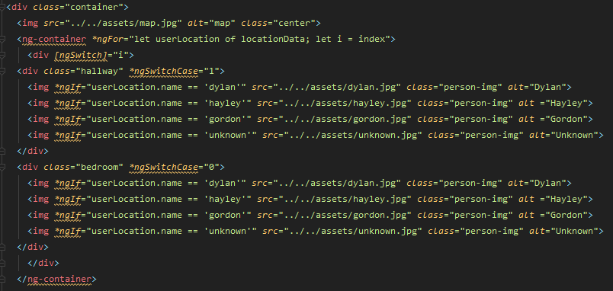
Figure 11: HTML Code for Map View
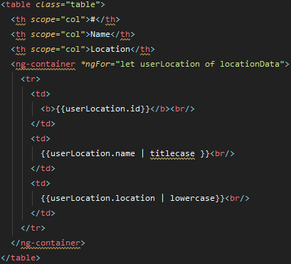
Figure 12: HTML Code for Table View

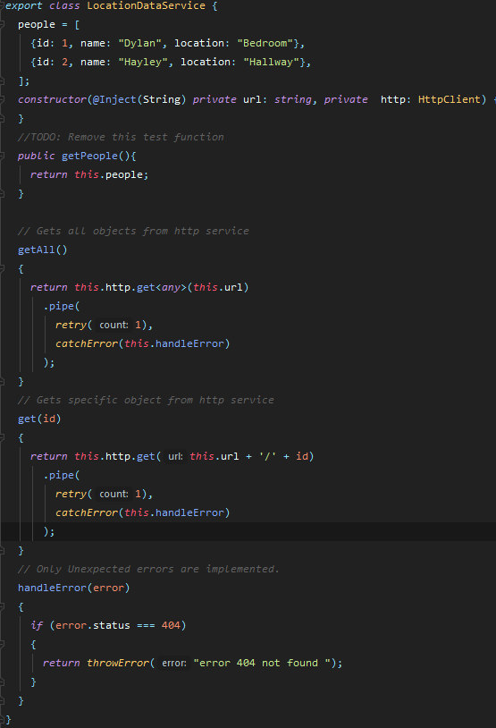
Figure 13: TS Code for Location Data Service

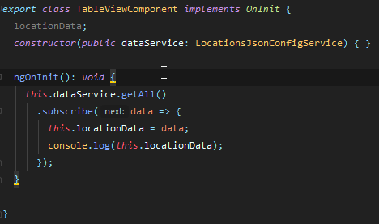
Figure 14: TS Code for Table View
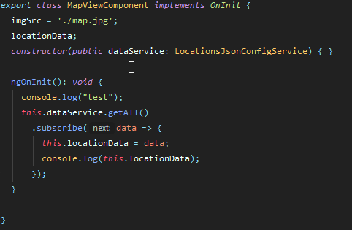
Figure 15: TS Code for Map View

Facial Recognition
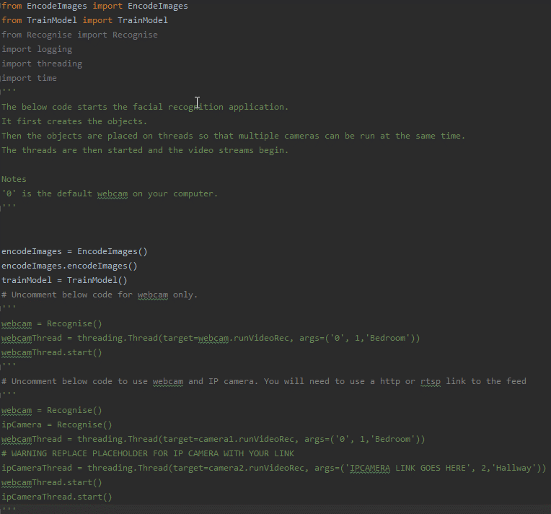
Figure 16: Code for MainProgram.py

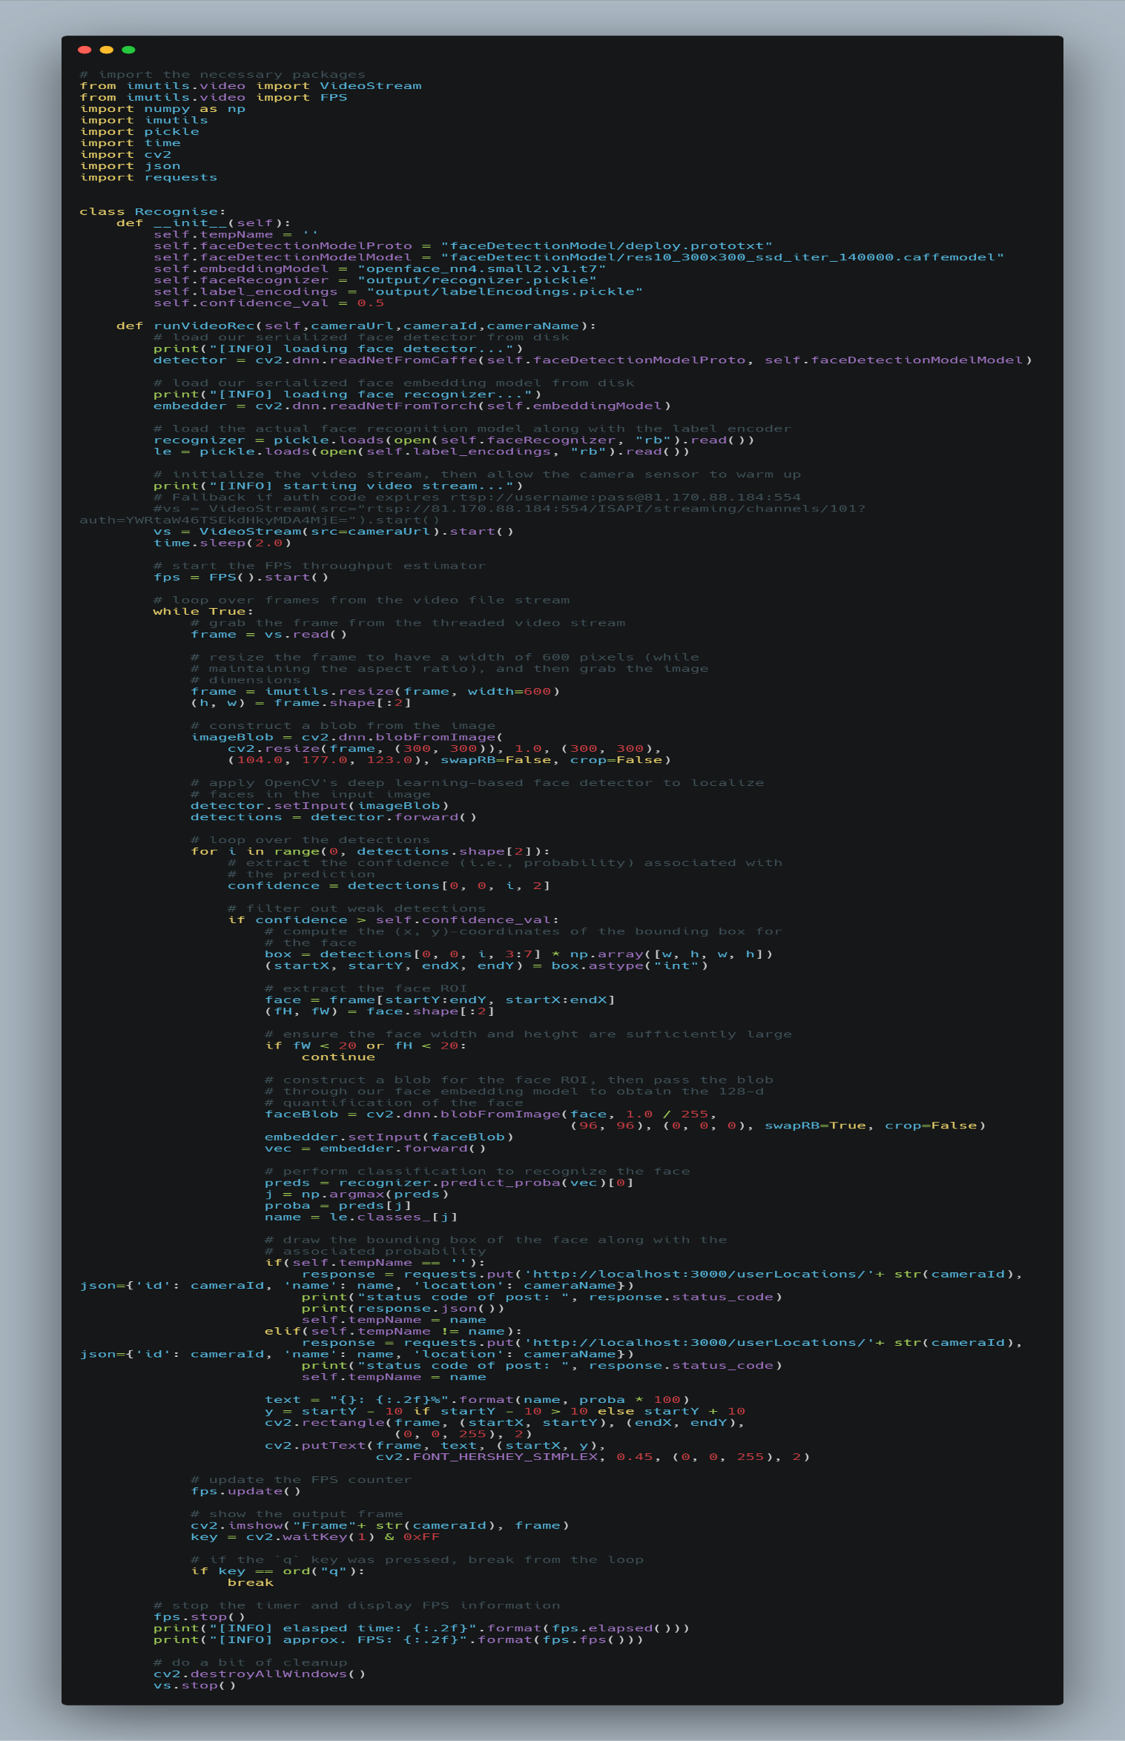
Figure 17: Code for Recognise.py

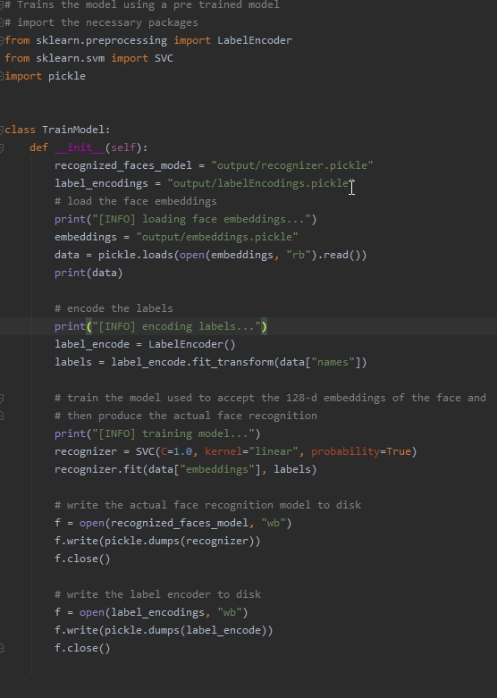
Figure 18: Code for TrainModel.py

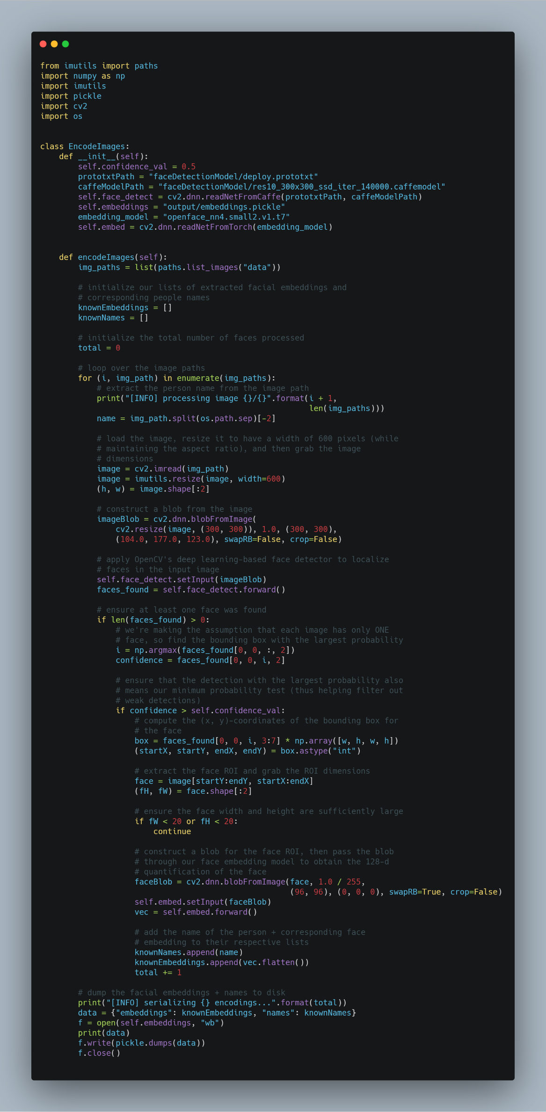
Figure 19: Code to Show EncodeImages.py

