Student Name: Aaron Jack Barry

Module Code: AHMS6004  Module title: Identity and Myth: the Normans and their World | Student number: 1500670
For completion by marker:
Comments:

Marker’s signature: |  | Date:
Provisional mark:
NB. All marks are provisional until confirmed by the final examination board.

What does the artwork commissioned by the Normans tell us about how they wished to be perceived?
Artwork has been used to express many forms and ideals by different people and civilisations throughout history all over the world. Artwork can be used to express power, freedom of speech, religious devotion, and the finality of death. The Normans were no strangers to using artwork to express their power and legitimacy to rule over a land or people and commissioned incredible pieces of art and architecture to cement their dominance. This essay will look into four pieces of Norman artwork that were commissioned by various Normans for the purpose of legitimising their claim on a land, projecting their power across countries, showing their religious devotion, and highlighting their divine right to rule. The pieces being examined are, one, the mosaic of Roger II of Sicily being crowned king by Christ found in Martorana in Palermo, Sicily, two, the Bayeux Tapestry commissioned after the Norman invasion of England, three, the coin of Richard the Lionheart compared with that of his brother, King John, and, fourthly, Durham Cathedral as a piece of art. These pieces will be dissected and investigated to tell us how the Normans wished to be perceived in the artwork they commissioned.
Firstly, to understand how the Normans wished to be perceived in the artwork they commissioned, one must first come to an understanding of what artwork encompasses. To do this, one must look to the Oxford English Dictionary, which describes art as:
‘The expression or application of human creative skill and imagination, typically in a visual form such as painting or sculpture, producing works to be appreciated primarily for their beauty or emotional power.’
By this very definition, anything that takes a visually appealing form, not matter the object, can be constituted as art by one person or another. This could quite easily mean that a building could be perceived as a piece of art, and many Norman buildings are visually impressive and appealing, such as Durham Cathedral.
Secondly, one must come to an understanding of who the Normans were and when they stopped calling themselves Normans, especially in Britain. For the duration of this essay, it should be understood that the author considers that the Norman period in England did not end until the Normans lost their ancestral homeland of Normandy to the French, therefore the seal of King Richard I can be included in this piece of work.
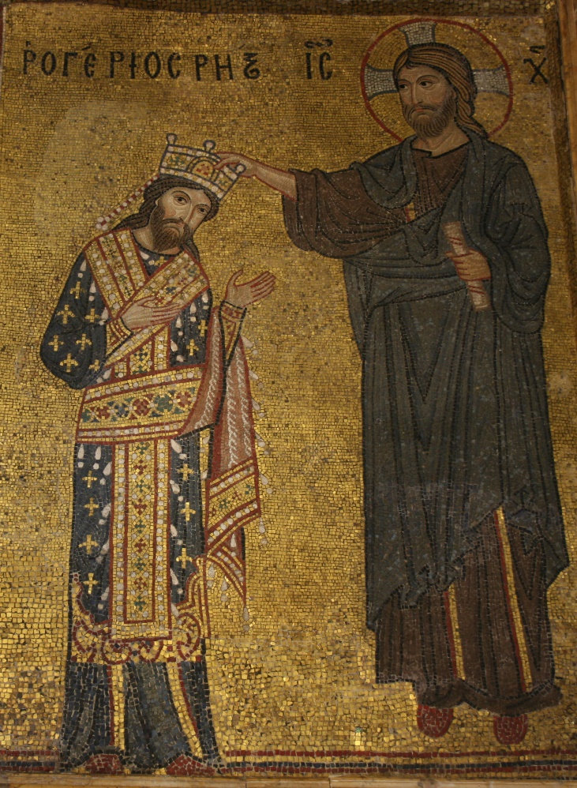
The first image to be analysed will be the mosaic of Roger II of Sicily being crowned by Christ. The mosaic stands out from many others due to several intriguing factors. Firstly, an incredible amount of gold is present in the mosaic, making up almost the entirety of the background and much of Roger’s clothing. This easily highlights the immense amount of wealth that Roger and the Normans who invaded Sicily possessed after the conquest. Roger’s clothes are also half made of gold, allowing everyone who saw the mosaic to witness his vast personal wealth. In comparison, Christ is not clothed in much gold, preferring a simple tunic to the extravagant gold clothing of Roger. Looking into this, it would seem the creator of the mosaic wanted to portray Christ, not as a wealthy man, but as a simple human living as a peasant, as the Bible tells those who read it.
On the other hand, the positions of the two people cannot be missed. Roger is standing on the floor, in a subservient pose, receiving his crown from Christ, whereas Christ is not only standing upright in the presence of a king, but he is also floating above the floor, clearly highlighting that Christ is the king of kings and a transcendent being. That in itself is yet another interesting point. Roger is being crowned by Christ, clearly showing his God given right to rule, despite often disagreeing and sometimes fighting with the Pope, God’s representative on Earth. The creator of the mosaic is obviously trying to legitimise Roger as the rightful ruler of Sicily and all the Norman holdings in Southern Italy by bypassing the Pope and going straight to Christ.
Yet another point to be made concerning the legitimacy of the Normans holding land in Sicily and Southern Italy is the fact that there is Greek writing in the background of the mosaic. Sicily had been a heavily contested island since the Roman times, and was inherited by the Byzantine Empire until an Islamic invasion. Placing Greek writing in the background would have been seen as a sign of tolerance and remembering the past by anyone who viewed the piece and would no doubt have gained Roger some measure of popularity as he assimilated the culture of Sicily rather than destroying it entirely.
All of this combined clearly shows that Roger commissioned this piece to gain legitimacy over his lands. From being dressed almost entirely in gold to show his extravagant wealth and literally being crowned by the king of kings to prove that he is rightful ruler of Sicily, this piece is an excellent example of the Normans commissioning artists and architects to help legitimise their claim to a recently conquered land.
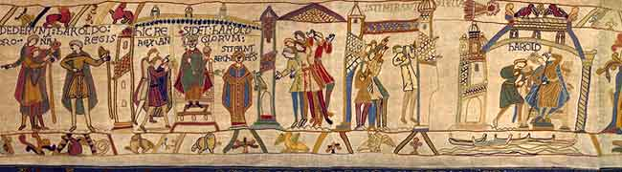
The second image that will be discussed and analysed is a frame from the Bayeux Tapestry. Any part of the Bayeux Tapestry could be analysed as it is all one long image, however, this particular frame highlights how the Normans employed artists to further their own agendas through different forms of media. This does not mean, however, that the author will neglect to mention other parts of the tapestry.
Firstly, the Norman who commissioned the tapestry to be made was Bishop Odo, a relative of King William, therefore one would think his agenda with employing an artist to make the tapestry was clear. For the most part it is clear; Odo was a Norman who saw William’s conquest as just and fair after being supposedly lied to by Harold Godwinson. William appears in many of the scenes, often supported by his relatives, however, the relative who appears most often is Odo due to the fact he is the person who commissioned the piece. This could be taken as fact; that Odo was present by William’s side at all times. On the other hand, Odo could be taking artistic liberties and placing himself in situation that he may not have necessarily been in, furthering his own political agenda.

Secondly, the image shows a part of the Bayeux Tapestry where Harold is crowned King of England after the death of Edward the Confessor, thereby breaking his oath to Duke William that he would hand England to William. The consequences of this action can be seen in the tapestry itself; a comet flying overhead and a fleet of ghostly ships beneath Harold’s seat. The comet itself could be yet another artistic liberty, as comets are often seen to herald a world changing event throughout most cultures, with this event being no particular exception. The comet could also be seen as a sign from God, with this particular comet expressing God’s favour of William’s invasion and His disappointment with Harold for breaking his oath. The fleet of ghost ships is also a premonition of what is to come, and highlights just how great a fleet the Normans could create and therefore making them out to be superior to the Saxons who invaded England five hundred years before.
Thirdly, the money that a project on the scale of the Bayeux Tapestry must have consumed would have been vast. The amount of material, people, and work hours must have been almost inconceivable to an ordinary peasant, and would, of course, have led to them perceiving the commissioner as an incredibly wealthy patron, once again highlighting the wealth the Normans possessed.
The Bayeux Tapestry is a clear indication of the grandeur the Normans wished to be perceived in by everyone who saw the artwork they commissioned. From Bishop Odo conveniently being by William’s side for the majority of the tapestry, to the comet that heralded God’s favour of the Normans and the doom of the Anglo-Saxons, the tapestry clearly highlights just how great the Normans thought they were.
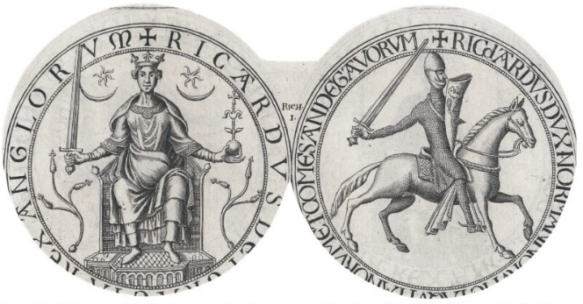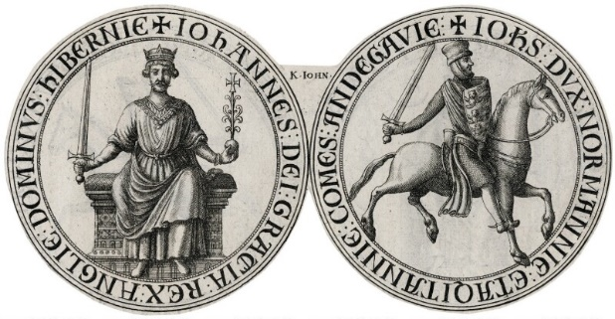
The third image to be analysed and discussed will be a coin depicting King Richard I, or Lionheart. The coin will be compared with that of King John, as the author feels there is much to consider when looking at the two together as pieces of art.
Firstly, the coin of King Richard is very much like that of a warrior king. Richard can be seen seated on a galloping horse with his sword drawn and shield raised, as if he is in battle. This clearly highlights that Richard wanted to be perceived as a warrior rather than a king, perhaps trying to instil fear in his enemies and making him out to be the defender of the realm. He can also be seen to be a strong man, carrying heavy armour, a shield, and a sword, exactly like the knights he would have commanded. On the reverse, Richard is also holding a sword, as he is the protector of England and Normandy, and he is also holding an orb to show he is the King of England.
Secondly, comparing the coin of Richard to his brother King John, there are immediate similarities. John can be seen riding a horse, holding sword and shield and dressed in full armour exactly like Richard. He can also be seen on the reverse holding the sword and orb, once again exactly like his brother Richard. However, history tells us that neither were like what they make out to be, as Richard spent most of his life away from England in Normandy and on campaign against the French and on crusade in the Holy Land. Therefore, he did not really earn the title of administrator. John, on the other hand, was the polar opposite of Richard. John was not a warrior king and lost most of the land held by his ancestors after the death of Richard. Neither was he a very good administrator, as England’s coffers ran dry under his reign.
Therefore, this is another clear indication that the Normans commissioned artists to create false images of themselves. As can be seen on both coins, both kings wanted to be perceived exactly the same way; as warrior kings defending the realm and leading their country into battle, however, only Richard earned that legend. John, on the other hand, was not a warrior king and was not a very decent ruler in general, as history tells us, despite perhaps wishing to be perceived as equal to his brother, Richard.
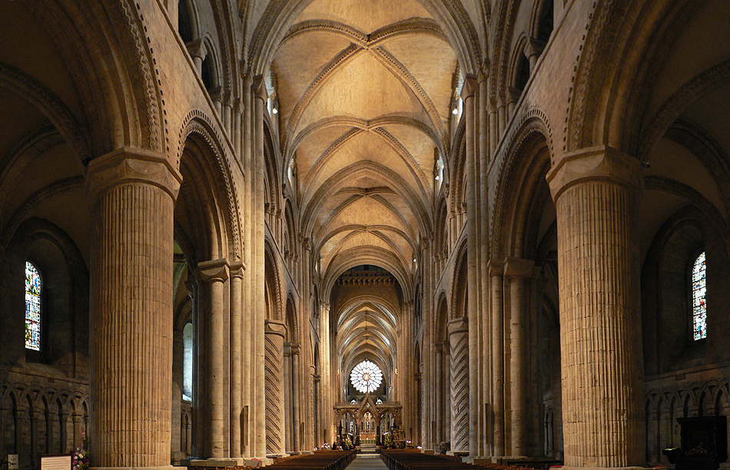

The final image to be analysed will be a photograph of a Norman building; Durham Cathedral. As per the definition of art, Durham Cathedral can be considered a piece of art, and there are many buildings that the Normans constructed in order to be perceived differently.
Firstly, one must look at the building itself. Many Norman buildings, such as castles and cathedrals, were built to emanate power, control, and dominance. Durham is no exception and was used by the Normans to not only promote secular control, but also religious control, as the everyday peasant would see the height and grandeur of the building, and be awed into submission when entering the cathedral to go to mass. The tower is also of a typical square Norman design seen on their early castles and fortifications in the shape of keeps and defensive towers.
Secondly, the interior of the cathedral also promotes power and dominance. The Normans who constructed this building obviously meant for anyone who entered to be amazed at the construction, clearly highlighted by the large columns supporting wide arches and criss-crossed vaulted ceilings, reminiscent of Islamic and Byzantine vaulted ceilings. This would make the Normans seem vastly superior to the Anglo-Saxons and also incredibly skilled as architects. The fact that the cathedral is very long also indicates that the Normans wanted there to be an obvious class divide. As in most churches, the nobility and people of any importance sit at the front, closest to the person reading the Bible and also closest to the altar and the crucifix; the symbol of God. This was intentional, as the majority of the workers and peasants in England after the Norman Conquest were still Anglo-Saxons, whom many Normans thought were inferior.
Thirdly, it is also obvious that the Normans wanted the peasants not only to be filled with awe by the building itself, but also by the amount of money that constructing the cathedral would have cost. As with many parts of Norman and higher society, a person’s status is determined by the wealth they show, for example, Roger II of Sicily. The fact that Durham Cathedral was constructed using one man’s wealth is incredible and would have no doubt made the everyday peasant perceive that man as one of high status and vast wealth.
Therefore, Durham Cathedral is yet another example of the Normans using their wealth and power to commission artists and architects to create vast and impressive works of art and buildings to perhaps be perceived differently from what they really were.
In conclusion, the Normans commissioned many pieces of art and architecture to be perceived in certain lights by different people. Firstly, the mosaic commissioned by Roger II of Sicily clearly highlights his vast personal wealth and the grandeur he wished to be perceived in just by the fact that half of the mosaic is covered in gold. His pose is subservient to Christ as he is being crowned by Him, not by any other religious leader such as the Pope, God’s representative on Earth. The second image, the Bayeux Tapestry, is yet another attempt at showing wealth on a grand scale, and also an attempt at creating a political agenda by Bishop Odo by placing him by William’s side almost every time he is seen, whether true or not. The comet seen in the frame included is also a clear indication of the Normans wishing to be perceived as Godly man, and that God favoured the Normans over the Anglo-Saxons. The images used for the third point also express the fact that the Normans waned to be perceived differently. King Richard I was a warrior king, as indicated by his coin, however, he was not a good administrator and spent more time on campaign than on the throne. King John is completely the opposite, however, and spent more time on the throne trying raise money than fighting for Normandy, even though both of their coins make them out to be warrior kings and protectors of the realm. The final image, the interior of Durham Cathedral, is the final show of grandeur and opulence commissioned by the Normans for this essay. The person who commissioned this vast and expensive project would have been perceived as an incredibly wealthy patron, but also as a religious and God fearing man who gave much to the church. Therefore, it seems that through the analysis of the four images that each one stems from a wish to be perceived differently due to wealth and status. Each project highlights a vast amount of wealth, including the coins, and a wish to be perceived as different people by the majority of others, much like many other projects and pieces of art commissioned throughout history.

Bibliography
Images
Bonjoch, Oliver, Durham Cathedral, 2010 <https://commons.wikimedia.org/wiki/File:Durham_Cathedral._Interior.jpg> [12 January 2018]
Great Seal Of Richard I<https://www.npg.org.uk/collections/search/portraitLarge/mw255283/The-Great-Seal-of-King-Richard-I-the-Lionheart> [11 January 2018]
Luiz, José, Cathedral Of Cefalù, 2015 <https://commons.wikimedia.org/wiki/File:Christ_Pantocrator_-_Cathedral_of_Cefal%C3%B9_-_Italy_2015_(crop).JPG> [10 January 2018]
Seal Of King John<https://www.npg.org.uk/collections/search/portraitLarge/mw209684/The-Seal-of-King-John-from-the-Magna-Carta> [11 January 2018]
Süßen, Matthias, Roger II. Wird Von Christus Gekrönt, Mosaik In La Martorana, 2007 <https://commons.wikimedia.org/wiki/File:Martorana_RogerII2008.jpg> [10 January 2018]
The Bayeux Tapestry <http://www.bayeuxtapestry.org.uk/Images/Bayeux/bayeux14.jpg> [11 January 2018]
Websites
"Art | Definition Of Art In English By Oxford Dictionaries", Oxford Dictionaries | English<https://en.oxforddictionaries.com/definition/art> [10 January 2018]
"Vault | Architecture", Encyclopedia Britannica<https://www.britannica.com/technology/vault-architecture> [11 January 2018]
Books
Duby, Georges, Medieval Art ([Geneva]: Booking International, 1995)
Morris, Marc, The Norman Conquest (London: Windmill, 2013)

"Art | Definition Of Art In English By Oxford Dictionaries", Oxford Dictionaries | English <https://en.oxforddictionaries.com/definition/art> [10 January 2018].
Matthias Süßen, Roger II. Wird Von Christus Gekrönt, Mosaik In La Martorana, 2007 <https://commons.wikimedia.org/wiki/File:Martorana_RogerII2008.jpg> [10 January 2018].
The Bayeux Tapestry<http://www.bayeuxtapestry.org.uk/Images/Bayeux/bayeux14.jpg> [11 January 2018].
Great Seal Of Richard I<https://www.npg.org.uk/collections/search/portraitLarge/mw255283/The-Great-Seal-of-King-Richard-I-the-Lionheart> [11 January 2018].
Seal Of King John<https://www.npg.org.uk/collections/search/portraitLarge/mw209684/The-Seal-of-King-John-from-the-Magna-Carta> [11 January 2018].
"Vault | Architecture", Encyclopedia Britannica<https://www.britannica.com/technology/vault-architecture> [11 January 2018].

