
Reflective Learning Log – Mr Chaudhry Muhammad Asim
Module title: Hotel placement – Managing Food and Beverage Operations.

Module: BMIH6002
Module Lead: Jessica Newport
Student ID: 2246597

AI Acknowledgement:

I conﬁrm that I have not used any AI tools in the research and creation of this assignment. I confirm that I only used ‘’Grammarly’’ on 17.02.2026 for word and sentence suggestions, spell checks and grammar. I have not presented any AI-generated materials as my own work. I confirm that I have copies of my drafts, notes, and other resources I used, which I may be asked to provide as evidence.

Table of Contents
BMIH6002 – Managing Food and Beverage Operations. 1
Reflective Learning Log – Mr Chaudhry Muhammad Asim 2
Introduction 2
Reflection on Experience 3
Linking Theory to Practice 3
Comparison with Marketing and Sustainability Modules 4
Personal Involvement and Learning 5
Conclusion and recommendations………………………………………………………………………………………….……………..5
References 6

Reflective Learning Log – Mr Chaudhry Muhammad Asim

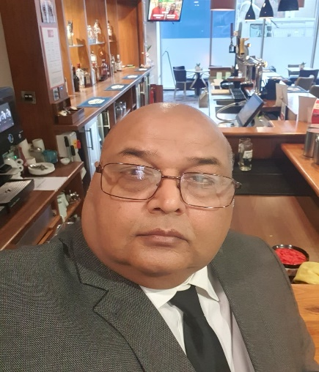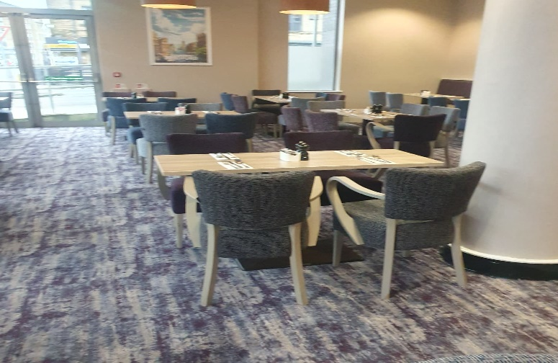

Introduction
Leonardo Hotel Bradford is located at Hall Ings, Bradford BD1 5SH, United Kingdom. https://www.leonardohotels.co.uk/hotels/leonardo-hotel-bradford. It is part of a large group of hotels known to prioritise convenience, comfort, and value. The hotel caters to both business and leisure guests and provides modern facilities including a full-service restaurant, bar, gym and several meeting rooms. During my placement, I worked in the Food and Beverage department under the supervision of Helena Graham, F&B manager. The total number of staff in F&B is 10.
The Food and Beverage section oversees breakfast service, bar snacks, conference catering, and evening meals. The department can serve around eighty guests in the main dining area, with extra space available in the bar. My experience enabled me to observe strengths in teamwork, sustainability practice, and menu consistency. However, one operational issue that I particularly noticed is the insufficient focus on sourcing local ingredients and the need for more systematic monitoring of food waste. This reflection examines that issue through theoretical perspectives linked to the Marketing and Sustainability modules.

Reflection on Experience
During an evening shift, I assisted Helena in reviewing weekly orders. I noticed that most supplies came from national distributors, despite the hotel being situated near local food producers. When I questioned this, she explained that it is the policy that is decided by the head office, and they choose all the vendors for supplies. And mostly they are National operators rather than local. She also hinted that previous trials of local suppliers had raised concerns about availability and pricing. Later, she pointed out how excess food sometimes had to be discarded due to inaccurate ordering.
As part of my involvement, I supported stock checks and discussed portion sizes during breakfast service. Helena mentioned that informal practices were used to reduce waste, such as carefully managing buffet replenishment, but no structured process was in place. This made me consider how food waste could be better tracked and how procurement could support more sustainable choices.

Linking Theory to Practice
The issue of waste management can be effectively examined through the Circular Economy Model (Ellen MacArthur Foundation, 2013). This approach encourages organisations to redesign operational processes to minimise waste by reusing, recycling, and regenerating resources rather than following traditional linear methods. Within the Food and Beverage context, this could involve using locally sourced seasonal produce, adjusting order quantities based on demand forecasting, and developing menu flexibility.
Walker (2021) notes that guests increasingly value hotels that demonstrate visible environmental responsibility. Implementing circular practices could enhance both operational efficiency and brand reputation. For example, if ingredients are sourced locally, their lifecycle could be shortened, reducing storage requirements and waste. Surplus produce could be repurposed into alternative dishes or redistributed through community networks. Speaking with Emma Rhodes (The general manager), she told me that there has always been a waste management policy in place however the new similar recycling scheme came into force in March 2025(Department for Environment, Food & Rural Affairs, 2024)

Lean Operations Theory (Womack and Jones, 2003) advocates removing inefficiencies through continuous improvement, enhancing forecasting and reducing the need for corrective actions. Better operational communication between front-of-house and kitchen staff boosts efficiency (Johnston, Clark and Shulver, 2012). In this hotel, ‘’systems thinking’’ was absent (Senge, 2006), leading to duplication and waste. Herzberg’s Two-Factor Theory (1959) emphasises staff motivation; involving employees in decisions, such as the F&B staff, Helena and Emma, in purchasing or waste monitoring, could increase engagement. Employee participation in system design fosters accountability (Rutherford and O’Fallon, 2007).

Comparison with Marketing and Sustainability Modules
The Marketing module highlighted how consumer perception is shaped by authenticity and social responsibility. Kotler, Bowen and Makens (2020) explain that promoting local sourcing can boost guest loyalty and differentiate the hotel's image. Discussing this with Emma made me reflect on how the hotel could market sustainability as part of its identity.
Insights from the Sustainability module, particularly Dias (2024), emphasised that meaningful environmental practices require structured monitoring. Informal actions, though well-intentioned, often fail to produce lasting change. Applying this knowledge, I proposed tracking waste more systematically, potentially presenting the data to senior management to justify strategic changes.
Leonardo’s sustainability policy is established by the head office. During my discussion with Emma, she mentioned that management recognises that sustainability largely involves changing people's mindset to understand its importance and the broader consequences of inaction as a company. They conduct annual assessments with Green Tourism, where each hotel must complete a portal detailing activities and policies for evaluation. She also informed me that they are currently rated as silver but have just submitted their application to the gold committee in the hope of advancing. Additionally, Leonardo hosts monthly training sessions on their online portal, all focused on Leo Care, their commitment to the environment, community, and people.

Personal Involvement and Learning
By participating in stock checks and discussing improvement opportunities with Emma and Helena, I gained confidence in communicating operational insights. I assisted Helena in drafting an initial waste observation sheet for breakfast service. Presenting the idea to Emma helped me enhance my professional communication skills. I realised that practical outcomes rely on both evidence and collaboration.
This experience also reinforced the importance of balancing theoretical knowledge with operational practicality. I realised that change must align with financial and quality objectives to be viable. Working with different staff members helped me develop leadership awareness, as I learned to approach change tactfully.
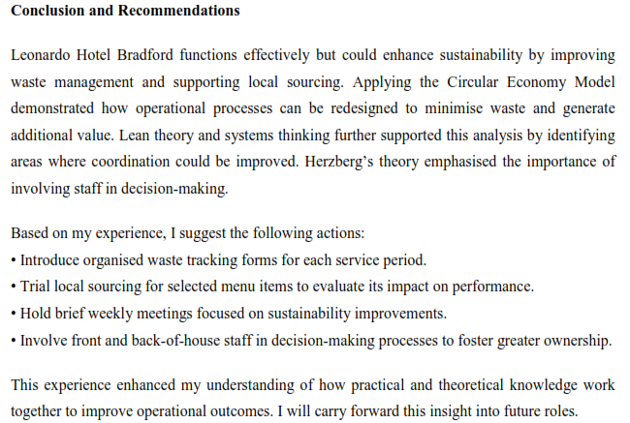

References
Department for Environment, Food & Rural Affairs (2024) Simpler recycling: workplace recycling in England. GOV.UK. Available at: https://www.gov.uk/guidance/simpler-recycling-workplace-recycling-in-england (Accessed: 17 February 2026).
Dias, A.L. (ed.) (2024) Cases on innovation and sustainability in tourism. Hershey, PA: IGI Global.
Ellen MacArthur Foundation (2013) Towards the circular economy: economic and business rationale for an accelerated transition. Available at: https://ellenmacarthurfoundation.org (Accessed: 11 February 2026).
Herzberg, F., Mausner, B. and Snyderman, B.B. (1959) The motivation to work. New York: John Wiley & Sons.
Johnston, R., Clark, G. and Shulver, M. (2012) Service operations management: improving service delivery. 5th edn. Harlow: Pearson.
Kotler, P., Bowen, J.T. and Makens, J.C. (2016) Marketing for hospitality and tourism. 7th edn. Harlow: Pearson.
Leonardo Hotels (2026) Sustainability at Leonardo Hotels: making a valuable contribution. Available at: https://www.leonardohotels.co.uk/sustainability (Accessed: 17 February 2026).
Rutherford, D.G. and O’Fallon, M.J. (2007) Hotel management and operations. 4th edn. Hoboken, NJ: John Wiley & Sons.
Senge, P.M. (2006) The fifth discipline: the art and practice of the learning organisation. Rev. edn. London: Random House Business Books.
Walker, J.R. (2021) Introduction to hospitality. 8th edn. Harlow: Pearson Education Limited.
Womack, J.P. and Jones, D.T. (2003) Lean thinking: banish waste and create wealth in your corporation. Rev. edn. New York: Free Press.

