Sports Infrastructure and Design Assignment

Contents Page
Part A:
Part B: Page 3-7
Part C: Page 8-10
Part D: Page 11-13
Part E: Page 14-18

Part A

Part B
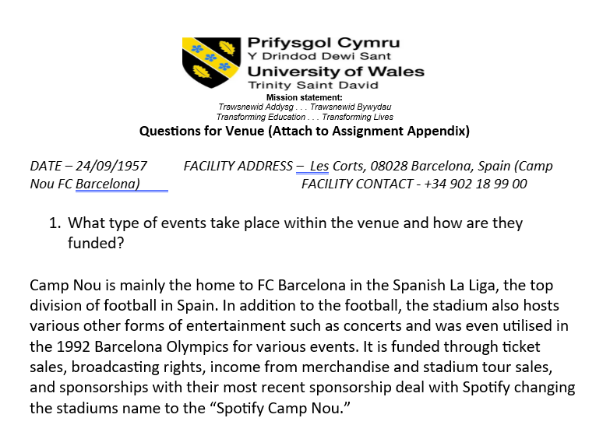
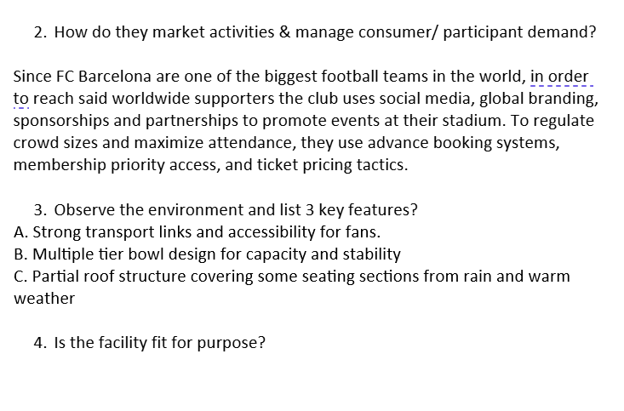
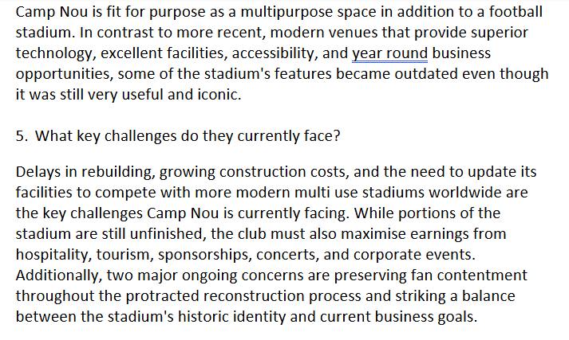
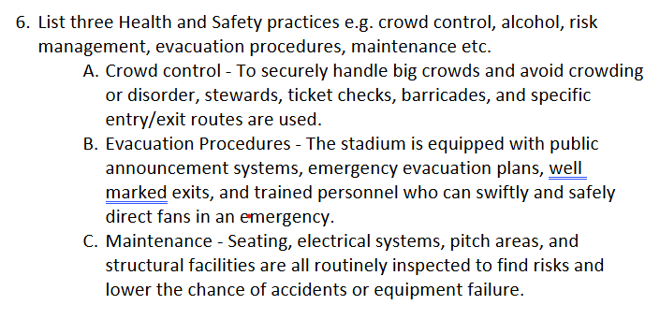
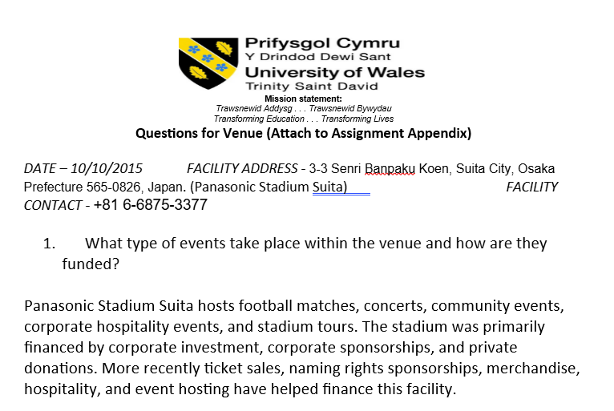
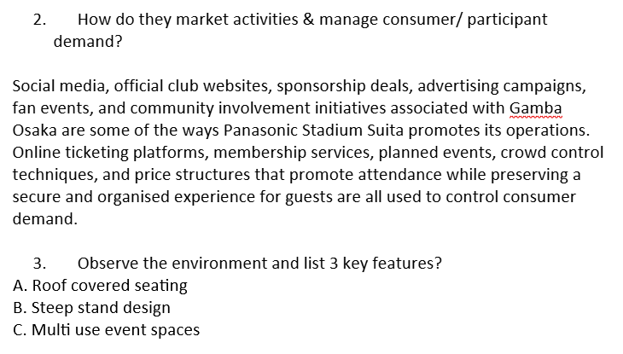


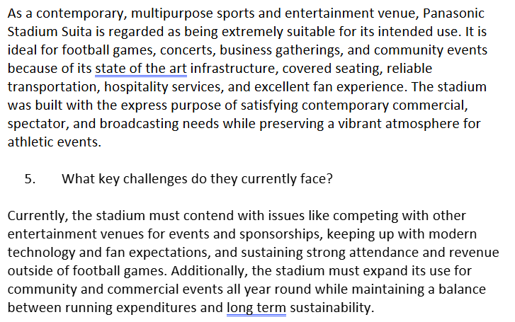
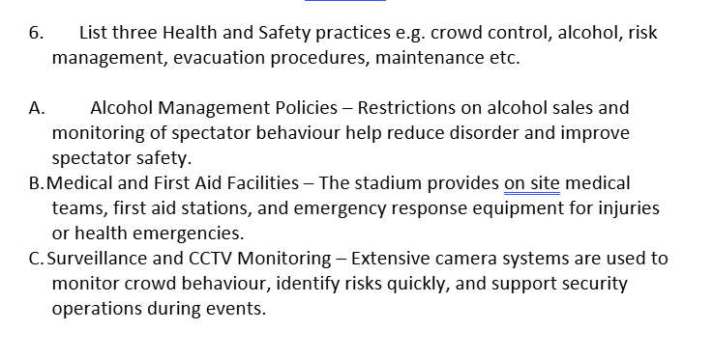

Part C
According to the results of question 1, 59% of participants have season tickets, whereas 41% of participants don't. This indicates that most supporters are devoted fans who frequently attend games. Season ticket holders are crucial since they generate steady income and enhance the atmosphere at games. The organization does, however, also rely on casual supporters, as evidenced by the high number of non season ticket holders. In order to entice more infrequent visitors to buy season tickets in upcoming seasons, Ospreys Rugby should concentrate on retaining as many season ticket holders as possible while simultaneously developing incentives like discounts and prizes.

According to the question 2, 31% of participants said that their child was in Ozzie's Army, 49% answered no, and 20% of participants were unapplicable. This implies that there is room for improvement in family interaction. The goal of Ozzie's Army is to draw in younger fans and foster a lifelong loyal fanbase at the club. The high proportion of those who answered no could be a sign of poor advertising or low awareness of the of the scheme. Participation levels could be raised by expanding family focused marketing, school collaborations, and family friendly events on matchdays. Strong youth involvement is crucial because it fosters the next generation of supporters and enhances the events general family friendly environment.

Question 3 found that 53% of supporters knew about the new Ticketmaster ticketing system, but 47% did not. Even though the majority of respondents were aware of the system, the findings show that a considerable number of people are not aware and therefore point to communication flaws. Effective marketing and straightforward instructions are necessary when introducing new technologies to minimise customer confusion. The fact that almost half of supporters were not aware of the system indicates that marketing tactics may need to be more effective. Social media, email updates, and stadium announcements could all be methods in which awareness can be raised by Ospreys Rugby. In future seasons, supporters would feel more at ease utilising new ticketing systems with clearer instructions and tutorials.

For question 4, supporters were asked to rate their ticketing experience on a scale from 1 to 5. According to the findings, the majority of respondents at 47% chose rating 3, whereas fewer chose ratings 2, 4 and 5 (2-26%, 4-31%, 5-16%) and no one chose 1. This suggests that fans thought the ticketing experience was mediocre rather than outstanding. The low number of top ratings indicates that there is still room for improvement, even though the findings were typically more positive than negative. Supporters expect rapid, dependable, and convenient ticket purchasing methods. Therefore, in order to boost consumer satisfaction in next seasons, The Ospreys should concentrate on increasing efficiency, decreasing difficulties, and making the process more user friendly.

The majority of fans bought tickets in person (38%), followed by online (24%), and their rugby clubs (17%), according to question 5. Smaller numbers used their employers (4%), schools (6%), half time activity (15%), and over the phone (13%). These results imply that supporters continue to favour traditional methods of making purchases. However, given the growing use of digital technologies in sports, website ticket sales were lower than anticipated. This could indicate that supporters are either less comfortable with the internet or prefer in person communication. In order to satisfy the demands of various client groups, Ospreys should maintain a variety of purchase alternatives, enhance digital accessibility, and keep pushing online booking methods.

The results of question 6 showed that only 35% of supporters were aware of the flexi ticket offer, while 65% were unaware. The flexi ticket offered both flexibility and value for money by enabling fans to purchase tickets for numerous games at a reduced cost, but most fans were unaware that the offer was available. This implies that the company's marketing tactics were unsuccessful. To raise awareness and boost ticket sales, the club should enhance promotion advertising through social media campaigns, email marketing, stadium announcements and collaborations with rugby clubs.

For questions 7a and b, they were only applicable to those who have purchased their tickets online. For 7a 50% of participants have their tickets sent to them by post, 38% have an eticket to be printed off at home and 12% of participants were unapplicable since they don’t purchase their tickets online. For 7b, 30% answered that they were aware that etickets were now availiable, 31% said that they were unaware, while the remaining 39% didn’t answer at all since this question doesn’t apply to them. This implies that a lot of fans still do not properly understand or utilise digital ticketing techniques. The club should emphasise the ease of digital ticketing and give more precise information on etickets. On matchdays, increasing awareness could cut expenses, shorten lines, and boost productivity.

For question 8a, the surveyed participants were once again asked to rate their experience on a scale of 1-5, though this time regarding the usability of the online ticketing website. 43% answered 3, 39% answered 4 and 18% answered 5. Question 8b asked the participants who answered 1 or 2 to justify their answer, but since no one answered 1 or 2, there were no responses for 8b. This implies that while the website was useful and generally simple to use, it could still be improved. Consumers want websites to be quick, easy to use, and mobile friendly. Supporters may be deterred from buying tickets online by a badly designed ticketing website. The club should keep enhancing the layout, usability, and mobile friendliness of the website. Increased consumer satisfaction and more supporters using digital ticket purchase systems would result from quicker loading times and an easier checkout process.

Question 9a asked supporters to rate the new access control scanners installed at the stadium. All respondents gave ratings of 3 (34%), 4 (44%) and 5 (22%), showing generally positive opinions about the technology. Once again 9b asked for those who voted either 1 or 2 to justify their answers, but since no one did yet again there is no need to analyse those answers. Because they shorten wait times, enhance crowd control, and make matchday more enjoyable, efficient entry methods are crucial. The encouraging results imply that fans valued the quicker and better organized stadium access procedure. When properly implemented, technological investments can increase customer satisfaction and operational efficiency. In order to preserve great customer experiences, Ospreys should keep an eye on fan comments about stadium admission methods and make additional adjustments as needed.

For question 10, 66% of participants said that they would be interested if the club offered pre ordered food, beverages and merchandise online during matchdays in the concourse while 34% claimed to be uninterested. This is evident that supporters wanted faster service and lower costs on matchdays. Long lines during halftime might lower customer satisfaction and restrict fans from experiencing the event to the fullest. Waiting times would be shortened and convenience would increase with the introduction of fast track collection systems. Additionally, by boosting productivity and promoting higher food and beverage expenditures, this would help the organization. The results of the study show that there is a substantial consumer desire for quicker service options, so Ospreys Rugby should seriously consider putting this system into place.

For the final question, it asks if pre purchases were utilized by the club 46% said they would most use it to purchase alcohol, 54% said they wanted meal deals, and an additional 34 more participants say that they would also want to purchase matchday programmes. This suggests that supporters place high value on affordability and convenience during events. Food and beverage promotions are likely to encourage greater spending while also improving customer satisfaction. Matchday programmes were less popular, which may reflect the growing use of digital media instead of printed content. Ospreys Rugby should focus on offering attractive food and drink packages, student discounts, and family meal deals. Providing value for money is essential for improving supporter experiences and encouraging repeat attendance.

Part D
The future development of sports and leisure facilities in Wales is influenced by a variety of factors, including public health priorities, demographic change, financial pressures, sustainability goals, technological innovation and social inclusion. Sources from the Welsh Government, Sport Wales and wider leisure sector research highlights how these factors are reshaping the planning, funding and management of facilities across the country. As participation trends evolve and public expectations change, sports and leisure facilities are increasingly being viewed as essential community assets that contribute to wellbeing, economic development and environmental sustainability.

The growing emphasis on physical activity and public health is one of the biggest motivators. According to research, obesity, physical inactivity, and mental health disorders are becoming more prevalent in Wales (Welsh Government, 2021). Sports and recreational facilities are now viewed by policymakers as crucial instruments for enhancing public health outcomes. The objective of building "an active nation where everyone can enjoy sport for life" is highlighted in Sport Wales' Vision for Sport in Wales (Sport Wales, 2023). This has prompted the creation of facilities that put participation and well being ahead of just elite performance. As a result, modern leisure facilities are developing into hubs for community wellbeing that house social areas, health programs, and exercise centers.

Another significant factor influencing future facility development is demographic shifts. Due to Wales' ageing population, facilities need to be more accessible and accommodate the older population who might prefer low impact activities like walking, swimming, and circuit training. In contrast to traditional club sports, younger generations are increasingly engaging in flexible and unstructured activities (Welsh Government, 2022). The need for more versatile and multipurpose facilities has arisen as a result of this change in participation patterns. Sport England's research from 2022 indicates that flexible spaces that can accommodate a range of recreational activities throughout the day are expected to replace single purpose sports halls in future leisure facilities.

The future of sports and leisure services in Wales is also heavily influenced by economic factors. In addition to managing aged infrastructure and rising operating expenses, many local governments are dealing with shrinking resources. Public leisure centers are under more stress due to rising energy costs, and some are in danger of closing. According to Sport Wales (2024), one of the main issues facing the industry is financial viability. As a result, future advancements will increasingly concentrate on building facilities that are more economical to run. Energy saving technology like solar panels, LED lighting, and better insulation are increasingly being invested in because they lower long term operating costs and help achieve environmental goals.

Environmental sustainability is another major driver of future sports facility development in Wales. The design, renovation, and administration of leisure centers are being impacted by the Welsh Government's dedication to reaching net zero carbon emissions (Welsh Government, 2021). To lessen the impact on the environment and running expenses, recent investments have concentrated on low carbon technologies and renewable energy (Sport Wales, 2024). It is anticipated that future amenities will encourage active travel, sustainable building design, and reduced carbon emissions.

Social inclusion and equality are also important factors in the future development of sports and leisure facilities in Wales. Following the COVID 19 pandemic, research revealed inequalities in involvement by gender, income, and ethnicity (Sport Wales, 2023). Future facilities are therefore anticipated to be more accessible and inclusive for all users. This entails enhancing accessibility for those with disabilities, expanding possibilities for women and girls, and offering reasonably priced facilities to underprivileged populations. The Welsh Government has made investments in initiatives that assist marginalised communities, especially in grassroots sports and women's football (Welsh Government, 2023).

Another factor changing the sports and leisure sector is technology. Through wearable fitness equipment, online reservation systems, and virtual workout classes, digital innovation is transforming how people participate in physical activity. According to Sport England (2022), the success of public recreation facilities in the future depends on digital transformation. Smart building technologies are being used by numerous leisure providers in Wales in order to track energy consumption and enhance operational effectiveness. Additionally, technology helps facilities stay competitive with home workout options and private sector clubs. In order to improve customer experience and boost involvement, future innovations are probably going to incorporate more digital services.

In conclusion, the future development of sports and leisure facilities in Wales is being shaped by several factors. Public health concerns, demographic changes, economic pressures, environmental sustainability, social inclusion and technological advancement are all influencing how facilities are planned and operated. Literature suggests that future facilities will need to become more flexible, accessible and environmentally sustainable while supporting wider community wellbeing. As a result, sports and leisure facilities in Wales are evolving beyond traditional recreation spaces and becoming central components of public health, social development and sustainable communities.

Reference List:

Department for Digital, Culture, Media and Sport (2023) Get Active: A Strategy for the Future of Sport and Physical Activity. London: DCMS.

Sport England (2022) The Future of Public Leisure.

Sport Wales (2023) Vision for Sport in Wales.

Sport Wales (2023) Strategic Equality Plan.

Sport Wales (2024) £3m Spent on Improving Sports Facilities and Leisure Centres.

Welsh Government (2021) Healthy Weight: Healthy Wales. Cardiff: Welsh Government.

Welsh Government (2022) National Survey for Wales: Sport and Recreation.

Welsh Government (2023) Investment in Women’s Sport Facilities.

Part E
This facility development plan proposes the construction of a new multi purpose leisure centre in Swansea. The proposed facility, named the Swansea Bay ActiveLife Leisure Centre, aims to address gaps in local sport and recreation provision while driving long term participation growth across Swansea and the wider region. The project has been developed around Sport England principles including accessibility, sustainability, community engagement, and long-term financial viability. An unoccupied piece of land on Fabian Way, close to the Swansea Bay waterfront, and next to important transit routes has been selected as the development's site. The site may be redeveloped without affecting the current housing communities because it is currently underutilised and mostly unoccupied. Its location offers excellent transportation access to the city center of Swansea, the surrounding schools, the university campuses, and neighbouring residential districts such SA1, St Thomas, and Port Tennant.
The Swansea Bay ActiveLife Leisure Centre's main goal is to boost sports participation rates among all age groups by offering innovative, reasonably priced, and welcoming facilities that serve both recreational and competitive users. Football, rugby, swimming, and community fitness are all part of Swansea's strong sporting culture, but many of the city's current recreational facilities are outdated and dispersed unevenly. The planned facility would establish a cutting edge athletic hub that could assist school programs, elite athlete development, grassroots sports, and community wellness.
The chosen location is strategically located between the Swansea University Bay Campus and the city center of Swansea. There is adequate room on the undeveloped property for a sizable leisure center, a car park, outdoor activity spaces, and landscaping. The location has good road access from the A483 and Fabian Way corridor, as well as connections to bus and bicycle routes. Accessible facilities are crucial for raising activity levels, according to Sport England participation data (Sport England, 2024). Participation in organised sport and physical activity is lower in deprived parts of Swansea than the national average for Wales. Barriers like cost, accessibility, confidence, and a lack of modern facilities are also identified by Sport Wales research as the main causes of the reduction in teen and adult participation rates (Sport Wales, 2023). These problems would be directly addressed by the construction of the Swansea Bay ActiveLife Leisure Centre, which would offer accessible community memberships, facilities that are inclusive of people with disabilities, spaces specifically designed for youth activities, school sport partnerships, community health initiatives, greater access to swimming facilities, and more opportunities for women and girls to participate in sports.
With a modern glass front and a view of Swansea Bay, the planned facility is a two story structure. In order to facilitate accessibility and navigation, the facilities are arranged around a central reception area.

To accommodate swimming lessons, rehabilitation, and leisure use, the indoor facilities would contain a 15 meter learner and therapy pool in addition to a 25 meter eight lane competition standard swimming pool. Along with a multipurpose sports hall that can hold four badminton courts and a variety of indoor sports, the facility would also have a fitness suite with a special functional training and strength zone. Additional facilities include an indoor five a side football pitch, a dance and aerobics studio, a spin cycle studio, a martial arts studio and an adaptable community activity suite. The facility would also have a sports rehabilitation and physiotherapy clinic in addition to sauna and steam rooms to promote health and wellness. While meeting rooms and educational classes will encourage community initiatives and collaborations with nearby schools, Swansea University and UWTSD Swansea, the social spaces would feature a cafe and seating area with a view of the coastline.
The outdoor area would have a multipurpose games area that could accommodate a range of leisure activities in addition to a floodlit 3G artificial football and rugby pitch intended for community and club use. An appealing social setting for tourists and locals would be created by manicured waterfront dining areas and public recreational green spaces. To promote sustainable and active travel, the property would also have an outdoor exercise track, bike parking, and electric vehicle charging bays. Instead of just being a sports facility, these outside features would help turn the location into a community center. The building footprint would be about 3 500 square meters, while the entire site area including parking and outdoor sports facilities would be more than 30,000 square meters.
A significant part of the project is environmental sustainability, which reflects the UK's current requirements for public leisure developments (UK Active, 2023). The Swansea Bay ActiveLife Leisure Centre would use energy efficient technologies, such as solar panels, rainwater harvesting systems, LED smart lighting, air source heat pumps, and heat recovery systems connected to the swimming pools, in accordance with Sport England guidelines and contemporary environmental standards. The facility would strive for a BREEAM excellent environmental rating while lowering long term operating expenses via energy efficiency (Welsh Government, 2022). Additionally, the site's surrounding landscaping would enhance biodiversity and make the waterfront area more appealing.
Increasing physical activity levels across Swansea is the facilitiy's main goal. Children, students, families, elderly people, and individuals with disabilities are just a few of the many categories that the institution is intended to serve. One of the biggest growing areas that the project would help would be swimming participation. A learner pool would help solve the problem of many Swansea schools not having enough pool time for swimming training. Swansea would also be able to host regional swimming competitions and events thanks to the eight lane competition pool. Badminton, basketball, volleyball, indoor football, and community sport programs would all be supported by the multipurpose sports facility. Collaborations with local organisations and educational institutions would optimise the use of the facilities all day and night. While rehabilitation facilities will assist injury recovery, the gym and fitness areas would cater to both casual customers and serious athletes. The facility's services could also include community health referrals via NHS Wales. Holiday sports camps, after school programs, and discounted memberships would all promote youth involvement. Swansea's student body is expanding, and the city's proximity to Swansea University offers chances for student memberships and sports science cooperation. By generating jobs in management, coaching, maintenance, hospitality, and sports development, the center would also promote local employment.
The leisure centre is expected to cost around £24 million to develop. Swansea Council investment, Sport Wales and Sport England subsidies, Welsh Government development funds, National Lottery support, and private sponsorship would all contribute to the budget. Memberships, swimming lessons, sports hall reservations, café sales, and community collaborations would all be used to fund the facility. A thorough company plan would guarantee long term financial viability while keeping prices reasonable for locals.
In conclusion, the Swansea Bay ActiveLife Leisure Centre would provide Swansea with a modern, inclusive, and sustainable sporting facility capable of increasing participation across all age groups. The development would improve access to sport, support community wellbeing, and encourage healthier lifestyles through high quality indoor and outdoor facilities. By following Sport England principles and focusing on long term sustainability, the project would become an important community hub and a major sporting destination within South Wales.

Picture of the Facility
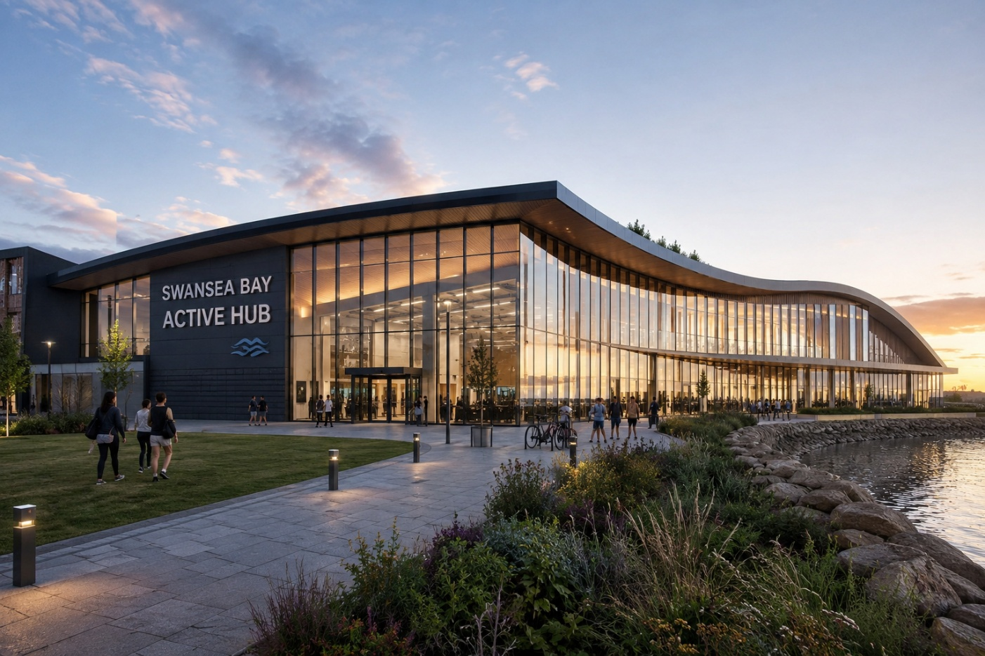

Floor Plan
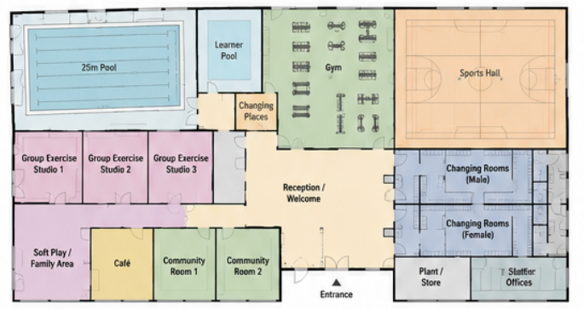
Area of Construction
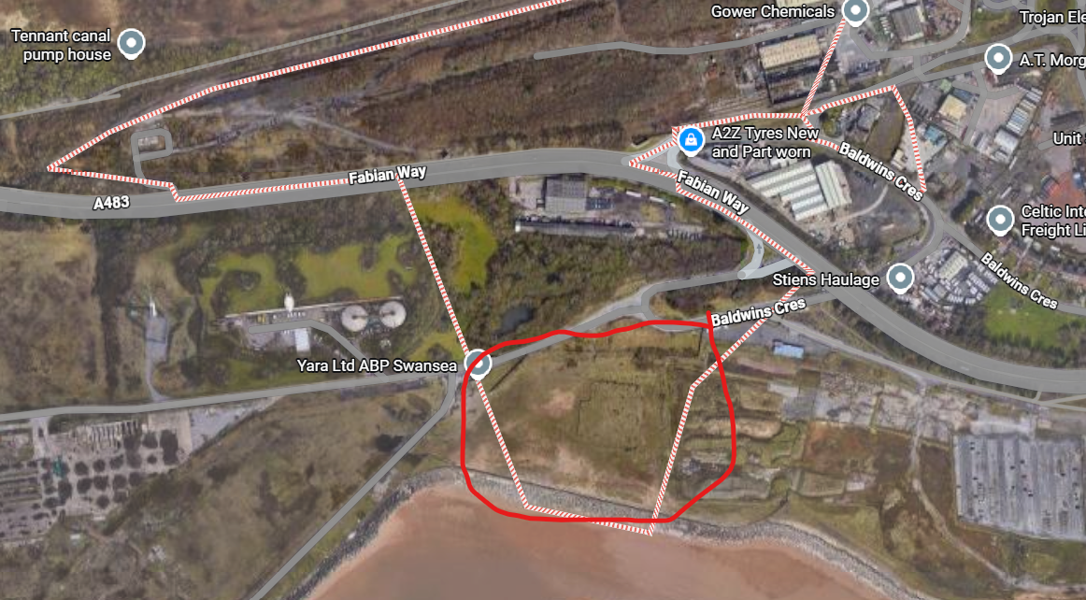

Reference List
Sport England (2015) Selby Leisure Centre Case Study. London: Sport England.
Sport England (2024) Facility Design Guidance. London: Sport England.
Sport Wales (2023) School Sport Survey and Participation Reports. Cardiff: Sport Wales.
Welsh Government (2022) Healthy Weight: Healthy Wales Strategy. Cardiff: Welsh Government.
UK Active (2023) Future of Public Leisure Facilities Report. London: UK Active.

