As with most aspects of modern life, digital, mobile and social media technology has its advantages and disadvantages. During the recent pandemic, for example, many children were able to continue learning in virtual classrooms but evidently missed out on many of the socialising aspects of school life and some struggled to even access the work not having a suitable device (Kraalingen et al., 2022). Similarly in the field of outdoor education digital technology has its advantages. In a recent assessment, we were able to analyse a critical incident that had been recorded using digital technology. We were able to see a “virtual” first-hand how an accident unfolded and review the way that those involved responded in a valuable and safe learning experience. However, review of the incident might also cause us to consider whether the principal might have been more focused on the incident if he were not trying to record it for his social media channel. This essay will critically analyse and review the effect and impact that the inclusion or exclusion of digital, mobile and social media technology can have on outdoor education and learning.
In the last decade as technology has become more mobile, it has become possible for society to use modern technology to access information anywhere and anytime as Bolliger and Shepherd (2018) state. The development of these technological tools has spawned their integration and use in most aspects of modern life. Students today can use the internet to research using their phones where earlier generations were limited to printed material and note taking. Shoppers can check that items are in store from their armchairs, and we can post pictures of holidays, outings or even lunch for friends and family to share. Inevitably these technologies have found their way into the outdoor adventure and education field.
“The last 10 years, in particular, have seen a virtual explosion of technological developments in the outdoors, ranging from clothes to equipment such as signaling devices and protective gear…communication is the area experiencing the fastest technological growth” (Ewert and Sibthorp, 2014, pp.168-169)
As Ewert and Sibthorp (2014) point out those accessing the outdoors have GPS units and smart phone applications that tell them where they are, where they are headed and potentially how to contact emergency services, all coming together to make outdoor adventure more accessible to more people. Improved accessibility is not without benefits, however. In 2016 the Ramblers Big Path Watch encouraged volunteers to adopt a section of the national network and feedback details of condition using a smartphone application which informed the maintenance and promotion of the network. (Recreation Alliance, 2016)

In discussing the effect of digital technology on outdoor education it is important to understand the relationship between young people and technology today. It is argued that digital and social media technology has now become an integral and compulsory part of young people's lives, both in how they communicate and present themselves in the world. (Kraalingen et al.,2022; Hodkinson, 2018; MacIsaac, Kelly and Gray, 2017). This is supported by evidence "The report, based on a survey of 2,167 UK five- to 16-year-olds, said 53% of youngsters owned mobile phones by around the age of seven." (PA Media, 2020). Although there are advantages to young people being technologically savvy there are also notable disadvantages. The integration of digital and social media technologies into young people's lives allows connectivity with people the world over. This became particularly evident during the COVID-19 pandemic as, during the various lockdowns when face-to-face social interaction was impossible, young people could still maintain relationships over social media. Reed (2020) highlights this pointing out that during the pandemic young people were likely to have relied upon their social networks more than ever. Such connectivity is not without risk, however. "Information...could spread widely and almost instantaneously" (MacIsaac, Kelly and Gray, 2017). Some information, regardless of its truth can reach so many people so quickly that it can have a profound impact on a young person's health, wellbeing, self-perception and social interaction.
With care personal image or identity can be developed and curated, an extension of the image that can be created by our choice of clothes and music, for example. Our online persona can allow us to connect with people who share similar interests and ideas; it can promote a way of life or certain activities (i.e., climbing, hiking, canoeing etc.); it can empower others (i.e., #outdoorwomen) and is a way to have a personalised space (teenage bedroom metaphor, Hodkinson, 2017). Gordon (2022) explains that “Social Media Is a Source of Authentic Support” as teens with more obscure interests can find support and community online.
Conversely, some may feel the need to fit in and feel pressure to develop an image that conforms to idealised standards set by mass media (i.e., celebrities, social media accounts with a large following or current trends). This can be evidenced in the work of MacIsaac, Kelly and Gray (2017) finding that for young people social status can be linked to diet or how the body looks with looking 'good' becoming synonymous with being thin and 'awful' being synonymous with being fat. This is also evident in the work of Gray et al. (2018) being troubled by burgeoning use of social media to create a public image through idealised eyes, whilst also stating that an idealised body can also endorse guilt-inducing messages, stigmatisation, objectifying connotations, and unhealthy restricted eating.
Such digital literacy and interdependence should inform the use of technology in outdoor adventure education. Some might argue that outdoor adventure education should be technology free to give students a break from the pressures of the digital world. They might further argue that authentic, real world, technology free experiences are the only way to protect young people from the pervasiveness of the web.
Analysis of the authenticity of outdoor education learning and experiences regarding technology depends on the aim and objective of the experience. For example, if the experience is intended to promote mindfulness, listening to music on your phone would interfere with your ability to be “in the moment”. If, however, you were undertaking an arduous task that you find distasteful, frightening or very difficult, the ability to listen to motivational tunes might be a real asset in completing the task. Cuthbertson, Socha and Potter (2004) whilst not speaking solely about digital technology, point out that outdoor education is more than “placing students in natural landscapes”. For example, they talk about the lack of “physical, cognitive and emotional engagement” that modern technologies require of its users “Modern technology, while perhaps more comfortable and convenient, can starve its users of the satisfaction of a task well performed.” (Cuthbertson, Socha and Potter, 2004, pp.141)
The inference being that prioritising convenience and efficiency over the more ‘authentic’ experience of setting and maintaining a fire or building your own shelter promotes values that have “serious flaws”. Clearly these arguments are value laden: struggling against the elements to erect a shelter may foster personal growth but could potentially end in a failure that some might find personally crushing.
Allison (2000) discusses the values inherent in many Outdoor Education Programmes. He points out that
“Outdoor educators take people to ‘their territory’, to their own comfortable environment and so have power, knowledge and power cannot be separated. It would be easy to slip away to subtle power relations, to very subtle oppression - to disempowering.” (Allison, 2000, pp.9)
Thus, where the educator may value the ability to build a shelter from scratch because it demonstrates a knowledge and understanding of the outdoor environment that they associate with ‘real’ or ‘authentic’ adventure, it is not an aim in itself. If the objective is to show people how you might survive if you have had an accident and need to rely totally on your own skills or maybe to show students how exploration was managed in the past, there would be value in passing on this skill, but it is not more “authentic” in and of itself. In a real sense educating students to exploit and understand the limitations of new and emergent outdoor adventure education technologies would be a more authentic aim as it reflects the realities of modern life. Indeed, Reed (2021) develops the idea of postdigital and implies that the binary between digital and a non-digital life no longer exists. Reed (2021) references a short film called “Dear Oak”. The oak in question was visited in 2018 as part of a Masters study programme. Reed (2021) had his own personal and profound reaction to the experience, but the tree was also photographed using a mobile and shared to social media…the record still exists.
“From the initial line of “Dear Oak” at the tree, to a video on YouTube that is immediately shareable and viewable globally…algorithms and data have continued this experience without us blinking twice.” (Reed, 2021, pp.30)
The digital footprint of Reed’s experience does not undermine or lessen the authenticity of his experience, but our experience of the tree secondhand cannot really be regarded as an authentic experience. However, our experience of the digital information that Reed has shared can be authentic in the same way that we might have our own authentic reaction to a book, poem or painting.
Experience of the world through the medium of digital media finds its most extreme expression using virtual reality. On the face of it a virtual experience is by its very nature not authentic. However, the wonder, joy, fear or exhilaration that is experienced using AR might be profoundly authentic. The Stanford Ocean Acidification Experience is a VR simulation that allows students to experience a hundred years’ worth of acidification on a coral reef. The students can move around the reef and experience at “firsthand” the death of a reef.
“When researchers measured the effect of this simulation by comparing student test scores, they found that knowledge of ocean acidification increased by almost 150 per cent and was retained after several weeks" (Jerowski, 2022)
Although this experience might not be authentic it led to authentic learning. Indeed, simulations are widely used for training purposes: pilots regularly use simulation to familiarise themselves with controls, cockpit layout and a variety of weather conditions. Full qualification does depend on real world performance, however.
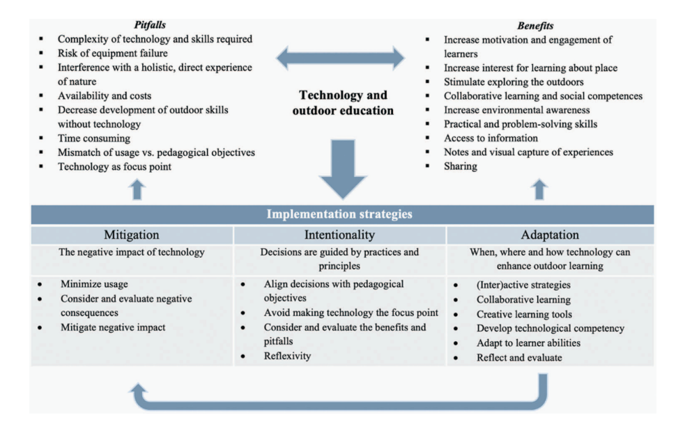
Inevitably then, technology has its limitations. Kraalingen (2021) reviews the advantages and disadvantages of mobile technology in an outdoor adventure education setting and undertakes a review of literature and develops a diagram which summarises the benefits and pitfalls of mobile technology.

Figure 1: Kraalingen, 2021, pp. 8

In reviewing the literature Kraalingen (2021) groups together her findings as above. For example, the first pitfall is the “complexity of technology and skills required”. Of the 34 studies reviewed, 15 mentioned complexity as a major downside to the use of mobile technology. Of the other pitfalls, risk of equipment failure, availability & costs and time consuming relate to the complexity point and the physical operation of technology. The points concerning the interference with a connection to nature and the decrease in skills refer to a perceived decrease in problem solving and independent thinking when people rely too heavily on technology. Lastly the mismatch of technology to objectives and technology as the focus relates to the inappropriate use of technology where its use does not add to the task, its aims or objectives.
The benefits of mobile technology are, according to Kraalingen (2021), the subject of a degree of consensus and outweigh its disadvantages. Technology increases motivation and engagement, helps students develop an understanding of a place and stimulates exploration of the outdoors. Further technology enhances collaborative learning, increases environmental awareness and develops practical and problem-solving skills. Lastly technology enhances students’ access to information, enables them to record information, learning and experiences and share all that they have achieved.
Kraalingen (2021) discusses the mitigation of the pitfalls of technology including minimisation of its use and a consideration of possible negative consequences whose impact should be evaluated and mitigated if possible. Interestingly the written analysis of the benefits of technology is more detailed and less generalised than that of pitfalls yet the mitigation of the negative aspects of technology is a major focus of the rest of the article. In the conclusion it is acknowledged that
“The argument that mobile technology places a barrier between the learner and nature did not emerge frequently in the reviewed articles” (Kraalingen, 2021, pp.12)
The pitfalls of technology are not internal to technology but rather related to its functionality, use and application. Where technology is used appropriately and well and can be accessed it enhances the experience. Where technology is poorly understood and exploited it can undermine the learning experience. Kraalingen concludes that outdoor adventure education should “focus on developing interactive, purposeful, and reflective initiatives in which mobile technology serves learning experiences in natural environments” (Kraalingen, 2021, pp.12).
Technology is an acknowledgement that technology has been proven to be useful when used correctly and in an informed way, but a persistent belief based on wider research that technology takes humans further and further away from the nature that nurtures them.
As a member of Generation Z who has been brought up with the internet and social media, I would take a mixed approach in that I would always bring a form of digital and or mobile technology with me. I say that I would have mixed approach as even though "We may not have invited the big tech companies into OEE, but they are here," (Reed, 2021), tech is as much a part of our world as the environment: the idea of having no technology at all when partaking in outdoor activities seems increasingly more unlikely. I would also feel uncomfortable not taking some form of technology with me as I would want a way to keep in contact or could contact someone were I to injure myself or get into trouble on an outdoor activity. Also in modern society, if I were leading an activity it is expected (if not required of me) to have some form of technology to contact others with should an accident/incident occur.
Whilst I would always take some form of technology with me on an outdoor activity I would choose to use it sparingly, to take a couple of pictures to remember the experience with but the rest of the time I would be try to be “present” and experience the activity to its fullest, the place in which the activity is happening (Williams, 2019), an simply being in nature and receiving the positive effects it can have on oneself (Grinde and Patil, 2009)
In conclusion technology is a tool; it can be used well or badly. There have always been problems “putting all your eggs in one basket”. If OEE only taught navigation using a mobile device a clear and dangerous omission would be taking place: what happens if the device loses charge, fails to get a signal, is broken? Safety in any situation with an element of risk requires a backup plan. This isn’t technology’s fault; it simply has limitations. Zita (2008) describes that using a map, a compass or GPS are all viable ways to navigate or find a destination, if you can use them properly, and using all three can increase the chances of success. Technology has the capacity to create awe and wonder but so does looking at the night sky without light pollution. We must all be clear about the value judgements we make in OEE: are we choosing a particular course of action because it gives students the greatest chance of success or opportunity for learning or because it’s what we prefer.
Word count: 2602 words
Reference list:
Allison, P. (2000) ‘Authenticity and Outdoor Education’, in Barnes, P. Outdoor Education and Values. Penrith: Association for Outdoor Learning.
Bolliger, D.U. and Shepherd, C.E. (2018) ‘Instructor and adult learner perceptions of the use of Internet-enabled devices in residential outdoor education programs’ British Journal of Educational Technology, 49(1), pp.78–87. DOI:10.1111/bjet.12524
Cuthbertson, B. Socha, T.L. and Potter, T.G. (2004) ‘The double-edged sword: Critical reflections on traditional and modern technology in outdoor education’, Journal of Adventure Education & Outdoor Learning, 4(2), pp.133-144. DOI: 10.1080/14729670485200491
Ewert, A.W. and Sibthorp, J. (2014) Outdoor adventure education: foundations, theory, and research. Champaign, IL: Human Kinetics.
Gordon, S. (2022) ‘Surprising Ways Your Teen Benefits From Social Media’, verywellfamily, 2nd November. Available at: https://www.verywellfamily.com/benefits-of-social-media-4067431
Gray, T. et al. (2018) ‘Curating a Public Self: Exploring Social Media Images of Women in the Outdoors’, Journal of Outdoor Recreation, Education, and Leadership, 10(2), pp. 153-170. Available at: https://doi.org/10.18666/JOREL-2018-V10-I2-8191.
Grinde, B. and Patil, G.G. (2009) ‘Biophilia: does visual contact with nature impact on health and well-being?’, International journal of environmental research and public health, 6(9), pp. 2332–2343. Available at: https://doi.org/10.3390/ijerph6092332.
Hodkinson, P. (2017) ‘Bedrooms and beyond: Youth, identity and privacy on social network sites’, New media & society, 19(2), pp. 272–288. Available at: https://doi.org/10.1177/1461444815605454.
Jerowski, M. and Borda, A. (2022) ‘Virtual reality can support and enhance outdoor environmental education’, The Conversation, 11th July. Available at: https://theconversation.com/virtual-reality-can-support-and-enhance-outdoor-environmental-education-183579
Kraalingen, I.V. et al. (2022) ‘Digital technology and networked spaces in outdoor education: reflections upon presenting at an international webinar’, Journal of adventure education and outdoor learning, ahead-of-print(ahead-of-print), pp. 1–14. Available at: https://doi.org/10.1080/14729679.2022.2127112.
Kraalingen, I.V. (2021) ‘A systematized review of the use of mobile technology in outdoor learning’, Journal of adventure education and outdoor learning, ahead-of-print(ahead-of-print), pp. 1–19. Available at: https://doi.org/10.1080/14729679.2021.1984963.
MacIsaac, S., Kelly, J. and Gray, S. (2018) ‘“She has like 4000 followers!”: the celebrification of self within school social networks’, Journal of youth studies, 21(6), pp. 816–835. Available at: https://doi.org/10.1080/13676261.2017.1420764.
PA Media. (2020) ‘Most children own mobile phone by age of seven, study finds’, The Guardian, 30th January. Available at: https://www.theguardian.com/society/2020/jan/30/most-children-own-mobile-phone-by-age-of-seven-study-finds
Recreation Alliance (2016) ‘Technological insights for outdoor recreation’, Recreation Alliance [blog]. 12th May. Available at: https://www.sportandrecreation.org.uk/blogs/guest-blog/technological-insights-for-outdoor-recreation
Reed, J. (2021). What is the postdigital? Why might it matter for outdoor experiential education? Pathways: The Ontario Journal of Outdoor Education, 33(2), pp. 28-31.
Williams, A. (2019) ‘Place is special when we do a bit of homework’, Horizons No. 82. Available at: https://www.outdoor-learning-research.org/Portals/0/Research%20Documents/Horizons%20Archive/H82%20Andy%20Williams%20Place%20is%20Specail%20when%20we%20do%20a%20bit%20of%20homework.pdf?ver=2019-10-15-152121-520
Zita, A. (2008) ‘Technology Works in the Outdoors’ Pathways: The Ontario Journal of Outdoor Education, 20(2) p8-10. Available at: https://files.eric.ed.gov/fulltext/EJ895045.pdf

