University of Wales Trinity Saint David

Wales Institute of Science & Art

Engineering Skills Technical Report
Engineering Skills (ACHA4022A)

Jacob Lyons
2500738
November 2025

Contents
1 Introduction 2
2 health and safety with risk Assessments 3
3 Security risk matrix 5
4 Engineers role in society 6
5 Problem solving 8
6 Team structure 10
7 Conclusion 12
8 Reference list 13

Introduction

This report will cover, health and safety with risk assessments on tasks that have been completed in university during the first term of study, a security risk matrix which will evaluate threats that modern vehicles could become susceptible to security threats, an engineer’s role in society where issues that occur on a regular basis will be identified and explained how engineers tackle said problems, how engineers work in teams to complete tasks more efficiently and faster.

health and safety with risk Assessments

Within engineering, one of the most important aspects that must be considered is health and safety and the implications that can have on the activities that are undertaken.
An activity that has been carried out in the university within the first term has been an engine strip and rebuild of a 1.25L Ford engine. This was part of the workshop sessions that have been completed to give a more hands on experience compared to other universities.
The relevant health and safety legislation for this task would be the health and safety at work act of 1974. This covers things like employers having a legal responsibility to safeguard the health, safety and welfare of their employees with key duties including
- Providing and maintaining a safe working environment
- Ensuring safe handling, storage and transportation of materials
- Offering adequate information, training, instruction and supervision to employees
- Maintaining a safe working environment with proper welfare facilities
- Conducting risk assessments to identify hazards and implement appropriate control measures.
GOV.UK (1974)

Although this activity was carried out by students this legislation still would have applied to the workshop where the engines were stripped and rebuilt.
hazard | risk | control | Risk level | PPE required
Heavy engine | Could crush limb/ person if dropped on them | Make sure the engine is securely fastened in the engine stand and wear steel toe cap shoes | Medium – engine has a high probability of falling if not secured properly | Engine stand  Steel toe cap shoes
Highly torqued bolts | Could snap off and inure the person using the tools | Make sure to brace yourself against the engine to avoid inuring yourself | Low – hard to injure self with overtightened bolts | Strong tools  Strong place to brace yourself
Oil is an irritant | Oil could enter eye and irritate or cause chemical burns on the eye | Wear safety goggles while carrying out the engine strip and rebuild | Low – not a lot of oil in engines as it was pre drained but could still be some remnants of oil in engine | Safety goggles

Security risk matrix
As modern vehicles become increasingly connected and autonomous, they are more vulnerable to security threats.
Keyless car theft
As more cars are produced with quality-of-life improvements such as keyless entry, they are more susceptible to theft. This is due to thieves being able to ‘hijack’ the signal given off by the key and boost it to the car, causing it to unlock. From there all they must do is hotwire the car or turn the ignition on and they can drive off with your car while being able to program a new key to it and sell it off as good as new.
likelihood |  | impact
 | Minor | significant | major
Almost certain
moderate |  |  | Keyless car theft
rare | Infotainment system attacks | Ev charging stations getting hacked | Car production lines getting hacked

(Davies, 2024)

The current largest risk included in this risk matrix is that of keyless car theft. This is where cars can be stolen by boosting the signal given off constantly by the keys of a car with a keyless entry system. A way around this would be to weaken the signal given off by they key fob so that the signal cannot be picked up through walls and will only be picked up by the car from withing a few feet.
Another option is to not weaken the signal by decreasing the output strength but by placing the key fob inside of a “faraday bag “. These are small bags designed to block signals like Wi-Fi, Bluetooth, GPS, cellular and RFID. These are usually produced from materials such as multiple layers of various metallic layers like copper, aluminium and static dissipative polyethene. These are an easier and often cheaper option of protecting from keyless car theft, while other cost-free options are available, they do not propose the same security of a faraday bag. These are things like, keeping the keys far away from the front door of your house, storing your car in a garage, so the car itself cannot be accessed, and having a property with gates so that thieves could not get close enough to the keys to boost the signal in the first place. Although even with a faraday bag these should still be followed to reduce the risk of keyless car theft occurring.
(Disklabs Ltd, 2018)

Engineers role in society
Chartered engineers are held to a high standard within the engineering community and depending on what part of the community they are part of different engineers will be held to different codes of conduct.
One example of these codes has been published by the institution of civil engineers. This code of conduct states that
- Members of the institution should conduct their professional duties with integrity and shall behave with integrity in relation to all conduct bearing upon the standing, reputation and dignity of the institution and the profession of civil engineering
- All members shall only undertake work that they are competent enough to complete
- All members should have full regard for public interest, particularly in relation to matters of health and safety, and in relation to the wellbeing of future generations
- All members shall show due regard for the environment and for the sustainable management of natural resources.
(ICE, 2025)

Just to name a few.

Another example of a code of conduct has been produced by the national society of professional engineers this includes things like, rules of practice and professional obligations

Rules of practice
- Engineers shall hold paramount the safety, health and welfare of the public
- Engineers shall perform services only in the area’s pf their competence
- Engineers shall issue public statements only in an objective and truthful manner
- Engineers shall act for each employer pr client as faithful agents or trustees
- Engineers shall avoid deceptive acts

Professional obligations
- Engineers shall be guided in all their relations by the highest standards of honesty and integrity
- engineers shall always strive to serve the public interest
- engineers shall avoid all conduct or practice that deceives the public
- (NSPE, 2019)

Problem solving
Engineers face issues on a regular basis, especially when working in teams. R. Keith Mobley from reliableplant.com proposes four problem solving tools, two of these being,
- Plan, do, check, act (PDCA)
- Ishikawa (fishbone) diagram

The “Deming” PDCA cycle provides good guidelines for problem solving, with this cycle including
Plan
- Clearly defining the problem
- Collecting evidence of the problem
- Identification of impacts or opportunities
- Measurement of problem
- Measure(s) of effectiveness

do
- Generate possible causes
- Broke need fixing causes identified, worked on
- Write experimental test or action plan
- Write action plan for cause remedies
- Write experimental test plan
- Resources identified
- Revised PDCA timetable
- Management team review / approval

Check
- Carry out experimental test or action plan
- Analyse data from experimental or action plan
- Decide whether to go back to “do” stage or proceed
- Implementation to make change permanent
- Force field on implementation
- Management team review / approval

Act
- Carry out implementation plan
- Post measure of effectiveness
- Analyse results vs team objectives
- Team feedback gathered
- Management team close-out meeting
Ishikawa Diagram
In some cases, the problem can be due to more than one cause or may have multiple functions that either singularly or in combination, will result in a problem. Because of these diagrams shape it has been called a “fishbone diagram”. This helps people find the root cause of the problem and potential contributing factors and/or forcing function in a simple straightforward graphic format while being very clear in the way it represents the relationship between the root cause of a problem and all the possible factors that may be associated with the problem
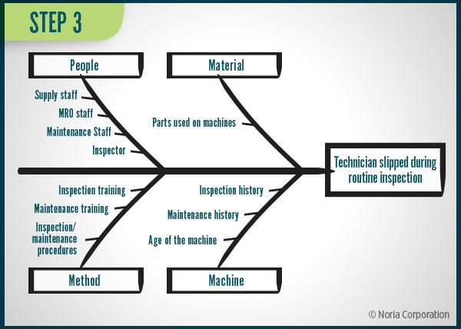

(mobley, n.d.)

Team structure
A time that I worked in a team of more than three people would be when I was with the UWTSD Rally team and we were removing, repairing and then reinstalling the engine of the BMW 1 series rally car. In this activity I believe that I could have been more helpful and productive as due to there being so many of us helping out there was not enough room around the front end of the rally car that we all did little jobs meaning that only one or two of us got to do the “big” jobs of actually removing the engine from the engine bay. However, I did assist with removing the front crash bar and the front radiation, while draining the coolant and oil out of the engine before it could be removed.
A team structure was not really used in this activity however there were two of the more senior members of the rally team also removing the engine with us, so they were mostly telling us first years what to do as we did not have much experience removing engines from cars. So, a positive aspect of this would be that there were two main leaders in the group whop gave clear instructions on what to do, how to do them and in what order to do them. However, they were constantly being asked questions on what to do so they could not get involved themselves with their experience with the car playing a role on why they were needed to remove the engine from the car.

The main goal of an engineering team structure is to maximise the effectiveness. For instance, technology teams might be organised around front-end or mobile development specialists, matrix teams are cross-functional but report to different managers and product teams are cross-functional teams who report to the same manager.
For this project a product team would be better than the no team structure that I worked in before as if one person oversees the whole group then people only must worry about their individual jobs and people can work better as a benefit of this.
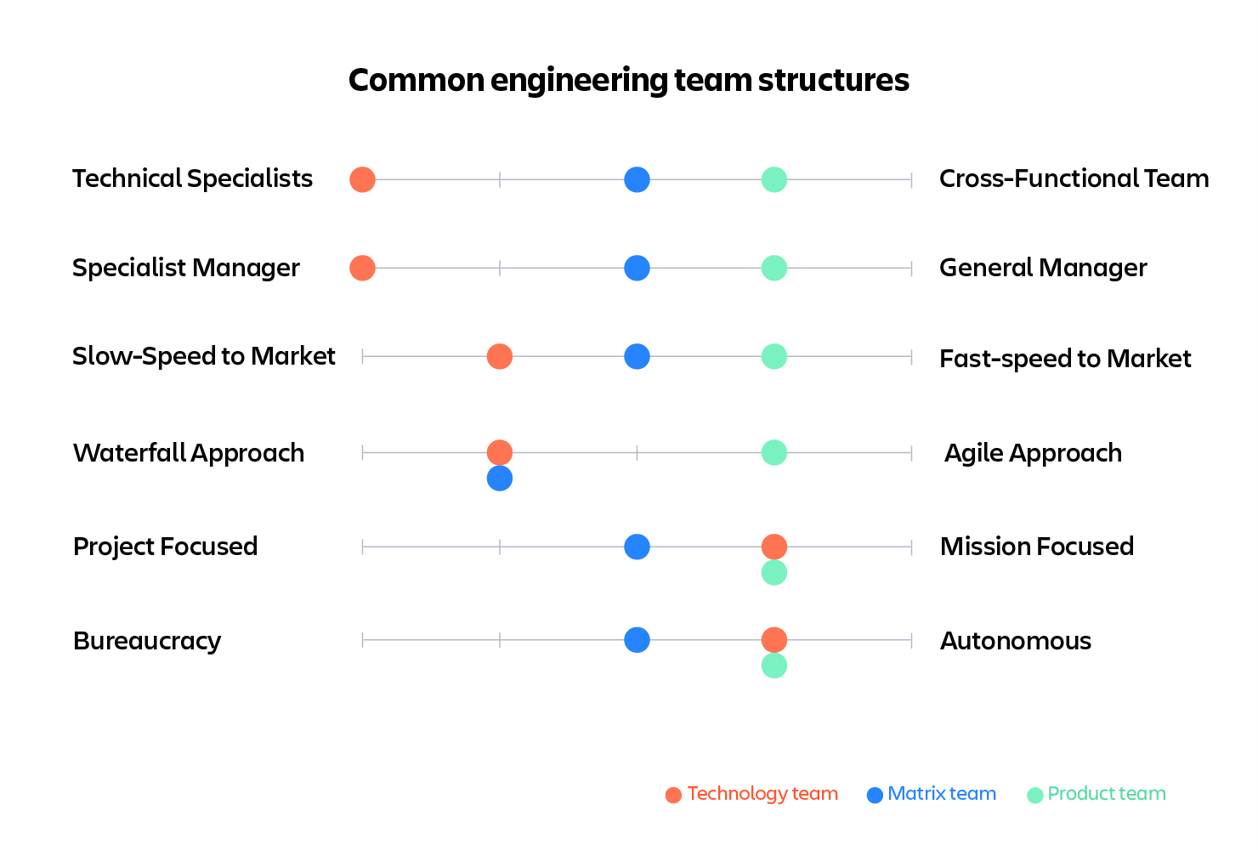
(austin, 2019)

Conclusion

This report has covered
- Health and safety with risk assessments
- Security risk matrix’
- Engineers’ role in society
- Problem solving
- Team structure
Each are in their own subheadings and the references are cited in brackets with the links to each source on the reference list page

Reference list

Reference list
austin, jamey (2019). How should you structure your engineering team? [online] Work Life by Atlassian. Available at: https://www.atlassian.com/blog/technology/engineering-team-structure [Accessed 2 Dec. 2025].
Davies (2024). The top 8 Cybersecurity threats facing the automotive industry heading into 2023. [online] Levelblue.com. Available at: https://levelblue.com/blogs/security-essentials/the-top-8-cybersecurity-threats-facing-the-automotive-industry-heading-into-2023.
GOV.UK (1974). Health and Safety at Work etc. Act 1974. [online] legislation.gov.uk. Available at: https://www.legislation.gov.uk/ukpga/1974/37/contents.
instituton of civil engineers (2025). ICE Code of Professional Conduct ICE Code of Professional Conduct. [online] Available at: https://www.ice.org.uk/media/pj1glzc1/ice-code-of-professional-conduct-january-2025.pdf [Accessed 1 Dec. 2025].
mobley, R.K. (n.d.). Problem-solving Techniques for a high-performance Team. [online] www.reliableplant.com. Available at: https://www.reliableplant.com/Read/14690/high-performance-team [Accessed 2 Dec. 2025].
NSPE (2019). NSPE Code of Ethics for Engineers | National Society of Professional Engineers. [online] Nspe.org. Available at: https://www.nspe.org/career-growth/nspe-code-ethics-engineers [Accessed 1 Dec. 2025].

