Student Name: [Stefan Mihaita Lucian]  Student ID: [2234126]  Module Title: [Foreign Languages and Cultural Awareness]  Module Code: [BMIH5003]  Lecturer: [Heidi Prosser]  Date: [09/02/2024] | 
ASSIGNMENT 1: PORTFOLIO
(4 Components)

Component 1: Professional Reflection (500 words +/- 10%)

Weighting: 25%
During dinner service, as an F&B employee in a lodging establishment restaurant, I got into a misinterpretation with a visitor who could not speak English, particularly about their vegetarian dietary needs. Owing to communication problems and a lack of mutual understanding, I suggested a recipe that, to my surprise, included meat stock and did not fit the guest's rigorous vegetarian diet.
This incident highlights the importance of language proficiency and cultural sensitivity in the hospitality sector. Misunderstandings can result from presumptions shaped by one's cultural background, which might lead to recommendations that don't correspond with the visitor's food habits. The research highlights how crucial cultural knowledge is to providing hospitality. Baum (2015) emphasises how important it is to recognise and appreciate cultural variances, particularly those related to eating customs. Reisinger & and Turner (2012) recommend effective communication techniques and cultural awareness to enhance visitor experiences. Henderson (2007) is in favour of providing cultural sensitivity training to staff members to help them avoid miscommunication.

After giving this experience some thought, I see that there are a few things I could have done better. Improving linguistic abilities, especially in languages that visitors frequently speak, may greatly lower communication obstacles. Making more educated recommendations would be possible if I gained knowledge about various eating practices and limits. Furthermore, improving one's ability to actively listen could aid in comprehending and meeting the wants of visitors more precisely.

Employees in the food and beverage industry must improve their sensitivity, cultural knowledge, and communication skills to avoid misunderstandings in the future. This experience has brought to light how crucial these abilities are for preventing miscommunications and enhancing the overall visitor experience. To accomplish these goals, training programmes emphasising language proficiency, cultural competency, and active listening should be put into place.
To sum up, to meet the various needs of visitors, the hospitality sector demands a high degree of cultural competency and communication skills. This experience has taught me the value of ongoing education and training in these areas to improve visitor happiness and avoid cross-cultural miscommunications.

References:
- Baum, T., 2015. Human resources in tourism: Still waiting for change?–A 2015 reprise. Tourism Management, 50, pp.204-212. https://doi.org/10.1016/j.tourman.2015.02.001
- Reisinger, Y. and Turner, L., 2012. Cross-cultural behaviour in tourism. Routledge. https://doi.org/10.1016/j.tourman.2007.04.005
- Henderson, J.C., 2007. Corporate social responsibility and tourism: Hotel companies in Phuket, Thailand, after the Indian Ocean tsunami. International Journal of Hospitality Management, 26(1), pp.228-239. https://doi.org/10.1016/j.ijhm.2006.02.001
Component 2: Training Plan (500 words +/- 10%)

Weighting: 25%

Identified cultural misunderstanding (in a few words):
During dinner service, there was a cultural miscommunication with a non-English-speaking guest about their vegetarian dietary needs.

Training plan (Why/What//Who/Where/When):
Plan for Staff Training: Improving Communication and Cultural Competence in Hospitality Objective:
The project seeks to provide comprehensive training to hotel personnel in effective communication, cultural sensitivity, and awareness, with a special focus on addressing guests' dietary requirements. The objective is to minimise cultural misunderstandings and optimise client pleasure and overall experience.
Why:
Cultural competence is of crucial importance in the hospitality industry as it enables the provision of great service and the effective handling of diversity. Instances of misunderstandings, such as offering unsuitable meals as a result of linguistic differences, highlight the importance of improving communication and sensitivity to ensure that every guest feels respected and appreciated (Baum, 2016).
What:
The programme consists of multiple modules that aim to develop proficiency in cultural competency, dialogue, nutritional information and problem-solving, empathy, and continual improvement. The modules encompass the following:
- Overview of Cultural Competence in the Hospitality Industry
• Analysing the influence of cultural diversity on the hospitality industry.
  - The importance of cultural knowledge in improving guest experiences has been emphasised by Baum (2016).
  - Analysis of cultural misunderstandings and their impact on service quality through case studies.
- Effective Communication Strategies
  - Addressing language difficulties by learning fundamental phrases in crucial languages.
  - Acquiring proficient listening abilities to precisely comprehend guests' requirements (Reisinger & Turner, 2012).
  - Role-playing to improve verbal and nonverbal communication.
- Understanding and Respecting Dietary Practices
  - Instructing employees on diverse dietary limitations and preferences.
  - Developing a strategic menu plan and making necessary revisions to cater to various dietary requirements.
  - Training focused on appropriately addressing dietary requests through scenario-based exercises.
- Developing Problem-Solving and Empathy Skills
  - Promoting compassionate interaction with guests in order to comprehend and honour their cultural and personal inclinations.
  - Utilising problem-solving techniques to address instances in which guests' requirements were originally misinterpreted.
  - Strategies for converting adverse encounters into constructive customer feedback.
- Feedback and Continuous Improvement
  - Utilizing guest feedback to refine services and enhance cultural competence.
  - Promoting an internal culture of feedback and continuous learning among staff.
Who:
All hotel staff are the focus of this training programme, however front desk staff, F&B employees, and customer service teams will receive particular attention because they are the ones who deal directly with clients.
Where:
Staff members will have the opportunity to engage in lively and participatory learning in hotel meeting spaces, creating a vibrant atmosphere. Staff members will have remote access to e-learning modules, providing flexible learning opportunities.
When:
The implementation will occur gradually in the following quarter. There will be regular refresher courses and continued e-learning possibilities after the initial workshops and seminars.
Training Methods:
- Workshops and seminars led by professionals with expertise in hospitality and cultural competency.
- Engaging in simulation and role-playing activities.
- E-learning to improve language proficiency and awareness of dietary restrictions.
Evaluation and Follow-Up:
- Use pre- and post-assessment instruments to gauge how well the training was received.
- Create a mentorship programme to provide continuing assistance and growth.
- Arrange semi-annual evaluations to update training materials in response to input from visitors and developments in the sector.
Conclusion:
Establishing a hotel environment that values communication and cultural competence requires this training programme. It's a calculated step to guarantee that every visitor receives individualised, considerate, and polite service, which will improve their overall experience and happiness and enhance the hotel's image (Baum, 2016; Reisinger & Turner, 2012; Henderson, 2007).

References:
Baum, T. (2016). Human resources in tourism: Still waiting for change? Tourism Management, 57, 318-327.
Reisinger, Y., & Turner, L. (2012). Cross-cultural behaviour in tourism: concepts and analysis. Butterworth-Heinemann.
Henderson, J.C. (2007). Corporate social responsibility and tourism: Hotel companies in Phuket, Thailand, after the Indian Ocean tsunami. International Journal of Hospitality Management, 26(1), 228-239.
Component 3: Student Self-Reflection (500 words +/- 10%)

Weighting: 25%
I will critically examine how my knowledge of cultural sensitivity in the hospitality sector has changed over time, a journey that has had a big influence on my viewpoint and professional growth, using Gibbs' Reflective Cycle.

Description:
My journey started when I was a new employee in the hotel industry and had no idea of the importance of cultural awareness. At first, I had a one-size-fits-all perspective on hospitality services, missing the varied requirements and expectations of visitors from different cultural backgrounds.
Feelings:
When I first encountered cultural misunderstandings, I experienced embarrassment and frustration. I can recall a specific incident in which I made an ignorant cultural assumption and unintentionally upset a guest. This encounter served as a wake-up call, exposing my cultural insensitivity and its possible effects on visitor satisfaction.
Evaluation:
Looking back, I see how important these early encounters were in pointing up the discrepancies in my understanding and expertise. I had misjudged the significance of cultural awareness in augmenting guest experiences, as highlighted by Sarwono et al. (2020). Although awkward, these interactions were priceless teaching moments.
Analysis:
My appreciation and understanding of cultural sensitivity in hospitality have grown over time. Through my experiences, comments from visitors and coworkers, and additional study, I discovered how crucial cultural sensitivity is to enhancing visitor experiences as well as preventing misunderstandings. According to Ismail et al. (2012), cultural awareness can personalise service interactions and ensure that they are respectful of the cultural settings of the patrons.
Conclusion:
An important turning point in my career development was realising that cultural competency is a set of abilities just as important in the hospitality industry as any technical aptitude. I discovered that offering outstanding customer service requires an appreciation of and recognition for cultural diversity. As a result of this realisation, I now prioritise active listening, empathy, and lifelong learning about cultures other than my own in my profession.
Action.Plan:
I'm determined to keep improving my cultural competency going forward by participating in focused training programmes like language classes and workshops on cultural sensitivity. I intend to read more about the literature on cultural sensitivity in hospitality and take inspiration from writers such as Uyar (2020), who emphasise the value of CSR in tourism, especially in the area of cultural sensitivity.
My experience has shown me that understanding other cultures is a dynamic talent that requires constant attention and improvement. In the hospitality sector, where difference is the norm and it is a luxury to be able to build significant relationships with clients from around the world, this knowledge is essential. My experiences—both positive and negative—showcase how crucial cultural sensitivity is to fostering welcoming, inclusive spaces that embrace diversity.

References:
- Sarwono, A.W., Ihalauw, J.J.O.I. and Suharti, L., 2020, December. Inter-organizational collaboration: Enhancing the quality of human resources in tourism. In Proceeding of the 4th Bogor International Conference for Social Science, Virtual Conference of Djuanda University (pp. 457-462). https://www.researchgate.net/profile/Saiful-Md-Ramlan/publication/353569001_EXPLORING_INDIGENOUS_PARENTS'_PERCEPTIONS_OF_INDIGENOUS_CHILDREN'S_EXPERIENCES_IN_SCHOOL/links/61037a0b0c2bfa282a0d73c7/EXPLORING-INDIGENOUS-PARENTS-PERCEPTIONS-OF-INDIGENOUS-CHILDRENS-EXPERIENCES-IN-SCHOOL.pdf#page=470
- Ismail, F., Alipiah, R.M., Mansor, N. and Syukri, W.H.W.Z., 2020. A cross-cultural study of destination attributes: impact on sustainability of island tourism. Journal of Sustainability Science and Management, 15(1), pp.1-14. https://jssm.umt.edu.my/wp-content/uploads/sites/51/2020/05/1.15.1pdf.pdf
- Uyar, A., Kilic, M., Koseoglu, M.A., Kuzey, C. and Karaman, A.S., 2020. The link among board characteristics, corporate social responsibility performance, and financial performance: Evidence from the hospitality and tourism industry. Tourism Management Perspectives, 35, p.100714. https://digitalcommons.murraystate.edu/cgi/viewcontent.cgi?article=1061&context=faculty
Component 4: Training Presentation (6 Slides)

Weighting: 25%
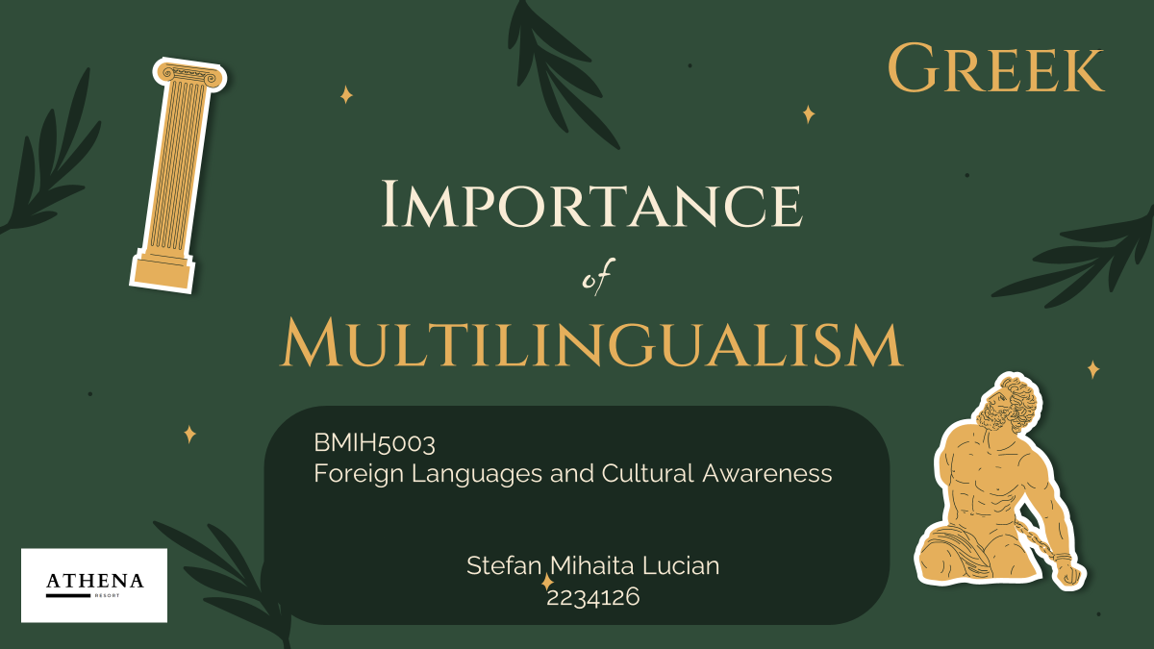
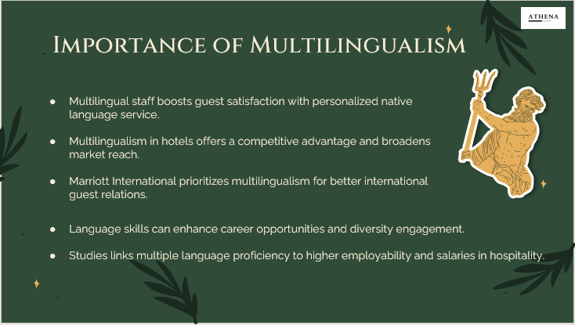
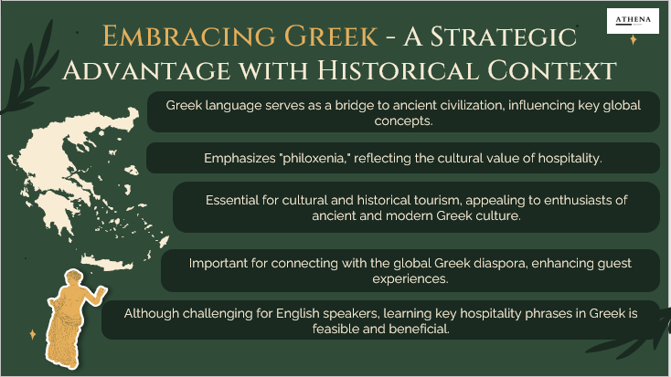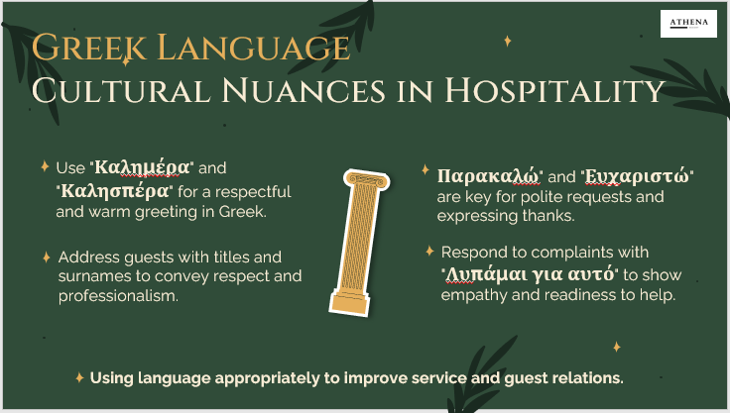
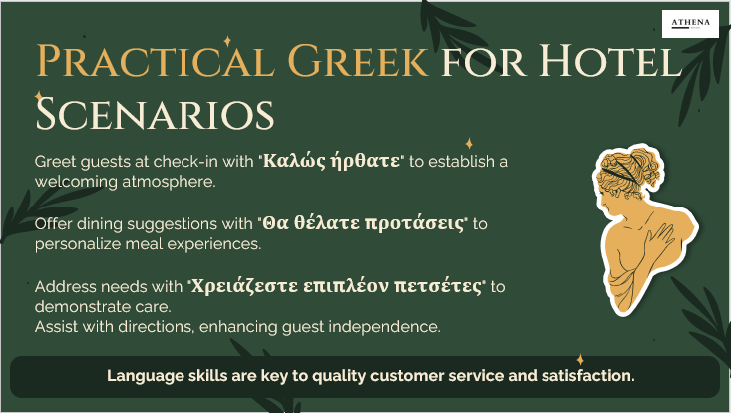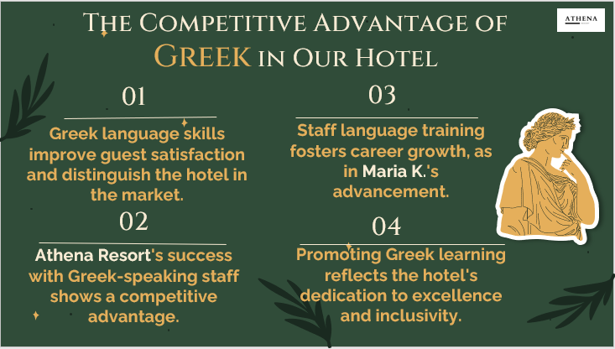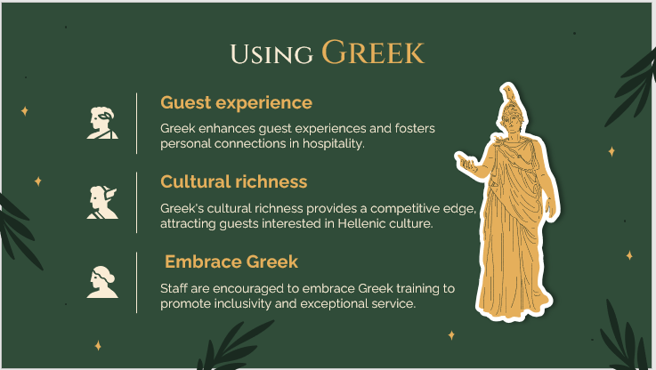

References
- Cesário, F., Sabino, A., Moreira, A., Portugal, M. and Correia, A., 2022. Students’ Motivation for a Sustainable Career in the Hospitality Industry in Portugal. Sustainability, 14(11), p.6522. https://www.mdpi.com/2071-1050/14/11/6522
- Eusébio, C., Alves, J.P., Rosa, M.J. and Teixeira, L., 2022. Are higher education institutions preparing future tourism professionals for tourism for all? An overview from Portuguese higher education tourism programmes. Journal of Hospitality, Leisure, Sport & Tourism Education, 31, p.100395. https://doi.org/10.1016/j.jhlste.2022.100395
- Jhaiyanuntana, A. and Nomnian, S., 2020. Intercultural communication challenges and strategies for the Thai undergraduate hotel interns. PASAA: Journal of Language Teaching and Learning in Thailand, 59, pp.204-235. https://files.eric.ed.gov/fulltext/EJ1240001.pdf
- Liu, Y., Liu, J. and King, B., 2022. Intercultural communicative competence: Hospitality industry and education perspectives. Journal of Hospitality, Leisure, Sport & Tourism Education, 30, p.100371. https://doi.org/10.1016/j.jhlste.2022.100371
- Renner, B., 2020. (In) directness as an (im) politeness strategy in the contact between german and Brazilian portuguese as additional languages. http://icts.unb.br/jspui/bitstream/10482/39433/1/2020_BerndRenner.pdf
- Sarwono, A.W., Ihalauw, J.J.O.I. and Suharti, L., 2020, December. Inter-organizational collaboration: Enhancing the quality of human resources in tourism. In Proceeding of the 4th Bogor International Conference for Social Science, Virtual Conference of Djuanda University (pp. 457-462). https://www.researchgate.net/profile/Saiful-Md-Ramlan/publication/353569001_EXPLORING_INDIGENOUS_PARENTS'_PERCEPTIONS_OF_INDIGENOUS_CHILDREN'S_EXPERIENCES_IN_SCHOOL/links/61037a0b0c2bfa282a0d73c7/EXPLORING-INDIGENOUS-PARENTS-PERCEPTIONS-OF-INDIGENOUS-CHILDRENS-EXPERIENCES-IN-SCHOOL.pdf#page=470

