
Assessment component: Individual report
Inditex (Zara): Nigeria

Student Name: Debashish Biswas
Student ID:2425482

Module Name: Strategic Management

Module Code: LCMB7003

Lecturer’s Name: Andry Rakotovololona

TABLE OF CONTENTS
INTRODUCTION 1
SELECTION OF ORGANISATION AND TARGET MARKET 1
COMPANY OVERVIEW: INDITEX (ZARA) 1
RATIONALE FOR SELECTING NIGERIA AS THE TARGET MARKET 2
MARKET POTENTIAL AND ECONOMIC OUTLOOK 2
FASHION INDUSTRY TRENDS AND CONSUMER BEHAVIOUR 3
STRATEGIC FIT WITH INDITEX’S GLOBAL OBJECTIVES 4
COMPREHENSIVE STRATEGIC ANALYSIS 4
PESTEL ANALYSIS OF NIGERIA AS A TARGET MARKET FOR ZARA 4
POLITICAL FACTORS 5
ECONOMIC FACTORS 5
SOCIAL FACTORS 6
TECHNOLOGICAL FACTORS 7
LEGAL AND REGULATORY FACTORS 7
ENVIRONMENTAL FACTORS 7
EVALUATION OF THE PESTEL FRAMEWORK 8
PORTER’S FIVE FORCES – NIGERIA’S FASHION & APPAREL RETAIL MARKET 8
THREAT OF NEW ENTRANTS 8
BARGAINING POWER OF SUPPLIERS 8
BARGAINING POWER OF BUYERS 9
THREAT OF SUBSTITUTES 9
RIVALRY AMONG EXISTING COMPETITORS 10
EVALUATION OF PORTER’S FIVE FORCES FRAMEWORK 10
STRATEGY DEVELOPMENT AND FORMULATION 11
STRATEGIC INTENT AND OBJECTIVES 11
GROWTH DIRECTION: ANSOFF MATRIX 12
COMPETITIVE STRATEGY: PORTER’S GENERIC STRATEGIES 13
PHASED IMPLEMENTATION ROADMAP 15
PERFORMANCE EVALUATION FRAMEWORK 15
PERFORMANCE FRAMEWORK 16
SUSTAINABILITY-ENHANCED BALANCED SCORECARD FOR ZARA NIGERIA 16
EMBEDDING THE TRIPLE BOTTOM LINE 18
USING THE FRAMEWORK ACROSS THE EXPANSION PHASES 18
CONCLUSION 19
REFERENCES 21

INTRODUCTION
The global fashion industry works in a complex, volatile and competitive environment defined by fast-changing consumer tastes, digital disruption and macroeconomic uncertainty. Global firms such as Inditex, one of the world’s largest fast-fashion groups and owner of Zara, must constantly strengthen their internationalisation strategies to remain competitive and continue growing (Inditex, 2025a; Zhu, 2023). Emerging markets with large, young and urban populations offer attractive expansion opportunities, but they also expose firms to political, economic and operational risks (World Bank Group, 2025).
This report develops an organisational expansion plan for Zara’s entry into Nigeria through physical stores and a fully localised online channel. The aim is to design an evidence-based strategy that aligns Inditex’s capabilities with the opportunities and challenges of the Nigerian market. The report first justifies the choice of Inditex/Zara and Nigeria, then applies PESTEL, Porter’s Five Forces and VRIO to assess external conditions and internal strengths. It then develops a market-entry strategy using Ansoff’s Matrix, Dunning’s OLI paradigm and Porter’s Generic Strategies. Finally, it proposes a performance evaluation framework using the Balanced Scorecard and Triple Bottom Line to track long-term success.

SELECTION OF ORGANISATION AND TARGET MARKET

COMPANY OVERVIEW: INDITEX (ZARA)
Inditex (Industria de Diseño Textil Sociedad Anónima) is a Spanish multinational company that specialises in fast fashion, and the world’s largest apparel retailer. The group has a distributed sales system with eight brands: Zara, Pull&Bear, Massimo Dutti, Bershka, Stradivarius, Oysho and Zara Home (Inditex, 2025), as well as 5,563 stores in more than 214 markets both offline and online. In 2024, the company turned over with its net sales of about €38.6 billion and a net income of €5.9 billion, showing strong financial status and world-wide presence (Inditex, 2025a).
Zara is the leading brand in sales, which amount to approximately €27.8 billion, generated via 2,866 stores worldwide (ECDB, 2024). Its power lays in the fast-fashion model, which allows it to go from concept in store within weeks. This agility enables Zara to quickly respond to the latest fashion trends and consumer preferences, thus generating a sustainable competitive advantage (Zhu et al., 2023).
Applying the VRIO framework, Inditex’s key capabilities can be assessed in terms of their value, rarity, imitability and organisational support to understand its sustainable advantages across markets.
TABLE 1: VRIO ANALYSIS
Resource/Capability | Valuable | Rare | Costly to Imitate | Organised | Strategic Implication
Vertically integrated supply chain and logistics | YES | YES | YES | YES | Sustained competitive advantage
Global brand equity (Zara) | YES | MODERATE | MODERATE | YES | Competitive advantage
Financial strength and scalability | YES | NO | LOW | YES | Temporary advantage
Omnichannel and digital infrastructure | YES | YES | MODERATE | YES | Competitive advantage
Sustainability and circular-fashion initiatives | YES | MODERATE | MODERATE | EMERGING | Potential advantage
Inditex manages few steps of its supply chain (design, merchandise and distribution) and is investing €1.8 billion (2024–2025) to improve logistics and facilitate the growth in omnichannel sales (Fashion United, 2025). Another €1.8 billion is being invested in digital infrastructure to integrate stores with online platforms, making possible real-time matching of stock and a frictionless customer experience (Inditex, 2025a). The strong financial position with net cash of €11.5 billion is the basis to grow without using debt. The group’s sustainability commitment also consolidates its long-term positioning, committing to sourcing all of its fibres from lower environmental impact sources by 2030 and achieving net-zero emissions by 2040 (Inditex, 2025b).
In general, the unique resources that Inditex possesses: a good supply chain; worldwide brand image; financial solvency; and ethical commitment make it an attractive venture to tap into new foreign markets.

RATIONALE FOR SELECTING NIGERIA AS THE TARGET MARKET
Nigeria has been selected as the target market for Zara’s physical retail and fully localised omnichannel expansion. At present, Nigerian consumers mainly access Zara products through third-party online platforms rather than directly operated stores (Zara, 2025). Establishing a direct presence would enable Inditex to capture unmet demand and strengthen brand control in a high-growth emerging economy.

MARKET POTENTIAL AND ECONOMIC OUTLOOK
Nigeria is the most populous country in Africa and had a projected population of 237.5 million in 2025, with a median age of 18 years old (UNFPA, 2025; Worldometer, 2025). More than half of the population is under 25, and that bodes well for a future pool of young, trend-following consumers. The economy gives some evidence of resilience, despite the inflationary headwinds. GDP grew 4.6 per cent in 2024 and is expected to continue at about an average rate of around 3.5 per cent in 2025 due to fiscal and exchange-rate reforms (World Bank Group, 2025; Bala Gbogbo, 2025).
Urbanisation: more than 50%, with commercial epicentres like Lagos and Abuja (Worldometer 2025). These cities are homes to growing malls and middle-class shoppers so they make natural entry point for opening Zara’s first few stores. The size of the population, youthfulness and urban prosperity being experienced in Nigeria make for a substantial growth proposition for affordable international fashion brands.

FASHION INDUSTRY TRENDS AND CONSUMER BEHAVIOUR
Nigeria fashion business is one of the most dynamic in Africa, with a worth ranging between US$ 2.5billion to US$6billion per annum (Emoekpere, 2025). Greater disposable income, urbanites and exposure to international media have raised demand for local as well as international brands (Huard, 2022).
Fashion consumption is also being digitalised. The e-fashion market size, which accounted almost USD 423 million in 2024 has seen a strong online spending growth trend (Ekugbe, 2024). Platforms such as Jumia and Ubuy already stock Zara products, indicating there is latent demand waiting for the official opening of brands.
Consumer insight indicates that, particularly in Lagos and Abuja, Nigerian shoppers perceive style, novelty, brand image as important factors when purchasing, but remain price sensitive due to inflation and exchange-rate fluctuation (This Day 2022). This combination of aspiration and pragmatism is more directly aligned with Zara’s positioning – stylish designs at affordable prices.
Nigeria’s youth are generally very into social media and celebrity fashion. These have come to be perceived as status symbols in the global arena. Sustainability and ethical sourcing are becoming increasingly important issues for predominantly middle-class consumer demand (Allen, 2024). Inditex’s circular fashion, renewable energy and eco-friendly materials commitments can then drive brand differentiation in this market (Inditex, 2025b).

STRATEGIC FIT WITH INDITEX’S GLOBAL OBJECTIVES
Nigeria’s market definitely aligns with the broader growth trajectory of Inditex internationally. The company prioritises growth in the under-penetrated Rest of World (RoW) greater geographic segment where it retains relatively low market share, and Nigeria offers strong prospects with the large size of its young consumer population and the dearth of leading global brands in fast fashion Inditex, 2025a. The company’s continued logistics and digital acquisitions can facilitate a regional hub-and-spoke model in West Africa where Nigeria serves as a distribution and e-commerce point to integrate omnichannel operations (Fashion United, 2025). In addition, entering into a new market is an opportunity for Inditex to embed its sustainability intentions from the beginning through developing energy-efficient stores, integrating renewable logistics networks and establishing reusable mechanisms oriented towards recycling and circular fashion in accordance with its 2040 net-zero ambition (Inditex, 2025b).
Inditex (through its leading brand Zara) has power in supply chain integration, digital transformation and sustainable fashion at global scale. Nigeria presents an appealing but daunting chance: a huge, youthful population and increasing taste for international fashion, with rising inflation, import tariffs and infrastructure challenges that elevate operational risk. Inditex's positioning or abilities and the Nigerian consumer market suggest Nigeria presents as a long-term opportunity if phased, people-centric, and supported with strong risk management. The second section uses strategic models (PESTEL, and Porter’s Five Forces) to study the macro-environmental factors and competition intensity in Nigeria.

COMPREHENSIVE STRATEGIC ANALYSIS
A comprehensive strategic analysis combines macro-environmental and industry-level assessments to evaluate opportunities and threats in Nigeria’s market for Zara. This section applies the PESTEL framework to understand the external environment and afterward Porter’s five forces are used to analyse competitive structures.

PESTEL ANALYSIS OF NIGERIA AS A TARGET MARKET FOR ZARA
The PESTEL tool is used to highlight the critical external factors – political, economic,
social, technological, legal and environmental – that will influence Inditex’s market
entry in Nigeria.

POLITICAL FACTORS
Nigeria is a federation that enjoys the title of being the democracy with highest population in Africa, and also known as the giant of Africa. Fuel subsidy removal and Unification of the Exchange Rate have implemented reform arms as a move to stabilise the fiscal condition in order to attract investment during the administration of President Bola Tinubu (World Bank Group, 2025). Real GDP growth stood at around 3.4 percent in 2024, its best non-rebound growth since 2014 (Bala-Gbogbo, 2025).
Yet, lack of economic diversity has led to political instability and the overreliance on oil in this country where Corruption (Rank: 134) and Insecurity/terrorism continue to be major concerns which add to operational risks particularly away from urban clusters (BTI, 2025). In these conditions it would make a lot of sense for Zara to enter the market in phases, Lagos and Abuja can be looked at as they are both relatively stable regions, go along with a risk management partner who has good logistics.
Hence, we observe that in Nigeria political reforms provide long term potential but also uncertainty and infrastructure limitations mean supply chain planning has to be flexible.

ECONOMIC FACTORS
Nigeria has a large but volatile economy. The population will be 232–237 million in year 2025, and the GDP is expected to be approximately US $240 billion (after rebasing) (Trading Economics, 2025). Growth forecasts for 2025 vary between 3.5% and 3.6% as a result of reforms improving the fiscal situation (Word Bank Group, 2025a).
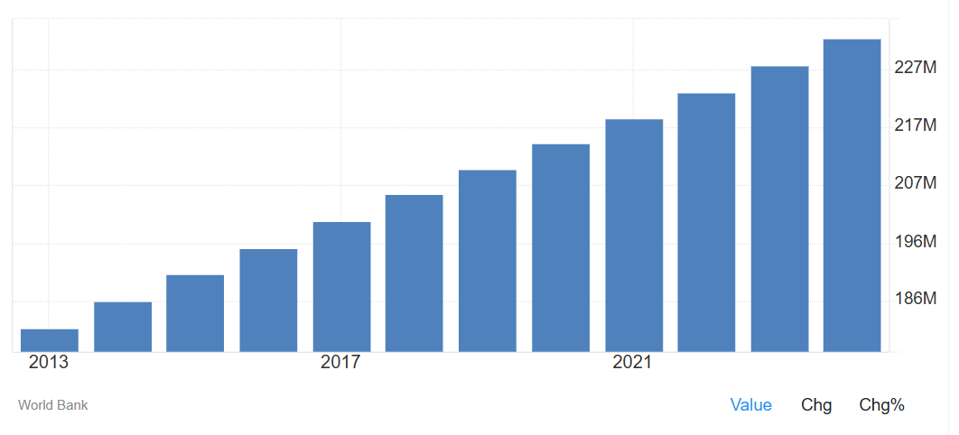
FIGURE 1: TOTAL POPULATION NIGERIA
(SOURCE: TRADING ECONOMICS, 2025)
The high inflation (about 23% in early 2025 compared to the previous year’s rate of 35%) and real income loss, remain factors that shape consumer behaviour in the country (NHM, 2025). Inflation and currency depreciation make customers highly price-sensitive, benefitting fast-fashion retailers offering affordable yet stylish products. However, high import duties and logistics costs may limit profitability unless local sourcing or regional supply integration is developed (Bailey, 2023).
Therefore, the economic indicators show long-term market attractiveness, but Zara’s pricing strategy must account for inflation, exchange-rate risk, and import tariffs to maintain affordability.

FIGURE 2: PESTEL ANALYSIS
(SOURCE: SELF-CREATED)

SOCIAL FACTORS
Nigeria’s population is among the youngest globally, with a median age of 18.1 years and nearly 70% under 30 (TechCabal, 2023). Urbanisation exceeds 55%, and major cities such as Lagos, Abuja, and Port Harcourt act as fashion and lifestyle hubs (Worldometer, 2025). This young, urban population is highly active on social media and responsive to fashion trends.
Nigerian clothing market was valued at about US $1.19 billion in 2024, experiencing an average annual growth rate of 17% for the past decade (DHL, 2024). By extension, unemployment and income inequality limit purchasing power as consumers opt for affordable -but aspirational- brands (This Day 2022). This latter part is very much in line with Zara’s “affordable luxury” value prop.
What this means is, on one hand Nigeria’s young population and its fashion-forward populace are the ideal Zara customers (to be) however affordability and relevance over different income levels are key.

TECHNOLOGICAL FACTORS
The pace of digital transformation in Nigeria is quickening. By early 2025, 163 million were online (43–45% internet penetration) (ITA, 2025; Okocha, 2025). Trading in e-commerce generated an income of US $15 billion worldwide in 2023 and is anticipated to exceed that amount by doubling to a total of US $33 billion by 2026(PCMI, 2024).
It supports Inditex’s omnichannel strategy (both online and physical stores). In addition, Nigeria’s digital growth provides a strong platform for Zara’s technology-driven retail model, but operational execution must consider infrastructure limitations and uneven internet access.

LEGAL AND REGULATORY FACTORS
Nigeria’s trade policy is both an opportunity and a limitation. A ban on the imports of cloth was recently loosed by the government, but 35 per cent or more is still charged by way of duties (ITA, 2025a; Bailey, 2023). This inward-looking approach incentivises ‘some local' sourcing or regional associations to minimise reliance on imports.
The national minimum wage rose between 2020 and 2024 from NGN 30,000” to NGN 70,000 BARGAINING POWER OF SUPPLIERS a month which can help consumer demand but also increases labour cost (WageIndicator, 2024). The legal environment places a strong emphasis on consumer protection laws, tax laws and local employment legislation which makes Zara’s operations absolutely necessary to have domestic law expertise.
Hence the complicated trade arrangements and labour laws can drive up entry costs; a joint venture or franchise model may help to reduce the risk of failure in the early years.

ENVIRONMENTAL FACTORS
Nigeria has huge climatic issues with floods and forests, so does desertification. The country has signed the Paris Agreement and created a long-term low-emission development strategy (UNDP, 2019). Meanwhile, the African textile and fashion industry are estimated at over US $31 billion, with Nigeria accounting for approximately 15% and an increasingly interest in sustainable production (Huard, 2022).
Zara’s sustainability efforts, like using lower-impact materials, recycling and aiming for net-zero by 2040 (Inditex, 2025b), fit local expectations and give the brand a chance to stand out in Nigeria by leading in eco-friendly fashion.

EVALUATION OF THE PESTEL FRAMEWORK
The PESTEL analysis helped us understand Nigeria’s overall environment by highlighting key risks and opportunities shaped by politics, inflation, digital growth and rising sustainability trends. But the model’s static nature is an impediment to it being able to keep pace with how quickly emerging markets like Nigeria can change in real life – with fiscal policies, tariffs and exchange rates all frequently changing. It also homogenizes the national field, dismissing wide disparities of infrastructure and consumer capacity among Lagos, Abuja and the rural states. Moreover, PESTEL isolates environmental forces without connecting them directly to firm-specific capabilities. Therefore, while the model offered a clear foundation for external analysis, its insights need integration with dynamic and firm-level frameworks, such as VRIO and Porter’s Five Forces, to produce a more holistic strategic perspective for Zara’s market entry.

PORTER’S FIVE FORCES – NIGERIA’S FASHION & APPAREL RETAIL MARKET
The competitive intensity and attractiveness of the Nigeria clothing industry is analysed using Porter’s five forces framework.

THREAT OF NEW ENTRANTS
With a population of more than 230 million, Nigeria provides scale for new players, but requires significant investments and expertise. The high import tariffs, regulatory constraints, and weak infrastructure in addition to the instability of foreign exchange (Owa et al., 2024) put off foreign retailers. Even though e-commerce portals such as Jumia are removing barriers, breaking into physical retail on a large scale is still expensive.
Given its worldwide scale, supply-chain prowess and financial power, Inditex has lower barriers to entry than smaller rivals. Thus, entry barriers are medium; Zara’s international capabilities reduce risks faced by smaller brands.

BARGAINING POWER OF SUPPLIERS
Nigeria’s textile manufacturing base is in decay, and the local clothiers are depending on foreign-made fabrics (Owa et al., 2024). This dependence, as well as logistics impediments and high import tariffs also drive-up supplier power. But Inditex distributes garments from its vertically integrated model, and through partnerships around the world, which means it relies less heavily on intermediaries at home. So, supplier power is moderate to high for the industry, but Zara’s global sourcing network and scale offer it some bargaining power.

BARGAINING POWER OF BUYERS
With high inflation, income inequality and an enormous market for second-hand “okrika” clothing have put Nigerian consumers in a strong bargaining position. Buyers have a number of alternatives including low-cost local brands, second-hand vendors and imported items, that make it easy to switch. Volume growth was held back by inflation, and price competition intensified according to Euromonitor International (2024). Zara will thus have to continue differentiating by design innovation, store experience and perceived brand cachet against almost-only-on price competitors. So buyer power is strong; Zara must trade off affordability with perceived quality if it is to stop lots of people from switching.

THREAT OF SUBSTITUTES
Alternatives are the purchase of used clothing, local tailors and street markets with informal fashion. Preloved fashion industry is booming, catering to the desire for fashionable items in an economic, recession (6Wresearch, 2022). Local tailoring also offers culturally appropriate options in addition to tailored local alternatives.
Because these alternatives are widespread, culturally embedded and economically compelling, the threat of substitutes is high. Zara must therefore position its offering carefully—through trend speed, store experience, brand status and perhaps local-relevance—to differentiate from these substitute channels.
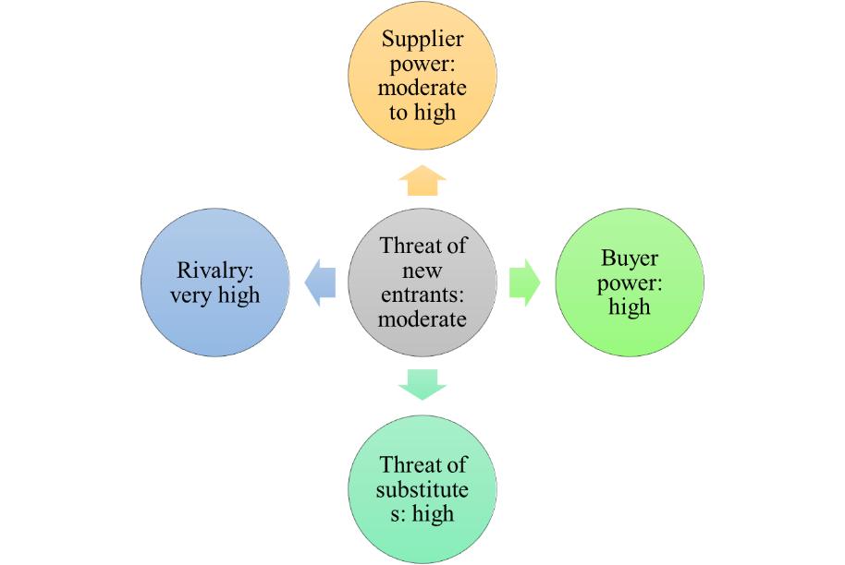
FIGURE 3: PORTER’S FIVE FORCES ANALYSIS
(SOURCE: SELF-CREATED)

RIVALRY AMONG EXISTING COMPETITORS
Nigeria’s fashion industry is deeply fragmented. It is home to domestic brands, informal trade and some international players that compete across price points (Euromonitor International, 2024). Inflation has pushed up promotions being offered and visibility at online channels has increased. Agility, fast turnover and worldwide brand power are important advantages for Zara, but driving the top line with defensible margins will require execution and localisation.
Overall, competitive rivalry is very high and Zara needs to seize the opportunities open to it by getting better and faster at responding than its competitors through an integrated supply-chain strategy and digital capabilities.

EVALUATION OF PORTER’S FIVE FORCES FRAMEWORK
Porter’s Five Forces successfully exposed the structural competitiveness of the Nigerian fashion and apparel retail market. It described how high buyer power, strong substitutes and fierce rivalry could threaten Zara’s entry but that Inditex’s scale, brand strength and supply chain integration might mute some of the forces. And the framework was useful for identifying where Zara’s core strengths meet external threats. Porter’s Five Forces doesn’t fully reflect Nigeria’s large informal market, fast-changing trends or the influence of social media, so it works best when combined with other tools like VRIO and PESTEL. Together, these frameworks show that Nigeria offers big opportunities for Zara but also major challenges such as inflation, price sensitivity and a fragmented retail landscape.
Therefore for Zara, to be successful, it needs to carefully localise and manage risks. Its integrated logistics, omnichannel capabilities, and strong financial base are all good things. Zara with relevant changes in product and pricing strategy can have long-term growth in Nigeria.

STRATEGY DEVELOPMENT AND FORMULATION
Based on the company analysis, VRIO assessment and external environment, this section provided strategic expansion strategy for Zara in Nigeria. This section uses the Ansoff Product–Market Growth Matrix, Dunning’s OLI paradigm and Porter’s generic strategies to formulate a market entry plan that aligns with Inditex’s global objectives and establishes a defensible competitive position in the Nigerian market.

STRATEGIC INTENT AND OBJECTIVES
Inditex aims to expand in under-penetrated “Rest of World” markets while strengthening its integrated store–online model and sustainability commitments. Nigeria offers a compelling but challenging context for this ambition. The country’s population is projected at more than 230 million in 2025, with a median age around 18 years and an urbanisation rate above 50 per cent, which indicates a large, young and city-concentrated consumer base (Owa et al., 2024; UNFPA, 2025; Worldometer, 2025). The domestic fashion market is estimated at between US$2.5–6 billion annually, and fashion e-commerce alone generated approximately US$0.48 billion in revenue in 2024 (Emoekpere, 2025).
Against this backdrop, the strategic intent is to establish a scalable omnichannel presence in Nigeria that delivers profitable growth, builds Zara’s brand equity with young urban consumers and, in the medium term, creates a platform for wider West African expansion. Over the first three years the main objectives are to:
- launch a fully localised online channel and a small network of flagship and mall stores in Lagos and Abuja
- achieve acceptable store-level profitability, sales per square metre and inventory turnover within defined timeframes
- embed Inditex’s 2040 net-zero and circular-fashion commitments into the new market from the outset, in line with group targets (Inditex, 2024, 2025b).
These objectives provide a clear link between the Nigerian project and Inditex’s global strategy; while recognising the macroeconomic and operational risks highlighted in the PESTEL and Five Forces analysis.

GROWTH DIRECTION: ANSOFF MATRIX
The Ansoff Matrix distinguishes four generic growth paths—market penetration, market development, product development and diversification—based on whether products and markets are existing or new, with risk increasing as firms move further from their current position (Ansoff, 1957). Figure 4 applies the matrix to Zara’s Nigerian opportunity.
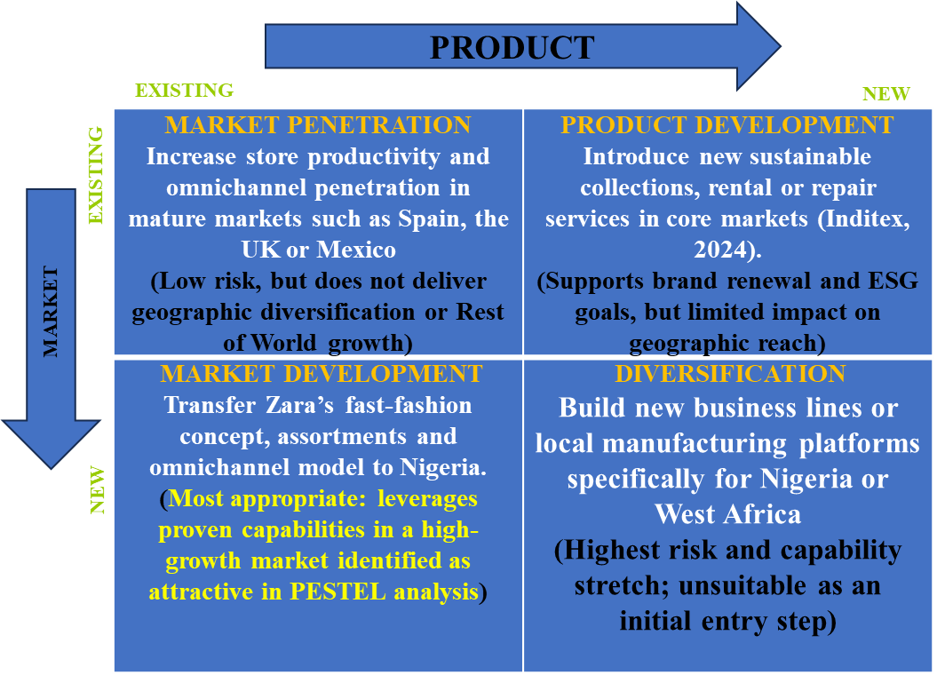
FIGURE 4.1: APPLICATION OF THE ANSOFF MATRIX TO ZARA NIGERIA (Inditex, 2024).

Given Inditex’s existing product portfolio and vertically integrated fast-fashion model, the Nigerian expansion clearly falls into market development: established products and capabilities deployed in a new geographic market (Inditex, 2024).
PESTEL and Five Forces show Nigeria has strong demand but serious economic and infrastructure risks, and a market-development entry lets Zara use its global strengths without changing its core model in such a high-risk setting. Hence, some targeted adaptation remains necessary to fit local conditions. Examples include lighter fabrics for hot climates, modest-wear options for specific segments, sizing appropriate for local body types and pricing structures that reflect inflation and income sensitivity. These adjustments are incremental and therefore remain consistent with a market-development strategy rather than full product development or diversification.
4.3 Entry mode decision: OLI paradigm
Dunning’s OLI paradigm explains foreign direct investment decisions through three types of advantages: Ownership (O), Location (L) and Internalisation (I). FDI is most attractive when firms possess strong ownership advantages, the host country offers compelling location benefits and internalising operations yields more value than licensing to third parties. Table 2 summarises how these factors apply to Zara in Nigeria.
TABLE 2: OLI ASSESSMENT FOR ZARA’S ENTRY INTO NIGERIA
OLI element | Assessment for Inditex/Zara | Implication for entry mode
Ownership (O) | Strong global brand equity, highly integrated design–production–logistics system, data-driven omnichannel platform and significant financial resources (Inditex, 2024). | Supports an active FDI presence. Zara’s firm-specific advantages are best exploited through direct involvement in Nigeria.
Location (L) | Large, young and urbanising population; fashion market estimated at US$2.5–6 billion; fashion e-commerce around US$0.48 billion within a wider e-commerce market of about US$8.5 billion in 2024 (Emoekpere, 2025). | Attractive growth platform, but offset by high inflation, currency volatility, tariffs and infrastructure constraints, which require risk-sharing and local expertise.
Internalisation (I) | Zara’s model depends on tight control over assortment, pricing, inventory and store/online experience; excessive franchising risks diluting these capabilities and damaging brand equity (Inditex, 2024). | Favourable to entry modes where Zara retains strong control over core functions rather than pure licensing or loose franchising.
The OLI assessment indicates that Zara’s ownership and internalisation advantages are strong, while Nigeria’s location advantages are attractive but risky. A joint-venture or partially owned subsidiary therefore emerges as the most appropriate initial entry mode. Under this configuration, Zara would retain control over brand management, assortment planning, pricing, IT and omnichannel integration, while a Nigerian partner contributes local market knowledge, regulatory navigation, property access and elements of logistics and labour management. This balance allows Zara to exploit its global capabilities, preserve brand and operational standards and at the same time share political, regulatory and execution risk in a complex emerging market.

COMPETITIVE STRATEGY: PORTER’S GENERIC STRATEGIES
Porter’s generic strategies framework proposes three broad routes to competitive advantage: cost leadership, differentiation and focus (cost focus or differentiation focus). The Five Forces analysis showed that Nigeria’s fashion market is highly fragmented, with intense rivalry, strong buyer power and a high threat from substitutes, including second-hand “okrika” clothing, informal street markets and low-cost local brands (Emoekpere, 2025). These conditions limit the feasibility of a pure cost-leadership position for a formal international retailer that must comply with quality, labour and import regulations. Figure 5 summarises the fit of each generic strategy.
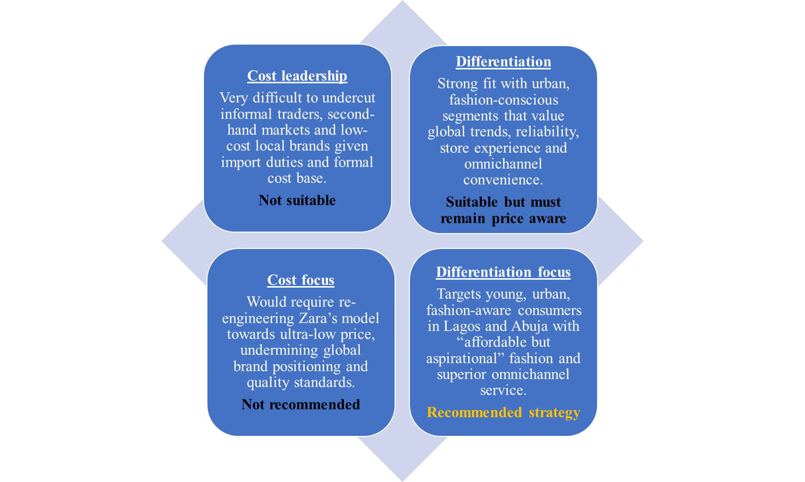
FIGURE 5: PORTER’S GENERIC STRATEGIES (Emoekpere, 2025).
Zara’s recommended competitive position in Nigeria is a differentiation-focus strategy aimed at young, urban consumers in Lagos and Abuja who seek global style and brand recognition but are constrained by income and inflation. Differentiation will be delivered through three main levers. First, Zara will use its fast-fashion capability to bring frequent new drops and short design-to-store lead times that local players struggle to match. Second, it will provide a superior technology-enabled customer experience, including a localised website/app, Click and Collect, reliable returns and local payment options that build trust in formal retail. Third, it will make visible sustainability and circular-fashion initiatives, such as garment take-back schemes and lower-impact materials, which distinguish Zara from informal and less sustainability-oriented competitors (Inditex, 2024, 2025b). To remain competitive in a price-sensitive environment, this differentiation focus must be supported by disciplined pricing and inventory management so that the offer remains “aspirational but attainable” rather than premium.
PHASED IMPLEMENTATION ROADMAP
To translate this strategy into action and manage risk, Zara’s entry into Nigeria should follow a phased roadmap with clear milestones and performance gates.
TABLE 3: PHASED MARKET ENTRY ROADMAP FOR ZARA NIGERIA
Phase | Timeframe | Geographic focus | Strategic focus | Key actions | Example KPIs / gates
Phase 1 – Set-up and Online Launch | Months 0–6 | Lagos and Abuja (planning) | Establish legal, digital and partnership foundations. | Finalise JV partner; establish legal entity; secure leases for flagship and first mall stores; launch localised website/app with Naira pricing and local payment options. | JV agreement signed; online platform live and stable; first-month traffic and conversion meet target ranges.
Phase 2 – Flagship and Omnichannel Roll-out | Months 6–18 | Lagos and Abuja (stores live) | Open initial stores and implement full omnichannel model. | Open Lagos flagship and 1–2 mall stores; integrate store and online inventory for Click and Collect and returns; implement staff training; launch targeted marketing campaigns. | Sales per m² and inventory turnover within target; Net Promoter Score above threshold; stores reach EBITDA breakeven within planned timeframe.
Phase 3 – Optimisation and Regional Platform | Months 18–36 | Nigeria and West Africa | Optimise model and assess regional hub potential. | Refine assortment and pricing; consider entry into additional Nigerian cities; explore regional logistics solutions; review JV structure and potential increase in equity stake. | Sustained profitability at country level; rising online share of sales; positive brand equity metrics; clear decision on further Nigerian and West African expansion.
This roadmap operationalises the market-development strategy identified through the Ansoff Matrix, the risk-sharing logic from the OLI analysis and the differentiation-focus positioning. By linking each phase to specific KPIs and decision gates, it also sets the foundation for the performance evaluation framework in the next section.

PERFORMANCE EVALUATION FRAMEWORK
The Nigerian expansion will only be successful if Zara can demonstrate that it delivers profitable growth, strengthens brand equity and supports Inditex’s sustainability commitments, rather than simply achieving store openings. Inditex already runs a highly data-driven model, combining store and online metrics across its global network, with 2024 net sales of €38.6 billion and strong growth in both channels (Inditex, 2024). A clear, structured performance system is needed so that the Nigerian business can be managed with the same discipline and can be directly linked to the strategy set out in Section 4 and the roadmap in Table 3.
PERFORMANCE FRAMEWORK FOR ZARA
The Balanced Scorecard (BSC) assesses performance across four perspectives: financial, customer, internal processes and learning and growth (Kaplan and Norton, 1992). It is widely used in retail because it links operational measures to long-term strategy. For an expansion market like Nigeria, where early years involve investment, experimentation and brand-building, a multi-perspective tool is more suitable than purely financial indicators.
Inditex has also set explicit sustainability targets, including 100% lower-impact fibres by 2030 and net-zero emissions by 2040 (Inditex, 2023; 2025b). The Triple Bottom Line (TBL) framework—profit, people and planet—helps assess whether an expansion contributes to broader ESG priorities.
Given these requirements, a sustainability-enhanced Balanced Scorecard is the most appropriate framework. It allows Zara Nigeria to track commercial viability while integrating social and environmental metrics aligned with Inditex’s global commitments.

SUSTAINABILITY-ENHANCED BALANCED SCORECARD FOR ZARA NIGERIA
Figure 6 sets out a proposed scorecard for Zara Nigeria, aligned with the market-development strategy, differentiation-focus positioning and the three phases in Table 3. The KPIs reflect typical performance drivers in fashion retail, where sales per square metre, inventory turnover and customer experience indicators are critical for success in volatile markets (Marr, 2024).
The financial perspective evaluates whether the market-development strategy is generating sustainable value. Metrics such as sales per square metre, store-level EBITDA margin, inventory turnover and online share of sales show how well the model performs in an inflationary, price-sensitive market.
The customer perspective reflects the differentiation-focus strategy. Rising brand awareness, Net Promoter Score, repeat purchasing and online conversion indicate whether Zara’s fashion offering, brand positioning and omnichannel services (e.g., Click and Collect) resonate with young urban consumers in Lagos and Abuja.
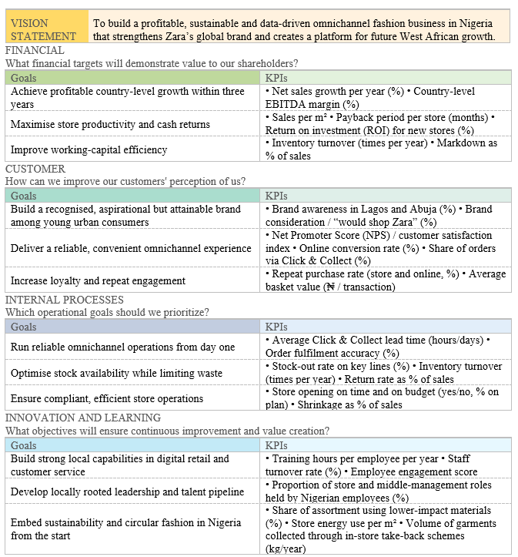
FIGURE 6: SUSTAINABILITY-ENHANCED BALANCED SCORECARD FOR ZARA NIGERIA
The internal process perspective links directly to Zara’s operational strengths. Inventory accuracy, stock availability, Click and Collect lead times and return rates demonstrate whether the integrated supply chain and omnichannel system are functioning effectively in Nigeria’s infrastructure environment.
The learning and growth perspective ensures long-term scalability. Metrics such as training hours, employee retention and ratio of local managers indicate whether local capabilities are developing within the joint-venture model proposed in Section 4. This Balanced Scorecard collectively operationalises the strategic objective of profitable, sustainable omnichannel growth in Nigeria.

EMBEDDING THE TRIPLE BOTTOM LINE
The TBL strengthens the Balanced Scorecard by clarifying success in terms of profit, people and planet (Kenton, 2025). Table 4 effectively links BSC measures to these TBL dimensions.
TABLE 4: LINKING THE BALANCED SCORECARD TO THE TRIPLE BOTTOM LINE
TBL dimension | Focus for Zara Nigeria | Linked KPIs (examples)
Profit | Sustainable commercial performance and capital efficiency. | Net sales growth; sales per m²; store-level EBITDA margin; inventory turnover; online share of sales (from financial perspective).
People | Quality jobs, skills and fair treatment, plus customer and community impact. | Training hours per employee; staff turnover; employee engagement; proportion of local managers; NPS/customer satisfaction; number of participants in community or skills programmes.
Planet | Contribution to Inditex climate and circularity goals. | Store energy use per m²; share of Nigerian assortment made from lower-impact fibres (%); CO₂ emissions per unit sold (scope 2 and logistics-related); volume of garments collected via in-store take-back or recycling schemes.
Inditex has already committed to using only lower-impact textile materials by 2030 and to reducing emissions by more than 50 per cent by 2030 on the path to net-zero in 2040 (Inditex, 2023, 2025b). The “planet” indicators in Table 4 translate these group commitments into country-level metrics for Nigeria. For example, Zara Nigeria can track the percentage of SKUs sourced from lower-impact fibres and the energy intensity of new stores, which should be designed using group guidelines for efficient lighting, HVAC and renewable sourcing where possible. The “people” indicators capture whether the expansion supports local employment, skills and community engagement, in line with the social trends and vulnerabilities identified in the PESTEL analysis.

USING THE FRAMEWORK ACROSS THE EXPANSION PHASES
The performance framework adds value only if it is used actively to manage the three phases of the Nigerian entry described in Table 3. In Phase 1 (set-up and online launch), priority KPIs sit mainly in the internal process and customer perspectives. Examples include website stability, online conversion, first-time customer satisfaction and Click and Collect lead times, alongside adherence to launch budgets.
In Phase 2 (flagship and mall store openings), the emphasis shifts towards financial and customer outcomes. Sales per square metre, store-level EBITDA, inventory turnover and NPS become central. These can act as “gates” for further store openings. For instance, Zara could require that new stores in additional Nigerian cities are approved only once existing Lagos and Abuja stores have achieved a defined EBITDA margin and NPS threshold for at least four consecutive quarters.
In Phase 3 (optimisation and regional platform), country-level profitability and brand metrics take precedence, together with selected “people” and “planet” indicators from Table 4. At this stage, management will decide whether to expand beyond Nigeria or to increase Zara’s equity stake in the joint venture, so the performance data needs to show that the business model is financially sound and aligned with Inditex’s climate and materials targets.
Regular monthly dashboards and quarterly strategy reviews can use this sustainability-enhanced Balanced Scorecard to identify trends, diagnose problems and adjust tactics. For example, if sales per square metre and NPS are strong but inventory turnover is weak, the issue is likely to sit in buying and allocation rather than in customer appeal. If energy-use or lower-impact fibre targets are off-track relative to group trajectories, Nigeria-specific sustainability projects can be prioritised without waiting for global interventions.
Overall, this performance evaluation framework provides a practical way to test whether the Nigerian expansion is delivering what Section 4 promised: profitable growth, a distinctive and trusted customer proposition, operational excellence in omnichannel retailing and a credible contribution to Inditex’s wider commitments on people and planet.

CONCLUSION
The report has developed an organisational expansion plan for Zara’s entry into Nigeria that links Inditex’s global capabilities with the specific conditions of a high-potential but challenging emerging market. The selection of Nigeria is supported by strong demographic and demand fundamentals, including a large, young and urbanising population and a growing fashion and e-commerce sector, while the PESTEL and Five Forces analysis highlights material risks related to inflation, currency volatility, infrastructure and intense competitive pressure.
VRIO analysis confirms that Inditex’s vertically integrated supply chain, omnichannel infrastructure, financial strength and sustainability commitments provide a solid base for market development. Building on this, the recommended strategy combines market development in Ansoff terms, a joint-venture based entry mode informed by the OLI paradigm and a differentiation-focus position targeted at young urban consumers in Lagos and Abuja.
The sustainability-enhanced Balanced Scorecard, aligned with Triple Bottom Line thinking, offers a practical way to measure whether the expansion delivers profitable growth, a distinctive and trusted customer proposition, operational excellence and credible progress on people and planet objectives. Taken together, the analysis suggests that Nigeria can become a viable long-term growth platform for Inditex, provided Zara executes the strategy with disciplined implementation, local adaptation and continuous performance review.

REFERENCES
Adeoye, A. and Cotterill, J. (2025) Nigeria’s economy 30% bigger after GDP recalculation. Financial Times. Available at: https://www.ft.com/content/38b06d3a-afd6-49bf-8860-235f807db934 (Accessed: 10 November 2025).
Kenton, W. (2025) Triple bottom line: What it is and how to measure. Investopedia. Available at: https://www.investopedia.com/terms/t/triple-bottom-line.asp (Accessed: 15 November 2025).
Marr, B. (2024) The four perspectives in a balanced scorecard. Bernard Marr & Co. Available at: https://bernardmarr.com/the-four-perspectives-in-a-balanced-scorecard/ (Accessed: 15 November 2025).
Inditex (2023) New sustainability commitments. Available at: https://www.inditex.com/itxcomweb/api/media/cdcf54dd-4c9b-4ee9-92ab-f55d28d65901/Inditex%2BNew%2BSustainability%2BCommitments.pdf?t=1690537968645 (Accessed: [insert date]).
Kaplan, R.S. and Norton, P.N. (1992) ‘The balanced scorecard—measures that drive performance’, Harvard Business Review. Available at: https://hbr.org/1992/01/the-balanced-scorecard-measures-that-drive-performance-2 (Accessed: 15 November 2025).
Oloni, V. (2024) From brick to click: E-commerce and the future of retail. Veriv Africa. Available at: https://www.verivafrica.com/insights/from-brick-to-click-e-commerce-and-the-future-of-retail (Accessed: 15 November 2025).
Emoekpere, E. (2025) ‘$6 billion fashion market: 6 ways Nigerians are dressing up—and who is really funding it’, Business Day. Available at: https://businessday.ng/bd-weekender/article/6-billion-fashion-market-6-ways-nigerians-are-dressing-up-a-and-who-is-really-funding-it/ (Accessed: 15 November 2025).
Inditex (2024) Inditex Group annual report 2024. Available at: https://www.inditex.com/itxcomweb/api/media/84135f02-0208-4439-b9c0-b13608fbfeb5/Annualaccountsanddirectorsreport2024consolidated.pdf?t=1742203067340 (Accessed: 15 November 2025).

Allen, E. (2024) ‘Stepping inside Africa’s fashion industry’, African Business. Available at: https://african.business/2024/01/trade-investment/a-pan-african-catwalk-stepping-inside-the-fashion-industry (Accessed: 10 November 2025).
Bailey, B. (2023) Nigeria’s textile imports double despite local production push. Business Day. Available at: https://businessday.ng/business-economy/article/nigerias-textile-imports-double-despite-local-production-push/ (Accessed: 10 November 2025).
Bala-Gbogbo, M. (2025) Nigeria's economy grows strongly amid high inflation, World Bank says. Reuters. Available at: https://www.reuters.com/world/africa/nigerias-economy-grows-strongly-amid-high-inflation-world-bank-says-2025-05-12/ (Accessed: 10 November 2025).
BCG Matrix (2025) What is growth strategy and future prospects of Inditex Company? Available at: https://matrixbcg.com/blogs/growth-strategy/inditex (Accessed: 10 November 2025).
BTI (2025) BTI 2024 Country Report: Nigeria. Available at: https://bti-project.org/fileadmin/api/content/en/downloads/reports/country_report_2024_NGA.pdf (Accessed: 10 November 2025).
DHL (2024) Fashion supply chain: Growth opportunities for Nigerian SMEs. Available at: https://www.dhl.com/discover/en-ng/small-business-advice/growing-your-business/fashion--supply-chain--growth-opportunities-for-nigerian-sme (Accessed: 10 November 2025).
ECDB (2024) Zara online sales: Global store count, revenue, markets. Available at: https://ecdb.com/blog/zara-rising-global-sales-zara-store-numbers-latest-fashion-trends/3098 (Accessed: 10 November 2025).
Ekugbe, G. (2024) Nigeria’s eCommerce fashion market to hit $423m in 2024 – Minister. Punch Newspaper. Available at: https://punchng.com/nigerias-ecommerce-fashion-market-to-hit-423m-in-2024-minister/ (Accessed: 10 November 2025).
Emoekpere, E. (2025) $6 billion fashion market: 6 ways Nigerians are dressing up—and who is really funding it. Business Day. Available at: https://businessday.ng/bd-weekender/article/6-billion-fashion-market-6-ways-nigerians-are-dressing-up-a-and-who-is-really-funding-it/ (Accessed: 10 November 2025).
Euromonitor International (2024) Apparel and footwear in Nigeria: The big picture. Available at: https://www.euromonitor.com/apparel-and-footwear-in-nigeria/report (Accessed: 10 November 2025).
Fashion United (2025) Inditex reveals €1.8 billion investment plan for 2024/25. Available at: https://fashionunited.com/news/business/inditex-reveals-1-8-billion-euro-investment-plan-for-2024-25/2024031458895 (Accessed: 10 November 2025).
Fibre2Fashion (2025) Spain's Inditex plans $1.96 bn investment for growth in 2025. Available at: https://www.fibre2fashion.com/news/fashion-news/spain-s-inditex-plans-1-96-bn-investment-for-growth-in-2025-301307-newsdetails.htm (Accessed: 10 November 2025).
Huard, A.A. (2022) Nigeria: A fashion hot spot. Business Sweden. Available at: https://www.business-sweden.com/insights/articles/nigeria-a-fashion-hot-spot/ (Accessed: 10 November 2025).
Inditex (2025) FY2024 results. Available at: https://www.inditex.com/itxcomweb/aq/en/press/news-detail/6f8d8db5-4d7a-43db-91b9-0c38065aec1e/fy2024-results (Accessed: 10 November 2025).
Inditex (2025a) Zara, Pull&Bear, Massimo Dutti, Bershka, Stradivarius, Oysho and Zara Home celebrate style and self-expression. Available at: https://www.inditex.com/itxcomweb/bd/en/home (Accessed: 10 November 2025).
Inditex (2025b) Sustainability. Available at: https://www.inditex.com/itxcomweb/es/en/sustainability (Accessed: 10 November 2025).
International Trade Administration (ITA) (2025) Nigeria Country Commercial Guide: Digital economy. Available at: https://www.trade.gov/country-commercial-guides/nigeria-digital-economy (Accessed: 10 November 2025).
International Trade Administration (ITA) (2025a) Import tariffs – Nigeria. Available at: https://www.trade.gov/country-commercial-guides/nigeria-import-tariffs (Accessed: 10 November 2025).
NHM (2025) Nigeria’s inflation hits 34.60% in November 2024: A 28-year high amid rising costs of living. Nigeria Housing Market. Available at: https://www.nigeriahousingmarket.com/real-estate-news-nigeria/nigerias-inflation-hits-3460-in-november-2024-a-28-year-high-amid-rising-costs-of-living (Accessed: 10 November 2025).
Okocha, S. (2025) Nigeria’s e-commerce boom: Who wins, who struggles, and what’s next? 234Digest. Available at: https://www.234digest.com/p/nigeria-s-e-commerce-boom-who-wins-who-struggles-and-what-s-next-ac60 (Accessed: 10 November 2025).
Owa, O.E., Chukwudi, C.E., Okongor, J.N. and Ezebuilo, P.C. (2024) ‘Gio–Nigeria economic relations on the development of the Nigerian textile sector, 2006–2017’, Journal of International Cooperation and Development, 7(2), pp.79–116.
PCMI (2024) Key insights into Nigeria’s e-commerce market. Payments and Commerce Market Intelligence (PCMI). Available at: https://paymentscmi.com/insights/nigeria-ecommerce-market-data (Accessed: 10 November 2025).
Research and Markets (2023) Nigeria apparel retail market summary, competitive analysis and forecast to 2027. Available at: https://www.researchandmarkets.com/reports/5717344/nigeria-apparel-retail-market-summary (Accessed: 10 November 2025).
TechCabal (2023) Beyond the numbers: Unlocking the potential of Nigeria’s booming youth population. Available at: https://techcabal.com/2024/06/19/unlocking-potential-nigerias-booming-youth-population/ (Accessed: 10 November 2025).
This Day (2022) How Nigeria’s expanding youth population fuels retail growth. Available at: https://www.thisdaylive.com/2023/02/23/how-nigerias-expanding-youth-population-fuels-retail-growth-in-nigeria/ (Accessed: 10 November 2025).
Trading Economics (2025) Nigeria – population, total. Available at: https://tradingeconomics.com/nigeria/population-total-wb-data.html (Accessed: 10 November 2025).
UNDP (2019) INDC project actions and impacts: Nigeria. United Nations Development Programme. Available at: https://climatepromise.undp.org/research-and-reports/indc-project-actions-and-impacts-nigeria (Accessed: 10 November 2025).
UNFPA (2025) Nigeria population 2025. United Nations Population Fund. Available at: https://www.unfpa.org/data/world-population/NG (Accessed: 10 November 2025).
WageIndicator (2024) Minimum wage increased in Nigeria from 19 July 2024. Available at: https://wageindicator.org/salary/minimum-wage/minimum-wages-news/2024/minimum-wage-increased-in-nigeria-from-19-july-2024-november-08-2024 (Accessed: 10 November 2025).
World Bank Group (2025) The World Bank in Nigeria: Country overview. Available at: https://www.worldbank.org/en/country/nigeria/overview (Accessed: 10 November 2025).
World Bank Group (2025a) Nigeria country data. Available at: https://data.worldbank.org/country/nigeria (Accessed: 10 November 2025).
Worldometer (2025) Nigeria population (live). Available at: https://www.worldometers.info/world-population/nigeria-population/ (Accessed: 10 November 2025).
Zara (2025) Shipping methods, times and costs. Available at: https://www.zara.com/ww/en/help-center/DeliveryMethods (Accessed: 10 November 2025).
Zhu, Y. (2023) ‘Research on fast fashion industry under sustainable development model: Based on ZARA’s SWOT analysis’, in Proceedings of the 6th International Conference on Economic Management and Green Development, Singapore: Springer Nature, pp.935–942.
6Wresearch (2022) Nigeria second-hand apparel market (2025–2031): Analysis, outlook and forecast. Available at: https://www.6wresearch.com/industry-report/nigeria-secondhand-apparel-market (Accessed: 10 November 2025).

