Radio Frequency Systems

ACDA5019

Investigating the Effect of Noise in SSB- SC and DSB- SC

Student ID: 2214461

Word count:1900

Author: Owen Wild

Table of Contents
Table of Figures 3
Abstract 5
Introduction 5
Background researcher 5
Task 1: 6
Task 2: 7
Task3: 7
Task 4: 8
Conclusion 8
Recommendations 8
References 9
Appendix 10

Table of Figures
Figure 1 AM block diagram [2] 10
Figure 2 AM circuit diagram [8] 10
Figure 3 AWGN SNR value 5db 11
Figure 4 AWGN SNR value -15db 11
Figure 5 AWGN SNR value -30db 12
Figure 6 AM Modulations Block Diagram 12
Figure 7 AM Modulation time scope 0.1 13
Figure 8 AM Modulation spectrum 0.1 13
Figure 9 AM modulation time scope 0.5 14
Figure 10 AM modulation spectrum 0.5 14
Figure 11 AM modulation time scope 1 15
Figure 12 AM modulation spectrum 1 15
Figure 13 AM demod block diagram 16
Figure 14 AM demod time scope 0.1 16
Figure 15 AM demod spectrum 0.1 17
Figure 16 AM demod time scope 0.5 17
Figure 17 AM demod spectrum 0.5 18
Figure 18 AM Demod time scope 1 18
Figure 19 AM demod spectrum 1 19
Figure 20 AM Message signal with 5db of AWGN spectrum 19
Figure 21 AM carrier signal with 5db of AWGN spectrum 20
Figure 22 AM signal with 5db of AWGN 20
Figure 23 AM demod signal with 5db of AWGN spectrum 21
Figure 24 AM Message signal with 5db of AWGN in the time domain 21
Figure 25 AM Message signal with -15db of AWGN spectrum 22
Figure 26 AM carrier signal with -15db of AWGN spectrum 22
Figure 27 AM AWGN signal at -15db spectrum 23
Figure 28 AM demod signal with -15db of AWGN spectrum 23
Figure 29 AM signals with -15db of AWGN in the time domain 24
Figure 30 AM Message signal with -30db of AWGN spectrum 24
Figure 31 AM carrier signal with -30db of AWGN spectrum 25
Figure 32 AM AWGN signal at -30db spectrum 25
Figure 33 AM demod signal with -30db of AWGN spectrum 26
Figure 34 Am signals with -30db of AWGN in the time domain 26
Figure 35 DSB-SC block diagram [5] 27
Figure 36 DSB-SC block diagram (2) [5] 27
Figure 37 DSB-SC receiver architectures [9] 28
Figure 38 DSB-SC MATLAB diagram 28
Figure 39 DSB -SC Time domain 29
Figure 40 DSB-SC message spectrum 29
Figure 41 DSB-SC carrier spectrum 30
Figure 42 DSB-SC demod spectrum 31
Figure 43 DSB-SC message signal with 5db of AWGN Spectrum 32
Figure 44 DSB-SC carrier signal with 5db of AWGN Spectrum 32
Figure 45 DSB-SC AM signal with 5db of AWGN Spectrum 33
Figure 46 DSB-SC AWGN at 5db 34
Figure 47 DSB-SC demod signal with 5db of AWGN Spectrum 34
Figure 48 DSB-SC signals in time scope with 5db of AWGN 35
Figure 49 DSBSC Signal in Time domain with -15db of AWGN 35
Figure 50 DSB-SC message signal with -15db of AWGN 36
Figure 51 DSB-SC carrier signal with -15db of AWGN 36
Figure 52 DSB-SC AM signal with -15db of AWGN 37
Figure 53 DSB-SC AWGN at -15db 37
Figure 54 DSB-SC demod signal with -15db of AWGN 38
Figure 55 DSB-SC message signal at -30db of AWGN 38
Figure 56 DSB-SC carrier signal at -30db of AWGN 39
Figure 57 DSB-SC AM signal at -30db of AWGN 39
Figure 58 DSB-SC -30 AWGN Spectrum 40
Figure 59 DSB-SC Demod signal at -30db of AWGN 40
Figure 60 DSB-SC signal at -30db of AWGN in time domain 41
Figure 61 SSB-SC block diagram [7] 41
Figure 62 SSB -SC receiving block diagram [10] 42
Figure 63 SSB-SC MATLAB schematic 42
Figure 64 SSB-SC signals in time domain 43
Figure 65 SSB-SC message signal spectrum 43
Figure 66 SSB-SC carrier signal spectrum 44
Figure 67 SSB-SC(2) signal spectrum 44
Figure 68 SSB-SC demod signal spectrum 45
Figure 69 SSB-SC message signal with 5db of AWGN spectrum 45
Figure 70 SSB-SC carrier signal with 5db of AWGN spectrum 46
Figure 71 SSB-SC with AWGN at 5db spectrum 46
Figure 72 SSB-SC(2) signal with 5db of AWGN spectrum 47
Figure 73 SSB-SC demod signal with 5db of AWGN spectrum 47
Figure 74 SSB-SC signal with 5db of AWGN in the time domain 48
Figure 75 SSB-SC message signal with -15db of AWGN spectrum 48
Figure 76 SSB-SC carrier signal with -15db of AWGN spectrum 49
Figure 77 SSB-SC with AWGN at -15db spectrum 49
Figure 78 SSB-SC(2) signal with -15db of AWGN 50
Figure 79 SSB-SC demod signal with -15db of AWGN spectrum 50
Figure 80 SSB-SC signal with -15 AWGN in time domain 51
Figure 81 SSB-SC message signal with -30db of AWGN spectrum 51
Figure 82 SSB-SC carrier signal with -30db of AWGN spectrum 52
Figure 83 SSB-SC signal with -30db of AWGN spectrum 52
Figure 84 SSB-SC(2) signal with -30db of AWGN spectrum 53
Figure 85 SSB-SC demod signal with -30db of AWGN spectrum 53
Figure 86 SSB-SC in the time domain with -30db of AWGN 54

Abstract
AM modulations have performed the best compared to DSB-SC and SSB-SC under random noise conditions. This assignment shows how this conclusion is drawn and what investigations are done to find this out.

Introduction
This assignment outlines an investigation of AM, DSB-SC and SSB-SC modulation techniques and their tolerance to random noise which is used in RF communications like radios. To be able to investigate these without a telecommunications license and the parts to make them, MATLAB Simulink is used instead. A study on the background of each technique is done to see which one performs the best under random noise conditions.

Background researcher
AM modulation is a communications transmission technique that uses RF as its transmission method. The AM modulation works because the carrier frequencies of the signal we are transmitting stay constant but the amplitude varies. Within the modulated waveform the peaks are taken as the references of zero rather than the flat line as zero. Modulation envelopes are a result of the carrier signal added together with side bands which are at the sum or differences of the carrier signal. The sidebands are equal to the carrier waveform and are created as modulation occurs. [1]
Figure 1 AM block diagram [2] [2] shows the transmissions block diagram which contains a carrier oscillator which generates our carrier signal which always has a higher frequency than the message frequency. A buffer amplifier is next which makes sure the input impedance is the same as the output impedance. The rest of the block diagram tunes and harmonies all the signals which then amplifies for transmissions. CITATION Com15 \l 2057 [2]
DSB-SC is another modulation technic used in RF transmission. DSB-SC or double sideband suppressed carrier has no information stored in the carrier signal only in the relevant sidebands. Thus saving power can be bought into the sideband from the carrier which is suppressed. CITATION Ele25 \l 2057 [3] the DSB part means there are two lots of upper sideband and lower sideband both of these carry the message information. CITATION DrS24 \l 2057 [4]
REF _Ref189842176 \h Figure 35 DSB-SC block diagram CITATION Sas15 \l 2057 [5][5]and REF _Ref189842177 \h Figure 36 DSB-SC block diagram (2) CITATION Sas15 \l 2057 [5] [5] show the productions and balances case for DSB-SC. The message signal is modulated and creates a pair that is 180° out of phase from each other while still retaining the original message. Once the message has been split off at 180° phase from each other the carrier signal can be inserted and then transmitted. Both part of the message signal split will have an upper and lower sideband that will equal to the original message signal.
SSB-SC or single sideband suppressed carrier is another advanced communications method. SSB-SC initials modulations are on the lower frequencies. An upper and lower sideband is 300 HZ apart from the carrier in total the upper and lower sidebands add up to 600Hz. Both sidebands are equal to each other and carry the information of the original message. CITATION GIM18 \l 2057 [6]
REF _Ref189845196 \h Figure 61 SSB-SC block diagram CITATION Art17 \l 2057 [7] [7] and depicts the block diagram of an SSB-SC transmission from the modulations to the demodulation of the signals. The blocks are similar to DSB-SC with one key difference SSB-SC has one sideband rather than two that are 180° apart from each other on the DSB-Sc block diagram.

Task 1:
Task one was to explore AM modulations and AM demodulation using Simulink on MATLAB. REF _Ref189914530 \h Figure 6 AM Modulations Block Diagram depicts the MATLAB setup where C(t) = 2*pi*100 and M(t)= 2*pi*10 where C(t) is our carrier signal and M(t) is our messages signal. For the rest of the setup for REF _Ref189915001 \h Figure 6 AM Modulations Block Diagram constants are set up as one is set to a modulation index of 1 and the other to 0.1 for the first simulations. The modulations index of 1 remains constant throughout this task so is are controlled variable. The modulations index of 0.1 will change so is are independent variables. How we got 0.1 was from my student number where the last digit was 1 so 0.1 was the modulations index, this was laid out in the assignment brief. All of these inputs are times together and added to create out AM modulation.
REF _Ref189915474 \h Figure 7 AM Modulation time scope 0.1 showcases an under modulation as the output does have a fully enveloped waveform so the messages will not be able to be fully read as it will be difficult to determine which is the carrier and the message signal apart. REF _Ref189915637 \h Figure 8 AM Modulation Spectrum 0.1 shows the AM modulation output in a spectrum analyser. What this spectrum shows is an under modulation as the are little to no sidebands which will hold the message information therefore the message will be lost.
To carry on investigating the AM modulations to determine its under-modulation, over-modulations and which modulations index is right for this transmission technique. C(t), M(t) and modulations index 1 remain constant where the 0.1 is changed to 0.5 and 1.
REF _Ref189916119 \h Figure 9 AM modulation time scope 0.5 showcases the output signal in the time scope with a modulation index of 0.5. On the output waver shows a textbook AM modulation with perfect enveloping. The difference in amplitude of this waveform is read and this is where we get our message information from. REF _Ref189916442 \h Figure 10 AM modulation spectrum 0.5 shows the AM modulations with the index of 0.5 in the spectrum analyser. The key observations of balance modulations can be seen in the AM sideband where they are exactly half of the message signal thus the message can be easily read with little to no distortion.
Finally, an over-modulation of AM Modulations is looked at and shown in REF _Ref189916671 \h Figure 11 AM modulation time scope 1 for the time aspect of the signal. The waveform demonstrates an over-modulation as it steeply slopes on and over and also crosses over in amplitude. These conditions show that it hasn’t fully enveloped and that the message signal is getting lost and distorted as the amplitude is not consistent with the original signal. REF _Ref189917082 \h Figure 12 AM modulation spectrum 1 showcased the over-modulations as well in the sideband by way of the upper and lower sidebands are almost equal to the message signal and when added together is a lot higher than the message signal in the Vrms value.
The next stage in task 1 was to look at the AM demodulations which is shown in REF _Ref189917548 \h Figure 13 AM demod block diagram. The independent and control variables stay the same as previously with the modulations index changing from 0.1, 0.5 and 1. To start with an under modulation with the modulation index of 0.1 shown in REF _Ref189917962 \h Figure 14 AM demod time scope 0.1. This portrays an under-modulation in the time aspects as the amplitude of the signal is less than half of the original message signal. Also, is shown in REF _Ref189918047 \h Figure 15 AM demod spectrum 0.1 as the Demod is a lot less than the input message signal in the spectrum analyser Additionally the sidebands are a lot lower and are not equal to the input message signal when combined.
A modulation index of 0.5 showcases that the signal is received correctly and has the right modulation. REF _Ref189918347 \h Figure 16 AM demod time scope 0.5 and REF _Ref189918359 \h Figure 17 AM demod spectrum 0.5 portrays this both in the time and frequency domain. The original message signal has been correctly transmitted as in the time scope its original signal is the same as the demodulated output signal. Spectrum analyser also portrays this and both sidebands are equal to the original message signal.
Over-modulations are shown to be the modulations index of 1. REF _Ref189918661 \h Figure 18 AM Demod time scope 1 and REF _Ref189918672 \h Figure 19 AM demod spectrum 1 showcases this both in the time and frequency domain. In both scopes, the amplitude is doubled for the output signal so distortions and errors can occur.
To conclude section one we have observed the AM modulations and AM demodulations and can see their coincide with each other for the over-modulations, optimal and under-modulation.

Task 2:
Task 2 is to investigate DSB-SC with both balance modulation and demodulations with the modulation index to be set at 0.5. REF _Ref189924170 \h Figure 38 showcases the MATLAB schematic with M(t) and C(t) remaining the same but with an additional two that are now 180° out of phase with M(t) and C(t). Both phases of the signals go through the same modulation processes and are added together before transmitting. On the received end the transmitted signal is multiplied with the carrier signal again to cancel it out. Finally, it's filtered to get are original message.
REF _Ref189924580 \h Figure 39 to REF _Ref189924587 \h Figure 42 showcases the DSB-SC signals both in the time and frequency domains. In time scope we can observe the C(t) and M(t) getting added together then the out-of-phase C(t) and M(t) added together then combined. The last signals show the output after filtering and are the same as the original M(t) except for it being doubled due to the addition of two pairs of message sidebands. This is further displayed in the spectrum as the demod is a lot higher than the original message signal.
The second half of task two is to introduce random noise into the system via an AWGN channel. Three different SNR values were used ranging from 5db, -15db and -30db. All three different SNR values and how they affect the efficiency and recoverability of the original message for DSB-SC are shown in REF _Ref189925610 \h Figure 43 to REF _Ref189925627 \h Figure 60 in both spectrum and time domains. We can see that as the SNR value increases the readability of the signal to get the original message information decreases significantly as it gets distorted. Also, the amplitude of the signal gets high as more random noise is introduced.

Task3:
Task three is all about the preformatted of SSB-SC under the same conditions as DSB-SC in task 2. REF _Ref189926649 \h Figure 69 to REF _Ref189926662 \h Figure 86 show how SSB-SC performs under different SNR values. We can observe that SSB-Sc fails from -15db as the output signal has been very subject to random noise. We can see that the signal is more chaotic than the original signal so we can determine that we are going to get errors and not a completely correct signal to its origin.

Task 4:
Task four brings this investigation together on how well all three modulation techniques are susceptible to random noise. To be able to compare we need to introduce AWGN to the AM modulations which is shown in REF _Ref189927254 \h Figure 20 to REF _Ref189927276 \h Figure 34. Both DSB-SC and SSB-SC are very susceptible to Random noise, whereas AM has shown its tolerance to random added noise. This can be seen both in the spectrum analyser and time scope as the input signal is the same as the output with the exceptions of amplitude.

Conclusion
In conclusion, AM has performed the best as its tolerances to random noise have been high whereas DSB-SC and SSB-SC got distorted a lot more. We saw these effects in both time and frequency domains in MATLAB. Considering DSB-SC and SSB-SC modulations are more advanced and complex modulation technic have performed lower against AM which is a lot simpler.

Recommendations
To be able to complete a more in-depth investigation into all three modulation techniques a better understanding needed to be obtained and a wider range of SNR values to be tested against all three modulation techniques. Another recommendation would be to live transmit and see these in real life to observe how they're affected by random noise and to see the applications of these methods. A communications license will need to be obtained before conducting any transmissions.

References
BIBLIOGRAPHY
[1] | in Amplitude Modulation, pp. 93 -117.
[2] | Communication Protocols Assignments, “Block diagram of AM transmitter and receiver with explanation,” 15 04 2015. [Online]. Available: https://cpassignments.blogspot.com/2015/04/block-diagram-of-am-transmitter-and.html. [Accessed 07 02 2025].
[3] | Electronics coach , “Double Sideband Suppressed Carrier (DSB-SC) Modulation,” Electronics coach , [Online]. Available: https://electronicscoach.com/double-sideband-suppressed-carrier-modulation.html. [Accessed 07 02 2025].
[4] | D. S. Arar, “Understanding Double-Sideband Suppressed-Carrier Modulation,” all about circits , 24 11 2024. [Online]. Available: https://www.allaboutcircuits.com/technical-articles/understanding-double-sideband-suppressed-carrier-modulation/. [Accessed 07 02 2025].
[5] | Sasmita, “Introduction to Double Sideband Suppressed Carrier (DSB-SC) System . Explain The Generation of DSB-SC Signal,” 3 12 2015. [Online]. Available: https://electronicspost.com/introduction-to-double-sideband-suppressed-carrier-dsb-sc-system-explain-the-generation-of-dsb-sc-signal/. [Accessed 07 02 2025].
[6] | V. S. B. G. I. Meljanets, “SSB-SC transmitter exciter,” Minsk, 2018.
[7] | A. J. Swart, “Modeling a single-sideband transmitter in SIMETRIX for instructional purposes,” 09 06 2017. [Online]. Available: https://www.researchgate.net/publication/258148939_Modeling_a_single-sideband_transmitter_in_SIMETRIX_for_instructional_purposes. [Accessed 07 02 2025].
[8] | theoryCIRCUIT, “Simple AM Radio using Transistors,” 07 01 2024. [Online]. Available: https://theorycircuit.com/communication-projects/simple-am-radio-using-transistors/. [Accessed 07 02 25].
[9] | R. Ford, “A novel DSP-based LVDT signal conditioner,” 07 2001. [Online]. Available: https://www.researchgate.net/publication/3090029_A_novel_DSP-based_LVDT_signal_conditioner. [Accessed 07 02 2025].
[10] | DAE notes , “SSB Receiver,” [Online]. Available: https://www.daenotes.com/electronics/communication-system/ssb-receiver. [Accessed 07 02 2025].

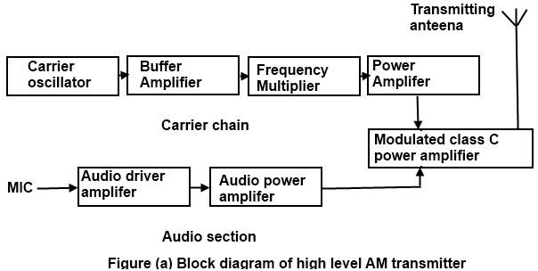
Appendix

Figure 1 AM block diagram CITATION Com15 \l 2057 [2]
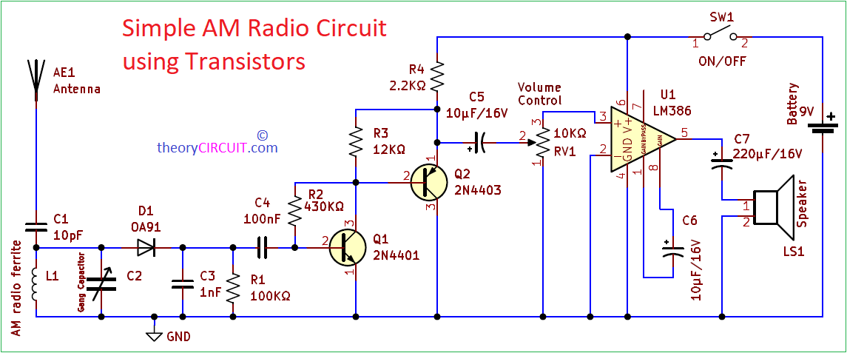
Figure 2 AM circuit diagram CITATION the24 \l 2057 [8]

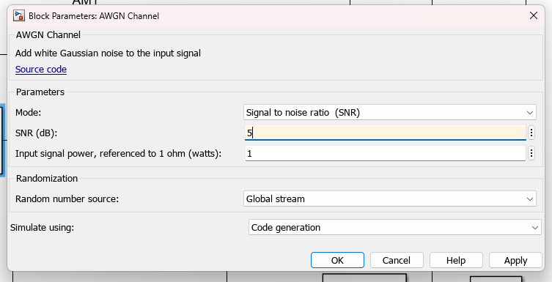
Figure 3 AWGN SNR value 5db
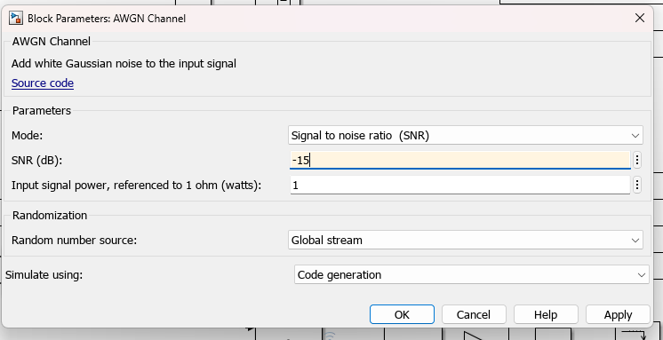
Figure 4 AWGN SNR value -15db
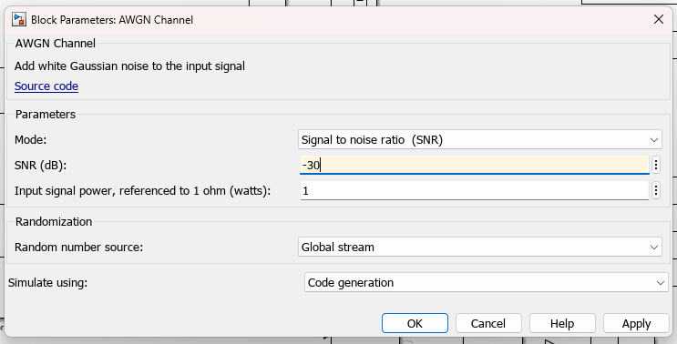
Figure 5 AWGN SNR value -30db
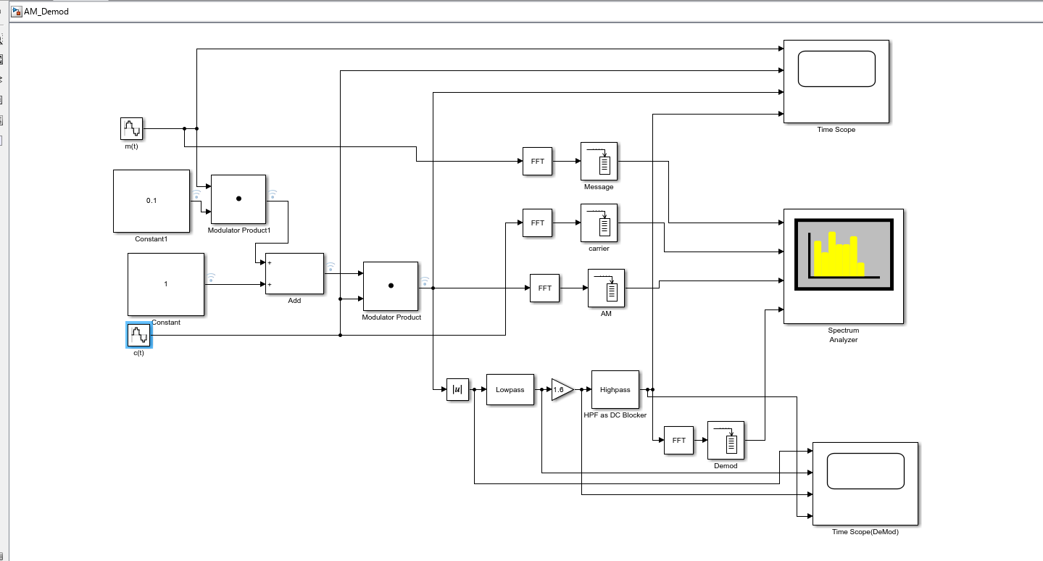
Figure 6 AM Modulations Block Diagram
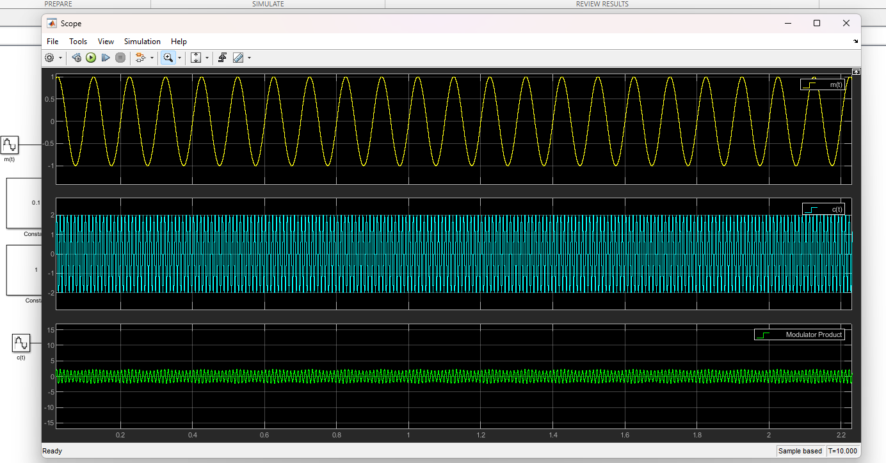
Figure 7 AM Modulation time scope 0.1
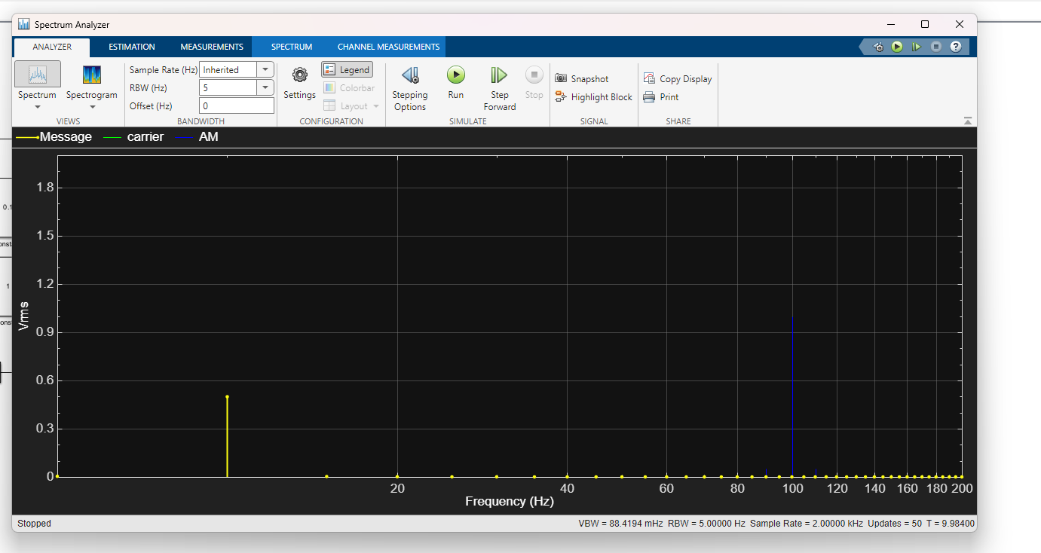
Figure 8 AM Modulation spectrum 0.1
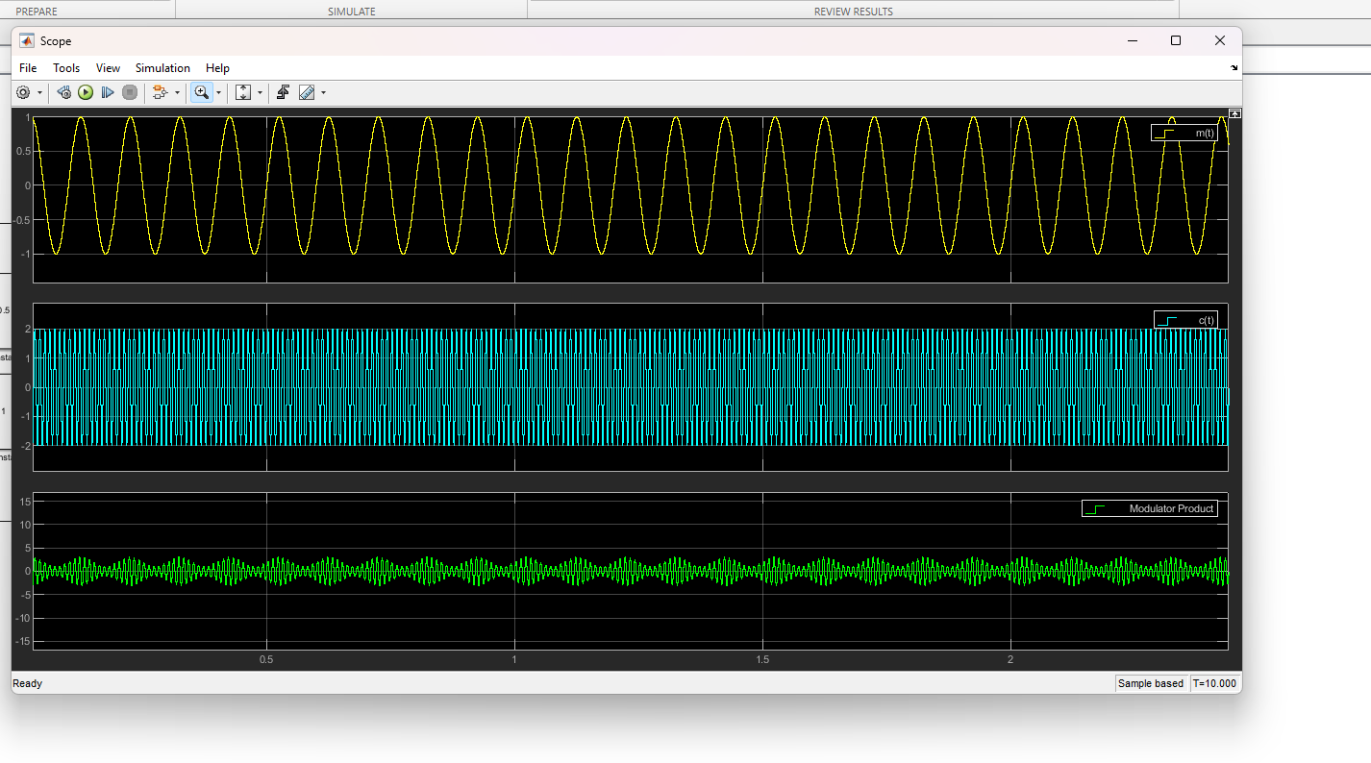
Figure 9 AM modulation time scope 0.5

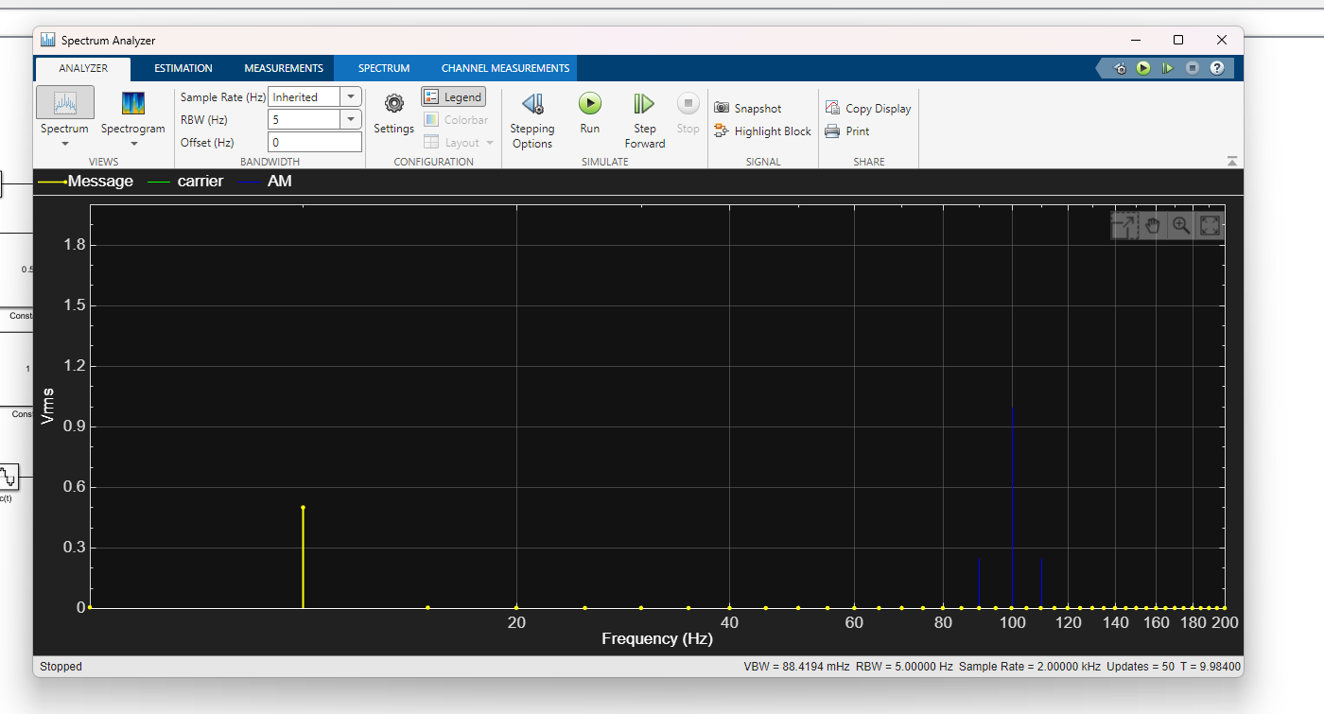
Figure 10 AM modulation spectrum 0.5

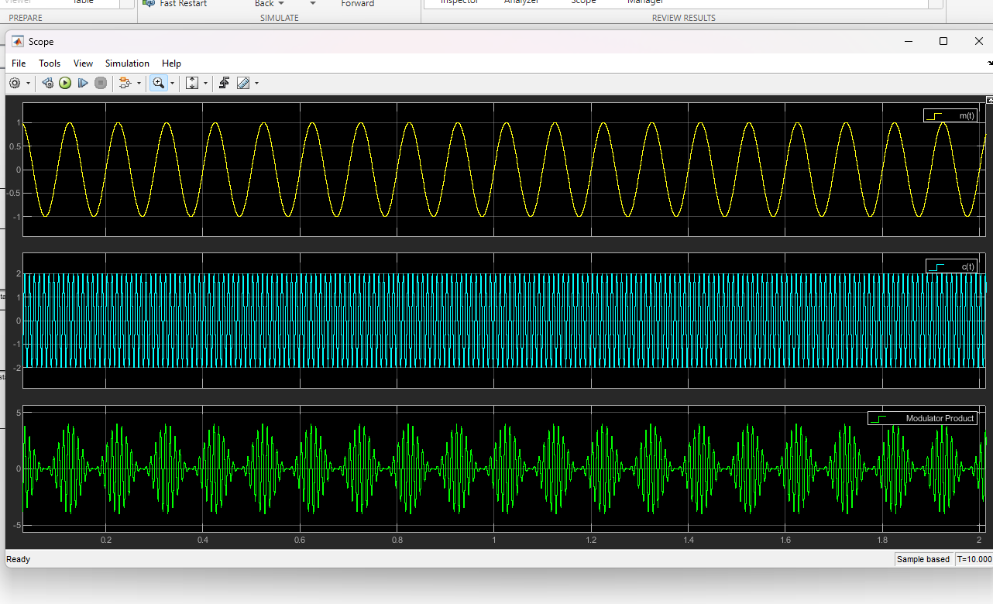
Figure 11 AM modulation time scope 1

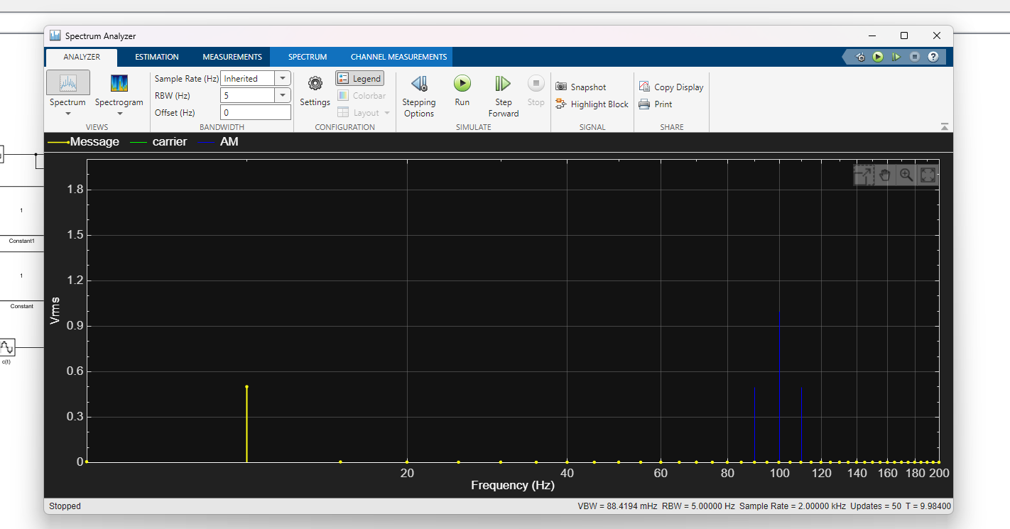
Figure 12 AM modulation spectrum 1

Figure 13 AM demod block diagram

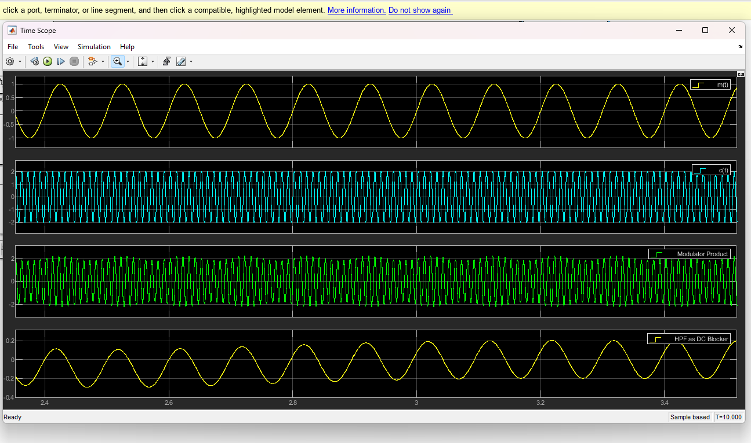
Figure 14 AM demod time scope 0.1

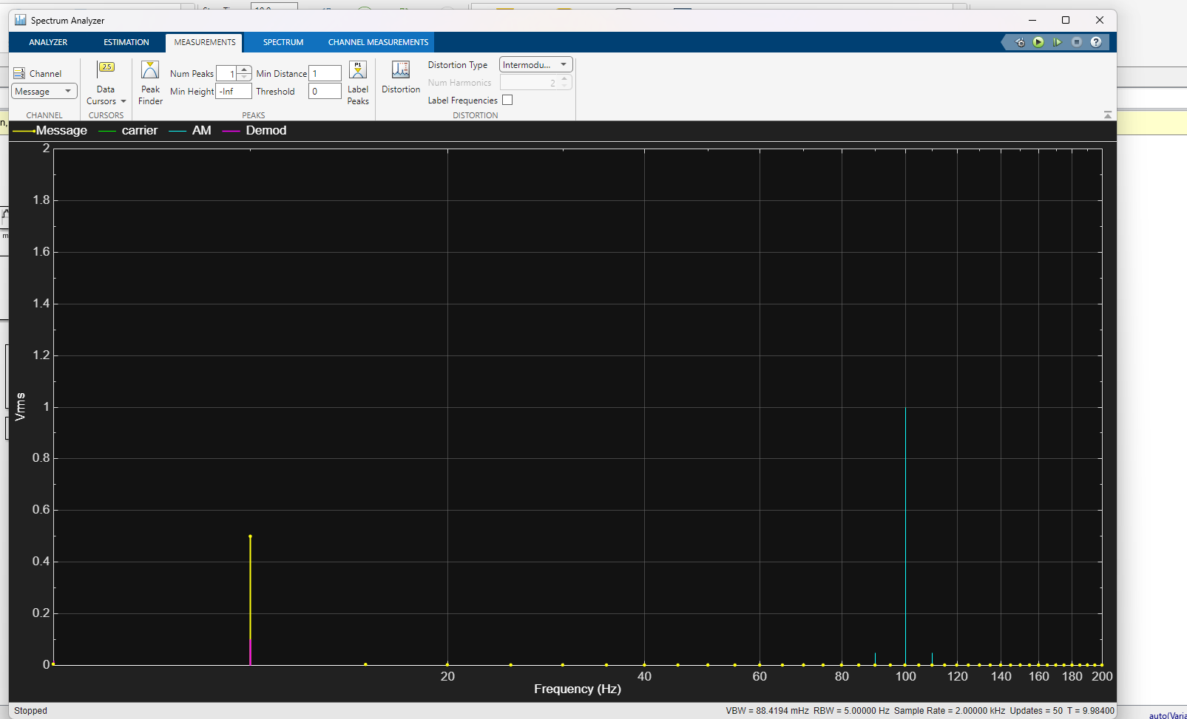
Figure 15 AM demod spectrum 0.1

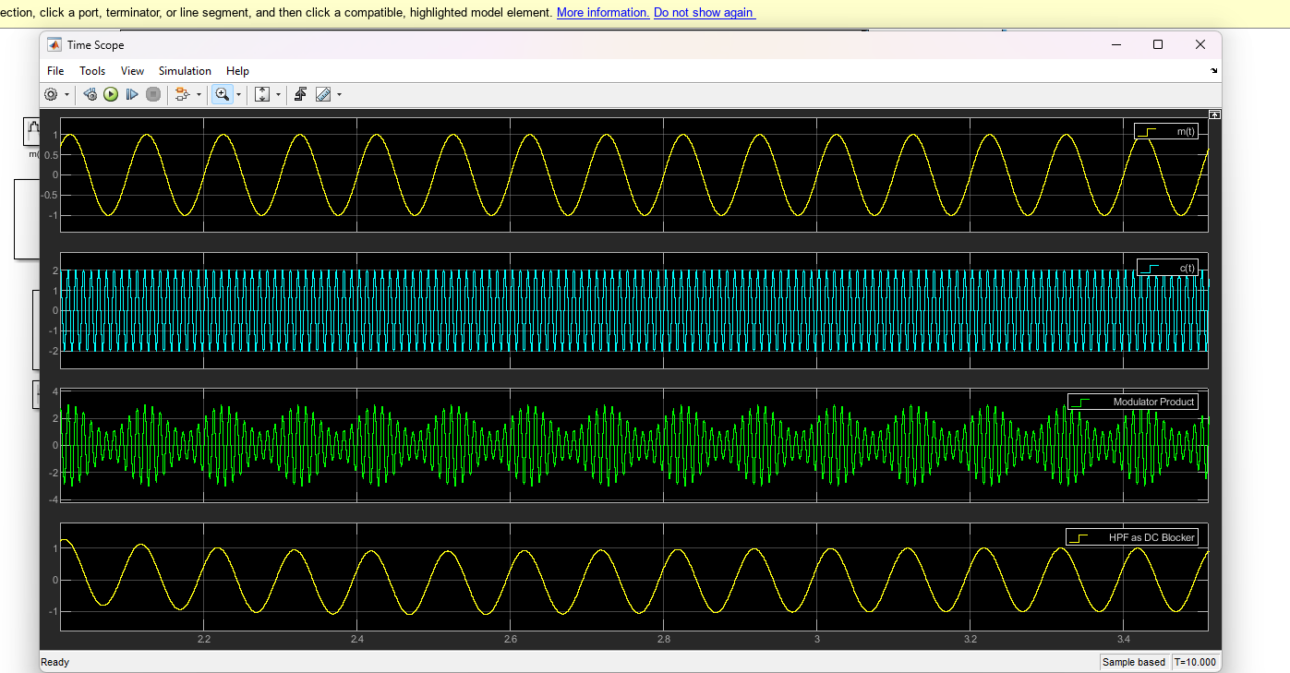
Figure 16 AM demod time scope 0.5

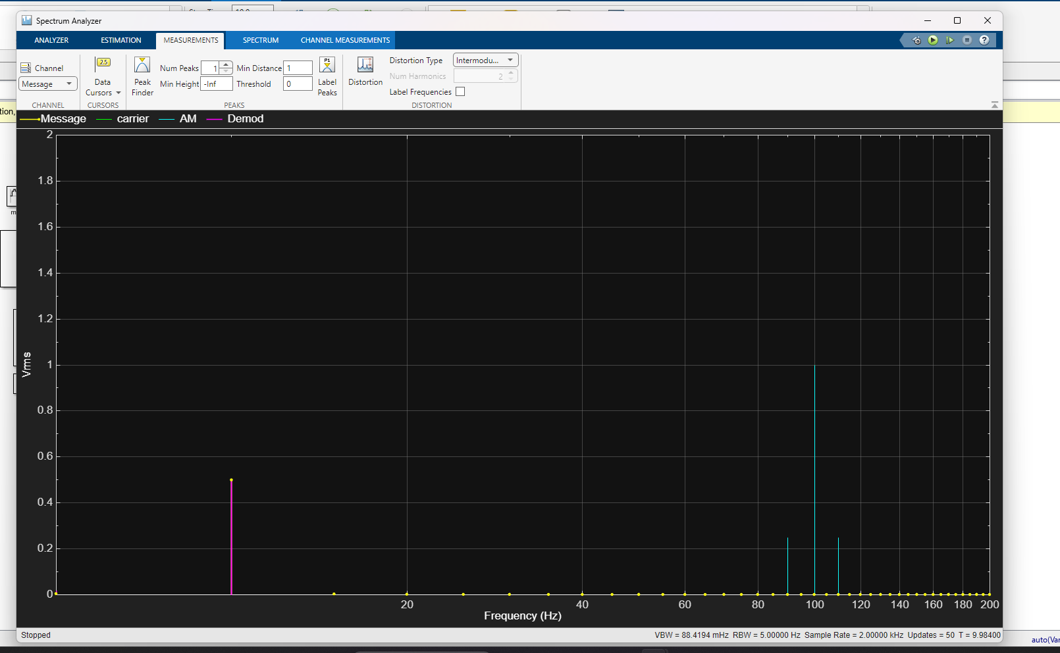
Figure 17 AM demod spectrum 0.5

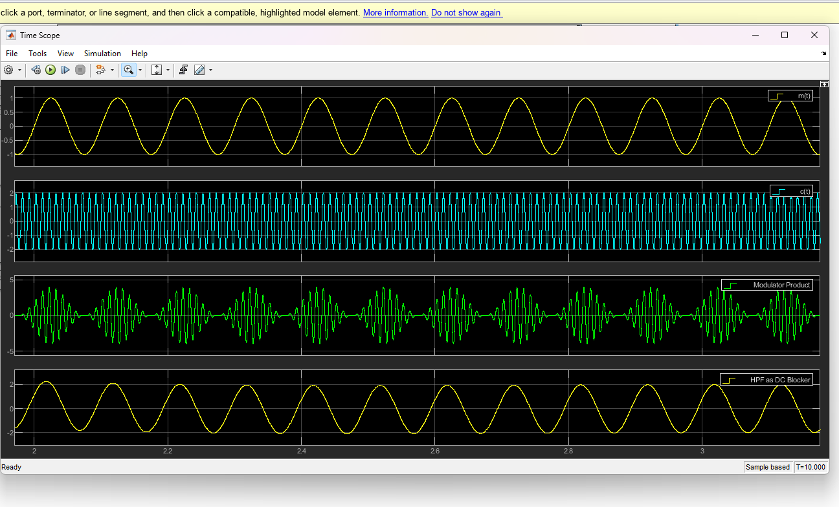
Figure 18 AM Demod time scope 1

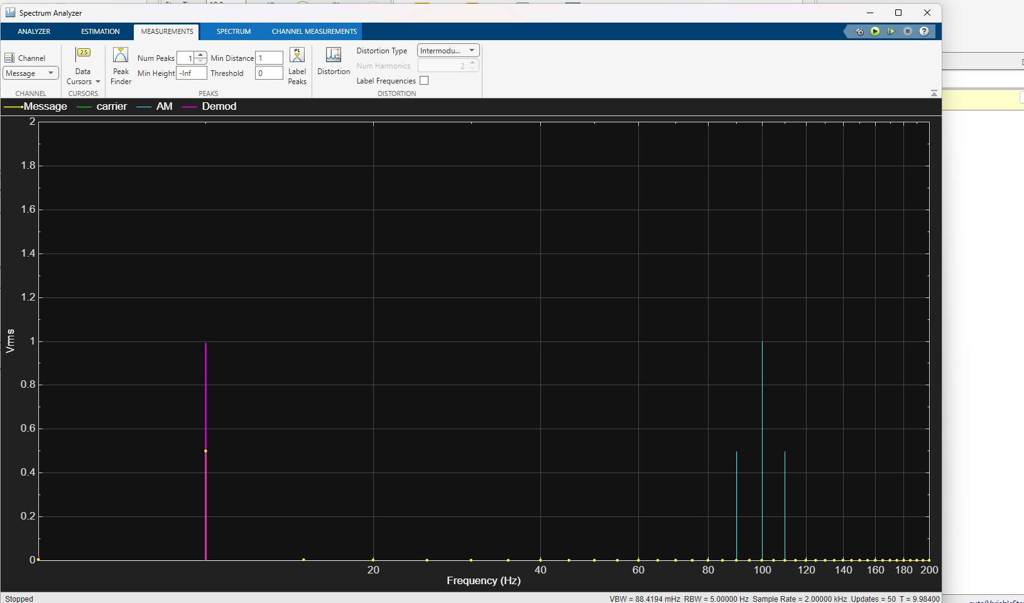
Figure 19 AM demod spectrum 1
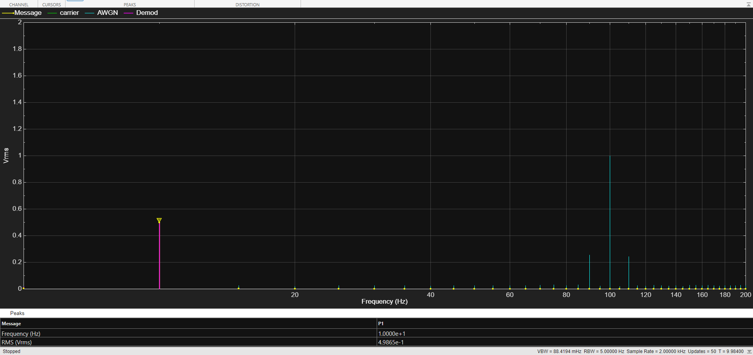
Figure 20 AM Message signal with 5db of AWGN spectrum
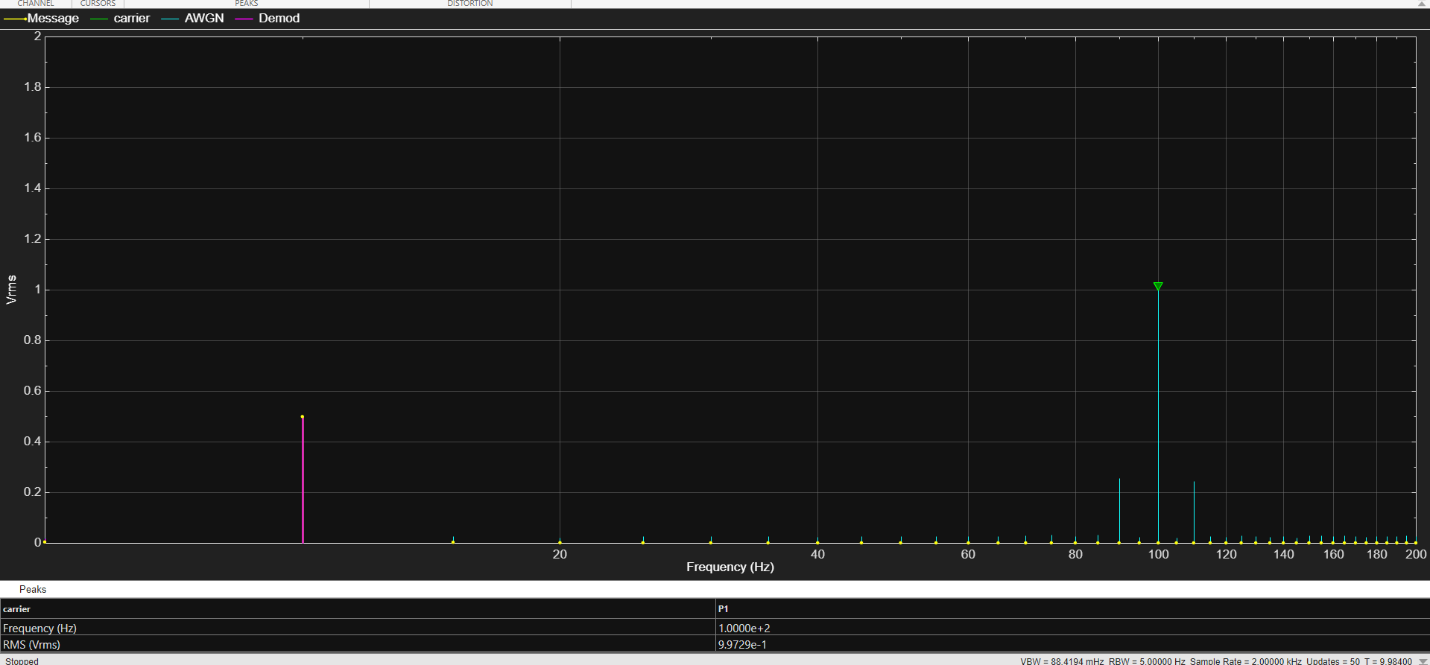
Figure 21 AM carrier signal with 5db of AWGN spectrum
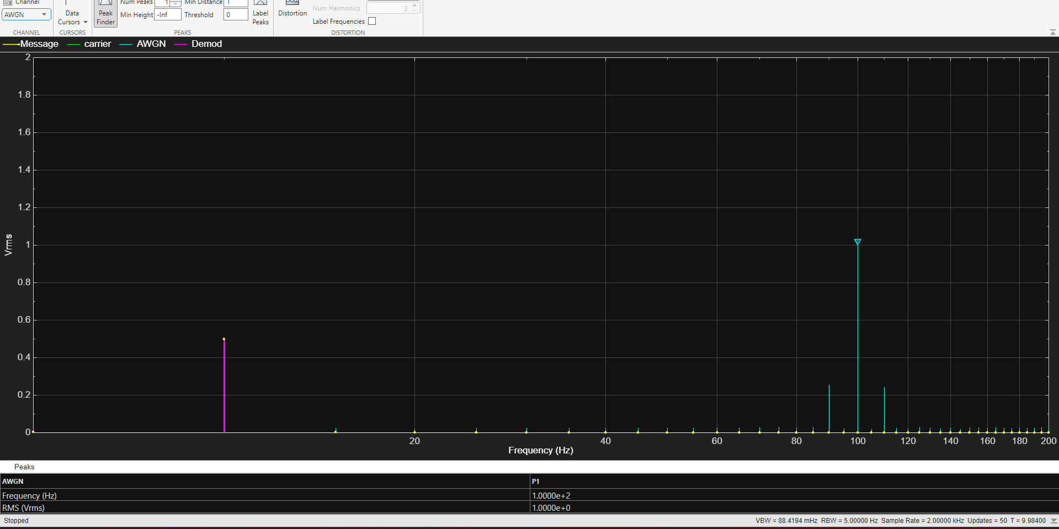
Figure 22 AM signal with 5db of AWGN
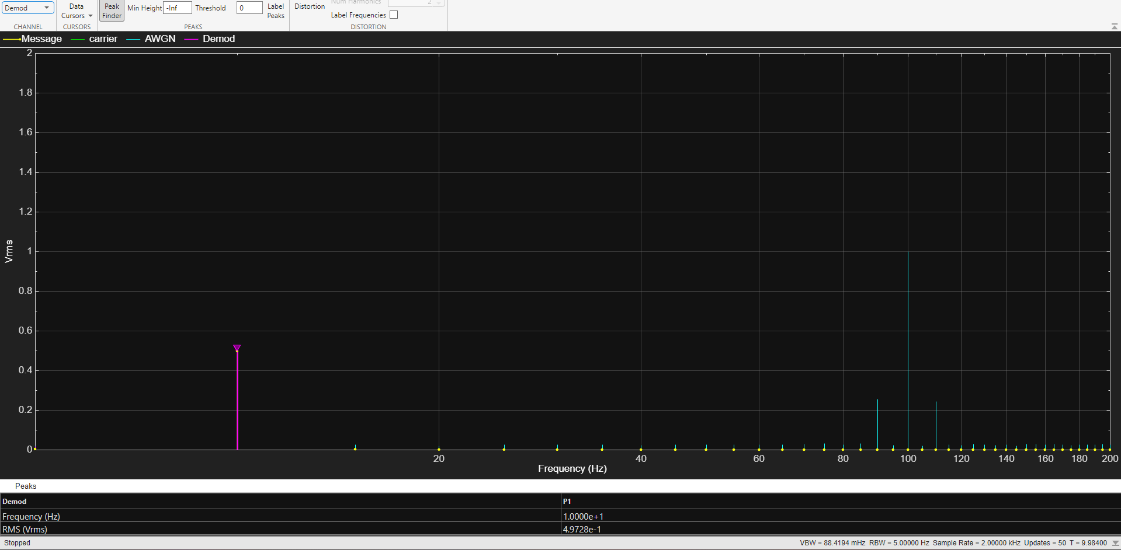
Figure 23 AM demod signal with 5db of AWGN spectrum
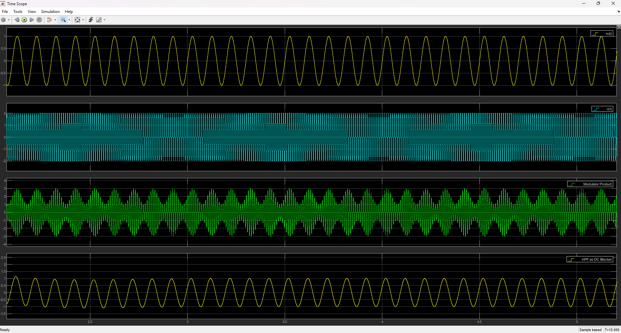
Figure 24 AM Message signal with 5db of AWGN in the time domain
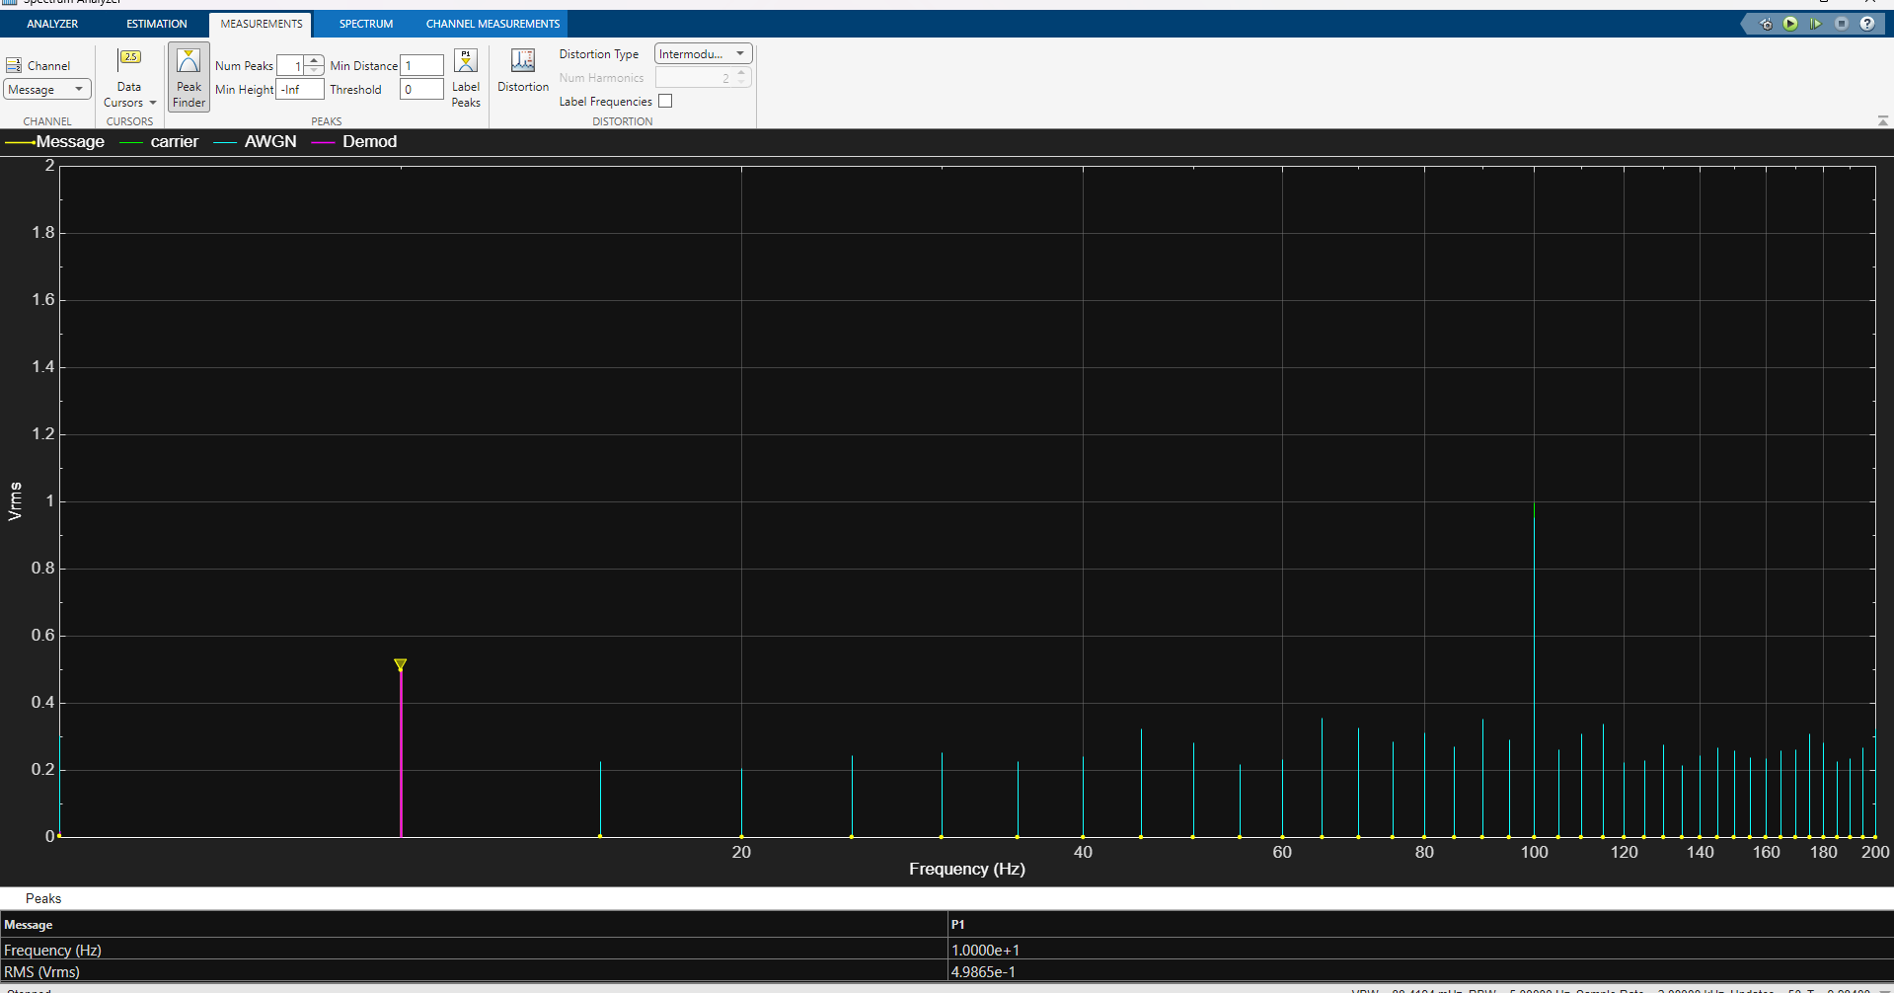
Figure 25 AM Message signal with -15db of AWGN spectrum
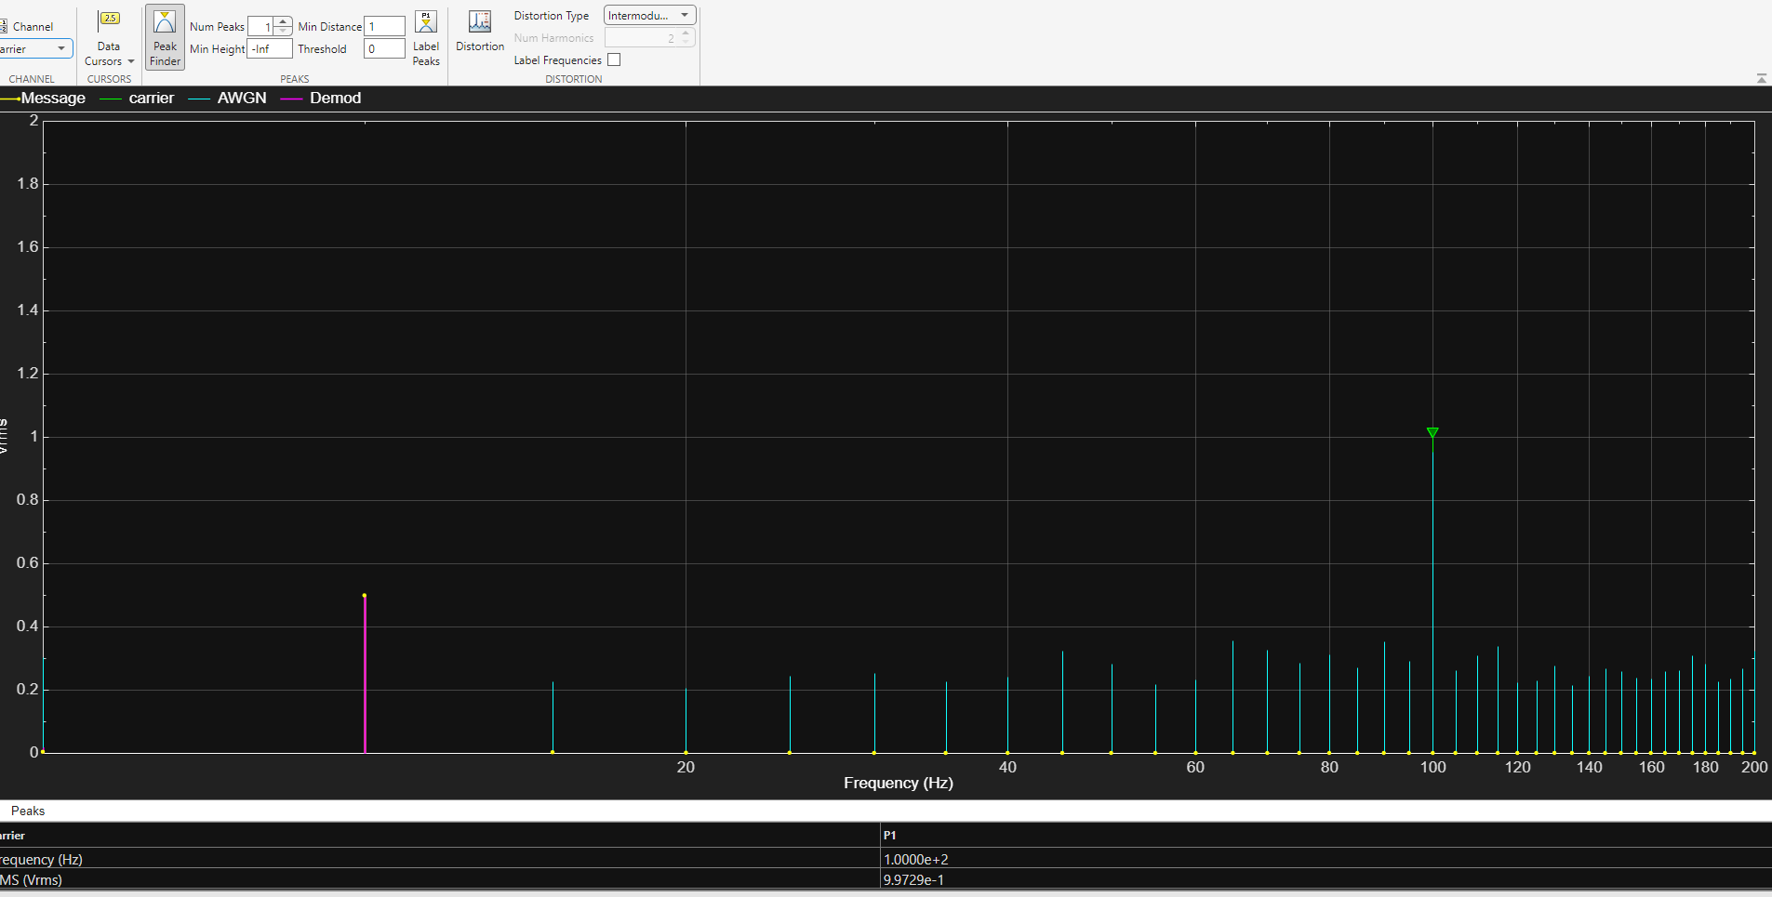
Figure 26 AM carrier signal with -15db of AWGN spectrum
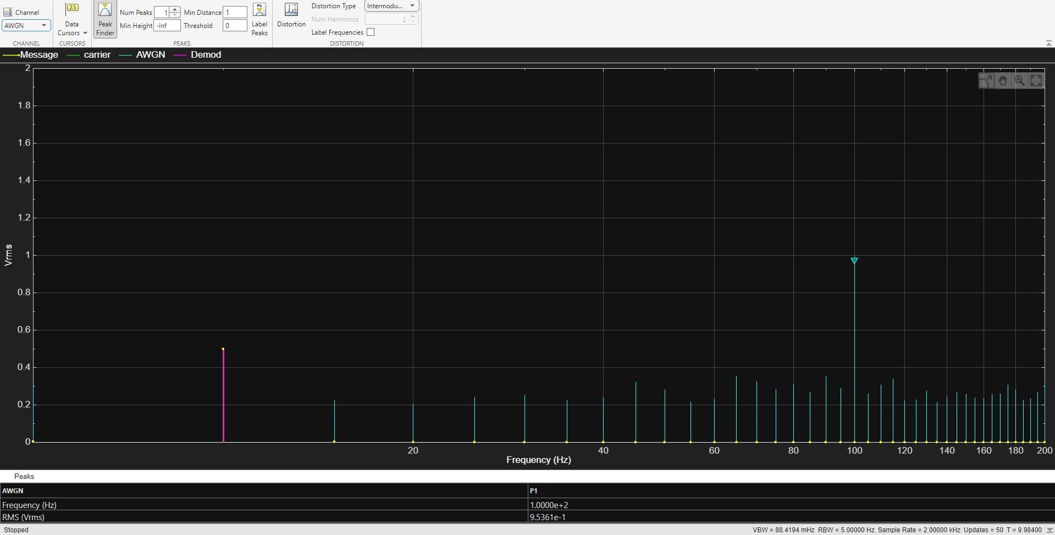
Figure 27 AM AWGN signal at -15db spectrum
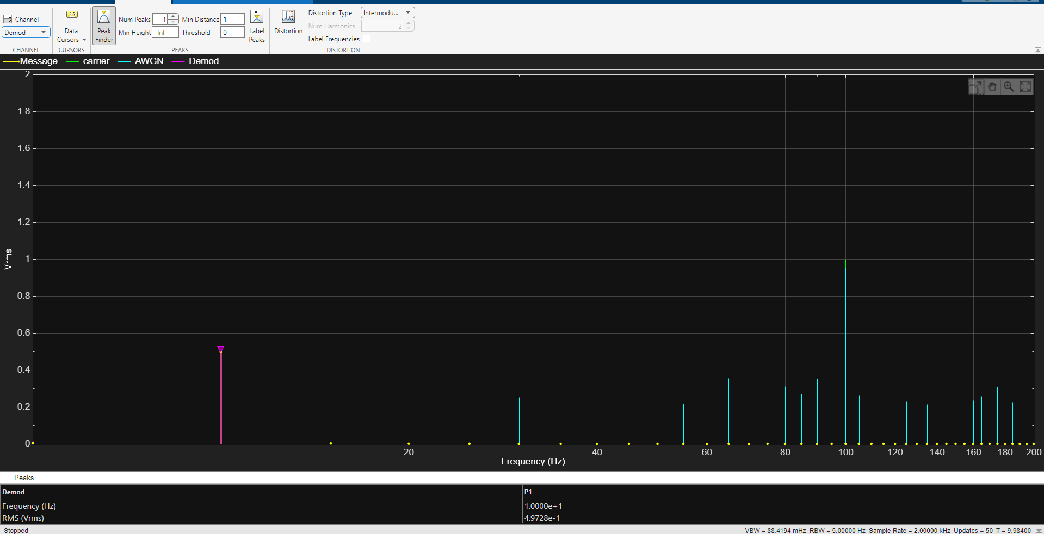
Figure 28 AM demod signal with -15db of AWGN spectrum
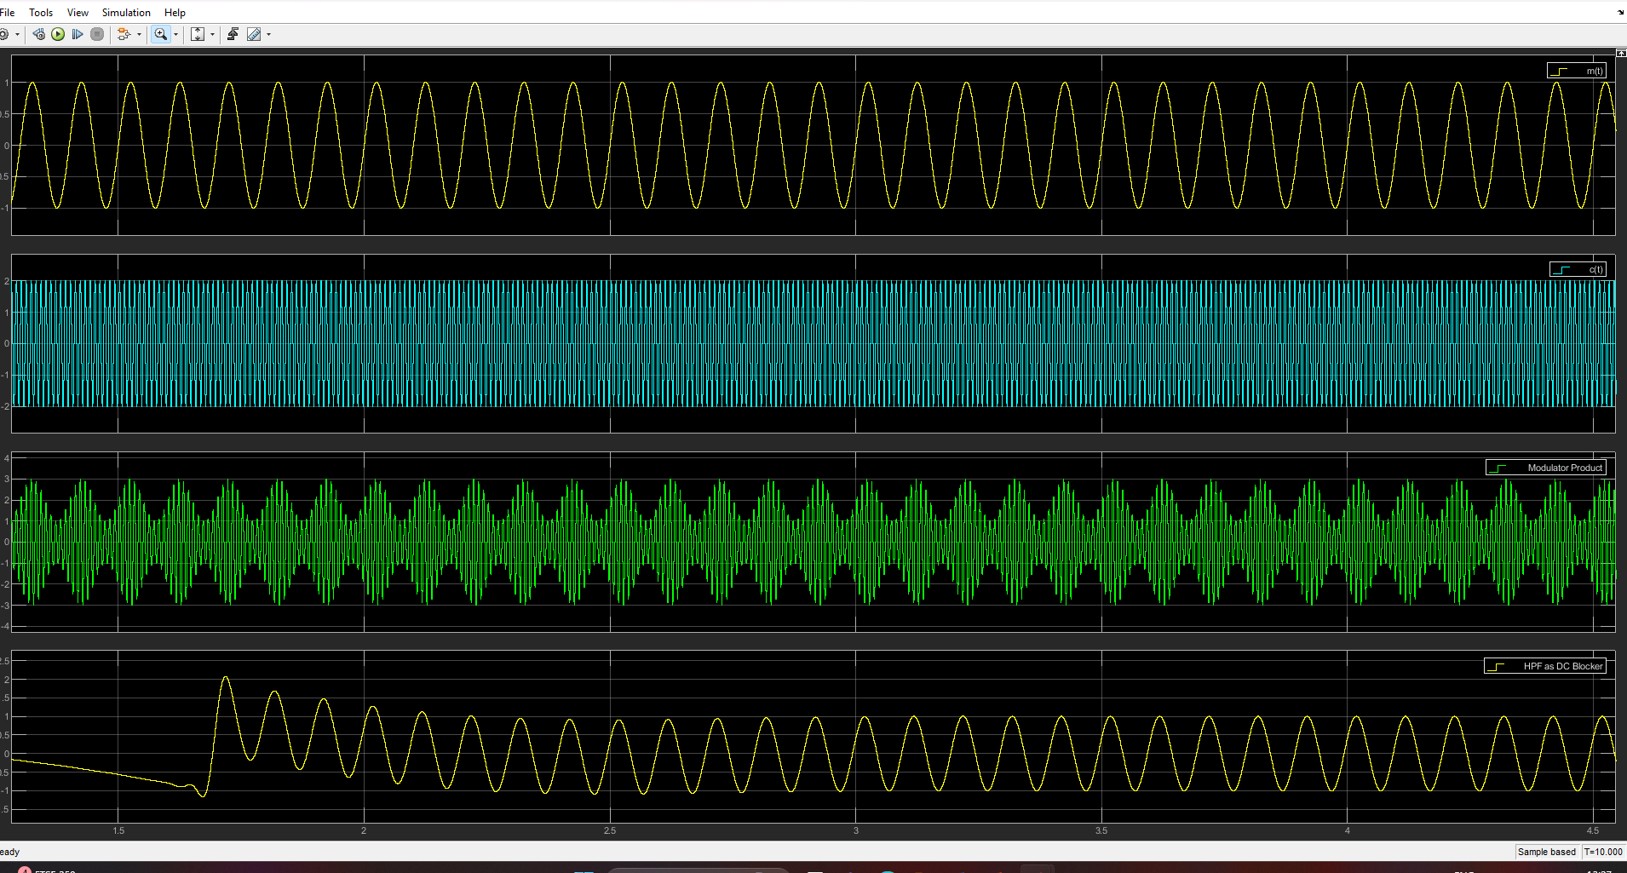
Figure 29 AM signals with -15db of AWGN in the time domain
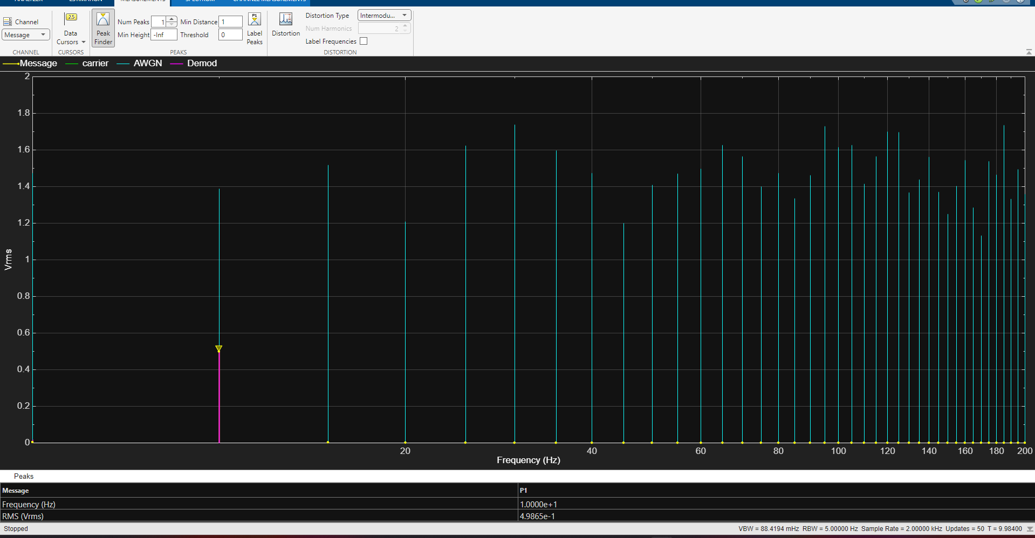
Figure 30 AM Message signal with -30db of AWGN spectrum
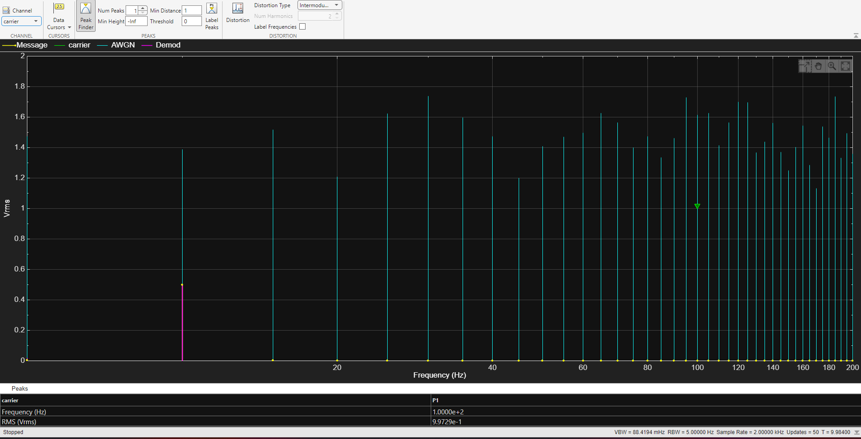
Figure 31 AM carrier signal with -30db of AWGN spectrum
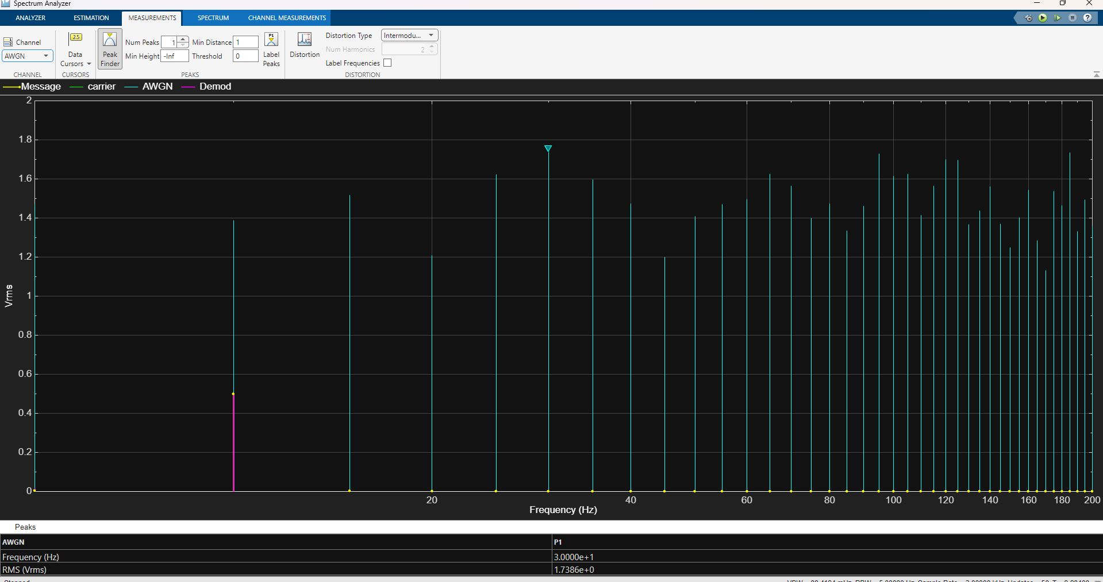
Figure 32 AM AWGN signal at -30db spectrum
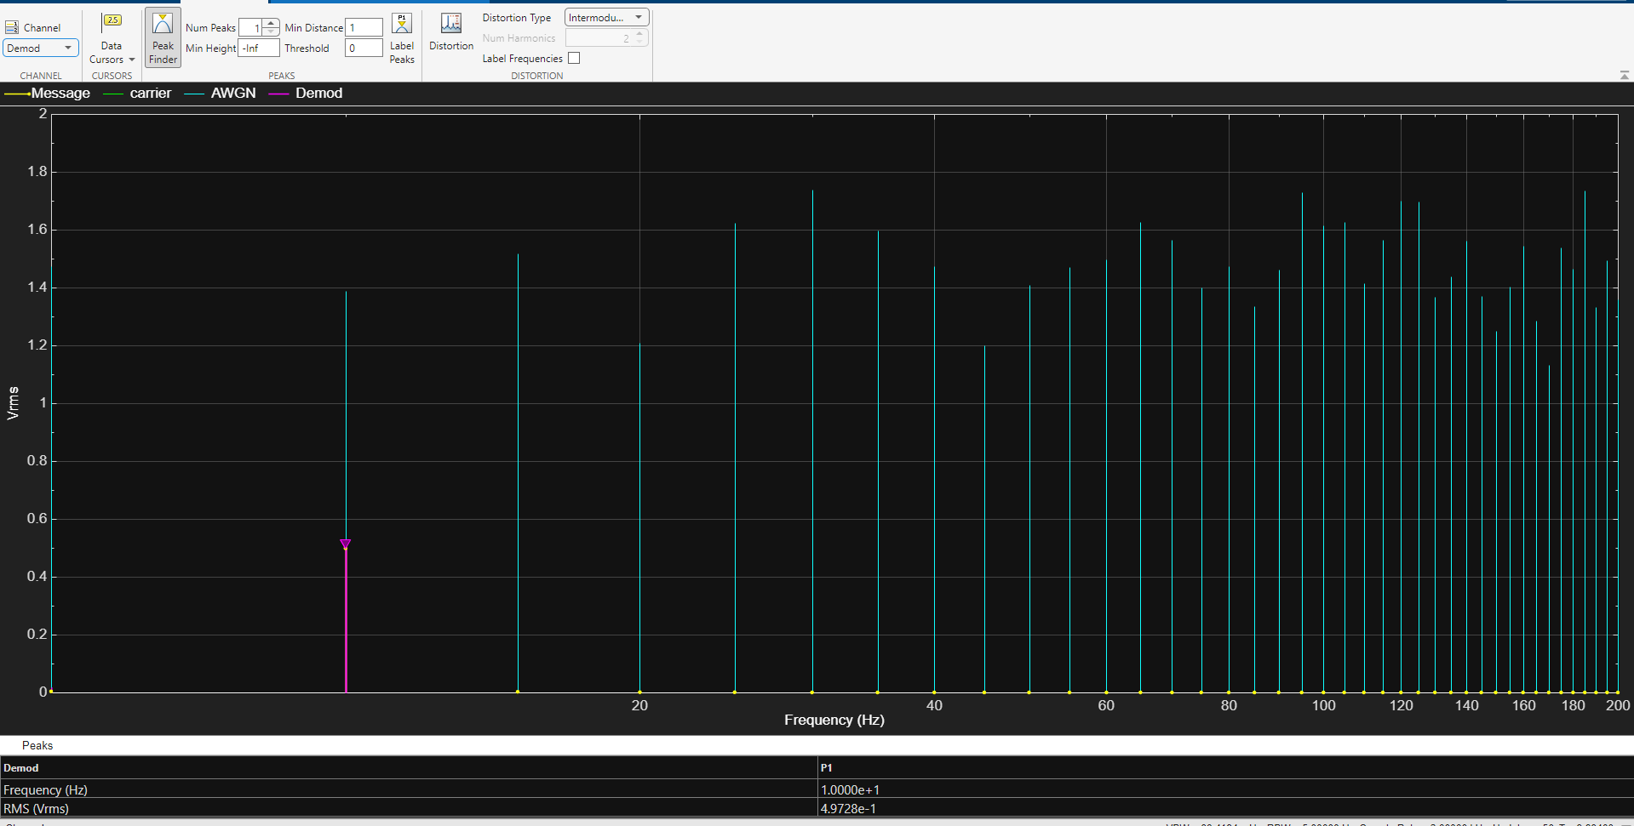
Figure 33 AM demod signal with -30db of AWGN spectrum
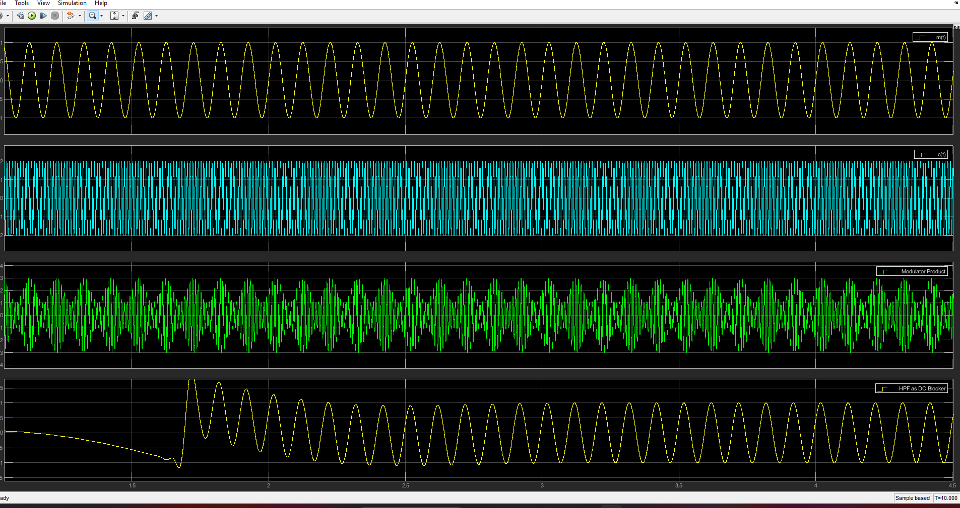
Figure 34 Am signals with -30db of AWGN in the time domain
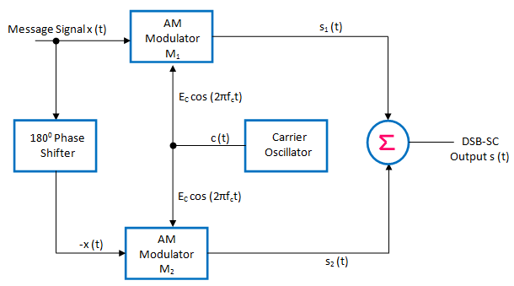
Figure 35 DSB-SC block diagram CITATION Sas15 \l 2057 [5]
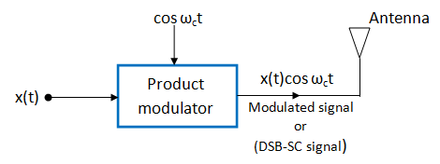
Figure 36 DSB-SC block diagram (2) CITATION Sas15 \l 2057 [5]

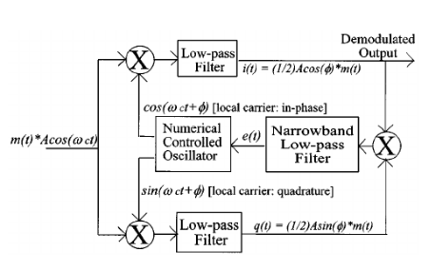
Figure 37 DSB-SC receiver architectures CITATION For01 \l 2057 [9]

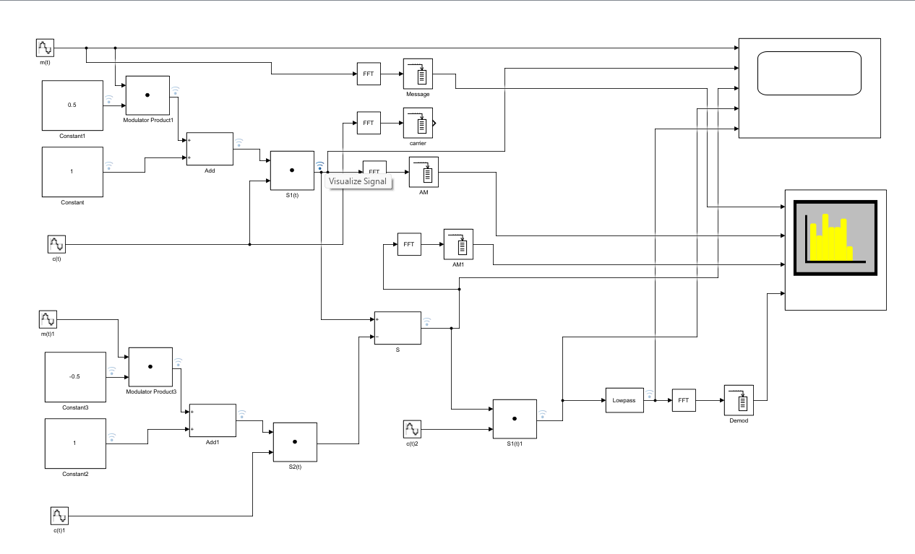
Figure 38 DSB-SC MATLAB diagram

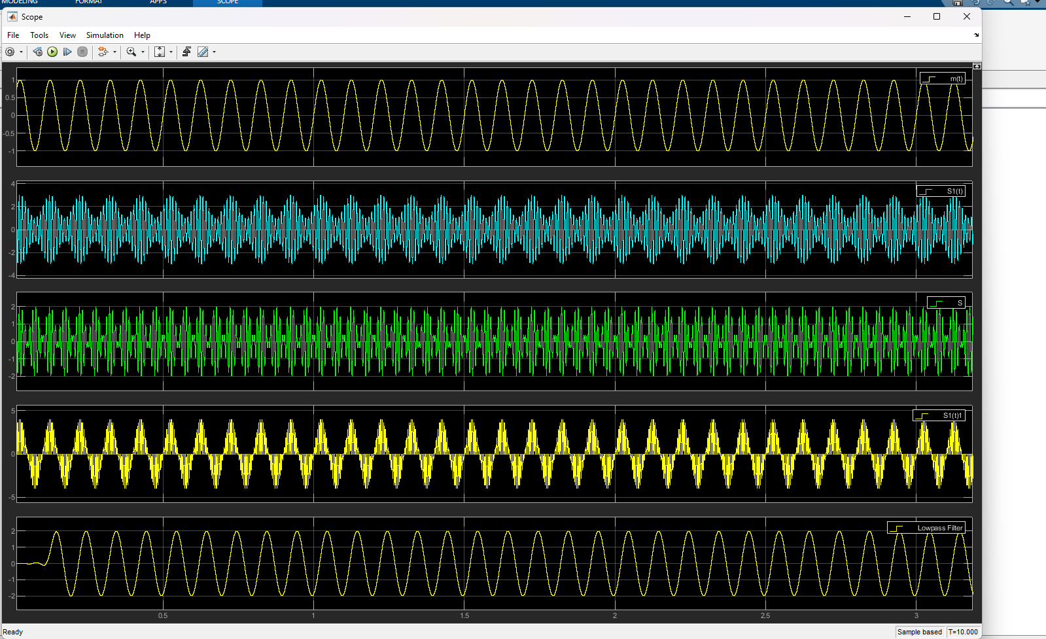
Figure 39 DSB -SC Time domain

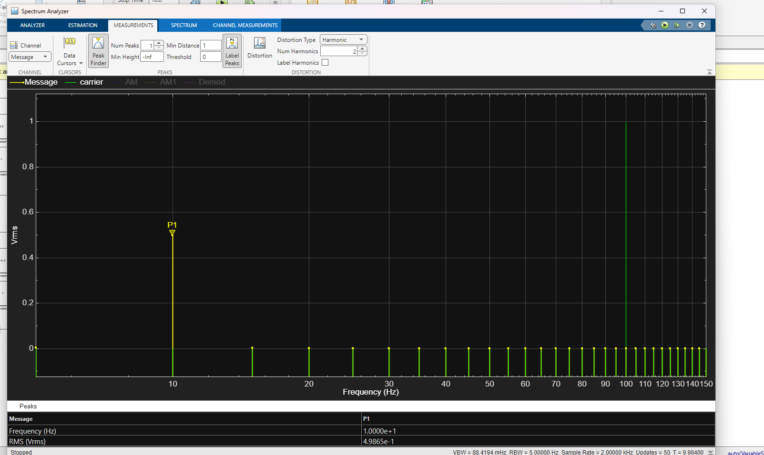
Figure 40 DSB-SC message spectrum
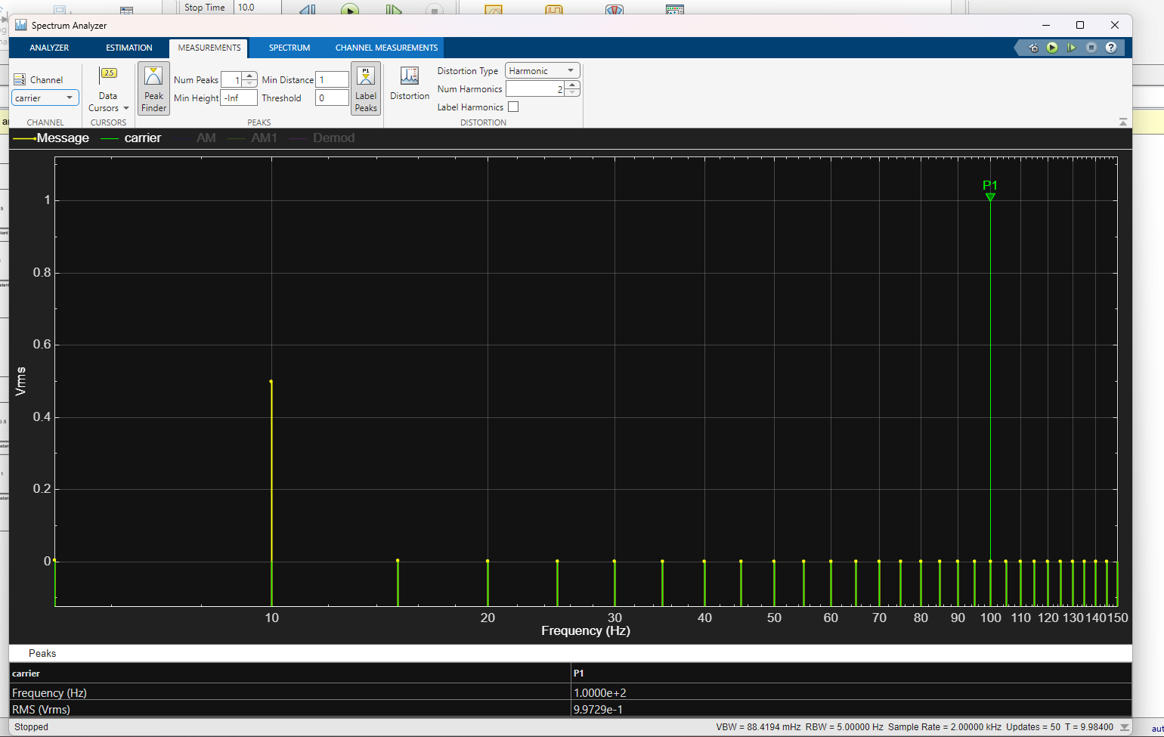
Figure 41 DSB-SC carrier spectrum
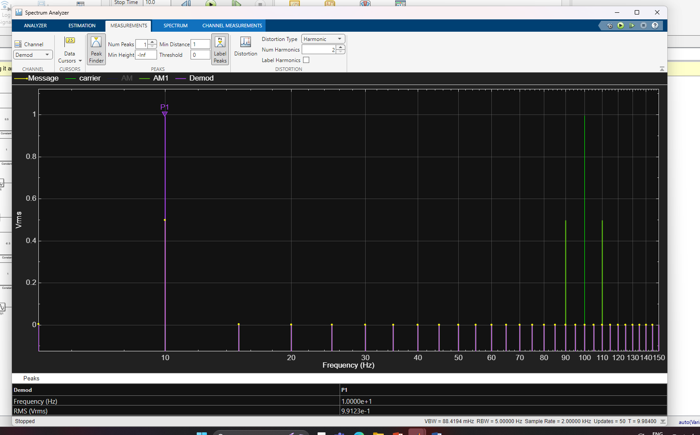
Figure 42 DSB-SC demod spectrum

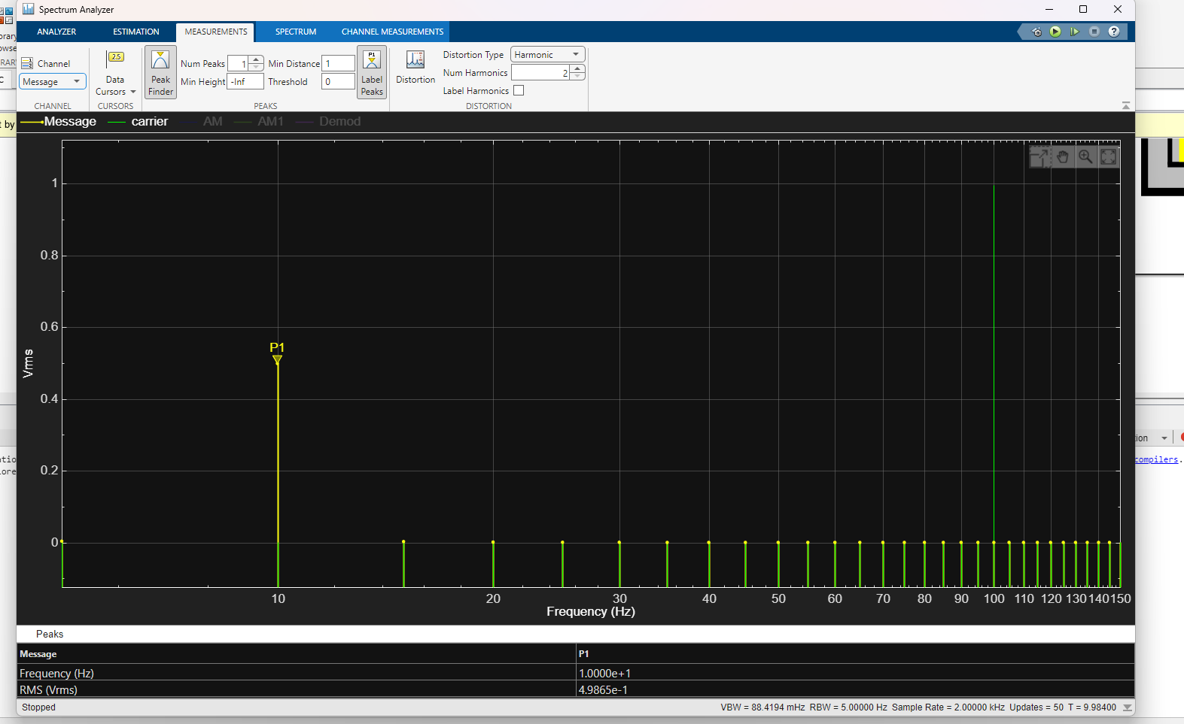
Figure 43 DSB-SC message signal with 5db of AWGN Spectrum

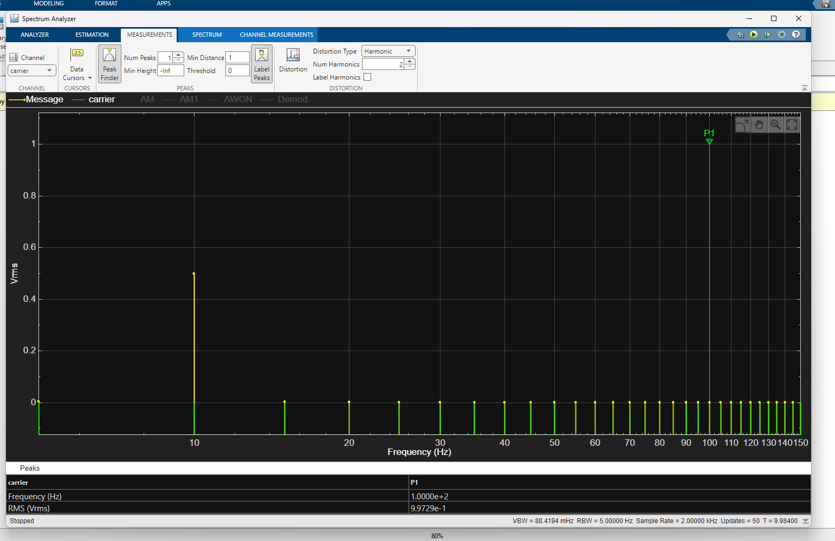
Figure 44 DSB-SC carrier signal with 5db of AWGN Spectrum

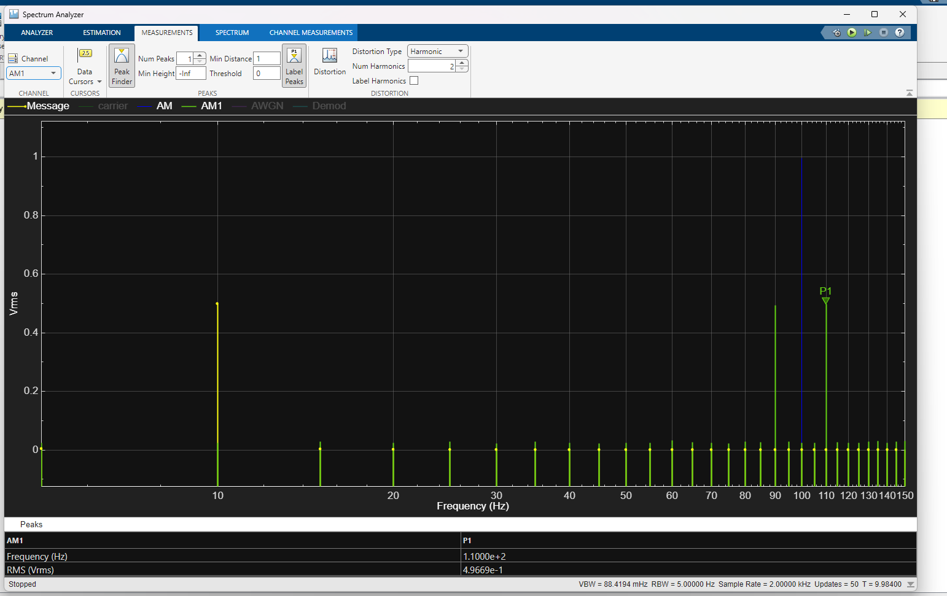
Figure 45 DSB-SC AM signal with 5db of AWGN Spectrum

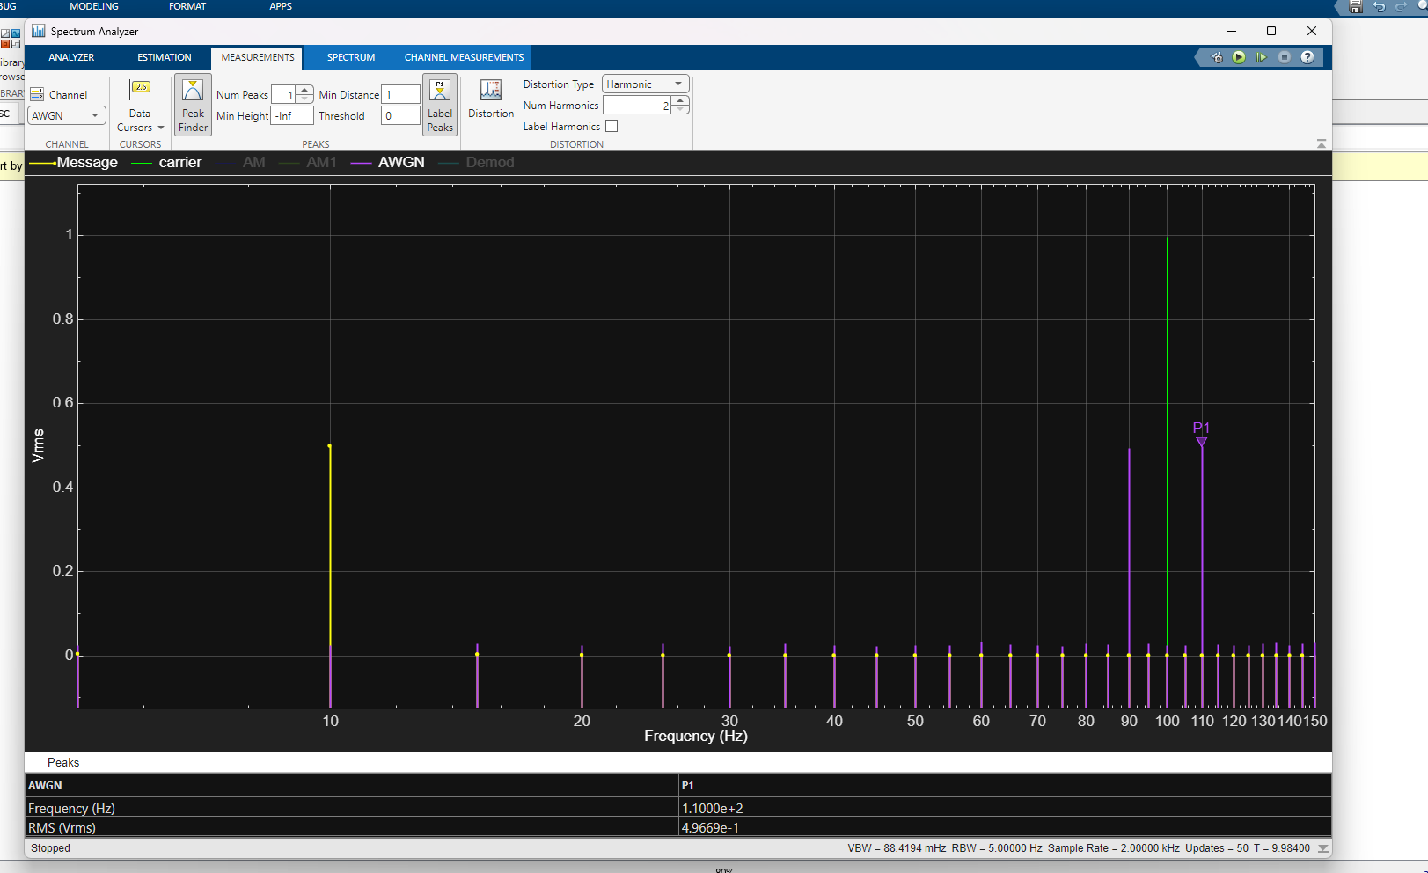
Figure 46 DSB-SC AWGN at 5db

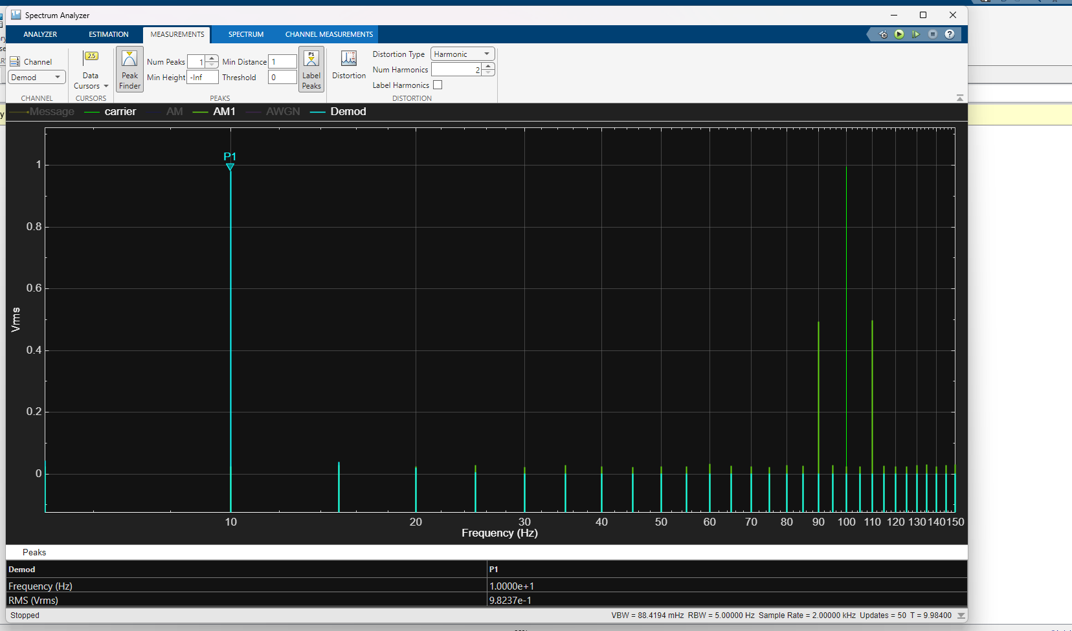
Figure 47 DSB-SC demod signal with 5db of AWGN Spectrum

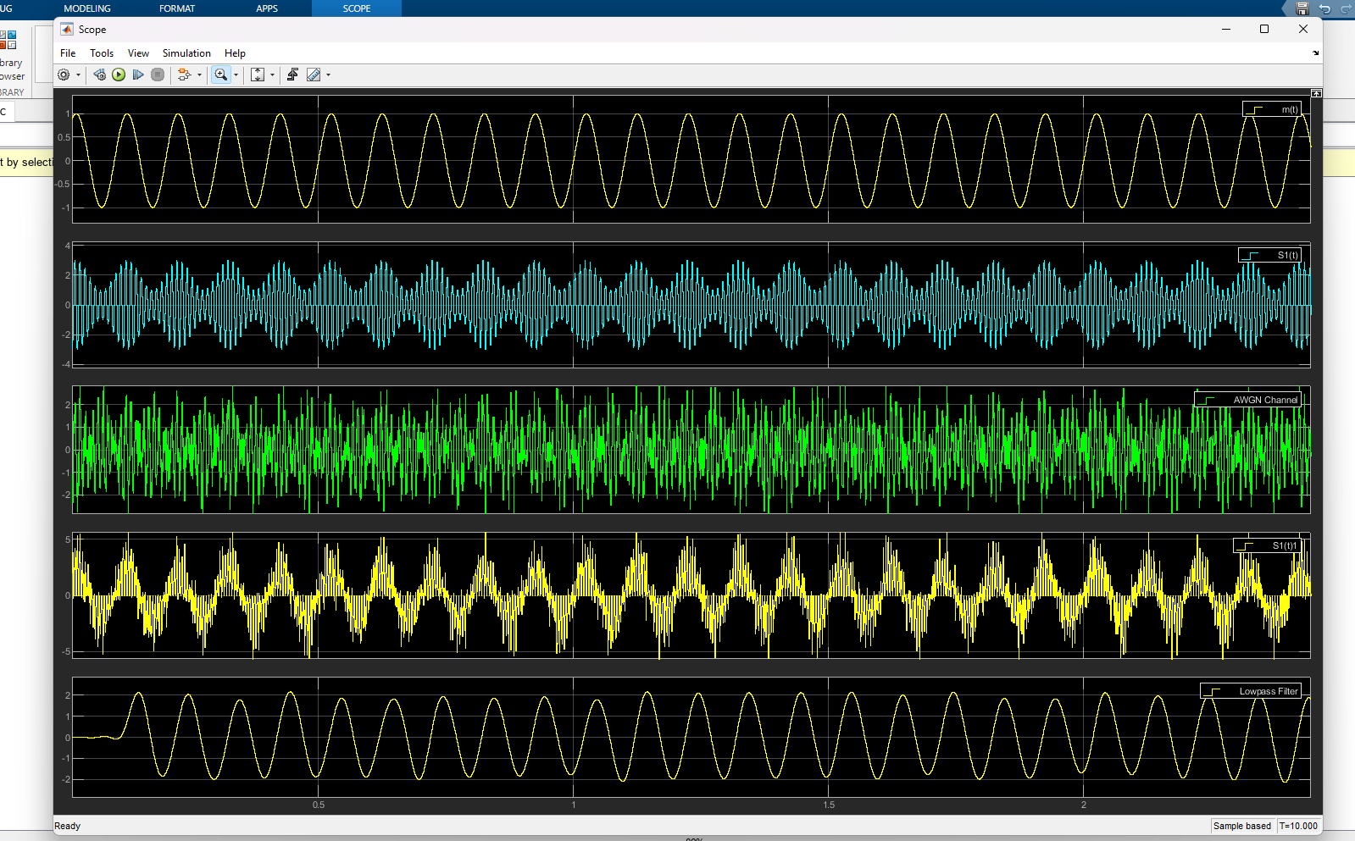
Figure 48 DSB-SC signals in time scope with 5db of AWGN
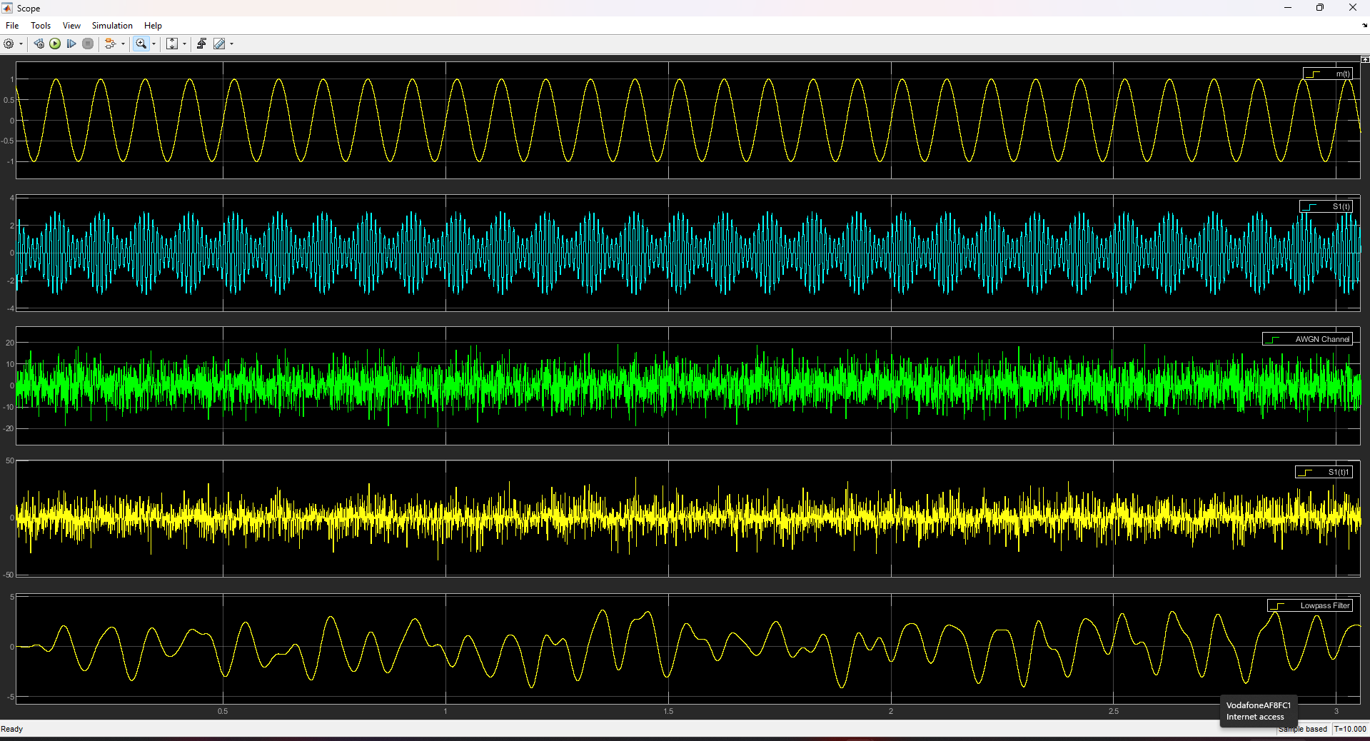
Figure 49 DSBSC Signal in Time domain with -15db of AWGN

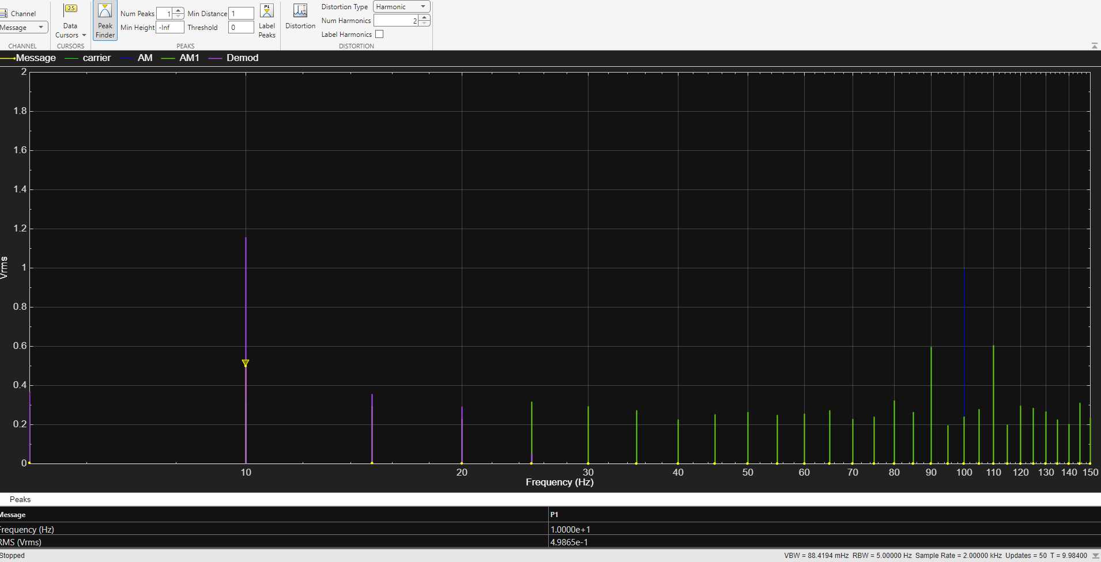
Figure 50 DSB-SC message signal with -15db of AWGN

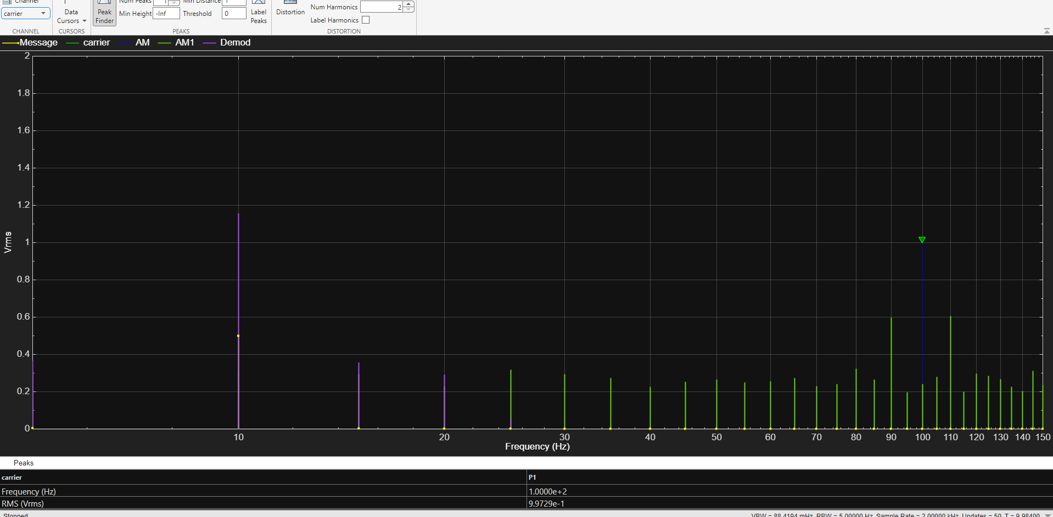
Figure 51 DSB-SC carrier signal with -15db of AWGN
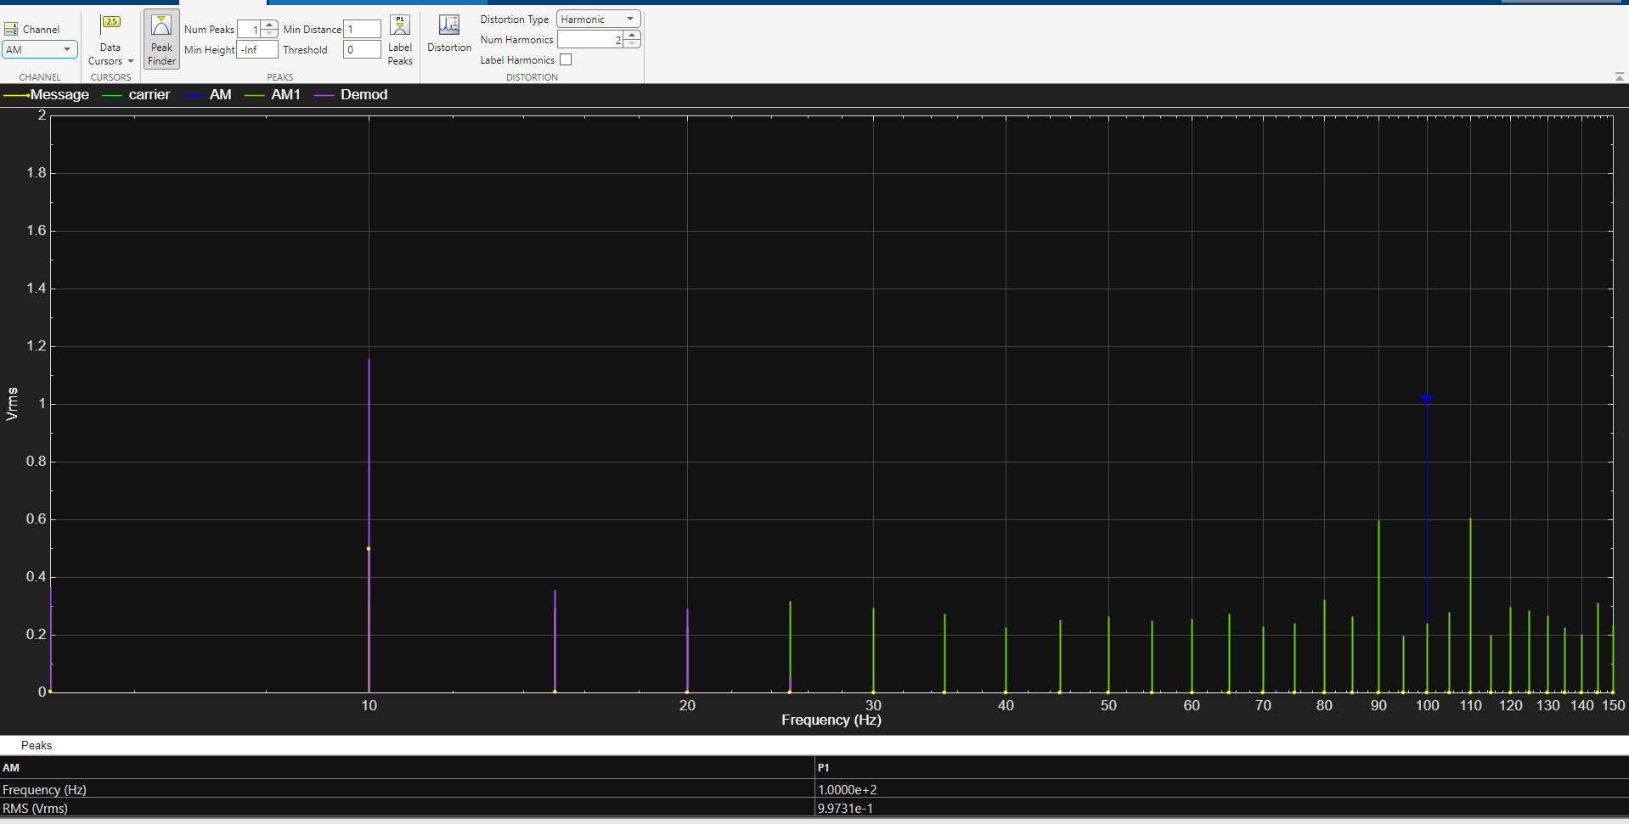
Figure 52 DSB-SC AM signal with -15db of AWGN
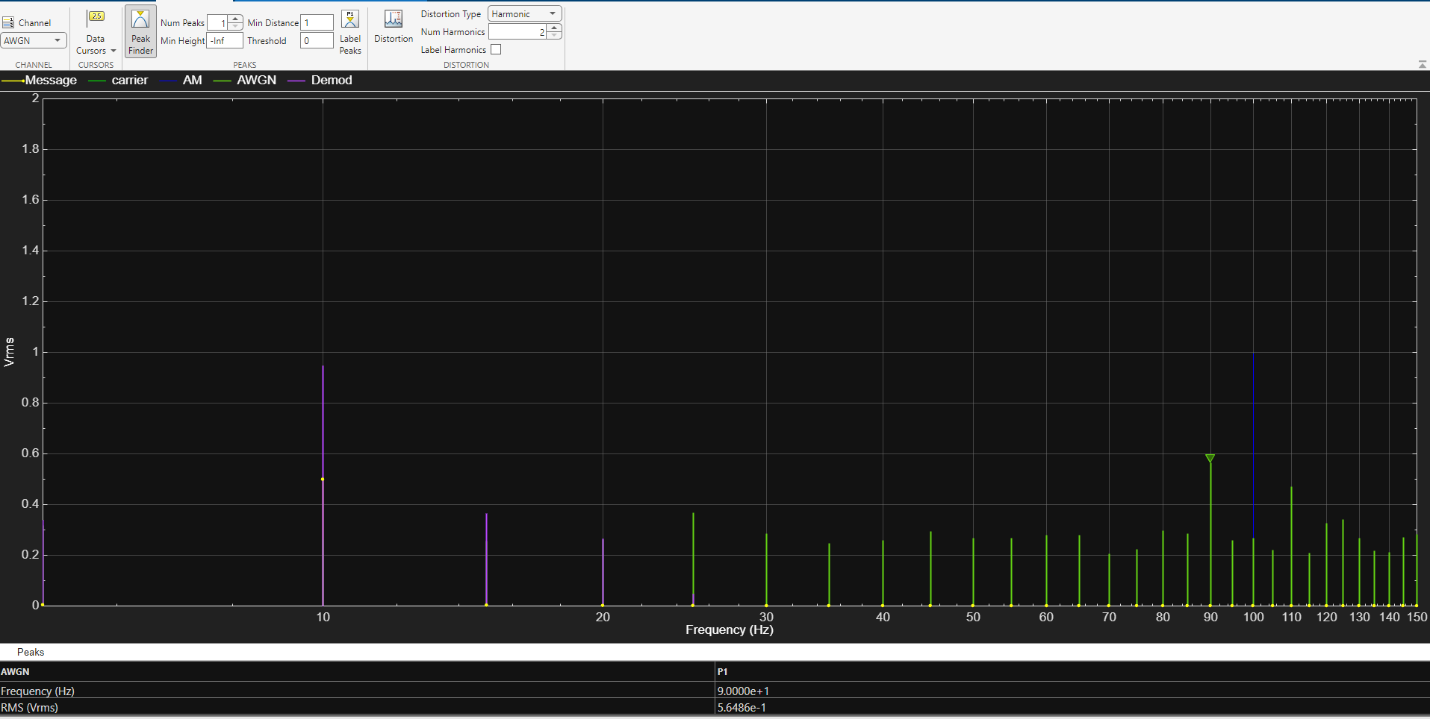
Figure 53 DSB-SC AWGN at -15db
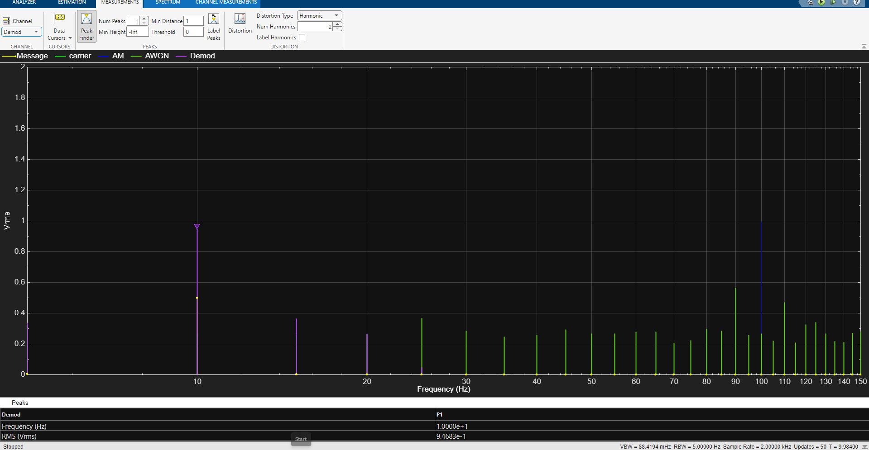
Figure 54 DSB-SC demod signal with -15db of AWGN
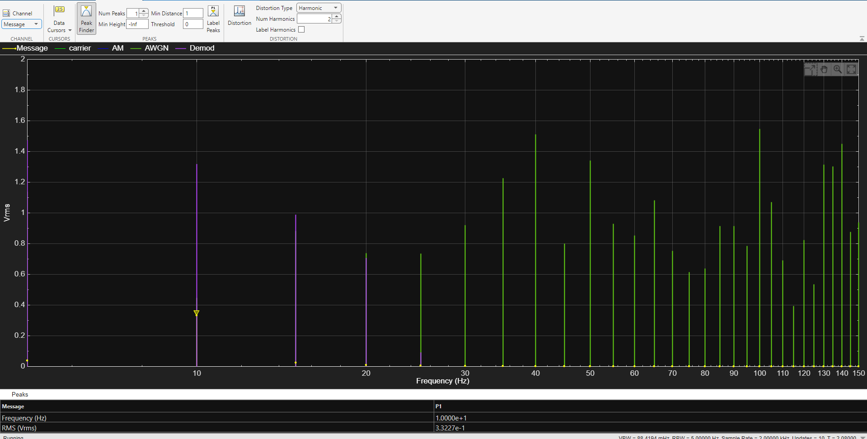
Figure 55 DSB-SC message signal at -30db of AWGN
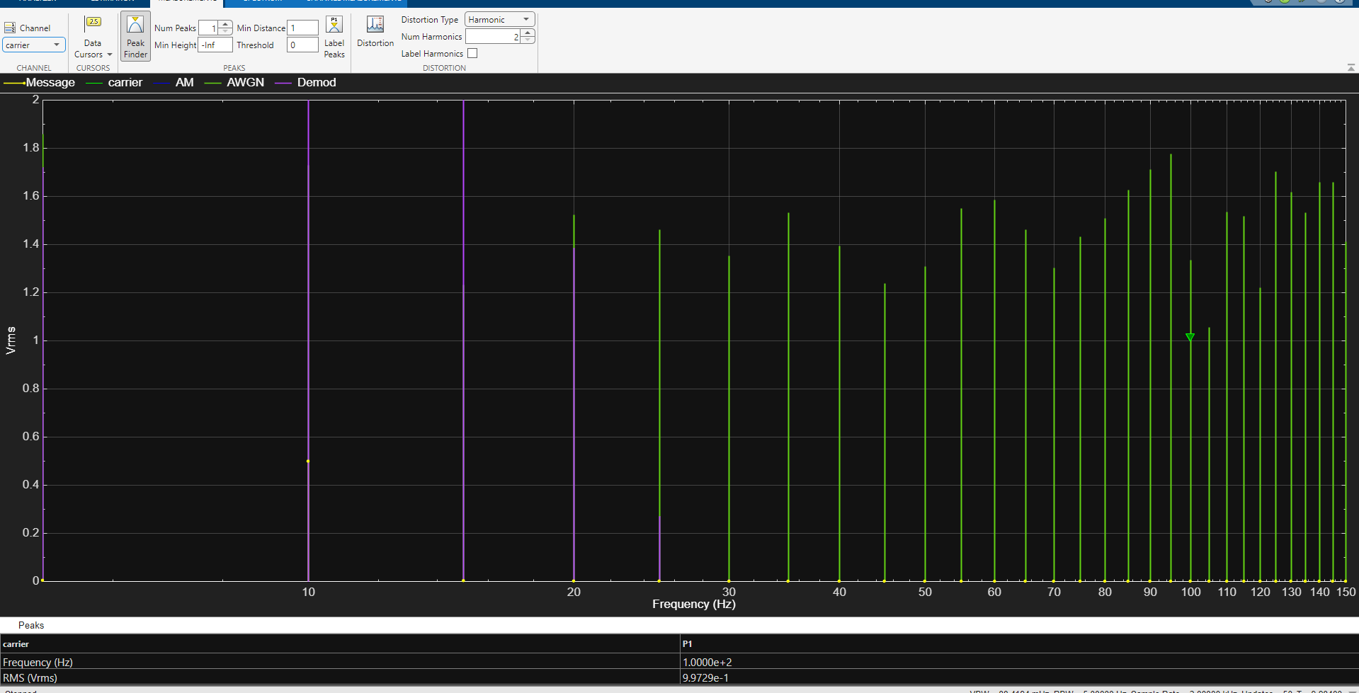
Figure 56 DSB-SC carrier signal at -30db of AWGN
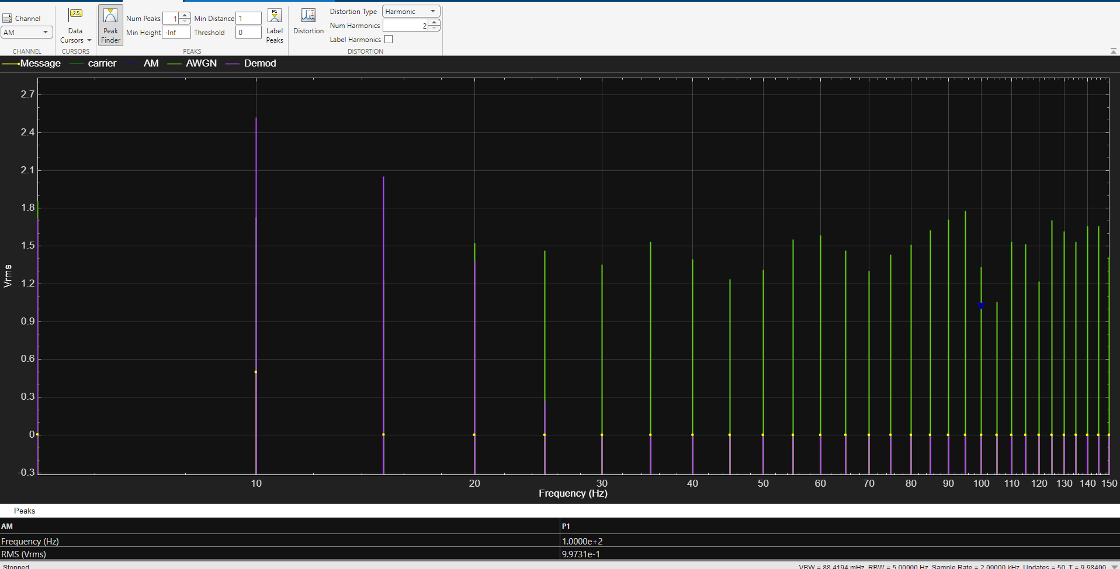
Figure 57 DSB-SC AM signal at -30db of AWGN
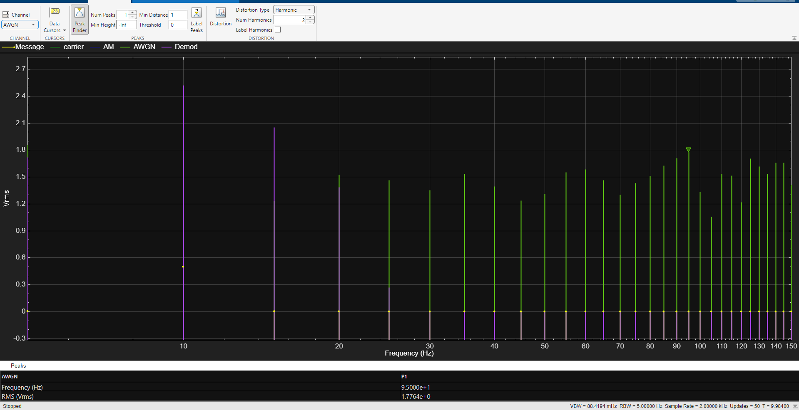
Figure 58 DSB-SC -30 AWGN Spectrum
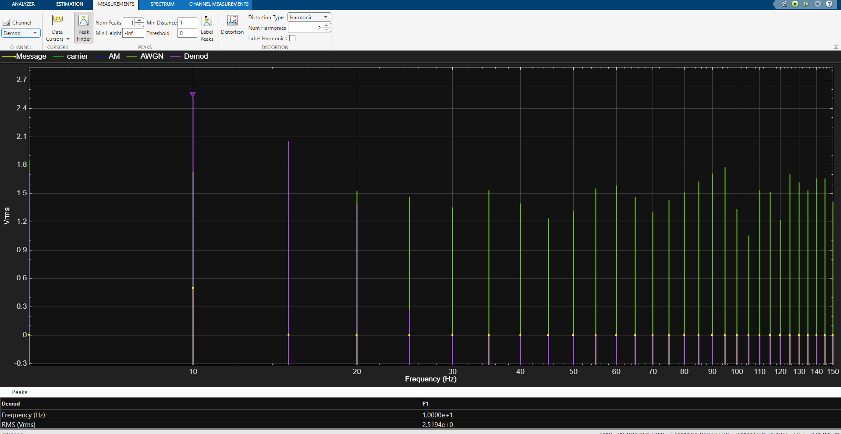
Figure 59 DSB-SC Demod signal at -30db of AWGN
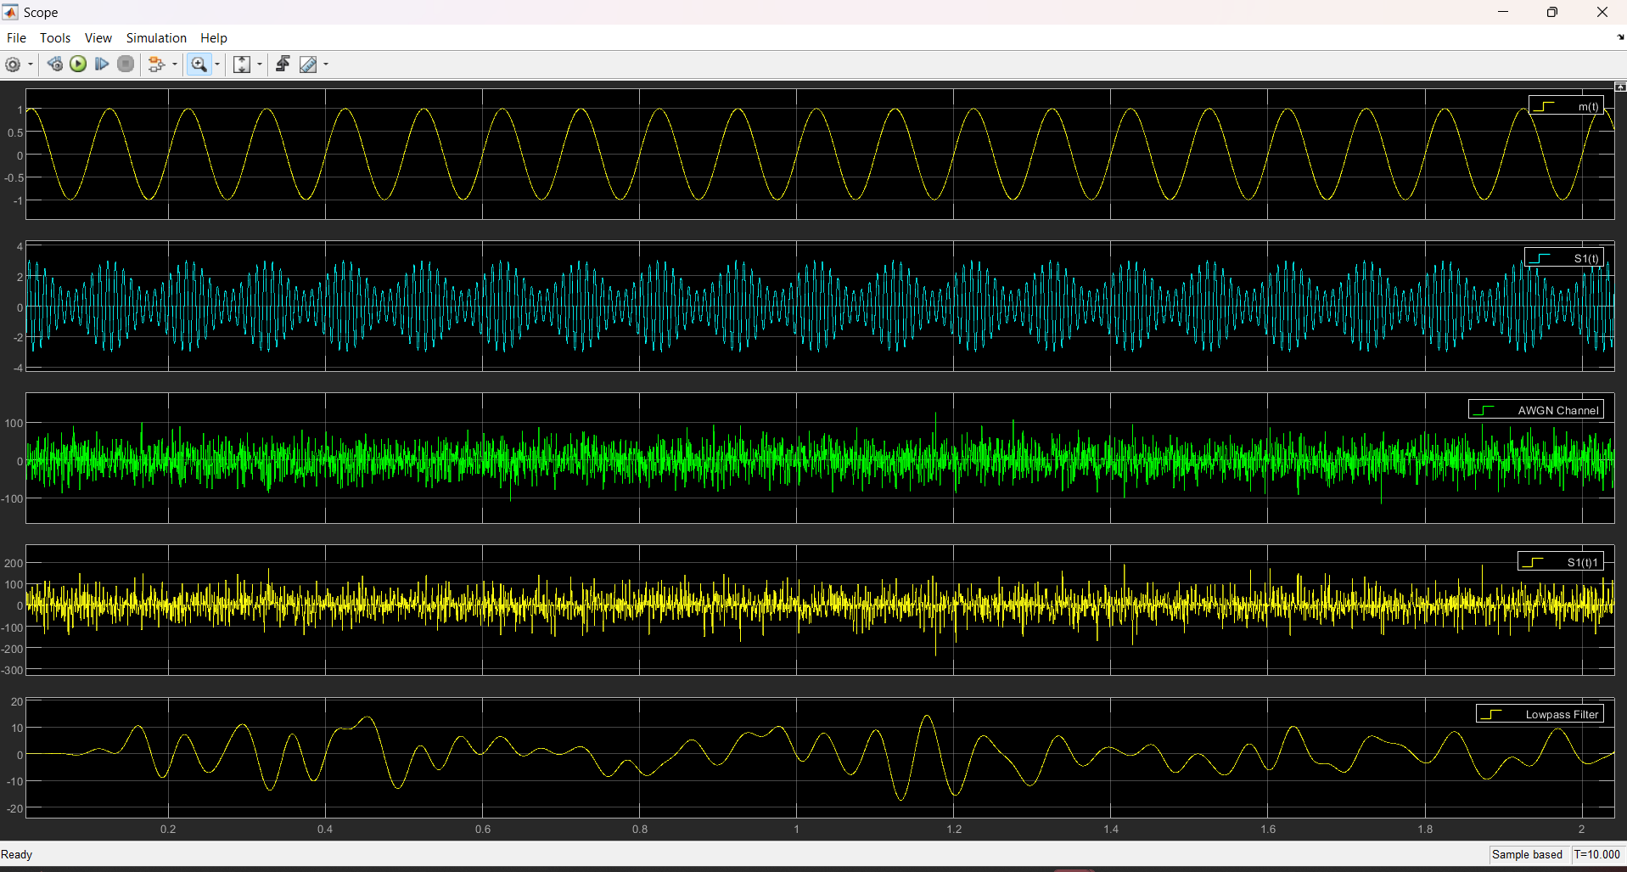
Figure 60 DSB-SC signal at -30db of AWGN in time domain
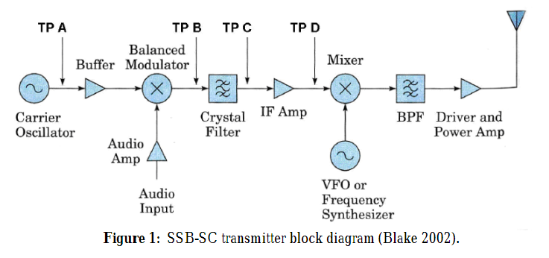
Figure 61 SSB-SC block diagram CITATION Art17 \l 2057 [7]

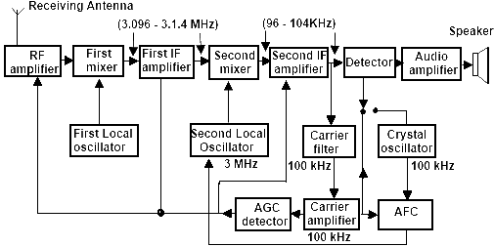
Figure 62 SSB -SC receiving block diagram CITATION DAE25 \l 2057 [10]

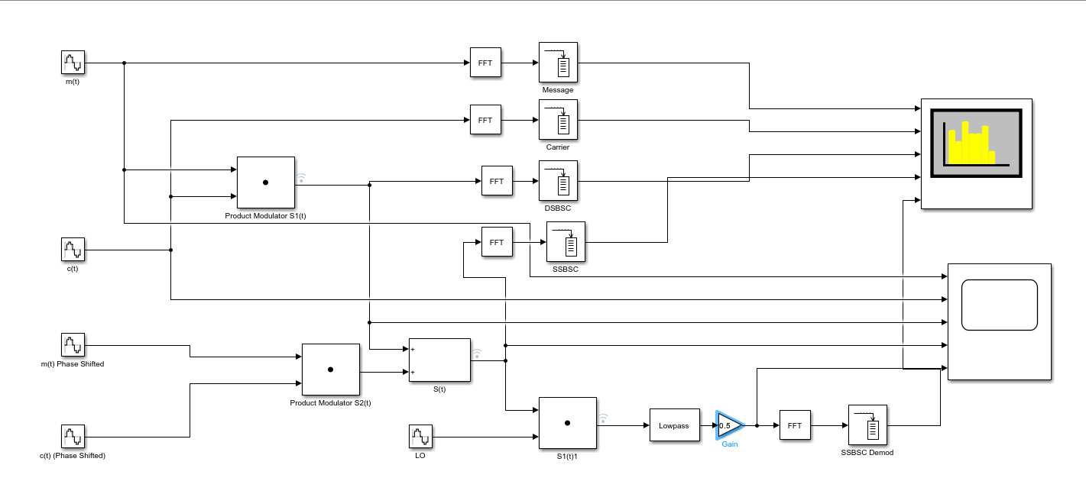
Figure 63 SSB-SC MATLAB schematic
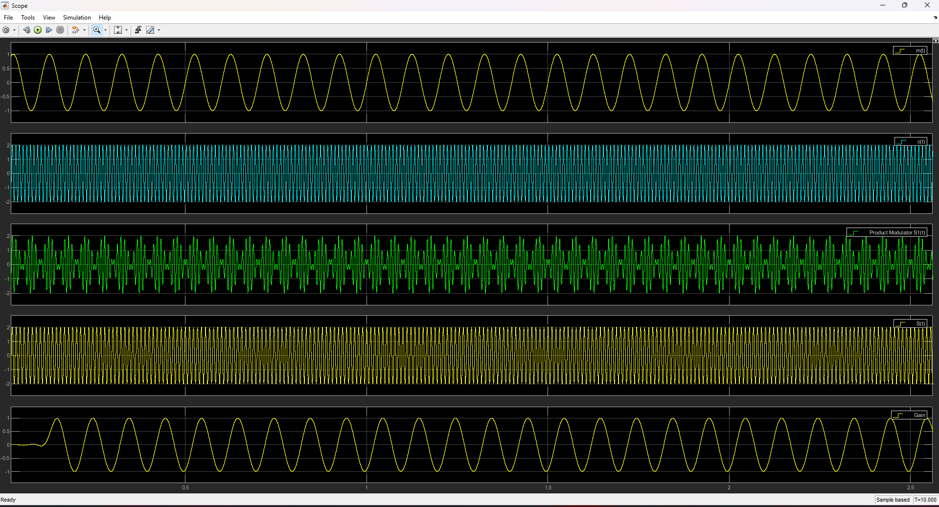
Figure 64 SSB-SC signals in time domain
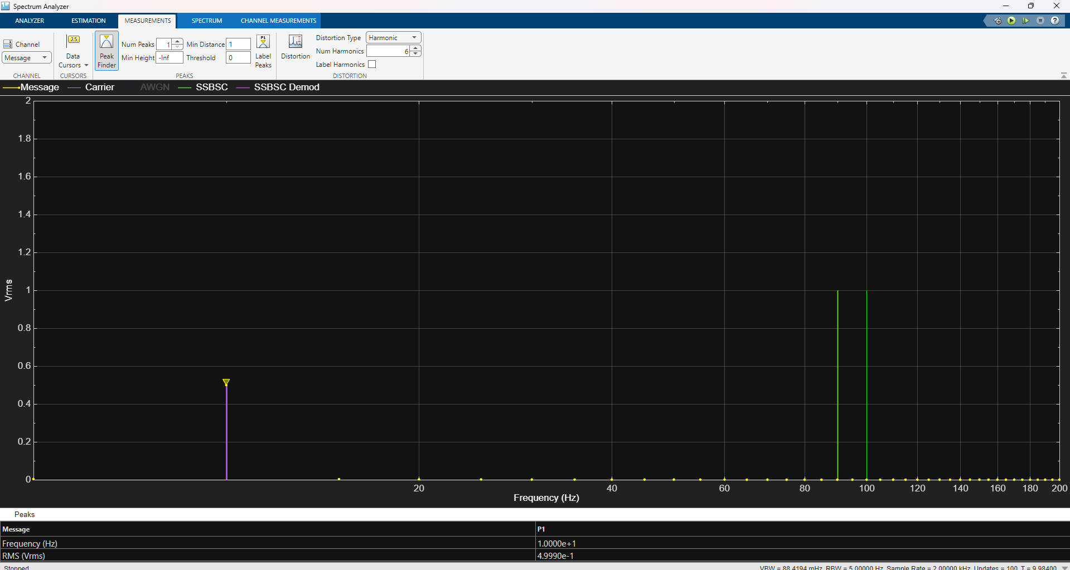
Figure 65 SSB-SC message signal spectrum
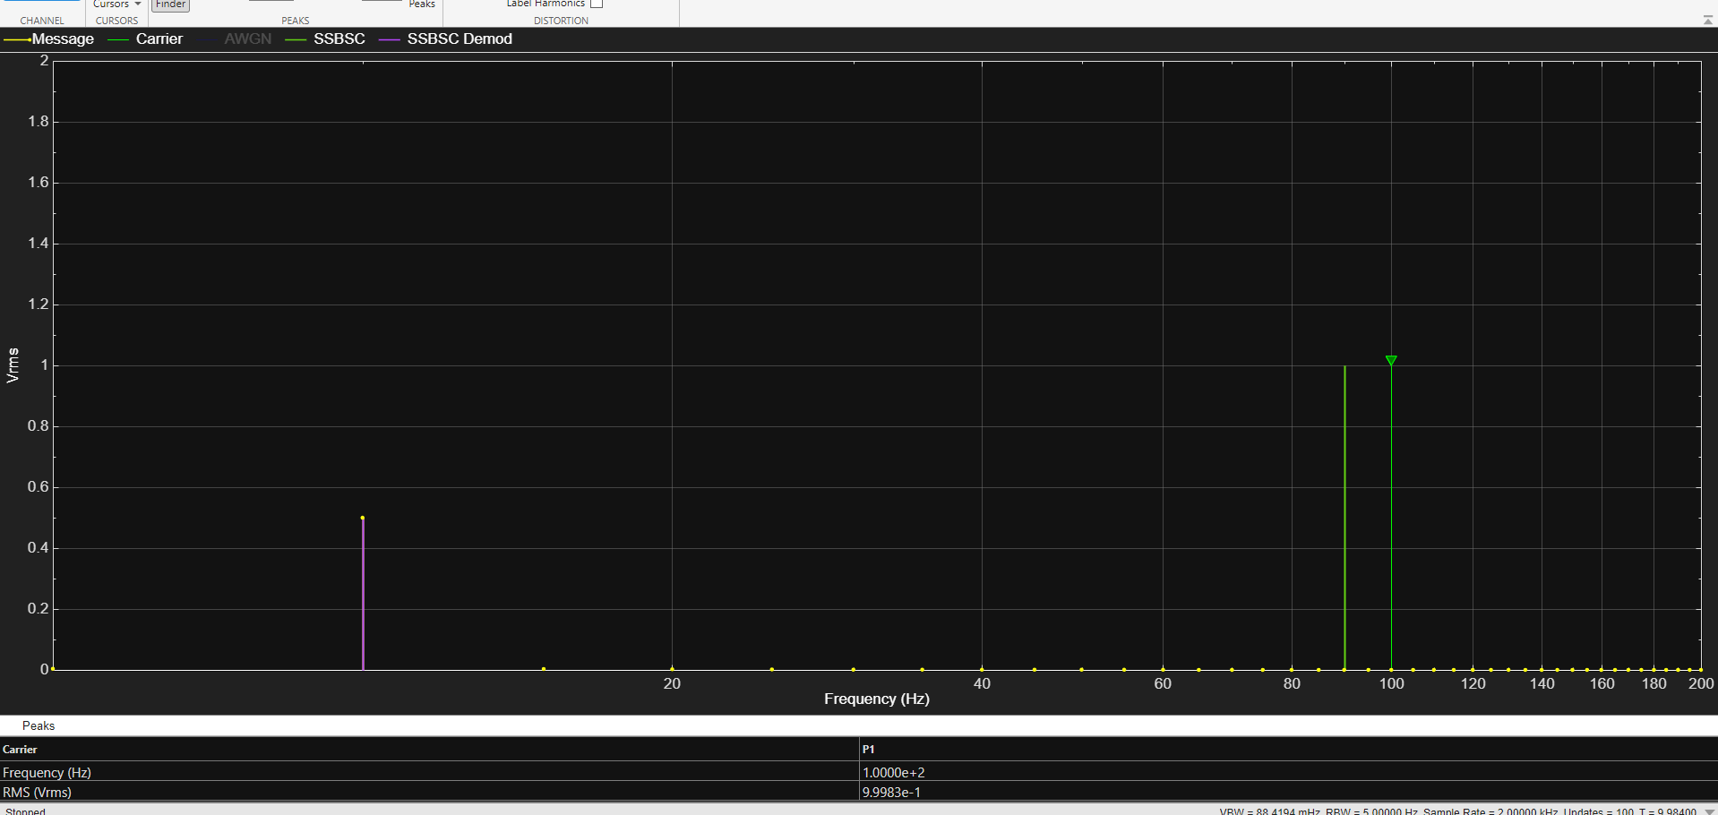
Figure 66 SSB-SC carrier signal spectrum
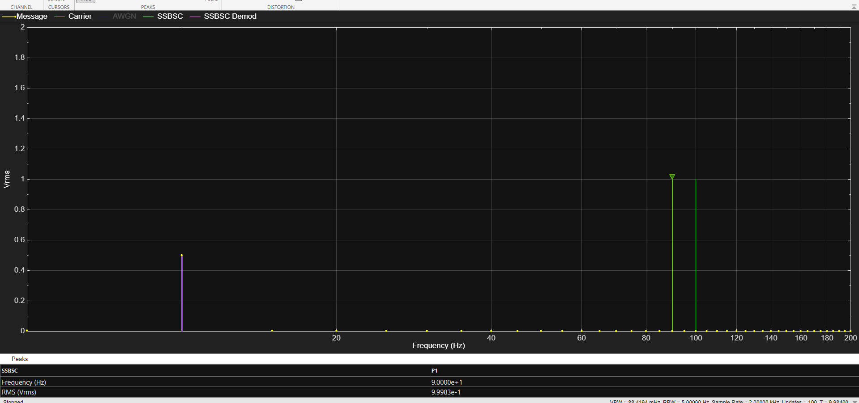
Figure 67 SSB-SC(2) signal spectrum
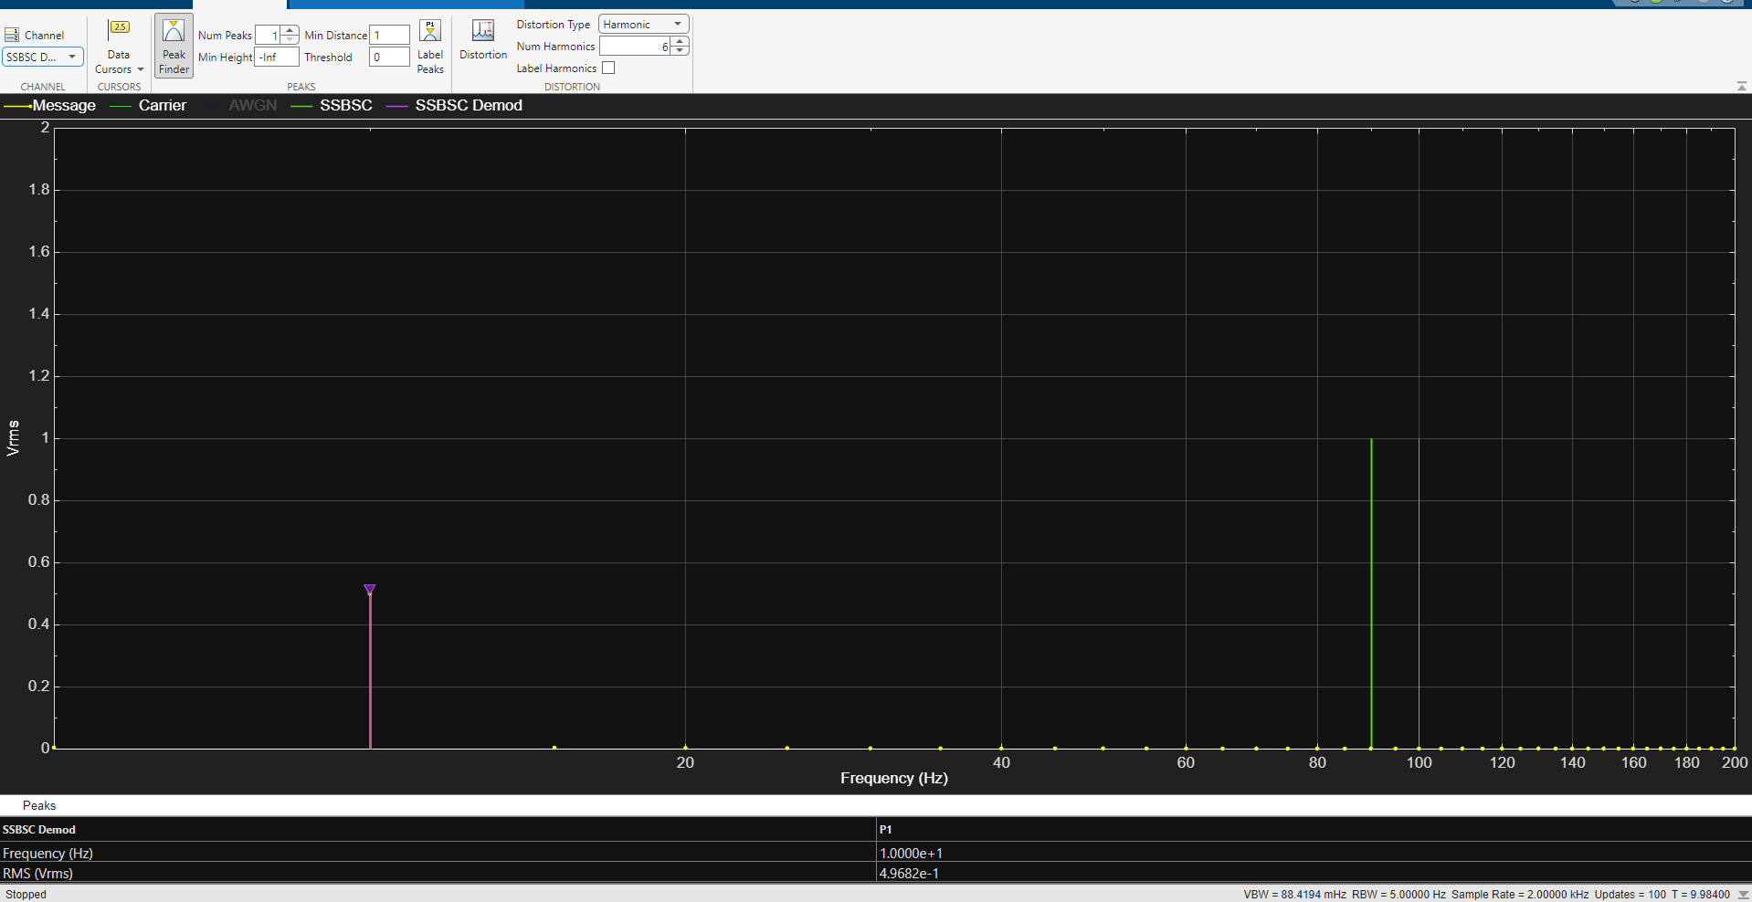
Figure 68 SSB-SC demod signal spectrum
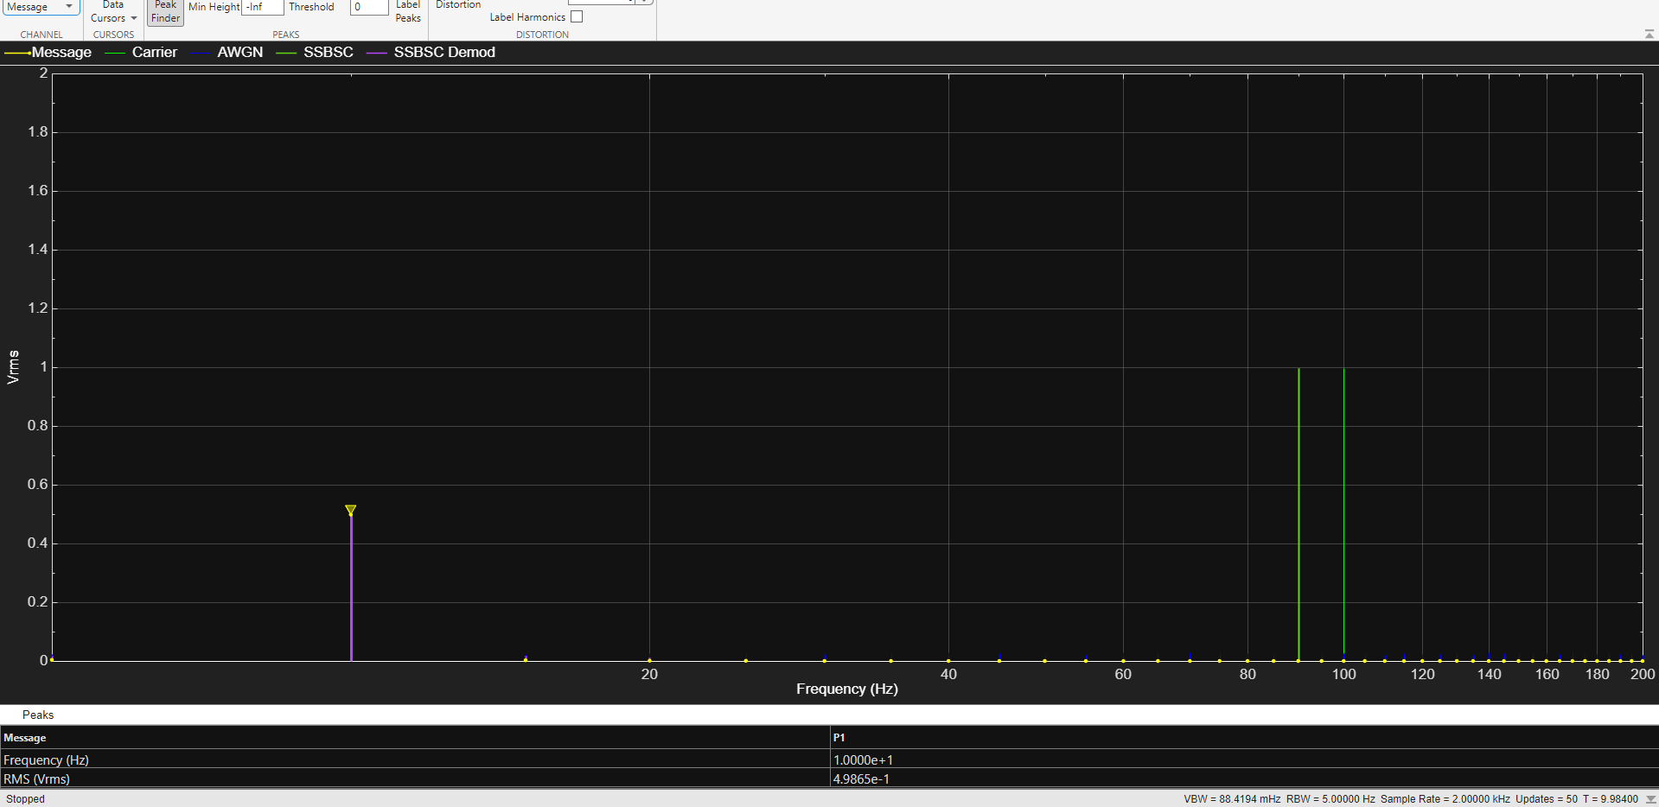
Figure 69 SSB-SC message signal with 5db of AWGN spectrum
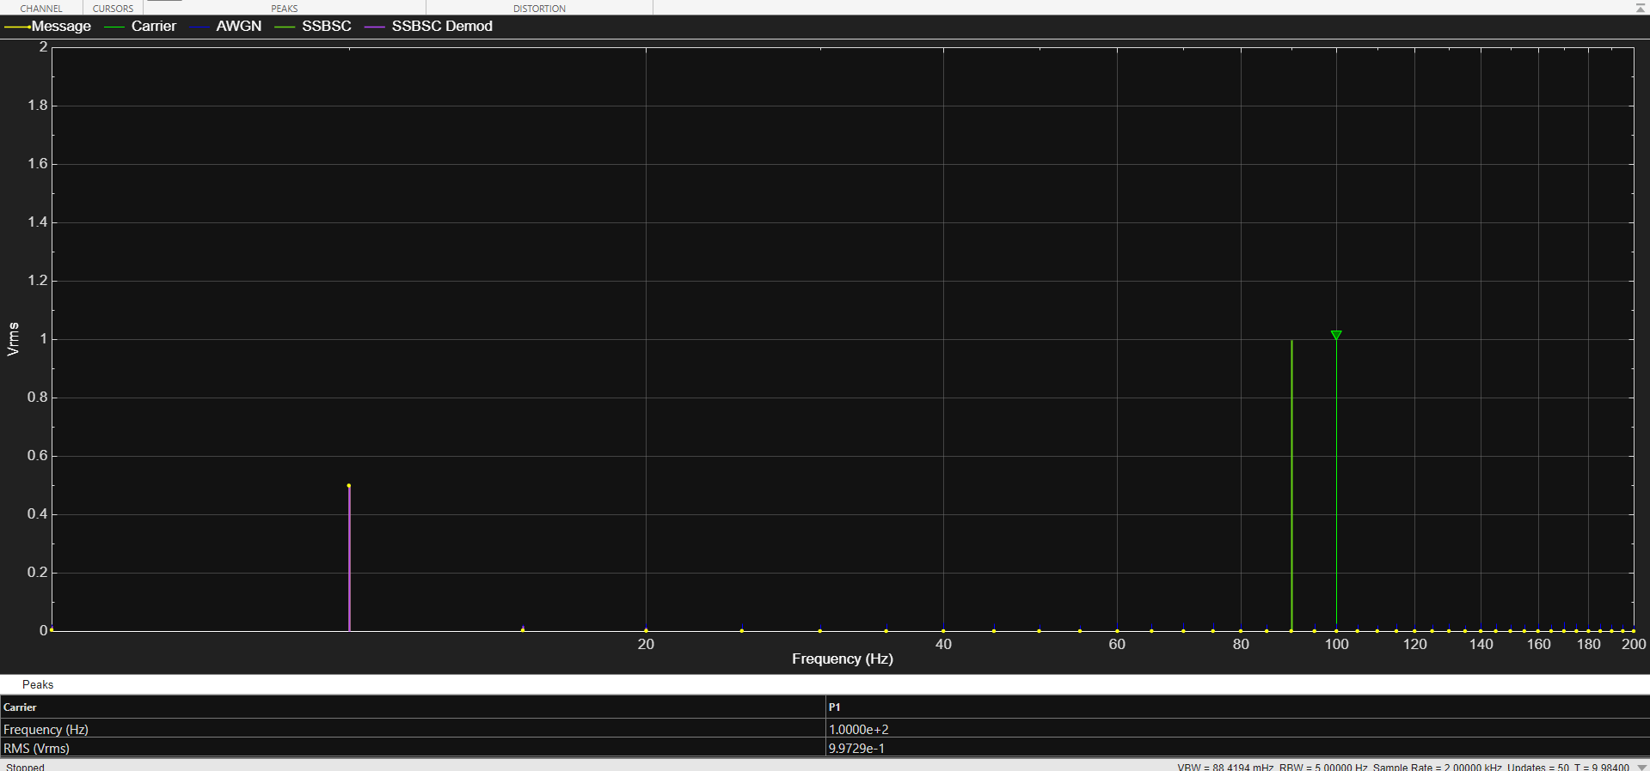
Figure 70 SSB-SC carrier signal with 5db of AWGN spectrum
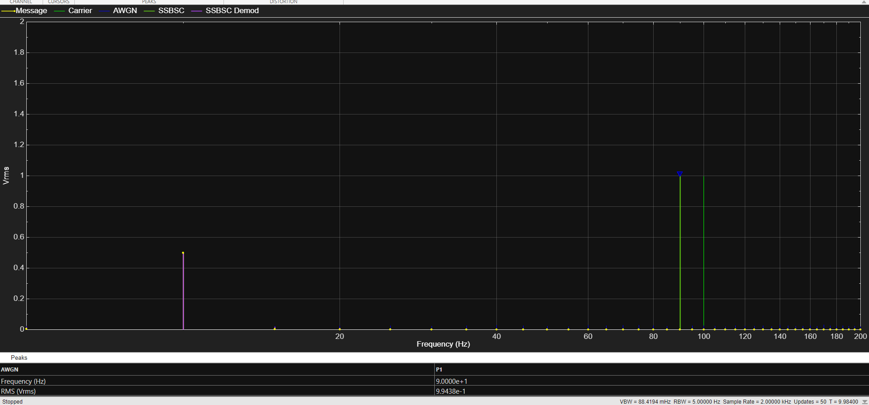
Figure 71 SSB-SC with AWGN at 5db spectrum
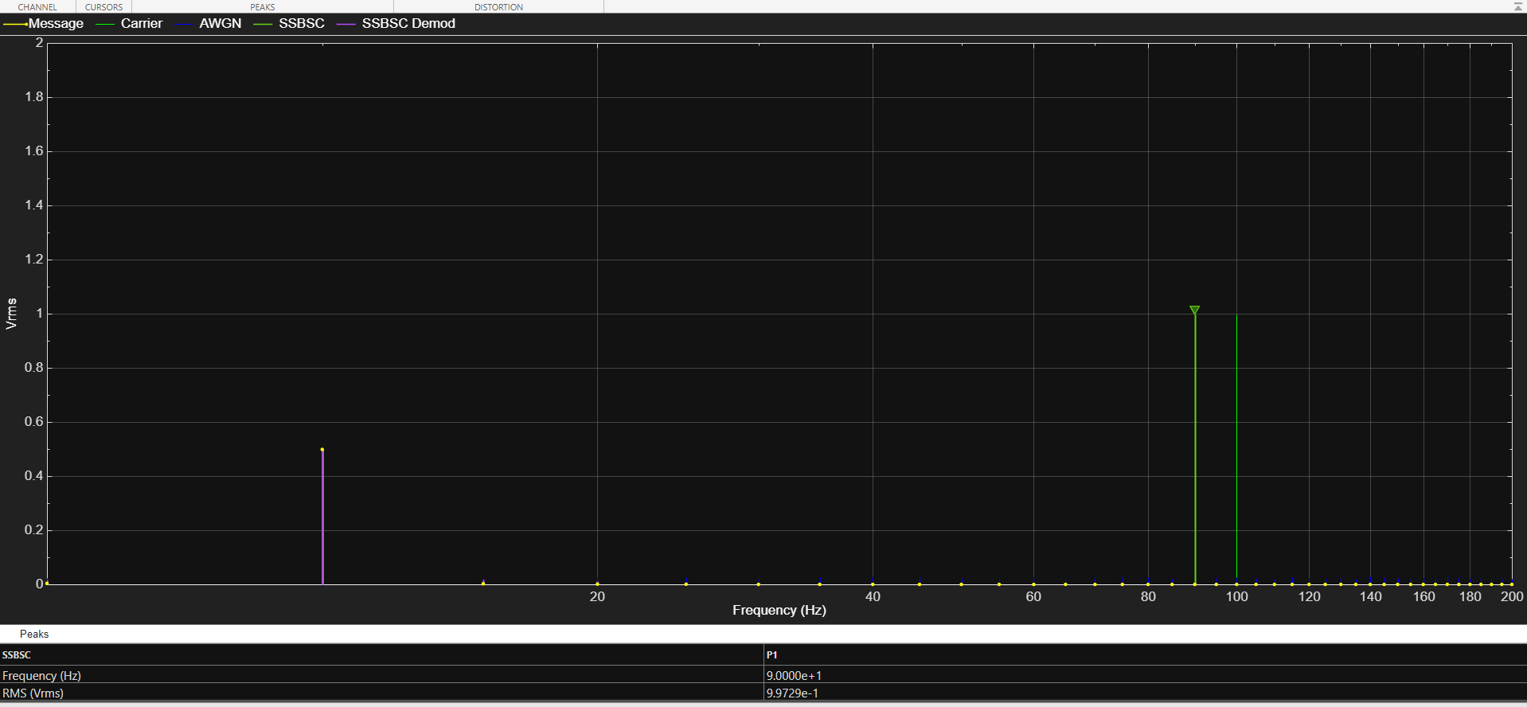
Figure 72 SSB-SC(2) signal with 5db of AWGN spectrum
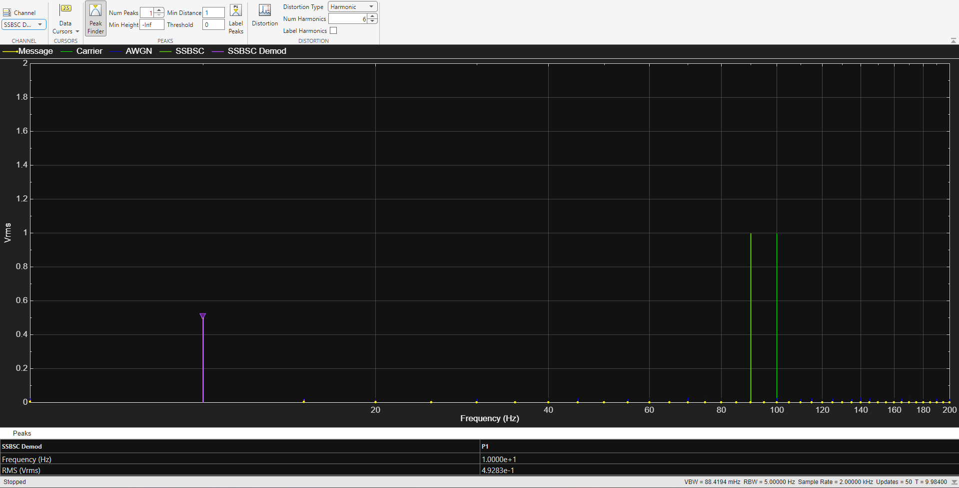
Figure 73 SSB-SC demod signal with 5db of AWGN spectrum
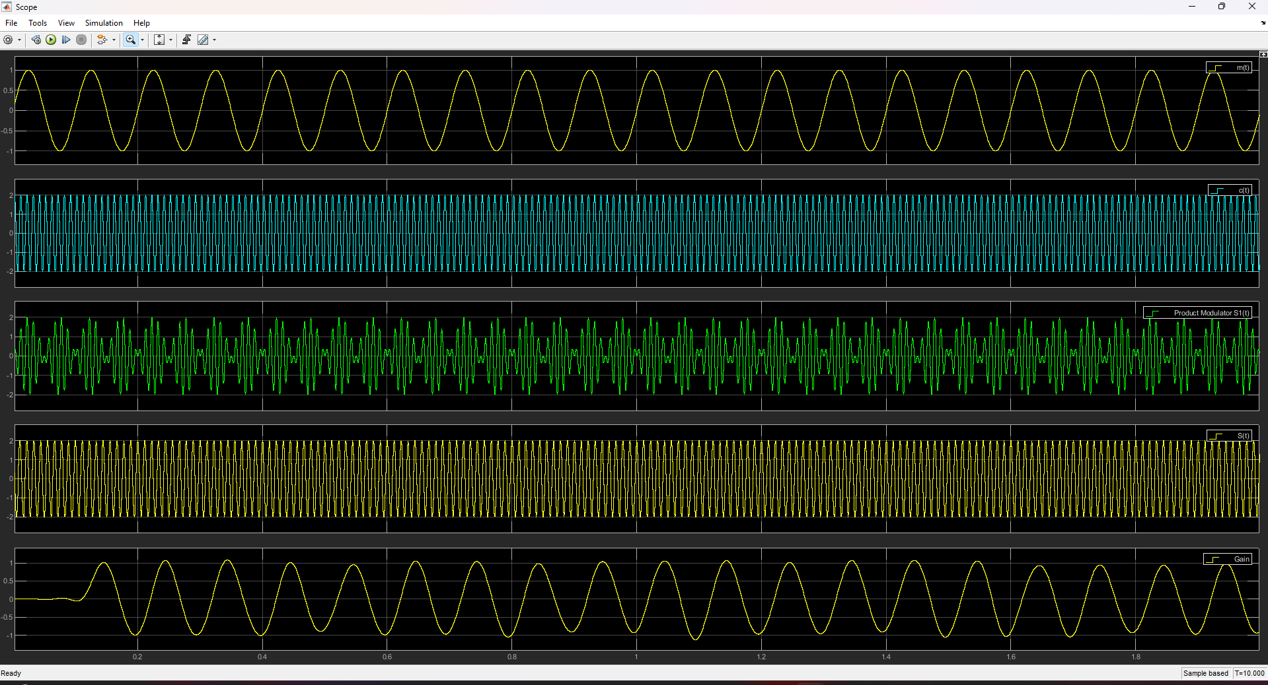
Figure 74 SSB-SC signal with 5db of AWGN in the time domain
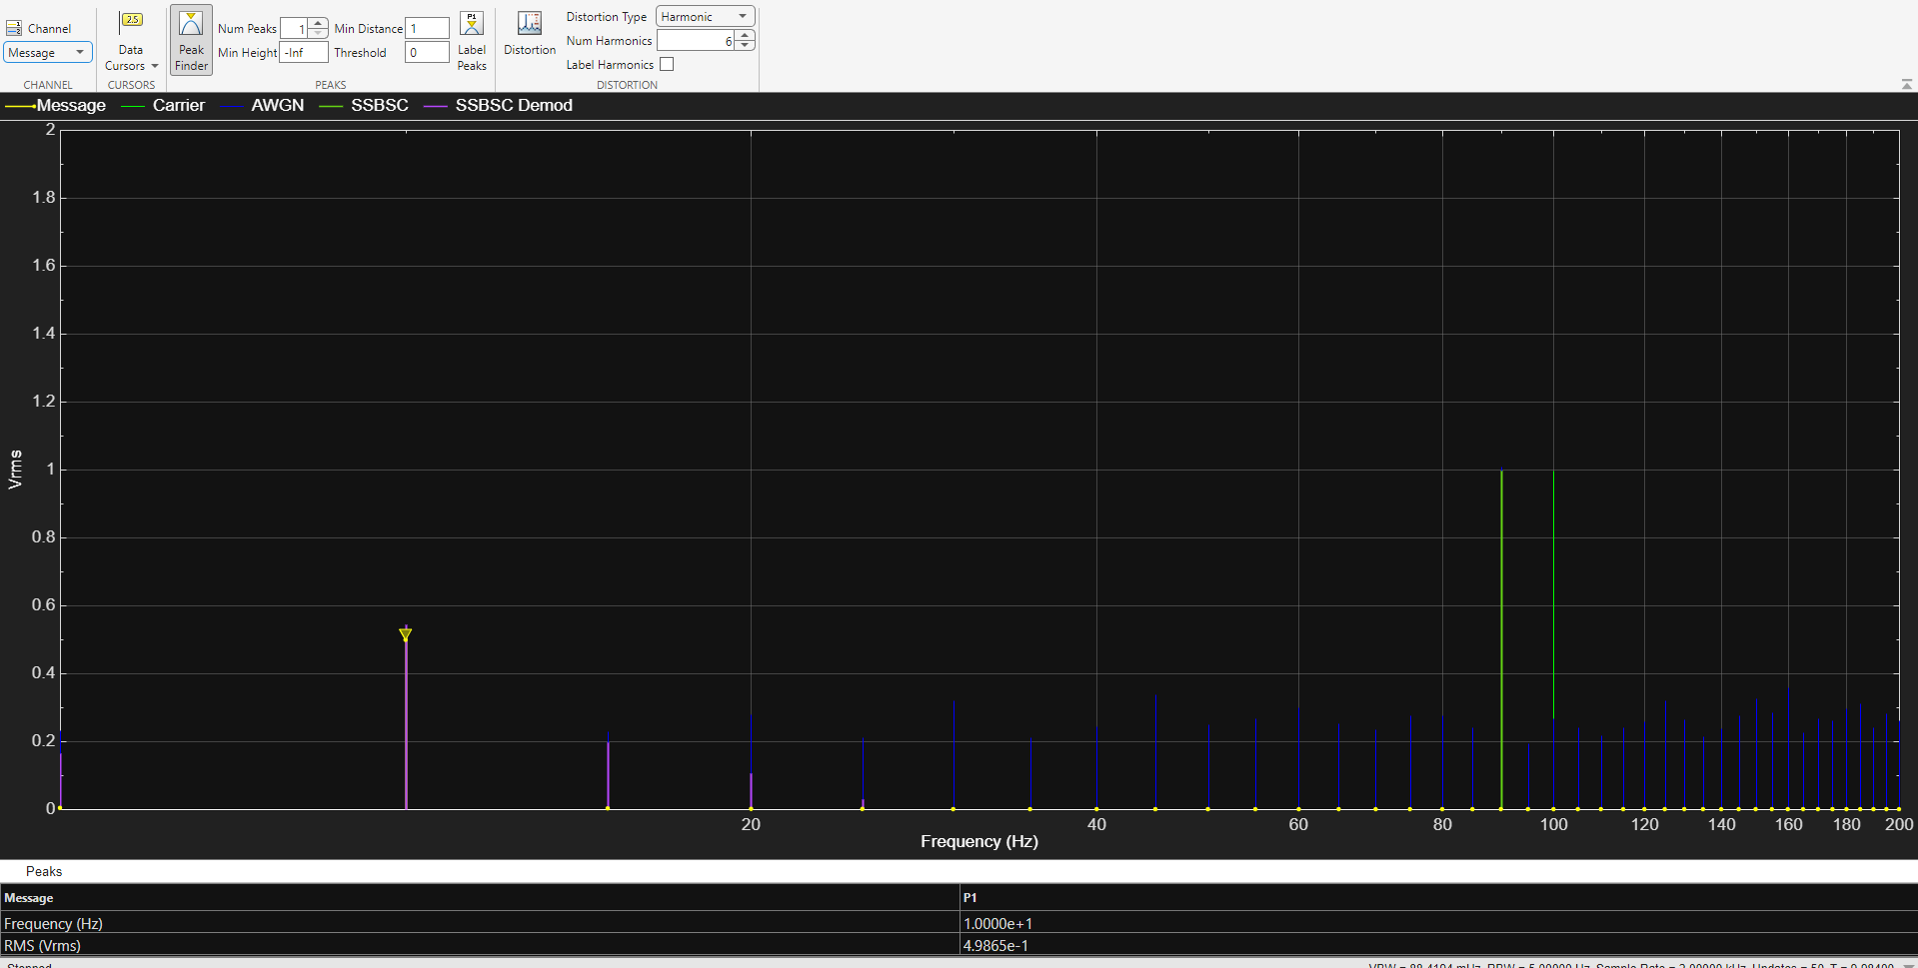
Figure 75 SSB-SC message signal with -15db of AWGN spectrum
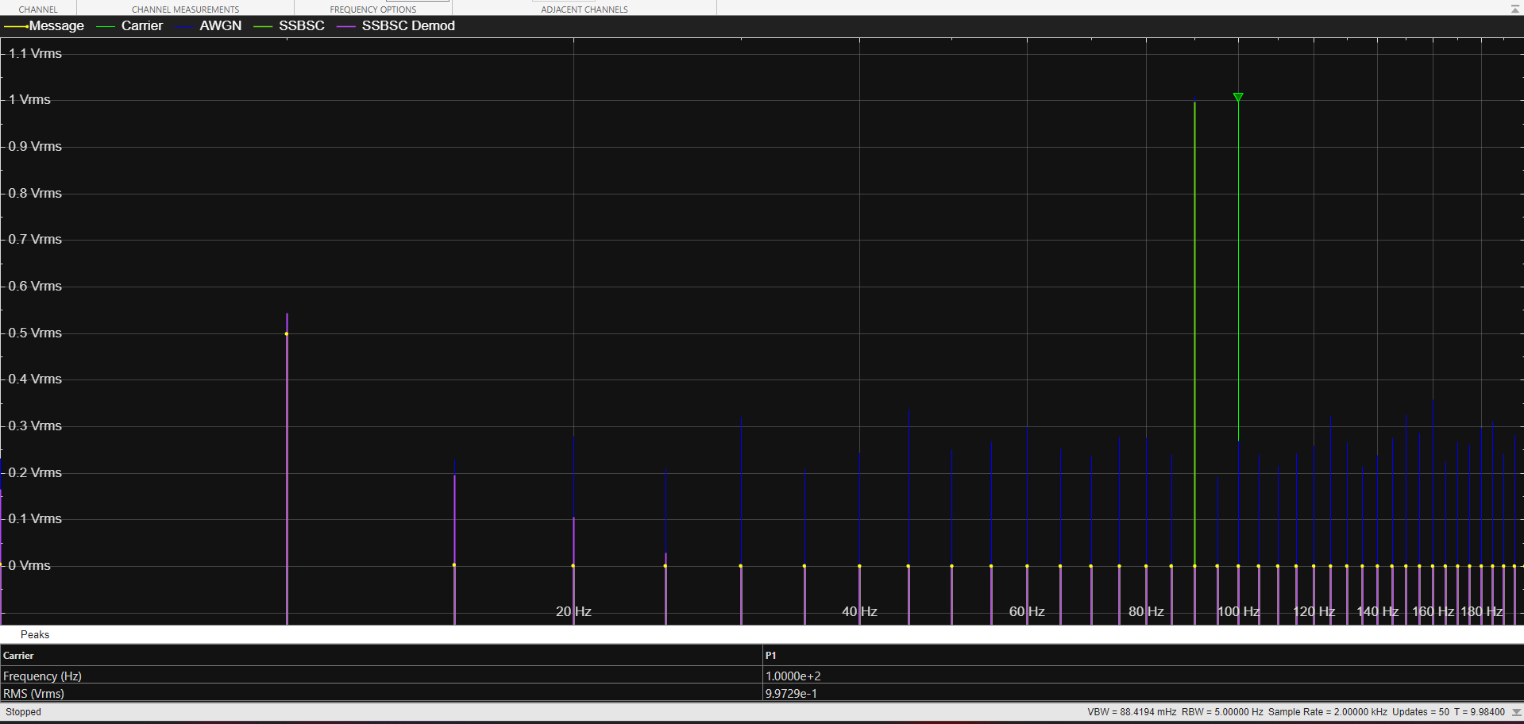
Figure 76 SSB-SC carrier signal with -15db of AWGN spectrum
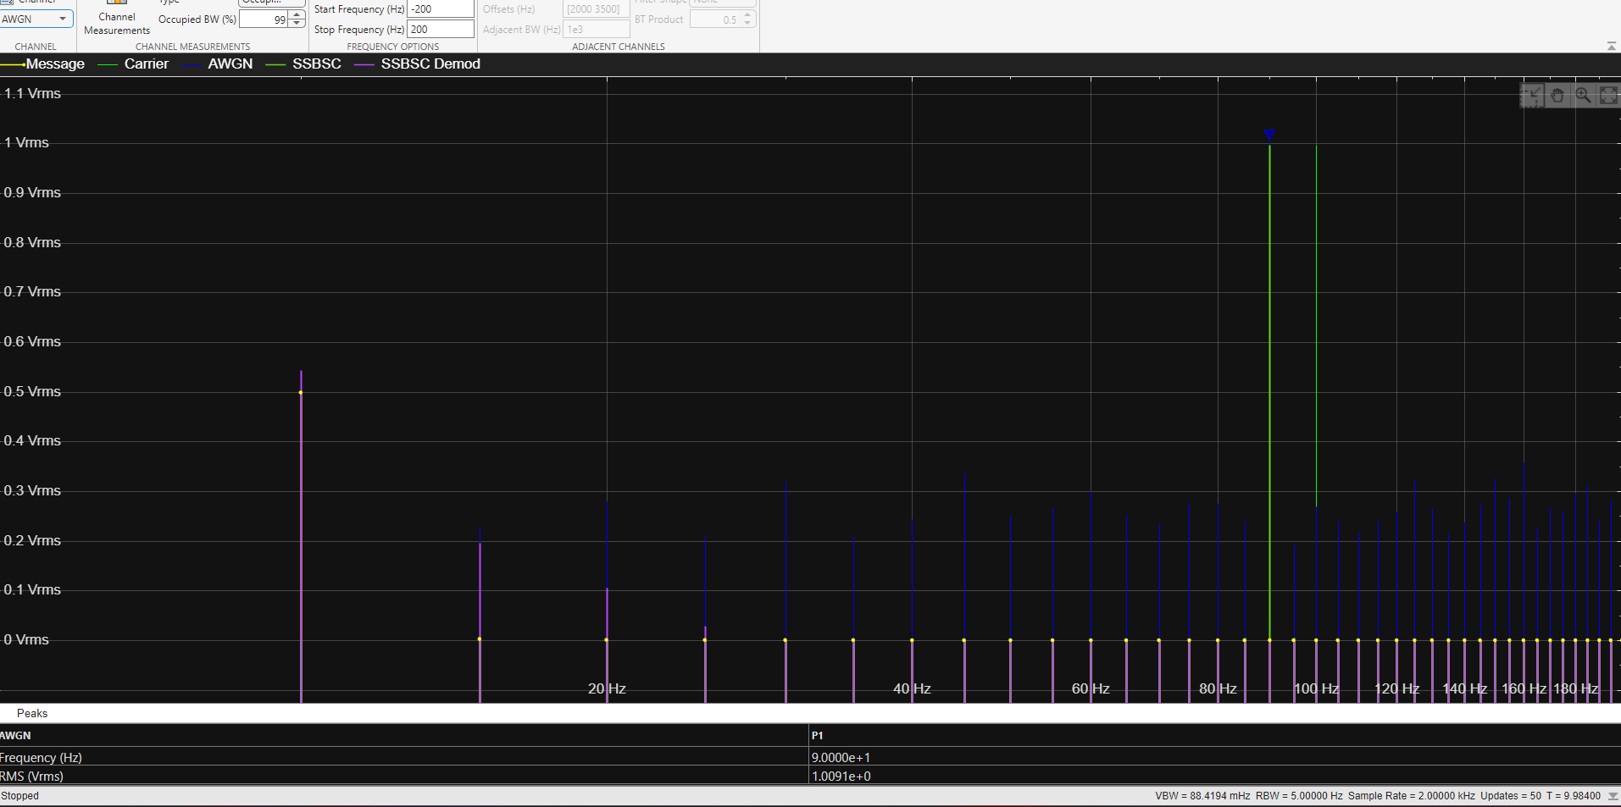
Figure 77 SSB-SC with AWGN at -15db spectrum
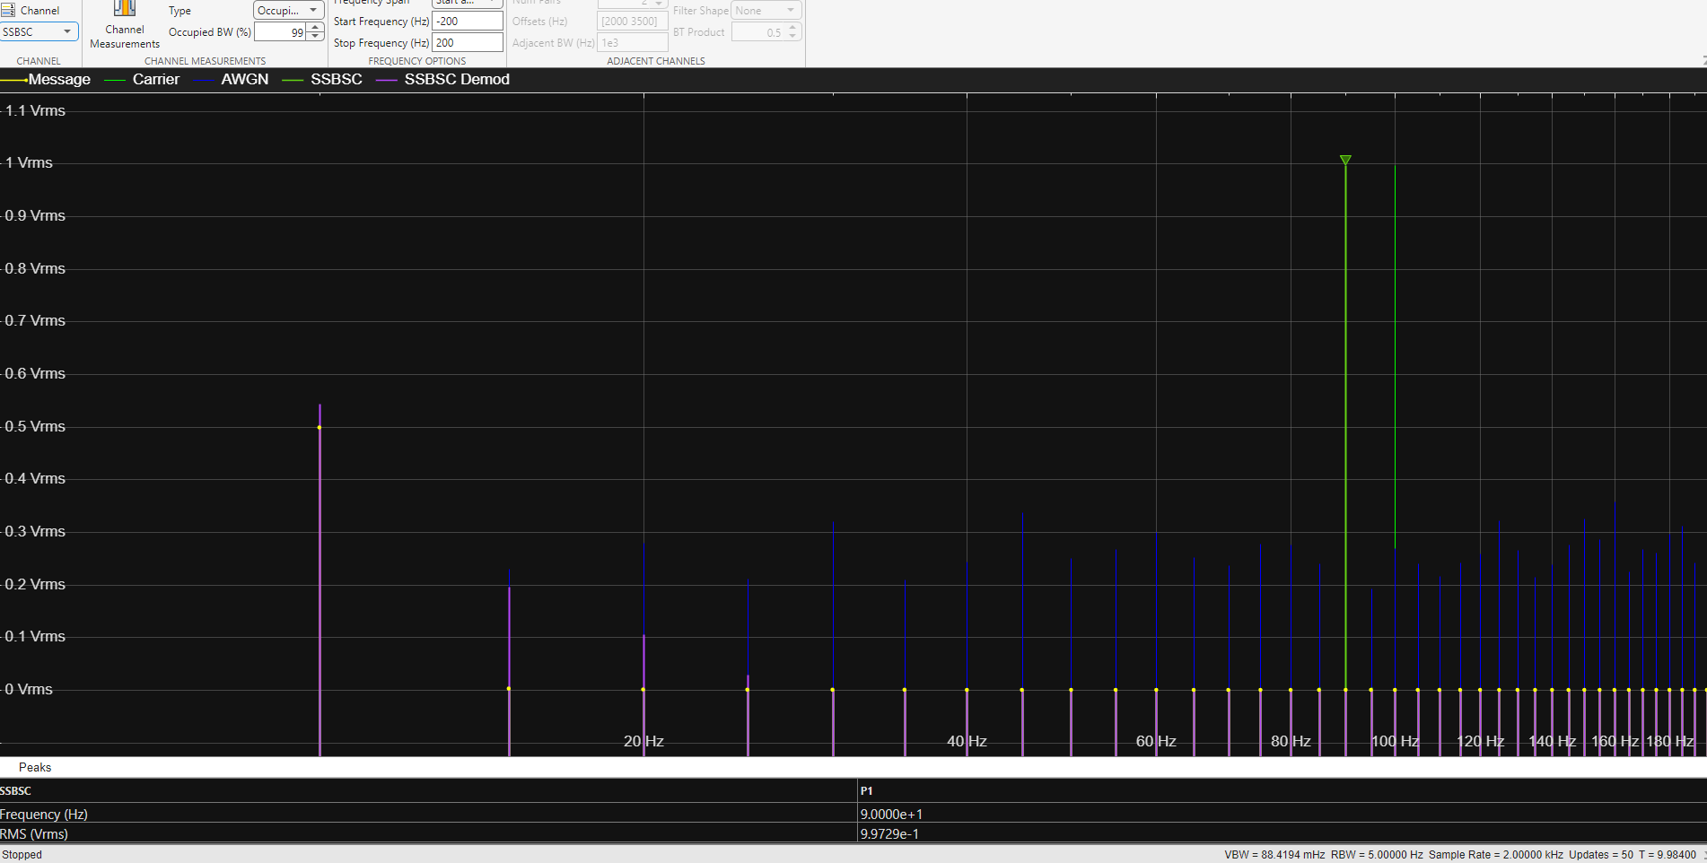
Figure 78 SSB-SC(2) signal with -15db of AWGN
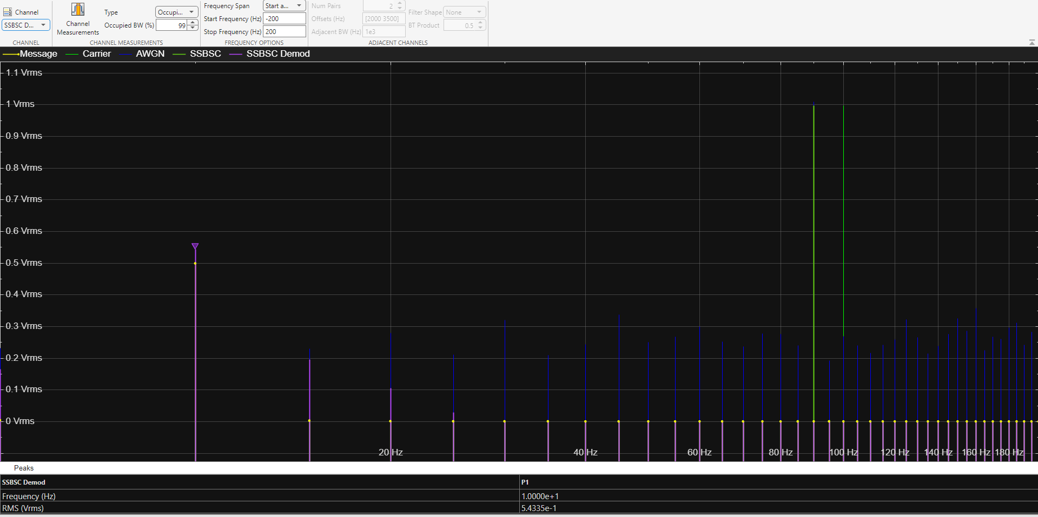
Figure 79 SSB-SC demod signal with -15db of AWGN spectrum
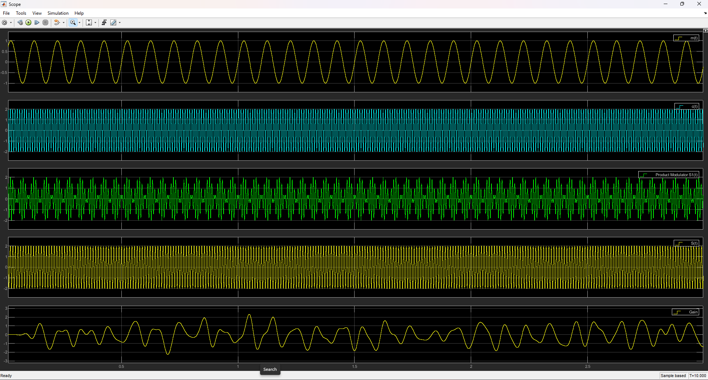
Figure 80 SSB-SC signal with -15 AWGN in time domain
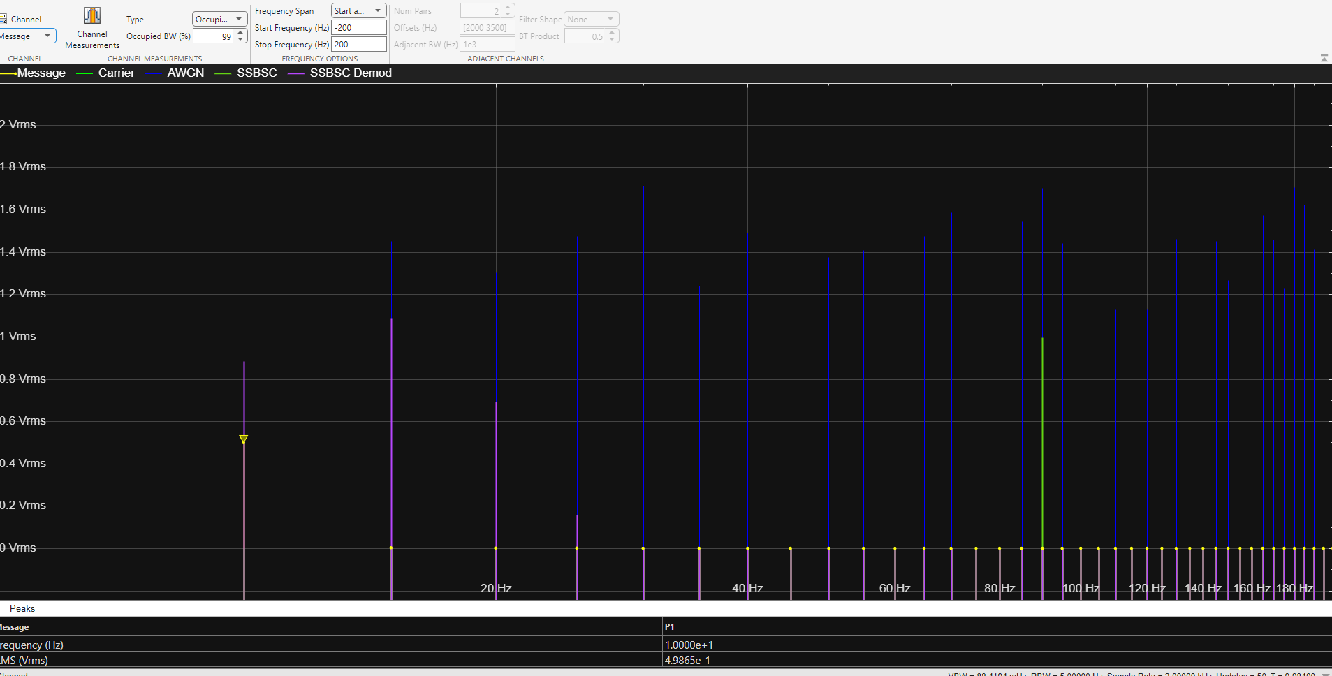
Figure 81 SSB-SC message signal with -30db of AWGN spectrum
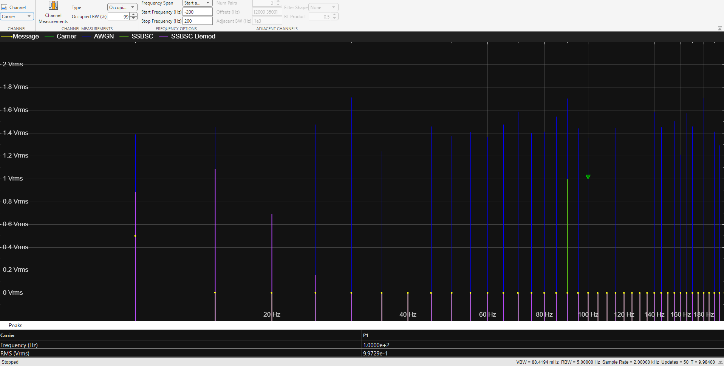
Figure 82 SSB-SC carrier signal with -30db of AWGN spectrum
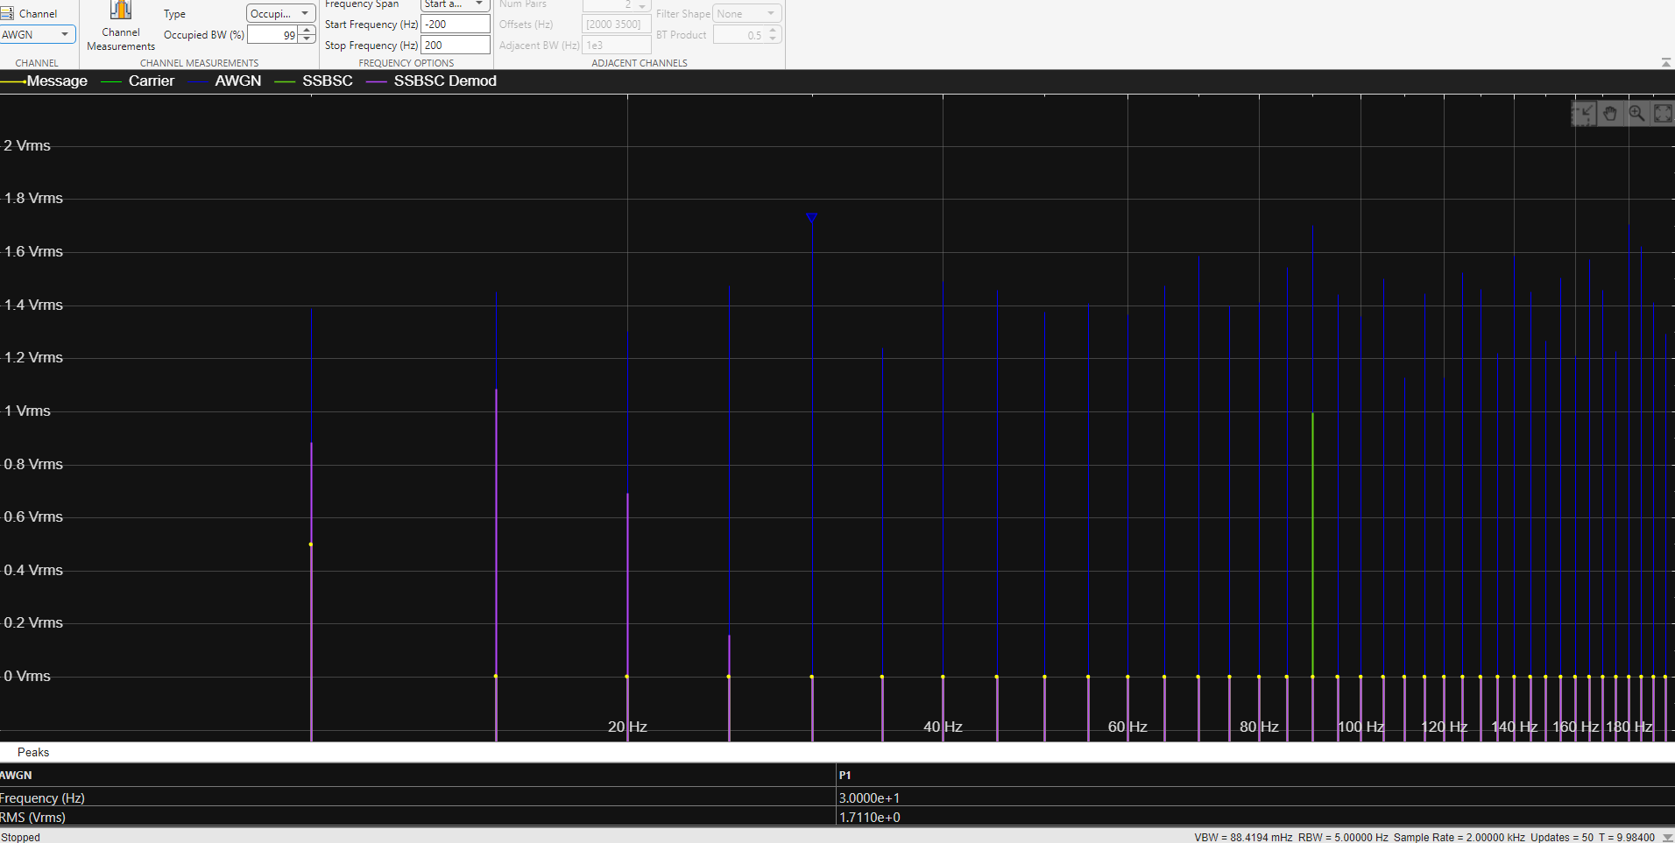
Figure 83 SSB-SC signal with -30db of AWGN spectrum
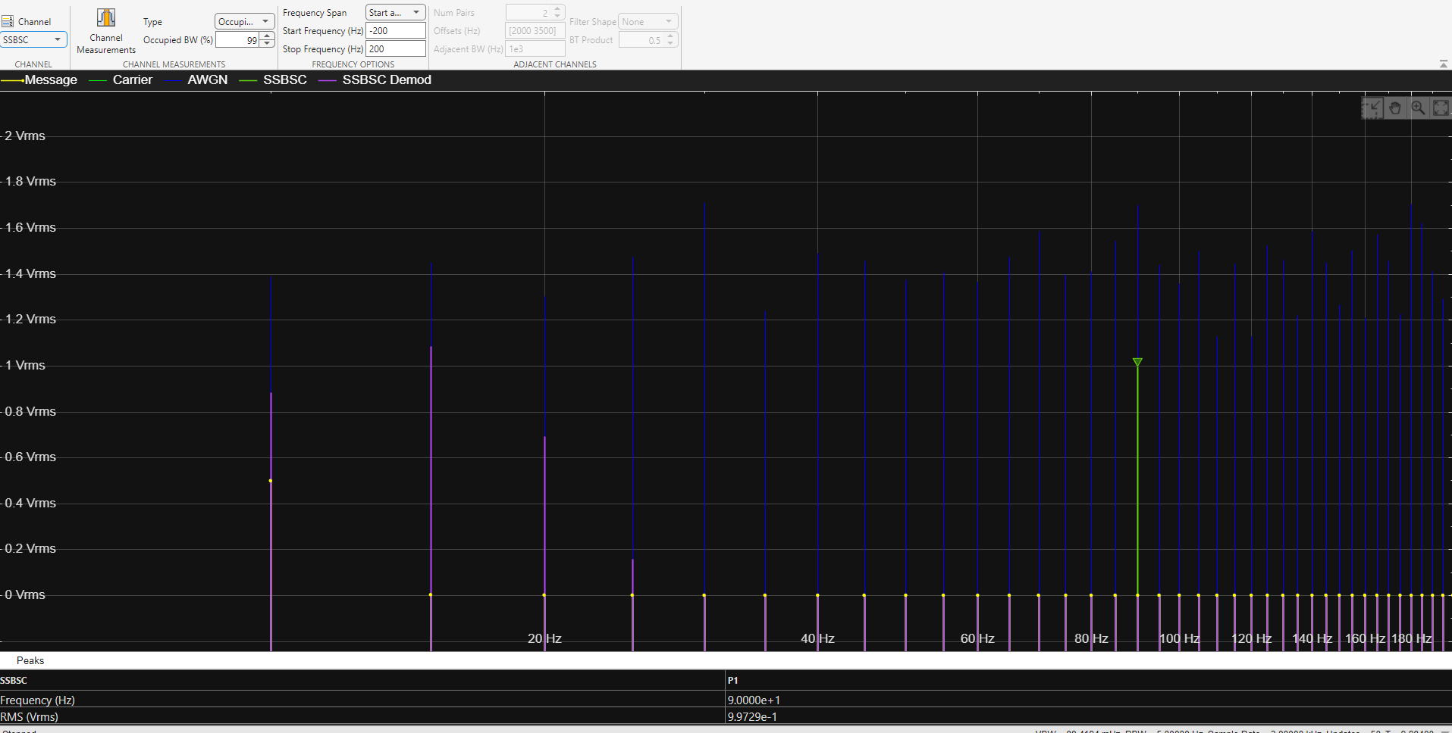
Figure 84 SSB-SC(2) signal with -30db of AWGN spectrum
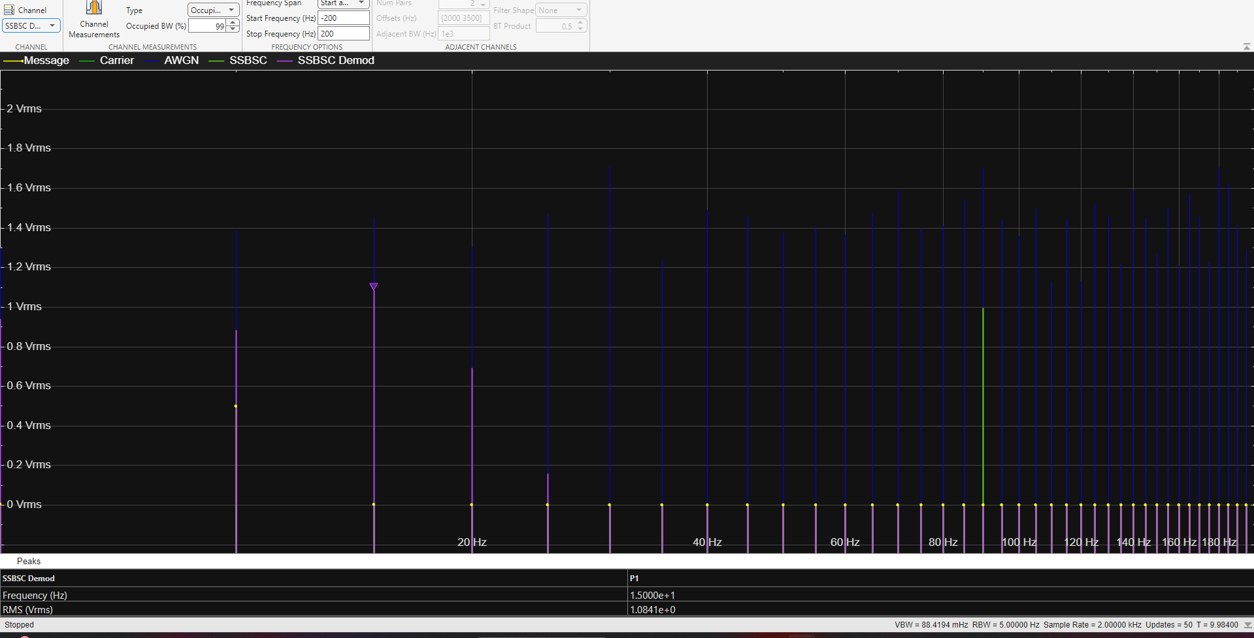
Figure 85 SSB-SC demod signal with -30db of AWGN spectrum
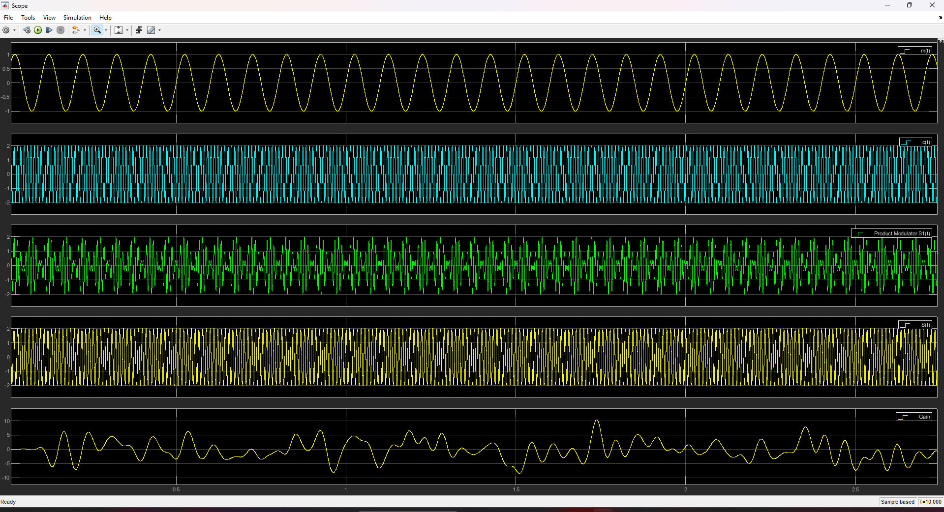
Figure 86 SSB-SC in the time domain with -30db of AWGN

