Report on: The Detrimental Effect of Water on Explosive Materials and OME Related Processes.

Author: Joseph Lyons 2030722
Faculty: University of Wales Trinity Saint David
Course: L4 – Chemistry (OME HNC) ACDA4011
Date of submission: 01/07/2022

2. Declaration

The work of this report completed under the supervision of (name supervisors). I declare that this report is the product of my own work and is not being submitted for any other degree etc.



3. Abstract

Explosives make a remarkably interesting subject due to their vastly different applications in the modern day. Originally designed for destruction, humanity has since harnessed the raw power contained within the highly energetic substance, to do excellent work, as well as bad. This “work” can range from a firework display, to quarrying or even creating a road through a mountain reuniting people once separated. The other end of the spectrum is that explosives are used against “targets” both inanimate and otherwise for their ability to destroy.

The unifying thing about explosives is that they do not discriminate. It is the people who employ them that cause devastation. The Explosives do not think. They cannot feel. They just are. They need to be interacted with by design or omission.
Because of the massive amounts of energy they store, they are very susceptible to third party stimulus such as shock, friction, heat, Electrostatic Discharge, acids/alkalis, Radio Frequency & grit to name a few. At all times Explosives must be treated with the respect they demand. Anything less will lead to catastrophe.

Care must be taken when handling explosives, by controlling the very environment to which they are exposed. This includes controlling the relative humidity, working within a conductive environment & a contraband-controlled area. The only people to ever handle explosives must be suitably qualified and deemed competent…. within the commercial industry that is regulated by the HSE. If you wish to have a fire works display within your garden, there are no rules but “common” sense.

4. Contents
1. Report on: The Detrimental Effect of Water on Explosive Materials and OME Related Processes. 1
2. Declaration 2
3. Abstract 3
4. Contents 4
5. Introduction 5
6. Physical and chemical properties of water 5
6.1 Physical Properties of Water 5
6.2 Chemical Properties of Water 5
7. Water in the Earth’s Atmosphere and Relative Humidity 6
7.1 What is the Earth’s Atmosphere? 6
7.2 Water, Earth & the Atmosphere 6
7.3 Humidity 6
7.4 Humidity & OME 6
8. The Role of Water in Chemical Processes 7
8.1 Water, Acids & Bases 7
8.2 Redox 7
9. The adverse & useful effects of water & Relevance to OME 8
9.1 Water & OME Materials 8
Flash Powder/Cartridges 8
Flares 9
Outgassing 9
Polymerisation 9
9.2 Water & OME Articles 9
9.3 Water & OME Processes 9
10. Possible Solutions to Prevent Performance Issues from Moisture Ingress 10
10.1 Weapon System Design 10
10.2 Packaging 10
10.3 Temperature 10
11. References 11
12. Appendices 12

5. Introduction

This report will go into the basic properties of water which is two molecules of Hydrogen that shares a covalent bond with an Oxygen molecule. This is well known as: $H_{2}O$.
Water is interesting in that within easily reachable temperatures (-1 to +${100}^{o}C$), water can be a liquid, solid or a gas.
Water forms part of the water cycle on earth in all three states. Whilst in vapor form it passes through the air as relative humidity, when frozen it is locked in as ice at the extreme polar ends of the earth.
Another interesting property of water is its ability to act as both an acid & a base, by excepting or donating molecules depending on the circumstance.
When handling certain types of explosives, a certain level of humidity must be maintained to reduce the chance of electrostatic discharge which could potentially set of the explosives. Water can also disrupt the explosive train, by displacing the oxygen required to maintain a chemical reaction.
This report will also investigate potential solutions to protect Ordnance, Munitions & Explosives from water egress preserving its integrity for prolonged use across varying environments.
.

6. Physical and chemical properties of water

6.1 Physical Properties of Water

Water can act as 3 separate states of matter, which are solid (ice), liquid and gas (vapour) as described by Filippo Menga & Erik Swyngedouw in the book “States of Water” [1], when subjected to the relevant temperature the state changes.
An experiment carried out by Qin, N; Y Wu; Wang, H W; Wang, Y Y found that when water reaches within range of its freezing point averaged at <${0.44}^{o}C$ [2] graph seen in appendices [1], water will start to freeze changing from a liquid into a solid. In a solid state the molecules that make up the substance a frozen in place.
When Water is in a solid state and heat is applied, the ice will start to melt, freeing the water molecules, allowing them to move freely as a liquid.
When a temperature above >${20}^{0}C$ (average room temperature) is applied to water, it will start to evaporate as vapor [3], which is the gas form of water. This process of evaporation forms part of the Earth’s water cycle, the results of an experiment carried out by Odile Carrier et all can be seen in Appendices [2].
When water reaches ${100}^{o}C$ it will start to boil [4]. As the water boils, it will start releasing molecules as steam, which will rise into the atmosphere.

To summarise the physical properties of water is that it is a fluid like substance that is a “ubiquitous prerequisite for life for which there is no substitute” [1].

6.2 Chemical Properties of Water

The chemical properties of water can be described as a compound that is made up of two hydrogen atoms and one oxygen atom [1] elements and is referred to as:

$$H_{2}0$$

Water is depicted by the “Lewis Structure” as the following:
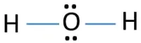

[5]

The Lewis Structure above shows that there are two single bonds of Hydrogen joining to the Oxygen atom that leaves two lone pairs of electrons.

The Hydrogen atoms each have one electron to share with the Oxygen atom that has six valence electrons. By sharing electrons, both the Hydrogen & Oxygen atoms have filled orbits. Hydrogen requiring one (each) to complete its “1S” orbit(s) of two electrons & Oxygen requiring two (one from each Hydrogen atom) to complete its “2P” orbit with six electrons. This is known as a covalent bond.

7. Water in the Earth’s Atmosphere and Relative Humidity

7.1 What is the Earth’s Atmosphere?

David Randall describes that the atmosphere can be explained with two parts. The first being that the atmosphere acts as an outer skin; protecting the Earth from losing its atmosphere into space.
The second part being that the atmosphere regulates energy exchanges between Earth & Space [6]. This helps to keep the temperature on Earth suitable to harbour life.

7.2 Water, Earth & the Atmosphere

Two Thirds of the Earth is covered water, which is held mostly within the oceans being “four hundred” times more massive than the atmosphere [6]. When the Sun heats water it changes forms from liquid to vapor and rises into the atmosphere making 0.25% of its total mass [6]. This process is called evaporation and forms part of the water cycle on earth [7] .

The water cycle consists of the following stages that changes the state of water on Earth: freezing, melting & evaporating. When water reaches its freezing point of $<{0.44}^{o}c$ [2] it starts to change state from liquid into solid. This solid state of water is referred to as “ice” with its molecules “locked” frozen in place.
Frozen water when heated turns from solid into liquid, allowing the water molecules to move freely. Unless held, the liquid water will follow the path of least resistance, converging to a point that is able to hold it such as ponds, lakes & oceans. These examples being the lowest point subjected to the forces of Earth’s gravity.
When the liquid is heated, it evaporates turning from a liquid into a gas known as vapor. The vapor then rises into the atmosphere, to eventually condense and start the water cycle again.

Water within the atmosphere is integral to supporting life across the Earth in the form of vapor from evaporation, to then condensing & falling back to earth in the form of Liquid (rain) or as a solid (ice) elsewhere [6]. It is this cycle that transfers the vital life sustaining compound around the Earth.

7.3 Humidity

Humidity can be defined as the amount of water vapor present in air relating to the ratio of vapor to air within a given volume [8]. The higher the concentration of water vapor within a given volume of air the higher the humidity- this is also known as relative humidity.

7.4 Humidity & OME

When handling or processing OME (Ordnance, Munitions & Explosives) a relative humidity must be kept depending on the conditions that are mandated as part of the task specific process that considers the sensitiveness of the material being handled.

There are three conditions that effect processing of OME. The first being “comparatively insensitive” where usual safe systems of work specific to the process will suffice.

The second category is “Sensitive.” This rating applies to OME that has an ignition energy of 1mJ to 450mJ and requires the relative humidity of no less than 40% be kept during the process. Previously this condition was referred to as “Anti-static.” [9]

Finally, the third rating is “very sensitive” where the ignition energy is <1mJ and requires the relative humidity within the APB (Ammunition Processing Building) of not less than 65% be kept. [9]

The more humid the environment, the lower chance of electrostatic charge build up and arching. This is because the higher relative humidity percentage makes the “atmosphere”- in the case of processing OME, an APB- a more conductive environment [10].

8. The Role of Water in Chemical Processes

Water is integral to many chemical reactions as it acts as a solvent either dissolving a substance or hydrogen bonding with other compounds [11]. It is this solvent ability that allows the ions or compounds to move around freely in a dissolved state acting as the reaction medium [11].

8.1 Water, Acids & Bases

Water has a PH level of seven which is the middle of a scale that ranges from one to fourteen, making it neutral. The lower end of the spectrum are the Acids and at the upper end are the bases.
An image created by the Water Science School [12] can be seen as appendices [3] that gives visual aid & some examples of Acids & Bases.

The word “Acid” is derived from the Latin acidus/acēre meaning sour. This is because acids include any substances that donates its Hydrogen Ions (protons) when combined with a further substance. The greater the concentration of Hydrogen Ions, the “sourer” (acidic) the substance, which relates directly to its pH level [13]. When Water is added to an acid, its “gifts” Hydrogen Ions to the water which accepts, acting like a base, neutralising some acidity [14].

Base in Chemistry came into first use in 1717 by a French Chemist Louis Lémery. Its first use was a synonym for a form of alchemy matrix [15], where more modern usage for the meaning of Base is credited to French chemist Guillaume-François Rouelle, who stated that a natural salt is the product of an acid and another substance, that worked as the “base” for the salt [15].
What is understood about bases now, is that unlike acids, base’s accept protons.
When water is added to a base (alkali), the water will “gift” Hydrogen Ions to the base, thus acting as an acid.

8.2 Redox

A redox (oxidation-reduction) is a form of chemical reaction that involves the transference of electrons between two types. The oxidation status of an element refers to the number of electrons, that an atom loses or gains during the chemical reaction. The reducing agent is the reactant that is being oxidized [16].

A clear example is the electrolysis of water is a redox reaction. When passing a current through water, Hydrogen is produced at the cathode whilst oxygen is produced at the anode. An example of the experiment can be seen is appendices [4]

$$H_{2}O H_{2}+O_{2}$$

The hydrogen and oxygen in the water share a covalent bond that breaks to make the element’s oxygen and hydrogen.

9. The adverse & useful effects of water & Relevance to OME

“When you lock in water you lock in the devil.”-Dave Holley

9.1 Water & OME Materials

Weapon Systems have varying systems & sub-systems that are needed to keep integrity to remain effective. An example being “Charge Propelling 120mm TK”. This article is made up of the following components: Combustible Cartridge Case (CCC) Igniter & Triple Based Propellant. All the previously listed make up the propelling charge.
The way this system works is by being loaded into a 120mm Gun breach, behind a projectile, the breach is then closed, where a Tube Vent Electric (TVE) is then inserted.
When the TVE is electrically initiated, the explosive train starts, rapidly forming the gasses needed to propel the projectile out of the weapon.
The TVE functions transferring energy to the Igniter, that then creates the heat needed to ignite the propellant bundle, which then combusts (at a rapid rate), creating rapidly expanding gases which are contained within the barrel (obturation), where the only way out is by propelling the projectile out.

The CCC is made of card, allowing for complete combustion which reduces the debris left inside the barrel. When this is exposed to water or a high humidity, the water reduces the ability for the CCC to combust fully- reducing the overall chamber pressure generated by the propellant, reducing overall performance. Which in an environment of war, can be the difference between life and death.

Flash Powder/Cartridges

Flash Powder begun in the 19th Century with the very first photograph being taken. A compound was used that was made up of metallic fuel & oxidiser (chlorate). When the powder was stimulated it would produce a bright flash as the substance was consumed. Due to the substance being in powder form, the compound was susceptible to water/humid environments. The water would desensitise the powder, interrupting the reactiveness.

The metals used as the fuel, can be sensitive to the relative humidity, causing instability [17] making the compound dangerous to manufacturer & handle.

Examples of flash powder & their balanced reactions are as follows:

Aluminium and chlorate
KClO3 + 2Al → Al2O3 + KCl

Potassium nitrate, aluminium, and sulphur
2 KNO3 + 4 Al + S → K2S + N2 + 2 Al2O3

Aluminium and perchlorate
3 KClO4 + 8 Al → 3 KCl + 4 Al2O3

Magnesium and nitrate
2 KNO3 + 5 Mg → K2O + N2 + 5 MgO [17]

When flash powders are confined, they are considered a cartridge. when initiated, they will no longer burn at their usual rate. The compound will burn more rapidly within the confined space at subsonic speed. This reaction is known as a deflagration.
If the Pressure builds up and accelerates the consumption rate to supersonic speeds, then the deflagration can turn into a detonation. [18]

Flares

Flares are used a means of communication across many industries. Primarily they are used as an emergency tool, burning brightly & emitting smoke that acts as a signal of distress. Some types of flare are susceptible to water, where if they get wet, then they simply do not work. This is because there is not enough oxygen to sustain the reaction. The water inhibits the chemical reaction.
Other types of flare used in the maritime industry, for example, are designed to work if wet. This is because the chemicals used provide their own oxygen, allowing the reaction to happen even if fully submerged. This process is called Oxidation.

Outgassing

Outgassing Is defined as the release of gas that was dissolved, trapped, frozen or absorbed in some material [19]. An example of this that holds relevance with OME, is when Mortar bombs that contain Phosphorus are stored & heated for extended periods of time, they are prone to release phosphine gas. The mitigation for this to ensure that when these mortars are being handled, that they are done so in a well-ventilated area, reducing the exposure of the hazardous gas to the individual.

Polymerisation

Polymerisation is the chemical reaction between monomers that join to form a polymer. This turns a single molecule into a three-dimensional hub, allowing for multiple bonds between the monomers.
Polymerisation is useful to High Explosives, due to its ability to desensitise explosive at a molecular level. The way this happens is by monomer intercalation followed by polymerisation This is particularly relevant, because it allows the Explosives to be classified as Insensitive High Explosives (IHE). What this means is that the IHE are far safer to handle, transport and/or manufacture due to the Explosives requiring a very particular stimulus to function.
Work has been carried out by Chinese Engineers across multiple institutions, have “micro capsulated” molecules of RDX, HMX & CL-20 within Melamine-Formaldehyde (MF), with remarkable success. By coating the explosive molecules within the resin, they have reduced the sensitivity of the explosives significantly [20]. This can be seen in the table of appendices [5].

9.2 Water & OME Articles

Some articles are fully sealed from the environment. Examples of this range from the smallest .22 calibre, right up to the 4.5” Navel Gun. What all these munition’s share is the materials used to form them. The cartridge cases are formed from Brass. The large calibre shells are formed steel & the smaller calibres (up to .05”) being copper jacketed/lead core. This is not the rule, as other rounds exist that have specific purposes.
Most of the materials used in ordnance & munitions are susceptible to water, by oxidation. When exposed or left within a humid environment these metals will react by rusting or corroding.

Copper is the exception to the above as it does not react to water or humid environments. This is of benefit that means the ballistic performance of the round is not compromised, as it keeps its aero dynamics & ballistics.

9.3 Water & OME Processes

Water is used to control the humidity of the local environment when handling explosives substances that are sensitive. This is done to reduce electrostatic shock allowing for safe processing to take place.

10. Possible Solutions to Prevent Performance Issues from Moisture Ingress

10.1 Weapon System Design

The materials used in the manufacture of OME should have an inherent resistance to water/humidity. Weapons are deployed in all environments and are subjected to all weathers. Recent technology advances within the manufacturer of SAA, has led to the change in the material used for the Cartridge Case (CC). Historically, the CC has been made of brass, whereas now trials are being conducted, with remarkable success, of using a hardened polymer instead. This change not only reduces the overall weight needing to be carried by an individual, but completely protects the SSA from the varying environments, in which the SAA will be employed.

A redesign of the means in which dynamic weapons are propelled would be the most viable solution to protecting the integrity of the OME. If the projectile could be launched via an alternative means such as electromagnetism, there would be no need for any form of propellant or igniter composition that would be susceptible to water. This solution however raises other problems, such as the need for massive amounts of stored energy. That much stored energy would be devastating to the person(s) operating the weapon system if the system were compromised.

10.2 Packaging

When Explosives are classified, they must have a Competent Authority Document (CAD). It is this document that allows for the safe transport and storage of the substance. Part of the process is prescribing what the suitable packaging is, that will allow for the hazardous substance to be transported, handled, or stored safely. Once a “Competent Authority” have accepted this the CAD is issued. For any interaction to be compliant, the relevant CAD must always be enforced. Before being transferred between establishments the CAD must be provided which grants approval for the transfer [21].
In the UK for military grade explosives the competent authority is The Defence Ordnance, Munitions & Explosives Safety Regulator (DOSR). The civilian counterpart for the Classification of Explosives is the (Health & Safety Executive (HSE). The HSE regulate the Explosives industry with a set of Regulations known as “Explosive Regulations 2014”. These regulations govern all persons or entities involved with the manufacture/storage of Explosives.

The packaging for a substance is prescribed and will consider the specific hazards associated to substance, and what the substance could be susceptible to. The substance will be protected from the environment or from another interaction whilst within its correct packaging.

For the transportation of Dangerous Goods Class One (Explosives) there are a set of regulations known as “European Agreement concerning the International Carriage of Dangerous Goods by Road” – ADR for short. These regulations have catalogued all the United Nations (UN) approved packaging for the transportation of Dangerous Goods Class One and must comply to these regulations before any form of transportation of Explosives can take place [22].

With the correct packaging being used, the potential performance of the explosive can be guarded and preserved for the duration of its service life.

10.3 Temperature

Explosives are susceptible to temperature whether it is the extreme cold of Norway at ${-46}^{o}C$ or the deserts of Afghanistan at ${+60}^{0}C$. When OME is subjected to temperature variation, it prematurely ages. This can degrade the potential energy output when called upon.
To this end it is vitally important that OME (where practicable) is temperature controlled, protecting it from the vast changes in temperature. The Desert for example can be incredible hot during the day, and then dropping significantly during the night.
With the sudden drop in temperature, this will lead to condensation forming, and degrading the OME. When packaged correctly the OME is from the environment.

11. References

[1] | F. Menga and E. Swyngedouw, States of Water, Publisher: Routledge Earthscan, 2018.
[2] | N. Qin, Y. Wu and Y. Y. Wang, “Experimental study and numerical simulation of the salinity effect on water-freezing point and ice-melting rate,” IOP Conference Series. Materials Science and Engineering, vol. 283, no. 1, 2017.
[3] | O. Carrier, N. Shahidzadeh-Bonn, R. Zargar, M. Aytouna, M. Habibi, J. Eggers and D. Bonn, “Evaporation of water: evaporation rate and collective effects,” Journal of Fluid Mechanics, 2016.
[4] | The Columbia Electronic Encylopedia , Compounnds & Elements - Water, Columbia University Press, 2012.
[5] | Chemistry School, “Lewis Structure of H2O (Water),” [Online]. Available: https://www.chemistryscl.com/general/h2o-lewis-structure/.
[6] | D. Randall, Atmosphere, CLouds and Climate, Princeton: Princeton Univeristy Press, 2012.
[7] | T. Brown, “Evaporation,” National Geographic Society , 20 May 2022. [Online]. Available: https://education.nationalgeographic.org/resource/evaporation.
[8] | M. Allaby , A dictionary of Zoology, 5 ed., Oxford University Press, 2020.
[9] | A. McAvoy, “OME-EMC, Static & Lightning,” QinetiQ, 2022.
[10] | Condair, “Why Does Low Humidity Cause Static Electricity?,” Humidification News, 18 Feb 2019.
[11] | Study Smarter , “Water in Chemical Reactions,” Study Smarter , [Online]. Available: https://www.studysmarter.us/explanations/chemistry/physical-chemistry/water-in-chemical-reactions/.
[12] | Water Science School, “pH Scale,” 19th June 2019. [Online]. Available: https://www.usgs.gov/media/images/ph-scale-0.
[13] | F. HER, K. Amato, M. Trautwein, L. Nichols, K. Schwenk, P. Breslin and R. Dunn, “The evolution of sour taste,” Proc Biol Sci, 2022.
[14] | Khan Academy, “Brønsted-Lowry acids and bases,” [Online]. Available: https://www.khanacademy.org/science/chemistry/acids-and-bases-topic/acids-and-bases/a/bronsted-lowry-acid-base-theory.
[15] | A. M. Helmenstine Ph.D., “Base Definition in Chemistry,” ThoughtCo, 06 May 2019. [Online]. Available: https://www.thoughtco.com/definition-of-base-604382.
[16] | M. W. Lister and W. A. E. McBryde, Elementary Experimental Chemistry, University of Toronto Press.
[17] | Wikipedia, “Flash Powder,” [Online]. Available: https://en.wikipedia.org/wiki/Flash_powder.
[18] | J. H. S. Lee, The Deotnation Phenomenon, Cambridge University Press, 2010.
[19] | Lexico, “English Dictionary”.
[20] | Y. Zhijian, D. Ling, W. Peng, L. Yonggang, N. Fude and H. Fenglie, “Fabrication of RDX, HMX and CL-20 based microcapsules via in situ polymerization of melamine–formaldehyde resins with reduced Sensitivity,” Chemical ENgineering Journal, no. 268, 2015.
[21] | H. &. S. Executive, Explosive Regulations 2014, 2014.
[22] | H. &. S. Executive, Packaging.

12. Appendices

- The temperature at which water freezes broken into three stages.
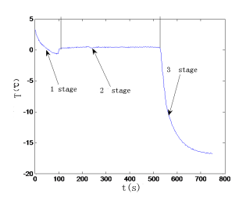

- Evaporation Rate of water at room temperature
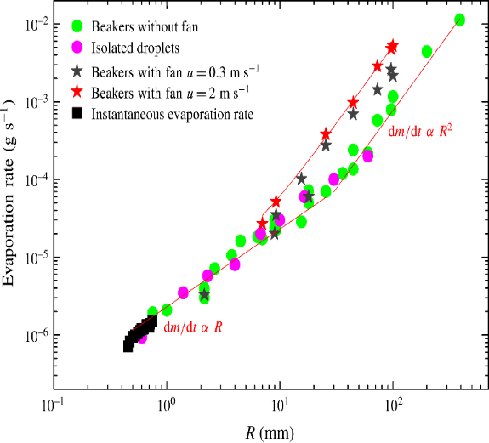

- Visual representation of the pH scale
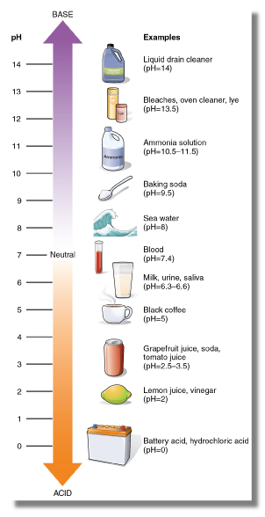

- Electrolysis of water

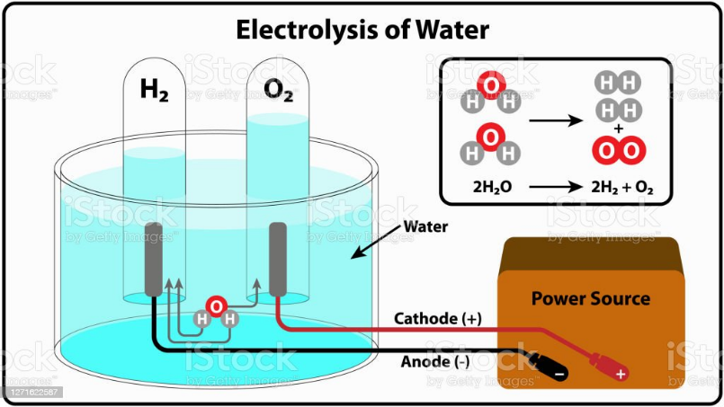

- Impact Sensitivity of CL-20, HMX & RDX before & after coating



