Qualitative Report: Beliefs and opinions relating to potential cognitive, emotional and social effects of social exclusion on older people, and how these effects might be ameliorated.

ECPS5014

AI Acknowledgement.

I acknowledge the use of Copilot on 7/04/2026 using the prompt(s):
- Step by step guide on how to write a qualitative research report
- What’s included in an abstract?
- Braun and Clarke’s step by step guide simplified

I acknowledge the use of Copilot on 11/04/2026 using the prompt(s):
- How can I use line numbers in word?
- What should be included in a literature review for a report?

I acknowledge the use of Copilot on 16/04/2026 using the prompt(s):
- How many themes and subthemes is average for a report for level 6 in university?
- Is a table of themes included in the word count for a research report?
- Should you use line numbers when quoting participants in results section of report?

I acknowledge the use of Copilot on 20/04/2026 using the prompt(s):
- List every section of a research report
- Do I use references in my discussion section?
- Do I need references anywhere else apart from in my Lit review section?

I acknowledge the use of Copilot on 23/04/2026 using the prompt(s):
- Put my References in alphabetical order – APA 7th format
- How do I label my appendices for my report?
- Do I need to add strengths and limitations in my report?
- Where do I add this?

I confirm that I have not presented any AI generated text as my own work. I confirm I
have copies of my drafts, notes, and other resources I used before, and after the use of
AI tools which I may be asked to provide in evidence.
Abstract
Older autistic adults are at increased risk of social exclusion, yet their experiences remain underrepresented in research, particularly in relation to ageing. This qualitative study explored how undergraduate students perceive the risk of social exclusion for older people with autism spectrum disorder (ASD) and how they believe negative effects might be improved. The literature review examined existing research on autism, social exclusion, and ageing, highlighting specific vulnerabilities faced by autistic individuals across the lifespan and justifying the research focus. Semi-structured interviews were conducted with two undergraduate students, using a scenario-based stimulus to support discussion. The qualitative data was analysed using reflexive thematic analysis. Two themes were interpreted: Reliance on Ongoing Support and Acceptance is Understanding. The findings suggest that students perceive older autistic adults as particularly vulnerable to social exclusion due to reliance on support, difficulties navigating social environments, and barriers to seeking help. Participants also identified increased understanding, education, and reduced stigma as key factors in improving social inclusion. The discussion places these findings within the existing literature, considers the strengths and limitations of the study, and highlights the importance of societal change alongside ongoing support in addressing social exclusion for older autistic adults.
Literature Review
Autism Spectrum Disorder (ASD) is a lifelong neurodevelopmental condition that affects how individuals communicate, interact socially, and experience the world. It is commonly associated with differences in social communication and interaction, alongside patterns of repetitive behaviour, interests, or routines (American Psychiatric Association, 2022). Research into autism has historically focused on childhood, which has limited understanding of how autistic people experience later life (Howlin & Moss, 2012; Viner et al., 2024). Increasingly, evidence shows that autism continues into adulthood and older age, and that social challenges often accumulate over time. One of the most frequently reported difficulties is social exclusion, which has been associated with poorer mental health, reduced quality of life, and increased vulnerability, particularly in later life (Roestorf et al., 2022).
Social exclusion is a multidimensional process involving restricted participation in social, economic, cultural, or political life (Levitas et al., 2007). It is closely related to, but distinct from, social isolation and loneliness. Social isolation refers to the objective absence of social contact, whereas loneliness reflects the subjective experience of emotional disconnection (Valtorta & Hanratty, 2012). Research indicates that autistic individuals are at heightened risk of all three experiences due to differences in social communication, difficulties navigating neurotypical expectations, and persistent stigma surrounding autism (Howlin & Moss, 2012).
Compared to neurotypical individuals, autistic people are more likely to experience negative social outcomes in education, employment, and community life. Differences in communication style and social reciprocity can contribute to misunderstanding, marginalisation, and exclusion in social and professional settings. Empirical research consistently shows that autistic adults report lower social connectedness and higher levels of loneliness than non-autistic adults (Stewart et al., 2024; Howlin & Moss, 2012). These experiences are often reinforced by social environments that prioritise neurotypical ways of interacting, increasing the likelihood that autistic people feel excluded or misunderstood.
Stigma and social pressure further contribute to exclusion. Many autistic adults engage in social camouflaging, which involves masking autistic traits to fit social norms. While camouflaging may reduce visible difference in some situations, research has consistently linked it to increased anxiety, emotional exhaustion, and poorer mental wellbeing (Hull et al., 2017; Cook et al., 2021; Seçer et al., 2025). These findings suggest that autistic individuals are often required to adapt to environments that remain insufficiently inclusive.
Older autistic adults may be particularly vulnerable to social exclusion due to the combined effects of ageing and lifelong disadvantage. Although social networks tend to reduce with age in the general population, this decline is more pronounced for autistic individuals. Stewart et al. (2024) found that autistic adults aged forty and above reported significantly greater isolation and loneliness than non-autistic adults, with loneliness increasing with age, only within the autistic group. Many older autistic adults were diagnosed in later life or remain undiagnosed, limiting access to autism appropriate support services throughout adulthood (Howlin & Moss, 2012; Ward et al., 2026).
Age related life transitions may further intensify exclusion. Retirement, bereavement, declining physical health, and reduced community participation can restrict opportunities for social engagement, particularly when support systems are not adapted to autistic needs. Longitudinal research suggests that anxiety and depression often persist into older adulthood for autistic individuals and are strongly associated with reduced quality of life (Roestorf et al., 2022). Stringfellow et al. (2024) highlighted a lack of research focusing on social connectedness in ageing autistic populations.
Social exclusion has been linked to increased loneliness, mental health difficulties, and social withdrawal. Experiences of rejection may be particularly distressing for autistic adults, who often report heightened sensitivity to perceived exclusion or criticism. Over time, repeated experiences of rejection can contribute to anxiety, depression, and disengagement from social life (Hull et al., 2017; van Asselt et al., 2026). These cumulative effects emphasise the importance of understanding social exclusion in older autistic adults.
Despite growing empirical evidence, public understanding of autism in later life remains limited. Undergraduate students represent future professionals and decision makers whose attitudes may shape inclusive practices. Exploring how undergraduate students perceive the risk of social exclusion for older autistic adults, and how they believe negative effects might be reduced, offers valuable insight into societal awareness and potential areas for future intervention.
Research question:
How do undergraduate students perceive the risk of social exclusion on older people with autism, and how do they think negative effects might be improved?
Method
This study used a qualitative research design to explore undergraduate students’ perceptions of social exclusion in older adults with autism spectrum disorder and their views on how negative effects might be improved. A qualitative approach was appropriate as the study focused on exploring participants’ views and understandings rather than measuring variables.
Design
Data were collected using semi-structured interviews, enabling participants to express their views in their own words while ensuring coverage of key areas relevant to the research question. A brief scenario describing an older autistic man named Alan was used to provide context (see Appendix F). The interview questions (see Appendix E) encouraged participants to move beyond the scenario and reflect more generally on the cognitive, emotional, and social experiences of older autistic adults, linking their responses to broader issues discussed in the literature.
Data was analysed using reflexive thematic analysis in line with Braun and Clarke’s (2021) approach, enabling flexible and systematic interpretation of meaning while recognising the active role of the researcher. Notes were made on the transcription sheets (see appendix H & I).
Participants
Participants were recruited using convenience sampling from the university population. All participants were provided with an information sheet prior to participation and a debrief sheet following the interview. Written informed consent and demographic information were obtained. Anonymity was ensured, and participants were informed of their right to withdraw at any point before leaving the interview setting.
Two undergraduate students studying psychology related degree programmes took part in the study. One participant (P1) was aged 35 and identified as female, and the other participant (P2) was aged 44 and identified as male.
Materials
Materials included an ethics form (see Appendix A), information sheet (see Appendix B), consent form (see Appendix C), demographic form (see Appendix D), interview schedule with questions (see Appendix E), scenario Alan (see Appendix F), and debrief form (see Appendix G). The interview schedule consisted of open-ended questions designed to explore perceptions of social exclusion, emotional and cognitive impact, and potential ways to reduce negative effects. The scenario was read aloud at the start of each interview and used as a reference point where relevant.
Procedure
Ethical approval was obtained in line with module requirements. Participants were provided with an information sheet and given time to ask questions before giving informed consent and completing the demographic form. Each interview was conducted individually in a quiet lab room on campus and lasted approximately 20-30 minutes. With participants’ permission, interviews were audio recorded to allow for accurate transcription. Following the interview, participants were debriefed and reminded of their right to withdraw and of the anonymity of their data.
Data Analysis
Interviews were transcribed verbatim and analysed using reflexive thematic analysis. The researcher familiarised themselves with the data through repeated reading of the transcripts, followed by initial coding of meaningful segments relevant to the research question. Codes were then reviewed and grouped into themes based on shared meaning. Themes were analysed, interpreted and finalised by the researcher. A table of themes, subthemes, and supporting quotations is presented in the results section below and for a complete table of all themes see Appendix J.
Results
Table of themes (Complete Table in Appendix J):
Key: Participant 1 (P1). Participant 2 (P2).
Theme 1 | Subthemes | Quotes
Reliance on Ongoing Support  Reliance on Ongoing Support  Reliance on Ongoing  Support  Reliance on Ongoing  Support  Reliance on Ongoing  Support | Difficulty Navigating Everyday Social Situations | “because maybe we know how to deal with the situation better than someone with autism.”  (P1, L84-85)
 | Difficulty Navigating Everyday Social Situations | “From a home that he, you know, not street wise.”  (P1, L106-107)
 | Difficulty Navigating Everyday Social Situations | “why would I put my head on the chopping block, so to speak, when actually I'm just going to be laughed at or teased”  (P2, L256-257)
 | Support as a Critical Resource for Inclusion | “He would maybe understand social norms a bit more.”  (P1, L105)
 | Support as a Critical Resource for Inclusion | “It doesn't always have to be a group for people with autism. Sometimes you may want to join a group just because you're interested in the subject, you shouldn't kind of be stopped doing that because you feel like you wouldn't fit in”  (P2, L277-280)
 | Support as a Critical Resource for Inclusion | “maybe if he had earlier like intervention maybe know social, social norms so you know how to maybe socialize more.”  (P1, L108-109)
 | Dependence on Family | “back in the day, there was no kind of care for people. It was just mum and dad looked after you.”  (P2, L107-108)
 | Dependence on Family | “he's kind of losing the social aspect of things by his dad not being able to drive. And I think that can make you vulnerable”  (P2, L110-111)
 | Dependence on Family | “And as they get older, and obviously, I think Alan's dad is getting older as well, so potentially he's going to be on his own”  (P1, L53-54)
 | Barriers to Seeking Help  Barriers to Seeking Help  Barriers to Seeking Help | “I think if they've been isolated for so long, they probably, like, don't know how to socialize or, you know, and lacking in confidence again and might have a bit of anxiety with it then.  And it can lead to other things like panic attacks”  (P1, L140-142)
“it would really affect your confidence because it's kind of like, well, actually, what do I do? How do I approach it? What's a good thing to say to someone to start a conversation.”
(P2, L257-259)
“if you are always excluded from something, in the back of your mind, you're going to be thinking, well, what's the point in me trying to make new friends?”
(P2, L250-252)
“Maybe they're on their own and they don't know how to reach out to someone.”
(P1, L63-64)

Theme 2 | Subthemes | Quotes
Acceptance is Understanding  Acceptance is Understanding  Acceptance is Understanding | Early interventions  Early Interventions | “if people are made aware of the differences at an early age, they're much more likely to be able to have a conversation with someone who's got ASD”  (P2, L143-145)
 | Early interventions  Early Interventions | “I think by introducing that at school level in particular, it hopefully will make like a generation of people that aren't quite so narrow-minded.”  (P2, L136-137)
 | Early interventions  Early Interventions | “because people have more awareness and more, like, say more empathy and will understand it more.”  (P1, L71-72)
 | Early interventions  Early Interventions | “I think in years to come, you know, hopefully people with autism will have grown up in this generation and the conversations have been started. But yes, sadly, we can't do anything for the people who are currently older adults, but we can start the building work for future generations.”  (P2, L176-179)
 | Reducing Stigma through Awareness  Reducing Stigma through Awareness | “And, you know, there won't be so much stigma around it then.”  (P1, L76-77)
“they used to think people were special or, you know, additional needs. They don't necessarily see the disorder, they just see someone who isn't ‘normal’ by society standards”
(P2, L95-96)
“You know, don't make those judgments before you've even met someone, because just because they've got it doesn't mean that they're not capable.”
(P2, L300-301)
“I think and saying that maybe like social media is like a good like influence on it as well, you know, like I think in getting rid of that stigma now as well.”
(P1, L171-172)

The qualitative analysis explored undergraduate students’ perceptions of the risk of social exclusion for older adults with autism and how negative effects might be improved. Participants are referred to as Participant 1, age 35 (P1) and Participant 2, age 44 (P2). Using reflexive thematic analysis, four themes were interpreted from the data. However, due to the word count restrictions of this report, only two of these four themes will be discussed in detail. These themes were selected because they directly addressed both aspects of the research question by illustrating perceived vulnerability and potential improvements. The two themes were titled Reliance on Ongoing Support and Acceptance Is Understanding.
Theme 1: Reliance on Ongoing Support
This theme reflects participants shared understanding that older autistic adults are particularly vulnerable to social exclusion due to ongoing reliance on external support. Participants described how difficulties navigating social interactions, dependence on family members, and challenges in seeking help contribute to increased isolation, particularly as individuals age and support networks diminish.
Subtheme 1.1: Difficulty Navigating Everyday Social Situations
Participants described older autistic adults as struggling to manage everyday social interactions due to difficulties understanding social norms and anticipating social responses. These challenges were perceived as increasing anxiety and discouraging social engagement. One participant suggested that autistic individuals may struggle because “maybe we know how to deal with the situation better than someone with autism” (P1, L84-85). This reflects a perceived difference between neurotypical and autistic social understanding.
Another participant described autistic individuals as “not street wise” (P1, L106-107), suggesting limited practical social awareness. Fear of negative judgement was also linked to social withdrawal, with one participant stating that individuals may avoid interaction to prevent being “laughed at or teased” (P2, L256-257). These accounts suggest that social interaction may be experienced as risky rather than supportive.
Overall, participants appeared to suggest that difficulties navigating everyday social situations increase a fear of judgement and contributes to social withdrawal in older autistic adults.
Subtheme 1.2: Dependence on Family Support
Family members were described as a central and often essential source of emotional and practical support for older autistic adults. Participants highlighted that many individuals rely on parents throughout adulthood, which becomes increasingly problematic as parents age or become unwell. One participant reflected that “back in the day, there was no kind of care for people. It was just mum and dad looked after you” (P2, L107-108), emphasising the lack of formal support structures.
Another participant noted that losing parental support reduced opportunities for social engagement, stating that “he’s kind of losing the social aspect of things by his dad not being able to drive, and I think that can make you vulnerable” (P2, L110-111). One participant raised concerns about the risk of individuals being left “on their own” as family support gradually diminishes (P1, L53–54).
Participants therefore interpreted reliance on family support as protective earlier in life but as a significant risk factor for social exclusion in later adulthood.
Subtheme 1.3: Barriers to Seeking Help
Participants also discussed barriers to seeking help, which were perceived as exacerbating social exclusion. Long term isolation, low confidence, and anxiety were described as limiting awareness of support and willingness to ask for help. One participant suggested that individuals may be “on their own and they don’t know how to reach out to someone” (P1, L63-64).
Uncertainty was also noted around initiating contact, with one participant asking “what do I do? How do I approach it? What’s a good thing to say to someone to start a conversation?” (P2, L257-259). Repeated exclusion was described as leading to a sense of futility, with one participant reflecting that individuals may think “what’s the point in me trying to make new friends?” (P2, L250-252).
Overall, participants appeared to suggest that emotional distress and past exclusion combine to create significant barriers to seeking help, increasing vulnerability and isolation.
Theme 2: Acceptance Is Understanding
This theme captures participants’ belief that acceptance of autism is strongly linked to understanding and awareness. Participants described lack of understanding as a key contributor to social exclusion and emphasised education and awareness as important pathways to improving outcomes for autistic individuals.
Subtheme 2.1: Early Social Interventions
Participants spoke extensively about the importance of introducing autism awareness early in life to normalise difference and reduce stigma. Education was viewed as essential for fostering empathy and inclusive behaviour. One participant stated that “if people are made aware of the differences at an early age, they’re much more likely to be able to have a conversation with someone who’s got ASD” (P2, L143-145).
The importance of school-based education was also highlighted, with one participant suggesting that introducing awareness earlier could create “a generation of people that aren’t quite so narrow-minded” (P2, L136-137). Another participant suggested that earlier intervention could support autistic individuals in adulthood by helping them “understand social norms a bit more” (P1, L105).
Although participants acknowledged that current older adults may not benefit from early interventions, they viewed education as essential for improving long term outcomes and preventing future exclusion.
Subtheme 2.2: Reducing Stigma Through Awareness
Stigma was consistently described as a barrier to inclusion, particularly for older autistic adults who grew up during a period of limited understanding. One participant reflected that autistic individuals were often viewed as “not normal by society standards” (P2, L95-96), which was perceived to have long lasting effects on confidence and self-esteem.
Participants emphasised the importance of withholding judgement, with one stating “don’t make those judgments before you’ve even met someone, because just because they’ve got it doesn’t mean that they’re not capable” (P2, L300-301). Increased awareness was viewed as a way to reduce stigma, with another participant suggesting that improved understanding would mean “there won’t be so much stigma around it then” (P1, L76-77). When discussing ways in which stigma may be reduced, one participant highlighted social media and online spaces as a progressive tool for “getting rid of that stigma now as well” (P1, L171–172).
Overall, participants appeared to suggest that increased understanding leads to greater acceptance, which may reduce social exclusion and improve social experiences for autistic and older individuals.
Discussion
This study explored how undergraduate students perceive the risk of social exclusion for older people with autism and how they believe negative effects might be improved. Two themes addressed these aims, suggesting that students view social exclusion as shaped by reliance on support and limited societal understanding, alongside the importance of education and acceptance. Social exclusion was understood as a cumulative process unfolding across the lifespan rather than a discrete outcome in later adulthood (Bronfenbrenner, 1979; Elder, 1998).
Reliance on Ongoing Support highlights perceptions that older autistic adults are vulnerable due to difficulties navigating social situations and reliance on family or external support. While often viewed as protective, participants recognised that reliance becomes increasingly problematic as individuals age and support networks diminish. This aligns with research identifying heightened isolation and loneliness among autistic adults in later life (Stewart et al., 2024). Interpreted ecologically, vulnerability appears shaped by changing support environments, including family ageing, reduced community engagement, and limited access to appropriate services (Bronfenbrenner, 1979).
Participants’ emphasis on support may also reflect broader societal assumptions about autism and dependency. As this study examined undergraduate perceptions rather than lived experience, these views may be influenced by medicalised or problem-focused understandings that prioritise protection over autonomy (Milton, 2012). This contrasts with research highlighting autonomy, identity, and self-determination as central to autistic adults’ wellbeing across the lifespan (Pellicano et al., 2018; Viner et al., 2024). The findings therefore highlight a tension between public perceptions of vulnerability and autistic adults’ priorities in later life.
Barriers to seeking help were also perceived as reinforcing exclusion. Participants described how repeated rejection, anxiety, and low confidence may discourage engagement, creating a cycle of withdrawal. This aligns with research linking social exclusion to psychological distress and social disengagement, indicating that exclusion operates through interconnected psychological and social processes rather than a simple absence of opportunity (Hull et al., 2017).
Acceptance Is Understanding captured beliefs that exclusion might be reduced through increased awareness and education. Lack of understanding and stigma were identified as central contributors, while education was viewed as key to fostering empathy and inclusion. This supports theoretical accounts framing social difficulties in autism as arising from mismatches in mutual understanding rather than individual deficits (Milton, 2012). Together, the findings position social exclusion as both a structural and attitudinal issue.
Conclusion
The findings suggest that students recognise vulnerability arising from reliance on support and reduced social understanding. Social exclusion was understood as a developmental process shaped by cumulative social experiences, evolving support needs, and environmental influences.
Participants emphasised the role of increased understanding, awareness, and acceptance in reducing exclusion and supporting inclusive social environments. This aligns with developmental and ecological theories emphasising the role of social environments in shaping wellbeing across adulthood. At the same time, the prominence of support highlights a tension between protective approaches and recognising autonomy in later life. Future research incorporating the lived experiences of older autistic adults would strengthen developmentally informed approaches to inclusion across the autistic lifespan.

References
Braun, V., & Clarke, V. (2021). Thematic analysis: A practical guide. Sage.
Bronfenbrenner, U. (1979). The Ecology of Human Development: Experiments by Nature and Design. Harvard University Press. https://doi.org/10.2307/j.ctv26071r6
Elder, G. H. (1998). The Life Course as Developmental Theory. Child Development, 69(1), 1–12. https://doi.org/10.2307/1132065
Howlin, P., & Moss, P. (2012). Adults with Autism Spectrum Disorders. Canadian Journal of Psychiatry, 57(5), 275–283. https://doi.org/10.1177/070674371205700502
Hull, L., Petrides, K. V., Allison, C., Smith, P., Baron-Cohen, S., Lai, M.C., & Mandy, W. (2017). “Putting on my best normal”: Social camouflaging in adults with autism spectrum conditions. Journal of Autism and Developmental Disorders, 47, 2519–2534. https://doi.org/10.1007/s10803-017-3166-5
Milton, D. E. M. (2012). On the ontological status of autism: the “double empathy problem.” Disability & Society, 27(6), 883–887. https://doi.org/10.1080/09687599.2012.710008
Pellicano, E., Dinsmore, A., & Charman, T. (2014). What should autism research focus upon? Community views and priorities from the United Kingdom. Autism, 18(7), 756–770. https://doi.org/10.1177/1362361314529627
Roestorf, A., Howlin, P., & Bowler, D. M. (2022). Ageing and autism: A longitudinal follow-up study of mental health and quality of life in autistic adults. Frontiers in Psychology, 13, 741213. https://doi.org/10.3389/fpsyg.2022.741213
Viner, H. E., Yuill, N., Costa, A. P., Radford, H., & Kornadt, A. E. (2024). A qualitative interview study on quality of life and ageing experiences of autistic adults. Communications Psychology, 2(1), Article 99. https://doi.org/10.1038/s44271-024-00142-0
Ward, N., Randle-Phillips, C., & Aldridge, R. (2026). Autistic adults’ experiences of a later life diagnosis. Journal of Autism and Developmental Disorders. https://doi.org/10.1007/s10803-026-07232-4

Appendices

Contents:
Appendix A: Ethics Approval form
Appendix B: Information sheet
Appendix C: Consent form
Appendix D: Demographic form
Appendix E: Interview schedule (with questions)
Appendix F: Scenario (Alan)
Appendix G: Debrief sheet
Appendix H: Transcript 1 (Annotated)
Appendix I: Transcript 2 (Annotated)
Appendix J: Complete Table of themes

Appendix A
Ethics Approval form:
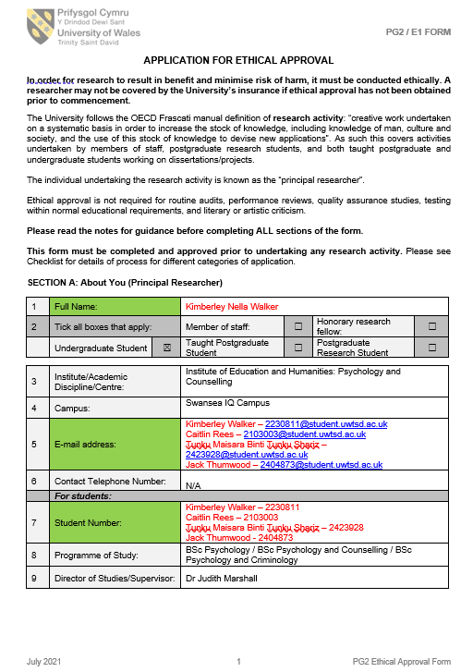
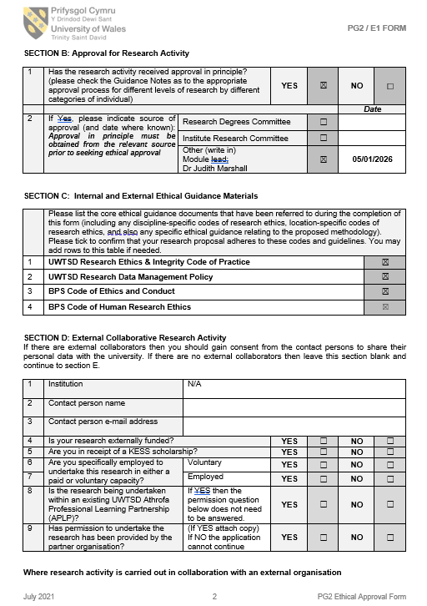
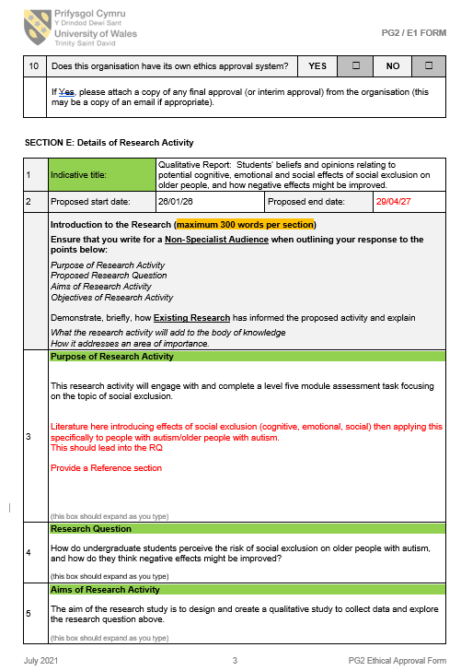
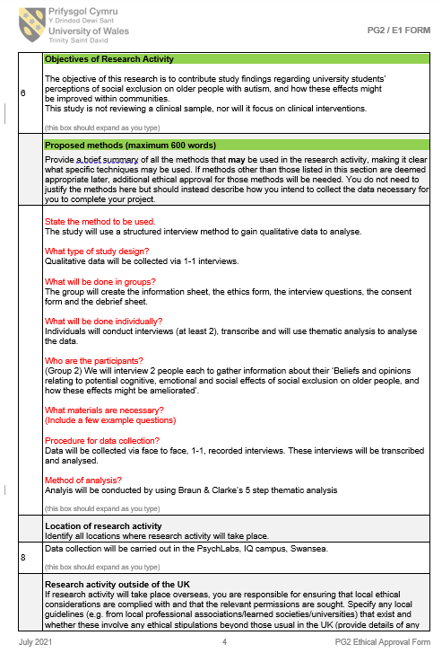
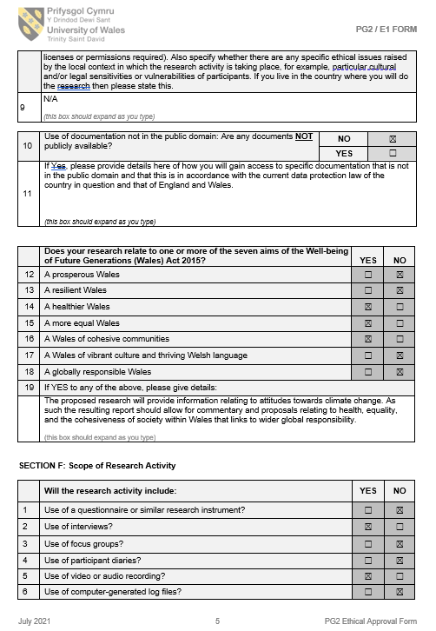
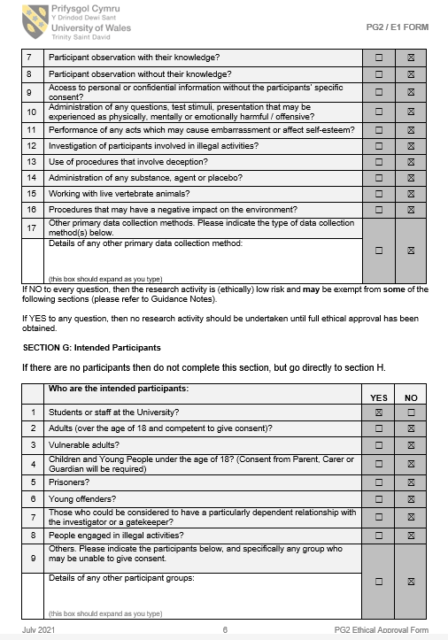
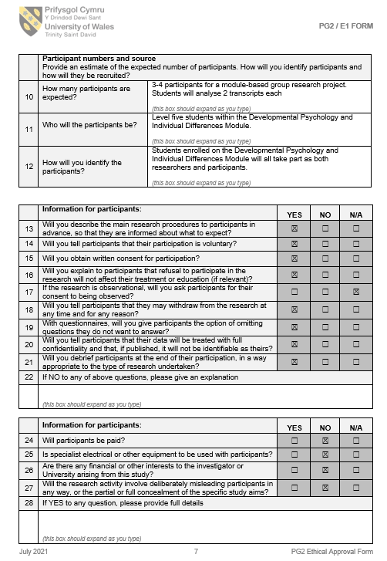
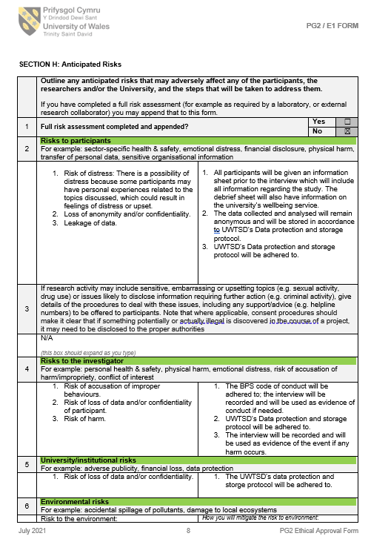
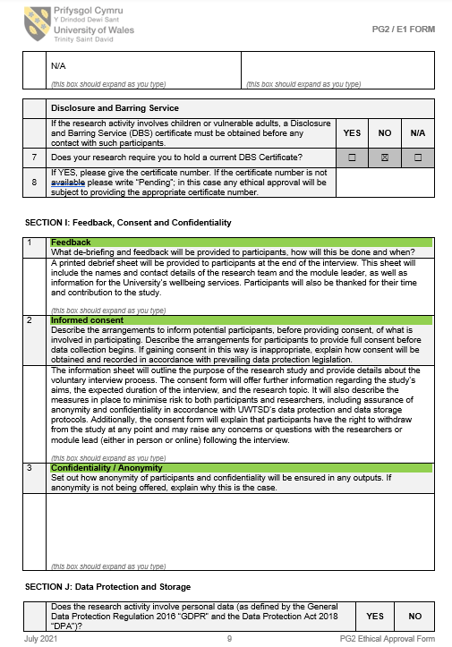
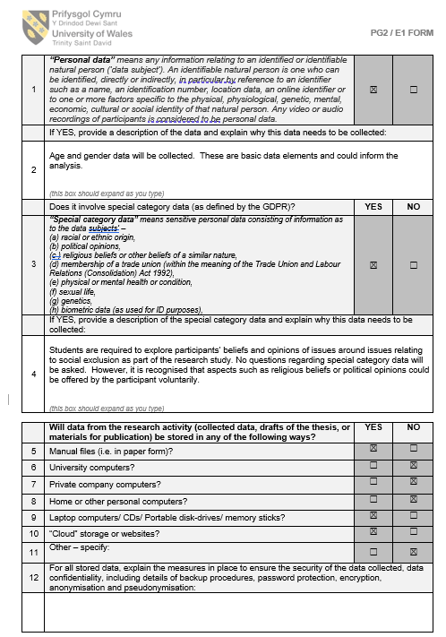
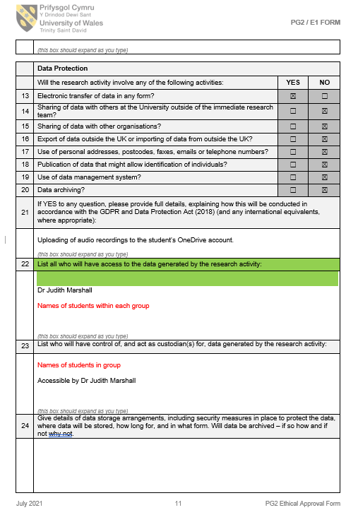
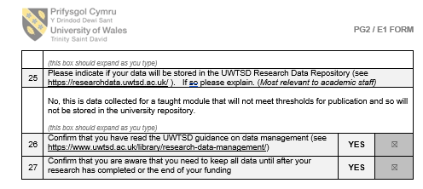
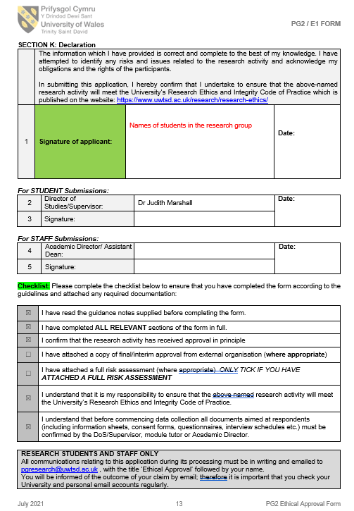
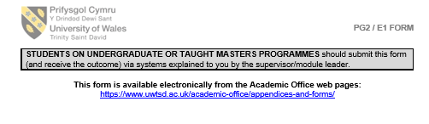
Appendix B
Information Sheet:
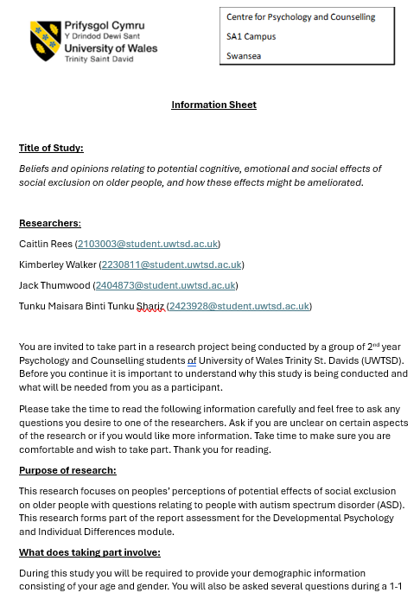
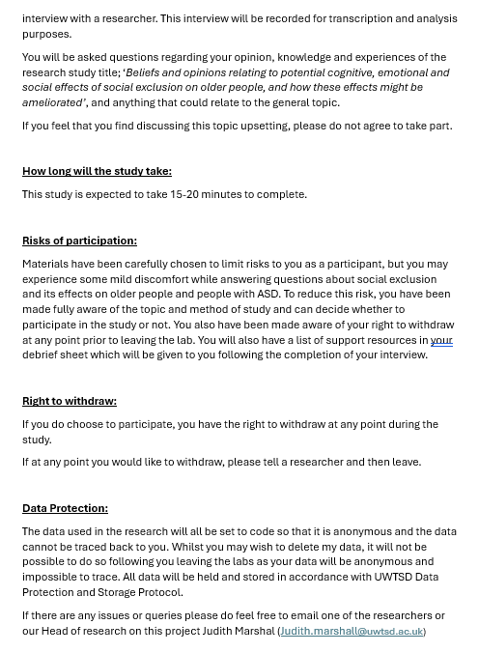

Appendix C
Consent form:
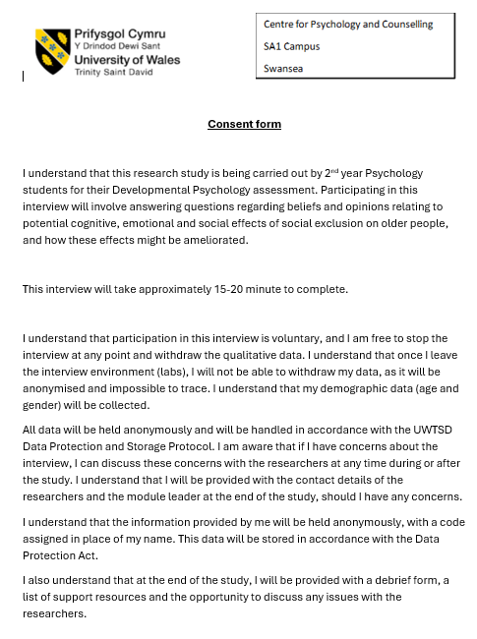

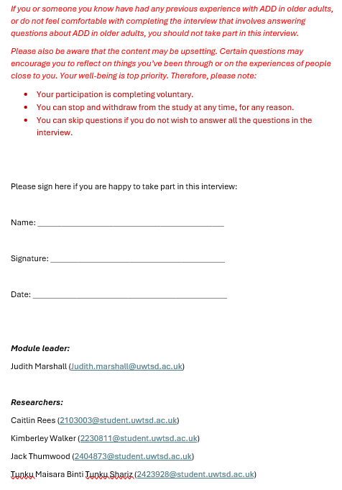
Appendix D
Demographic sheet:
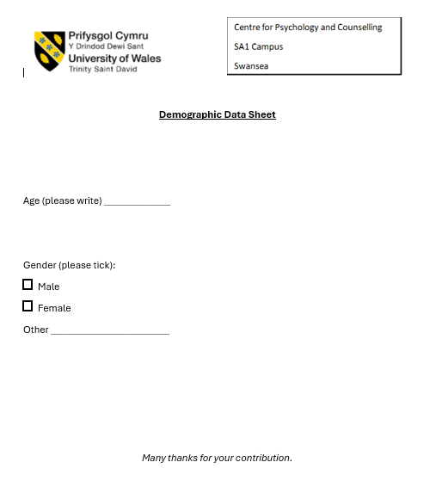

Appendix E
Interview sheet:
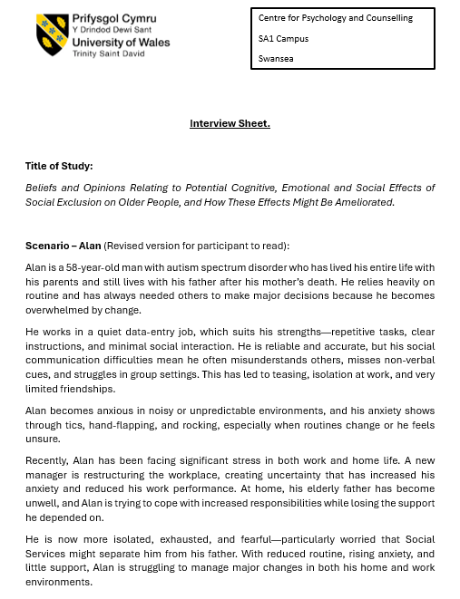

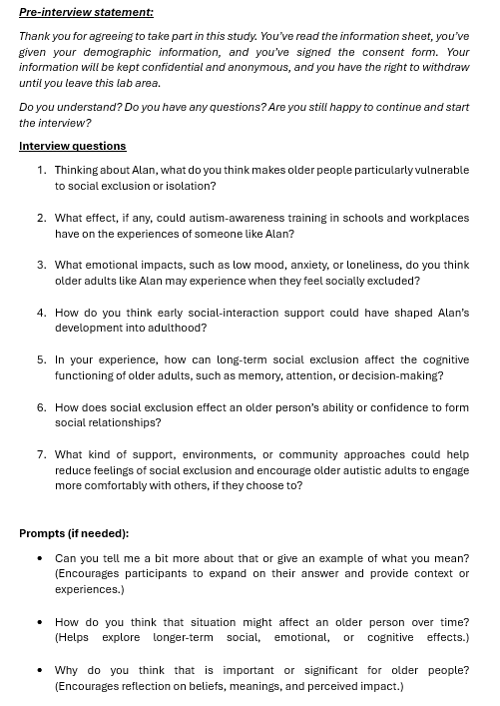
Appendix F
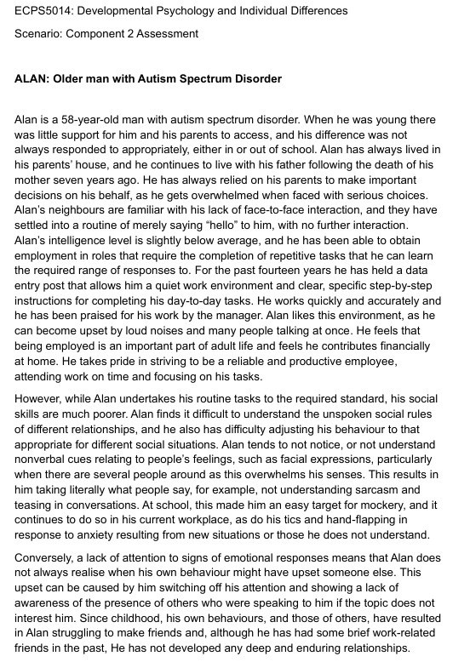
Scenario:
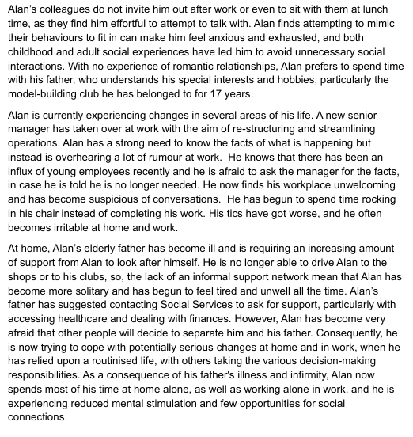

Appendix G
Debrief sheet:
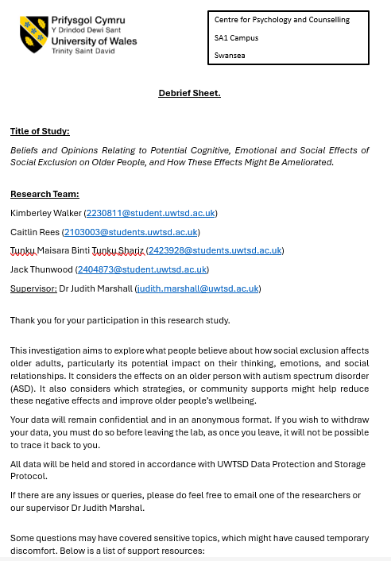
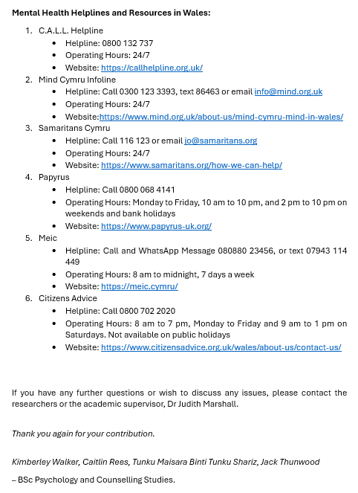

Appendix H
Transcript 1 (Participant 1):
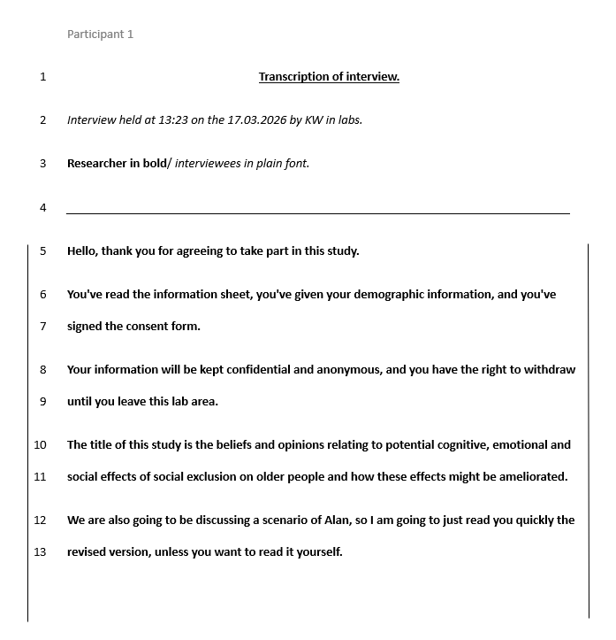
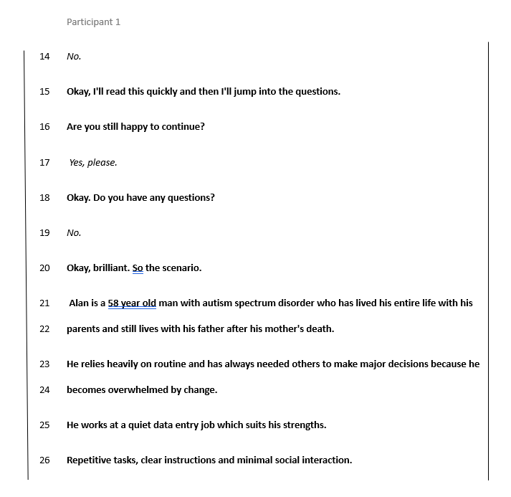
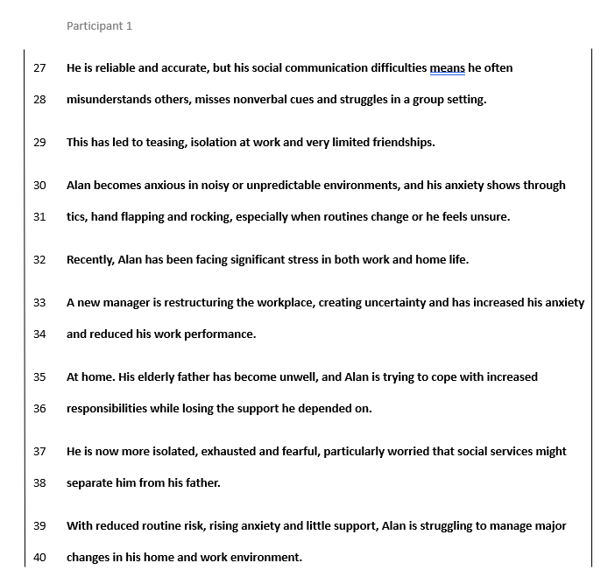
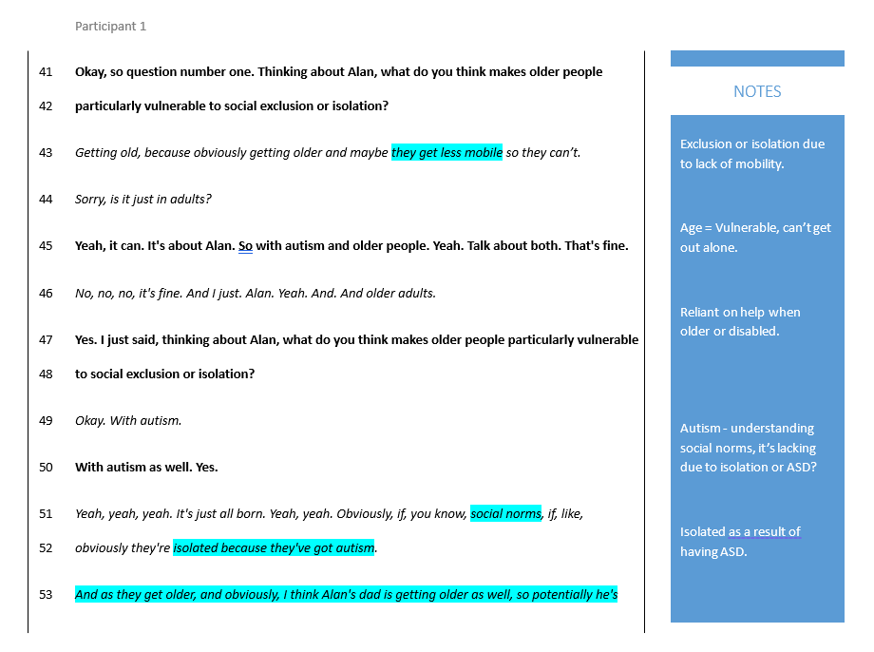
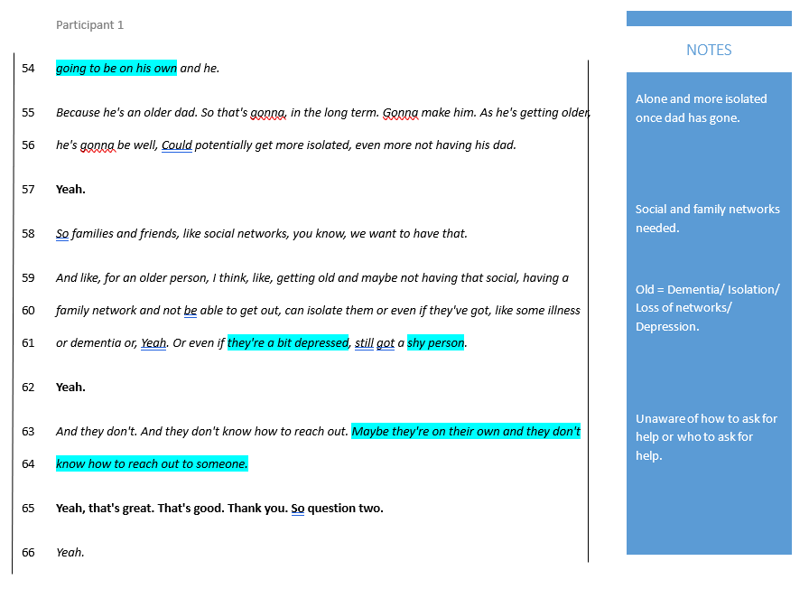
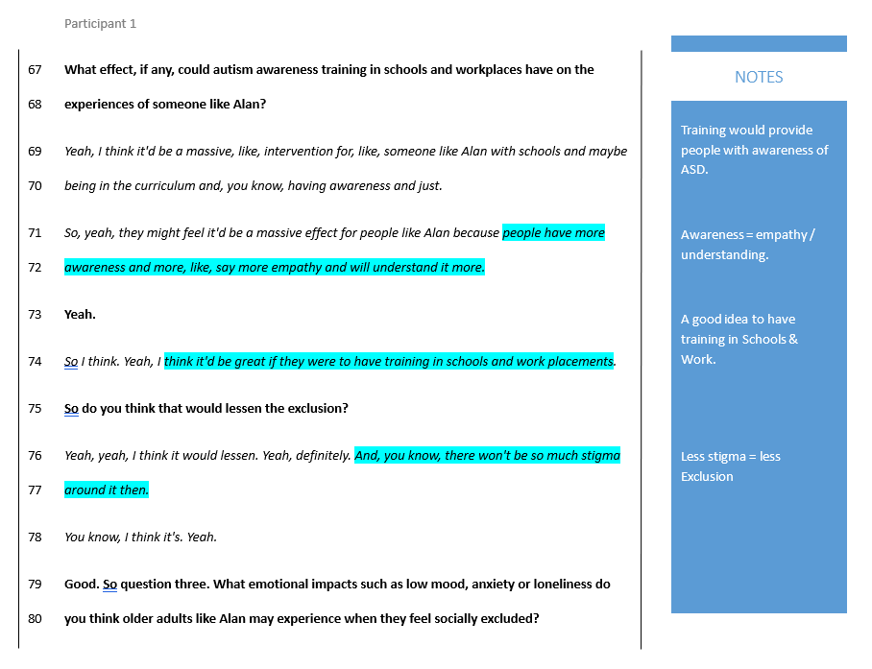
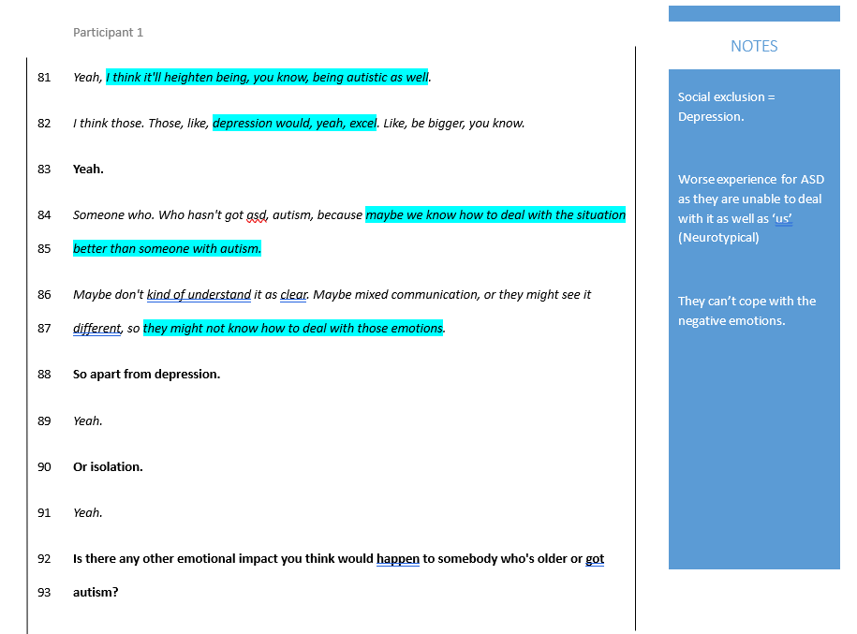
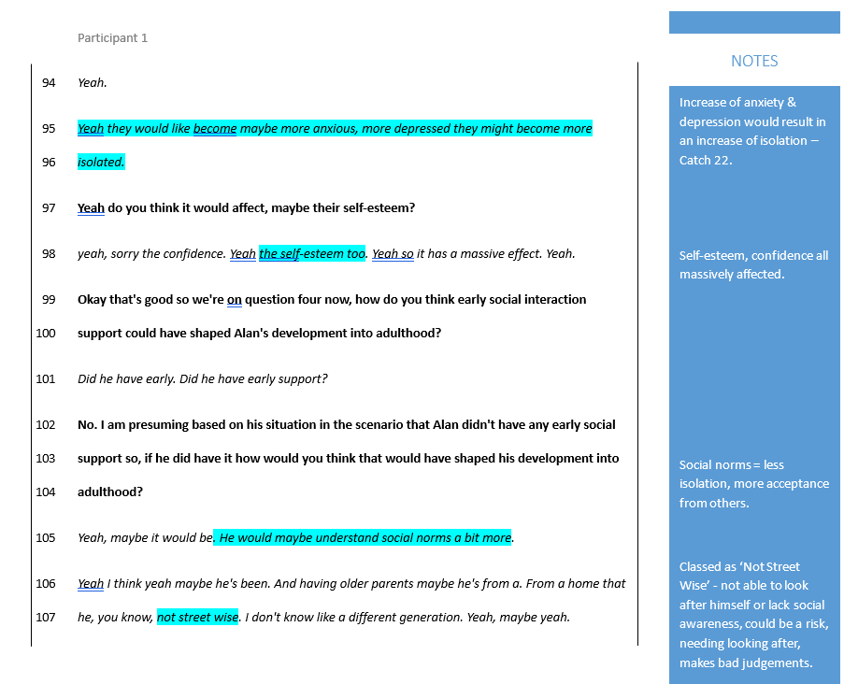
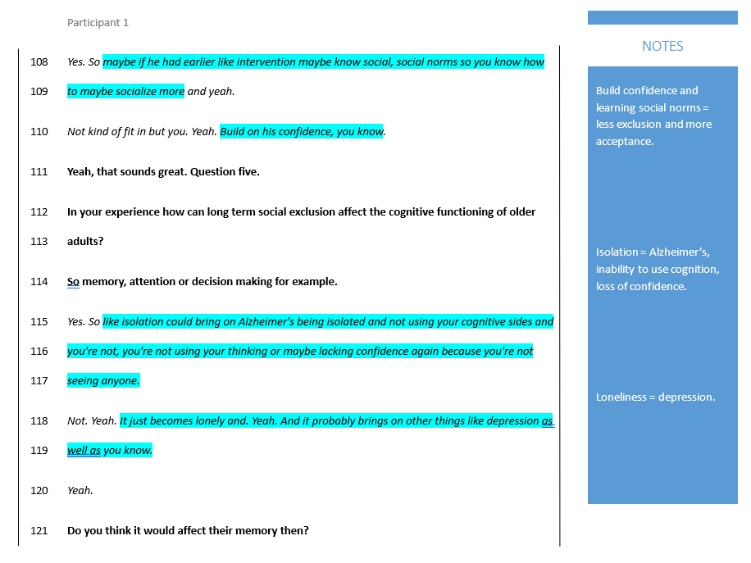
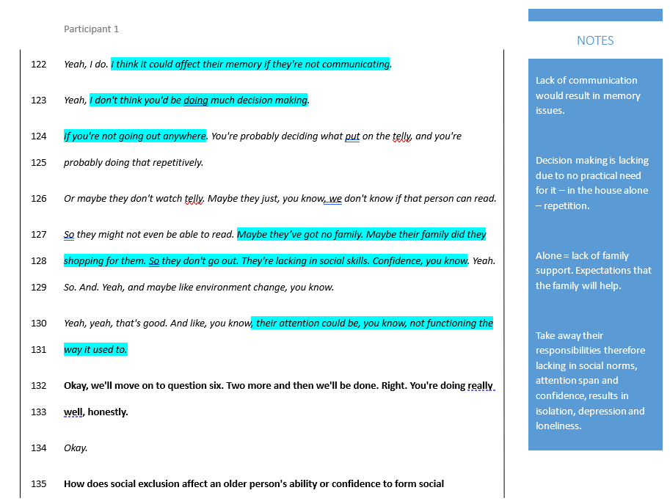
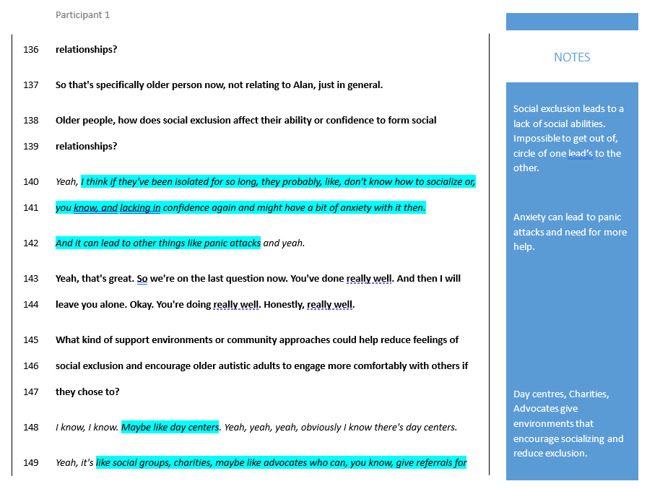
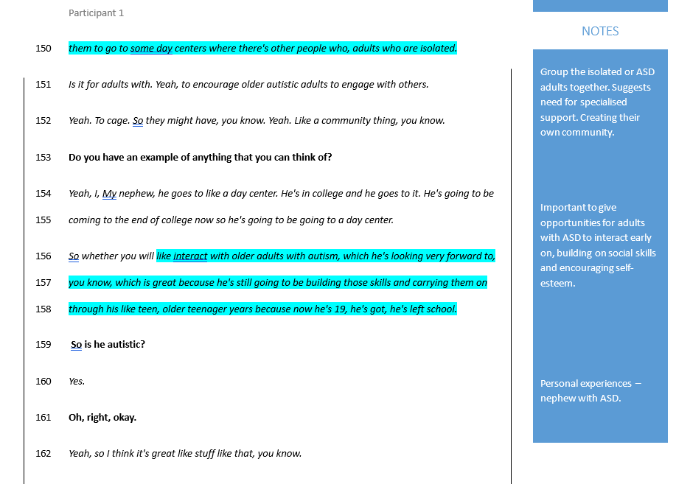
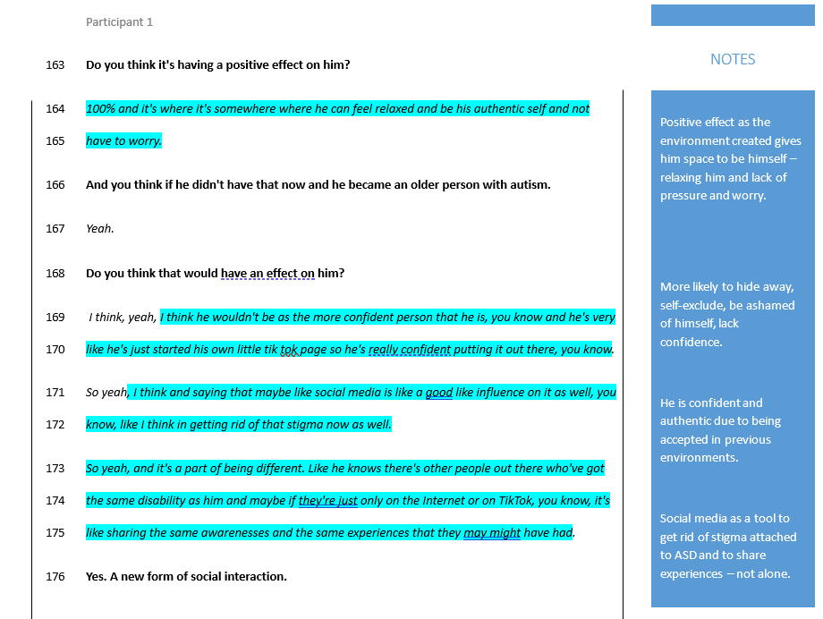
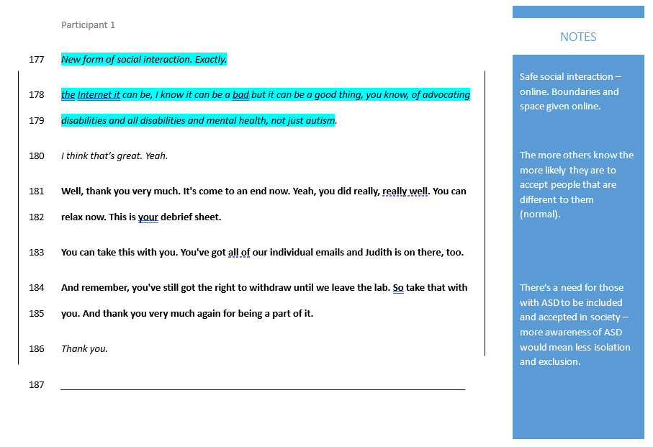

Appendix I
Transcript 2 (Participant 2):
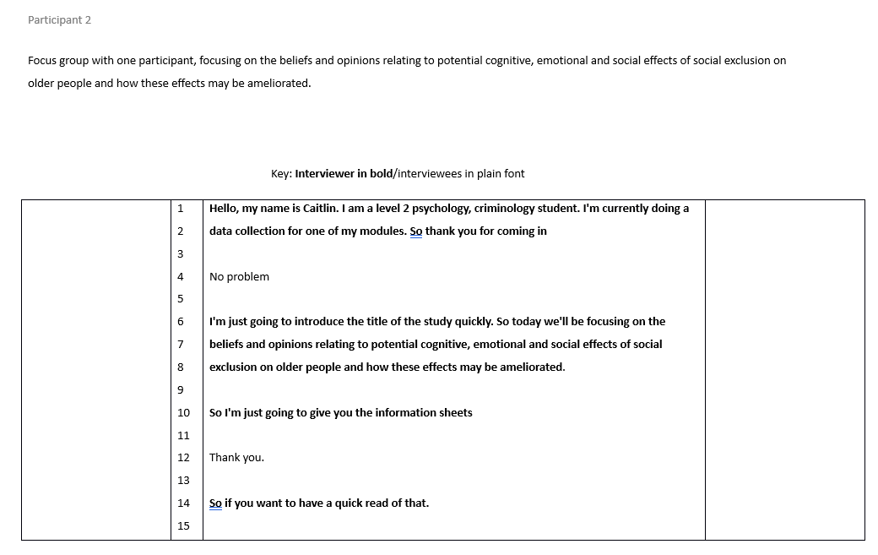
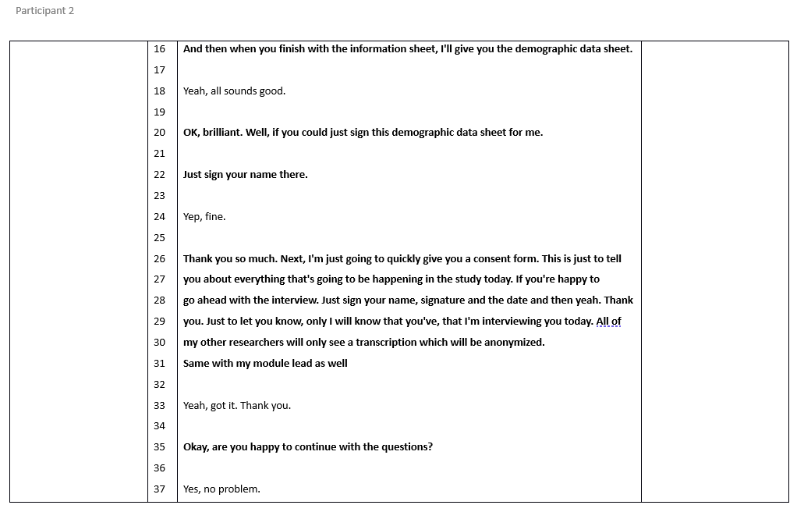
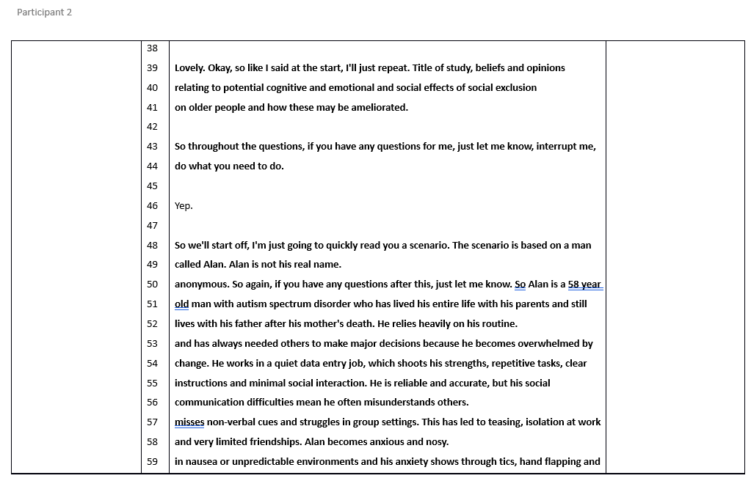
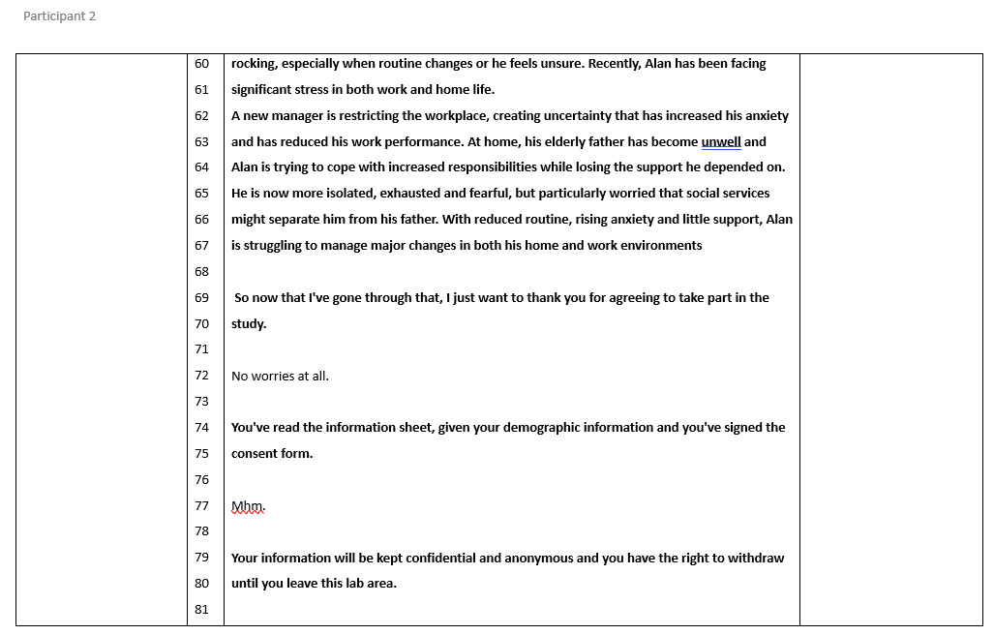
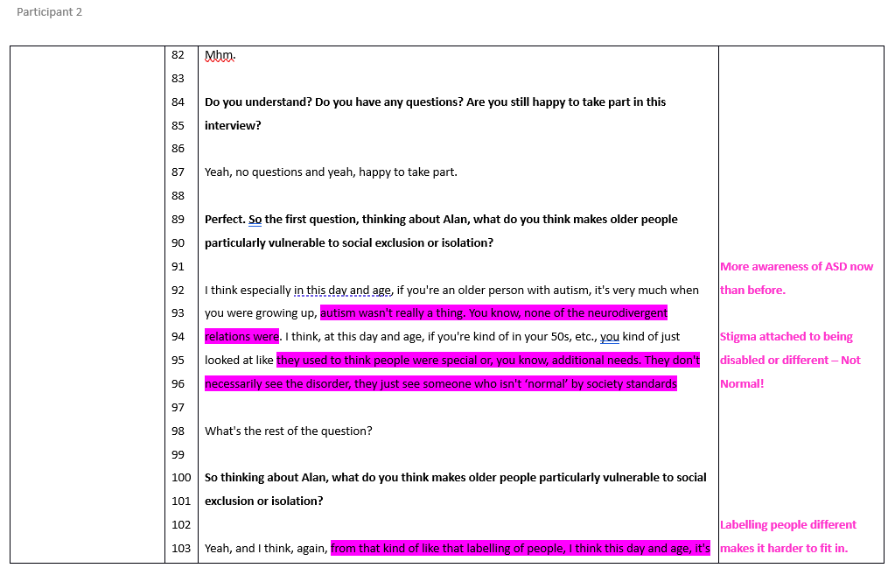
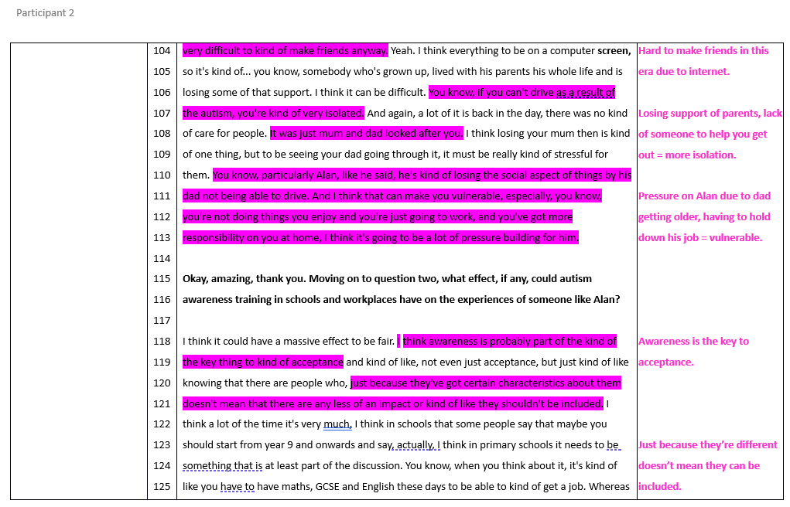
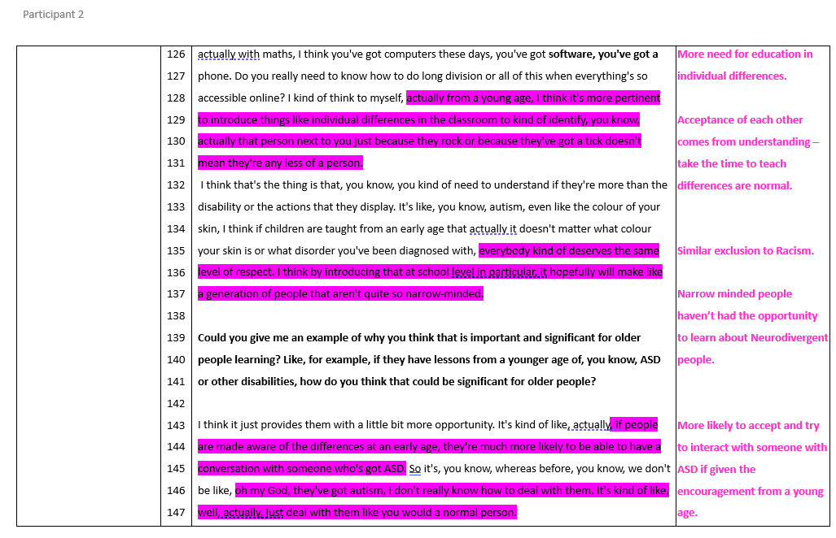
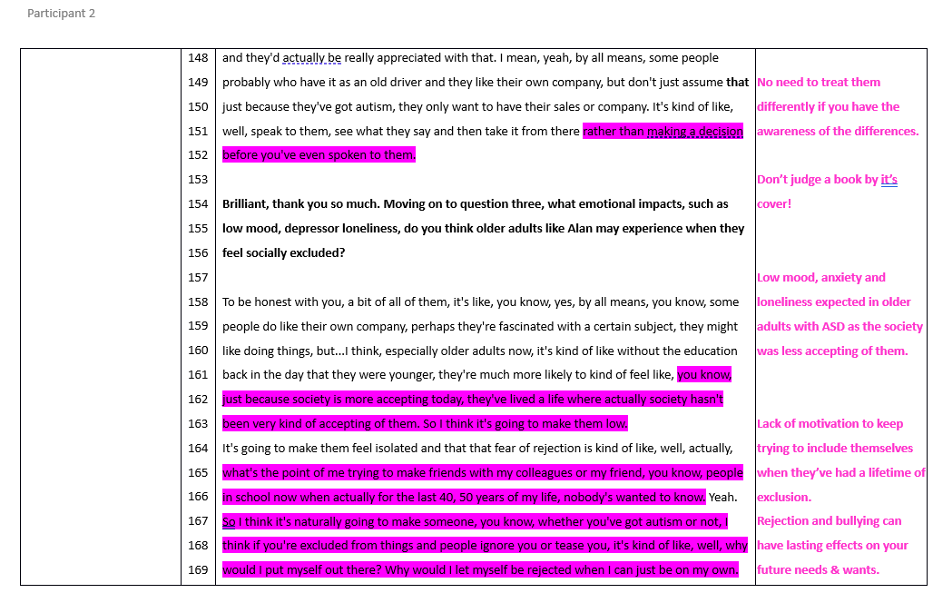
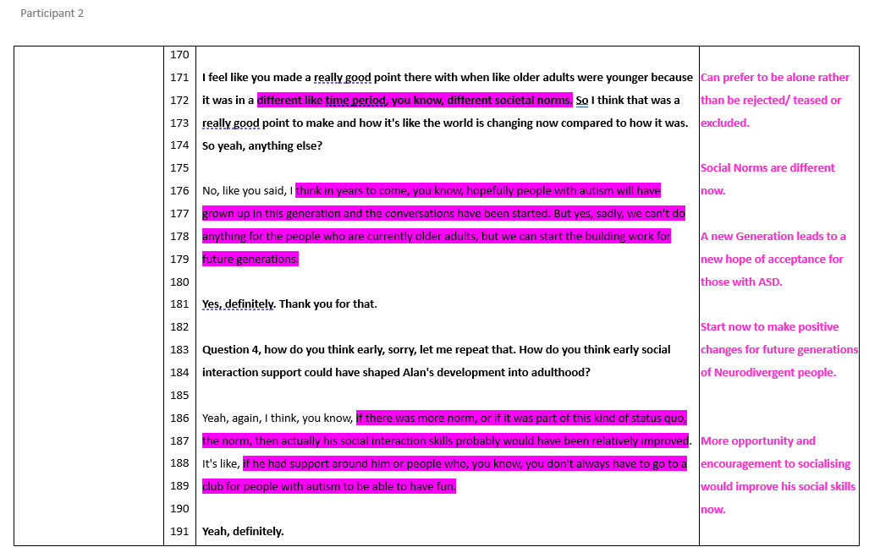
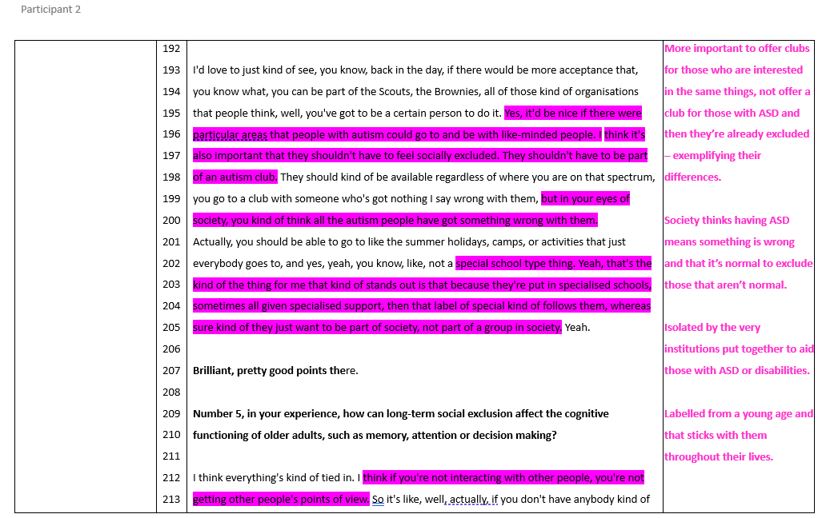
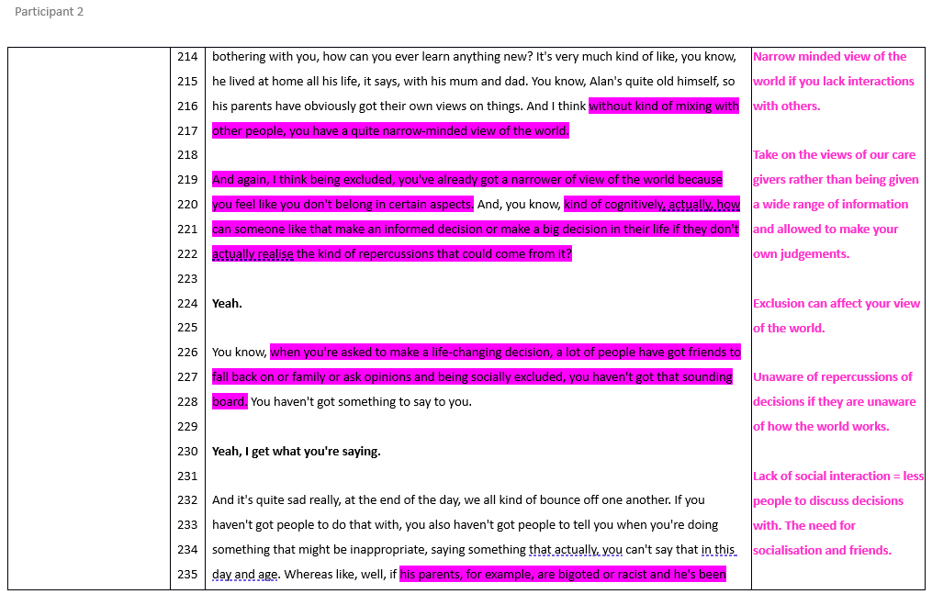
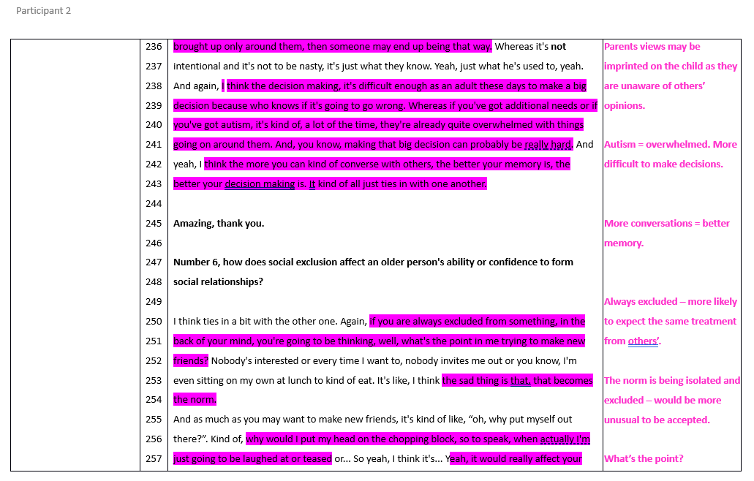
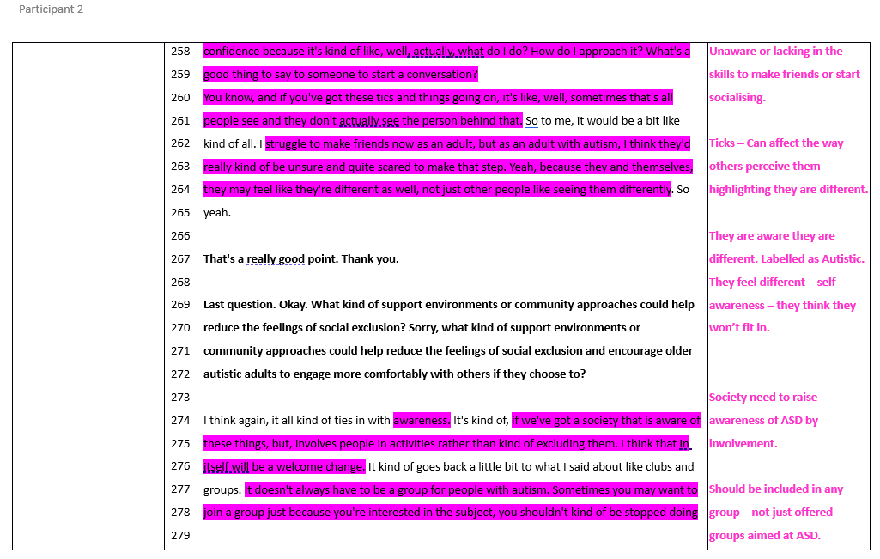
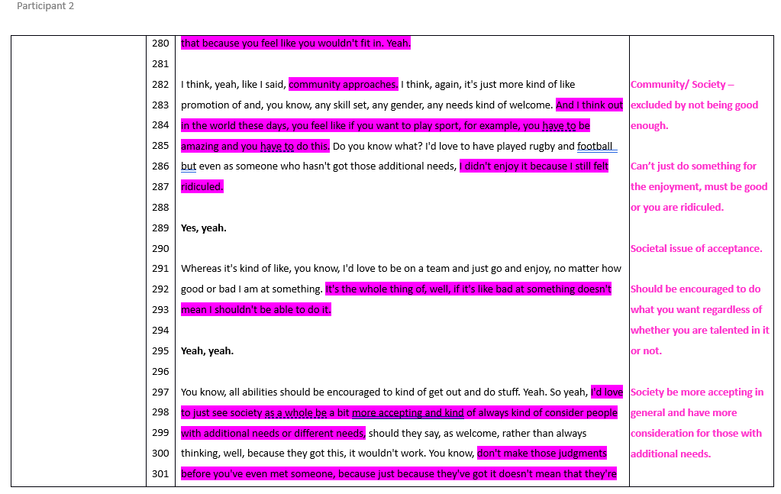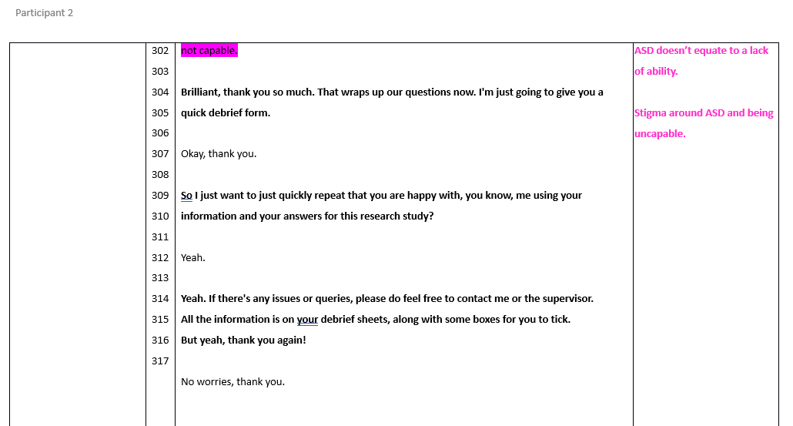

Appendix J
Complete Table of Themes:
Key:
Theme - Reliance on ongoing support | Subthemes for ROOS | Quotes from Transcript 1 | Quotes from Transcript 2
Theme - A rock and a hard place | Subthemes for ARAAHP | Quotes from Transcript 1 | Quotes from Transcript 2
Theme - Acceptance is understanding | Subthemes for AIU | Quotes from Transcript 1 | Quotes from Transcript 2
Theme - Long-Term Consequences | Subthemes for LTC | Quotes from Transcript 1 | Quotes from Transcript 2


