Additional Learning Needs Post Graduate Certificate

Independent Study
ECEU7003

Can SLCN interventions have a positive impact on reducing
adolescent SEBD risk factors?

Student Number: 0500217

Speech, language and communication (SLC), both spoken and visual, is one of the most important skills humans possess, and has been at the core of what we do for over two million years. SLC is infinite in style, content and meaning. SLC ‘tools’ require a highly complex set of skills related to reasoning and abstract thinking. Civilization developed through efficient exchange and transmission of knowledge, skills and experiences, across generations. Few understand the science behind language; it is one of the most complicated things our brain does. For most, SLC is as automatic as breathing, but, children and adolescents with SLC Needs (SLCN) are at a major disadvantage compared to their peers. They live, learn and socialise in a world where the major medium used is their major difficulty. SLCN impact on multiple areas of learning, thinking, attainment, communication, socialisation, relationships and behaviour (Fig 1).
Historically, research has been concerned with the cause, effect and outcomes of SLCN and Social, Emotional and Behavioural Difficulties (SEBD), not the relationship until McCarthy (1954) who suggested the ‘link’ between personality traits and language difficulties. In 1960, Trapp and Evan noted the ‘correlation’. The 1970’s saw a transitional stage in the study of communication disorders with the Quirk Report (1972), Bullock Report (1975), and Warnock Report (1978), and more recently, the Bercow Report (2008). The 1980’s saw a re-emphasis on the ‘co-occurrence’; 50 – 90% of children with communication difficulties are likely to develop SEBD and psychiatric difficulties, 60 – 95% of children with SEBD are likely to have communication difficulties (Baker and Cantwell, 1987; Camarta, Hughes and Rhul; 1988, Cohen et al, 1993).
Multiple studies exist that investigate and document the ‘comorbidity’ between SLCN and SEBD and vice versa. Debates centre around the cause, effect, direction of relationships,
1
links to other ALN, awareness, understanding and training (Armstrong and Nettleton, 2004; Baker and Cantwell, 1985; Beichman et al, 1996; Brenner et al 2002, Cohen et al 1998, Cross 1997; Davies et al, 1988; Donahue, 1983, 1994; Frith, 1989; Gallagher, 1999; Prizant et al., 1990; Quinn et al, 1999; Rutter and Lord 1987; Rutter and Mawood, 1991; Scott, 1993; Toppelberg and Shapiro, 2000). The Education Select Committee on Behaviour and Discipline in Schools (2011) made powerful recommendations around the links between SLCN and SEBD. Ofstead, hold communication skills in a strong position in inspection frameworks, and The Primary National Curriculum Expert Panel (2011) believe in SLC becoming a strong feature of the National Curriculum.
Recently focus has turned to diagnosis and treatment (See-Ed.co.uk). However, there is little up to date literature that examines the effects of SLCN interventions on SEBD adolescents. For professional development reasons I will question whether SLCN interventions can have a positive impact on reducing adolescent SEBD risk factors such as labelling, exclusion and youth offending.
SLC
Adolescents in 2020 live in a technological world rich in information and communication. Unfortunately, this places increased demands on social acceptance, interaction and prospects, during a time of hormonal and developmental surge, when the brain is becoming ‘hardwired’. The ‘illusionary recovery’ of SLCN and SEBD in children may re-materialize in adolescence due to increased pressures and demands. The consensus is, comorbidity is not straightforward, but might become more complex and hidden during adolescents (Conti-Ramsden and Durkin 2008; Stringer and Clegg, 2006). Notably, SLCN and SEBD are risk factors for adolescents becoming NEET’s. (ICAN – 2010).
2
SLC is a complex chain of processes which can be summarised into three stages; production – transmission – reception, or, neurological – physiological – anatomical (Fig 2). The Communication Chain enables SLC professionals to recognise fundamental factors, or broken links, needed for classification and relationships of disorders (Fig 3).
SLCN is the most prevalent childhood disability (Pearson, 2014), which impacts on the ability to think and learn, literacy (Beitchman et al., 1996; Botting et al., 1998; Dockrell and Lindsay, 1998; Snowling, 2005; Stothard et al., 1998), organisational skills, social and emotional development, self-esteem (Coopersmith, 1967; Brinton and Fujiki, 1996; Harter, 1999) and behaviour (Dockrell et al., 1997). SLCN is an ‘invisible’ need that can have some profound effects on emotional wellbeing which manifest in behavioural deficiencies (Brown and Edwards, 1989; Lindsay and Dockrell, 2000). Beveridge and Conti-Ramsden (1987) documented the failure to master the basic underpinnings of language in early childhood, results in limited expressive language, withdrawal, non-participation and attention difficulties.
Adolescents have difficulties with literacy, expression, understanding and recognising their own or other’s feelings/emotions leading to misinterpretation, frustration and unwanted behaviours. Their responses to the social and educational environment can range from withdrawal, low self-esteem, disaffection, work-avoidance, truanting, disruptiveness, difficulties following rules, and accepting boundaries (Cohen et al, 1992; Prizant et al, 1990). These could be considered ‘normal’ adolescent traits, but are exacerbated by the lack of developed ‘inner speech’, needed for the regulation of social and emotional language demands, which can manifest as, the inability to self-regulate unwanted behaviours (Major, G. 2019). The British Psychological Society (2005) study of expressive and receptive
3
difficulties of adolescent boys, supports the need for early identification and intervention, as it concluded excluded boys had significantly poorer skills in both areas, including non-verbal IQ, memory and emotional problems.
Secondly, speech is a conduit for self-expression; understanding this and the patterns of development is vital for teaching. In the 1970’s Browns study of SLCN adolescents noted behavioural difficulties ‘stemmed from their disordered and confused speech’ (Byers and Brown, p85, 1971).
“The earlier that all children develop confidence in their speech, along with an extensive vocabulary, the more likely it is that they will be able to improve their overall competence in reading and writing.” (Ofsted, 2012).
Thirdly, language is about rules for talking and understanding and is made of morphological, semantic, syntactic, narrative and discourse elements. It enables instruction, exploration, evaluation, imagination, negotiation, prediction, in a verbal and symbolic way. Language is a complex and connected range of receptive and expressive processes, knowledge and awareness. Difficulties can lead to delinquent, challenging withdrawn and anxious behaviours due to misinterpretation or inability to express.
There are many theories of language. Chomsky (1957, 1959, 1965, 1969) discussed language acquisition being related to experience; input equals output. Piaget (1926) viewed language as reflecting thought. He has been criticised for underestimating the importance of language in cognitive development, but, recognised, for his theories of early language acquisition and development ending before puberty. Elliott (1994), viewed language is data rather than development. Vygotsky (1978) saw thought and language as having separate roots which when combined were needed for self-regulation.
4
Finally, communication is a key concept; it is the fundamental and foundational vehicle that underpins and enables our ability to think, learn, understand, and be understood. Communication is at the heart of social interaction and participation, the key to relationship building, personal development, educational achievement and life choices (Institute for Education - Communication Trust). Competent communication enables one to initiate and maintain conversations, read non-verbal cues, tell when someone is suggesting, offering an opinion or, passing a comment. They understand how utterances can be used to extend and decline invitation, how to dissuade others from a certain course of action, and how to forge friendships and interrelationships.
“Language is the means of getting an idea from my brain into yours without surgery.”
(Mark Amidon).
The Brain
It is imperative to acknowledge the brain due to the wealth of research identifying extensive brain growth, SLC acquisition and development throughout adolescents (Locke and Bogin, 2006; Nippold, 2007; Reed, 2005). The brain is an information, understanding and transmission processing device and permits the development of behavioural frameworks. There are several areas of the brain that play a crucial role in SLC and SEB.
In 1861, Brocca identified the left hemisphere as central for speech production, articulation and logical thinking. In 1871, Wernicke identified the posterior superior temporal lobe as playing a primary role in comprehension and language processing. The right hemisphere enables humans to go beyond literal meanings and damage has implications for language, behaviour and personality as comprehension of non-literal language, humour, intentions, expressive language and prosody processing are affected (Cheang and Pell, 2006;
5
Myers, 1979; Papagno et al., 2006). In the 1960’s Gerschwind found the parietal cortex to be connected through nerves to Brocca’s and Wernickes areas and discovered the brain reacts to images in the same way as it does to hearing words, which suggests the brain is organised for language, not speech. Notably, Gerschwind’s territory is the last to mature in children.
Compromised language centres (Brocca’s/Wernickes’ aphasia), results in impaired extralinguistic communication. Areas affected are, implicature processing (Kasher et al., 1999), comprehension of metaphor (Mancopes and Shultz, 2008), proverb interpretation (Chapman et al., 1997) and extralinguistic communication (Cutica et al., 2006; Dronkers et al., 1998). Importantly, any language breakdown or deficit in brain processing can affect aspects of personality and behaviour (Crystal, 1990).
Attachment
Firstly, it is unclear exactly how information is formed and stored by the brain, and how many levels of storage there are. Secondly, SLC does not develop in a vacuum, and the act of thinking and communicating, which cannot be separated, involves language. Thirdly, early stimulation, attachment and experiences from care givers stimulate gene response and shape the brain. Through stability and socialisation, infants learn to communicate, express and interact. In time this ‘inner voice’ enables them to regulate their emotions and behaviours.
Some discuss the relationship between SLCN and SEBD is a question of nature or, nurture. Van Ijzendoorn, et al (1995) suggested a strong causal influence of the quality of attachment on language and cognition. Cutting and Dunn (1999) believe family background and relationships are a significant variable for the development of social cognition. Notably, Denham, Cook and Zoller (1992) and Dunn, Bretherton and Munn (1987) found children’s
6
social cognition of emotions appear to be related to their mothers’ use of emotion language. Finally, Cook, Greenberg and Kusche (1994) found that the ability to conceptualise the inner world helps with regulation of emotional states and choice of behaviours. Kaler and Kopp’s (1990) investigated non-compliance or, non-comprehension. They found children who had developed secure relationships through quality interactions understood and, were compliant to 77% of requests and, 22% demonstrated non-comprehensive and non-compliant behaviours. A secure infant develops a strong theory of mind, empathy, executive thinking and early language. An insecure or anxious child is often avoidant and resistant therefore lacks oral language and social communication skills needed for emotional wellbeing and academic success. The development of a strong sense of inner speech, learnt through
quality attachment and interaction, helps to regulate behaviour and emotions whereas, a child with poor processing skills finds this difficult.
Therefore, I propose that open expressiveness about emotions and feelings transmitted from communicative and emotionally competent care givers can have a positive effect on the child’s ability to communicate and understand behaviours and emotions throughout their lifespan. However, literature lacks insufficient explanations about the mechanisms; studies have not taken place over a whole life span, many do not consider fathers roles, or separate genders. Therefore, further investigation is needed.
SEBD
SEBD encompasses many different problems. Baker and Cantwell (1987) see it as
“a disorder of behaviour, emotional or relationships that is sufficiently severe or prolonged, to cause disturbance in the child or disruptions of his immediate environment” (p193).
7
This definition covers five axes of clinical, developmental, personality, physical, psychosocial and global syndromes, disorder and functioning, covering maternal, sibling, sexual or academic difficulties, receptive and expressive language, reading writing, coordination and environmental factors. Finally, self-harm, harm to others, lack of personal awareness and expulsion. SEBD problems can be categorised into ‘Externalising’ and ‘Internalising’ problems; aggressiveness, anti-social behaviour, anxiety, depression. It has been documented boys are more prone to external behaviours such as ADHD and ODD, whilst girls exhibit internal depressions and anxiety (Major. G, 2019).
A survey of forty admissions to a child psychiatric facility found half had SLCN. It concluded, there is a strong comorbidity between SLCN and SEBD, central to the development of human personality (Gualtieri et al., 1983). SEBD is often an educational diagnosis. The Department for Education and Skills define SEBD behaviours as being disruptive/aggressive, hyperactivity, concentration/attention difficulties, sematic difficulties, emotional or related problems. These take the form of withdrawal, depressive/suicidal tendencies, eating disorder, school phobia, substance misuse, frustration, anger, threatened or actual violence (DfES, SEN Code of Practice, 2001). They also note the link between social and psychological factors, which lead to the use of the term, social, emotional, behavioural difficulties (SEBD).
Rinaldi (1992) studied adolescent children and found they often exhibit difficulties making friends, a lack of self-awareness and of their peers which…
“appeared to stem from inadequate language skills…they frequently did not have adequate vocabulary to express…but were able to do so in a more gross and often socially unacceptable way.” (p1 1992).
8
Similarly, Quinn et al (1999) recognised children with SEBD have difficulties with communicating their physical and emotional need. These relate to language processing, social communication, comprehension and expression that manifest as low self-esteem (Byrne, 1996; Coopersmith, 1967; Harter, 1989, 1999; Marsh, 1990), poor attention, disruptive behaviours, recklessness, difficulty negotiating and resolving conflicts, poor peer interactions (Conti-Ramsden et al., 1995), aggressive or passive behaviours, inability to see fault or blame, poor regulation and identification of emotions (Dockrell et al, 2000; Lindsay and Dockrell, 1997), lack of understanding of sarcasm, idioms, inability to recall and recount events, inability to concoct plausible excuses, verbal mediation difficulties, lack of key information, poor ‘inner speech’ and problem solving, perceived boredom, and difficulties mixing with peers. Finally, Brenner (2002) found 71% demonstrated pragmatic difficulties, whereas 64% experienced expressive difficulties and 56% demonstrated receptive. There is consensus that future research should concentrate on expressive language difficulties relating to anxiety (Aram and Hall, 1989; Toppleberg and Shapiro, 2000).
Facts and Figures
In 2019, The Department for Education (DfED) released data for schools in England. ALN pupils have increased for the third consecutive year to 1,318,300 which is 14.9% of the population. SLC was the most common need; 23% of pupils (25% of boys, 20% of girls). In Wales 103,976 (22.2%) pupils have ALN in 2019. Figures are down from 105,976 in 2018. However, 24,652 have SLCN and 25,003 have SEBD.
The Royal College for Speech and Language Therapists (RCSLT), found ALN pupils have increased by 3.3% between January 2018 to 2019. SLCN pupils has increased by 6% in the same period. In total 261,718 (3.2%) pupils have SLCN as their primary need, and 7.6%
9
of children (2 out of 30) start school with developmental language disorder (DLD). A further 2.3% of children start school with a language disorder linked to, or co-occurring with, another condition (Promoting public health document, 2019; Norbury, Courtenay et al.,2016).
The 2008 Bercow Report stated by the end of Primary school 25% of children with long term communication needs reached their expected level in English, as compared to 80% of their peers. Secondly, by the end of Key stage 4 the ‘attainment gap’ between SLC pupils and their peers is marked; 15% of SLCN pupils achieve five G.C.S.E grades as compared to 57% of their peers. The review states if language difficulties are resolved by the age of five years old, children are more likely to achieve their exam grades and a successful career (Bercow, 2008).
The 2018 review found nothing has changed. Five years olds with SLCN are four times more likely to struggle with reading by the age of eleven. Also, 15% of SLC children achieve expected levels in reading, writing and maths at the end of Primary school as compared to 61% of their peers. Finally, 20.3% of SLC adolescents gain four GCSE grades as compared to 63.9% of their peers. Clearly, impacts are long lasting. Vocabulary difficulties at the age of five are significantly associated with poor literature, mental health and employment outcomes in adulthood (Law et al., 2009). 60% of young offenders have SLC alongside 88% of long term unemployed young men. (Bryan, Freer, Furlong., 2007; Elliott, 2009).
These figures are corroborated by The Communication Trust (2014), who estimated that 10% of children have persistent SLCN and 7% have SLC as their main difficulty, compared to 3% who have SLCN as part of another ALN. In areas of poverty over 50% start

10
school with delayed communication skills, and by five years, are 19 months behind their peers. Notably, two thirds of seven to fourteen-year-old children who have serious behaviour difficulties have a language impairment (Ofstead, 2012).
Norbury et al (2016) found 7.58% or two in every thirty children, had DLD and an additional 2.34% have language disorders connected to another condition. The Bercow Review (2018) note 1.4 million children, or 10%, have long term SLCN, and 7.6% have DLD with no obvious reason for their difficulties. In 2017, The Royal College for Speech and Language Therapists (RCSLT), stated that 20% of the overall population in the UK may experience some difficulties with communication at some point in their lives.
Comorbidity.
“What we sometimes see as a failure to behave properly is actually a failure to communicate properly.” (www.notjust cute.com)
50 – 70% of children and adolescents with SLCN reported having emotional difficulties, frustration, aggression, conduct disorder and confidence. Three hundred five-year-old children were screened. When followed up at twelve and nineteen, an increase and trend of anxiety was found (Clarke. H, 2019). SLCN can impact self-esteem (Cantwell and Baker, 1987), social withdrawal (Fujiki, 2001; Howlin et al., 2000), depression and anxiety (Beichman, 2001), peer relationships (Botting and Conti-Ramsden, 2000) and victimisation (Botting, 2004). Notably, over 60% of excluded children have SLCN (Clegg et al., 2009).
81% of SEBD children have unidentified language difficulties, and are twice as likely to be unemployed also, 3% of young people referred to mental health services have unidentified SLCN (ICAN – Bercow Review, 2018). SLCN adolescents are at significant risk of offending (Brownlie et al., 2004, Snart et al., 2003). The RCSLT Justice Evidence
11
Base review (2017) found that SLCN is more prevalent in the offending community (Talbot, 2010). 20 – 90% of those in the Criminal Justice System (CJS) have SLCN (Anderson et al, 2016). 11% of Educational Tribunals are related to SLCN pupils (SEN and Disability Tribunals Report, 2005/6). A comorbidity exists between the severity of an offence and the presence of SLCN (Snow and Powell, 2012). One third of young offenders have speaking and listening skills below those required at age eleven (Davies et al, 2004); only 5% are diagnosed before entry (Bryan et al, 2007).
Notably, 88% of boys in custody have previously been excluded (Youth Justice Board, 2013) and two thirds of seven to fourteen-year olds with communication difficulties were found to have behavioural difficulties (Cohen et al, 1998). Of new entrants to the Youth Offending Services (YOS), 65% required SLCN therapy, 20% were severely delayed (Gregory et al 2009). 109 offenders in a secure training centre were screened for SLCN; 28% did not need additional support, but, 14.4% did require SLC therapy (Bryan et al, 2015). Bryan et al (2004) noted that 40% of offenders cannot access interventions, anger management, drug rehabilitation or education due to their SLCN. Lanz et al (2009) noted that they cannot ask for, or indicate that, they need clarifications or explanations, persevere at tasks or appointments so become frustrated, angry, upset and eventually give up.
As SLCN can be lifelong one must consider adults. In 2010 the Pontypridd probation service project found all the participants had ‘below average’ SLC skills (Iredale eta l, 2010). The RCSLT Review (2017) states that 80% of adult prisoners in England had SLCN, with 44% of these being women.

12

Research
The comorbidity between SLCN and SEBD is widely recognised in literature (Baker and Cantwell, 1982; Brenner et al., 2002; Cohen et al., 1998; Cross, 2011; Dockrell et al, 2000, 2010; Donahue, 1994; Donno et al., 2010; Gallagher, 1999; Harter, 1989, 1999; Hill and Coufal, 2005; Leonard, Milich and Lorch, 2011; Levy et al., 1996; Mackie and Law, 2010; Toppleberg and Shapiro, 2000). However, not in practice, (Botting and Conti Ramsden 2000; Cohen et al., 2013; Herbert 1998; Im-Bolter and Cohen, 2007; Law and Garret, 2004; Rutter et al 1970, 1976), due to high levels of underreporting (Cross 1997) or a lack of expertise in assessment, provision, resources (Law et al 2000).
Lauria, (1961) and Vygotsky (1962) believe the lack of intact language may affect social behaviour, interaction and ‘inner speech’, needed for the internalisation of social codes for the self-regulation of behaviour. Baker and Cantwell (1982) concluded those with SLCN are at risk of both psychiatric and learning disorder (P546). In 1985, added patterns of deviant parent-child interactions, and in 1987 found the rates of psychiatric disorders in SLC children increased from 44% to 60%. Beitchman et al (1986) assessed 1,655 children for SLCN. They found 11% had SLCN, of these, 48.7% presented with accompanying SEBD.
Gualtieri et al., (1983) state literature has yet to demonstrate a unidirectional causal relationship between SLCN and SEBD however, clinical experiences indicate interventions for SLCN can have a positive effect. Their findings suggest “behavioural and emotional problems may be precipitated and perpetuated by difficulties in communication.” (Prizant, 1990, p183).

13

Some argue language disorders are likely to interfere with cognitive development and are “instrumental in causing or exacerbating behavioural problems” (Chen et al, 1989 cited Prizant 1990). Others claim linguistic impairment, specifically receptive language, is a risk factor for psychopathology in general (Baker and Cantwell, 1982, Beitchman et al, 1986). There are five possible patterns in the relationship (Rutter and Lord, 1987).
- Psychiatric disability may lead to language problems, and vice versa.
- The two may be different facets of the same phenomena.
- The two may co-occur, but with different causal mechanisms.
- There may be multiple interconnected causal processes.
Stevenson (1996), believes different models will operate for different individuals and there is bound to be an interactive relationship between the two.
Significant is Isaac T Peterson’s (2013) who concluded language ability played a key role in predicting later behavioural problems more strongly than behaviour predicted language ability. These findings suggest the direction of effect may be from language to behaviour hence SLC interventions can treat and prevent unwanted behaviours. However, Baker and Cantwell note therapists are challenged by client’s behaviour due to emotional disturbances (Prizant,1990, p 291).
Law and Sivyer, (2003) investigated the communication skills of excluded and at risk Primary School children. They noted those receiving SLCN interventions made significantly more progress in social communication, emotional and behavioural difficulties. Even though frequent absenteeism, high levels of exclusions and time restrictions negatively affected results, language, narrative and semantic skills improved, with significant enhancement in self-esteem.
14
They also noted
- SLCN are not always identified when there is a strong behavioural component in their profile of needs.
- SLCN intervention should be available for all SEBD children and adolescents at risk of exclusion.
- Strong case for SLCN therapy/therapist for those who have been excluded.
- Teachers need to be more ‘mindful’ in their approach to behaviour and communication difficulties.
- Benefits to LSA’s and teachers would arise from training and collaborative working.
- Parents need to be engaged in the process of intervention.
Their future recommendations are to ensure a ‘package of care’ is available and, SEBD behaviours/ incidents should be fully investigated and recorded.
Lipsky (1985) describes ‘marginal handicaps’ related to ‘language and learning’ problems, can contribute to the perception of the child as being problematic. Similarly, Paul and James (1990), Chen and Lipsett (1997, cited Prizant 1990), Law and Garret (2004), found the parents of children with SLCN perceived their child to be temperamental, difficult, ‘delinquent’ and hard to manage. The ’invisible’ problem in producing and understanding language may manifest as noncompliance, inattentiveness and social withdrawal. Fujiki et al (1999) found children with SLCN had greater difficulty with impulse control and had less prosocial behaviours. They noted, boys with SLCN are more likely to show active withdrawal, impulsivity and aggression (P185). Conroy et al (2005) summarised seventy-three articles of SEBD and found 16% included children with SLCN. Nungesser and Watkins (2005) found 25% of participant teachers perceived SLCN contributed to SEBD.
15
They added, withdrawn behaviours were less of a concern than aggressive. Squires and Bricker (2007), stated SEB competencies need a communication system to express appropriately (p3). They were corroborated by Schneider and Goldstein (2008) who found SLCN can affect how children meet their needs, choices, social and emotional competencies.
The Journal of Emotional and Behavioural Disabilities (2002, Vol 10) review of twenty-six studies, discovered three out of four (71%), formally identified with SEBD experienced clinically significant language difficulties, and, one out of two (57%), of those diagnosed with SLCN had SEBD. The percentage levels and areas of difficulties found were, 71% pragmatic, 64% expressive and 56% were receptive. They discovered students with SEBD struggle academically with reading and language (Griffith, Rogers-Adkinson and Cusick, 1997; Hindshaw 1992; Kaiser and Hester, 1997). Other studies noted it was a primary risk for conduct and social problems, high dropout rates, unemployment and adjudication (Caspi, Wright, Moffitt and Silva, 1998; Cornwall and Bawden, 1992; Epstein et al., 1998; Kaminski and Good, 1996; Werner, 1993). Others noted, students with SLCN had persistently depressed academic achievement, felt demoralised and had psychiatric problems (Aram, Ekelman and Nation, 1984; Beitchman, Cantwell, Forness, Kavale and Kauffman, 1998; Catts, 1993; Silva, Williams and McGee, 1997; Tomblin, Zhang, Buckwalter and Catts, 2000).
The review offers four principles for comorbidity. Firstly, receptive difficulty leads to a substantially higher risk of the most delinquent and aggressive anti-social behaviours and undetected needs led to higher rates of problem behaviours (Cantwell and Baker, 1991; Cohen, 1996; Silva et al., 1987). Thirdly, the concomitant prevalence of language difficulties in children who exhibit antisocial behaviours is ten times that of the population
16
(Donahue et al., 1994; Warr Leepr, Wright and Mack., 1994). Finally, aggressive individuals used less verbal communication and more direct physical actions to solve interpersonal problems which has a lifelong effect on relationships (Baker and Cantwell, 1985; Gallagher, 1999; Redmond and Rice, 1998; Rutter and Mawhood, 1991).
This supports the theory that children who are prone to noncompliance may have
undiagnosed SLCN which, due to ‘chains’ of miscommunication, limit their ability to comprehend and comply (Fujiki et al., 1999), increase their misinterpretations and frustrations, and, develop anti-social patterns (Prizant et al., 1990; Ruhl et al., 1992).
Notably, psychopathological problems tend to increase with age (Baker and Cantwell, 1987; Stevenson, Richman and Graham, 1985), hence in adolescence as academic, language, vocabulary and social demands increase, so do frustrations. Between 50 – 80% of adolescents with SEBD have undetected SLCN (Cohen et al., 1998; Bryan et al., 2007); 37% of teaching instructions contains expression, multiple or non-literal meaning; 20% of these are idioms (National Behaviour Support Service, 2011).
There are many variables in the 2002 review including, language, time tracking, lack of diagnosis before investigating, demographics and, unequal distribution of gender and ethnicity. Also, socio economic status, unidentified ALN, school settings, access to interventions, speech clinic, treatment and psychiatric care. However, comorbidity was found which is either stable or increases over time and that future correlational, longitudinal and experimental research is needed to clarify the strength and nature of the relationship.
The RCSLT pilot study (2010) explored the interaction between behaviours and communication disorders and concluded there was a high incidence of unrecognised SLCN in SEBD participants. Out of 380 children aged between seven and fourteen years old, 40% had
17
unidentified SLCN (Cohen et al., 1993, 1998; Nelso et al., 2005; Ripley and Yuill, 2005). SEBD children were significantly more likely to have structural, word decoding and pragmatic language difficulties (Baker and Cantwell, 1987; Beitchman et al., 1996, 2001; Brownlie et al., 2004; Cont-Ramsden and Botting, 2000; Lindsay and Dockrell, 2000; Redmond and Rice, 1998). This could account for misunderstood performance being viewed as behavioural issues which can lead to exclusion (p398). The estimates of a co-existence of difficulties vary between 40% to over 90% (Brenner et al., 2002).
The review has implications for how Educational Professionals should view behaviour in schools as the factors commonly associated with SLCN play a more significant role in the incidents of SEBD than the language difficulties themselves. I concur with their conclusions that more in-depth and accurate research is needed, especially in adolescents, as unmet needs do not simply disappear with age. Variables in this review include, not investigating specific language difficulties, therefore a failure to explain why SLCN and SEBD are linked and Mackie and Law (2008/2009), whose findings were based on only seventeen children aged between seven and eleven years old.
The distinctive needs of adolescents
Caution should be exercised when seeking to characterise the social and emotional profiles of adolescent SLCN and SEBD pupils. Like their peers, they may be perceived as being more interested in socialising than achievement, and, show rebelliousness in the face of authority. However, it is possible to identify a social and emotional profile which can cautiously be applied to one’s professional understanding (Stevenson, 1990; Freedman and Wiig, 1995).

18
Understanding and coping with the physical and emotional changes which take place in adolescence, is a potential minefield of misunderstandings for even the most competent. Partially grasped concepts of social, moral, sexual issues along with drugs, contraception, abortion, racism, sexism, equal opportunities and capital punishment, can be confusing and frightening.
It is likely that there are many adolescent pupils, identified as ‘difficult’, without their language and communication needs being considered. Prizant, (1990) questions if these adolescents are placed in the wrong settings, such as classes for behaviours, when their subtle communication difficulties are overlooked (p186). Camarate et al (1988) believe SLCN assessment should become routine for adolescents who access behavioural management programmes (Prizant, 1990, p198). Notably, half of all adult mental health difficulties have their onset in adolescence (Belfer, 2008).
‘Typical’ difficulties include achievement gaps, delayed maturity, reduced tolerance of difference and pressures to conform. Some struggle with multiple teaching styles and content, vocabulary and linguistic demands, self-organisation, methods of working and formal learning (Wiig and Semel, 1984). ‘Distinctive’ difficulties such as conflicts and deterioration of friendships, escalate leading to increased stress, loneliness and mental health problems (Durkin and Conti-Ramsden, 2010; Leonard et al., 2011), and, feelings of being socially unaccepted (Im-Bolter et al., 2013).
A study of one hundred and thirty-nine SLCN adolescents found they had twelve times higher levels of emotional, behavioural and peer related problems, associated with receptive language difficulties (Conti-Ramsden, 2013). Distinctive difficulties with communication makes it difficult to relate to others (Brinton and Fujiki, 1993); difficulties
19
expressing needs, feelings and understanding messages from others can result in frustration and distress (Brinton and Fujiki, 2010). Therefore, the profile for adolescents with SLCN is being at greater risk of developing low self-worth and increased SEBD (Dunkin and Conti-Ramsden, 2010; Lindsay and Dockrell, 2000).
Freedman and Wiig (1995) studied the teaching of adolescents with SLCN; areas of difficulties included acquisition of vocabulary, expressive and figurative language, abstract reasoning, inference, implications, memory and pragmatic function were found. More significant were their social and emotional development and reactions to their environment. Responses ranged from withdrawal, low self-esteem and confidence, boredom, disaffection, work-avoidance, difficulties following instructions and rules, and, accepting boundaries. One might consider these ‘normal’ adolescent behaviours, however it is a key profile for those who have ALN (Fig 4). Conti-Ramsden (2013) concluded for some SLCN adolescents, having poor social functioning is a strength. SLCN males were eighteen times more likely to report poor social functioning than females. 87% of the whole group, had no awareness of their inabilities, and were found to gravitate to similar others to form ‘gangs’ of badly behaved teenagers; viewing themselves as popular.
The RCSLT (2017) and DfED (2016) calculated SEBD children and adolescents are more likely to be excluded than the population as a whole; 1% are permanently excluded, 17% have one or more fixed period exclusions compared to 0.08% and 2.11% of their peers (DfED, 2016). A meta-analysis of 22 studies discovered 81% of SEBD excluded pupils had unidentified SLCN (Hollo et al, 2014). The RCSLT Exclusions Review (2017) of twenty-six studies, noted a link. 71% of identified SEBD pupils have language difficulties, similarly, 57% of diagnosed SLCN were identified with SEBD (Norbury and Boodle, 2016).
20
Clegg, (2004) found, for a high proportion of ‘at risk’ of exclusion pupils, SLCN was a factor in their behavioural problems; two thirds were found to have SLCN after assessment. Ripley and Yuill (2005), noted 100% of the excluded boys they studied had undetected communication needs and behavioural issues.
The RCSLT Independent Commission (2017), found 90% of pupils placed in an alternative setting in London, have unidentified communication needs. A similar setting in Sheffield noted between 2014 and 2018, of the seventy-five pupils who were assessed for SLCN, 63% identified as positive (Meltzer, 2002). Notably, both identified contributing factors to behaviour included lack of quality stimulation, neglect, maltreatment, sexual abuse, trauma, domestic violence, perinatal mental health, social deprivation, ethnicity which all influence SLC acquisition and child development. They concluded there is a clear comorbidity between exclusion and communication needs.
Considering this comorbidity, is there any reason to resort to full exclusion? All children have a right to education, but the figures suggest, if schools are unable to manage pupils social and emotional distress the resulting behaviours are leading to unwanted exclusions.
The Government and House of Lords published the ‘Mental Health and Behaviour in Schools’ (2018), which demonstrated a high comorbidity between SEBD and SLCN which led to exclusions. There was a prevalence of undiagnosed needs which impacted on adolescent’s life choices. The Rt Hon Robert Halfon MP, felt it was scandalous that education was failing pupils and lead to them being forgotten; exclusion should be a last resort. ALN Reform and the SEND (2014) code of practice notes there is a duty of care to support these pupils.
21
In 2019, The Wales Online reported in 2016/17 academic year, 129 adolescents were permanently excluded and 2,930 temporarily. In 2017/18, 7,905 pupils in England were permanently excluded which is 42 every day, and, 410,000 had fixed term exclusions which is a 52% rise since 2013/14. A staggering 83% of all permanent exclusions in England were ALN children, 1,250 of these were under eleven years of age. These figures have increased for the first time in six years. Reasons were physical assaults, verbal abuse and persistent disruptive behaviours. They note, there appears to be a ‘vicious circle’ whereby when an adolescent is expelled, they become bored, stressed and on returning to school, the behaviour continues, so they develop a ‘label. The hope is ALN Reforms in Wales will help to ensure the issues relating to exclusions are identified and dealt with earlier.
SLCN or SEBD excluded pupils are over represented in the criminal justice system; 88% of boys and 74% of girls had been excluded; 36% of boys and 41% of girls were fourteen or younger when they were last educated (Murray, 2012). Research by Lane, (1980), Wilgosh and Paitich (1982), Maxwell and Wallch (1984) and, Meltzer et al (1986) found learning and behavioural difficulties occur simultaneously to school failure, low self-esteem and negative self-image. Crew and Ellis (2008) believe if these individuals ‘misunderstand’ or are ‘misunderstood’ by the system, they are at risk of making uninformed choices leading to inappropriate sentencing, and a subsequent increase of SEBD. The inability to communicate, interact and understand the processes of the criminal justice system has profound implications. Individuals cannot verbalise experiences, fully participate, access training, education or rehabilitation (Humber and Snow, 2001). They can have difficulties with expressive language, word recall, sentence construction, narrative so can appear to be ‘untruthful’ or accused of lying (RCSLT, 2019, p3). The Audit Commission (2004) noted
22
80% of magistrates surveyed said the attitude and demeanour of young people influence their sentencing decision (cited in RCSLT Review 2017).
Interventions
Literature demonstrates positive outcomes for SLCN interventions (Enderby and Emerson, 1996; Gallagher, 1998; Guralnick, 1998; Leonard, 1997; McClean and Woods Cripe, 1997). These are corroborated by (Law et al, 1998, 2003; Nye et al., 1987; Yoder and Mcduffie, 2002). A case study of Flying Start nursery aged children in Bridgend found, out of six hundred pupils surveyed, 73% started nursery with assessed significant SLC delay. After intervention 68% had improved (RCSLT – Giving Voice, 2019). However, the consensus is, SEBD interventions based around nurture, behaviour and community based mentoring schemes were ineffective in producing, long term transferrable social skills (Gresham et al., 2001), reducing emotional problems (Evans et al., 2003), or for improving outcomes and behaviours (Harden et al., 2003).
In 2006, The Therapy Strategy for Wales, aimed to provide interventions for SLCN and SEBD during a period of service transformation, to reduce the emerging crisis in Wales. An outcome of the 2008 Bercow Report was the creation of the Better Communication Research Programme, set up in partnership with The Communication Trust – ‘What Works’, who created a web database for schools to search for appropriate, evidence based, intervention programmes. The Nutbrown Review (2012), highlighted the importance of workplace understanding. It concluded, schools focus must be on early identification of SLCN and implementation of interventions, to prevent pupils from developing unwanted behaviours or ‘labels’. Owen (2015) noted the identification and intervention of difficulties
23
prevents associating settings and adults with uncomfortable and negative feelings, therefore unwanted behaviours are reduced but, questions the efficiency of schools.
Importantly, DfES notes, those who are persistently disruptive should undertake assessment of SLCN to reduce the ‘risk cycle’ of exclusion or offending. They promote the VAK model (visual, auditory, kinaesthetic) of learning, which encompasses inter/intrapersonal, musical, linguistic, logical, spatial, bodily and naturalistic techniques. The Department of Health’s, ‘Future in Mind’ project (2015) believes educational professionals should be trained in mental health and child development. Similarly, in 2016 The Department for Education produced clarification of schools’ responsibilities to support behaviour and the awareness of unmet mental health issues. In 2018 the Government took a ‘trailblazing’ approach and proposed, training will be delivered to 20% of schools in 2019.
Today, ALN Reforms require all who encounter SLCN and SEBD pupils must be aware of their responsibility for recognising the whole child to meet all their needs. Critically reflecting, a whole school approach to age appropriate intervention is needed as, what works for a five-year-old child is not going to work for adolescents. To prevent the ‘risk cycle’, practitioners must think from the adolescents’ point of view, work out pupil preferences and, build on the skills pupil’s lack to enthuse development of a variety real life transferrable skills.
SLCN interventions are needed for young offenders to develop talk, memory, vocabulary, understanding, reading, NVC, I could go on. The Carlise Report (2014), highlighted the need for greater recognition and training of SLCN. The Bradley Report (2010), which focussed on mental health in prisons, emphasised the need for SLCN identification when in custody. This was essential to negate antisocial behaviour and aid
24
understanding of all aspects of the system. Screening tools can include the CELF, CHAT or ASSET PLUS, based on the RCSLT health and neuro disability screening projects. RCSLT recommend SLC interventions for SEBD young offenders, based on narrative, vocabulary, time, memory, social communication, reasoning, writing skills, consultations and working with others.
The Communication Trust survey found there was a change for the better when SLCN therapy was provided (2014). Interventions were rated as seventeen out of nineteen by YO Teams for having a critical impact on offenders’ outcomes (Brooks, 2011). Confidence in awareness and the understanding of offender’s behaviour increased from 2.9 to 7.8 in Leeds YO team (Gregory and Bryan, 2009, 2013; Snow et al., 2017). The Youth Offenders Service in Leeds found 75% of offenders who completed SLC therapy made significant improvements in communication and behaviour; figures for formulating sentences and understanding paragraphs were 88% (Gregory et al., 2009). The Charlie Taylor Review (2016), acknowledged the positive contributions SLCN therapy can have on those who offend and those who work in the YO Teams.
The benefits for society of SLCN intervention for offenders means that offending rates reduce, as access to rehabilitation increases, so does the feeling of empowerment to change behaviours (ASLHA, 1973). Considering the evidence, the Government Response acknowledges 60% - 90% of young offenders may have SLCN but, unfortunately does not commit to therapy and resources for secure schools. Instead, these establishments should ‘attract’ a wider range of specialists.

25

Policy and Practice
The Welsh Assembly set out a ten-year vision for health and social care (Designed for Life, 2010), built on the Wanless Review (2003). These underlined the need for a coordinated and sustained effort to improve, and modernise attitudes and services to SLCN and SEBD in Wales. In Bridgend and Port Talbot there have been pilot projects aimed at basing programmes on three key elements – ELKLAN training, SULP (social use of language programmes), and BTEC (SLCN Therapy Support).
DR Z. Owen (2015) believes due to the curriculum requirements and teaching methods in secondary schools there is an escalation in unwanted behaviours. Schools need to ensure robust procedures for SLCN and SEBD are in place and, teaching skills are adjusted to provide opportunities for pupils to practice skills in all three dimensions of language development. The cornerstone of a whole school approach is staff knowledge and understanding (SEC-ED). Ofstead report examples of SLCN and SEBD being misinterpreted. Some adolescents were being allocated behaviour support when in fact their needs were SLC (Ofstead, 2010). It would be useful for schools to use the Communication Supporting Classroom Observation Tool which enables evaluations of arrangements and identification of areas for development (Dockrell et al, 2012).
Staff do not need to be specialists, but do require training to recognise the comorbidity and signals of potential difficulties for individuals or ‘at risk’ groups. (Fig 5). They can make reasonable adjustments to their teaching, communication and environment. They must give more time to talk and reciprocal interactions, communicate in a clear, brief way that avoids idioms, irony, ambiguity and rhetorical questions. The Bullock Report (1975) identified lessons are often teacher talk dominated. This rarely improves spoken
26
language or enhances learning. It calculated pupils had twenty seconds of talk time in a forty-five-minute lesson. Things have not progressed as today, teachers talk for 90% of the time and pupils contribute four words to lessons (Communication Trust, 2013).
However, teachers must recognise interventions cannot take place in isolation as they are not real-life scenarios. Social communication and pragmatic language development must be undertaken through activities that will benefit them in real life situations such as, shopping, banking, debt, household bills, travel, etc. Consider learning to drive is not just theory, as our skills and knowledge must be put into practice. Therefore, interventions should overlap. There must be a balance between individual and targeted activities. Teachers should be trained to recognise that if a targeted session is not producing the desired outcome then it may suggest more complex needs which require a Speech and Language Therapist (SLT) (Owen, 2015).
Consistency is the key for both SLCN and SEBD. Professionals should develop adolescents’ concrete to abstract thinking skills, promote memorisation techniques, problem solving and functional strategies in safe spaces that provide exit strategies and make the implicit explicit. They must view the whole child and keep their views in mind, use integrated working, develop independence and personal organisation. In doing so barriers are removed and access to the curriculum and life choices are increased.
Conclusion
Critically reflecting, it is clear the comorbidity between SLCN and SEBD is not straightforward. It is an invisible, overlapping and complex area that is often hidden or misinterpreted as ‘a-typical’ behaviours. SLCN and SEBD adolescents, exhibit similar patterns of difficulties and behaviours, non-comprehension and non-compliance relating to
27
receptive and expressive language, communication, brain development, nature/nurture. Effects impact on the rates of adolescent exclusions, youth offending, economic success and life chances.
Evidence supports the effectiveness of SLCN interventions for decreasing SEBD incidences. The benefits for society of SLCN intervention are numerous; as access to rehabilitation increases, so does the feeling of empowerment to change behaviours. However, there is a gap in the literature in relation to adolescents. More evidence supporting my hypothesis centres around, ASD, ADHD, ODD, young children or youth offenders. This leads one to question, firstly, are behaviours being misinterpreted by parents and professionals? Secondly, if appropriate SLCN interventions are put in place for SEBD adolescents, would this lead to a reduction of SEBD and SLCN youth offending rates? More research is needed.
Future studies should firstly consider identifying what specific aspects of language are important for the development of behaviour regulation. Secondly, whether poor language skills elicit greater parental/adult punishments. Thirdly, I was interested as to why adolescents with bilingual skills appear to have better self-regulation (Bialystok and Viswanathan, 2009) Finally, the relationship between SLCN and SEBD in adults.
In conclusion, SLCN interventions for SEBD can be effective if professionals have the skills to identify needs and make reasonable adjustments. To prevent the vicious ‘risk cycle’ of incidents, labels and exclusions, a programme of prevent, reduce, ensure and enable, is needed to support, regulate and restore adolescent’s communication and behavioural skills. Professionals must recognise the difference between non-compliance and non-comprehension.
“Behaviour is the language of children who have lost their voice.” Dr K Purvis
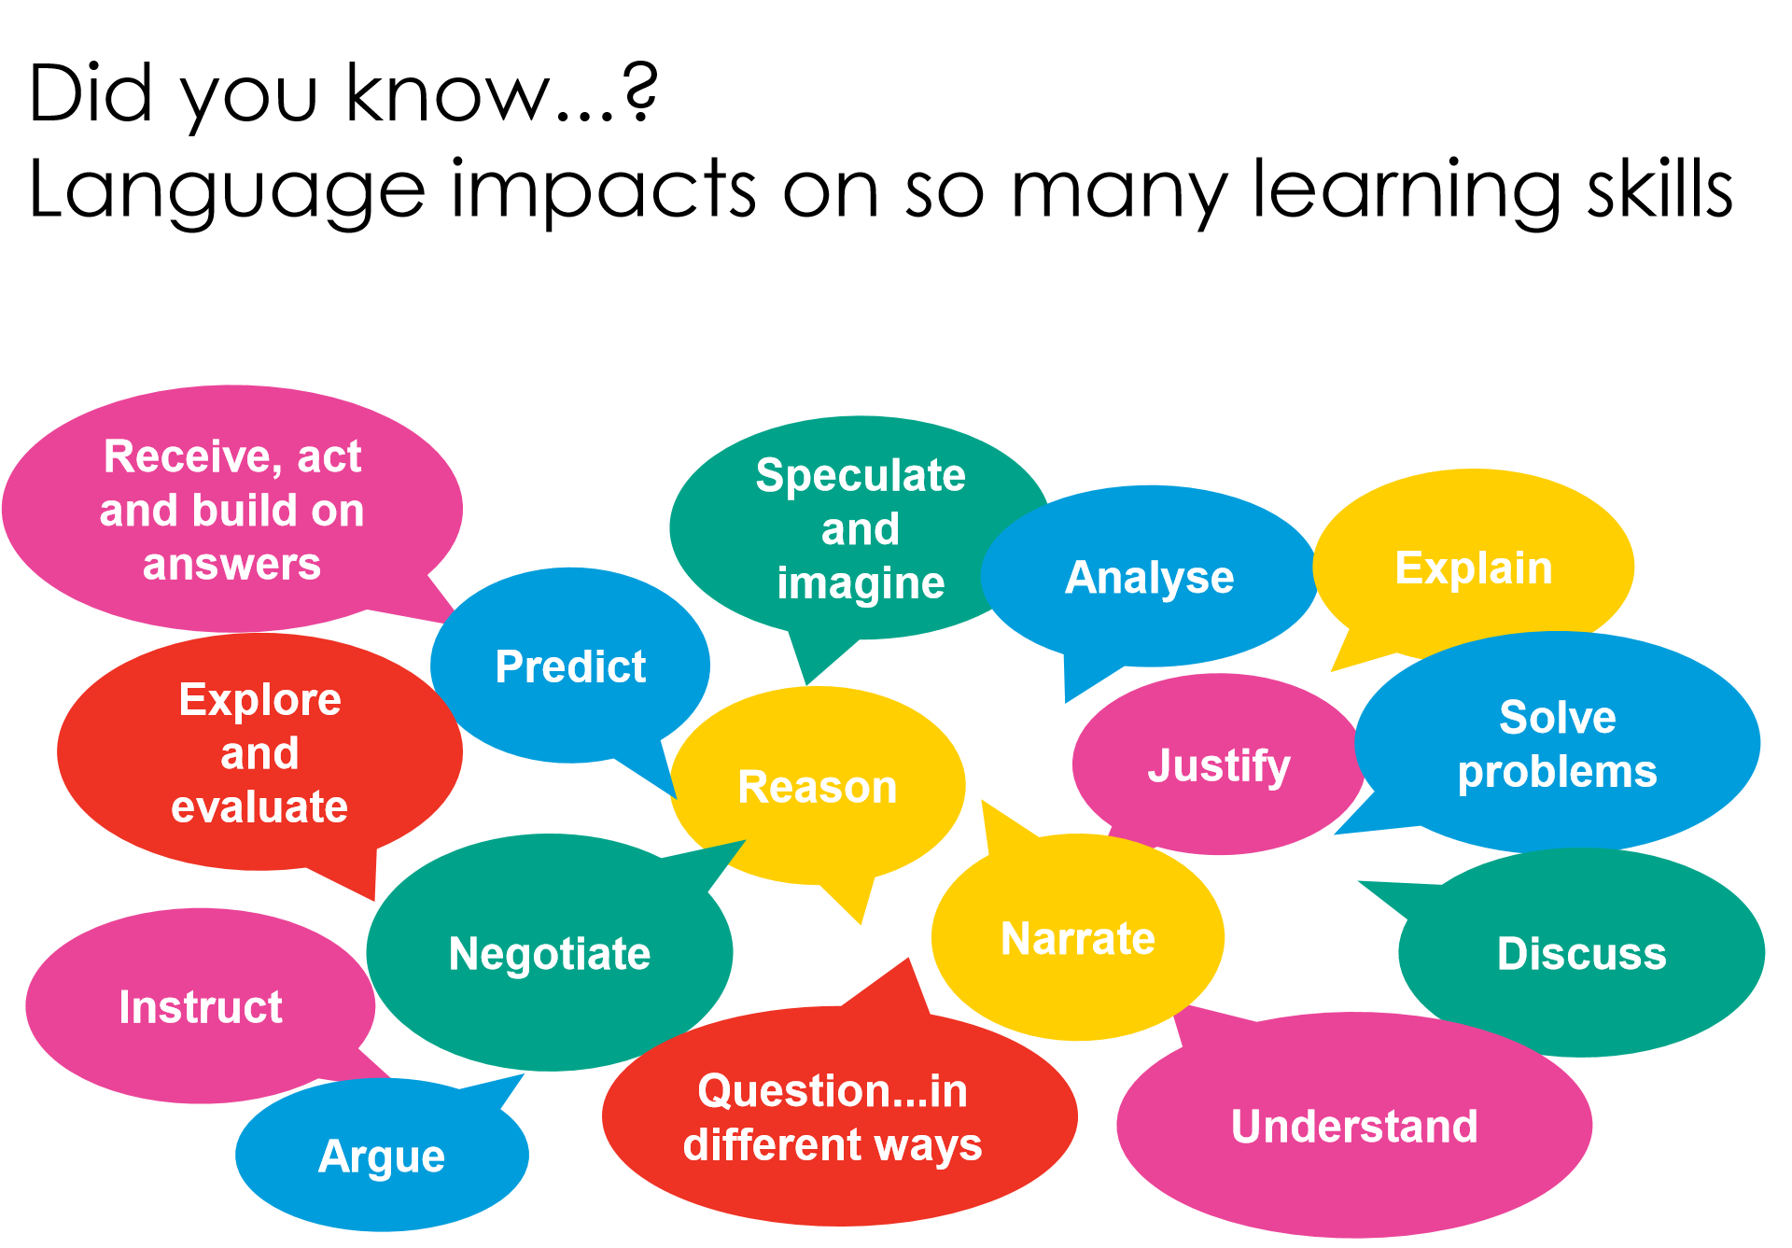
Figure 1 –

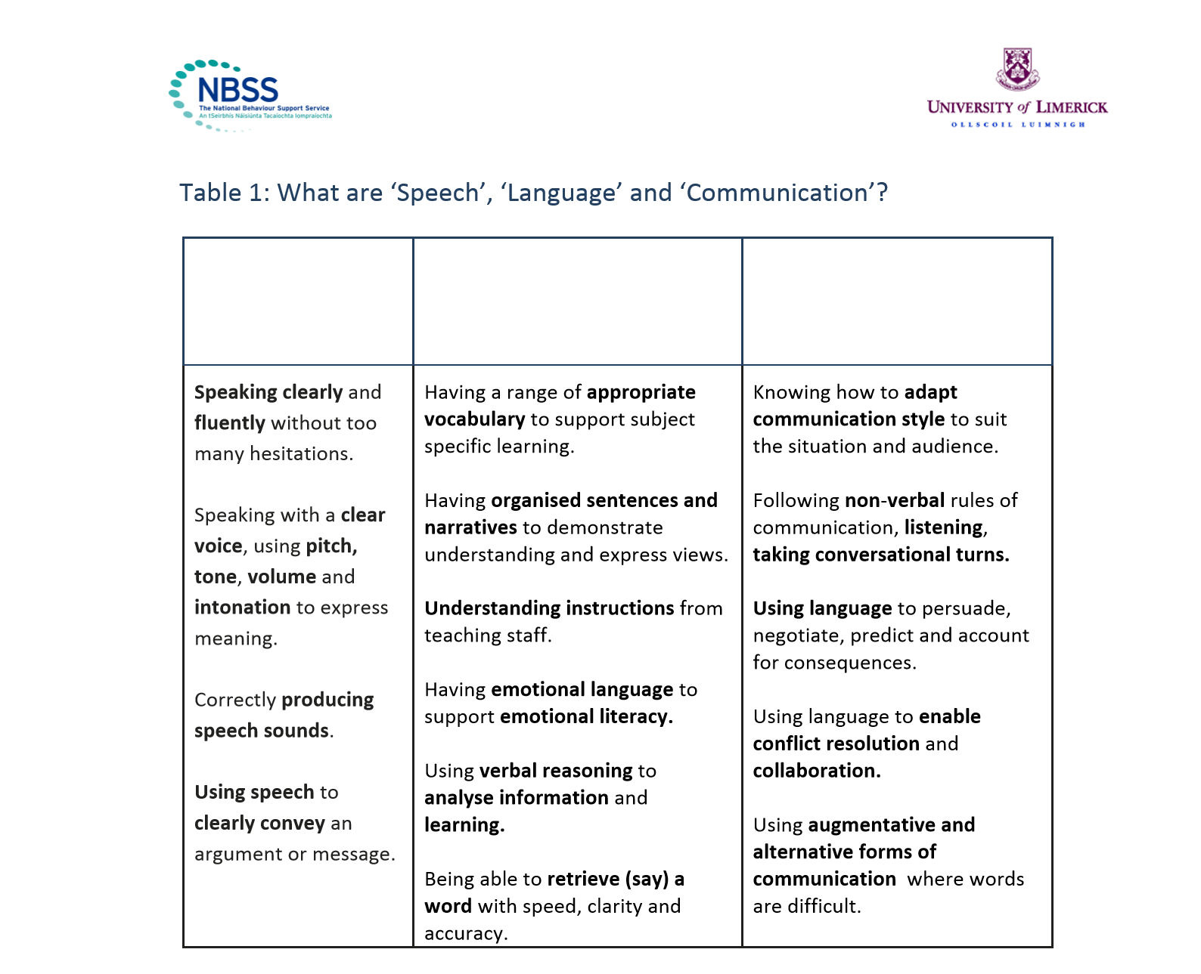
Figure 2 –

29
Figure 3 – ELKLAN
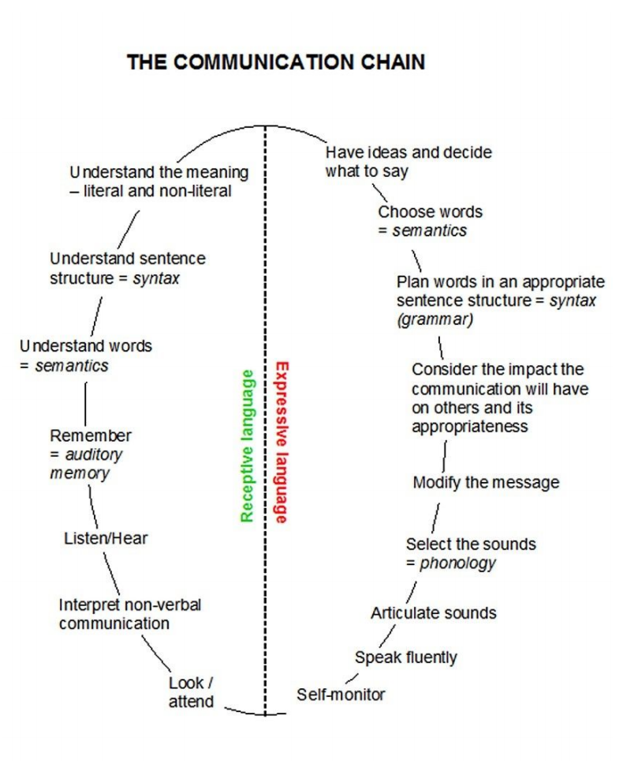

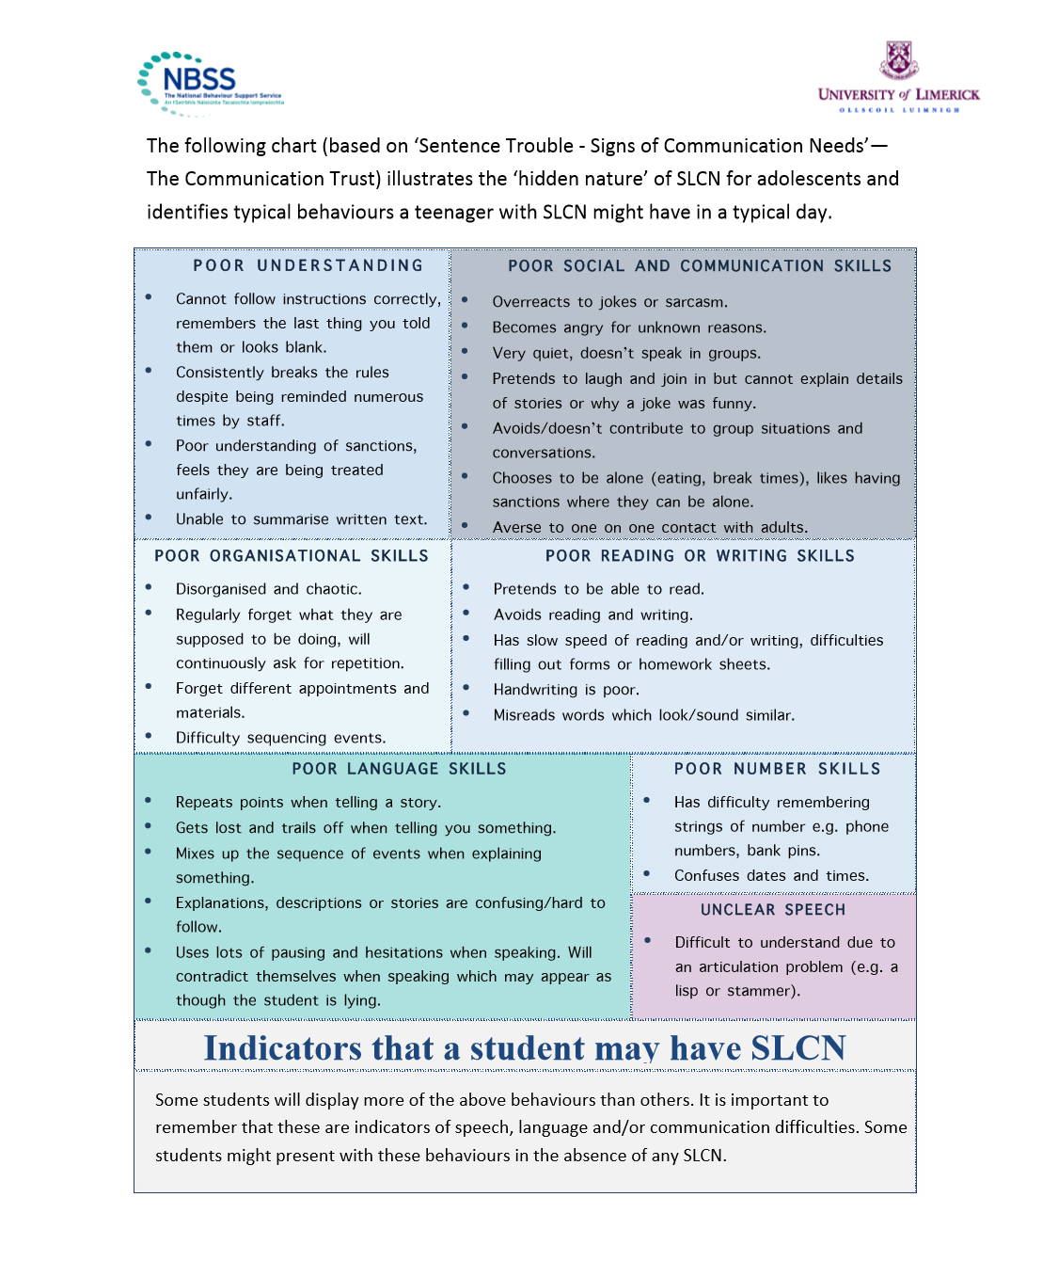
Figure 4 –

30
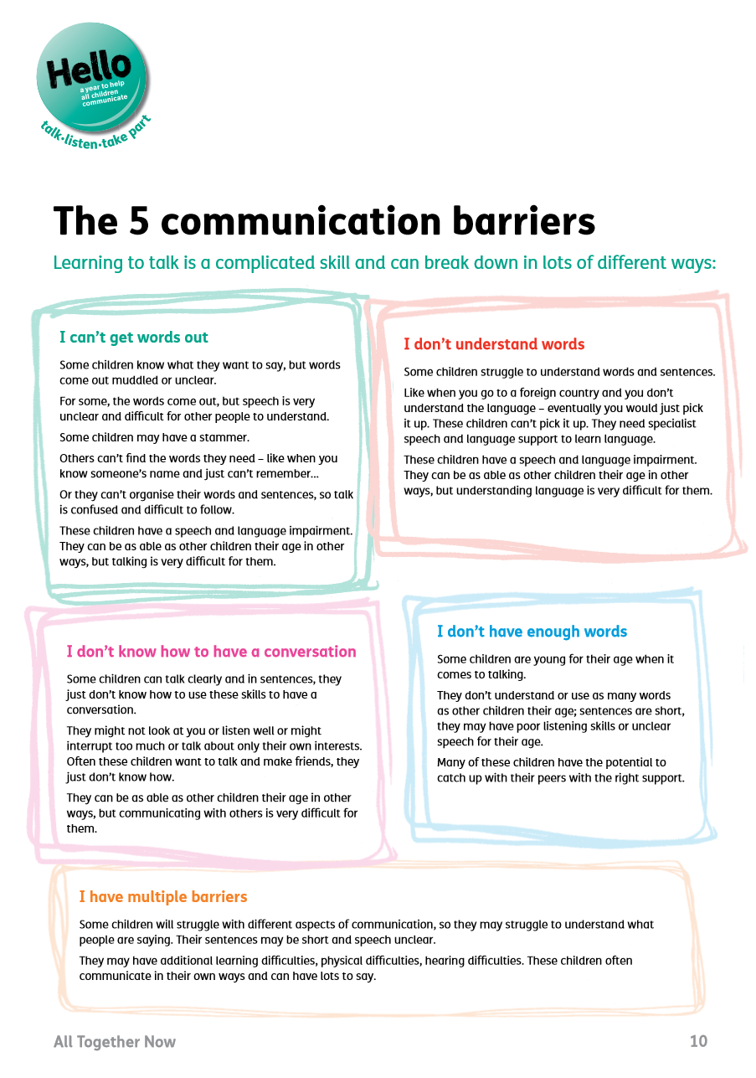
Figure 5 –

31
Reference List
Abriorm Psychol, J. (2013). American Psychological Association – NIH – National Institute of Health, Language Ability Predicts the Development of Behaviour Problems in Children: www.nih.org
American Speech-Language-Hearing Association – ASLHA. (1973). Task force on speech pathology and audiology service needs in prisons: National Criminal Justice Reference Service, Washington, DC.
Audit Commission. (2004). A Review of the reformed youth justice system. Criminal Justice National Report. London: Audit Commission
Bercow, J. (2008). The Bercow Report: A Review of Services for Children and Young People (0–19) with Speech, Language and Communication Needs: Department of Children, Schools and Families) (available at: http://www.dcsf.gov.uk/slcnaction).
Berk, L. E. (1992). Children’s private speech: An overview of theory and the status of research. In R. M. Diaz & L. E. Berk (Eds.), Private speech: From social interaction to self-regulation. Hillsdale, NJ: Erlbaum. Berk, L. E., & Winsler, A. (1995). Scaffolding children’s learning: Vygotsky and early childhood education. Washington DC: National Association for the Education of Young Children.
Brenner, G.J., Nelson, J.R., Epstein, M.H., (2002). Journal of Emotional and Behavioural Disorders – Language skills of children with EBD – A Literature Review: Vol 10, No 1, p43 – 59
British Psychological Society. (2005). Exclusions.
Byers Brown, B., Edwards, M., (1989). Developmental Disorders of Language: Whurr Publishers, London
Child and Adolescent Mental Health Workforce Group. (2005). Getting the right workforce, getting the workforce right: a strategic review of the child and adolescent mental health workforce: www. headsupscotland.co.uk/workf1.html
Child Language Teaching and Therapy. (1997). Working with 11 – 16-year-old pupils with language and communication difficulties in the mainstream school: Volume 13, number 3
Clarke, H. (2019). NHS – Speech and Language workshop power point: www.helenclarke@nhs
Coles, H., Gillett, K., Murray, G., Turner, K., Royal College of Speech and Language Therapists. (2017). Justice Evidence Base Consultation: www.info@rcslt.org
Conti-Ramsden, G., Mok, P., Pickles, A., Durkin, K. (2013). Research in Developing Disabilities – Adolescents with a history of Speech and Language Impairments (SLI): Strengths and difficulties in social, emotional and behaviour functioning: Elsevier Press Lld
CRG Research Ltd. (2008). Evaluation of Speech and Language Service Pilots in Wales - Response to Recommendations CRG Research Ltd. www.learning.wales.gov.uk
32
Cross, M. (2001). ICAN – Talk Series Issue 9 – Children with severe SLCN
Cross, M. (2011). Tutor Materials – Understand the speech, language and communication needs of children and young people with behaviour, social, emotional difficulties: The Communication Trust: Pearson
Cross. (2011). ICAN – Talk Series 9 - Children with severe SLCN
Crystal, D. (1989). Introduction to language pathology: Second Edition: Whurr Publishers, London
Cummings, L. (2013). Pragmatic Disorders: Nottingham Trent University Press, UK
Curtis et al, (2018). Language Disorders and Problem Behaviours – A Meta-Analysis: Vol142, No 2. www.aappublications.org
Department for Education (2017). Permanent and fixed-period exclusions in England: 2015 to 2016. National tables: SFR35/2017
Department for Education (2018). Mental health and behaviour in schools: https://www.gov.uk/government/publications/ mental-health-and-behaviour-in-schools--2
Department for Education and Employment. (1994). Code of practice for the identification and assessment of special educational needs (Circular 9/94). London: DfEE.
Department for Education and Skills. (2001). SEN Code of Practice: www.dfes.org.uk
Department for Education and Skills. (2010). Relationships between Speech, Language and Communication Needs: www.dfes.org.uk
Department for Education and Skills. (2016). Exclusion Figures: www.dfes.org.uk
Department for Education and Skills. (2019). School Data: www.dfes.org.uk
Department for Health. (2015). Future in Mind Project: www.dfh.org.uk
Dr. Owen, Z. (2015). Sec-ed – The Links between language ability and behaviour: www.sec-ed.co.uk
Elliott, A. (1994). Child Language: Cambridge University Press
Elliott, A. (2009). No Wrong Door: Cambridge University Press
Erin Harte. (2019). How your brain processes language - www.brainworldmagazine.com
Gregg, K. (2016). Communication Disorders and Challenging Behaviours: Supporting Children’s Functional Communication Goals in the classroom: Early Childhood Education J (2017) 45:445–452 DOI 10.1007/s10643-016-0789-7: Springer
Hartshorne, M. (2011). ICAN – Talk Series 10 – Speech, Language and Communication in Secondary Aged Pupils

33
Helland, W., Lundervold, A., Heinman, M. (2014). Research in Developmental Disabilities: Stable associations between behaviour problems and language impairments across childhood – The implications of pragmatic language problems: Elseiver
Helland, W.A., Lundervold, A.J., Heinmann, M., Posserud, M. B. (2014). Stable associations between behavioural problems and language impairments across childhood – The importance of pragmatic language problems: Elseiver
ICAN. (2006). Talk Series 2 – The cost to the nation of children’s poor communication: ICAN
ICAN. (2008). Talk Series 6 – Speech, Language and Communication Needs and Primary School aged children: ICAN
Inclusion Toolkit, (2019). No Need to Exclude – Working together to end exclusion in Devon: Babcock, UK. www.badcockldp.co.uk
Issac, T Peterson. (2013). Language Ability Predicts the Development of Behaviour Problems in Children: American Psychological Association: 122(2): 542–557.
Journal of Speech and Language Disorders. (1990). Communication Disorders and Emotional/Behavioural Disorders in children and Adolescents:
Knox, E. (2002). Educational attainments of children with specific language impairments at year 6: Human communication and deafness, School of Education, Manchester University: Arnold
Kopp, C. B. (1982). Antecedents of self-regulation: A developmental perspective: Developmental Psychology, 18, 199–214.
Law, J and Plunkett, C. (2009). Interaction between behaviour and speech and language difficulties – Intervention for one affects the other: EPPI Centre.
Lee, W. (2013). A generation adrift – the case for speech and language to take a central role in schools’ policy and practice: The Communication Trust: Pearson: www.thecommunicationtrust.org.uk
Lindsay, G., Dockrell, J., Letchford, B., Mackie, C. (2002). Self-esteem of children with specific speech and language difficulties: University of Warwick: Arnold
Locke, A. (1997). Child Language and Teaching Therapy: Volume 13, number 3: Arnold
Long, R., Bate, A., Bellis, A. (2018). Speech, language and communication support for children: CDP-0163-2
Long, R., Bate, A,. Bellis, A. (2018). House of Commons - Speech, Language and Communication support for children: CDP-0163. www.Gov.UK
Luria, A. R. (1961). The role of speech in the regulation of normal and abnormal behaviour: London: Pergamon.
34
Mackie, L and Law, J. (2008). Pragmatic language and the child with emotional/behavioural difﬁculties(EBD): a pilot study exploring the interaction between behaviour and communication disability: Leila Mackie and James Law Centre for Integrated Healthcare Research: INT. J. LANG. COMM. DIS., 45, (4), 397–410
Major, G. (2019). Behind the behaviour … Communication difficulties and behaviour problems: www.makesensetraining.co.uk
Martin, D., Miller, C. (1996). Speech and Language Difficulties in the Classroom: David Fulton Publishers
McGill (2020). The brain from top to bottom. Broca’s Area, Wernicke’s Area and other language processing areas of the brain – www.thebrain.mcgill.ca
Miller, C and Roux, J. (1997). Working with 11 – 16-year-old pupils with language and communication difficulties in the mainstream school: Arnold
Miller,C., Wright, J. (2002). Child Language Teaching and Therapy. Volume 18, Number 2: Arnold
Murphy, S.M., Faulkner, D.M., Farley, L.R. (2013). The behaviour of young children with social communication disorders during dyadic interaction with peers: Media, New York
National Behaviour Support Service. (2011). Speech, Language and Communication Needs in Adolescence
Ofsted (2012): From training to teaching early language and literacy: The effectiveness of training to teach language and literacy in primary schools.
Partridge, L. (6 Aug 2019). The RSA 21st Century Enlightenment – School Exclusions are a social justice issue, new data shows: www.thersa.org
Prizant, B.M., Audet, L., Burke, G., Hummel, L., Maker, S., Theadore, G. (1990). Communication Disorders and emotional/behavioural disorders in children and adolescents: Journal of Speech and Hearing Disability, 55, 179-192
Rinaldi, W. (1992). I-CAN. Working with Language Impaired Teenagers with Moderate Learning Difficulties: I.C.A.N
Ripley, K and Yuill, N. (2005). Patterns of language impairment and behaviour in boys excluded from school: British Journal of Educational Psychology, 75, 37–50
Royal College of Speech and Language Therapists. (2010). International Journal of Language and Communication Disorders – Pragmatic Language and EBD: www.info@rcslt.org
Royal College of Speech and Language Therapists. (2017). Exclusions Review – A call for evidence: www.info@rcslt.org
Royal College of Speech and Language Therapists. (2017). Independent Commission: www.info@rcslt.org
35
Royal College of Speech and Language Therapists. (2017). Justice Evidence Review: www.info@rcslt.org
Royal College of Speech and Language Therapists. (2018). ICAN – Bercow 10 years on: www.info@rcslt.org
Royal College of Speech and Language Therapists. (2018). Pilot Study – Behaviour and Communication: www.info@rcslt.org
Royal College of Speech and Language Therapists. (2019). Giving Voice – Speech and Language Therapy Transforming Lives – Speech and Language Therapy promoting Public Health: www.info@rcslt.org
Royal College of Speech and Language Therapists. (2019). Promoting Public Health: www.info@rcslt.org
The Bercow Report. (2008). A Review of Services for Children and Young People (0–19) with Speech, Language and Communication Needs, Department for Children, Schools and Families
The British Psychological Society. (2005). Patterns of language impairment and behaviour in boys excluded from school: www.bps.jounals
The Bullock Report. (1975). A language for life. Report of the Committee of Enquiry appointed by the Secretary of State for Education and Science under the Chairmanship of Sir Alan Bullock FBA: www.educationengland. org.uk/documents/bullock/bullock01.html
The Communication Trust - Hello. (2011). Communication Difficulties – Why Communication is Important: www.communicationtrust.org.uk
The Communication Trust – Hello. (2011). Communication Difficulties - Facts and Statistics: www.communicationtrust.org.uk
The Communication Trust Institute of Education. (2010). How children develop speech language and communication skills: www.thecommunicationtrust.org.uk
The Communication Trust Institute of Education. (2010). ICAN – Talk Series 6: www.thecommunicationtrust.org.uk
The Communication Trust Institute of Education. (2013). Generation Adrift: www.thecommunicationtrust.org.uk
The Communication Trust Institute of Education. (2014). Every child understood- Information on National Prevalence: www.thecommunicationtrust.org.uk
The Communication Trust Institute of Education. (2014). Hello – Facts and Figures – Every Child Matters: www.thecommunicationtrust.org.uk
The Communication Trust Institute of Education. (September 2011). Tutor Materials Understand the speech, language, and communication needs of children and young people with behavioural, social and emotional difficulties (BESD): www.thecommunicationtrust.org.uk
36
The Communication Trust. (2011). How child develops speech, language and communication skills: Pearson: : www.communicationtrust.org.uk
The Communication Trust. (2012). Goodbye, Hello: www.thecommunicationtrust.org. uk/media/27944/helloevaluationreport_-_ final.pdf
The relationship between speech, language and communication needs (SLCN) and behavioural, emotional and social difficulties (BESD)
Thordardoltir, E.T., Weisman, S.E., Smith, M.E. (1997). Vocabulary learning in bilingual and monolingual clinical intervention: Arnold
Van Ijzendoom et al. (1995). American Psychological Association – Attachment: www.nih.org
Vygotsky, L. (1962). Thought and language: Cambridge, MA: MIT Press.
Weill Institute for Neurosciences. (2020). Memory and Aging Centre – Speech and Language: University of California, San Francisco – www.memory.ucsf.edu/symptoms/speech-language
Welsh Government – WAG, (2008). Speech and Language in Wales. Pilot Project Review: WAG, Cardiff
Welsh Government – WAG, (2019). The Additional Learning Needs (ALN) Transformation Programme. Frequently Asked Questions: WAG, Cardiff
Wightwick, A. (7 March 2019). The awful price paid by children permanently excluded from school left in limbo: www.walesonline.co.uk
Youth Justice Board. (2007). Accommodation needs and experiences. London: Youth Justice Board.
Youth Justice Board. (2013). Inspection of Youth Offending Work: Inspection Criteria for full joint inspection: www.justice.gov.uk/about/hmi-probation/inspectionprogrammes-youth/full-joint-inspection
Youth Justice Board. (2013). Youth Justice Statistics 2011/12 England and Wales, London: Ministry of Justice.

Bibliography
Anderson, S. A. S., Hawes, D. J., & Snow, P. C. (2016). Language impairments among youth offenders: A systematic review: Children and Youth Services Review, 65, 195-203.
Aram, D.M., Hall, N.E. (1989). Longitudinal follow-up of children with preschool communication disorders: treatment implications. School Psychology Review 18 (4): 487–501.
Aram, D. M., Ekelman, B. L., National, J. E. (1984). Pre-schoolers with language disorders: 10years later: Journal of Speech and Hearing Research, 17, 232–244.
37
Baker, L., and Cantwell, D. P., (1982). Psychiatric disorder in children with different types of communication disorders: Journal of Communication Disorders, 15, 113 - 126
Baker, L., and Cantwell, D. P., (1985). Psychiatric and Learning Disabilities in children with Speech and Language Disorders: A critical reviews: Advances in Learning and Behaviour Disabilities, 4, 1 - 28
Baker, L., and Cantwell, D. P., (1987). A prospective psychiatric follow-up of children with speech/language disorders: Journal of the American Academy of Child and Adolescent Psychiatry, 26, 546–553.
Beitchman, J.H., Cohen, N.J., Konstantareas, M.M., Tannock, R., (1996.) Language, learning, and behaviour disorders: developmental, biological, and clinical perspectives, Cambridge: Cambridge University Press.
Beitchman, J.H., Wilson, B., Johnson, C.J., Atkinson, L., Young, A., Adlaf, E., Douglas, L., (2001). Fourteen-year follow-up of speech/ language-impaired and control children: Psychiatric outcome: Journal of the American Academy of Child & Adolescent Psychiatry: 40:75–82. PubMed: 11195567
Beitchman, J.H., (1985). Therapeutic considerations with the language impaired preschool child: Canadian Journal of Psychiatry, 30, 609–613.
Beitchman, J.H., Cantwell, D.P., Fortness, S.R., Kavale, K.A., and Kauffman, J.M., (1998). Practice parameters for the assessment and treatment of children and adolescents with language and hearing disabilities: Journal of American Academy of child and adolescent psychiatry, 37(10) 465 - 625
Beitchman, J.H., Nair, R., Clegg, M., & Patel, P. G. (1986). Prevalence of speech and language disorders in 5-year-old kindergarten children in the Ottawa-Carlton Region: Journal of Speech and Hearing Disorders, 51, 98-110.
Beitchman, J.H., Nair, R., Clegg, M., Ferguson, B., & Patel, P. G. (1986). Prevalence of psychiatric disorders in children with speech and language disorders: Journal of the American Academy of Child Psychiatry, 25, 528-535.
Beitchman, J.H., Wilson, B., Brownlie, E. B., Inglis, A., & Lancee, W. (1996). Long-term consistency in speech/language profiles II: Behavioural, emotional and social outcomes: Journal of the American Academy of Child and Adolescent Psychiatry, 35, 815-825.
Beitchman, J.H., Wilson, B., Johnson, C. J., Atkinson, L., Young, A., Adlaf, E., Escobar, M. and Douglas, L., (2001). Fourteen-year follow-up of speech/language-impaired and control children: psychiatric outcome: Journal of the American Academy of Child and Adolescent Psychiatry, 40, 75–82.
Beitchman, J.H., Brownlie, E.B., Inglis, A., Wild, J., Ferguson, B. and Schachter, D., (1996). Seven-year follow-up of speech/language impaired and control children: psychiatric outcomes: Journal of Child Psychology and Psychiatry, 37, 961–970.

38
Belfer, M.L., (2008). Child and adolescent mental disorders: The magnitude of the problem across the globe: Journal of child psychology and Psychiatry, 49, 226 - 236
Benner, G.J., Nelson, J.R., Epstein, M.H. (2002) Language skills of children with EBD: a literature review: Journal of Emotional and Behavioural Disorders 10 (1): 43–56.
Benner, G.J., Nelson, J.R., and Epstein, M.H. (2002). Language skills of children with EBD: A literature review: Journal of Emotional and Behavioural Disorders, 10 (1), pp. 43-59
Beveridge, M. and Conti-Ramsden, G., (1987). Children with Language Disorders: Open University Press
Bialystok, E. and Viswanathan, M., (2009). Components of executive control with advantages for bilingual children in two cultures: Elseiver, 112, (3), 494 - 500
Botting, N., & Conti-Ramsden, G. (2000). Social and behavioural difﬁculties in children with language impairment: Child Language Teaching and Therapy, 16, 105–119.
Botting, N., (2004). Social difficulties and victimisation in children with speech and language impairments at 11 years of age: PubMed.gov
Botting, N., Crutchley, A, Conti-Ramsden, G., (1998). Educational transitions of seven-year-old children with Speech, Language Impairments in language units: A longitudinal study: International journal of language and communication disability, 33, 177 - 197
Brinton, B. and Fujiki, M. (199). Withdrawn and sociable behaviour of children with language impairment: Language, Speech and Hearing Services in Schools, 30, 183 – 195
Brinton, B. and Fujiki, M. (1993). Language, social skills, and socioemotional behaviour: Language, Speech and Hearing Services in Schools, 24, 194 - 198
Brinton, B. and Fujiki, M. (1996). Social Skills of Children with Specific Language impairment: Language, Speech and Hearing Service in Schools. Vol27. 195-202
Brinton, B. and Fujiki, M. (2010). Living with language impairment: Journal of Interactional Research in Communication Disorders, 1, 69 - 94
Brooks, V., (2011) Report outlining the findings of a 13-month pilot project examining the effectiveness of speech and language therapy for young people known to Exeter, East and Mid Devon Youth Offending Team
Brown, B.B and Edwards, M. (1989). Developmental Disorders of language: Whurr
Brown, R. and Hanloc, C. (1970). Derivational complexity and order of acquisition in child speech: Wiley, p 11-53
Brown, W. H., Odum, S. L., McConnell, S. R., & Rathel, J. M. (2008). Peer interaction interventions for preschool children with developmental disabilities. In W. H. Brown, S. L. Odom, & S. R. McConnell (Eds.), Social competence of young children (pp. 141–163). Baltimore, MD: Brookes Publishing.

39
Brownlie, E.B., Beitchman. J., Escobar. M., Young. A., Atkinson. L., Johnson. C., Douglas, L. (2004). Early Language Impairment and Young Adult Delinquent and Aggressive Behaviour: Journal of Abnormal Child Psychology Vol 32
Bryan, K. (2004), Prevalence of speech and language difficulties in young offenders: International Journal of Language and Communication Disorders, 39, 391-400
Bryan, K., Freer, J., Furlong, C. (2007). Language and communication difficulties in juvenile offenders: International Journal of Language and Communication Disorders: 42,505-520
Bryan, K., Garvani, G., Gregory, J., Kilner, K. (2015). Language difficulties and criminal justice: the need for earlier identification: International Journal of Language and Communication Disorders, 50(6), 763-775
Bullock Report. (1975). A language for life: London. HMSO
Byers Brown, B. (1971). Speak for yourself. Reading Educational Explorers: A suggested rationale for the treatment of developmental disorders of language: Cambridge
Byrne, D. (1996). Measuring self-concept across the life span: Issues and instrumentation: Washington D C: American Psychiatric Association
Camarata, S., Hughes, C., & Ruhl, K. (1988). Behaviourally disordered students: A population at risk for language disorders: Language, Speech and Hearing in Schools, 19, 191–200.
Camarate, S., Hughes, C., & Ruhl, K. (1988). Mild/moderate behaviourally disordered students: A population at-risk for language disorders: Language, Speech, and Hearing Services in Schools, 19, 191-200.
Cantwell, D.P., and Baker, I. (1991). Psychiatric and developmental disorders in children with communication disability: Washington DC: American Psychiatric Press
Cantwell, D.P., and Baker, I. (1987). The interrelationships of communication disorders, learning disorders and psychiatric disorders: Paper presented at the symposium Child Psychiatry and Special Education Issues, Walter Reed Medical Centre, Washington, DC.
Caspi, A., Wright, B.R.E., Moffitt, T.E. and Silva, P.A. (1998). Early failure in the labour market: Childhood and adolescent predictors of unemployment in the transition to adulthood: American sociological review, 63, 424-451
Catts, H. and Hogan, T. (2003). Language Basis of Reading Disabilities and Implications for Early identification and remediation: Reading Psychology 24, 223–246
Catts, H.W., Fey, M. E., Tomblin, J. B. and Zhang, X. (2002). A longitudinal investigation of reading outcomes in children with language impairments: Journal of Speech, Language, and Hearing Research, 45, 1142–1157.
Catts, H.W. (1993). The relationship between speech and language impairment and reading disability: Journal of Speech and Hearing Research, 36, 948-958

40
Chapman et al. (1997). Proverb interpretation in fluent aphasia and Alzheimers disease: Implications beyond abstract thinking: Aphasiology 11(4-4):337-350
Cheang, H.S, and Pell, M.D. (2006). A study of humour and communicative intention following right hemisphere stroke. 447-462
Chomsky, N. (1957). Syntax Structures: The Hague. Mouton
Chomsky, N. (1959). Review of verbal behaviour: Mouton de Gruyler Language, 35, 26-58
Chomsky, N. (1965). Aspects of the Theory of Syntax: Cambridge, Mass: MIT Press
Chomsky, N. (1969). The Acquisition of Syntax in Children from 5 to 10: Cambridge, Mass: MIT Press
Clegg, J., Hartshorne, M.A. (2004) Speech and language therapy in hyperactivity: A United Kingdom perspective in complex cases: Seminars in Speech and Language 25 (3): 263–270.
Clegg, J. (2004). Language and behaviour: an exploratory study of pupils in an exclusion unit: British Psychological Society Conference, University of Leeds, UK, September 2004
Clegg, J. Stackhouse, J. Finch, K. Murphy, C & Nicholls, S. (2009). Language abilities of secondary age pupils at risk of school exclusion: A Preliminary Report Child Language Teaching and Therapy, 25 (1)
Cohen, N and Lipsett, L. (1991). Recognised and unrecognised language impairment in psychologically disturbed children: child symptomatically, maternal depression, and family dysfunction: Canadian Journal of Behavioural Science, 23, 376-389
Cohen, N. J. (1996). Unsuspected language impairment in psychiatrically disturbed children: Developmental issues and associated conditions. In J. H. Beitchman, N. J. Cohen, M. M. Konstantareas, & R. Tannock (Eds.), Language, learning and behaviour disorders (pp.118–123). Cambridge: Cambridge University Press.
Cohen, N. J., Farnia, F., and Im-Bolter, N. (2013). Higher order language competence and adolescent mental health: Journal of Child Psychology and Psychiatry, 54(7), 733–744.
Cohen, N. J., Menna, R., Vallance, D. D., Barwick, M. A., IM, N. and Horodezky, N. B., (1998). Language, social cognitive processing, and behavioural characteristics of psychiatrically disturbed
children with previously identiﬁed and unsuspected language impairments: Journal of Child Psychology and Psychiatry, 39, 853–864.
Cohen, N.J, Farnia, F., Im-Bolter, N. (2013). Higher order language competence and adolescent mental health: Journal of Child Psychology and Psychiatry, 54, 733-744
Cohen, N.J. (1998). Language, achievement, and cognitive processing in psychiatrically disturbed children with previously identiﬁed and unsuspected language impairments: Journal of Child Psychology and Psychiatry, 39, 865–877.

41
Cohen, N.J., Davine, M., Horodezky, M.A., Lipsett, L., Isaacson, L. (1993). Unsuspected language impairment in psychiatrically disturbed children: Prevalence and language and behavioural characteristics: Journal of the American Academy of Child and Adolescent Psychiatry, 32(3), 595-603
Communication Trust. (2014). Working with Speech and Language Therapists: Pearson
Conroy, M. A., Dunlap, G., Clarke, S., & Alter, P. J. (2005). A descriptive analysis of positive behavioural intervention research with young children with challenging behaviour: Topics in Early Childhood Special Education, 25, 157–166.
Conti-Ramsden, G and Adams, C. (1995). Transitions from clinic to school: The changing picture of specific language impaired educated children from preschool to school age: Journal of speech and language studies, 5, 1-11
Conti-Ramsden, G and Durkin, K. (2008). Language and Independence in Adolescents with and without a history of specific language impairment (SLI): Journal of Speech, Language and Hearing Research Vol 51
Conti-Ramsden, G. and Botting, N. (1999) Characteristics of Children attending Language Units in England: a national study of 7-year olds IJLCD 42
Conti-Ramsden, G. and Botting, N. (2000). Social and behavioural difﬁculties in children with language impairment: Child Language Teaching and Therapy, 16, 105–120.
Conti-Ramsden, G. and Botting, N. (2004). Social Difficulties and Victimization in Children with SLI at 11 Years of Age: Journal of Speech, Language and Hearing Research Vol 47
Conti-Ramsden, G. (2013). Adolescents with a history of specific language impairment (SLI) Strengths and difficulties in social, emotional and behavioural functioning: Elseiver
Conwall, A. and Bawden, H.N. (1992). Reading Disabilities and aggression: A critical review: Journal of learning disabilities, PubMed, 25, (5), 281-288
Cook, E.T., Greenberg, M.T. and Kusche, C.A. (1994). The relations between emotional understanding, intellectual functioning, and disruptive behaviour problems in elementary school aged children: Journal of Abnormal Child Psychology, 22, (2), 205-219
Coopersmith, S. (1967). The antecedents of self-esteem: Consulting Psychologist Press
Crew, M. and Ellis, N. (2008) Speech and Language Therapy within Bradford Youth Offending Team.
Cross, M. (2004) Children with Emotional and Behavioural Difficulties and Problems: there is always a reason: Jessica Kingsley Press
Cross, M. (2011). Children with social, emotional and behavioural difficulties and communication problems, London, UK: Jessical Kingsley Publishers
Cross,M. (1997). Challenging Behaviour or Challenged Comprehension: RCSLT Bulletin, 545, 11-12
42
Crystal, D. (1990). English as a global language: Cambridge
Cutica et al. (2006). Neuro-pragmatics: Extralinguistic pragmatic ability is better preserved in left-hemisphere-damaged patients than in right-hemisphere-damaged patients: Brain and Language 98(1):12-25
Cutting, A.L and Dunn, J. (1999). Theory of mind, emotion, understanding, language and family background: individual difficulties and interrelations: Wiley
Davis, K. Lewis, J. Byatt, J. Purvis, E and Cole, B. (2004) An evaluation of the literacy demands of general offending behaviour programmes: Findings 233, 1-4.
Denham, S. A., Cook, M., Zoller, D. (1992). Baby looks very sad: Implications of conversations about feelings between mother and pre-schooler: British Journal of Child Psychology, 10, 301–315.
Department for Education and Science. (1981). Education Act: London. HMSO.
Department for Education. (1994). Code of practice on the identification and assessment of children with special education needs: London, Department for Education
Department for Education. (1996). Education Act: London. HMSO.
Dockrell, J. and Lindsay, G. (1998). The ways in which speech and language difficulties impact on childrens access to the curriculum: Child language teaching and therapy, 14, 117-135
Dockrell, J. and Lindsay, G. (2010). Children with specific Speech and Language difficulties: the teacher’s perspective: Oxford Review of Education, 27, (3), 369-94
Dockrell, J. and Lindsay, G. (1997). Problems in the identification and assessment of children with specific speech and language difficulties: Educational Psychology in practice, 12, 29-38
Dockrell, J. and Lindsay, G. (2000). Meeting the needs of children with specific Speech and Language difficulties: European Journal of Special Needs Education, 15, 24-41
Dockrell, J. and Lindsay, G. (2000). The Behaviour and Self-esteem of Children with Specific Speech and Language Difficulties: British Journal of Educational Psychology 7, 4
Dockrell, J. and Lindsay, G. (2008). Specific Speech and Language Difficulties and Literacy in T. Nunes and P. Bryant (eds) (2003) Handbook of Children’s Literacy pp 403-435 London Kluwer Academic Publishers 55 Myer, L. and Botting, N. (2008) Literacy in the mainstream inner-city school: its relationship to spoken language CLTT 24,1pp28-114
Dockrell, J. E., Bakopoulou, I., Law, J., Spencer, S., and Lindsay, G. (2012). Developing a communication supporting classrooms observation tool. London: Department for Education.
Dockrell, J., Ricketss, J. and Lindsay, G. (2012). Understanding speech, language and communication needs: Profiles of need and provision: Department for Education Research Report DFE-RR247-BCRP4
43
Dockrell, J., Lindsay, G., & Palikara, O. (2011). Explaining the academic achievement at school leaving for pupils with a history of language impairment- previous academic achievement and literacy skills: Child Language Teaching and Therapy, 27 (2), 223-237
Donahue, M (1983). Learning disabled children as conversational partners: Topics in Learning Disorders 4: 15–27.
Donahue, M, Cole D, Hartas D (1994). Links between language and emotional/behavioural disorders: Education and Treatment of Children, 17 (3): 244–254
Donno, R., Parker, J., Gilmour, J., Skuse, D. H. (2010). Social communication deficits in disruptive primary-school children: British Journal of Psychiatry, 196,282 - 289
Dronkers et al. (1998). Pragmatics in the absence of verbal language: Descriptions of a severe aphasic and a language-deprived adult: Journal of Neurolinguistics 11(1-2):179-190
Dunn, J., Bretherton, I. and Munn, P. (1987). Conversations about feeling states between mothers and their young children: Developmental Psychology, 23, (1), 132-139
Durkin, K. and Conti-Ramsden, G. (2010). Young people with specific language impairment: A review of social and emotional functioning in adolescence: Child Language and Teaching Therapy, 26, 105-121
Elliott, N. (2009). An investigation into the communication skills of unemployed young men: PhD thesis. University of South Wales.
Elliott, D.S. (1994). Serious violent offenders: Onset, developmental cause, and termination, 32, (1), 1-21
Elliott, N. (2009). An exploration of the communication skills of unemployed young men RCSLT conference presentation: Locked Up and Locked Out: Communication is the Key, Cardiff
Enderby, P., Emerson, J. (1996) Speech and language therapy: does it work? British Journal of Medicine 312: 1655–1658
Epstein, M.H et al. (1998). The academic status of adolescents with behavioural disability: Kinder Berstock
Evans, J., Harden, A.T.J., Benefield, P. (2003) Support for pupils with emotional and behavioural difficulties (EBD) in mainstream primary classrooms: a systematic review of the effectiveness of interventions. In: Research Evidence in Education Library. London: EPPI-Centre, Social Science Research Unit, Institute of Education, University of London.
Freeman, E., & Willig, E. (1995). Classroom management and instruction for adolescents with language disabilities: Seminars in Speech and Language, 16, 46–64.
Fujiki, M., Brinton, B., Hart, C. and Fitzgerald, A. (1999). Peer acceptance and friendship in children with specific language impairment: Topics in Language Disorders 19. 34-48

44
Fujiki, M., Brinton, B., Isaacson, T., & Summers, C. (2001). Social behaviours of children with language impairment on the playground: A pilot study. Language, Speech, and Hearing Services in Schools, 32, 101-113.
Fujiki, M., Brinton, B., Morgan, M., & Hart, C. H. (1999). Withdrawn and sociable behaviour of children with language impairment: Language, Speech, and Hearing Services in Schools, 30, 183–195.
Gallagher, T. (1998). Treatment research in speech, language and swallowing: lessons from child language disorders: Folia Phoniatrica Logopaedica 50: 165–182.
Gallagher, T.M. (1999). Interrelationships among children’s language, behaviour, and emotional problems: Topics In Language Disorders 19 (2): 1–15
Gregory, J. and Bryan, K. (2009). Evaluation of Leeds Speech and Language Therapy Service Provision within the Intensive Supervision and Surveillance Programme provided by the Leeds Youth Offenders Team.
Gregory, J. and Bryan, K. (2013). Perceptions of staff on embedding speech and language therapy within a youth offenders team: SAGE Journals, 29, (3)
Gregory, S. (2012). Investing in their future: how do we ensure our children get the good quality early years provision they need if they and the country are to succeed in the future? Ofsted Early Years Annual Lecture
Gresham, F.M., Sugai, G., Horner, R.H. (2001). Interpreting outcomes of social skills training for students with high-incidence disabilities: Exceptional Children 67 (3): 331–344
GriffithP. L., Rogers-Adkinson, D.L. and Cusick, G.M. (1997). Comparing language disorders in two groups of students with severe behaviour disabilities and behavioural disabilities, 22, (3), 160-166
Gualtieri, C. T., Koriath, U., Van Bourgondien, M., & Saleeby, N. (1983). Language disorders in children referred for psychiatric services: Journal of the American Academy of Child Psychiatry, 22, 165-171.
Guralnick, M.J. (1998). Efficacy in early childhood intervention programs. In: Odom, SJ, Karnes, MB (eds) Early intervention for infants and children with handicaps. Baltimore: Paul Brooks.
Harden, A., Thomas, J., Evans, J., Scanlon, M., Sinclair, J. (2003). Support for pupils with emotional and behavioural difficulties (EBD) in mainstream primary classrooms: a systematic review of recent research on strategy effectiveness (1999–2002). In: Research Evidence in Education Library. London: EPPI-Centre, Social Science Research Unit, Institute of Education, University of London
Harter, S. (1989). Causes, correlates and the functional role of global self-worth: a lifespan perspective: Yale University Press
Harter, S. (1999). The construction of self: A developmental perspective: London, The Guilford Press
45
Herbert, M. (1998). Clinical child psychology. Social learning, development and behaviour, 2nd edition: Chincester, Wiley, p414
Hill, J. W. and Coufal, K. L. (2005). Emotional/behavioural disorders: a retrospective examination of social skills, linguistics, and student outcomes: Communication Disorders Quarterly, 27, 33–46.
Hindsaw, S.P. (1992). Externalising behaviour problems and academic underachievement in childhood and adolescence: causal relationships and underlying mechanisms: Psychological Bulletin, 111, 127-155
Howlin, P., Mawhood, L., Rutter, M. (2000). Autism and developmental receptive language disorder – a follow up comparison in early adult life: Journal of child psychology and psychiatry, 41, (5), 561-576
Humber, E. and Snow, PC. (2001). The language processing and production skills of juvenile offenders: A pilot investigation. Psychiatry, Psychology and Law, 8, 1-11
Im-Bolter, N. & Cohen, N. J. (2007). Language Impairment and Psychiatric Comorbidities: Pediatric Clinics of North America, 54,525-542
Im-Bolter, N., Cohen, N.J. & Farnia, F. (2013). I thought we were good: Social cognition, figurative language, and adolescent psychopathology: Journal of Child Psychology and Psychiatry. 10.1111/jcpp.12067
Iredale, N. (2010). Enterprise education as pedagogy: Emerald
Kaiser, A.P, and Hester, P.P. (1997). Prevention of conduct disorder through early interrelations: A social-communicative perspective: Behavioural Disorders, 22, 117-130
Kaler, S.R and Kopp, C.B. (1990). Compliance and comprehension in very young toddlers: Child Development, 61, (6)
Kaminski, R.A and Good, R.H. (1996). Assessing early literacy skills in a problem-solving model: Dynamic indicators of basic early literacy skills: New York Press, 113-153
Kasher et al. (1999). Effects of right- and left- hemisphere damage on understanding conversational implicatures. Brain and Language 68(3):566-590
Lane, B. (1980). The relationship of learning disabilities to juvenile delinquency: Journal of Learning Disabilities, 8, 425-434.
Lanz, R. (2009). A pilot project examining the Speech, Language, Communication needs of young people accessing the Milton Keynes Youth Offending Team
Law, J. and Sivyer S. (2003). Promoting the communication skills of primary school children excluded from school or at risk of exclusion: an intervention study: Child Language Teaching and Therapy 19 (1): 1–25.
Law, J., Boyle, J., Harris, F., Harkness, A., Nye, C. (1998) Screening for speech and language delay: a systematic review of the literature: Health Technology Assessment 2: 1-184.
46
Law, J., Garrett, Z., Nye, C. (2003). Speech and language therapy intervention for children with primary speech and language delay or disorder: Cochrane Database of Systematic Reviews 2003, Issue 3. Art. No.: CD004110. DOI: 10.1002/14651858.CD004110.
Law, J., Lindsay, G., Peacey, N., Gascoigne, M., Soloff, N., Radford, J., Band, S. (2000). Provision for children with speech and language needs in England and Wales: facilitating communication between education and health services. London: DfEE/DoH.
Law, J. and Garrett, Z. (2004). Speech and language therapy: its potential role in CAMHS: Child and Adolescent Mental Health, 9, 50–55.
Law, J., Boyle, J., Harris, F., Harkness., A and Nye, C. (2000). Prevalence and Natural History of Primary Speech and Language Delay: findings from a systematic review of the literature IJLCD Vol 35 no.2
Law, J., Rush, R., Schoon, I., Parsons, S. (2009). Modelling developmental language difficulties from school entry into adulthood: literacy, mental health, and employment outcomes: Journal of Speech, Language and Hearing Research, 52(6):1401-16
Leonard, L.B. (1997). The nature and efficacy of treatment. In: Leonard LB: Children with specific language impairment. Cambridge, MA: MIT Press, 1997, pages 193–210.
Leonard, M.A., Milich, R. & and Lorch, P. (2011).The role of pragmatic language use in mediating the relation between hyperactivity and inattention and social skill problems: Journal of Speech, Language and Hearing Research, 54: 567-579
Levy, F., Hay, D., McClaughlin, M., Wood, C., Walman, I. (1996). Twin sibling differences in parental reports of ADHD, speech, reading and behaviour problems: Journal of child Psychology and Psychiatry, 37, (5), 569-578
Lindsay, G. and Dockrell, J. (1997). Are we ready for inclusion? Values into practice in special education: London
Lindsay, G. and Dockrell, J. (2002). Meeting the needs of children with speech language and communication needs: a critical perspective on inclusion and collaboration: Arnold
Lindsay, G. and Dockrell, J. (2000). The behaviour and self-esteem of children with speciﬁc speech and language difﬁculties: British Journal of Educational Psychology, 70, 583–601.
Lindsay, G. Dockrell, J. and Strand, S. (in press). Longitudinal Patterns of Behaviour Problems in Children with Specific Speech and Language Difficulties: child and contextual factors British Journal of Educational Psychology
Lindsay, G. Dockrell, J. Letchford, B. Mackie, C (2002). Education Provision for Children with Specific Speech and Language Difficulties in England and Wales CEDAR
Lindsay, G. Dockrell, J. Letchford, B. Mackie, C. (2002). Self-esteem of children with specific speech and language difficulties: Arnold

47
Lindsay, G., Dockrell, J., & Strand, S. (2007). Longitudinal patterns of behaviour problems in children with specific speech and language difficulties: Child and contextual factors. British Journal of Educational Psychology, 77, 811-828.
Lindsay, G., et al (2008). Effective and Efficient Use of Resources in Services for Children and Young People with Speech, Language and Communication Needs: DCSF Research Report RW05
Lipsky, D.K. (1985). A parental perspective on stress and coping: American Orthopsychiatry Association, 55, (4), 614-617
Locke, J. L. and Bogin, B. (2006). Language and Life History: A new perspective on the development and evolution of human language: Behavioural and Brain Sciences Vol 29
Mackie, L. and Law, J. (2008). Pragmatic Language and the child with emotional/behavioural difficulties (EBD) a pilot study: Informa
Mackie, L. and Law, J. (2010). Pragmatic language and the child with emotional/behavioural difficulties (EBD): A pilot study exploring the interaction between behaviour and communication disability: International Journal of Language and Communication Disorders 45(4):397-410
Mancopes, R. and Shultz, F. (2008). Processing of metaphors in transcortical motor aphasia: Dementia and Neuropsychologia 2(4):339-348
Marsh, K. (1990). An economic evaluation of speech and language therapy: Matrix Evidence, p75 www.rcslt.org/giving_voice/matrix_report
Maxwell, S. E. and Wallach, G. P. (1984). The language learning disabilities connection: Symptoms of early language disability change over time. In G. Wallach & K. Butler (Eds.), Language learning disabilities in school age children (pp. 15-34). Baltimore, MD: Williams and Wilkins.
Mclean, L.K., Woods Cripe, J.W. (1997). The effectiveness of early intervention for children with communication disorders. In: Guralnick MJ (ed.) The effectiveness of early intervention. Baltimore: Paul H. Brookes, pages 349–429
Meltzer, H. (2002). The mental health of young people looked after by local authorities in England. Office of National Statistics.
Meltzer, L. J., Roditi, B. N., and Fenton, T. (1986). Cognitive and learning profiles of delinquent and learning-disabled adolescents. Adolescence, 21, 581-591
Miller, C., Roux, J. (1997). Working with 11 – 16-year-oldpupils with language and communication difficulties in the mainstream school: Arnold
Murray, R. (2012). Children and Young People in Custody 2011-12: London: HM Inspectorate of Prisons and Youth Justice Board

48

Myers, PS. (1979). Profiles of communication deficits in patients with right cerebral hemisphere damage: Implications for diagnosis and treatment: Clinical Aphasiology Conference. Phoenix: BRK Publishers. P, 38-46
Nelson, J. R., Benner, G. J., and Cheney, D. (2005). An investigation of the language skills of students with emotional disturbance served in public school settings: The Journal of Special Education, 39, 97-105
Nippold, M.A. (2007). Later Language Development: School-age children, adolescents and young adults: 2nd ed., Publ., Pro.Ed
Norbury, C. and Courtenay et al. (2016). The impact of nonverbal ability on prevalence and clinical presentation of language disorder: evidence from a population study: Journal of Child Psychology and Psychiatry
Norbury, C.F., Gooch, D., Wray, C., Baird, G., Charman, T., Simonoff, E., Vamvakas, A. and Pickles, A. (2016). The impact of nonverbal ability on prevalence and clinical presentation of language disorder: evidence from a population study: Journal of Child Psychology and Psychiatry, 57(11): 1247-1257. See: https://www.ncbi.nlm.nih.gov/pubmed/27184709
Norbury, C. and Boodle, E. (2016). Equip teachers to support children with language disorders in the classroom: The Guardian, 1 November 2016
Nungesser, N. R., & Watkins, R. V. (2005). Preschool teachers’ perceptions and reactions to challenging classroom behaviour. Implications for speech-language pathologists: Language, Speech, and Hearing Services in Schools, 36, 139–151.
Nye, C., Foster, S.H., Seaman, D. (1987). Effectiveness of language intervention with language/learning disabled children: Journal of Speech and Hearing Research 52: 348–357.
Ofstead. (2010). The Special Education Needs and Disability Review: www.ofstead.gov.uk
Ofstead. (2012). The Framework for School Inspection: www.ofstead.gov.uk
Owen, Z. (2010). Incidence of pragmatic language difficulties in children at risk of exclusion from mainstream secondary schools: unpublished
Papagno et al. (2006). Is the right hemisphere involved in idiom comprehension? A neuropsychological study: Neuropsychology 20(5):598606
Petersen, I., Bates, J. and Staples, A. (2015). The role of language ability and self-regulation in the development of inattentive–hyperactive behaviour problems: Development and Psychopathology, 27(1), 221-237.
Petersen, I., Bates, J., Onofrio, B. M., Coyne, C., Lansford, J., Dodge, K., . . . Van Hulle, C. (2013). Language Ability Predicts the Development of Behaviour Problems in Children: J. Abnorm. Psychol., 122(2), 542-557.
Piaget, J. (1926). The Language and Thought of the Child: London, Routledge

49
Quinn, M.M., Kavale, K.A., Mathur, S.R., Rutherford, R.B. Jnr., Forness, S.R. (1999). A meta-analysis of social skill interventions for students with emotional or behavioural disorders: Journal of Emotional and Behavioural Disorders 7 (1): 54–64.
Redmond, S. M. and Rice, M. L, (1998). The socioemotional behaviours of children with SLI: social adaptation or social deviance? : Journal of Speech Language and Hearing Research, 41, 688–700.
Reed, V.A. (2005). An Introduction to children with language disorders: 3rd edition: Allyn and Bacon/Pearson
Rinaldi, W. (1992). Social use of language programme: NFER-Nelson
Ripley, K. and Yuill, N. (2005). Patterns of language impairment and behaviour in boys excluded from school: British Journal of Educational Psychology, 75, p37-50
Ruhl, K.L., Hughes, C.A., Camarate, S.M. (1992). Analysis of the Expressive and Receptive language characteristics of emotionally handicapped students in public school settings: SAGE Journals, 14, (2)
Rutter, M., Lord, C. (1987) Language disorders associated with psychiatric disturbance. In: Yule W, Rutter M (eds) Language development and disorders: Oxford: MacKeith Press, pages 206–233.
Rutter, M. and Mawhood, L. (1991). The long term psychosocial sequelae of specific developmental disorders of speech and language: New York Press, 233-259
Rutter, M., Graham, P., Chadwick, O.F.D., Yule, W. (1976). Adolescent turmoil fact or fiction: Journal of child psychology and psychiatry
Rutter, M., Tizard, J., Whitmore, K. (1970). Education, Health and Behaviour: London, Longman
Rutter, M., Izard, C., & Read, P. (1986). Depression in young people. New York: Guilford.
Schneider, N., & Goldstein, H. (2008). Peer-related social competence interventions for young children with communication and language disorders. In Brown,W.H., Odom,S.L., & McConnell, S.R. (Eds.), Social competence of young children (pp. 233–252). Baltimore, MD: Brookes Publishing.
Silva, P.A., Williams, S., McGee, R. (1987) A longitudinal study of children with developmental language delay at age three: later intelligence, reading and behaviour problems: Developmental Medicine and Child Neurology 29 (5): 630–640.
Smart, D., Vassallo, S., Sanson, A., Richardson, N., Dussuyer, I., Mckendry, W., Marshall, B., Toumbourou, J., Prior, M. and Oberklaid, F. (2003). Patterns and Precursors of Adolescent Antisocial Behaviour. Types, Resiliency and Environmental Influences: Melbourne, Australian Institute of Family Studies

50
Snow, P. and Powell, M. B. (2005). What’s the story? An exploration of narrative language abilities in male juvenile offenders: Psychology, Crime & Law, 11(3), 239–253. https://doi.org/10.1080/1068316042000209323
Snow, P. (2018). The Snow Report: Behaviour as a form of communication: What’s the issue? Available at: http://pamelasnow. blogspot.com/2018/06/behaviour-as-form-of-communication.html
Snow, P. C. (2013). Language competence: A hidden disability in antisocial behaviour: InPsych. June 2013. www.psychology.org.au/ publications/inpsych/2013/june/snow/
Snow, P. C. and Powell, M. B. (2011). Oral language competence in incarcerated young offenders: Links with offending severity: International Journal of Speech Language Pathology, 13(6), 480–489.
Snow, P. C., Bagley, K. and White, D. (2017). "Speech-language pathology intervention in a youth justice setting: Benefits perceived by staff extend beyond communication.": International journal of speech-language pathology, 1-10.
Snow, P.C., Powell, M.B and Sanger, D.D. (2012). Oral language competence, young speakers, and the law: Language, Speech and Hearing Services in School. Oct; 43(4):496-506
Snowling, M. J. and Hayiou-Thomas, M. E. (2006). The dyslexia spectrum: continuities between reading, speech, and language impairments: Topics in Language Disorders, 26, 110–126.
Snowling, M. J., Hulme, C., Bailey, A. M., Stothard, S. and Lindsay, G. (2011). Language and Literacy Attainment of Pupils during Early Years and through KS2: Does teacher assessment at five provide a valid measure of children’s current and future educational attainments? Better Communication Research
Snowling, M.J. (2005). Literacy Outcomes for children with oral language impairments: Developmental interactions between language skills and learning to read. In Catts, H. W. & Kamhi, A. G. (2005). The connections between language and reading disabilities
Snowling, M.J., Adams, J.W., Bishop, D.V.M., and Stothard, S.E. (2001). Educational Attainments of School Leavers with a Pre-School History of Speech-Language Impairments: IJLCD 36
Squires, J., & Bricker, D. (2007). An activity-based approach to developing young children’s social emotional competence: Baltimore, MD: Brookes.
Stevenson, J. (1996). Developmental changes in the mechanism linking language disabilities and behaviour disorders. In: Beitchman, J.H., Cohen, N.J., Konstantereas, M.M., Tannock, R. (eds) Language learning and behaviour disorders: Developmental, biological and clinical perspectives. Cambridge: Cambridge University Press, 78–100.

51
Stevenson, J., Richman, N., & Graham, P. (1985). Behaviour problems and language abilities at 3 years and behavioural deviance at 8 years: Journal of Child Psychology and Psychiatry and Allied Disciplines, 26, 215–230.
Stevenson, J. (1990). The relationship between emotional/behavioural problems and communication difficulties in young children: Presented Paper
Stothard, S.E., Snowling, M.J., Bishop, D.V.M., Chipchase, B.B. and Kaplan, C.A. (1998). Language-impaired preschoolers: A follow-up into adolescence: Journal of speech, Language and Hearing Research, 41, 407-418
Stringer, H. and Clegg, J. (2006). Language, Behaviour and Social Disadvantage in Clegg, J and Ginsborg, J (eds) Language and Social Disadvantage: theory into practice. Wiley
Stringer, H. (2006). Facilitating Narrative and Social Skills in Secondary School Students with Language and Behaviour Difficulties in Clegg, J and Ginsborg, J. (eds) Language and Social Disadvantage: theory into practice: Wiley
Survey of parents’ experiences of services provided to disabled children (BMRB) http://www.dcsf.gov.uk/rsgateway/DB/STR/d000846/index.shtml
Talbot, J (2010). Seen and Heard: Supporting vulnerable children in the youth justice system. Prison Reform Trust. Available at: http://www.prisonreformtrust.org.uk/uploads/documents/SeenandHeardFINAL.pdf
The Audit Commission. (2004). A Review of the Youth Justice Service: Gov.uk
Tomblin, J. B., Zhang, X., Buckwalter, P., & Catts, H. (2000). The association of reading disability, behavioural disorders, and language impairment among second-grade children: Journal of Child Psychology and Psychiatry, 41, 473-482.
Toppelberg, C.O., Shapiro, T. (2000). Language disorders: a 10-year research update review: Journal of the American Academy of Child Adolescent Psychiatry, 39 (2): 143–152.
Turner, K. (2017). Reviewing the prevalence of SLCN in the custodial population: Unpublished PhD studies, University of Sheffield, UK
Turner, l (2017). Introducing Communication Theory: Analysis and application: McGraw-Hill Education
Van Ijzendoorn, M. H., Dijkstra, J., Bus, A. G. (1995). Attachment, Intelligence, and Language: A Meta-analysis: Social Development, 4(2), 115–128.
Vygotsky, L. S. (1962). Thought and Language: Cambridge, Mass: MIT Press
Vygotsky, L. S. (1978). Mind in Society: Cambridge: Harvard University Press
Warnock Report. (1978). Special education needs. Report of the Committee of Inquiry into the education of handicapped children and young people: London.HMSO
Warr-Leeper, G., Wright, N., & Mack, A. (1994). Language disabilities of anti-social boys in residential treatment: Journal of Behavioural Disorders, 19, 159–169.
52
Werner, E. (1993). Risk, Resilience and Recovery: Psychology, 5, (4), 503-515
Wigg, E. and Semel, E. (1984). Learning, Assessment and Intervention for the learning disabled: Columbus, Ohio
Wilgosh, L. and Paitich, D. (1982). Delinquency and learning disabilities: More evidence. Journal of Learning Disabilities, 15(5), 278-279.
Yoder, P.J. and Mcduffie, A. (2002). Treatment of primary language disorders in early childhood: evidence of efficacy. In: Accardo P, Rogers B, Capute A (eds) Disorders of language development. Baltimore: York Press, pages 151–177.

Newspapers
Developmental Language Disorder: The most common childhood condition you’ve nerver heard of – The Guardian – 22 September 2017
Hidden disorder hinders speech of 860,000 children: The Times – 22 September 2017
Case of 4-year olds arriving at school unable to speak properly on the rise – The Telegraph – 6 September 2017
Children with language disorders – Missed or Misidentified? – The Huffington Post – 13 January 2017
Equip teachers to support children with Language Disorders in the classroom – The Guardian – 1 November 2016
Wales online – The awful price paid by children permanently excluded from school left in limbo – Abbie Wightwick – 7th March 2019

Reports
Designed for Life. (2010). www.wag.cardiff
SEN and Disability Tribunals Report. (2005 -2006). www.gov.uk
SEND Code of Practice. (2014). www.gov.uk
The Bercow Report. (2008). www.gov.uk
The Bercow Review. (2018). www.gov.uk
The Bradley Report. (2010). www.gov.uk
The Bullock Report. (1975). A language for life. www.gov.uk
The Carlise Report. (2014). www.gov.uk
The Charlie Taylor Review: Review of the youth justice system. (2016). www.gov.uk
The Nutbrown Review. (2012). www.gov.uk
53
The Wanless Review. (2003). www.gov.uk
The Welsh Language Act. (1993). www.wag.cardiff
Therapy Strategy for Wales. (2006).
Quirk Report. (1972). Speech therapy services: London.HMSO
Youth Justice Board. (2013). www.yjb.gov.uk

54

