Name Joan McDonald
Student Number 1714477
Module code BMHP5013
Lecturer Dr. Betsy Jose
Submission Date Friday 20th November 2020

Impact of Covid-19 on the Black, Asian and minority ethnic (BAME) communities

Table of Contents

Introduction………………………………………………………………………………………3
Background………………………………………………………………………………………3
Strategies used to measure, monitor, and control the incidence………………………4-5
Current public health policy approaches to reduce or control incidence…………….5-8
Prominent Clinical research on different potential vaccines…………………………….8
Recommendations…………………………………………………………………………………9
Conclusion…………………………………………………………………………………………10
References………………………………………………………………………………………11-12

Introduction
This report will evaluate the background and continued impact of Coronavirus (Covid-19), alongside the various approaches and strategies that are being deployed to measure, monitor, and controlled the spread of it around the world.
The report will crucially examine the impact of COVID-19 on BAME communities and consider recent developments in health and social care policy. It will further analyse current public health policy and approaches to reduce and control incidence, prominent clinical research on different potential vaccines, lifestyle and behavioural changes, model, and theories of behaviour changes. The impact of legislation and policies on the health and wellbeing of BAME communities will be assessed, and recommendations to address societal disparities.
Background
Covid-19 was first identified in Wuhan, China, in December 2019.The World Health Organisation (WHO) was informed of a cluster of cases of pneumonia that was spreading rapidly and declared it a pandemic in March. A SARs coronavirus-2 was identified from patient samples (Gov.uk, 2020). Covid-19 is said to cause severe respiratory disease and is considered as an airborne and highly infectious disease. Covid-19 symptoms can vary, ranging from mild illness to pneumonia. It is transmitted from person to person through having direct contact or airborne transmitting from sneezing or coughing. Some people complain of having difficulty breathing, and so far approx. 1.4 million worldwide have died from it because of it (WHO.int,2020). The elderly and people with underlying health issues are more prone to have a severe infection.
The incident rate in England continues to rise over the past weeks.
According to the Office for National Statistics there has been 1,317,496 confirmed cases of Covid-19 and 51,304 deaths in the UK. Growths have been observed in all age groups, especially in young adult. Data used to calculate the incidence rate shows that there are 9.5 to Covid-19 infection per 10,000 people per day (ONS,2020).
Covid-19 policies were designed to control the growth of the transmission virus. Policies such as restriction of large gatherings and closure of restaurants were introduced, although some policies have different effects on different people, it is proven that most of the government and health care policies have achieved a measurable outcome (Chinazzi, 2020).
Public Health England is responsible for advising the government and giving support to local government. They have a duty of care to protect the country from public health hazard by collecting and analysing data also to improve the understanding of public health to prevent transmission of the virus (PHE,2020).

Strategies used to measure, monitor, and control the incidence
Surveillance is a central function for Public Health England (PHE) in ensuring that they have the right information available to the public at the correct time also to update public health results and actions. The government sets out the role PHE expects to play within the health and care system. It is the expectation that they provide, among other things, 'the national infrastructure for health protection including an integrated surveillance system. PHE surveillance activities follow the principles of the proposed general model of health

surveillance. They should also give information of policy development and the role of the sponsor and should be collaborative with knowledge experts.
There are also surveillance experts who are required to ensure current data is analysed and interpreted so findings can be used to support and inform response and improved service delivery. Currently, PHE, continue to adopt a standards-led approach to all its surveillance activities and data should be reviewed regularly by the appropriate staff to ensure the prompt identification of trends and the subsequent communication of any action that may be required (Public Health England: approach to surveillance - GOV.UK, 2020). The main data collections managed by PHE can be classified as health protection incident/case management and outbreak control, communicable and non-communicable disease surveillance (PHE,2020).
Many countries have demonstrated the ability to reduce or stop the spread of the COVID-19 virus by using the Strategic Preparedness and Response Plan for COVID-19. It aims to slow the transmission and to prevent further outbreaks, provide enhanced care for all persons, especially individuals with severe illness and Minimising the impact of the epidemic on health systems and social services. All countries have put comprehensive measures in place to prepare, mitigate transmission of the virus. Guidelines were given, based on the current situation differing countries face.
With the rapid spread of COVID-19 that is happening globally, social measures have been put in place by Public Health authorities. This includes limitations on travelling both national and international, order to stay at home, closure of schools, shops, churches along with other measures. These surveillances are to limit the spread of the disease. Surveillance is also necessary to monitor other long-term trends of COVID-19 transmission and the change in the virus.
Mortality surveillance records the number of deaths in hospitals and in the local communities. Covid-19 deaths in hospital should be reported daily, while COVID-19 deaths in the community are reported daily or weekly.
All deaths should record the age, sex, and location of all who died from COVID-19 then reported to the vital statistics office. The number of deaths that mention COVID-19 on the death certificate (voxeu.org, 2020). Covid-19 deaths in the UK are reported to the Vital Statistics Office and record the age, sex, ethnicity, and location of those who have died. Contact tracing system is the identification of all persons who may have had contact with an individual COVID-19. If a person contracts the virus, they will have to isolate for 14 days before they can infect anyone else this will make it possible to identify who is at high risk. There are other surveillance approaches, such as the surveillance of environmental samples from wastewater that are being explored. The objectives of COVID-19 surveillance are to detect first suspected cases by testing, isolate, and manage (World Health Organisation,2020).
Current public health policy approaches to reduce or control incidence
As the Covid-19 virus intensified, people are encouraged to wear face masks to protect themselves and others from sneezing and coughing. Wearing a face mask is crucial as it prevents the spread of infection. It is recommended by WHO to choose a reusable face mask that can be washed and reuse. PHE also published information on the correct ways to wear, removing a face mask from face and how to dispose of them properly. With that said, strong public resistance to wearing of face masks have been reported worldwide (WHO, 2020). However, (Department of Health and Social Care, 2020) advise face-coverings should be worn correctly to be effective in reducing the risk of transmission. Face masks should be worn on public transport, in shops, visiting a hospital or an appointment. It was noted that people with existing breathing difficulties should not wear a face mask.
According to PHE and the WHO guidance, facemasks should be worn when working in close contact with others. A facemask is used to prevent the transmission of the infection and to protect the individual wearing it from becoming infected, by blocking viral particles from entering the nose or mouth. Face-covering may reduce exposure to COVID-19 while working with the public.
Face covering is also essential in enclosed areas where social distancing may be difficult also make sure your nose and mouth are covered. Social distancing policies is used to stop the spread of Covid-19. It is done by not having close contact with others outside your household. COVID-19 spreads mainly between people who are in close contact for a lengthy period. Spreading of the virus occurs when an infected person coughs, sneezes, or talks, and droplets from their mouth or nose are released into the air and land in the mouths or noses of people nearby, which is then inhaled into the lungs. Studies have shown that people can be asymptomatic with no symptoms but still have the virus and therefore spread it unknowingly. Hence, as people can spread the virus before they are aware of being ill, the following of social distancing measures is imperative.
The implementation of social distancing affected different people in different ways as their situations or circumstances present challenges. Social distancing is especially important for people from BAME communities who are statistically at an increased risk of getting sick and dying from COVID-19 (Disparities in the risk and outcome of Covid-19, 2020). Social distancing also limits the chances of encountering any contaminated surfaces or infected people outside the homes. COVID-19 is said to live for hours or days on surfaces, depending on factors such as sunlight, humidity, and the type of surface (Gray, 2020). A person can get Covid-19 by touching a surface or object that has the virus on it and then touching their own mouth, nose, or eyes. Everyone needs to follow the government guideline to stay at home except for work and essential purpose. If going out, try and keep contact at a minimum, to maintain social distancing.
The government introduced the latest series of lockdown restriction, trying to tell people what they can and can't do also how long the lockdown is expected to last. Lockdowns rules are put into place to restrict the movement of people, with the mounting threat posed by the second wave of Covid-19. These rules affect the meeting of other people in public, social gathering and events and the operation of hospitality and leisure venues. Businesses must close, and non-essential travel is being discouraged. The increase in cases shown in the diagram below was the key driver for the new government lockdown measures introduced. The government encouraged people to stay at home to limit their contact with other people.
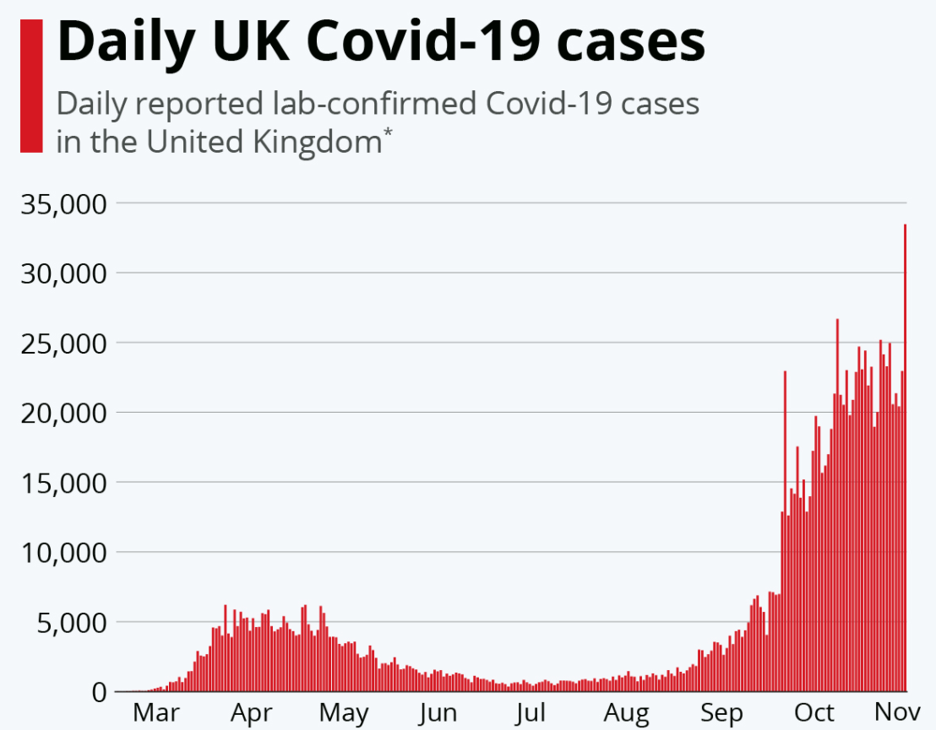
Source: (Armstrong, 2020)
Where possible, people should work from home; however, it is not formal order for offices be closed.
People who work cannot work from home e.g. manufacturing or construction workers are advised to continue working whilst following set Covid-19 measures and guidance to ensure safety (Pope, 2020). Research projects have been funded into why minority group have been disproportionately affected by COVID-19, but there was still no policies announcement on how to protect the population shown to be the most vulnerable to the pandemic (Cox, 2020). There is a drastic need for action to prevent more deaths from happening. Describing the new rules and ongoing local downs as one size fit all.
Health Belief Model (HBM) is a theory that attempts to understand or explain health behaviour choices. It was developed in the 1950s by psychologists in the United States Public Health Service. In the 1980s, it was updated to incorporate the role of self-efficacy in decision-making. Self-efficacy is the confidence you have in your ability to make that positive health change; this is not the same thing as self-confidence. HBM has six constructs; they are Perceived Susceptibility, Perceived Severity, Perceived Benefits, Perceived Barriers, Cues to Action and Self-Efficacy.
Health behaviour can be defined as any behaviour relating to the maintaining of one's health, preventing health problems. These actions may be intentional or unintentional. A person behaviour may include their physical activities mental health and having a balanced diet.
Some unhealthy behaviour includes smoking, using drugs and alcohol, health behaviour is linked to a variety of health outcomes such as developing long term condition, including cancer on heart disease. There is a need to understand health behaviour, especially in this COVID-19 pandemic.
The public must follow specific guidelines from the government, to reduce the spread of the virus by having changed from typical behaviour pattern. This includes regular hand washing in warm soapy water, avoid touching nose, eyes and mouth and maintaining social distancing. Take for example a smoker they are more at risk of contracting COVID-19 reason being there will continually having their hands to their mouth some may also have underlining illness like lung disease making them more likely to be admitted in hospital.
People tend to have to make changes to their lifestyles, like continually using hand sanitiser as a mode for staying safe. Some BAME groups tend to find lockdown policies more challenging as they are mostly from large family background with close family network living in a household or regular contact. The impact of lockdown on extended families, children, are not allowed to interact with their grandparents, unemployment on eyes the rise.
Prominent clinical research on different potential vaccines
The UK government support companies that would like to do research work in relating to Covid-19. Some of these companies are UK Research and Innovation (UKRI), Public Health England, National Institute for Health and Research, Health Research Authority, and others. This enables a complete picture of all COVID-19 urgent public health research across the UK, ensuring the appropriate geographical distribution of critical public health for COVID-19. UKRI have invested over £400 million to tackles the coronavirus pandemic and supported hundreds of projects that are addressing the challenges of COVID-19.
Oxford University has put together a team of scientists, funded by UKRI Medical Research Council and the National Institute for health research (NIHR) as part of the Covid-19 rapid research respond. They started the work on developing a vaccine in January 2020 and have since worked with unprecedented urgency to take steps towards the discovery of a safe, effective, and accessible vaccine against Covid-19. Phase one and two trials showed no early safety concern, showing antibody response against the SARS-CoV-2 virus were demonstrated (UKRI.org, 2020a).
Another vaccine trial done by the Imperial College London is extending additional site throughout England, the vaccine trial was funded by the COVID-19 rapid research response from UKRI, the Department for Health and Social Care, and the National Institute for Health Research. They received £41 million from the UK government and a further £5 million in a philanthropic donation. The Imperial vaccine uses self-amplifying RNA (saRNA) technology, has so far been tried on 92 volunteers who are closely monitored (UKRI.org,2020b).

Recommendations
- Considering the seriousness of COVID-19 pandemic, regular surveys should be done on surveillance that is already in place to proactivity identify people from BAME communities with underlining illnesses thus putting them at increased risk of death from the virus. This proactive approach means necessary precautionary measures are taken early.
- When a vaccine becomes available to the public, the most at-risk people in society should be prioritised and governments should continue monitoring levels of immunity and current infections in the population.
- Assess the impact of the effectiveness of implemented control measures and provide reliable population estimates for the spreading of disease, modelling and research to support policymaking.
- The government must urgently carry out an impact assessment of BAME key workers and ensure that the safeguard is implemented to guard them against greater risk of Covid-19 infection.
- Carry out a survey that can reveal if BAME groups are coping with Lockdown measures or social distancing behaviours also help people manage the changes.
- Monitor infection rate by testing and reporting positive cases
- Government to set strategies for the benefits and environmental supports to meet the health and safety needs of everyone.

Conclusion
As the incidence rate of covid-19 in England continues to rise, statistics have shown that it has affected all age groups. Public Health England surveillance ensure that they have the right updated information available for the public at the all times. Social measures have been put in place for the public to follow, they are encouraged to wear face masks and adhere to social distancing. The government introduction of Lockdown rules restricts the movement of people, also the use of the health belief model predicts some health behaviour and lifestyle changes throughout this pandemic. Government is funding research relating to COVID-19 to find a vaccine against COVID-19.

References
Armstrong, M., 2020. Infographic: Daily UK Covid-19 Cases. [online] Statista Infographics. Available at: <https://www.statista.com/chart/21079/coronavirus-cases-uk/> [Accessed 5 November 2020].
Assets.publishing.service.gov.uk. 2020. Disparities in The Risk and Outcomes Of COVID-19. [online] Available at: <https://assets.publishing.service.gov.uk/government/uploads/system/uploads/attachment_data/file/908434/Disparities_in_the_risk_and_outcomes_of_COVID_August_2020_update.pdf> [Accessed 4 November 2020].
BBC News. 2020. Covid-19 In The UK. [online] Available at: <https://www.bbc.co.uk/news/uk-51768274> [Accessed 1 November 2020].
GOV.UK. 2020. Department of Health and Social Care. [online] Available at: <https://www.gov.uk/government/publications/face-coverings-when-to-wear-one-and-how-to-make-your-own/face-coverings-when-to-wear-one-and-how-to-make-your-own> [Accessed 12 November 2020].
Gray, R., 2020. Covid-19: How Long Does the Coronavirus Last on Surfaces? [online] Bbc.com. Available at: <https://www.bbc.com/future/article/20200317-covid-19-how-long-does-the-coronavirus-last-on-surfaces> [Accessed 12 November 2020].
nhs.uk. 2020. Social Distancing: What You Need to Do - Coronavirus (COVID-19). [online] Available at: <https://www.nhs.uk/conditions/coronavirus-covid-19/social-distancing/what-you-need-to-do/> [Accessed 9 November 2020].
Pope, T., 2020. Performance Tracker 2020. [online] The Institute for Government. Available at: <https://www.instituteforgovernment.org.uk/our-work/coronavirus> [Accessed 4 November 2020].
Dodwell, C., 2020. The Impact of Covid-19 On Children and Families - Institute of Public Care - Oxford Brookes University. [online] Ipc.brookes.ac.uk. Available at: <https://ipc.brookes.ac.uk/about-ipc/news/Covid-19Children_Families.html> [Accessed 15 November 2020
Campbell, P., 2020. WHO Is Right: Lockdowns Should Be Short and Sharp. Here Are 4 Other Essential COVID-19 Strategies. [online] The Conversation. Available at: <https://theconversation.com/who-is-right-lockdowns-should-be-short-and-sharp-here-are-4-other-essential-covid-19-strategies-148175> [Accessed 19 November 2020].

Ecdc.europa.eu. 2020. Strategies for The Surveillance of Covid-19. [online] Available at: <https://www.ecdc.europa.eu/sites/default/files/documents/COVID-19-surveillance-strategy-9-Apr-2020.pdf> [Accessed 12 November 2020].
Gable, L., Ram, N. and Ram, J., 2020. Legal and Ethical Implications of Wastewater Sars-CoV-2 Monitoring for COVID-19 Surveillance. SSRN Electronic Journal,
GOV.UK. 2020. Public Health England: Approach to Surveillance. [online] Available at: <https://www.gov.uk/government/publications/public-health-england-approach-to-surveillance> [Accessed 18 November 2020].
Jutel, A., 2020. Face masks for the public during covid-19: the more things change. BMJ, p.m1435.
Kim, M., 2020. What Type of Face Mask is Appropriate for Everyone-Mask-Wearing Policy Amidst COVID-19 Pandemic. Journal of Korean Medical Science, 35(20).
World Health Organization, 2020. Advice on The Use of Masks in The Context Of COVID-19: Interim Guidance, 5 June 2020. [online] Apps.who.int. Available at: <https://apps.who.int/iris/handle/10665/332293> [Accessed 18 November 2020].
Public Health England. 2020. [online] Available at: <https://www.gov.uk/government/publications/public-health-england-approach-to-surveillance/public-health-england> [Accessed 2020]. 14 November
Who.int. 2020. Clinical Management Of COVID-19. [online] Available at: <https://www.who.int/publications/i/item/clinical-management-of-covid-19> [Accessed 17 November 2020].
Who.int. 2020. Responding to Community Spread Of COVID-19. [online] Available at: <https://www.who.int/publications/i/item/responding-to-community-spread-of-covid-19> [Accessed 19 November 2020].
Ukri.org. 2020. UKRI – UK Research and Innovation. [online] Available at: <https://www.ukri.org/> [Accessed 18 November 2020].
The Guardian. 2020. Make Masks Compulsory in GP Surgeries to Reduce Covid-19 Risk, BMA Urges. [online] Available at: <https://www.theguardian.com/world/2020/jul/21/make-masks-compulsory-in-gp-surgeries-to-reduce-covid-19-risk-bma-urges> [Accessed 17 November 2020].
Freeourhealthcarenow.com - Information Blog. 2020. What You Should Know About This Common Virus - Freeourhealthcarenow.Com - Information Blog. [online] Available at: <https://www.freeourhealthcarenow.com/what-you-should-know-about-this-common-virus/> [Accessed 12 November 2020].
Cox, D., 2020. The UK’S New Lockdown Rules Are Still Failing BAME Communities. [online] WIRED UK. Available at: <https://www.wired.co.uk/article/uk-coronavirus-rules-ethnic-minorities> [Accessed 17 November 2020].

