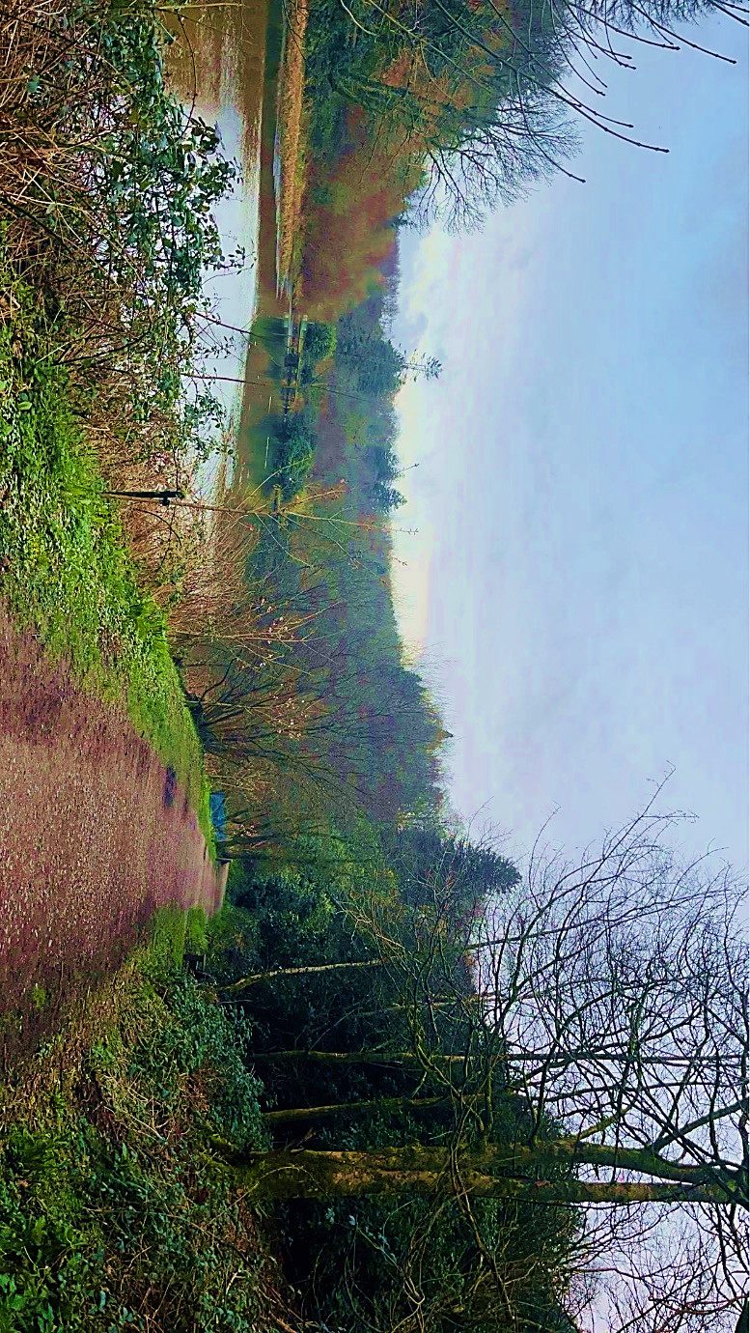
Awe and Wonder- science, mathematics and the outdoors

Name: Lily-Mai Dyer
Location: Penllergare Valley Woods

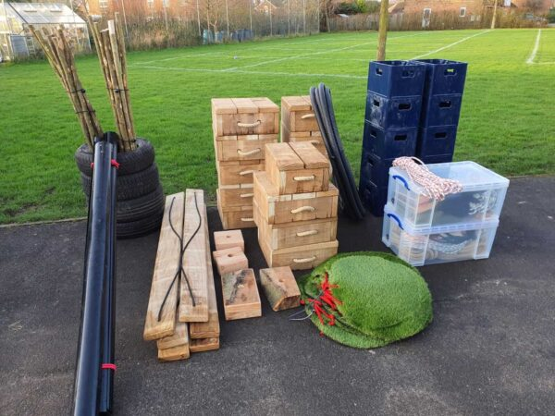
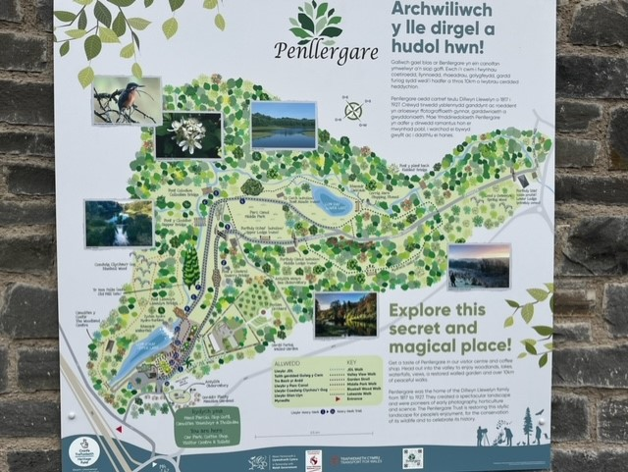
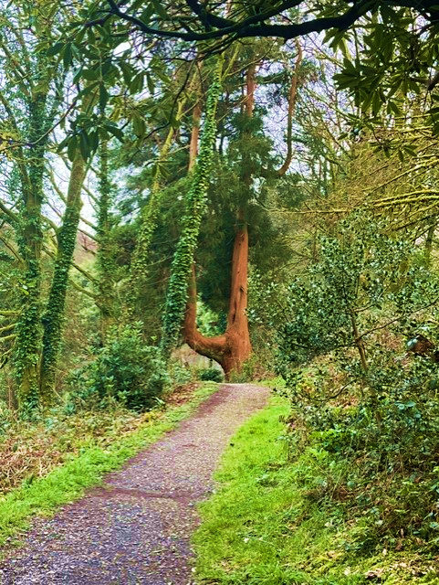
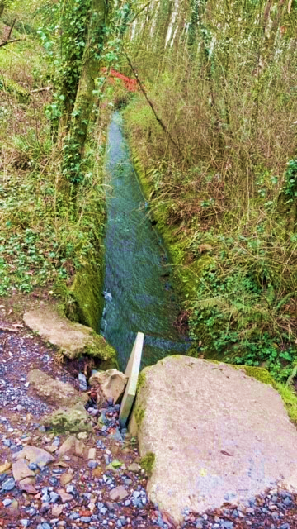
Part 2 On this day myself and two other members of staff planned an educational trip to Penllergare Valley woods. Penllergare Valley Woods was chosen, as the nature-filled environment allows the children to mathematically and scientifically explore safely as it contains alot of uneven ground, hills, steps, trees, plants, wildlife and much more. We decided on taking a small group of six children aged 6–7 with us as they would be the most responsible and aware of any danger around them. Upon arrival at the woods, the other staff members and I carefully guided the children across the car park and introduced the children to the environment whilst lying down some ground rules. We explained that it was important for the children to stick together and always remain in sight of an adult. We also explained that further along into the woods there were a lot of sources of water that the children needed to be cautious around due to falling and drowning hazards. After ensuring that the children’s safety came first, the other members of staff and I presented the children with many natural loose parts such as string, rope, sheets, and we also brought along magnifying glasses. We set safety guidance rules and boundaries however we allowed the children to engage in child-led play and did not interfere with their ideas or decision making. Welsh Government (2022) enforces the importance of the children having freedom with play decisions and the opportunity to initiate their own play in the Curriculum for Wales. All of the children were eager to pick out the loose parts that they would like to use to support their play and learning experiences. Half of the children grabbed magnifying glasses to start as some wanted to “see the very small bugs bigger and clearer,” some wanted to “see the plants and flowers better” and some also decided that they wanted to “be explorers” and search for clues regarding the “woodland monster.” The children collectively came up with the idea that there was a woodland monster/beast living in the woods and decided that they must try and stay safe and capture the monster. The children decided that before catching the monster they had to construct a den/shelter to stay safe from the monster and rely on as a base. The children started to grab sheets, rope, and other materials from the loose parts that we had provided along with going to collect their own sticks in order to create their den. On the way to find the area where they would later build their base, we were approaching a hill, but whilst we were still on flat ground, one child dropped a ball of string and it fell straight to the ground. One staff member said to the child “be careful not to drop the string on the hill in case we lose it” to which the child questioned “why?” We questioned all the children to see if they could predict what could happen if the string was dropped on the hill. One child explained that it could “roll away because it is a slope.” One child suggested that we should experiment this and see if their prediction was right. Another child was worried that we were going to lose the string so I questioned “what could we do to make sure we do not lose the string?” The children decided they were going to have all five of the other children stood at the bottom of the hill to catch the string as it was more likely that they would catch it if they covered more area. The child counted down from five and dropped the ball of string down the hill where it rolled to the other children. The children seemed immensely proud of themselves for predicting the outcome correctly. The terms that the children were using also showed us their understanding of learning mathematics and science in the outdoors. One of the staff members explained that it is due to a scientific term called gravity and that force is what makes items roll downwards on a hill. As the children were still young, the member of staff did not go into any more detail about gravity and ensured that the information was age appropriate for the children however, by predicting, experimenting, and estimating, the children were educating themselves mathematically and scientifically before their initial ‘play’ had even begun. The Curriculum for Wales explains that this is beneficial as it is important for children to be able to question, problem solve and incorporate mathematical concepts. After a discussion, the children looked around using their magnifying glasses and decided on an area to build their fort. They came to this decision as one child explained that they should “build it here because it is close enough to the trees to enable the rope and other building materials to reach them.” The children were pretending that they had to build their den to survive for several days and nights against this monster. One child explained that in order for this to be possible, they needed to be close to the river to be able to collect water. The river that was nearby was actually connected to a waterfall. The children were fascinated by the waterfall and stood and watched it for a while. One child was then questioning how and why the water was flowing that way. We asked the children if they had any ideas as to why this might be, and one child responded with “is it the same as the string?” We explained that the child was right, and the water would flow that way due to gravity and the force. This showed us that the children had grasped the idea of gravity and were able to recognise it in other aspects of problem solving. Whilst some of the children were exploring the waterfall and recognising patterns, ripples and reflections in the water, some other children had made a start on building the den. The children opened up the sheet to “measure it to see how big the den is going to be.” Building the den was not achieved on the first attempt it required the children to reflect on their work to spot room for improvement and carry out those developments. The children had to work together holding long branches on either side which required them to communicate with one another and learn science through understanding how their body works to be able to move it accordingly to the task. It also made the children aware of their ability to lift heavy objects and they would often realise that some objects were “too heavy” or too high” or “too long.” In this case they would ask one of us adults to assist them but during this, we ensured to help them with the task they required support with and continued to allow them to have child-led play and only interact if they invited us to. Watching the children try to balance objects and measure them to see if they would fit in the designated space showed that they were developing their science and mathematical skills in the outdoors. As well as this, hearing the terms that the children were using shows their understanding of mathematical and scientific terms and knowledge. The Curriculum for Wales supports this as it recognises the importance of the children working together as a team and taking responsibility.
(SOUL 2024)

Part 3
Experience exploring outdoor space in photograph | How will young people BENEFIT from this activity? | Hazards and associated risks | Who is at risk? | PRECAUTIONS in place to reduce the risk of injury | Overall risk after precautions RATING: L/M/H
Crossing the car park | They will learn about road safety, self-awareness, and their awareness of their surroundings. They will also learn patience and build on their responsibility. | No pavement  Uneven ground  Cars driving. | The children | Before entering the car park, it is important to ensure that the children are capable of understanding the danger and risk that may come with cars. It is important to explain to the children the plan of action of how to get across the car park safely and how to act around cars. It is also important to have a suitable child to adult ratio, keep the children close to the adults whilst remaining undistracted and for the children to be wearing hi-vis jackets. | Low
Observing the water sources | During this activity, the children will be able to learn about patterns and ripples in the water. They could also spot some living beings/organisms that are aquatic. As well as this they could learn about the water cycle and the force of water. | Slipping near the water,  Drowning | The children and adults | Wearing appropriate footwear is important when walking on slippery surfaces in order to reduce the chance of slipping. It is also important to ensure that there are barriers in place to stop people from falling into the water. It is just as important for the children to be supervised by the adults at all times to ensure that no child past through the barriers. As well as this, it is important to check if there are lifeguards and safety precautions in place in the event of an accident. | Low
Being in a nature-filled outdoor environment | Being outdoors is great for a child’s physical and emotional health and well-being. It allows children to partake in physical activities and exercise whilst channelling their senses and imagination. Being outside often prompts children’s creativity and offers them an authentic perception. | Weather conditions: very windy - it would not be a good idea to take children on a walk with lots of steps and water, heavily raining or snowing - the children could slip and injure themselves or become wet and cold and in severe cases this could lead to hyperthermia, the sun - sun burnt or in severe cases develop heat stroke | The children | It is important to check the weather forecast before setting off for the trip. If the weather is windy or snowing it would not be a promising idea for the trip to go ahead as the risk would be too high. As long as it is not raining an unsuitable amount, the children can go out in the rain as long as they are wearing waterproofs, layers and wellies or suitable footwear. If it is sunny, it is important that the children do not go outside for too long at the hottest period of the day, wear suncream and hats. It is also crucial that the children take plenty of water to stay hydrated. | Low
Walking the steps on the woodland trail | The children will be given the opportunity to explore their surroundings and educate themselves on the nature around them. | Fall up or down the steps | The children | The steps in the woods are painted in bright yellow paint so that the children will be able to see the steps which will lower the chance of them falling. The steps also have a hand rail alongside the entirety of the steps that will allow the children to be able to maintain their balance and if they were to trip, it could help save them from falling over or down the steps. It is also important to verbally warn the children about the steps and instruct them to walk slowly one at a time in a single file form.
Inspecting plants and berries | The children could learn to identify different plants and berries and get to experience it physically with their senses | Could put them in their mouth/consume them  Sickness/poisoned  Touch harmful plants like stingy nettles | The children | Inform the children before hand that some plants and berries are poisonous. Explain that some berries can not be consumed so the children must not try to eat anything that they find on the trip. Also to be cautious and inform an adult before touching a plant. | Low

Part 4
This section will evaluate the importance of adults supporting children to learn maths and science using the outdoors. It will look at the perspective of the adults both being involved and not being involved. Within this piece of academic writing there will be focus on enabling environments, the use of loose parts and the importance of adults using different techniques to spark children’s creativity and curiosity. It will be supported by both research and well known topic related theorists.
Science Minded (2021) focuses on Jean Piaget. Piaget was a theorist and was also one of the first people to study cognitive development in children. He referred to children as little scientists as they would often be experimenting and drawing conclusions from their results to further their learning. This supports children learning through science and mathematics in the outdoors as outdoor environments provide a plethora of opportunity for children to explore and experiment. To ensure that a child gets the best opportunities for play and education, it is crucial for them to have an enabling adult. Welsh Government (2022) support this with the curriculum for funded non-maintained nursery settings. The curriculum for funded non-maintained nursery settings highlights what it means to be an enabling adult. They state that an enabling adult has the responsibility to portray learning as fun and enjoyable whilst supporting the child’s natural curiosity. Having an enabling adult that is comfortable and confident to take children into the outdoors and allow them to freely experiment and educate themselves through trial and error is fundamental to a child’s development of learning through maths and science in the outdoors as it offers them the opportunity to learn physically using their senses. Brodie (2014, p.3-4) highlights the importance of sustained shared thinking between adults and children in the early years. Sustained shared thinking is someone voicing the questions that appear in their inner thoughts in hope to make peers think and question the same. This helps children by offering them a new perspective and in effect, develop their knowledge. This is most common between an enabling adult and a child. However, this experience could take place between two children if there is a ‘more knowledgeable other.’ Abtahi, Graven and Lerman (2017) show that in 1978 Vygotsky developed the idea of the ‘more knowledgeable other’. The ‘more knowledgeable other’ refers to a situation where a child is developing their learning by being in the presence of one with more knowledge than them. This is more often found between a child and an adult however it can also be present between two children. This supports Vygotsky’s other concept of the Zone of Proximal Development (ZPD). The ZPD concept illustrates the difference between what the child would be capable to learn on their own, versus what they would be able to learn if they were in the company of a ‘more knowledgeable other.’ The ZPD and ‘more knowledgeable other’ demonstrate the significance of having an enabling adult to be working with children to support their maths and science learning through outdoor play as having an adult there to support the child and offer them their thoughts and knowledge offers the child the opportunity to see a new perspective and learn through their peers. Furthermore, Margolis (2020) shows that Bruner supports Vygotsky’s view on ZPD and also relates it with the idea of scaffolding children. Scaffolding children requires the enabling adult to work alongside children and temporarily support them if the help is required. This is similar to the concept of the ‘more knowledgeable other’ however, this also states the importance of not taking over the child’s play and still allowing them to engage in child-led play. Referring back to the curriculum, the enabling adult not only has the responsibility to provide the child with knowledge and support, but they must also have the ability to allow the child to participate in child-led play. Being able to take a step back and not interfere with a child’s play unless you are invited in, is just as important as providing children with support and a suitable learning rich, outdoor environment. Georgeson et al. (2014) show that like most things in the early years, there are barriers to children having access to enabling adults. This could have a detrimental impact on the children having the opportunity to have an outdoor learning environment. There may also be a lack of resources for several reasons including funding. As well as this, shortage of staff and unsuitable ratios could become an issue when enabling adults try to offer children the opportunity to learn and play in the outdoors. Even if there are enough staff members, some may not have experience in allowing children to play outdoors and may not have the confidence to let children explore freely which could have a negative impact on their development, creativity, and opportunities to learn maths and science through the outdoors. Kuh (2014 pp. 44-46) shows Malaguzzi’s (1993) theory on the effects an environment can have on a child. He believed that the environment is like a third teacher to the child as it offers a lot of opportunities for learning and the child’s learning is dependent on it. They also show that he believed that an outdoor environment is specifically beneficial to a child’s learning because it is a rich learning environment for children as it is natural and allows flexibility within the child’s open-ended play and options. Malaguzzi’s ideas and theories developed into the Reggio Emilio Approach. Reggio Emilia Approach (2022) shows that Malaguzzi is responsible for all of the ideas about the learning environment in which a child is provided with is an educator and has a significant impact on their knowledge and education. Twinkl (2022) also support the Reggio Emilio Approach and children learning maths and science through outdoor play as they show that the Reggio Emilia Approach also influences children’s provocations. A provocation is something that provokes awe and wonder in children and their creativity and learning. This relates to children learning through the outdoors as it shows the importance of flexibility and the child having the opportunity to explore and be creative. Caws and Hamel (2016, pp.42) relates this to Gibson’s Affordance Theory as he states that the perception of an environment leads to action. Relating this to the topic, this means that the environment that a child is placed in, inevitably leads a child allowing themselves to wonder and explore. An outdoor learning environment does not require much in order for it to be educational. It does not need to be made up of lots of man-made toys, it is actually more beneficial for the children if it has more natural aspects such as trees, plants, and mud. Although it can be beneficial to have some toys in there, for example a mud kitchen, it is important that the mud kitchen is to be made from natural materials such as wood instead of toys made of plastic as plastic toys are all one texture and do not change. A theorist that widely supports this is Froebel. Tovey (2016, pp.1) explains that Froebel created the term ‘kindergarten’ which loosely translates to a nursery or garden where children can develop and grow. Froebel believed that the earliest years are the most important years of a child’s life and that they should be spent learning especially in the outdoors with activities such as gardening. He also shows that children must be nurtured by enabling adults which shows the importance of learning maths and science through play in the outdoors. Whilst being in an outdoor environment, natural loose parts can be used as a tool to upgrade a child’s experience whilst learning maths and science in the outdoors. Casey and Robertson (2016) explain that loose parts are natural resources that can be used for whatever purpose the child would desire. For example, a stick grows on a tree but does not have a specific purpose however in a child’s imagination a stick could be anything they dreamed of like a sword, a fishing rod or could be used as a tool to do something like building. Loose parts help to create a richer environment for children to play and learn maths and science in the outdoors. Gull et al. (2019) shows Nicholson’s (1971) theory of loose parts. He believed that providing children with loose parts in an outdoor environment can support children in using their imagination and building creativity through transforming and allowing the loose parts to be whatever they would like them to be so that they fit into their play. He also states that enabling adults allowing children the opportunity to play in the outdoors with loose parts is crucial for their development and helps them to become healthy, creative, and capable learners like stated by the Welsh Government (2022). This is supported by Casey and Robertson (2017) in their toolkit to loose parts as they state that the adults role in supporting children in outdoor play using loose parts is an essential step to help a child develop and learn as they need to be able to supply the children with the loose parts but they must also have the ability to give the children the opportunity to engage in open-ended self-lead play. The adults must ensure that they are not restricting the children and are offering the opportunity to engage in balanced risk. Hunter et al. (2019) shows how the curiosity of an enabling adult is a necessity in the growth and development of a child learning maths and science through the outdoors. They show that the adult’s perspective that they can offer the child and their early years training skills will be a great stepping stone in developing a child’s learning and creativity. Wall and Hall (2016) show that a greatly effective way of adults sparking a child’s questioning and encouraging their curiosity is through metacognitive talk. Metacognitive talk is when an adult says their inner questions and thoughts aloud in order to get the child thinking and looking at things in an unfamiliar perspective. These questions often start with “I wonder what would happen if…” or “Why do you think….” These open-ended questions are beneficial for a child learning maths and science through the outdoors as it can help them to spark curiosity and questioning which is a key part of maths and science as it helps to provide answers which will turn into new knowledge.
After researching deep into the benefits and barriers of practitioners and adults supporting a child’s learning of maths and science through outdoor play it is clear to see that the adult’s role is crucial. They must be able to be there to supply and support the child when needed and help is requested however, it is just as important for the adult to be able to take a step back and just observe the child whilst they engage in child-led play in a natural environment. The presence of loose parts and enabling adults are also very apparent in guiding a child to develop their learning.

Reference List:
Abtahi, Y., Graven, M. and Lerman, S. (2017) Conceptualising the more knowledgeable other within a multi-directional ZPD, ‘Educational Studies in Mathematics’. 96, pp. 275-287. DOI: 10.1007/s10649-017-9768-1. (Accessed: 11th April 2024)
Brodie, K. (2014) Sustained Shared Thinking in the Early Years: Linking theory to practice. London: Routledge.
Casey, T. and Robertson (2016) Loose Parts Play. Available at: https://creativestarlearning.co.uk/wp-content/uploads/2020/05/Loose-Parts-Toolkit.pdf (Accessed: 18th April 2024)
Casey, T. and Robertson, J. (2017) Resources for playing – providing loose parts to support children’s play: A toolkit. Available at: https://play.wales/wp-content/uploads/2023/03/loose-parts-toolkit.pdf (Accessed: 18th April 2024)
Caws, C. and Hamel, M. (2016) Language-Learner Computer Interactions: Theory, methodology and CALL applications. Amsterdam: John Benjamins Publishing Company.
Georgeson, J, Porter, J., Daniels, H. and Feiler, A. (2014) Consulting young children about barriers and supports to learning, ‘European Early Childhood Education Research Journal’. 22(2), pp. 198-212. Available at: http://dx.doi.org/10.1080/1350293X.2014.883720 (Accessed: 14th April 2024)
Gull, C., Bogunovich, J., Goldstein, S. and Rosengarten, T. (2019) Definitions of Loose Parts in Early Childhood Outdoor Classrooms: A Scoping Review, ‘The International Journal of Early Childhood Environmental Education’. 6(3), pp. 37. Available at: https://files.eric.ed.gov/fulltext/EJ1225658.pdf (Accessed: 18th April 2024)
Hunter, J., Syversen, K., Graves, C. and Bodensteiner, A. (2019) Balancing Outdoor Learning and Play: Adult Perspectives of Teacher Roles and Practice in an Outdoor Classroom, ‘The International Journal of Early Childhood Environmental Education’. 7(2), pp. 34. Available at: https://files.eric.ed.gov/fulltext/EJ1254849.pdf (Accessed: 20th April 2024)
Kuh, L. (2014) Thinking Critically About Environments for Young Children: Bridging Theory & Practice. New York: Teachers College Press.
Margolis, A. (2020) Zone of Proximal Development, Scaffolding and Teaching Practice, ‘Cultural-Historical Psychology’. 16(3), pp. 15-26. Available at: https://doi.org/10.17759/chp.2020160303 (Accessed: 11th April 2024)
Reggio Emilio Approach (2022) Loris Malaguzzi. Available at: https://www.reggiochildren.it/en/reggio-emilia-approach/loris-malaguzzi/ (Accessed: 14th April 2024)
Science minded (2021) Children are little Scientists. Available at: https://www.scienceminded.org/post/children-are-little-scientists (Accessed: 8th April 2024)
SOUL (2024) Loose Parts Play Pack. Available at: https://www.schooloutdoorlearning.com/product/loose-parts-play-pack/ (Accessed: 8th April 2024)
Tovey, H. (2017) Bringing the Froebel Approach to your Early Years Practice. 2nd edn. London: Routledge.
Twinkl (2022) Invitations to Play and Provocations in Early Years – What Are They? Available at: https://www.twinkl.co.uk/blog/invitations-to-play-and-provocations-in-early-years-what-are-they-pviblog (Accessed: 15th April 2024)
Wall, K. and Hall, Elaine. (2016) Teachers as metacognitive role models, ‘European Journal of Teacher Education’. 39(4), pp. 403-418. Available at: http://dx.doi.org/10.1080/02619768.2016.1212834 (Accessed: 20th April 2024)
Welsh Government (2022) A curriculum for funded non-maintained nursery settings. Available at: https://hwb.gov.wales/api/storage/b1801d78-38c3-4320-9818-d9996c21aef8/220914-a-curriculum-for-funded-non-maintained-nursery-settings.pdf (Accessed: 8th April 2024)

Welsh Government (2022) Developing a vision for curriculum design. Available at: https://hwb.gov.wales/curriculum-for-wales/designing-your-curriculum/developing-a-vision-for-curriculum-design/#curriculum-design-and-the-four-purposes (Accessed: 8th April 2024)

