

University of Wales Trinity Saint David

School of Engineering

Manufacturing Systems

Control Technology

Control System Modelling
ACMA6001

Joseph Lancastle
2214707
29/07/2024
Wordcount: 3271
Edited Wordcount: 4848
Contents
List of Figures 3
Task 1 4
Introduction 4
Control System Overview 5
Sampling Times 8
Improvement Opportunities 8
Conclusion 12
Task 2 13
Introduction 13
Encoding and Decoding Functions 14
Sensor Signal 14
Demand Signal 15
Actuator Signal 16
PID Tuning 17
Sampling Times and Delay 21
Conclusion 23
References 24
Appendices 25
Appendix 1 25
1A) Main Control Script 25
1B) Send Control Demand 27
1C) Get Raw Velocity Demand 28
1D) Calc Control Script 29
1E) Get Raw Velocity 30

List of Figures
Figure 1: HCF in Closed Position and Air Flow Direction 5
Figure 2: HCF in Open Position and Air Flow Direction 6
Figure 3: T-Sponge Detail 6
Figure 4: Feedback Loop Control System (Haidekker, 2020) 7
Figure 5: PID Control Block Diagram (Kansagara, 2018) 7
Figure 6: Relative Humidity Vs. HCF Position 10
Figure 7: Relative Humidity Vs. HCF Position of an Erroneous System 11
Figure 8: getRawVeloctiy Function 14
Figure 9: Sensor Signal Encoding 14
Figure 10: getRawVelocityDemand Function 15
Figure 11: Demand Signal Encoding 15
Figure 12: Demand Signal Decoding 15
Figure 13: Actuator Signal Encoding 16
Figure 14: Actuator Signal Decoding 16
Figure 15: PID Controller Tuning Kp = 6, Ki = 0, Kd = 0 17
Figure 16: PID Controller Tuning Kp = 6, Ki = 1, Kd = 0 17
Figure 17: PID Controller Tuning Kp = 6, Ki = 1.1, Kd = 0 18
Figure 18: Actuator Saturation due to Integral Windup 18
Figure 19: PID Controller Tuning Kp = 0.8, Ki = 0, Kd = 0 19
Figure 20: PID Controller Tuning Kp = 0.6, Ki = 0, Kd = 0 19
Figure 21: PID Controller Tuning Kp = 0.7, Ki = 0, Kd = 0 20
Figure 22: PID Controller Tuning 0.1s Sampling Time 21
Figure 23: PID Controller Tuning 8-Bit 22

Task 1

Introduction
Revvity’s Opera Phenix Plus Confocal Microscopy instrument is used for research and drug discovery for a variety of human health concerns. Cell division from drug interactions can be a time-consuming process, during this time the sample needs to be kept in optimal environmental conditions to minimise cell decay.
The Microscopy system enables this by having environmental systems such as C02 saturation, to provide optimal conditions for cell growth and acts as a medium for air filtration to minimise the introduction of external environmental bacteria that could inhibit the drug and cell reaction. An environment temperature control set to a stable 37 degrees centigrade mimics that of the human body to limit cell decay. A trade off of the necessary temperature settings is evaporation. The medium in which cells are kept is typically water-based solution, therefore evaporation must be kept to a minimum. The instrument enables this with a Proportional, Integral, and Derivative (PID) Humidity Control system. This keeps the Relative Humidity (RH) within the sample chamber to a user defined limit, usually around 80%. The Humidity Control System can also be used to imitates ideal growth conditions for live cell cultures (van Laarhoven et al., 2016).
Task 1 will research and provide insight into the humidity control system’s functionality and performance and will highlight flaws and potential development opportunities of utilising this system.

Control System Overview
Under normal operating conditions, the instrument will recirculate 37-degree, C02-rich air from the sample chamber through the air conditioning system continually. When the humidity control system is not activated, the Humidity Control Flaps (HCF), as in Figure 1, will be in the closed, horizontal position.
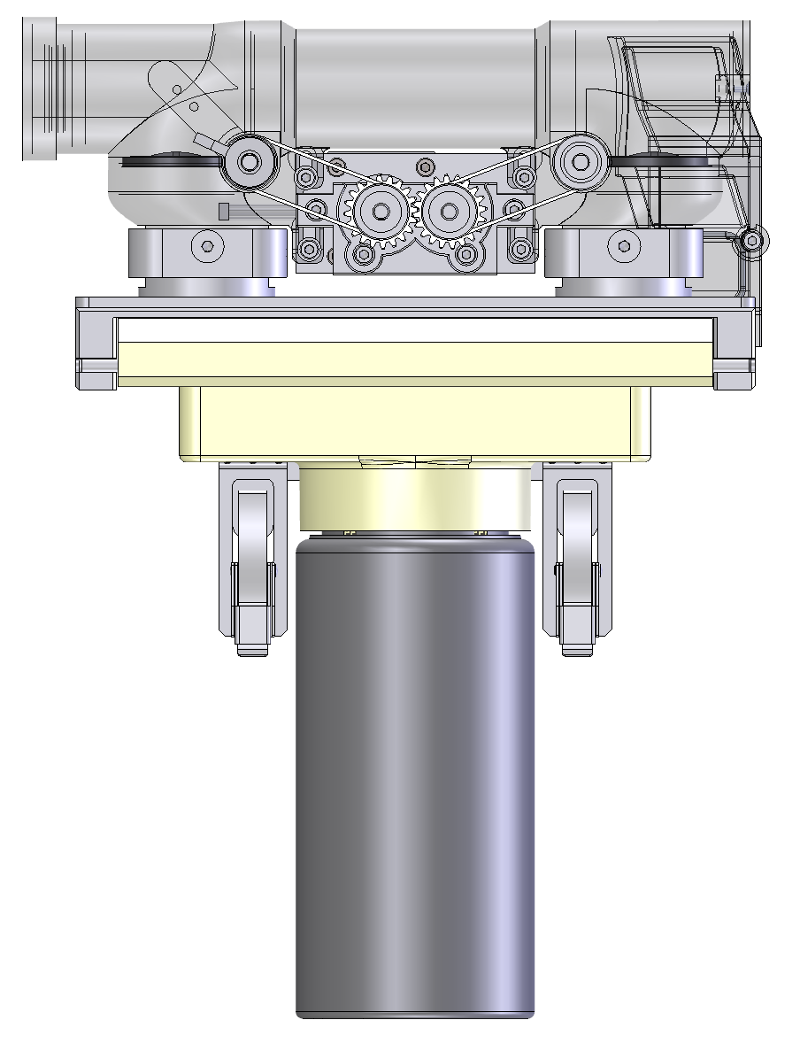
Figure 1: HCF in Closed Position and Air Flow Direction

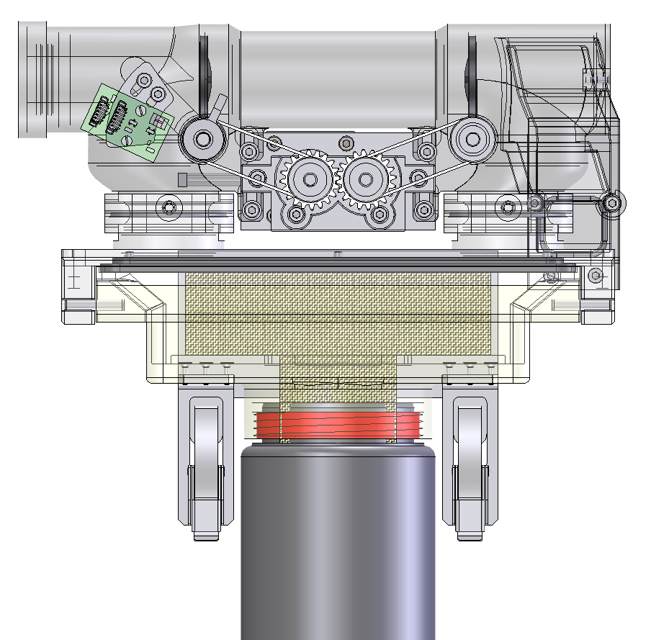
When the humidity control set point is selected, the HCF will open (Figure 2), guiding the warm air over a Millipore water-saturated T-Sponge where the top is finned as to increase the exposed surface area, and the water evaporation coefficient (Figure 3). The humid air will be fed into the sample chamber until the humidity setpoint has been reached, as measured by a sensor. At this point, the system will attempt to maintain the setpoint by controlling the position of the HCF with an 0.01-degree angle increment resolution using PID control.
Figure 2: HCF in Open Position and Air Flow Direction

Figure 3: T-Sponge Detail

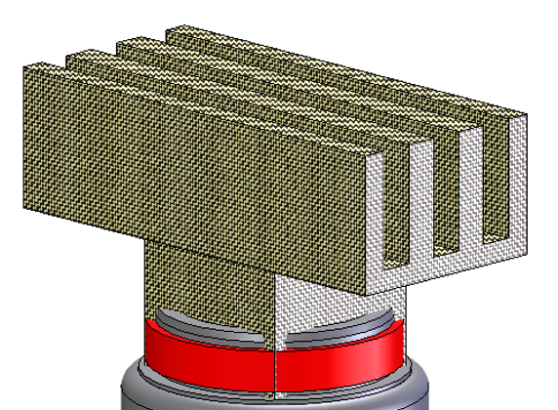

In the abstract, the control system mirrors that of a standard feedback loop as in Figure 3. The reference input is the setpoint is 80% relative humidity. The error detector or comparator will measure the deviation between the setpoint and the measurement output/feedback signal from the humidity sensor located in the sample chamber which makes up the feedback loop. This will produce an error signal to the controller which will respond with an appropriate actuating input or corrective action based on Proportional, Integral and Derivative Gain terms (Figure 4). The Corrective action is then sent to the Process/Plant, comprised of the Sample chamber and an actuator, in this case being the humidity control flaps which will open or close depending of the deviation from the set point. The culmination of these elements produces a controlled variable of the sample chamber humidity.

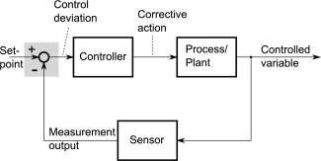
Figure 4: Feedback Loop Control System (Haidekker, 2020)

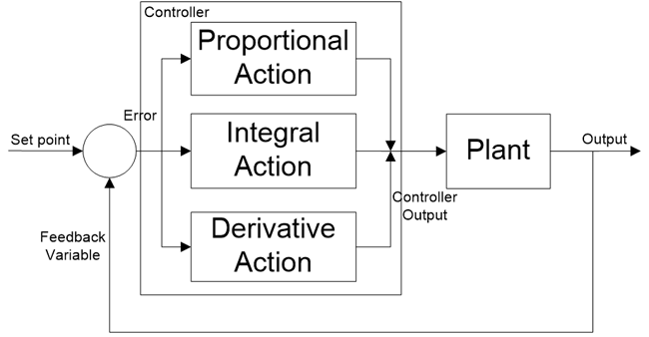
Figure 5: PID Control Block Diagram (Kansagara, 2018)

Sampling Times
Depending on the importance of the Controlled Variable, defined by the risks associated with its failure, the sampling time will vary. According to Isa and Hamza (2014) an increased sampling time produced an increased settling time. The increased settling time is an anticipated effect as a decreased sampling time resolution will delay the sensor feedback signal reaching the controller thus impeding the corrective action potency. Liu et al. (2011) concisely confirm this rhetoric explaining that increased sample time in networked control systems produce a data transmission delay causing actuators to operate based on outdated control signals, negatively affecting performance.

Improvement Opportunities
The PID control systems utilises a communication protocol called Controlled Area Network (CAN) bus to facilitate communication between the control system elements. This system is selected for microscopy instruments as it is robust and resistant to external disturbances in the form of electrical noise (Ma et al., 2009), (Merchut, 2021). A vital characteristic in a confined environment where multiple technologies are situated including motors with fluctuating AC voltages in the cabling, this fluctuating voltage produces an Electromagnetic Field (EMF) that can induce a small voltage in the nearby communication cabling which will manifest as signal noise. Correct spacing, cable routing, and shielding methods such as ferrite cores are methods of mitigating the effects of the EMF.
Another benefit of the CAN bus system is the ability to add components such as sensors and actuators to the system with relative ease (Thompson et al.,1999). Due to this system design, taking advantage of improvement opportunities is possible. The graph shown in Figure 6 reflects the instrument relative humidity against HCF position over time. The PID Control system will adjust the HCF to ensure that the setpoint can be reached. However, there is potential for the Humidity Control system to fail as the HCF position is not continuously monitored. The system has an inductive proximity sensor, colloquially known as a Homing Flag and Light Barrier Sensor. The system design of stepper motors connected to the HCF via tensioned belts, has a shortcoming of positional slip and offset error from backlash in the gear and belt mechanisms. Over time, due to continual, minute slip, the HCF may not be synchronous regarding its anticipated and actual position therefore unable to correct itself as this disparity will not be highlighted by homing sensor. This could lead to increased ramp times from the flap not being fully opened when it is expected to. Inversely the system could still be humidifying the sample chamber environment, even when the humidity system is shut off. Figure 7 shows a system that has condensation in the chamber after the drying procedure a typical issue for Humidity enabled microscopy systems and laboratory environments (Postolache et al., 2006), (Veldscholte and de Beer, 2022). This is erroneous as the HCF are not maintaining the setpoint and produces condensation that can gather on imaging optics, obscuring experiment images.
Furthermore, contrary to a typical PID control system, the humidity system described only engages PID Control once the set point has been achieved. For the control system to calculate its position to produce a control action, the HCF must fully close for the Light Barrier to be broken to know its relative position, shown in Figure 6. This results in a negative deviation from the setpoint and a larger control action to reach the setpoint again. This problem is an additional motivator for using an Absolute Rotary Encoder, as once the setpoint is achieved, it does not have to return to its homing position and move incrementally from there. Alternatively, engaging PID control from when Humidity Control is initiated will ensure that the HCF incremental position away from home does not have to be recalculated. However, engaging PID control from the selection of the setpoint is engaged, will require additional PID gain tuning.
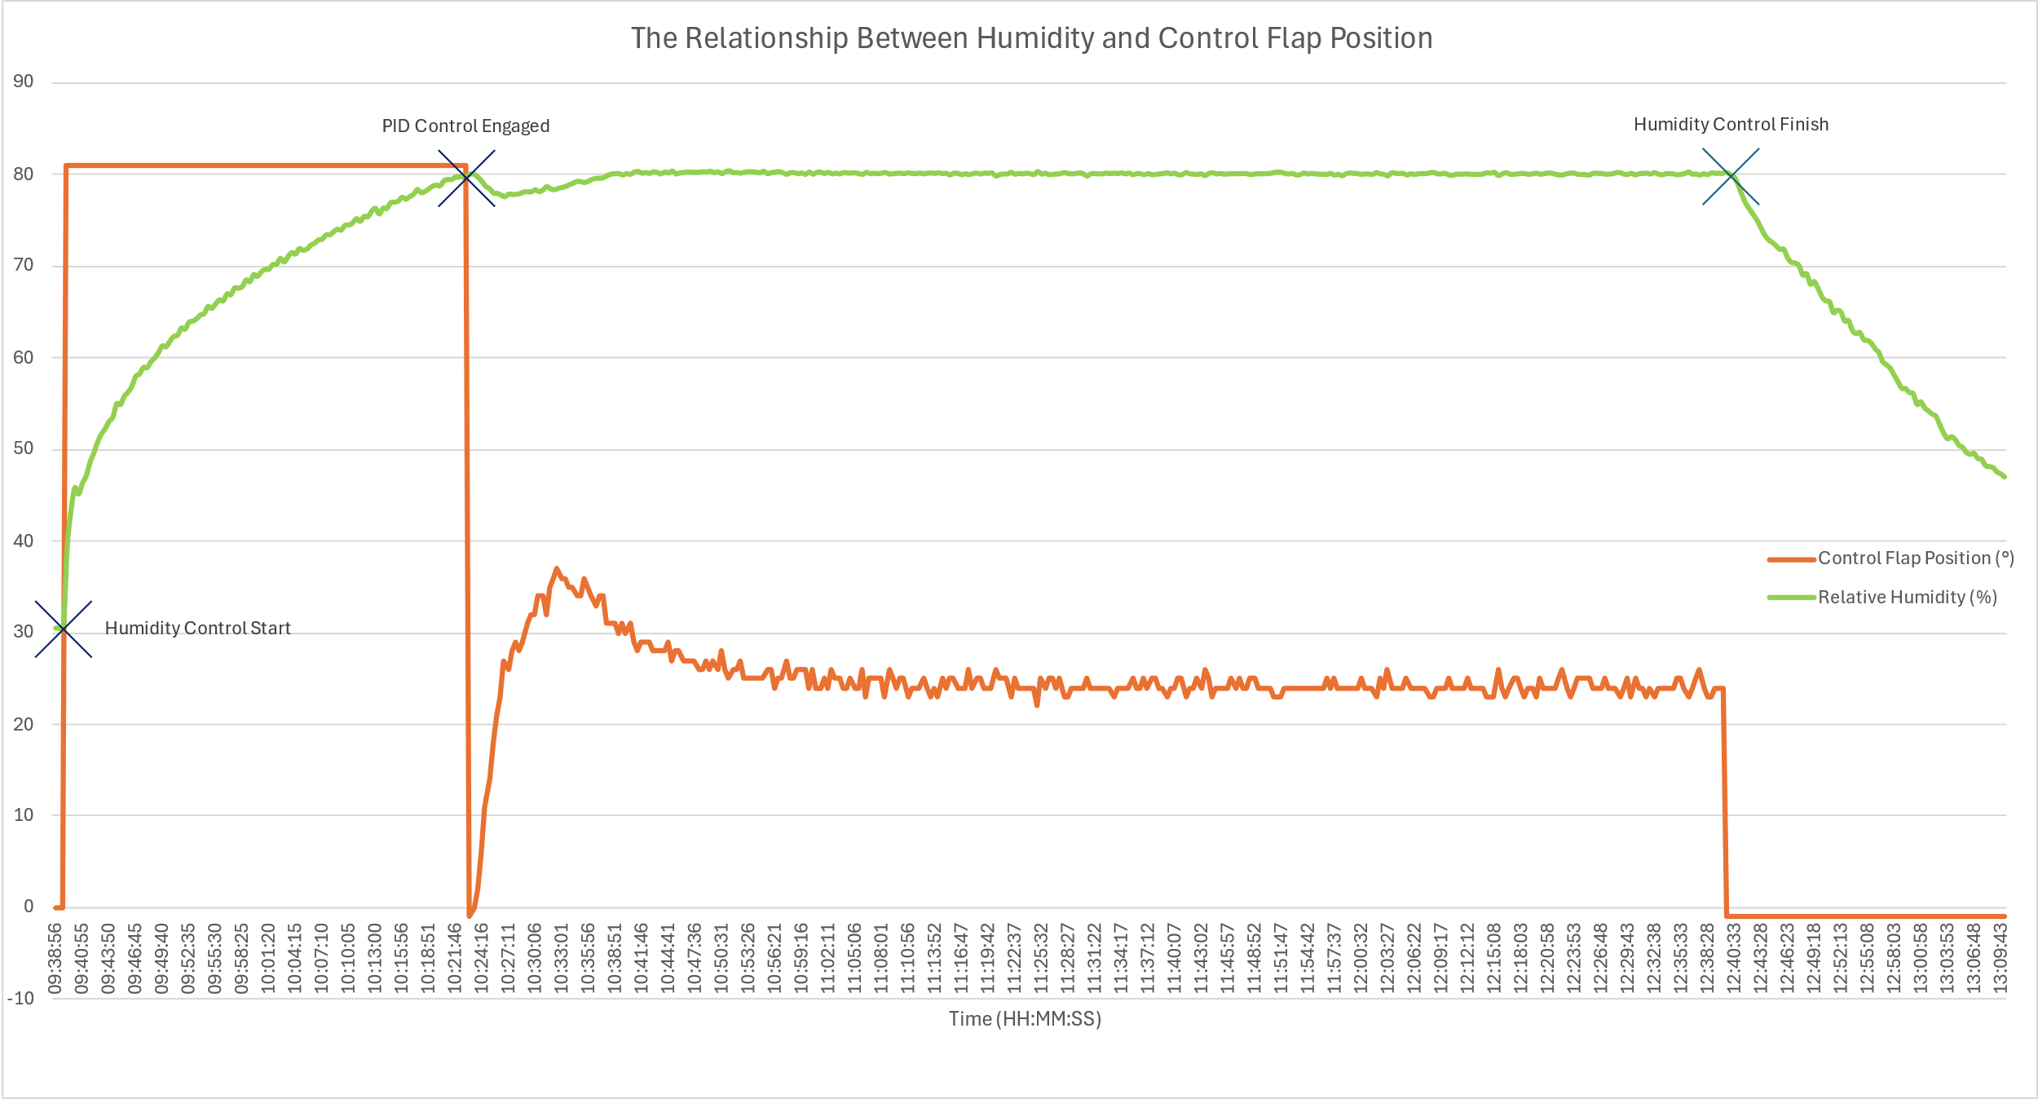
Figure 6: Relative Humidity Vs. HCF Position
Figure 7: Relative Humidity Vs. HCF Position of an Erroneous System

Conclusion
To conclude, the Opera Phenix Plus Confocal Microscopy instrument maintains cell longevity and structure during rigorous testing by utilising C02, temperature and humidity control systems. This robust albeit somewhat archaic system for controlling relative humidity saturation in the sample chamber uses Proportional, Integral and Derivative (PID) control to ensure that the humidity setpoint is consistently maintained.
As this report highlights, despite the system’s efficacy, it is not devoid of potential flaws, such as positional slip and offset error due to backlash in the gear and belt mechanisms affecting the instrument accuracy over time. Furthermore, the need for the Humidity Control Flaps to fully close for position recalibration introduces humidity deviation from its setpoint. However, the system utilising a CAN bus system means that additional technologies to remedy these problems can be integrated seamlessly.

Task 2

Introduction
For Task 2, the analysis and implementation of a PID-controlled Cruise Control System coded using MATLAB has been undertaken. The analysis includes a description of the encoding and decoding functions within the control script for the Cruise Control System, as in Appendix 2.
The Cruise Control system has been tuned to achieve an appropriate response to the setpoint input by the user and devoid of any errors such as zero steady state error (ESS) and oscillations. This will be achieved by evaluation, research and manipulation of the controller PID gain terms. Additionally, the maximum system delay and the minimum number of bits will be identified to achieve reasonable performance.

Encoding and Decoding Functions
The purpose of encoding sensor inputs is to allow the continuous analogue signal to be compressed into a standard digital, discrete digital format (binary) so that it can be transmitted over a digital bus, most likely a CAN bus in a vehicle cruise control system (Ngo et al., 2022). This quantized signal arrives at the controller in a format that it can process. This signal is then decoded, which is converting the received binary signal back into an analogue signal for actuation or further processing. The benefit of encoding signals produces data in a standard language that can be processed by means of decoding by all components in the system; a vital characteristic in a vehicle that customarily utilises a CAN bus where many elements of the system are interconnected (Liang & Popovic, 2001). For example, a car may use wheel speed data to not only control the cruise control system but additionally, the steering wheel resistance, suspension stiffness and active-aerodynamic systems, all of which will adapt to changing vehicle speeds. If the wheel speed data was not encoded prior to entering the communication, each of the individual control systems for these vehicle systems must decode this data individually, which is an inefficient process and could introduce bottle necks and processing delays into the system.

Sensor Signal
The function in Figure 8 simulates the vehicle dynamics such as throttle settings, gear ratios, vehicle mass and converts wheel speed input in rads/s into MPH to compute the real velocity “velocity_real”. This velocity is encoded into a Binary format “velocity_raw” using the “dec2bin” MATLAB function, converting the analogue data signal output from the sensor (Figure 9).
Figure 8: getRawVeloctiy Function
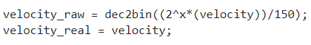
Figure 9: Sensor Signal Encoding

Demand Signal
In the “getRawVelocityDemand” function (Figure 10), the velocity “demand” is mapped to a specific binary signal based on the current simulation time “j*sim_step”, then encodes the signal into a binary format using the code in Figure 11.
Figure 10: getRawVelocityDemand Function
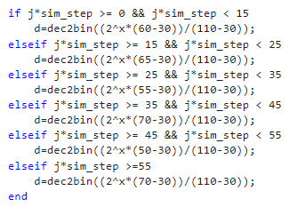
Figure 11: Demand Signal Encoding
This Binary signal for the demand is then decoded back into the velocity value, shown in Figure 12, where “demand_raw” is decoded from a binary format and called to the velocity range: “min_demand” and “max_demand”.
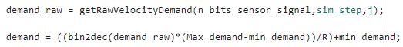
Figure 12: Demand Signal Decoding

Actuator Signal
The control signal computed by the PID controller logic is encoded into a Binary format “control_raw” for communication to the actuator (Figure 13). This ensures that the control signal will fit within the user defined Binary levels, represented as “R” or “2^n_bits_actuator_signal”, in this case set to 16-bits.
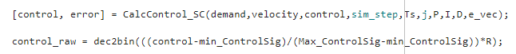
Figure 13: Actuator Signal Encoding
The binary signal “u_raw” received by the actuator is decoded back into an analogue control value “u” to produce an output in the function “sendControlCommand” (Figure 14).
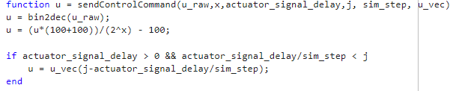
Figure 14: Actuator Signal Decoding

PID Tuning
Originally, the Zieglar-Nicols tuning method was to be used to tune the PID controller. This is where the first step is to zero the integral and differential gains and subsequently increase the proportional gain until the system is unstable (Ellis, 2012). An unstable system is categorised by oscillations around the setpoint with an equal amplitude. However, this specific requisite was not achievable, as this method is for mainly applied to preliminary PID tuning with only a single setpoint (Bennett et al., 2023). As the Cruise Control System changes its setpoint it was difficult to achieve the equal amplitude after each setpoint change.
Therefore, the Trial-and-Error methodology outlined by Aras et al. (2014) was followed. As such, the Proportional gain term was increased until a graph mirroring the driver demand was achieved (Figure 15), albeit an unstable real velocity, with overshoot and offset error (ESS).
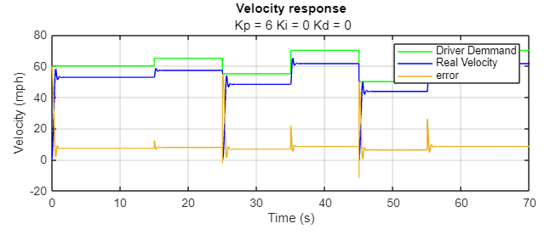
Figure 15: PID Controller Tuning Kp = 6, Ki = 0, Kd = 0
To alleviate the offset error produced, the Integral Gain term must be increased (Webb and Reis, 1999). The Integral Gain considers the accumulation of error over time. In Figure 16, it is visible to see where this come into effect, correcting the ESS compared to the set point. However, the overshoot characteristic remains.
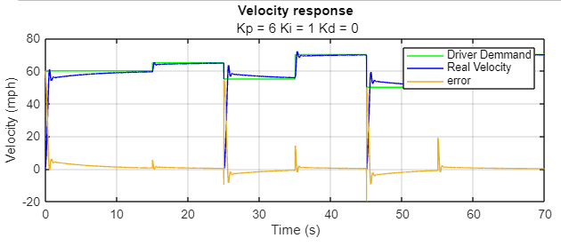
Figure 16: PID Controller Tuning Kp = 6, Ki = 1, Kd = 0
The Integral Gain could not be increased higher than 1 due to the effects of Integral Windup. This is due to the Integrator term considers the sum of the error over time, if the error cannot be corrected, the error sum will continue to increase unchecked, producing an overshoot as in Figure 17. This is caused by actuator saturation, where the throttle response has reached its maximum, as in Figure 18 (Maani et al., 2023).
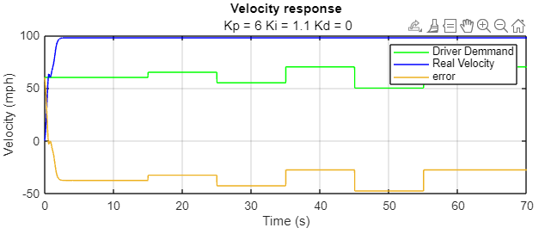
Figure 17: PID Controller Tuning Kp = 6, Ki = 1.1, Kd = 0
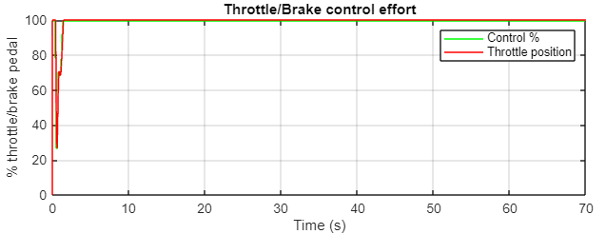
Figure 18: Actuator Saturation due to Integral Windup

The implementation of Derivative gain is used to increase system stability around the set point and reduce settle times (Ellis, 2002). These negative characteristics are not present in Figure 16. However, the initial peak indicates that the Proportional Gain term is too high (Sharma, 2017). Slowly reducing this term, a stable cruise control system was achieved.
It was found that a Proportional Gain term set between 0.6 and 0.8 produced the best characteristics for a cruise control system. Figure 19 shows a gain setting of 0.8 which eliminated any overshoot, however, the ramp up gradient tapers exponentially just prior to reaching the set point, delaying setpoint actualisation. Whereas in Figure 20, a 0.6 gain setting was used and produced a manipulated variable that had very slight overshoot but removed the tapering velocity effort and achieved a faster response.
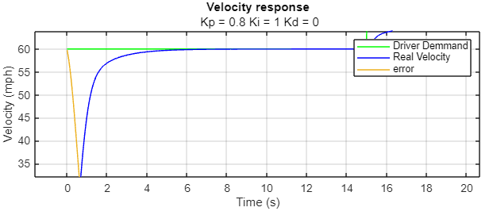
Figure 19: PID Controller Tuning Kp = 0.8, Ki = 0, Kd = 0
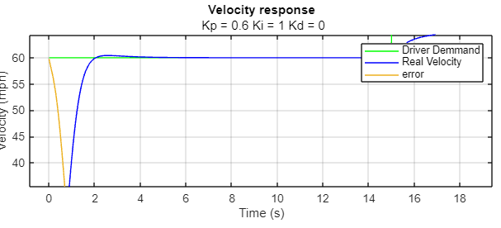
Figure 20: PID Controller Tuning Kp = 0.6, Ki = 0, Kd = 0

In a vehicle cruise control system, overshoot can be difficult to control. Once the acceleration effort has been applied to bring the vehicle speed up to the setpoint, the mass of the vehicle will continue driving, even after the driving effort has ceased. Significant overshoot can lead to exceeding speed limits and decreased vehicle control. To mitigate overshoot, the highest Proportional gain term that produced no overshoot was selected, as in Figure 21. An increased ramp up time is an unwanted feature in many PID control systems. However, in a cruise control system, this not only prevents exceeding the setpoint, but beneficially has a less aggressive acceleration gradient meaning a more comfortable driving experience (Cryan, 2004).
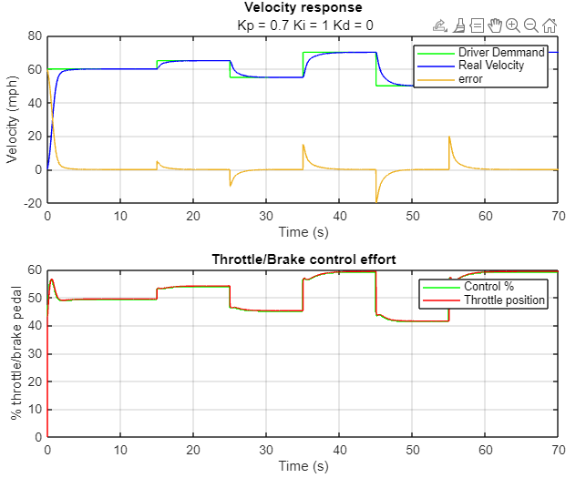
Figure 21: PID Controller Tuning Kp = 0.7, Ki = 0, Kd = 0
It is important to note that graphically analysing control systems using software is useful to gain insight of how the system will respond to idealistic parameters. However, this does not take real world disturbances, system degradation and changes such as differences in vehicle inertia, weight changes, temperature sensitivity, acceleration, drag and system delay into account. Observing the graphical representation of the PID control system (Figure 21), it looks well-tuned and adjusted. However, it is achieving the 60mph setpoint within 3 seconds at less than 60 percent throttle effort, a problem Manju Prasad and Inayathullah (2021) similarly encountered when simulating control systems. This implausible response is likely due to a control script inaccuracy as decreasing the Proportional Gain should reduce system responsivity, but does not (Bolton, 2004).

Sampling Times and Delay

Using the PID controller gain terms as detailed above produced a stable control system. Therefore, other areas of control system tuning could be investigated with this Velocity and Time graph as a benchmark. The minimum sampling time and number of bits are to be evaluated.
The sampling time for the PID control system was set to 0.05 seconds, already more than the 0.01 sampling time used in typical cruise control system (Davis, 2012). Increasing the sampling time to 0.1 second introduced overshoot errors instantaneously at every controlled variable change (Figure 22).
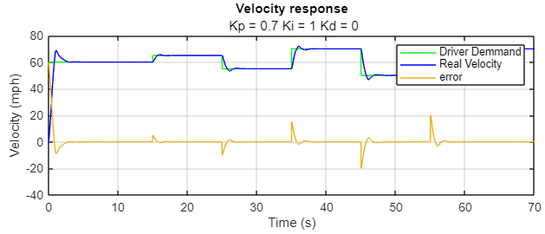
Figure 22: PID Controller Tuning 0.1s Sampling Time

Increasing the sampling time introduced poor control system performance as the delay between sensor readings introduces a delay in the data transmission to the control system. Highlighted in Figure 23, the increased delay in sensor readings where the Real Velocity intersects the Driver Demand (Setpoint) the control systems functions introducing their remedial actions are based on outdated information, which then reduces the Real Velocity down to the setpoint, where it remains stable as the Driver Demand is unchanged. (Hamza, 2014), (Liu et al., 2011).

Reducing the number of bits in the system by an Octet to 8 bits introduced oscillations and ESS, this is due to quantising error. Whereby, when the standard continuous analogue signal is discretised, it will be rounded to a binary integer, in this case to 8 binary levels. This is known as truncation, and the reduction in accuracy indicates that the continuous data provided by the sensor exceeds that of data carrying capacity of an 8-bit network, creating poor control system conditions as it is working on an incomplete data set. (Slaughter, 1964), (Jothin et al., 2020).
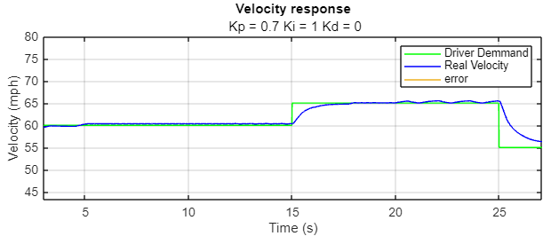
Figure 23: PID Controller Tuning 8-Bit
The number of bits or system resolution suitability will be selected based upon the cost of upgrading the system components versus the relative risk to the user should data inaccuracies occur. On this premise, it could be argued that a 32 or a 64-bit system would be more suitable for the cruise control system compared to the 16-bit system utilised in this script. This is due to the risk to life should there be inaccuracies in the data decoded from quantizing error leading to actuator errors. However, a higher resolution system must transfer larger encoded data packets that can induce system latency from the increased signal processing operations, causing communication network delays. These increased processing times can similarly negatively affect the cruise control systems responsiveness, creating similar, negative control issues to that of the 8-bit system should it not have the necessary memory and bandwidth requirements.
As it could not be ascertained using the MATLAB control script if a 32-bit system would be more than the system requirements and pose data transfer bottle necks, there is no visible difference in performance between a 16-bit and 32-bit operation system, therefore a more cost effective 16-bit option was selected.

Conclusion
The analysis and implementation of a PID-controlled Cruise Control system using MATLAB highlighted the complexities of tuning a PID controller. Underpinning knowledge of each of the PID gain terms’ functionalities was vital in establishing a stable system with no steady state error and devoid of overshoot or oscillation.
Experiments with varying bit counts for signal encoding and decoding functions showed that a 16-bit system provides an adequate compromise between performance and data transfer efficiency. Additionally, adjusting sampling times highlighted the importance of balancing data transmission delays in accordance with system responsiveness.
Although, the simulation of a PID controlled Cruise Control system, is advantageous to visualise expected outcomes. Theoretical models should never be used in place of real-world testing and validation to ensure optimal performance and safety.

References
Aras, M.S. et al. (2014) ‘Development of PID controller tuned by using Ziegler Nichols method for controlling the fluid level in coupled tank system.’, International Conference on Innovative Academic Studies, pp. 32–36. doi:10.59287/icias.1606.

Bennett, J. et al. (2023) 9.3: PID tuning via classical methods, Engineering LibreTexts. Available at: https://eng.libretexts.org/Bookshelves/Industrial_and_Systems_Engineering/Chemical_Process_Dynamics_and_Controls_(Woolf)/09%3A_Proportional-Integral-Derivative_(PID)_Control/9.03%3A_PID_Tuning_via_Classical_Methods (Accessed: 12 July 2024).

Bolton, W. (2004) Instrumentation and control. Boston, MA: Elsevier.

Cryan, M. (2004) Transducers for Modelling Systems, The University of Edinburgh. Available at: https://www.inf.ed.ac.uk/teaching/courses/inf1/cl/notes/Comp1.pdf (Accessed: 12 July 2024).

Davis, L.C. (2012) ‘Stability of adaptive cruise control systems taking account of vehicle response time and delay’, Physics Letters A, 376(40–41), pp. 2658–2662. doi:10.1016/j.physleta.2012.07.019.

Ellis, G. (2002) ‘The luenberger observer: Correcting sensor problems’, Observers in Control Systems, pp. 67–96. doi:10.1016/b978-012237472-2/50005-5.

Ellis, G. (2012) Control System Design Guide using your computer to understand and diagnose feedback controllers. San Diego, CA, USA: Elsevier Science & Technology Books.

Groover, M.P. (2024) Feedback Controls, Encyclopædia Britannica. Available at: https://www.britannica.com/technology/automation/Development-of-robotics (Accessed: 20 July 2024).

Haidekker, M.A. (2020) Linear feedback controls: The essentials. Amsterdam: Elsevier.

Isa, A.I. and Hamza, M.F. (2014) ‘Effect of sampling time on PID controller design for a heat exchanger system’, 2014 IEEE 6th International Conference on Adaptive Science &amp; Technology (ICAST) [Preprint]. doi:10.1109/icastech.2014.7068134.

Jothin, R., Mohamed, M.P. and Vasanthanayaki, C. (2020) ‘High performance compact energy efficient error tolerant adders and multipliers for 16-bit image processing applications’, Microprocessors and Microsystems, 78, p. 103237. doi:10.1016/j.micpro.2020.103237.

Kansagara, R. (2018) PID controllers: Working, structure and tuning methods, What is PID Controller? Learn PID Controller Working, Structure and Tuning Methods. Available at: https://circuitdigest.com/article/what-is-pid-controller-working-structure-applications (Accessed: 12 July 2024).

Liang, N. and Popovic, D. (2001) ‘The can bus’, Intelligent Vehicle Technologies, pp. 21–64. doi:10.1016/b978-075065093-9/50004-9.

Liu, J., Wan, J. and Yan, Y. (2011) ‘Study on CANbus control system-oriented simulation platform based on the node task’, Procedia Engineering, 15, pp. 3984–3988. doi:10.1016/j.proeng.2011.08.746.

Ma, X., An, G. and Li, B. (2009) ‘Design and implementation of an automated microscope stage’, 2009 International Forum on Information Technology and Applications [Preprint]. doi:10.1109/ifita.2009.268.

Maani, F.A. et al. (2023) ‘Particle-based optimization algorithms for longitudinal control of Autonomous Vehicle: A comparative study’, International Journal of Automotive and Mechanical Engineering, 20(2), pp. 10523–10535. doi:10.15282/ijame.20.2.2023.14.0812.

Manju Prasad, M. and Inayathullah, M.A. (2021) ‘Root locus approach in design of PID controller for Cruise Control Application’, Journal of Physics: Conference Series, 2115(1), p. 012023. doi:10.1088/1742-6596/2115/1/012023.

Merchut, B. (2021) Robustness and reliability in can-based networks, Control Engineering. Available at: https://www.controleng.com/articles/robustness-and-reliability-in-can-based-networks/ (Accessed: 07 July 2024).

Ngo, P., Sprinkle, J. and Bhadani, R. (2022) ‘Canclassify: Automated decoding and labeling of CAN bus signals’, Journal of Engineering Research and Sciences, 1(10), pp. 5–12. doi:10.55708/js0110002.

The PID Controller & Theory explained (2024) NI. Available at: https://www.ni.com/en/shop/labview/pid-theory-explained.html (Accessed: 14 July 2024).

Postolache, O. et al. (2006) ‘Dew point and relative humidity smart measuring system’, Proceedings of the 21st IEEE Instrumentation and Measurement Technology Conference (IEEE Cat. No.04CH37510), 55, pp. 2259–2264. doi:10.1109/imtc.2004.1351000.

Sharma, K.L.S. (2017) ‘Automation strategies’, Overview of Industrial Process Automation, pp. 53–74. doi:10.1016/b978-0-12-805354-6.00006-2.

Slaughter, J. (1964) ‘Quantization errors in digital control systems’, IEEE Transactions on Automatic Control, 9(1), pp. 70–74. doi:10.1109/tac.1964.1105624.

Thompson, H.A. et al. (1999) ‘A CANbus-based safety-critical distributed Aeroengine Control Systems Architecture Demonstrator’, Microprocessors and Microsystems, 23(6), pp. 345–355. doi:10.1016/s0141-9331(99)00042-3.

van Laarhoven, K.A., Huinink, H.P. and Adan, O.C. (2016) ‘A microscopy study of hyphal growth of penicillium rubens on gypsum under dynamic humidity conditions’, Microbial Biotechnology, 9(3), pp. 408–418. doi:10.1111/1751-7915.12357.

Veldscholte, L.B. and de Beer, S. (2022) ‘OpenHumidistat: Humidity-controlled experiments for everyone’, HardwareX, 11. doi:10.1016/j.ohx.2022.e00288.

Webb, J.W. and Reis, R.A. (1999) ‘PID Control of Continuous Processes’, in Programmable Logic Controllers: Principles and Applications. Fourth Edition. Upper Saddle River, NJ: Prentice Hall.

Appendices

Appendix 1

1A) Main Control Script
%% MAIN FILE FOR CRUISE CONTROLLER SYSTEM %%

% (1) initialize
% (2) set implementation parameters
% (3) set simulation parameters
% (4) simulation loop
% (5) plot results

%% (1) Initialize %%

clc
clear all
close all
global sim_step u j u_vec
d_vec = []; u_vec = []; y_vec = [];e_vec = [] ; T_vec = [];
P = 0.7;
I = 1;
D = 0;

%% (2) set implementation parameters %%

Ts = 0.05;
min_velocityS =0;
Max_velocityS = 150;
n_bits_sensor_signal = 16;
min_demand = 30; Max_demand = 110;
n_bits_demand_signal = 16;
n_bits_actuator_signal = 16;
R = 2.^n_bits_actuator_signal;

%% (3) set simulation parameters %%

sim_step = 0.01;
sim_time = 70;
T = 0:sim_step:sim_time;
throttle_setting = 0;
actuator_signal_delay = 0.01;
%% Initialise Values %%
min_ControlSig = -100;
Max_ControlSig = 100;
u = 0;
control = 0;
velocity_real = 0;

%% (4) simulation loop %%

for j = 1:length(T)

loops_remaining = length(T)-j
[velocity_raw, velocity_real,throttle_setting] = getRawVelocity(n_bits_sensor_signal,velocity_real,throttle_setting, sim_step,u);
velocity = ((bin2dec(velocity_raw)*(Max_velocityS-min_velocityS))/R)-min_velocityS;
if mod((j-1)*sim_step,Ts) == 0

demand_raw = getRawVelocityDemand(n_bits_sensor_signal,sim_step,j);
demand = ((bin2dec(demand_raw)*(Max_demand-min_demand))/R)+min_demand;
[control, error] = CalcControl_SC(demand,velocity,control,sim_step,Ts,j,P,I,D,e_vec);
control_raw = dec2bin(((control-min_ControlSig)/(Max_ControlSig-min_ControlSig))*R);
u = sendControlCommand(control_raw,n_bits_actuator_signal,actuator_signal_delay,j, sim_step, u_vec);
end

e_vec = [e_vec error];
d_vec = [d_vec demand];
u_vec = [u_vec control];
y_vec = [y_vec velocity_real];
T_vec = [T_vec throttle_setting];
end

%% (5) plot results %%

figure;

subplot(2,1,1)
plot(T,d_vec,'g-');hold on
plot(T,y_vec,'b-');
plot(T,d_vec-y_vec); grid;
title('Velocity response');
subtitle([' Kp = ', num2str(P),' Ki = ', num2str(I),' Kd = ', num2str(D)]);
ylabel('Velocity (mph)'); xlabel('Time (s)');
legend('Driver Demmand','Real Velocity','error')
subplot(2,1,2)
stairs(T,u_vec,'g-');
hold on;
plot(T,T_vec,'r-'); grid;
title('Throttle/Brake control effort');
ylabel('% throttle/brake pedal'); xlabel('Time (s)');
legend ('Control %','Throttle position')

1B) Send Control Demand
function u = sendControlCommand(u_raw,x,actuator_signal_delay,j, sim_step, u_vec)
u = bin2dec(u_raw);
u = (u*(100+100))/(2^x) - 100;

if actuator_signal_delay > 0 && actuator_signal_delay/sim_step < j
u = u_vec(j-actuator_signal_delay/sim_step);
end

1C) Get Raw Velocity Demand
function [d]=getRawVelocityDemand(x,sim_step,j)
%% simulate driver's velocity demand (in mph)

if j*sim_step >= 0 && j*sim_step < 15
d=dec2bin((2^x*(60-30))/(110-30));
elseif j*sim_step >= 15 && j*sim_step < 25
d=dec2bin((2^x*(65-30))/(110-30));
elseif j*sim_step >= 25 && j*sim_step < 35
d=dec2bin((2^x*(55-30))/(110-30));
elseif j*sim_step >= 35 && j*sim_step < 45
d=dec2bin((2^x*(70-30))/(110-30));
elseif j*sim_step >= 45 && j*sim_step < 55
d=dec2bin((2^x*(50-30))/(110-30));
elseif j*sim_step >=55
d=dec2bin((2^x*(70-30))/(110-30));
end

1D) Calc Control Script
function [ControlOut, error] = CalcControl_SC(demand,velocity,control,sim_step,Ts,j,P,I,D,e_vec)

persistent Prev_I_part
Min_ControlSig = -100;
Max_ControlSig = 100;

error = demand - velocity;

if j >1
prev =e_vec(j-(Ts/sim_step));
else
prev = control;
Prev_I_part = prev;
end
P_part = error*P;
I_part = (((error+prev)/2)*(Ts)+Prev_I_part)*I;
D_part = ((error-prev)/Ts)*D;

ControlOut = P_part+I_part+D_part;

Prev_I_part = I_part;

if ControlOut > Max_ControlSig
ControlOut = Max_ControlSig;
end

if ControlOut < Min_ControlSig
ControlOut = Min_ControlSig;
end

end

1E) Get Raw Velocity
function [velocity_raw, velocity_real,throttle_setting] = getRawVelocity(x,old_velocity,~,sim_step,u)

h = sim_step;
throttle_setting = u;
persistent d v_dot x_v v_dot_last x_v_old

if isempty (d)
d = 1;
x_v_old = 0.25;
v_dot_last = 0;
end

gear = 1.2;
final_drive = 2.82;
rs_to_rpm = 9.549;
mps_to_mph = 2.2369;
radius = 0.3;
cd = 0.29;
roh = 1.23;
area = 2;
mass = 1824;

if abs(throttle_setting) > 100
throttle_setting = 100;
end

if throttle_setting < 0
brake = abs(throttle_setting);
throttle_setting = 0;
else
brake = 0;
end

wheel_speed = (old_velocity / mps_to_mph) / radius;
engSpeedRPM = wheel_speed * rs_to_rpm * gear * final_drive;

x_v_dot = (-10 * x_v_old + 0.05 * (throttle_setting));
x_v = x_v_old + x_v_dot*h;
x_v_old = x_v;

engSpeedRPM = 528.7 + (engSpeedRPM * 0.152) + (-0.0000217 * engSpeedRPM^2);
engine_torque = x_v * engSpeedRPM*gear * final_drive;

v_dot = ((engine_torque / radius) - (cd * roh * area* 0.5 * old_velocity^2) ...
- (0.05 * mass * 9.81) -(brake * mass * 9.81)) / mass;

acc = v_dot + (h / 2) * (v_dot - v_dot_last);
v_dot_last = v_dot;
velocity = old_velocity + acc;

if velocity < 0 || isnan(velocity)
velocity = 0;
end
if velocity > 150
velocity = 150;
end
throttle_setting = throttle_setting + brake;

velocity_raw = dec2bin((2^x*(velocity))/150);
velocity_real = velocity;

