NX CAD Exercise 1
Guidance Notes

We have studied most of the tools, techniques and strategies which are required to model the component detailed in the NX CAD Examples. The exercises have been designed to allow you to self evaluate how well you understand the content of the tutorials which you have completed.

Remember, the tutorials are used as a vehicle to demonstrate tools and techniques. Reaching the end of a tutorial by reading each step and going through the motions is unsatisfactory. Regularly ask yourself, do I really understand what I have done? If you don’t, ask the lecturer for assistance and spend time going through the tutorial again, carefully reading the tutorial notes.

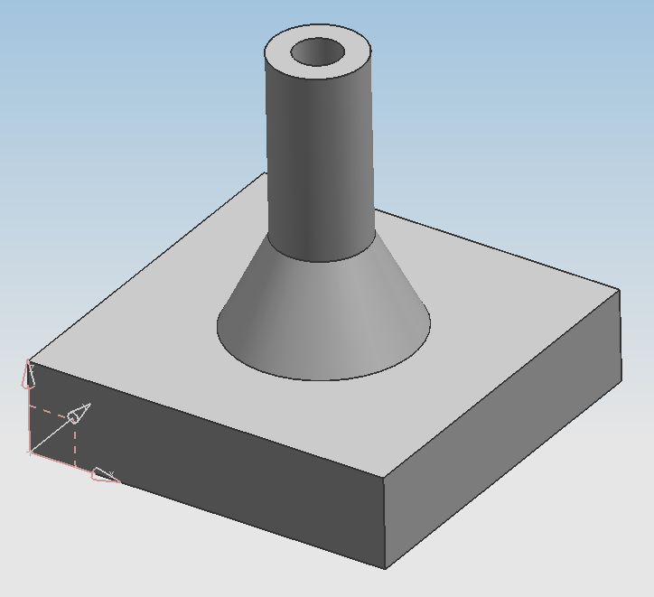

- Use the ‘Primitive’ Block creation tool to create the base of the component.

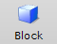

The Block Icon

Remember – if the modelling tool which you want to use is not accessible on the ‘Tool Bar’, use ‘add and remove buttons’ to make the modelling tool visible.

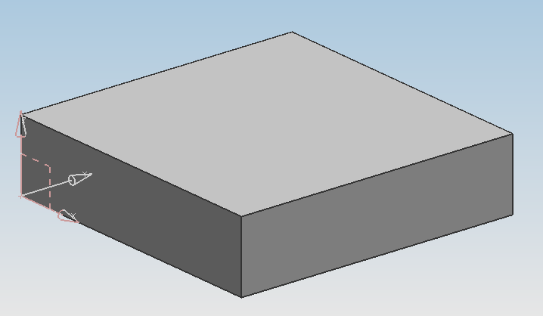

The Base of the Component

- Create a Datum Plane which is positioned half way between the two (small) side faces.

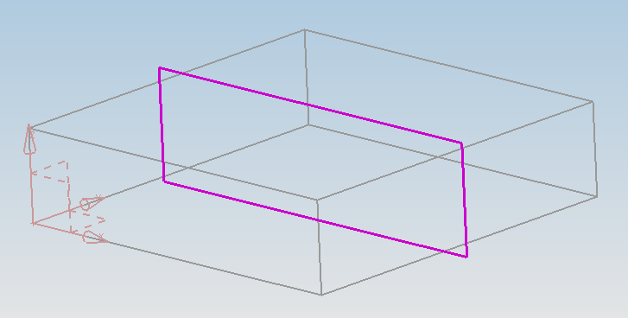

The Base (With Datum Plane)

Hint – Ensure that ‘Inferred’ is selected on the ‘Datum Plane’ dialogue box before picking the surfaces which will define the position of the plane.

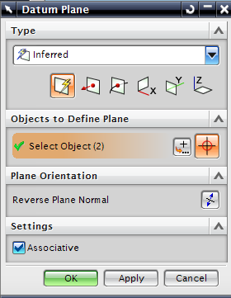
Ensure that ‘Inferred’ is selected

The Datum Plane Dialogue Box

Remember – If two parallel faces are picked to define a datum plane, the resulting plane will be positioned half way between the two faces.

- Sketch the cross section of the conical/cylindrical feature on the datum plane which was created in the previous step.

Remember – Once the ‘Sketch’ icon has been selected, a plane to sketch on needs to be selected (the cue line will prompt you for this). You should select the datum plane as the plane to sketch on.

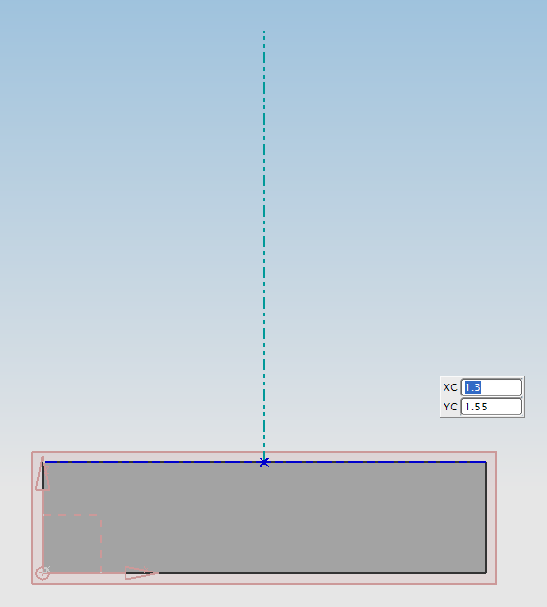
End point for the line
Start point for the line

Creating the Vertical Centre Line

Sketch a vertical line, making sure that the start point for the line snaps onto the centre of the block. This line will be used to define the centre of the cylindrical/conical feature.

Deselect the line command (by selecting ‘Escape’ or by clicking on the ‘Line’ icon again).

Move the mouse pointer over the line which you have just created and use MB3 (right hand mouse button) to select ‘Convert to/from Reference’

Do not click on ‘Finish Sketch’ yet.

Use the ‘Profile’ tool to create the cross section of the cylindrical/conical feature. In the next step, you will revolve this cross section about the centre line which you created in the previous step.

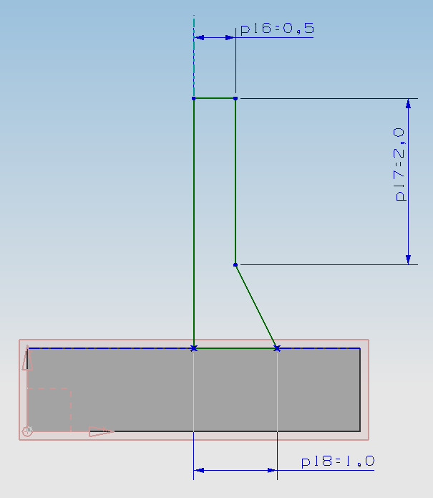

Sketch of Cylindrical/Conical Cross Section

Select ‘Finish Sketch’ to re-enter the ‘Solid Editing’ or ‘3D Modelling’ part of the package.

- Use the ‘Revolve’ tool to create the cylindrical/conical feature from the ‘Sketch Section’ which you created in the previous step.

Remember
When the Cue Line reads “Select Planar Face to Sketch or Select Section Geometry” you are required to select the cross section which you wish to revolve.

Once the cross section is selected, it will change to an orange colour. In order to fully select the cross section, you must click MB2 (the middle mouse button). The cross section should then turn light blue and be labelled ‘Section’.

The ‘Cue Line’ will then read “Select Object to Infer Vector”. The “Object to Infer Vector” is the line or axis about which you wish to revolve the cross section. You will need to select the vertical reference line which you created in the previous step.

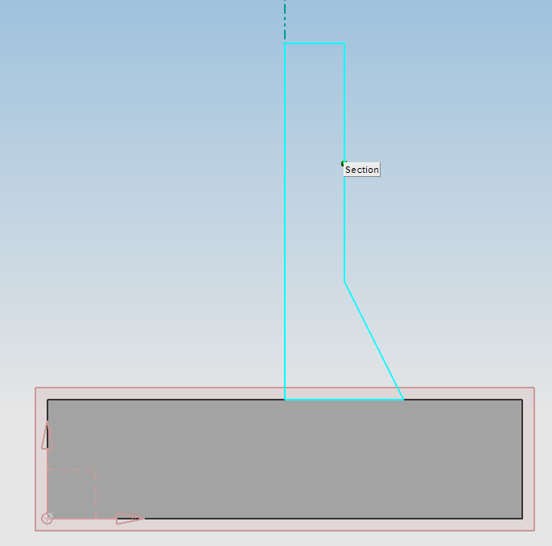
Section
Geometry
(Cross Section)
Object to Infer Vector

Selecting the Section Geometry and the Object to Infer Vector

In the ‘Revolve’ dialogue box, set the ‘Start Angle’ to 0° and the ‘End Angle’ to 360°. In order to join the resulting cylindrical/conical solid body onto the square base (Block), change the ‘Boolean’ setting to ‘Unite’.

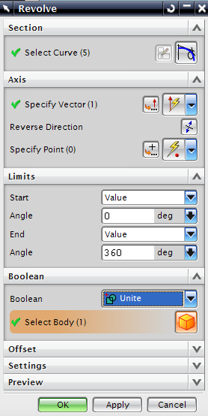
Boolean should be set to Unite
Start Angle = 0°
End Angle = 360°

The Revolve Dialogue Box

OK the ‘Revolve’ dialogue box.

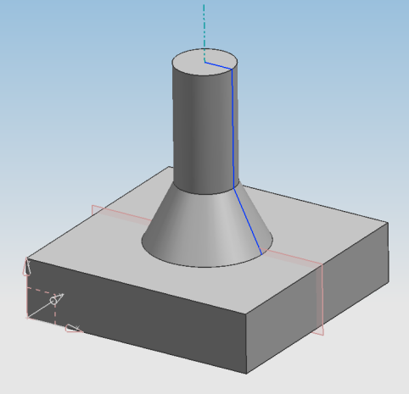

The Cylindrical/Conical Feature United With the Block Base

- To cut a hole through the centre of the part, select the ‘Hole’ tool and choose ‘Simple Hole’.
Following the prompts in the ‘Cue Line’, select the top face of the cylinder as the ‘placement Face’ and select the lower face of the block base as the ‘Thru Face’. You have now specified that the hole will go all the way through the part from the top of the cylinder to the bottom surface of the base.

Using the ‘Diameter’ field in the ‘Hole’ dialogue box, input a hole diameter of 0.5mm. Don’t worry if the hole appears to be previewed in the wrong position, we will align it in the next dialogue box.
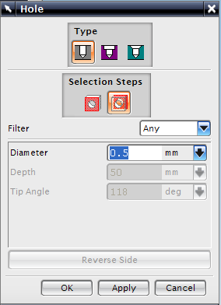
Diameter = 0.5mm
Simple Hole

The ‘Hole’ Dialogue Box

Click on OK to open the ‘Positioning’ dialogue box.

Choose ‘Point onto Point’ as the positioning method and then select the edge where the cylindrical face meets the flat end face of the cylinder. Choose ‘Arc Centre’ from the menu. The hole should reposition and cut through the whole component.

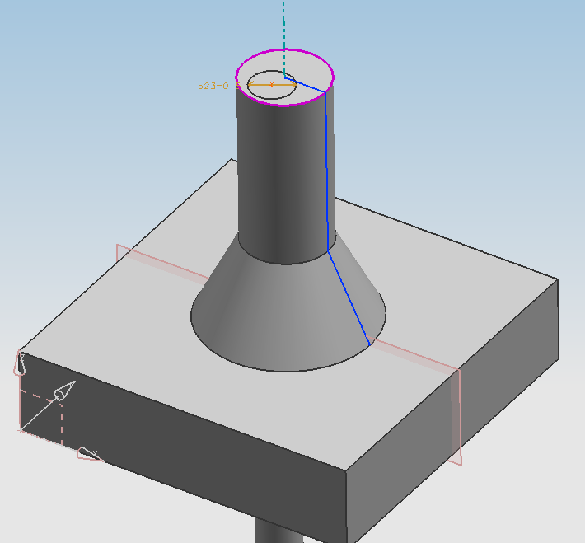
Select this
edge to position the hole.

Selecting the Edge where the Cylindrical Surface meets the End (Flat) Face

The Finished Component

