

MASTER OF BUSINESS ADMINISTRATION PROGRAMME

LCMB7035 - DISSERTATION

TOPIC: EVALUATION OF THE EFFECTIVENESS OF CHATBOTS IN DIGITAL MARKETING AND CUSTOMER SERVICE INTERACTIONS IN THE E-COMMERCE SECTOR

Student ID: 2427130
Name: Dixit Pipaliya
Date :11th November 2025

Table of Contents
1. Introduction 3
1.1 Introduction 3
1.2 Problem statement 4
1.3 Rationale and significance of the research 4
2. Literature review 5
2.1 Role of chatbots in DM and customer service interactions 5
2.2 Influences of chatbot practice in DM on purchaser satisfaction and faithfulness 6
2.3 Issues connected to chatbots in DM and purchaser support 7
2.4 Theoretical underpinning 8
2.5 Literature gap 8
3. Methodology 9
3.1 Research paradigm 9
3.2 Research strategy 9
3.3 Data collection and analysis 10
3.4 Ethical consideration 10
4. Expected findings 11
5. Limitations 11
6. Timeframe 12
7. Conclusion 12
References 14

1. Introduction

1.1 Introduction
In this digitalised epoch, marketing and customer service have been revolutionized with the integration of advanced technologies. Chatbots are automated conversational agents that use AI (Artificial Intelligence) and NLP (Natural Language Processing) and have become essential to contemporary marketing operations (Shrivastava et al. 2025). As businesses tried to satisfy consumer aspirations for immediate, round-the-clock assistance and customised digital experiences, their use grew rapidly. Likewise, they are employed in DM (Digital Marketing) for interaction, lead generation, and customised product suggestions (Huseynov, 2023). They manage frequently asked questions, automate repetitive processes, and lower operating expenses in customer support. However, while using it in DM and client service, the primary concern centres on comparing their potency in meeting marketing objectives, and providing positive customer experiences against possible drawbacks, including the inability to handle complex enquiries with factuality, ensure security, or a lack of human empathy.
Aim and objectives
The study aims to assess the potency of chatbots in DM and client service interactions in the e-commerce sector.
Objectives:
- To analyse the function of chatbots in DM and customer service interactions in e-commerce industry
- To evaluate the impacts of chatbot usage in DM on client satisfaction and loyalty in e-commerce industry
- To recognise the issues linked with chatbot applications in DM and client service interactions in e-commerce industry
- To offer advice for overcoming issues related to chatbot application and boost its usefulness
Research questions
- What is the function of chatbots in DM and customer service interactions in the e-commerce industry?
- How does the use of chatbots in DM impact consumer satisfaction in the e-commerce industry?
- What are the difficulties associated with using chatbots in customer care and DM interactions?
- What are the best practices that companies should implement to overcome problems with chatbot use and increase its usefulness?

1.2 Problem statement
Regardless of acknowledging the advantages of using chatbots in DM as well as elevating client satisfaction, difficulties related to guaranteeing security, factuality, and showing empathy while offering customer service (Tanase, 2024). Despite investing in chatbots, businesses lack focus on the actual effects of using this technology on their client satisfaction in the long run. With respect to this, the problem statement of the research is to analyse the actual potential of chatbots in terms of elevating client service interactions and the outcomes of DM.

1.3 Rationale and significance of the research
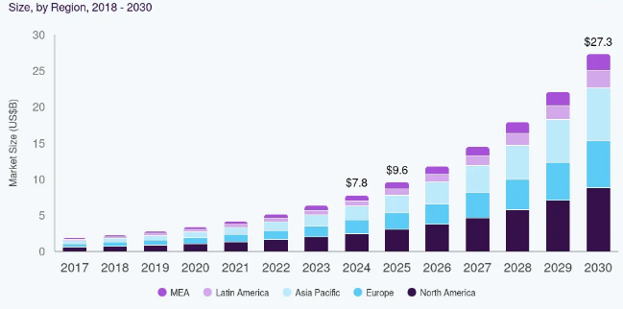
Figure 1: Growth of chatbot usage worldwide
(Source: Grandview Research, 2025)
In the contemporary corporate landscape, e-commerce businesses in different industries have been positively embracing AI-powered chatbots in their digital marketing and customer service operations. This is because this automatic tool allows them to enhance the engagement of clients and generate leads through 24/7 services or offering support in real-time (Grandview Research, 2025). Conversational interaction with clients through chatbots on social networking sites, messaging apps, and websites enhances client engagement. As a result, by ensuring a personalised experience for clients through the use of chatbots, businesses enhance customer satisfaction and loyalty. In support of this, the global market size of using chatbots has been increasing at a rate of 23.3%, which makes it around $9.6 billion and is predicted to be a $27.3 billion market (Grandview Research, 2025).
However, notwithstanding the benefits of utilising chatbots for direct messaging and increasing customer happiness, there are challenges in ensuring security, factuality, and empathy when providing customer support (Huseynov, 2023). For example, an e-commerce organisation, Amazon, faced issues related to the factuality of information or services to customers with its chatbot Rufus, which led to client dissatisfaction. The foremost criticism regarding “Rufus” is that it recurrently makes erroneous product advice, is incapable of directing intricate queries, and is not incorporated with order tracking and other indispensable buyer support features (Myers, 2024). Therefore, there is an obvious gap in practice, while using chatbots in DM and shopper service, as over-focusing on the benefits provided by this technology sometimes guides businesses to complexities. With respect to the worth of solving this issue, the research intends to analyse the genuine impact of chatbots on shopper service and DM.

2. Literature review

2.1 Role of chatbots in DM and customer service interactions
As demonstrated by Dsouza and Panakaje (2023), digital marketing today differs greatly from traditional marketing in the past. Marketing in the digital age is intelligent, automated, and data driven. Chatbots are artificial intelligence programs that imitate speech from humans. In order to understand and interpret user input and generate responses according to pre-programmed rules or neural network algorithms, they employ natural language processing technology. Chatbots are extensively used in customer support and e-commerce sales (Adam et al. 2021). In addition, chatbots help organisations by managing numerous client enquiries and lowering the need for more employees. E-commerce businesses may also be employed internally, answering questions from staff members and helping with different duties.
Additionally, Adam et al. (2021) referred to that chatbots can be categorised based on how they communicate. While some chatbots concentrate on voice-based conversation, others are made for text-based communication. Besides this, text-based chatbots are made to comprehend written language and react to text input. These chatbots can be found in online forums, messaging apps, and other text-based communication systems. For instance, Facebook gives developers the resources they need to build text-based chatbots for their platforms (Huseynov, 2023). Moreover, these chatbots can be used by businesses to automate answers to consumer enquiries, offer tailored information, and carry out other duties. Facebook revealed in 2018 that the Messenger platform had over 300,000 active bots. Conversely, voice-based chatbots employ spoken language to communicate with consumers (Huseynov, 2023). Voice-based chatbots can be incorporated into a variety of platforms and devices and provide a more organic and natural user experience. For indication, Huseynov (2023) mirrored that Alexa, Amazon's virtual associate, uses voice-based chatbots. Clients can use voice instructions to interconnect with Alexa in command to place instructions, monitor consignments, ask inquiries about products, and access other service areas. In this context, customers value chatbots' rapid comebacks and dimensions to deliver essential information deprived of the need for humanoid appointment.

2.2 Influences of chatbot practice in DM on purchaser satisfaction and faithfulness
AI chatbot promotion has radically changed the DM setting by providing corporations with creative methods to cooperate with clients and advance their entire involvement (Alsadoun and Alnasser, 2025). Connecting to that, e-commerce are progressively using AI chatbots to accelerate communication and bid prompt support as customer demands endure to descent. These intellectual technologies deliver more individualised and operative customer service by relating with individuals in real time over the usage of sophisticated algorithms and dispensation of natural idioms.
Despite this, AI chatbots are convenient in promotion because of their dimensions to evaluate massive volumes of shopper data, which allows e-commerce companies to customise their amenities and infrastructures to each buyer's difficulties (Nwabekee et al. 2025). Likewise, Alsadoun and Alnasser (2025) exposed that AI-powered chatbots are used more often as a tool to improve purchaser contentment by donation individualised connections and real-time support. Furthermore, customer happiness is momentously prejudiced by these chatbots' capacity toward delivering detailed, timely, and relevant answers to consumer interrogations. Chatbots are made to cooperate with patrons around-the-clock, responding to questions, fixing difficulties, and making propositions without the need for humanoid assistance (Alsadoun and Alnasser, 2025).
Moreover, customers now demand speedy and smooth communications, especially in online purchasing and service settings, consequently this competence is a major factor in consumer happiness. In AI chatbot marketing, customer satisfaction is also associated with the chatbot's ability to recognise and respond to detailed demands. Besides, Wahbi et al. (2023) confirmed that contextual information and personalisation in chatbot rejoinders make for a more nourishing consumer involvement, which raises gratification levels. In this regard, AI chatbots improve customer satisfaction and loyalty, allowing e-commerce businesses to create focused campaigns that cater to the local consumer base.

2.3 Issues connected to chatbots in DM and purchaser support
Tanase (2024) points out that while chatbots are swiftly used by corporations to offer customer support, this introduces a variety of intricacies for e-commerce organisations. This is since, notwithstanding having the facility to provide purchaser service by sorting out and understanding facts on their emotions, due to being short of human emotions, it can be unsuccessful in developing a real connection with customers, leading to dissatisfaction. In support of Tanase’s (2024) observations, Huseynov (2023) observed that there can be issues related to offering factual information while supporting customers with chatbots.
Moreover, Huseynov (2023) also opined that the chatbots in DM and client service can hoist concerns regarding ethics. Being short of human participation may make the suggestions counterfeit or biased, which leads to ethical concerns. In addition, customer data may be misused while using this technology, which can also enhance customer dissatisfaction and reduce trust. Nevertheless, Huseynov (2023) noted that as this offers customised recommendations, it is beneficial for e-commerce companies for elevating the experience of clients effortlessly. In contrast, Bhardwaj et al. (2024) contended that while guaranteeing personalisation, chatbots can increase ethical issues for businesses, as there is a potential that they can manipulate personal info of clients as well as their preferences, by disrespecting consent.
Additionally, Bhardwaj et al. (2024) also pointed out a range of issues forced by this technology on businesses, including intricacy related to the algorithm, as it requires particular resources and expertise, just use of AI to stay away from discrimination, and security related to Information safeguards. Nevertheless, regardless of acknowledging these issues, the chances for e-commerce businesses to enhance conversion rate, loyalty of clients, make fact-driven decisions, and enhance client involvement through chatbots cannot be unnoticed. Nonetheless, while leveraging chatbots for these favourable outcomes, businesses must tackle the intricacy associated with ethics.

2.4 Theoretical underpinning
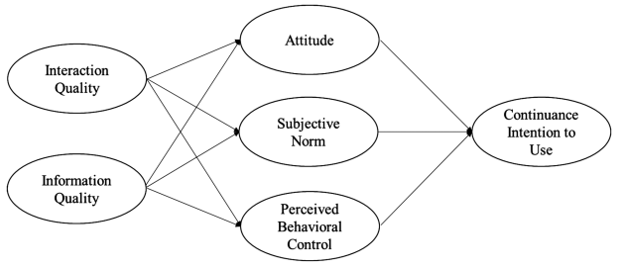
Figure 2: TPB
(Source: Kim et al. 2023)
The TPB (Theory of Planned Behaviour) explores the usefulness of chatbots in inspiring customer provision and the consequences of DM in e-commerce. The theory indicates that individuals’ intention toward having a particular behaviour is usually influenced by aspects like their attitude, SN (Subjective Norms), and PBC (Perceived Behavioural Control) (Kim et al. 2023). Likewise, as chatbots offer customised information and instant replies to customers' queries, it positively influences individuals' attitudes. While concerning SN, customers of e-commerce companies are more likely to use the chatbot if they think that their social circle expects them to use it for basic questions. Furthermore, high PBC strongly predicts its utilisation and is fuelled by a seamless, user-friendly interface and the assurance that the chatbot can manage tasks such as complicated order tracking or product recommendations (Kim et al. 2023). However, low PBC or perceived complexities in performing particular behaviour, driven by the fear of using a chatbot or inability to directly communicate with a human executive, can decrease individuals' attention to using it. This can be fostered due to the concern related to information privacy and the veracity of information.

2.5 Literature gap
Review of existing literature offers insights about the use of chatbots in DM as well as client satisfaction. However, it is irrefutable that there is a clear gap in the present literature in terms of providing a comprehensive idea about the actual potency of chatbots in elevating the outcomes of DM and customer service interactions in e-commerce, as limited studies have explored this context. Specifically, gaps in identifying the issues interlinked with chatbot usage and their effects on customer service, as well as satisfaction, have been noted, with this research intent to fill.

3. Methodology

3.1 Research paradigm
Research onion has been identified as a structured framework that allows researchers in order to ensure systematic and logical progression towards the research conclusion while addressing research problem statements (Alturki, 2021). Regarding this, the researcher has considered the framework for designing the research methodologies along with collecting specific data that will be adequate for the research. Research onion will allow for the consideration of significant research methods, such as in terms of philosophy, approach, and design. These are noted as the core aspects for research in terms of addressing the objectives and research topic.
In this regard, interpretivism philosophy will be considered by the researcher, which will refer to exploring meanings of the research context. Besides, interpretivism philosophy has been noted to be providing high validity information regarding complex social phenomena that will be adequate for this research (Ikram and Kenayathulla, 2022). This philosophy would allow the researcher to evaluate the impact of chatbot on customer satisfaction and loyalty. In addition, inductive research will be undertaken by the researcher in order to understand the complex phenomena of chatbots in digital marketing. Through this, the researcher would be able to gain flexibility while gaining rich insights considering research objectives. Furthermore, descriptive design would be the core approach that will allow researchers to provide a comprehensive understanding regarding the research context (Ghanad, 2023). This also captures different aspects and phenomena, which will reflect a holistic understanding of the research objectives.

3.2 Research strategy
In research, a strategy is a methodical plan, directing individuals while they undertake a study in order to address particular research questions or accomplish goals. Researchers use “quantitative”, “qualitative”, or “mixed methods” in their studies, with respect to requirements. Unlike the quantitative method, which emphasises statistical analysis, the qualitative method permits the use of non-numerical information to explore a topic, offering flexibility in generating comprehensive ideas (Sharma et al. 2023). Thus, in this research, the qualitative strategy will be applied. This is because there is a great potential that it will help in understanding the user experience with chatbots and comprehend their impact on customer satisfaction, leading to answering research questions. In addition, this strategy has been observed to be beneficial in terms of comprehending social issues better by understanding human behaviour, which is beneficial for answering “how”, “what”, and “why” research questions (Abdelhakim, 2021). Therefore, by using this strategy, the actual implications of chatbots in DM, as well as difficulties related to this, can be explored positively.

3.3 Data collection and analysis
Researchers undertake “primary” or “secondary” methods for the collection of information. The primary method permits them to accumulate information from respondents by leveraging a survey or interviews. In contrast, the other one permits the accumulation of facts from existing sources. Thus, compared to primary, the other one is better in terms of saving time and resources (Ganesha and Aithal, 2022). Likewise, the “secondary method” will be incorporated for collecting data regarding the use of chatbots in client service and DM. Regarding this, Google Scholar, ResearchGate, and other online libraries will be utilised to get faithful data sources published from 2021. Additionally, organisational websites, news articles, and other reliable sources will also be used while collecting information.
Facts that are gathered with the “secondary method” will be interpreted using the “thematic technique”. This technique permits creating themes and the development of smaller units using the research variables, which is beneficial for the structural evaluation of all collected data, supporting qualitative analysis. This method has been regarded to be favourable in terms of delivering insightful findings, which are faithful and can be used to answer study questions (Chen et al. 2021). Therefore, there is a potential that, using this, faithful results can be derived, and the research issue can be solved proactively. Thematic analysis can be supported with “Braun and Clarke's 6-step coding tool” (Chen et al. 2021). Likewise, this tool will be utilised in order to outline themes while carrying out the thematic analysis.

3.4 Ethical consideration
There are numerous ethical issues, which have the possibility of impacting the researcher's approach and entire understanding of the study, such as in terms of maintaining the scope of the original content, information plagiarism, and misinterpretation of finding. Regarding this, the researcher will significantly focus on maintaining ethical aspects while ensuring trustworthy and credible sources, along with enhancing the academic integrity through peer-reviewed journals. Besides this, the researcher would also consider regulations of Data Protection Act 2018 and Copyright, Design and Patent Act 1988, which will protect sensitive data along with increasing trust in the research findings (GOV, 2025; GOV, 2025). The researcher will also focus on aligning the coding procedure for generating themes to address the research objectives. This will significantly ensure the research is accurate while minimising any potential ethical constraints.

4. Expected findings
There is a great potential for this research to deliver comprehensive ideas regarding the use of chatbots in client service interactions and DM, as well as its impacts on client loyalty and service in the e-commerce sector. With respect to the theoretical implications of TPB, the behavioural intentions of customers in various sectors behind the use of chatbots can be positively understood in this research. The outcomes of this research can also have positive implications for e-commerce businesses in terms of understanding the complexities associated with chatbots, as well as gaining knowledge about the initiatives that can help them to overcome issues. By acknowledging the ethical and privacy-related concerns while using chatbots, with support of real business evidence, this research will add value to existing ideas.

5. Limitations
Despite an immense potential to deliver positive outcomes, there is potential for limitations, led by solely depending on pre-existing data. Explicitly, while completely keeping the study away from primary information, there can be a gap in understanding. For example, it may have remained better to use surveys to comprehend clients' behaviour toward chatbots of e-commerce companies and their consequences on their trustworthiness. However, due to time restrictions, alongside the possibility of delivering appreciated conclusions by leveraging secondary qualitative data, confines created by the nonappearance of primary data are disregarded. Nevertheless, it is approved that the nonappearance of primary data can limit learning discoveries to some extent, leading to the possibility to carry out a forthcoming study on the identical topic.

6. Timeframe
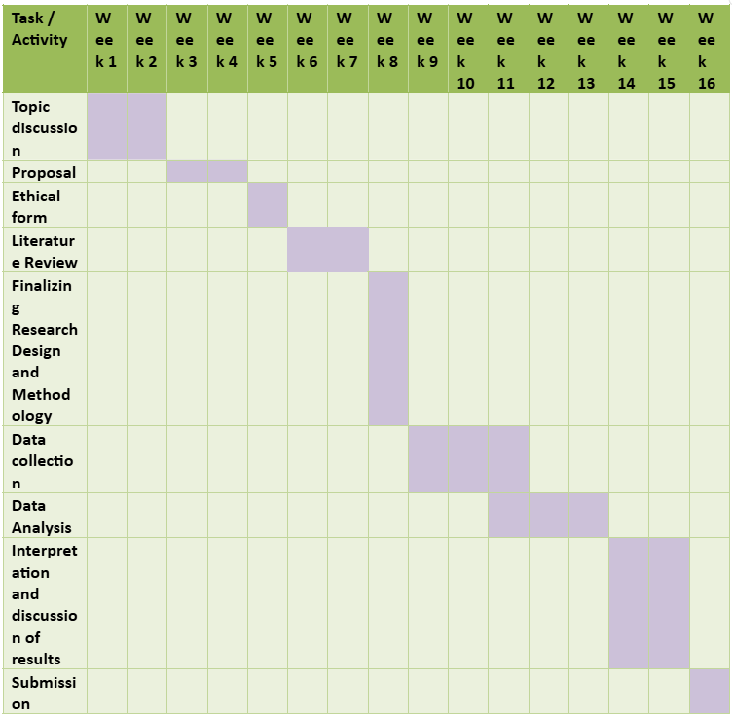

7. Conclusion
Based on the analysis, chatbots empower e-commerce businesses to advance customer appointments and create leads by providing real-time help or round-the-clock services. Nevertheless, its custom can lead productions to a diversity of challenges, as well as customer disappointment, by levitation issues pertaining to confidentiality and factuality. Regarding this, the study emphasises measuring how well chatbots achieve in DM and customer provision discussions. By means of thematic analysis for rendering secondary qualitative evidence, in the provision of interpretivist and inductive cognitive, the research is envisioned to be accomplished.

References
Abdelhakim, A.S., (2021). Adopted Research Designs by Tourism and Hospitality Postgraduates in The Light‎ of Research Onion. International Journal of Tourism and Hospitality Management, 4(2), pp.98-124. https://ijthm.journals.ekb.eg/article_206774_39a512b92a6470df762792c8d0c60a12.pdf
Adam, M., Wessel, M. and Benlian, A., (2021). AI-based chatbots in customer service and their effects on user compliance. Electronic markets, 31(2), pp.427-445. https://link.springer.com/article/10.1007/s12525-020-00414-7
Alsadoun, A.A. and Alnasser, A.N., (2025). Role of artificial intelligence chatbot marketing in enhancing customer satisfaction and loyalty in digital shopping experiences. International Journal of Innovative Research and Scientific Studies, 8(1), pp.1902-1909. https://www.researchgate.net/profile/Asem-Alnasser/publication/389288855_Role_of_artificial_intelligence_chatbot_marketing_in_enhancing_customer_satisfaction_and_loyalty_in_digital_shopping_experiences/links/67c8a71a32265243f582a9b7/Role-of-artificial-intelligence-chatbot-marketing-in-enhancing-customer-satisfaction-and-loyalty-in-digital-shopping-experiences.pdf
Alturki, R., (2021). Research Onion for Smart IoT‐Enabled Mobile Applications. Scientific programming, 2021(1), p.4270998. https://onlinelibrary.wiley.com/doi/abs/10.1155/2021/4270998
Bhardwaj, S., Sharma, N., Goel, M., Sharma, K. and Verma, V., (2024). Enhancing customer targeting in e-commerce and digital marketing through AI-driven personalization strategies. Advances in Digital Marketing in the Era of Artificial Intelligence, pp.41-60. https://elib.vku.udn.vn/bitstream/123456789/5657/1/2025.%20Advances%20in%20Digital%20Marketing%20in%20the%20Era%20of%20Artificial%20Intelligence%20Case%20Studies%20and%20Data%20Analysis%20for%20Business%20Problem%20Solving.pdf#page=54
Chen, S., Liu, X., Yan, J., Hu, G. and Shi, Y., (2021). Processes, benefits, and challenges for adoption of blockchain technologies in food supply chains: a thematic analysis. Information Systems and e-Business Management, 19, pp.909-935.https://im.nju.edu.cn/_upload/article/files/45/43/dad9ab6d48b1bb78344fc8d813d8/1023c156-7c45-4537-88ae-1db13cdaae44.pdf
Dsouza, A. and Panakaje, N., (2023). A study on the evolution of digital marketing. International Journal of Case Studies in Business, IT, and Education, 7(1), pp.95-106. https://www.academia.edu/download/116712356/6._20A_20Study_20on_20the_20Evolution_20of_20Digital.pdf
Ganesha, H.R. and Aithal, P.S., (2022). How to choose an appropriate research data collection method and method choice among various research data collection methods and method choices during Ph. D. program in India. International Journal of Management, Technology, and Social Sciences, 7(2), pp.455-489. https://www.academia.edu/download/100063600/26._How_to_Choose_an_Appropriate_Research_Data.pdf
Ghanad, A., (2023). An overview of quantitative research methods. International journal of multidisciplinary research and analysis, 6(08), pp.3794-3803. https://www.researchgate.net/profile/Anahita-Ghanad/publication/373370007_An_Overview_of_Quantitative_Research_Methods/links/67b28ffc645ef274a48341a1/An-Overview-of-Quantitative-Research-Methods.pdf
GOV, (2025). Copyright, Designs and Patents Act 1988. [Online]. Available at: https://www.legislation.gov.uk/ukpga/1988/48/contents [Accessed on 23 October 2025]
GOV, (2025). Data Protection Act 2018. [Online]. Available at: https://www.legislation.gov.uk/ukpga/2018/12/contents/enacted [Accessed on 23 October 2025]
Grandview Research, (2025). Chatbot Market Summary. [Online]. Available at: https://www.grandviewresearch.com/industry-analysis/chatbot-market [Accessed on 23 October 2025]
Huseynov, F., (2023). Chatbots in digital marketing: Enhanced customer experience and reduced customer service costs. In Contemporary approaches of digital marketing and the role of machine intelligence (pp. 46-72). IGI Global. https://www.researchgate.net/profile/Farid-Huseynov/publication/372837440_Chatbots_in_Digital_Marketing_Enhanced_Customer_Experience_and_Reduced_Customer_Service_Costs/links/659fc2a440ce1c5902d3f764/Chatbots-in-Digital-Marketing-Enhanced-Customer-Experience-and-Reduced-Customer-Service-Costs.pdf
Huseynov, F., (2023). Chatbots in digital marketing: Enhanced customer experience and reduced customer service costs. In Contemporary approaches of digital marketing and the role of machine intelligence (pp. 46-72). IGI Global. https://www.igi-global.com/chapter/chatbots-in-digital-marketing/327550
Ikram, M. and Kenayathulla, H.B., (2022). Out of touch: comparing and contrasting positivism and interpretivism in social science. Asian Journal of Research in Education and Social Sciences, 4(2), pp.39-49. https://www.researchgate.net/profile/Maryam-Ikram/publication/366810045_Out_of_Touch_Comparing_and_Contrasting_Positivism_and_Interpretivism_in_Social_Science/links/63b30f54097c7832ca84ccd3/Out-of-Touch-Comparing-and-Contrasting-Positivism-and-Interpretivism-in-Social-Science.pdf
Kim, J.Y., Li, Y. and Choi, J., (2023). Understanding the continuance intention to use chatbot services. Pp.100-110. https://opal.latrobe.edu.au/articles/journal_contribution/Understanding_the_Continuance_Intention_to_Use_Chatbot_Services/25217405/1/files/44567744.pdf
Myers, Z., (2024). Reviews: Amazon’s ‘Rufus’ is often wrong. [Online]. Available at: https://fox59.com/news/reviews-amazons-rufus-is-often-wrong/#:~:text=This%20appears%20to%20be%20the,%2C%20but%20also%20mostly%20useless.%E2%80%9D [Accessed on 23 October 2025]
Nwabekee, U.S., Okpeke, F. and Onalaja, A.E., (2025). Modeling AI-enhanced customer experience: The role of chatbots and virtual assistants in contemporary marketing. World Scientific News, 203, pp.54-77. https://worldscientificnews.com/wp-content/uploads/2025/05/WSN-203-2025-54-77-1.pdf
Sharma, L.R., Jha, S., Koirala, R., Aryal, U. and Bhattarai, T., (2023). Navigating the research landscape: A guide to the selection of the right research design. International Research Journal of MMC (IRJMMC), 4(1), pp.64-78. https://irjmmc.edu.np/index.php/irjmmc/article/download/166/137
Shrivastava, N., Tewari, P., Sujatha, S., Bogireddy, S.R., Varshney, N. and Sharma, V., (2025), March. Natural Language Processing for Conversational AI: Chatbots and Virtual Assistants. In 2025 IEEE International Conference on Interdisciplinary Approaches in Technology and Management for Social Innovation (IATMSI) (Vol. 3, pp. 1-6). IEEE. https://www.researchgate.net/profile/Srinivasa-Rao-Bogireddy/publication/391611622_Natural_Language_Processing_for_Conversational_AI_Chatbots_and_Virtual_Assistants/links/682578f78a76251f22e1e225/Natural-Language-Processing-for-Conversational-AI-Chatbots-and-Virtual-Assistants.pdf
Tanase, C., (2024). The Integration of Emotional Intelligence into AI Marketing: Connecting Brands with Consumers. Romanian Distribution Committee Magazine, 15(1), pp.29-37. http://crd-aida.ro/RePEc/rdc/v15i1/3.pdf
Wahbi, A., Khaddouj, K. and Lahlimi, N., (2023). Study of the relationship between chatbot technology and customer experience and satisfaction. International Journal of Accounting, Finance, Auditing, Management and Economics, 4(6-1 (2023)), pp.758-771. https://hal.science/hal-04403080/

