Tom Walters (0652274)
UWTSD – 0652274@student.uwtsd.ac.uk
Network Operating Systems and Services
Assignment 1

Table of Contents
Introduction 2
Task 1 3
Hypervisors 3
IP Addressing 3
Routing 4
Network Services 5
Task 2 7
Hypervisor Selection 7
Creation of Virtual Machines 7
Windows 2022 Server (Hostname: S-DC) 11
Windows 11 Client (Hostname: ClientS1) 13
Debian Server (Hostname: L-CD) 14
Debian Client (Hostname: ClientL1) 15
IP Addressing 16
IP Addressing Table 16
Test and Troubleshoot 17
Lab Environment 17
Connectivity Testing 17
Task 3 20
Bibliography 22
Table of Figures 23
Further Reading 25

Introduction
This coursework examines the design and deployment of a virtualised enterprise network for the organisation NOSS2026, operating across two locations in Swansea and London.
Key areas of investigation include:
- Hypervisor technologies,
- IP addressing,
- Routing approaches,
- Network services such as Active Directory and DHCP.

The practical component requires the construction of a virtualised network environment that reflects the provided topology and supports basic connectivity testing. The objective of this work is to demonstrate both theoretical understanding and the practical skills required to deploy and manage enterprise network infrastructure.

Task 1

Hypervisors
Hypervisors allow multiple virtual machines (VMs) to run on a single physical machine, but the way they are built has a direct impact on performance, security, and reliability. Type 1 hypervisors, often referred to as bare metal, run directly on the physical hardware. Examples include VMware ESXi and Microsoft Hyper-V. Type 2 hypervisors, such as VirtualBox or VMware Workstation, run on top of an existing operating system, which means they rely on that host OS to manage hardware access.

The key difference between the two lies in control and efficiency. Because Type 1 hypervisors communicate directly with the hardware, they generally provide better resource management and lower overhead. Research has shown that bare-metal designs tend to perform more consistently under enterprise workloads and offer stronger isolation between VMs [1]. In contrast, Type 2 hypervisors introduce an extra software layer. While modern hardware virtualisation support (e.g., Intel VT-x, AMD-V) has reduced the performance gap, hosted hypervisors still depend on the stability and security of the underlying operating system [2].

From a security standpoint, Type 1 hypervisors usually present a smaller attack surface because fewer services are running alongside the virtualisation layer [3]. However, Type 2 solutions remain highly practical for development, testing, and educational use where ease of installation and flexibility are priorities.

A further development in virtualisation is container technology. Containers share the host operating system kernel but isolate applications at the process level (Merkel, 2014). They are more lightweight and efficient than full VMs, yet they do not provide the same level of isolation as hypervisors, meaning they complement rather than replace traditional virtualisation in infrastructure design.

IP Addressing

IPv4 uses a 32-bit address space, structured into network and host components defined by subnet masks or CIDR prefix notation (e.g., 192.168.10.0/24) [4]. CIDR enables route aggregation (supernetting), reducing global routing table size and improving backbone routing efficiency. However, IPv4 exhaustion led to temporary mitigation mechanisms such as NAT and private addressing (RFC 1918), which compromise true end-to-end connectivity and increase state-tracking complexity on edge devices.

IPv6 expands addressing to 128 bits, supporting approximately 3.4 × 10³⁸ unique addresses. Its structure includes global routing prefix, subnet ID, and interface identifier components. IPv6 eliminates the need for NAT in most deployments and introduces features such as Stateless Address Autoconfiguration (SLAAC) and simplified header processing for more efficient forwarding.

Subnetting and Variable Length Subnet Masking (VLSM) allow granular allocation of address blocks according to host requirements, optimising address utilisation and reducing broadcast domains. Smaller subnets minimise ARP traffic and improve network performance while supporting logical segmentation for security policies.

Therefore, IP addressing is not merely an identification mechanism; it underpins routing scalability, segmentation strategy, and overall network efficiency through hierarchical design and prefix-based forwarding logic [5].

Routing
Routing is the Layer 3 process that enables packet forwarding between distinct IP networks [6]. Unlike switching, which operates within a broadcast domain using MAC addresses, routing decisions are made using logical addressing and routing tables. When a router receives a packet, it examines the destination IP address and performs a longest-prefix match against its routing table to determine the optimal outbound interface. This process relies on control-plane mechanisms to build and maintain routing information, and data-plane mechanisms to forward packets efficiently.

Static routing involves manually configured routes that remain fixed unless administratively modified. It provides predictability, minimal protocol overhead, and reduced attack surface, making it suitable for small or stable topologies. However, static routing does not scale efficiently and offers limited resilience; route changes require manual intervention, which can delay convergence during link failures.

Dynamic routing protocols automate route discovery and adaptation. Distance-vector protocols (e.g., RIP) calculate paths based on hop count, periodically sharing full routing tables. Link-state protocols (e.g., OSPF) build a complete topology map using Link State Advertisements (LSAs) and compute shortest paths using Dijkstra’s algorithm. Link-state approaches generally offer faster convergence, hierarchical design capability, and improved scalability compared to distance-vector methods.

The choice between static and dynamic routing depends on network complexity, fault tolerance requirements, and administrative overhead. While static routing provides simplicity and control, dynamic protocols enable scalability, rapid convergence, and adaptive routing — characteristics that are critical in enterprise and multi-site environments where availability and resilience are priorities.

Network Services
Enterprise networks rely on integrated network services to provide identity management, secure communication, and automated configuration. Within the proposed topology, services such as DHCP [7], Active Directory Domain Services (AD DS) [8], Certificate Authorities (CA), and Virtual Private Networks (VPNs) enable reliable connectivity between the Swansea and London environments while supporting centralised administration.

Dynamic Host Configuration Protocol (DHCP) reduces administrative overhead by automatically assigning IP configuration parameters to hosts. In a segmented network, deploying a DHCP relay on the Debian server allows clients on different subnets to obtain addresses from a central DHCP service. This approach reflects enterprise best practice, where centralised IP management improves consistency, scalability, and monitoring while reducing the likelihood of configuration errors.

Active Directory Domain Services provides the foundation for identity and access management within the SWANSEA.ACCA domain. AD DS enables centralised authentication, authorisation, and policy enforcement through mechanisms such as Group Policy. By integrating Windows clients into a domain environment, administrators gain consistent control over user credentials, security policies, and resource access.

Certificate Authorities support these services by providing a Public Key Infrastructure (PKI) used to issue and manage digital certificates. Certificates enable trusted encryption for services such as authentication, VPN connectivity, and secure communications, which is particularly important in mixed operating system environments.

Finally, VPN technologies enable secure communication across untrusted networks by encrypting traffic between sites or remote users. Within the topology, VPN connectivity would allow secure communication between the Swansea and London networks, extending enterprise services while maintaining confidentiality and integrity.

Task 2

Hypervisor Selection
The virtual network was initially deployed using a Type 2 hypervisor; however, display resolution issues were encountered when managing the environment via Remote Desktop from macOS, which affected usability during configuration. An alternative Type 1 hypervisor environment was therefore tested. An initial Azure-based lab was provisioned but subsequently lost its assigned public IP address, preventing further access. A replacement Azure instance was provided, although its hardware specification proved insufficient to reliably run multiple virtual machines concurrently. As a result, the deployment was completed using university lab hardware (IQ004). During setup it was identified that the workstation’s network interface card had been disabled, which prevented remote connectivity. Once re-enabled, the environment could have been accessed via RDP from a Windows laptop that had been procured specifically for completing the assignment, allowing the virtual machines and network configuration to be deployed and tested. As a result there was a requirement to attend site.

Creation of Virtual Machines

Device | 1 | 2 | 3 | 4
Hostname | S-DC | ClientS1 | L-CD | ClientL1
Operating System | Windows Server 2022 | Windows 11 | Debian Server (CLI) | Debian Client (GUI)
Processor | 1.4GHz 64 Bit processor | 1GHz 2xCore
RAM | 2GB | 4GB | 512Mb /1024Mb Recommended | 1024Mb Min/2048 Mb Recommended
HDD | 32Gb Min | 64GB Min | 4GB minimum | 10GB
Additional Considerations |  | UEFI and TPM Support

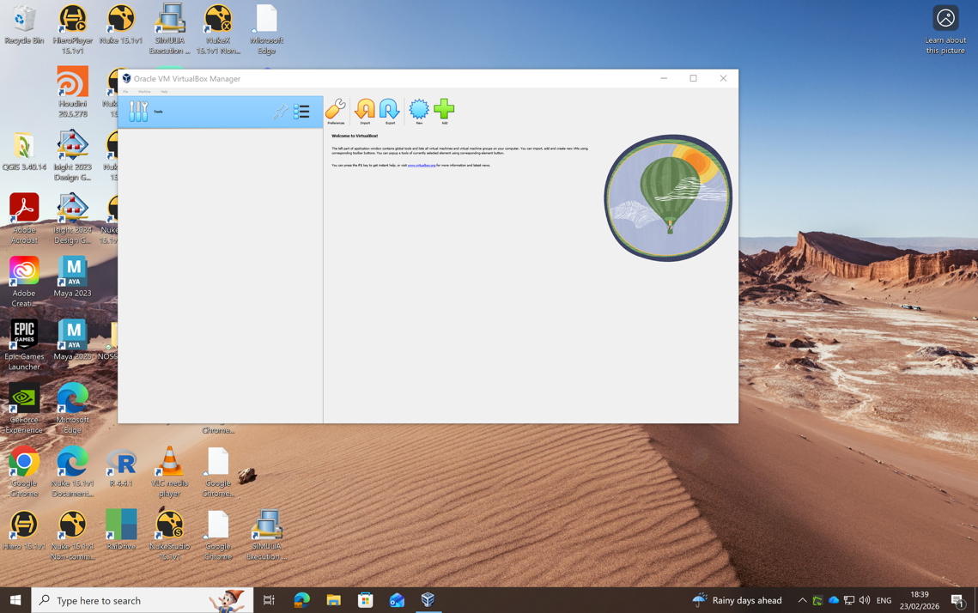

Figure 1: Initial VirtualBox

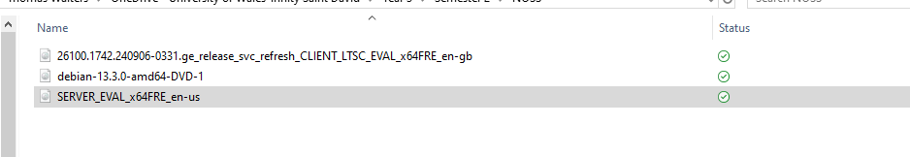

Figure 2: ISO Images prior to VM installation

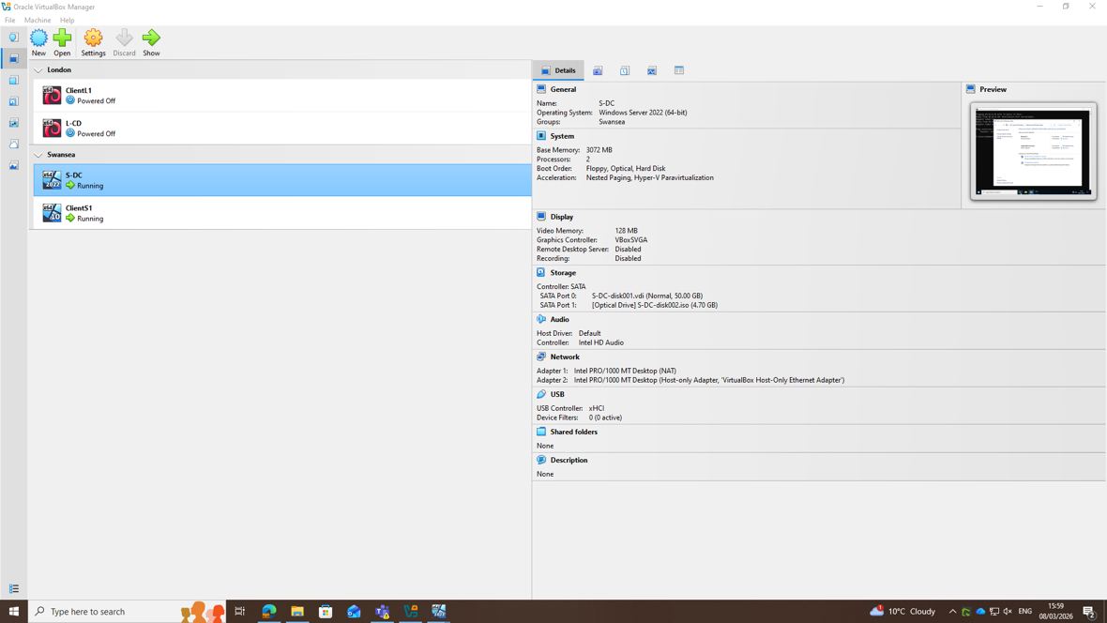

Figure 3: Windows Server Config

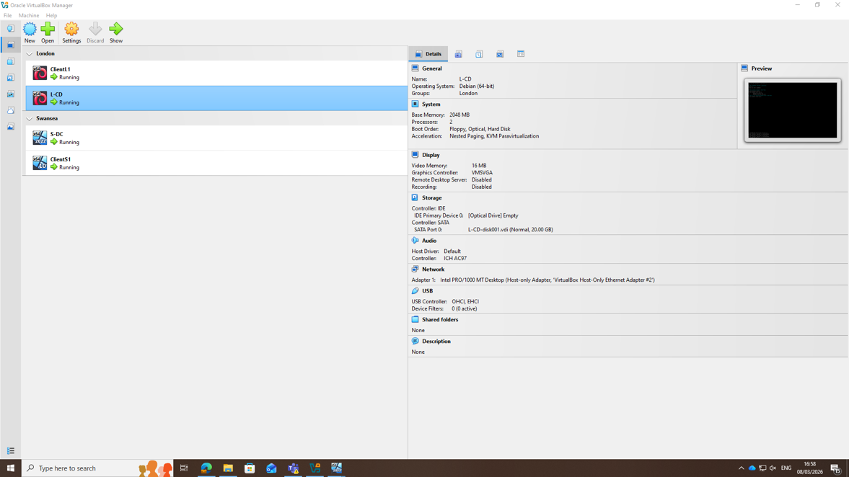

Figure 4: Debian Server Config
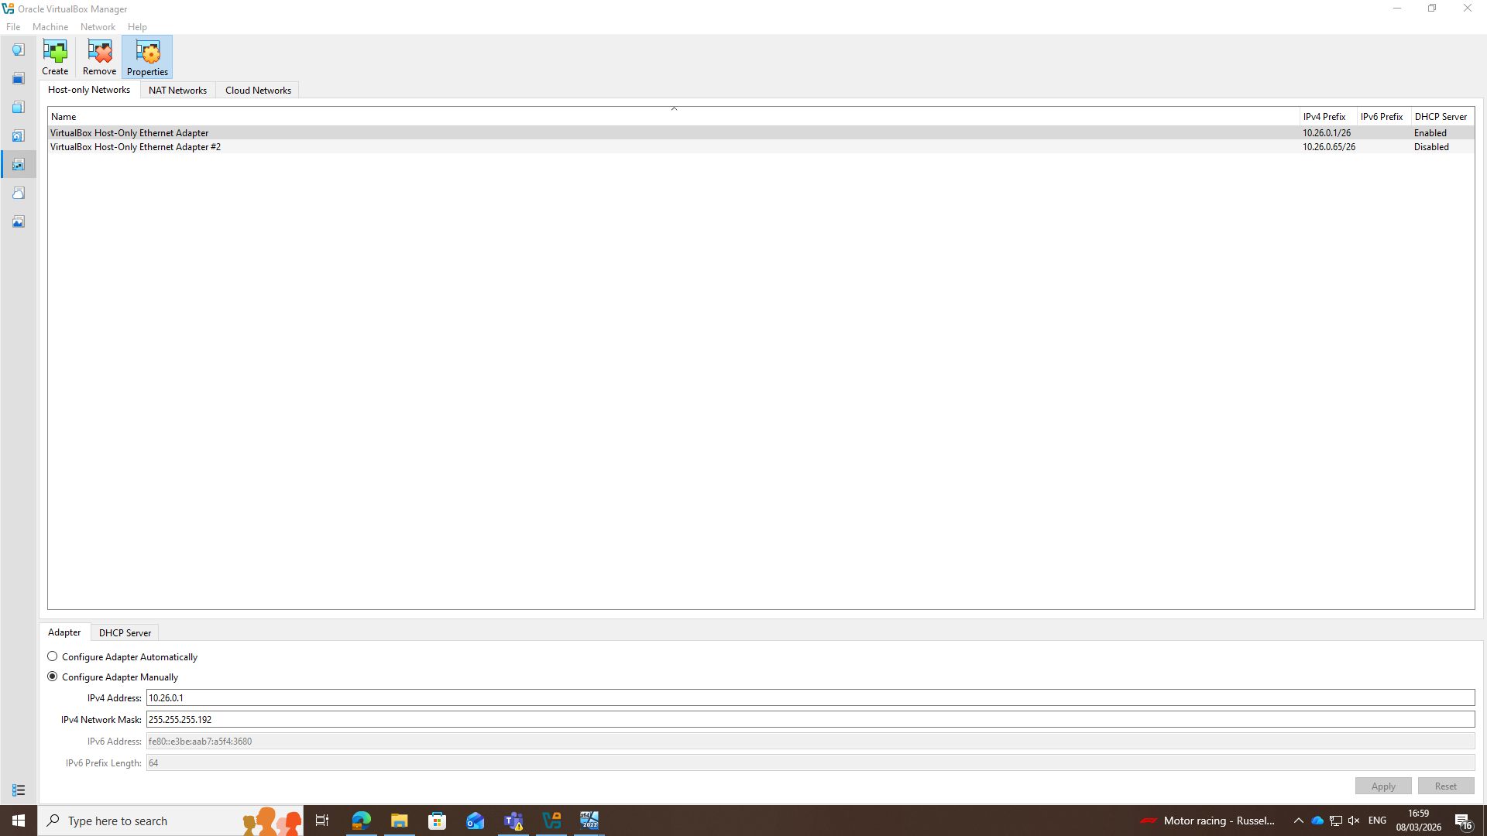

Figure 5: VirtualBox Ethernet Adapter Config

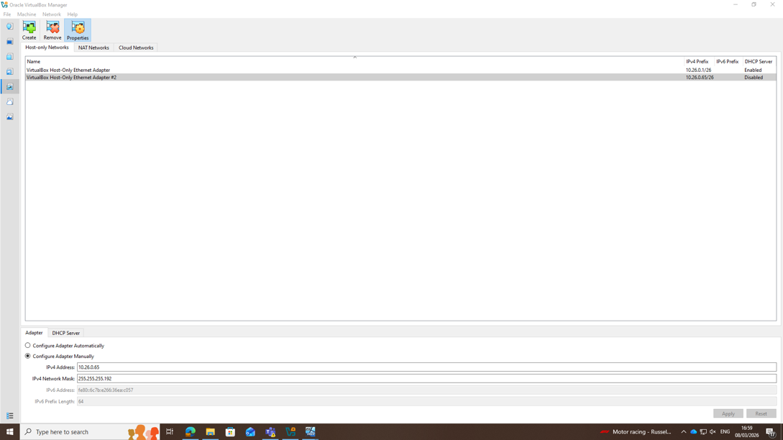
Figure 6: Ethernet Adapter London Office

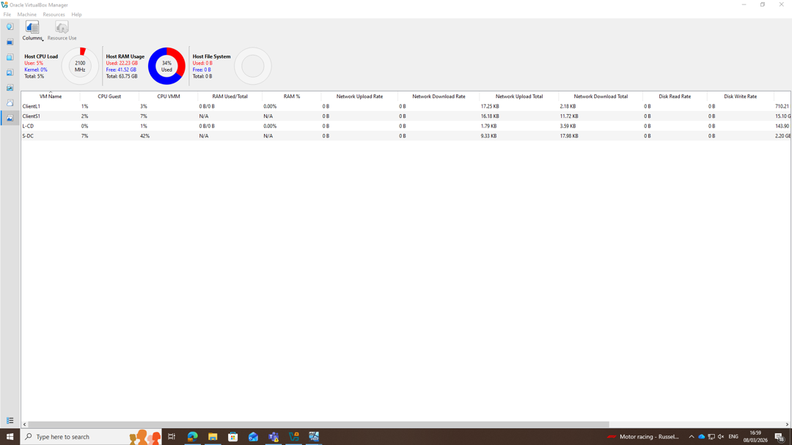

Figure 7: Resource Usage under load of 4VMs

Windows 2022 Server (Hostname: S-DC)
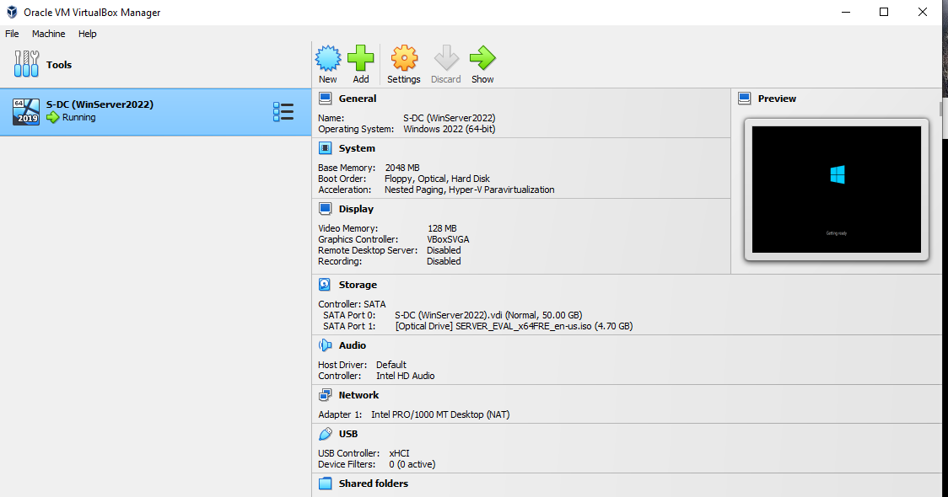
Figure 8: Windows 2022 Configuration

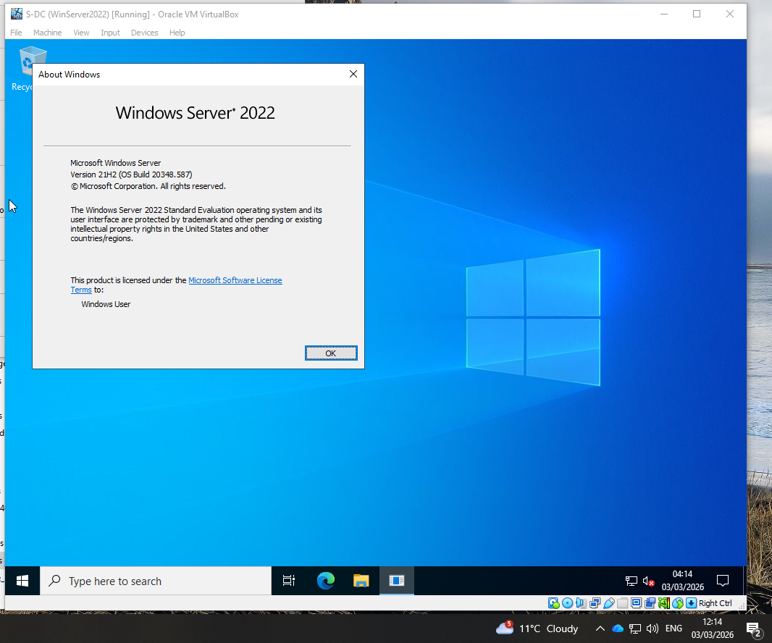
Figure 9: Windows 2022 Desktop

Windows 11 Client (Hostname: ClientS1)
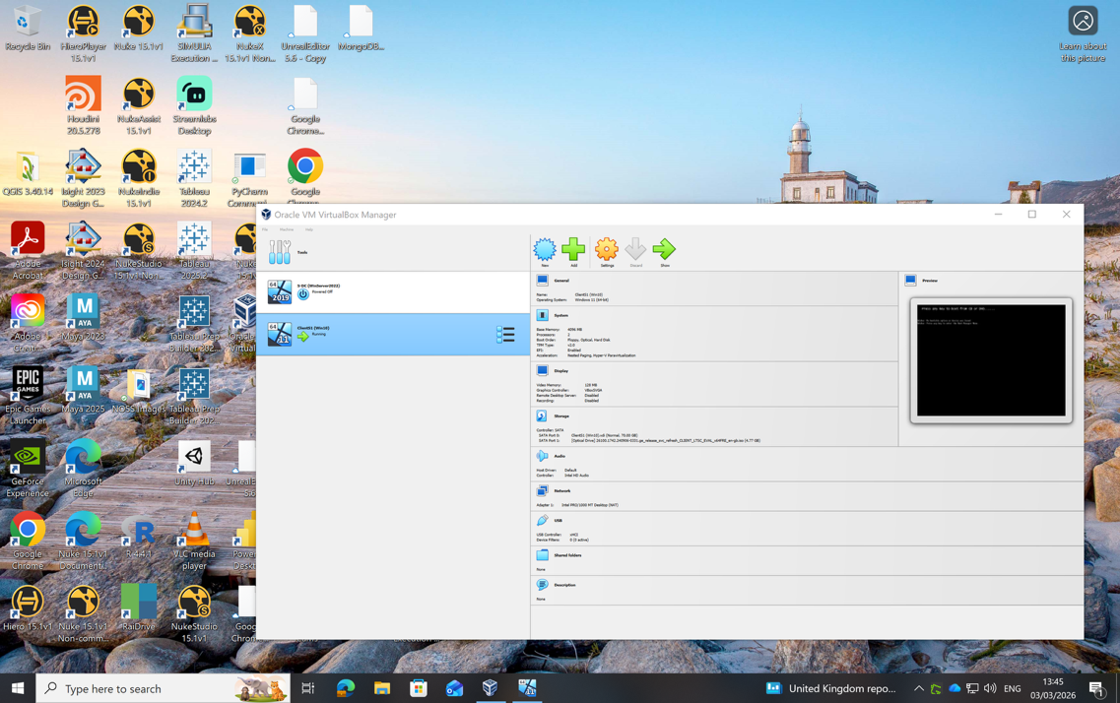
Figure 10: Windows Client VM Configuration

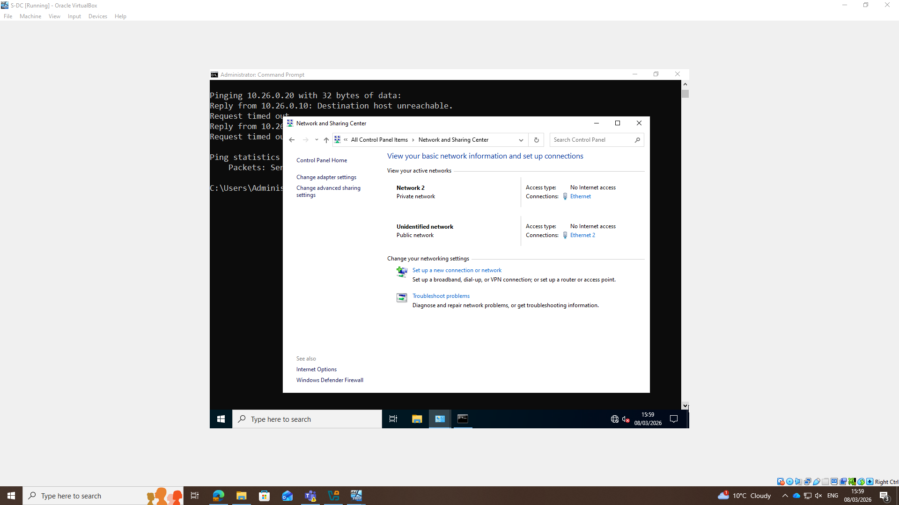
Figure 11: Windows 11 Ethernet Configuration

Debian Server (Hostname: L-CD)
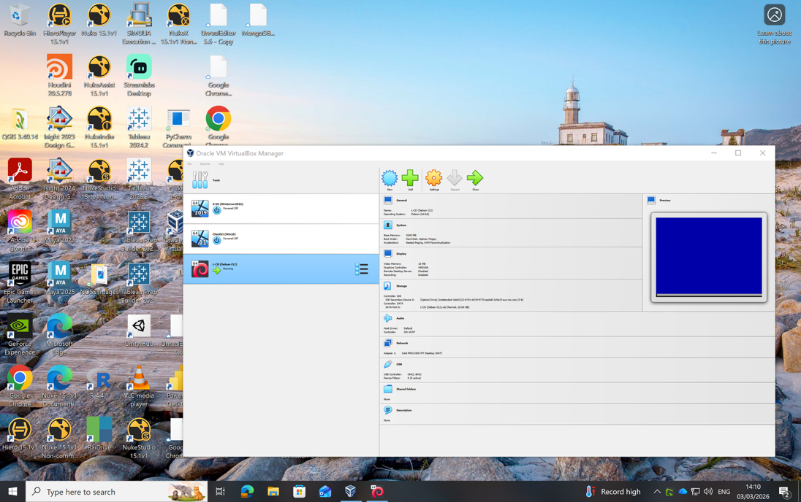
Figure 12: Debian Server Config

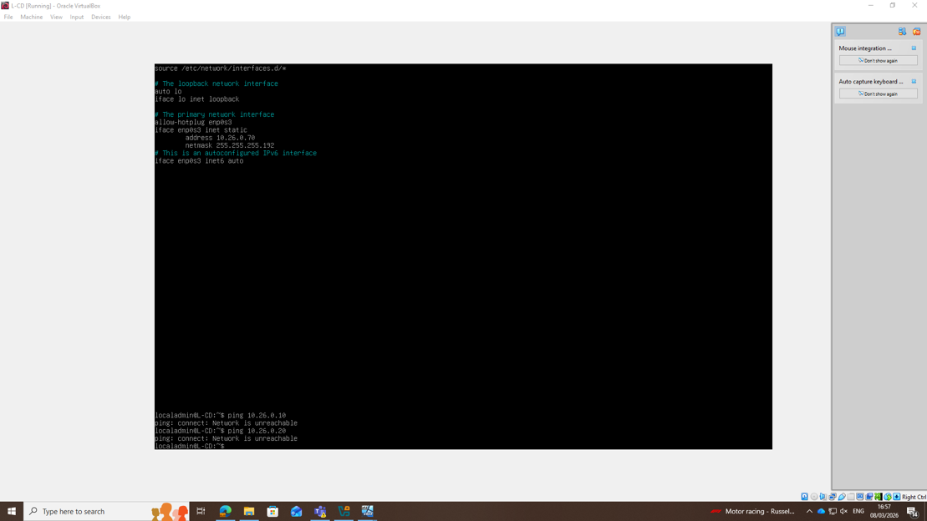
Figure 13: Debian Ethernet Adapter configuration

Debian Client (Hostname: ClientL1)
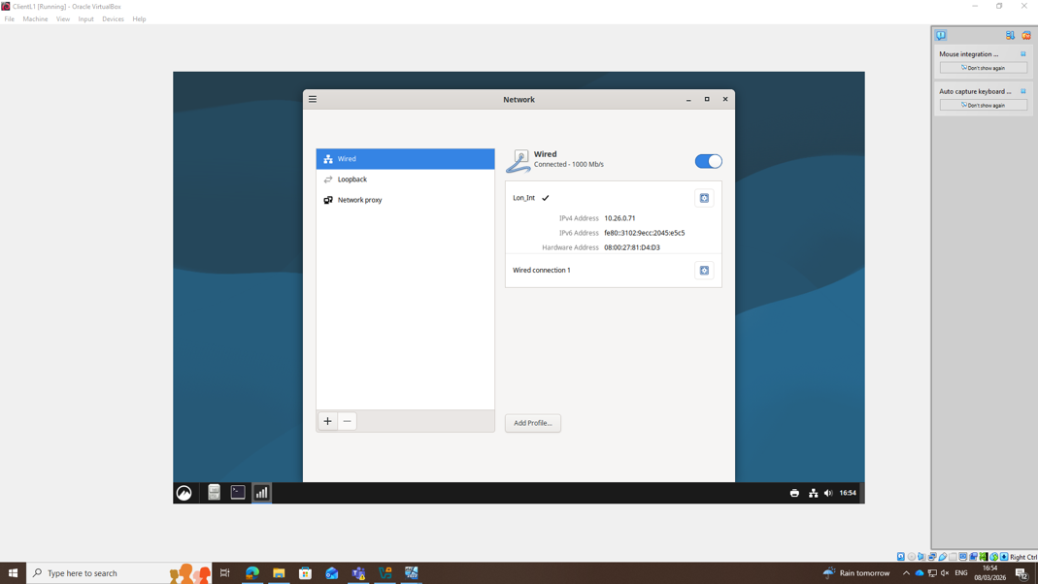
Figure 14: Debian GUI Ethernet Config

IP Addressing
The addressing scheme was designed on the assumption that the organisation operates as a multinational enterprise with two currently active sites. To support scalability and future network growth, each site has been allocated a /26 subnet, providing up to 62 usable host addresses for servers, client systems, and supporting infrastructure. This approach ensures sufficient capacity for expansion without requiring immediate network redesign. It is further assumed that personal or non-corporate devices would be placed on a separate guest or BYOD network segment, preventing direct access to internal corporate resources such as domain services or on-premises file servers. Implementing this level of logical network segmentation supports improved security, access control, and overall network management.

As part of the network design, I have adopted the naming convention in the topology diagram, however a structured hostname convention could be used following the format Site–DeviceType–Number. The site identifier indicates the location, the device type identifies the system role, and the numerical value provides a unique identifier. For example, SWA-LPTP-0001 represents a laptop at the Swansea site, while LON-SRV-DC-01 represents a domain controller server located in London.

IP Addressing Table
Hostname | Location | Device Type | IP Address | Subnet Mask | CIDR
S-DC | Swansea | Server (Windows) | 10.26.0.10 | 255.255.255.192 | /26
ClientS1 | Swansea | Client (Windows) | 10.26.0.20 | 255.255.255.192 | /26
L-CD | London | Server (Debian) | 10.26.0.70 | 255.255.255.192 | /26
ClientL1 | London | Client (Debian) | 10.26.0.71 | 255.255.255.192 | /26

For this coursework – Virtual box has two VirtualBox host only ethernet adapters configured –
Location | VM Network Adapter | Network ID | Subnet
Swansea | Host Only Ethernet Adapter | 10.26.0.1 | 255.255.255.192
London | Host Only Ethernet Adapter | 10.26.0.65 | 255.255.255.192

Test and Troubleshoot

Lab Environment

Connectivity Testing
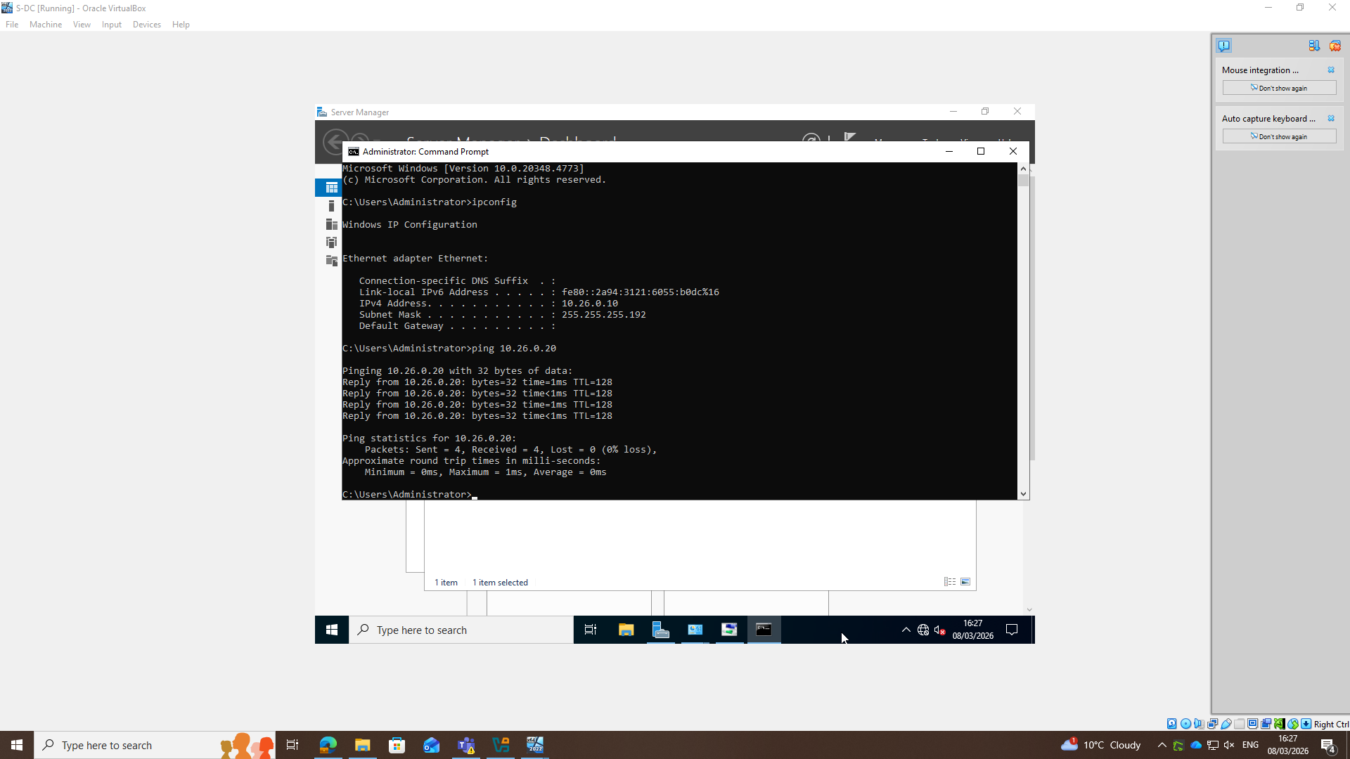
Figure 15: Windows Client Ping to Server

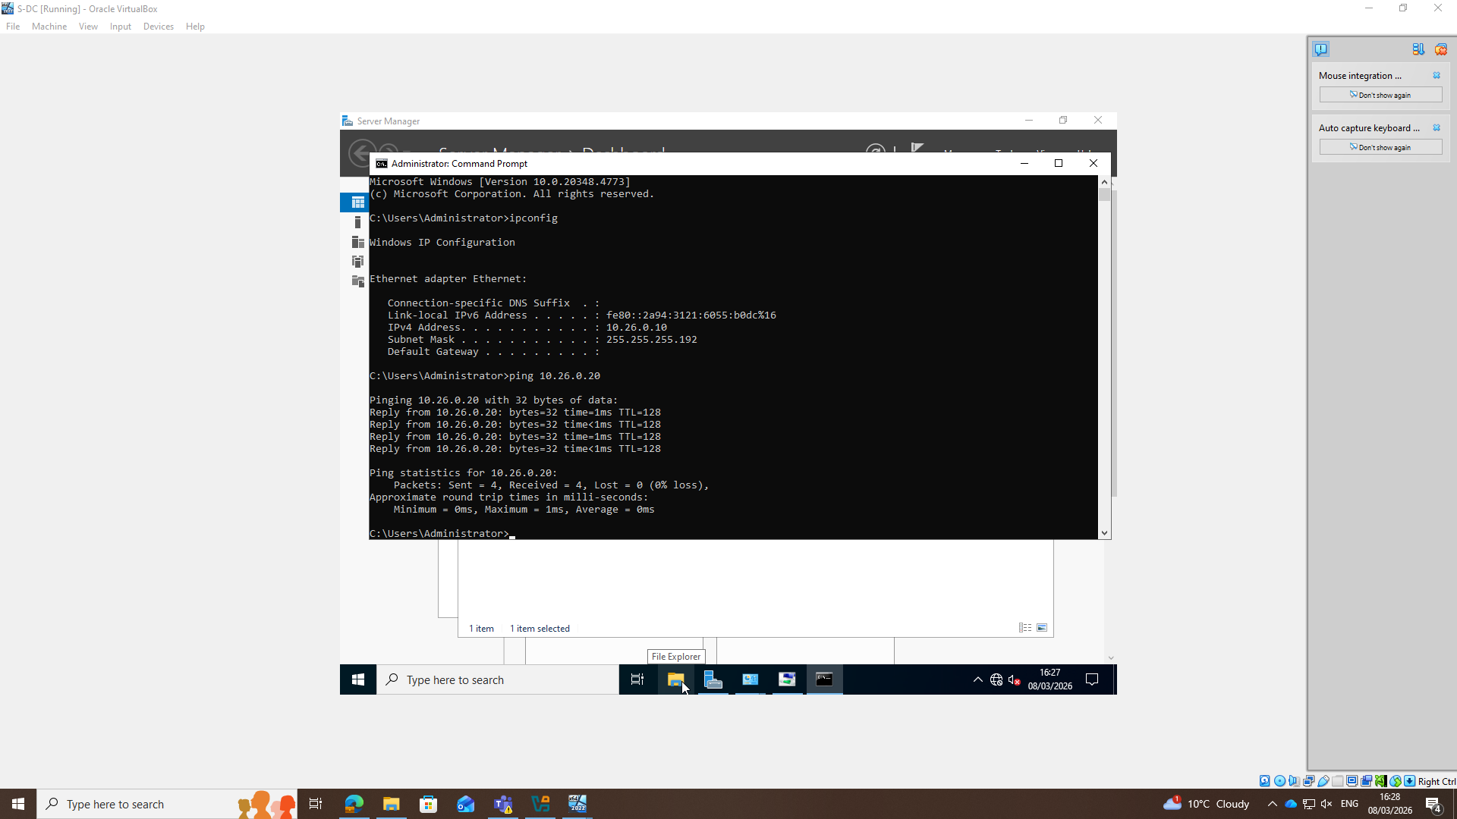
Figure 16: Windows Server ping to Client
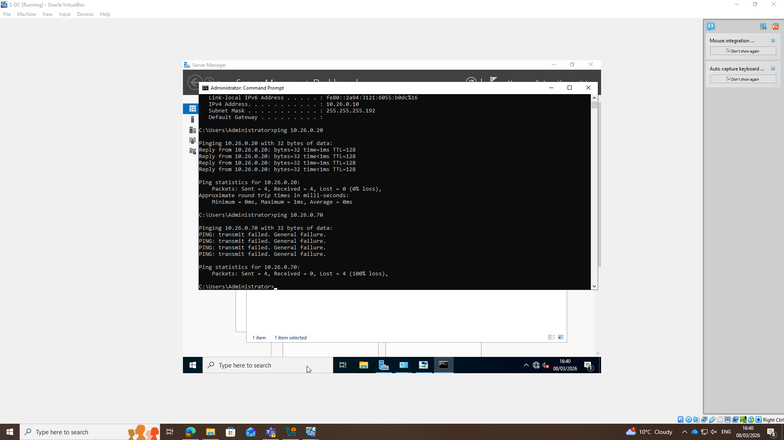
Figure 17: Windows Server ping to Debian Server
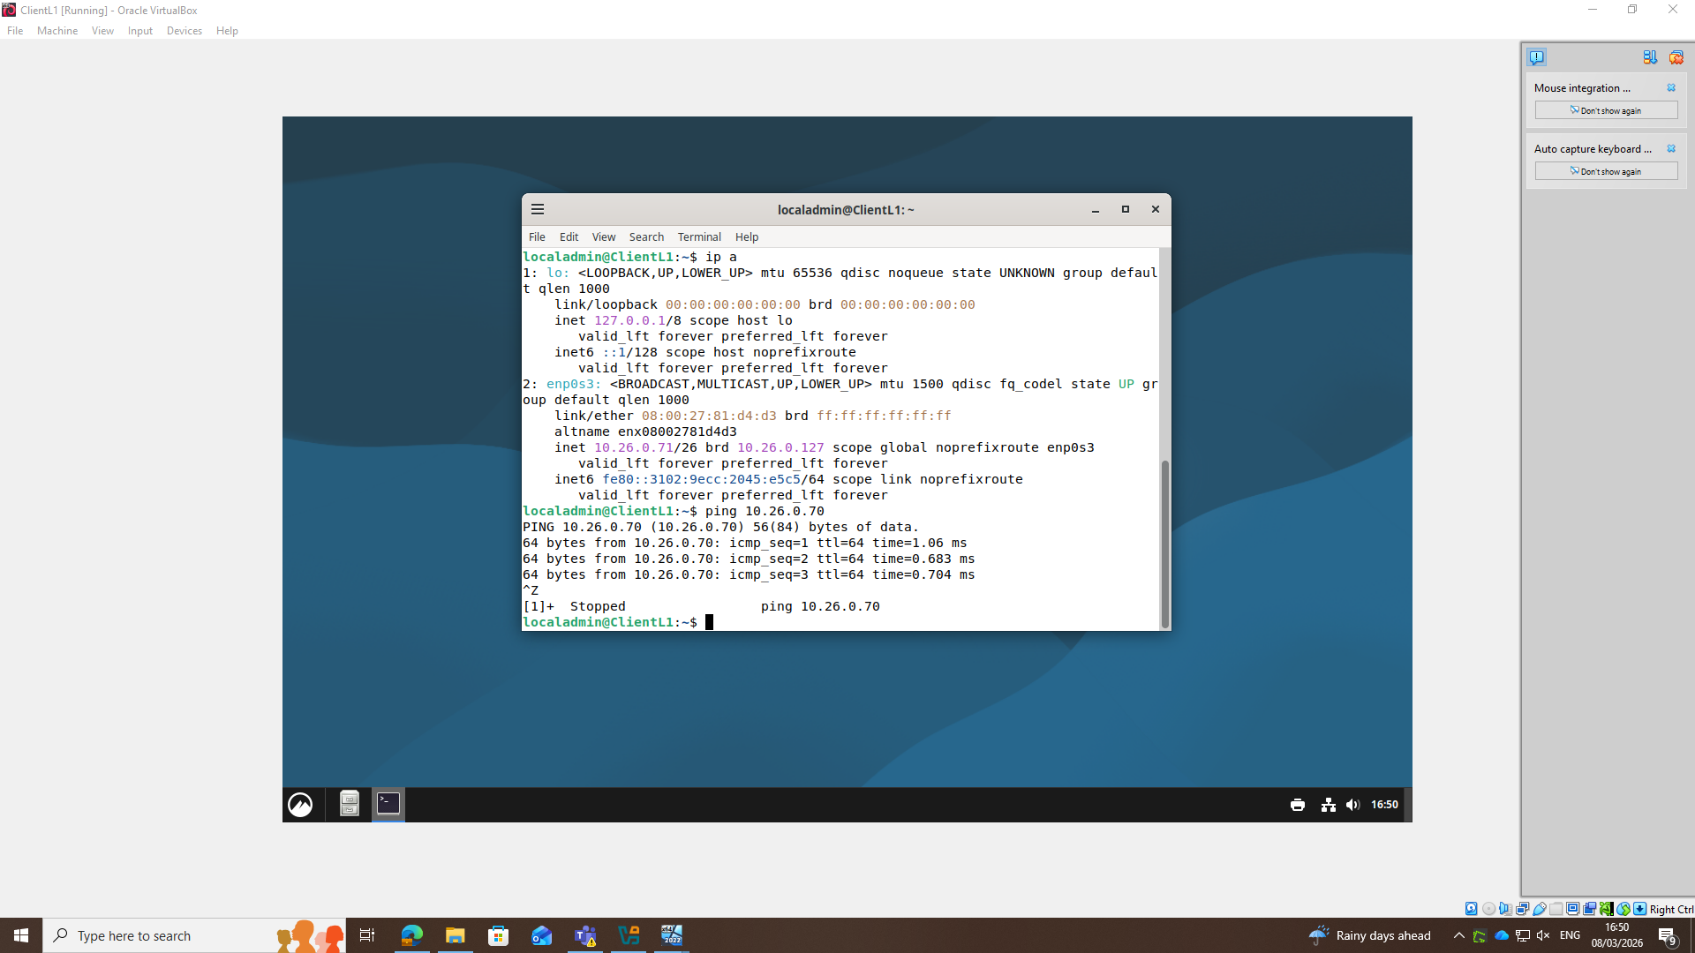
Figure 18: Debian Client Ping to Server
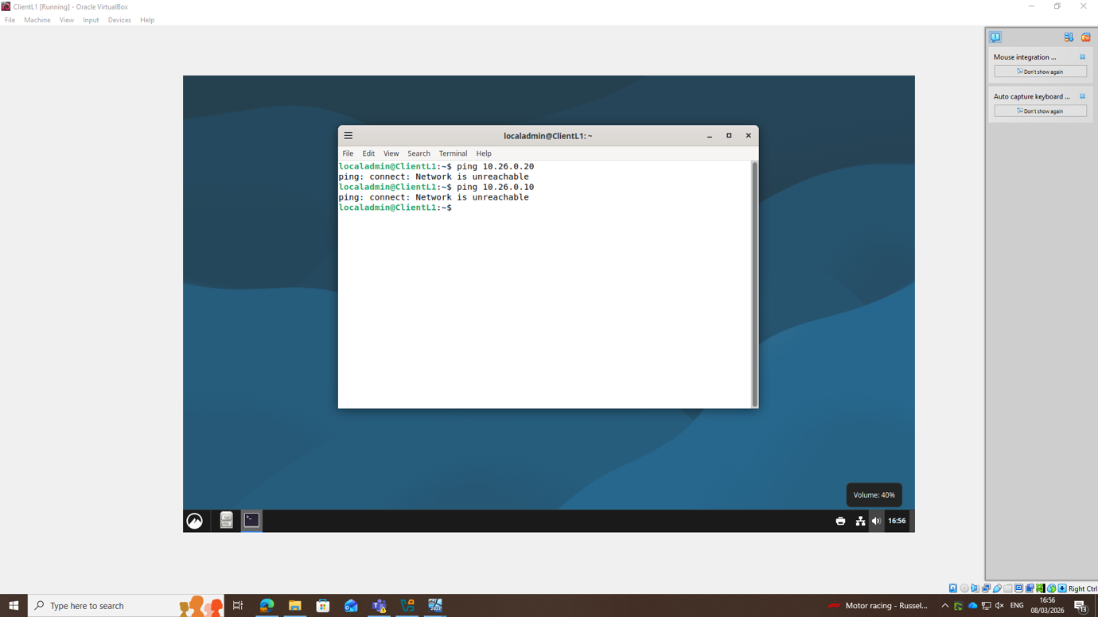
Figure 19: Debian Client ping to Windows Server
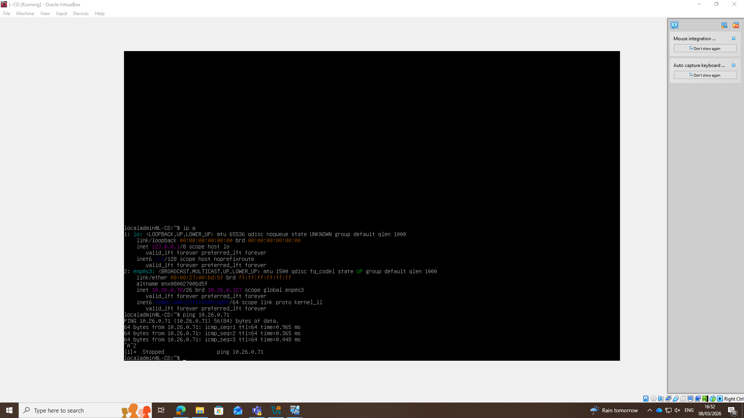
Figure 20: Debian Server ping to Client

Task 3
The deployment of the virtualised enterprise network required a structured evaluation of both the virtualisation environment and the network configuration strategy. Initially, both Type 1 and Type 2 hypervisors were explored to determine the most suitable platform for the coursework topology. Although a Type 1 hypervisor would typically provide stronger isolation and enterprise-level performance, several operational constraints influenced the final decision to deploy the environment using a Type 2 hypervisor. These constraints included inconsistent access to classroom laboratory systems via remote labs, the unexpected loss of the public IP address assigned to the initial Azure lab instance, and limited hardware resources on the replacement system. Additionally, remote access to the classroom workstation was temporarily unavailable when the network interface card had been disabled. These issues required adaptation and highlighted the importance of infrastructure reliability and contingency planning when deploying virtualised environments.

From a network configuration perspective, static IP addressing was implemented in accordance with the coursework requirements, with the addressing scheme designed to allow future scalability. The allocation allowed sufficient host capacity to reflect a realistic corporate scenario in which corporate-managed devices and potential BYOD endpoints would operate on separate network segments. Connectivity and configuration validation were performed using diagnostic utilities including ping, ipconfig, and arp, enabling verification of addressing configuration and host communication. During the initial testing phase, local firewalls were temporarily disabled to simplify connectivity testing rather than implementing specific ICMP rules. While effective for troubleshooting, this approach emphasised the operational security implications of such decisions in production environments, where hardened firewall rules and stronger authentication controls would be required.

The deployment process also reinforced the value of systematic troubleshooting methodologies when diagnosing network configuration issues. By verifying addressing configuration, network adapter settings, and connectivity sequentially, problems could be isolated and resolved efficiently. From a personal development perspective, the exercise improved my confidence navigating Linux environments using the command line and strengthened my understanding of how enterprise networks are constructed from first principles rather than maintained within an existing infrastructure. Although the coursework timetable itself was manageable, the lack of a dedicated and stable workspace occasionally disrupted progress, demonstrating the importance of controlled environments when undertaking infrastructure deployment.

If rebuilding the environment in the future, I would implement a more structured resilience strategy by exporting and backing up virtual machines at the end of each session. This would provide redundancy and enable rapid restoration should technical issues occur, reflecting standard operational practices in enterprise virtualisation environments.

Bibliography

[1] | T. Garfinkel and M. Rosenblum, “When Virtual Is Harder than Real: Security Challenges in Virtual Machine Based Computing Environments.,” HotOS, no. May, pp. 227-232, 2005.
[2] | K. Scarfone, M. Souppaya and P. Hoffman, “Guide to Security for Full Virtualization Technologies,” January 2011. [Online]. Available: https://nvlpubs.nist.gov/nistpubs/Legacy/SP/nistspecialpublication800-125.pdf. [Accessed 11 02 2026].
[3] | M. Rosenblum and T. Garfinkel, “Virtual machine monitors: current technology and future trends.,” Computer, vol. 38, no. 5, pp. 39-47, 2005.
[4] | K. Wallace, “Linkin Learning - Cisco Networking Foundations: IP Addressing,” 2022. [Online]. Available: https://www.linkedin.com/learning/cisco-networking-foundations-ip-addressing?u=77966930&auth=true. [Accessed 05 02 2026].
[5] | M. A. Sportack, IP Addressing Fundamentals, Indiannapolis: Cisco, 2003.
[6] | K. Wallace, “LinkedIn Learning,” LinkedIn, 12 11 2020. [Online]. Available: https://www.linkedin.com/learning/networking-foundations-networking-basics. [Accessed 10 02 2026].
[7] | Microsoft Learn, “DHCP Overview,” Microsoft Learn, 04 11 2025. [Online]. Available: https://learn.microsoft.com/en-us/windows-server/networking/technologies/dhcp/dhcp-top. [Accessed 05 02 2026].
[8] | Microsoft Learn, “Active Directory Domain Services Overview,” Microsoft Learn, 03 11 2025. [Online]. Available: https://learn.microsoft.com/en-us/windows-server/identity/ad-ds/get-started/virtual-dc/active-directory-domain-services-overview. [Accessed 20 02 2026].

Table of Figures
Figure 1: Initial VirtualBox 8
Figure 2: ISO Images prior to VM installation 8
Figure 3: Windows Server Config 9
Figure 4: Debian Server Config 9
Figure 5: VirtualBox Ethernet Adapter Config 9
Figure 6: Ethernet Adapter London Office 10
Figure 7: Resource Usage under load of 4VMs 10
Figure 8: Windows 2022 Configuration 11
Figure 9: Windows 2022 Desktop 12
Figure 10: Windows Client VM Configuration 13
Figure 11: Windows 11 Ethernet Configuration 13
Figure 12: Debian Server Config 14
Figure 13: Debian Ethernet Adapter configuration 14
Figure 14: Debian GUI Ethernet Config 15
Figure 15: Windows Client Ping to Server 17
Figure 16: Windows Server ping to Client 17
Figure 17: Windows Server ping to Debian Server 18
Figure 18: Debian Client Ping to Server 18
Figure 19: Debian Client ping to Windows Server 19
Figure 20: Debian Server ping to Client 19

Further Reading

Hypervisors
IBM, What Are Hypervisors?, IBM Think online article. Available: https://www.ibm.com/think/topics/hypervisors. Accessed: Feb. 26, 2026. This discusses the definition of hypervisors and how they support multiple virtual machines (VMs) on shared hardware.
Robert P. Goldberg and G. J. Popek, Architectural Principles for Virtual Computer Systems, PhD thesis, Harvard University, Cambridge, MA, USA, 1974. This foundational academic work introduced the formal classification and principles of virtualization and hypervisors, including the Popek–Goldberg virtualization requirements.
K. Scarfone, M. Souppaya, and P. Hoffman, Guide to Security for Full Virtualization Technologies (NIST SP 800-125), NIST, Gaithersburg, MD, USA, Jan. 2011. A comprehensive government standard detailing virtualization security, including hypervisor deployment and security considerations. (Available from NIST SP 800-125)
R. Chandramouli, Security Recommendations for Hypervisor Deployment on Servers (NIST SP 800-125A), NIST, Gaithersburg, MD, USA, Jan. 2018. This extension of SP 800-125 provides detailed hypervisor security guidance for server platforms. (Available from NIST SP 800-125A)
Microsoft, Hyper-V Architecture, Microsoft Learn, updated Jan. 21, 2026. Available: https://learn.microsoft.com/en-us/windows-server/virtualization/hyper-v/architecture. Accessed: Feb. 26, 2026. Official documentation outlining the Hyper-V hypervisor architecture and components. (Microsoft Learn)
VMware, Security of the VMware vSphere Hypervisor (ESXi), White Paper, 2014. Available:
. Accessed: Feb. 26, 2026.
Microsoft Corporation, “Guest Operating System and Application Supportability for Hyper-V,” Microsoft Learn, 2025. [Online]. Available: https://learn.microsoft.com/en-us/windows-server/virtualization/hyper-v/plan/guest-operating-system-application-supportability. [Accessed: 12-Feb-2026].
Microsoft Corporation, “Hyper-V Architecture,” Microsoft Learn, 2025. [Online]. Available: https://learn.microsoft.com/en-us/windows-server/virtualization/hyper-v/architecture. [Accessed: 19-Feb-2026].
Microsoft Corporation, “Hyper-V Features and Terminology,” Microsoft Learn, 2025. [Online]. Available: https://learn.microsoft.com/en-us/windows-server/virtualization/hyper-v/features-terminology. [Accessed: 08-Feb-2026].
Microsoft Corporation, “Hyper-V Overview,” Microsoft Learn, 2025. [Online]. Available: https://learn.microsoft.com/en-us/windows-server/virtualization/hyper-v/overview?pivots=windows. [Accessed: 24-Feb-2026].
GeeksforGeeks, “Hypervisor,” GeeksforGeeks, 2024. [Online]. Available: https://www.geeksforgeeks.org/system-design/hypervisor/. [Accessed: 15-Feb-2026].
Amazon Web Services, “The Difference Between Type 1 and Type 2 Hypervisors,” AWS, 2025. [Online]. Available: https://aws.amazon.com/compare/the-difference-between-type-1-and-type-2-hypervisors/. [Accessed: 11-Feb-2026].
Microsoft Corporation, “Virtualization,” Microsoft Learn, 2025. [Online]. Available: https://learn.microsoft.com/en-us/virtualization/. [Accessed: 20-Feb-2026].
IBM, “What Are Hypervisors?,” IBM, 2025. [Online]. Available: https://www.ibm.com/think/topics/hypervisors. [Accessed: 09-Feb-2026].
VMware, “Bare-Metal Hypervisor,” VMware Topics, 2025. [Online]. Available: https://www.vmware.com/topics/bare-metal-hypervisor. [Accessed: 18-Feb-2026].
VMware, “Hypervisor,” VMware Topics, 2025. [Online]. Available: https://www.vmware.com/topics/hypervisor. [Accessed: 25-Feb-2026].
VMware, “Server Virtualization,” VMware Topics, 2025. [Online]. Available: https://www.vmware.com/topics/server-virtualization. [Accessed: 13-Feb-2026].

IP Addressing

Cisco Systems, IP Addressing: IPv4 Addressing Configuration Guide (Cisco IOS XE 16), Cisco, 2024. Available: https://www.cisco.com/c/en/us/td/docs/ios-xml/ios/ipaddr_ipv4/configuration/xe-16/ipv4-xe-16-book.pdf. Accessed: Feb. 27, 2026.
Cisco Systems, IPv4 Addressing White Paper, Cisco, Aug. 2013. Available: https://www.cisco.com/c/dam/en/us/td/docs/solutions/CVD/Aug2013/CVD-IPv4AddressingWhitePaper-AUG13.pdf. Accessed: Feb. 27, 2026.

Fortinet Sources
Fortinet, “What Is an IP Address? How It Works,” Fortinet Cyberglossary, 2025. Available: https://www.fortinet.com/resources/cyberglossary/what-is-ip-address. Accessed: Feb. 27, 2026.
Fortinet, FortiIPAM 1.0.0 Online Help – Subnet Basic, Fortinet, 2025. Available: https://docs.fortinet.com/document/fortiipam/1.0.0/online-help/196662/subnet-basic. Accessed: Feb. 27, 2026.

Palo Alto Resources
Palo Alto Networks, PAN-OS® 11.0 Administrator’s Guide – Perform Initial Configuration, Palo Alto Networks, 2025. Available: https://docs.paloaltonetworks.com/pan-os/11-0/pan-os-admin/getting-started/integrate-the-firewall-into-your-management-network/perform-initial-configuration. Accessed: Feb. 27, 2026.
Palo Alto Networks, “Policy Object: Addresses,” Palo Alto Networks Documentation, 2025. Available: https://docs.paloaltonetworks.com/network-security/security-policy/administration/objects/addresses. Accessed: Feb. 27, 2026.
F5 Documentation
F5 Networks, BIG-IP TMOS Routing Administration (14.1): Self IP Addresses for SNATs, F5 Networks, 2025. Available: https://techdocs.f5.com/en-us/bigip-14-1-0/big-ip-tmos-routing-administration-14-1-0/self-ip-addresses/self-ip-addresses-for-snats.html. Accessed: Feb. 27, 2026.
Scholarly/Academic Texts
M. Hossain, “A Review Paper on IPv4 and IPv6: A Comprehensive Survey,” American Journal of Computer Science and Technology, 2024.
SL Levin and L. Decurtin, “IPv4 to IPv6: Challenges, Solutions, and Lessons,” Computer Networks, vol. 72, pp. 200–211, 2014.

Routing
Moy, J., “OSPF Version 2,” Internet Engineering Task Force (IETF) RFC 2328, Apr. 1998.
Coltun, R., Ferguson, D., Moy, J., and Lindem, A., “OSPF for IPv6,” Internet Engineering Task Force (IETF) RFC 5340, Jul. 2008.
Atlas, A., and Zinin, A., “Basic Specification for IP Fast Reroute: Loop-Free Alternates,” Internet Engineering Task Force (IETF) RFC 5286, Sept. 2008.
Medhi, D., and Ramasamy, K., Network Routing: Algorithms, Protocols, and Architectures, 2nd ed. San Francisco, CA: Morgan Kaufmann, 2017.
Odom, W., CCNA 200-301 Official Cert Guide, Volume 1, Indianapolis, IN: Cisco Press, 2020.
Odom, W., CCENT/CCNA ICND1 100-105 Official Cert Guide, Indianapolis, IN: Cisco Press, 2016.
Lammle, T., CCNA Certification Study Guide: Exam 200-301, 2nd ed. Hoboken, NJ: Sybex (Wiley), 2023.
Cisco Systems, “Understanding OSPF Fundamentals,” Cisco Systems White Paper, 2022.

