  Component One:  “What are the key skills required when working in the housekeeping team?” | Student name & No: | Mohammad Tanvir Ahmed (2211271)
 | Module Title: | Hospitality & Tourism Management  Institute of Management & Health
 | Module Code: | BMIH4006
 | Lecturer: | Mohammad Cassamo
The hospitality industry is one the wide category which includes a variety of services like food and drink services, lodging, theme parks, event planning, tourism, hotels, travel agency, bars and restaurants (Dashper, 2020). To full these services the hospitality companies comprise the different types of departments within their company. These departments are interlinked with one another and work simultaneously to cater for the needs of the customers and enhance the brand name of the company. As a student, I have been analysing the importance of these departments which would make the whole industry a success. One such department which is a crucial sector is the housekeeping team of the company (Zutshi, 2019). It is an operational department where its members are entitled to the role of maintenance, cleanliness, clearing public areas and surroundings and maintaining the rooms for the customers.
I have acknowledged the importance of the housekeeping team as it maintained the high satisfaction level of the guest by making sure that the guest rooms and comfortable and clean (Palm and Kleinau, 2021). In addition to it, the academic knowledge that I have gathered has been crucial for me to analyse and apply my theoretical knowledge into practice as it helps in the maintenance of special guests effectively and quickly. The successful and effective housekeeper must have various characteristics which include both soft skills as well as hard skills which would be beneficial for the effective functioning of the company and in the industry as a whole. During my course of study, I was also able to analyse the skills which are crucial for the working of the housekeeping team. These skills include customer service by providing effective communication and unique responsibilities (Aagaard, 2023). For instance, the housekeeper of the tourism industry is obliged to follow strict rules for sanitation so that they will be able to make sure that the guests are in a healthy and clean environment. I have evaluated the importance of acquiring the skills which would make the team run in a successful manner.
One of the most crucial skills for any housekeeping staff is the skill of time management. The members of the housekeepers are to complete various tasks in the given time (Jubaedah et al., 2020.). They should be able to manage the schedule of their work in an effective manner. In addition to it, I have also laid emphasis on and gathered knowledge about the communication skills of the housekeeper team. For instance, housekeepers in the hotel industry should be able to effectively navigate the guests in a daily manner and initiate interaction with the customers (Guo et al., 2019.). Similarly, they have to know interpersonal skills, which refer to reading the gestures or signals that others transmit and analysing them precisely in order to maintain effective reactions or feedback. Housekeepers usually work straight with customers or clients and even must be capable to work skillfully with others to be victorious at their work. The standard interpersonal skills required by the housekeeper to function in their work well contain responsibility, dependability and teamwork. Mainly it helps them to involve with the clients continually and satisfy or profit from being capable to function well with other specialists. The housekeepers must also have flexibility in their work because there is no suitable time for their work (Tra, 2020). They have to operate any time they are called or needed by the customers and they must function well in those times. If they happen to fail in those moments and earn a bad reputation from the customers it will affect the reputation of the whole staff and the hotel as well. This is one of the main reasons the housekeeping staff should have flexibility in their work. Even though many workers can wake up early and still do work at night but they do not do it with perfection and fail to do their job correctly (Pai et al., 2020).
On the other hand, the housekeeping staff must be well organised with their work which will help them to do their job quicker and with more ease (Franciosi et al., 2020). It will help them to do their job with more pleasure and happiness and to do it with more perfection. It will help the brand to earn more positive feedback from the customers and they might visit again if the services and the rooms are well organised. To be well organised the staff should provide the best quality products such as coffee, soap, toothpaste, bedsheets, shampoo and many other products (Aagaard, 2023).

Component Two: Action Plan
“Problem” | “Why did it happen?” | “What are you going to do?” | “How will you prevent this from happening in the future?” | “What measures would you introduce to improve team effectiveness?”
The staff fails to meet the demands and requirements of the customers. | The staffs were not trained properly in this field and they were still in the learning process and most of the staff was newcomers (Shokouhyar et al., 2020). This thing happened to make a huge mistake where they failed to meet the requirements of the customers. | To overcome this problem each and every staff member will be provided with more sufficient training and those who will still fail to meet the requirements will be fired. | Each and every staff will be in monitor and they will be on track of the company (Saffar, and Obeidat, 2020). The company will track their activities each day and the staff with bad behaviour will be given effective counselling to improve their competence. | I would introduce workshops for improving their etiquette and behaviour collectively.
The staff failed to clean the rooms and achieved bad feedback from the customers. | There are shortages of staff in the company and most of the staff are new to the company (Shuqair et al., 2019). This thing even involved the senior staff teaching the newcomers about their work and failing to do their own jobs. | The shortage of staff will be covered in a few days as the new recruitment will be open. In the recruitment phase, the candidates will be selected more precisely and with strict rules. | This problem will not occur again as this is a rare moment it has occurred and then recruitment of the staff will be conducted every 6 months (Allard et al., 2020). | I will choose, recruit and lead the team who are ready to collaborate. With the right individual and the right habitat for development and growth.
The company does not provide sufficient equipment for the staff. | The company does not give attention to the housekeeping staff as they are mostly focused on the advertisement or the promotion of the company (Herron et al., 2020). Even the staff does not complain about these things to the company as there is shortage of staff. | For this problem, the staff will be provided with the best equipment for cleaning as the company has grabbed the attention of this issue from the feedback from the customers. | In future, the equipment of each and every staff will be checked monthly and they will be provided with new equipment if the old one is broken or damaged (Ranney et al., 2020). | I will prioritise the well-being of each and every staff. If I practise this thing then the whole staff can work more efficiently with their day-to-day jobs and can help the company to achieve success.
The time management skills of the staff are very bad. | As I have discussed above there is very shortage of staff and most of the staff were forced to do two work at the same time (Adams and Blair, 2019). It even resulted that the time management skills of the staff were poor as they were having difficulties in making time for extra work. | To improve their time management skills the staff will be given a short duration of training where they can achieve these skills slowly. | The company will have a monthly report of the staff where they have to know which staff is improving and which ones are not (Wang, 2019). The staff who are not improving will give more training. | For the improvement of the team effectiveness, I will diversify my whole team. These things have a huge benefit in the workplace.
The communication of the staff must be improved. | The staffs were not given much rest and they were having a rough time with their work and their communication with the customers turned into more aggressive (Kaasinen et al., 2020). | The staff will be provided with more off time and will also be getting some training to improve their communication skills. | To avoid this in the future I will help every staff with their work and make them feel like they are important to the company (Verčič, 2021). If they are more happy and more satisfied with their work they will try to improve their capabilities in every field including their communication skills. | I will lead the team with gratitude and share ideas regularly. I will support them in every field whether they do not feel comfortable.

Component Three: Presentation
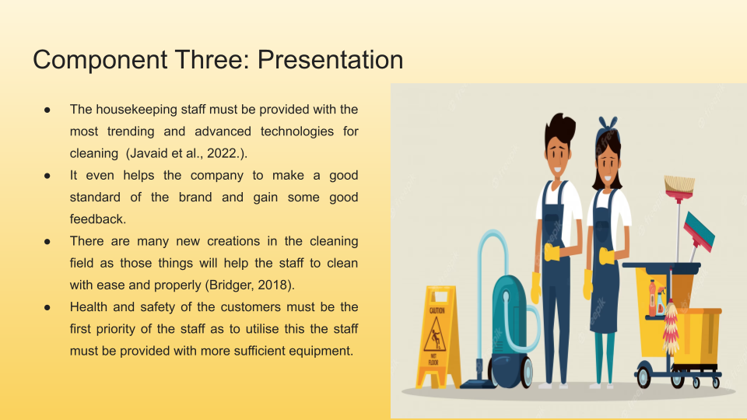

Training Notes: The housekeeping staff must be provided with the most trending and advanced technologies for cleaning (Javaid et al., 2022.). It even helps the company to make a good standard of the brand and gain some good feedback. There are many new creations in the cleaning field as those things will help the staff to clean with ease and properly (Bridger, 2018). If the staff are provided with new products and equipment it will ensure the safety of health and can even help to stop the complaints from the consumers. Health and safety of the customers must be the first priority of the staff as to utilise this staff must be provided with more sufficient equipment.
Training Notes: The appropriate knowledge about the cleaning chemicals, solutions and uniforms are also significant aspects that are needed for the housekeeping staff to complete the cleaning (Leiter and Bakker, 2010). As uniforms help to acquire two purposes such as to safeguard the staff from the toxins and stains which arrive from day-to-day cleaning of commodity use. It even helps to make a good reputation in front of the customers. The chemicals are the final touch of cleaning as it helps to kill germs and bacteria and make the place smell good. It even helps to safeguard the customer's health from different kinds of diseases and earn good feedback from them.
Training Notes: Even though the housekeeping group may not be truthfully doing supervision or maintenance, it is their assignment to notify the maintenance of the issue (Raghubalan and Raghubalan, 2016). And even to observe their restoration from a damaged TV remote to a defective light fixture. It helps the company to make a good appearance and make a good reputation for the brand. The housekeeping should be informed that they are notified to observe each and every detail that is needed to be fixed or repaired.
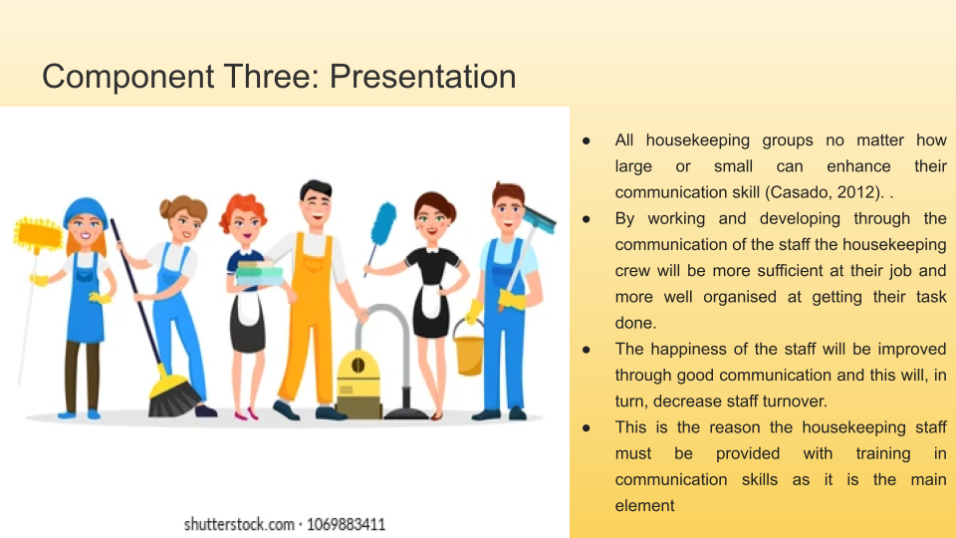
Training Notes: All housekeeping groups no matter how large or small can enhance their communication skill (Casado, 2012). By working and developing through the communication of the staff the housekeeping crew will be more sufficient at their job and better organized at getting their task done. The happiness of the staff will be improved through good communication and this will, in turn, decrease the staff turnover. This is the reason the housekeeping staff must be provided with training in communication skills as it is the main element. It even helps the staff to make a good connection with the customers.
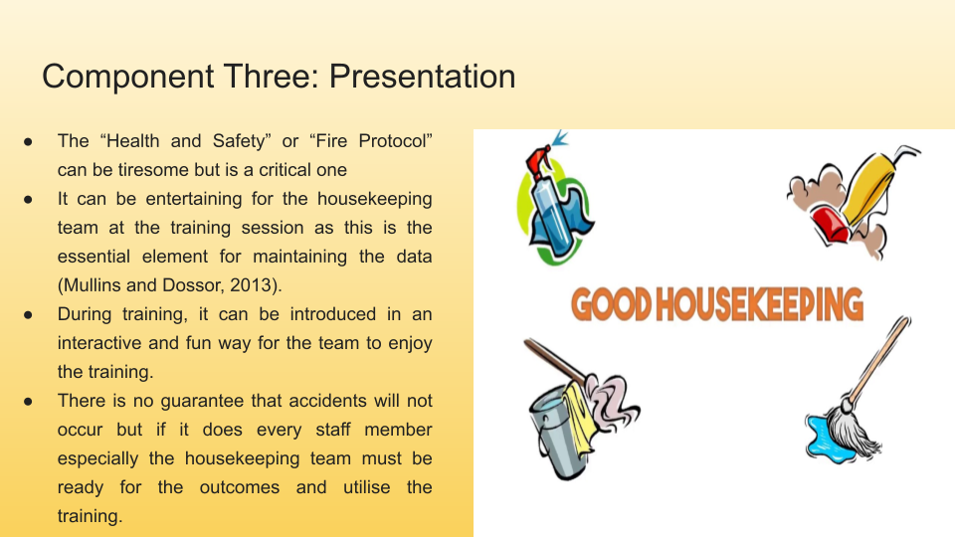

Training Notes: The "Health and Safety" or "Fire Protocol" can be tiresome but is a critical one. It can be entertaining for the housekeeping team during the training session as this is the essential element for maintaining the data (Mullins and Dossor, 2013). During training, it can be introduced in an interactive and fun way for the team to enjoy the training. This internship can literally protect the lives of the customers and even their own lives. There is no guarantee that accidents will not occur but if it does every staff member especially the housekeeping team must be ready for the outcomes and utilise the training.

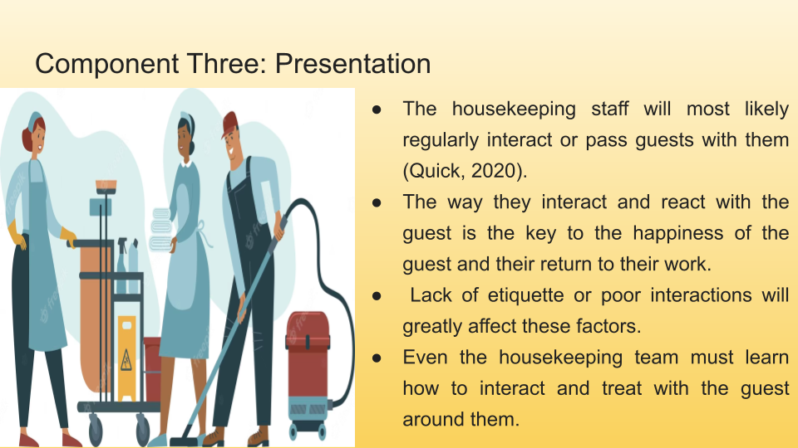

Training Notes: The housekeeping staff will most likely regularly interact with or pass guests with them (Quick, 2020). The way they interact and react with the guest is the key to the happiness of the guest and their return to their work. Lack of etiquette or poor interactions will greatly affect these factors. During training, the staff can be taught how to understand cultural differences, and how to approach etiquette and body language within the housekeeping team. Even the housekeeping team must learn how to interact and treat with the guest around them.
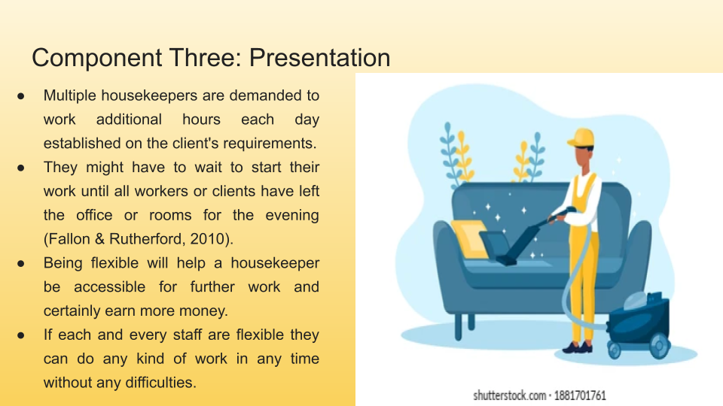
Training Notes: Multiple housekeepers are demanded to work additional hours each day established on the client's requirements. For example, if a staff is requested with cleansing an office or room. They might have to wait to start their work until all workers or clients have left the office or rooms for the evening (Fallon & Rutherford, 2010). Some staffs even have to work early in the morning or even overnight. Being flexible will help a housekeeper be accessible for further work and certainly earn more money. If each and every staff is flexible they can do any kind of work at any time without any difficulties.
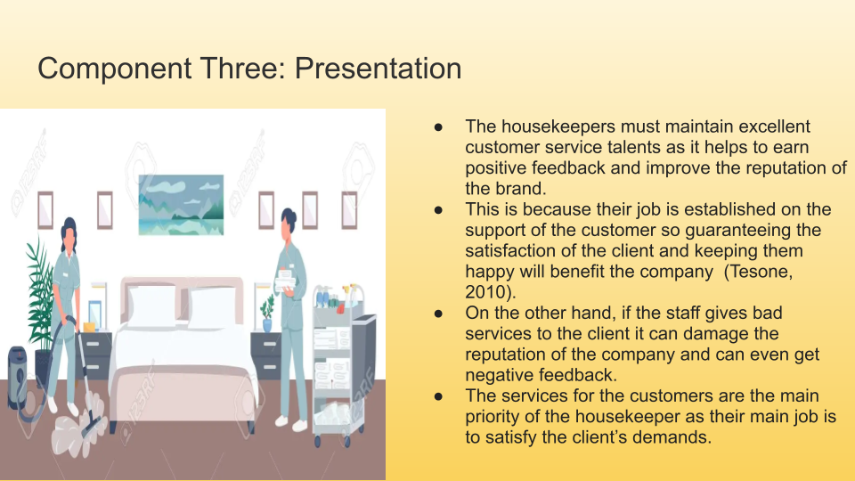

Training Notes: The housekeepers must maintain excellent customer service talents as it helps to earn positive feedback and improve the reputation of the brand. This is because their job is established on the support of the customer so guaranteeing the satisfaction of the client and keeping them happy will benefit the company (Tesone, 2010). On the other hand, if the staff gives bad services to the client it can damage the reputation of the company and can even get negative feedback. The services for the customers are the main priority of the housekeeper as their main job is to satisfy the client’s demands.
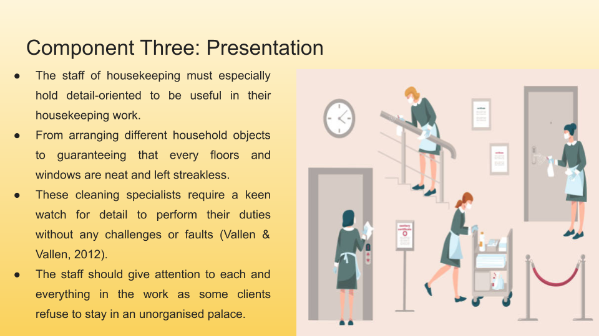

Training Notes: The staff of housekeeping must especially hold detail-oriented to be useful in their housekeeping work. From arranging different household objects to guaranteeing that every floors and windows are neat and left streakless. These cleaning specialists require a keen watch for detail to perform their duties without any challenges or faults (Vallen & Vallen, 2012). The more detailed a housekeeper is at achieving their work, the more acceptable they will be at their work. The staff should give attention to each and everything in the work as some clients refuse to stay in an unorganised palace.
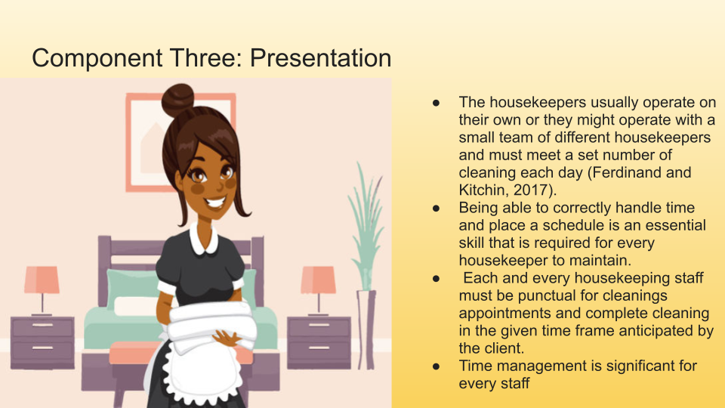
Training Notes: The housekeepers usually operate on their own or they might operate with a small team of different housekeepers and must meet a set number of cleaning each day (Ferdinand and Kitchin, 2017). Being able to correctly handle time and place a schedule is an essential skill that is required for every housekeeper to maintain. Each and every housekeeping staff must be punctual for cleanings appointments and complete cleaning in the given time frame anticipated by the client.

References
Aagaard, L.K., 2023. When smart technologies enter household practices: The gendered implications of digital housekeeping. Housing, Theory and Society, 40(1), pp.60-77.
Adams, R.V. and Blair, E., 2019. Impact of time management behaviours on undergraduate engineering students' performance. Sage Open, 9(1), p.2158244018824506.
Allard, T., Dunn, L.H. and White, K., 2020. Negative reviews, positive impact: Consumer empathetic response to unfair word of mouth. Journal of Marketing, 84(4), pp.86-108.
Bridger, E. (2018). Employee engagement: a practical introduction. 2nd ed. HR Fundamentals. London: CIPD and Kogan Page.
Casado, M. (2012) Housekeeping Management. London: Wiley.
Cottrell, S. (2019) The Study Skills Handbook. 5th ed. London: Red Globe Press.
Dashper, K., 2020. Mentoring for gender equality: Supporting female leaders in the hospitality industry. International Journal of Hospitality Management, 88, p.102397.
Fallon, M. & Rutherford, D. (2010) Hotel Management and Operations. London: Pearson.
Ferdinand, N. and Kitchin, P. (2017) Events Management - An International Approach. 2nd ed. London: SAGE Publications Ltd.
Franciosi, C., Voisin, A., Miranda, S., Riemma, S. and Iung, B., 2020. Measuring maintenance impacts on sustainability of manufacturing industries: from a systematic literature review to a framework proposal. Journal of Cleaner Production, 260, p.121065.
Guo, X., Cheng, A. and Pavlou, P., 2019. Skill-biased technical change again? Estimating the effect of TaskRabbit on local employment in the housekeeping industry.
Herron, J.B.T., Hay-David, A.G.C., Gilliam, A.D. and Brennan, P.A., 2020. Personal protective equipment and Covid 19-a risk to healthcare staff?. British Journal of Oral and Maxillofacial Surgery, 58(5), pp.500-502.
Javaid, M., Haleem, A., Singh, R.P., Suman, R. and Gonzalez, E.S., 2022. Understanding the adoption of Industry 4.0 technologies in improving environmental sustainability. Sustainable Operations and Computers.
Jubaedah, Y., Rinekasari, N.R., Rohaeni, N.E.N.I., Maosul, A.S.E.P. and Ana, A., 2020. Competency based-assessment using electronic rubric: implementation on manual polishing practice in housekeeping. Journal of Engineering Science and Technology, 15(1), pp.046-053.
Kaasinen, E., Schmalfuß, F., Özturk, C., Aromaa, S., Boubekeur, M., Heilala, J., Heikkilä, P., Kuula, T., Liinasuo, M., Mach, S. and Mehta, R., 2020. Empowering and engaging industrial workers with Operator 4.0 solutions. Computers & Industrial Engineering, 139, p.105678.
Leiter, M. P. and Bakker, A. B. (2010) Work Engagement : A Handbook of Essential Theory and Research. Hove [England]: Psychology Press.
Mullins, L. and Dossor, P. (2013) Hospitality Management and Organisational Behaviour. 5th ed. Harlow: Pearson.
Pai, A., Manjunath, M., Kowshik, C.S., Ayedee, N., Malarout, N. and Naik, N., 2020. SOFT SKILLS AS A KEY COMPETENCY FOR THE FUTURE LEADERS OF THE HOSPITALITY INDUSTRY. PalArch's Journal of Archaeology of Egypt/Egyptology, 17(9), pp.4341-4355.
Palm, A.K.E. and Kleinau, S., 2021. Marginal zone B cells: From housekeeping function to autoimmunity?. Journal of Autoimmunity, 119, p.102627.
Quick, L. (2020) Managing Events. Real Challenges, Real Outcomes. London: SAGE Publications Ltd.
Raghubalan, G. and Raghubalan, S. (2016) Hotel Housekeeping - Operations And Management. 3rd ed. India: Oxford University Press.
Ranney, M.L., Griffeth, V. and Jha, A.K., 2020. Critical supply shortages—the need for ventilators and personal protective equipment during the Covid-19 pandemic. New England Journal of Medicine, 382(18), p.e41.
Saffar, N. and Obeidat, A., 2020. The effect of total quality management practices on employee performance: The moderating role of knowledge sharing. Management Science Letters, 10(1), pp.77-90.
Shokouhyar, S., Shokoohyar, S. and Safari, S., 2020. Research on the influence of after-sales service quality factors on customer satisfaction. Journal of Retailing and Consumer Services, 56, p.102139.
Shuqair, S., Pinto, D.C. and Mattila, A.S., 2019. Benefits of authenticity: Post-failure loyalty in the sharing economy. Annals of Tourism Research, 78, p.102741.
Tesone, D. (2010) Principles Of Management For The Hospitality Industry. 1st ed. London: Routledge.
Tra, T., 2020. Action plan for training new Housekeeping Employee: case: Hotel Indigo Helsinki.
Vallen, G. & Vallen, J. (2012) Managing Hotel Operations. London: Pearson.
Verčič, A.T., 2021. The impact of employee engagement, organisational support and employer branding on internal communication satisfaction. Public Relations Review, 47(1), p.102009.
Wang, W.C., 2019. Exploring the relationship among free-time management, leisure boredom, and internet addiction in undergraduates in Taiwan. Psychological reports, 122(5), pp.1651-1665.
Zutshi, A., 2019. How to develop well-informed and assured teams to embed food safety compliance in the UK catering and hospitality industry. Perspectives in Public Health, 139(6), pp.294-295.

