Assessment Component 2
Marketing plan and slides for Travelodge Hotel
Name:
Alexandra Beatrice Crisan
Student ID:
2208395

The module title:
Marketing Essentials BMIH4005
Lecturer’s name
Luciana Suardi
Table of contents
Introduction 3
The Marketing Mix 3
The Marketing Environment (Micro) 4
The Marketing Environment (Macro) 6
Creating Customer Value and Engagement 9
Effective use of Digital Marketing 9
Conclusion and Bibliography 10
References 11

Introduction
Marketing can be defined as the activity and a bunch of institutions that deal with the process of creating, exchanging offerings, delivering and communicating that has value for the clients, customers, society and partner’s at large (ama, 2022). Travelodge is the first value hotel brand that was launched in the UK in 1985 and now is perceived as the largest independent hotel brand in the UK. The marketing plan is prepared for Travelodge in order to identify their customer segmentation to make an effective marketing plan. The study is going to include different frameworks such as PESTLE, SWOT, Porter’s five forces, Marketing and others.
The smart objectives for the company is given below:
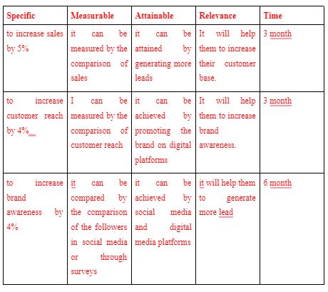
Figure 1: Smart objectives
(Source: Created by the learner)

The Marketing Mix
5C’s of marketing
Company | The company has great knowledge of the market
Collaborators | The company has partnerships with different suppliers and companies
Customers' | The customers of Travelodge are business people and economic class people
Competitors' | There are many competitors of the company such as Premier Inn, Holiday Inn, Marriott and others.
Climate | The technological factors and advanced technology such as AI, AR/VR and others are influencing the company positively.
Table 2: 5C’s of marketing
(Source: Created by the learner)
Product- Presently Travelodge operates in the UK, Spain and Ireland. The hotels are distributed in the major city centres, seaside, important roadsides towns and others.
Place – The Company also provides an option to check for the availability of rooms and provide options to book the hotels online through the company website (Travelodge, 2022). Price – The Company uses a value pricing strategy and the price of the hotel rooms remains flexible based on the demands of the rooms. The basic tariff of the rooms starts from £34 in the UK (Travelodge, 2022).
Promotion–The new segment of Travelodge will be promoted through a digital media campaigning. The RACE model can be applied in order to understand the promotional tactics of the company. It has four stages Reach, Act, Convert and Engage (Fickle, 2019).
Research: The Company can increase its customer reach through Omni channel promotional strategies and build traffic by promoting its brands on microsites.
Act: The brand can interact with the company through conversations of social media, organising events and other promotional stunts.
Convert: the company can pay attention to the needs and demands of the customers and generate leads from the company websites and social media handles.
Engage: The Company also can pay attention to customer feedback in order to keep a track of customer satisfaction and others.

The Marketing Environment (Micro)
SWOT analysis of Travelodge
Strengths | Weakness
- Market knowledge  - A number of employees | - Gender pay gap
Opportunities | Threats
- Diversion in the portfolio | - Lack of capital investments  - Skill gap
Table 1: SWOT analysis
(Source: Created by the learner)
Segmentation: The Company also uses demographic segmentation as the company targets mostly leisure and business people in the UK.
Targeting: Since the majority of the customers are business people and young travellers it can be assumed that their target customers are around the 18-45 age group of people.
Positioning: according to the strategy of the company it aims to deliver affordable services and provide low-cost choices for business and leisure travel (Travelodge, 2022). Thus, the company can be positioned in a low-price-high-quality position.
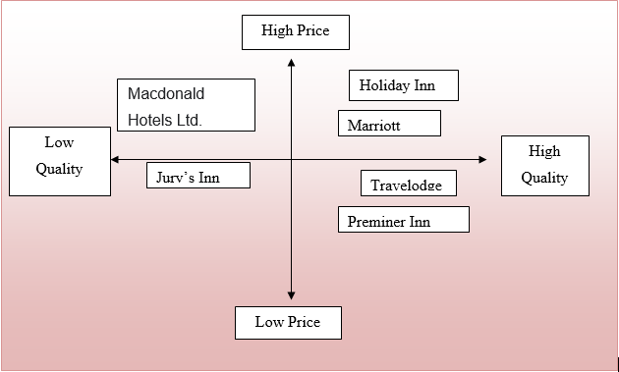
Figure 2: Positional map
(Source: Created by the learner)
The porter five forces are conducted for Travelodge and is given below:
Competitive rivalry: | High
Buying power of the customers: | High
Buying power of the suppliers: | High
The threat of substitutes: | High
The threat of new entreats: | Moderate
Table 3: Porter’s five forces
(Source: Created by the learner)

The Marketing Environment (Macro)
Element | Factor | Implications
Political | Brexit: | Brexit had a “negative impact on the tourism industry”. It impacted the UK labour market drastically. As a result, it will impact Travelodge negatively in terms of hiring and recruiting employees.
Economic | “GDP of the UK”: | The increased GDP will provide economic stability to the tourism industry impacting it positively. Thus, it will also benefit Travelodge in terms of getting higher investment in their upcoming projects.
Social | Literacy rate: | A higher literacy rate will impact the tourism industry positively as the companies will get educated and skilled employees. Thus, it will also impact Travelodge positively.
Technical | “Internet penetration rate”: | The increasing internet penetration rate will impact the tourism industry positively in terms of increasing customer reach. Hence, it will also benefit Travelodge.
Legal | “The equality act 2010”: | The gender pay gap in the travel and tourism industry is 14% in the UK thus, there is a huge gap between the salary of male and female employees. Thus, it will also negatively impact Travelodge.
Environmental | “The Climate protection Act 2008” | The climate protection act will impact the tourism industry negatively Thus, it will also impact Travelodge negatively.
Table 4: Pestle analysis of Travelodge
(Source: Created by the learner)

Creating Customer Value and Engagement
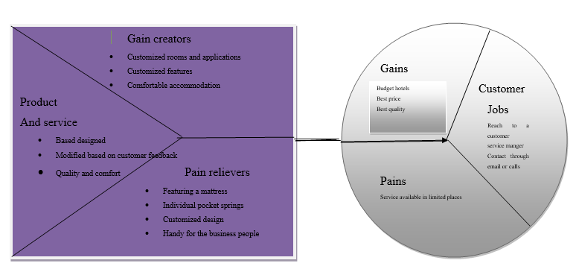
Figure 2: value proposition
(Source: Created by the learner)
The organisation differentiates from the other companies in terms of providing customers with mixed accommodation that has all the facilities to work and travel as well as spend time in leisure. The value proportion is created based on the target market such as leisure and business people and the features are also created for the benefit and preferences considering the feedback from the customers. Moreover, besides providing customised services the company also provides these facilities at the most affordable price possible (Travelodge, 2022).
The bowman's strategic clock is used to determine the pricing strategy of a company. In the case of Travelodge, the company can use a Hybrid pricing strategy. Using this pricing strategy the company will be able to keep their prices competitive as well as low perceived prices from the buyers and promote the added value aspects to the customers. It will enable them to attract the target market customers and establish their position as the best service-providing company within an affordable budget.
Gantt chart
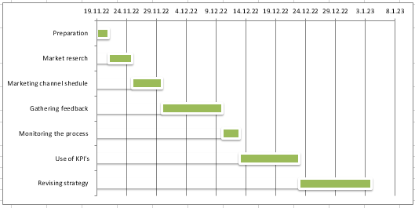
Figure 3: Gantt chart
(Source: Created by the learner)
The company will promote their brand through social media channels due to the presence of Young people on a large scale in those channels. On the other hand, it will also promote online hotel booking applications to generate more traffic to their website and other applications.
Control
USP of Travelodge: Travelodge is well aware of the present and future trends of tourism and the rise of Hybrid work culture that allows people to work and travel. Travelodge has customised its hotel rooms and provided the best available features to make its accommodation compatible with this new segment of customers at an affordable price (Travelodge, 2022).
Features: The organisation such as a room coffee machine, and Hansgrohe Raindance 3jet adjustable shower. Freeview TV, hairdryer iron and ironing facility and others.
Benefits: The benefit of using Travelodge accommodation is that the travellers will get every facility within their room at a convenient price that will save them money and time.
KPI’s to measure the success: The feedback provided by the customers will also help to measure the positive attitude of customers toward the brand. The Company can expand its hotel chain in order to achieve high profit.

Conclusion
The study has analysed the internal and external environment and its impact on the new marketing plan of the company. Travelodge is the lack of skilled employees and resource constraints. Thus it is recommended to the organisation use social and digital media marketing as it will help Travelodge to have a greater customer reach. The employees can be trained with IT skills to get the best ROI.

References & Bibliography
- Alvianna, S., Earlike, F., Sani, A., Lasarudin, A. and Hidayatullah, S., (2020). The Impact of Visitor Satisfaction Mediation from the Relationship between Marketing Information Systems, Tourist Destinations and Service Quality towards Returning Interest in Malang Topeng Village Tourism Destinations. East African Scholars Multidisciplinary Bulletin, 4413(12), pp.332-338.

- Ama.org. (2022). Definition of Marketing. [Online] available at:<https://www.ama.org/the-definition-of-marketing-what-is-marketing/#:~:text=Marketing%20is%20the%20activity%2C%20set,%2C%20and%20society%20at%20large.%20(:> (Accessed on 30th October 2022)

- Bbc.com. (2022). Brexit: What you need to know about the UK leaving the EU. [Online] Available at:<https://www.bbc.com/news/uk-politics-32810887:> (Accessed on 30 October 2022)

- Bruijl, D. and Gerard, H.T., 2018. The relevance of Porter's five forces in today's innovative and changing business environment. Available at SSRN 3192207.
- Fickle, T., 2019. Race Card, The. In Race Card, The. New York University Press.

- Gov.uk. (2022). HMRC gender pay gap report 2021. [Online] Available at:<https://www.gov.uk/government/publications/hmrc-and-valuation-office-agency-gender-pay-gap-report-and-data-2021/hmrc-gender-pay-gap-report-2021#:~:text=2021%20gender%20pay%20gaps%20in%20hourly%20pay&text=Image%20showing%20the%20mean%20hourly,reduction%20of%201.6%25%20from%202020:> (Accessed on 30 October 2022)

- Holz-Clause, M., (2018). Conducting market research.

- Niculescu, A., Dumitriu, D., Purdescu, C. and Popescu, M.A.M., (2019). Enhancing brand value of modern organizations through digital marketing tools and techniques: A study on top ten Romanian companies. TEM Journal, 8(1), p.171.
- Sánchez-Gutiérrez, J., Cabanelas, P., Lampón, J.F. and González-Alvarado, T.E., (2018). The impact on competitiveness of customer value creation through relationship capabilities and marketing innovation. Journal of Business & Industrial Marketing.

- Statista.com. (2022). United Kingdom: online usage penetration rate 2018-2027. [Online] Available at:<https://www.statista.com/statistics/553589/predicted-internet-user-penetration-rate-in-the-united-kingdom-uk/:> (Accessed on 30 October 2022)

- Statista.com. 2022. Gross domestic product (GDP) in current prices of the United Kingdom (UK) from 1987 to 2027. [Online] Available at:<https://www.statista.com/statistics/263590/gross-domestic-product-gdp-of-the-united-kingdom/:> (Accessed on 30 October 2022)

- Statista.com.2022. Most well-known social networks in the UK (2022). [Online] Available at:<https://www.statista.com/statistics/1309958/most-well-known-social-networks-in-the-uk/:> (Accessed on 30 October 2022)

- Travelodge.co.uk. (2022). Amazing value prices. [Online] available at:<https://www.travelodge.co.uk/about/amazing-value-prices/:> (Accessed on 19th November 2022)

- Travelodge.co.uk.2022. Where would you like to go? [Online] available at:<https://www.travelodge.co.uk/destinations:> (Accessed on 30th October 2022)

- Travelodge.wpengine.com. (2022). Travelodge UK Hotels Limited gender pay disclosure for 2021. [Online] available at:<http://travelodge.wpengine.com/wp-content/uploads/2022/03/Travelodge-Hotels-Gender-Pay-report-2021-FINAL.pdf:> (Accessed on 30th October 2022)

- Una.org.uk. (2022). International Literacy Day. [Online] Available at:<https://una.org.uk/international-literacy-day-factsheet:> [Accessed on 30 October 2022]

- Weston, P. and Nnadi, M., 2021. Evaluation of strategic and financial variables of corporate sustainability and ESG policies on corporate finance performance. Journal of Sustainable Finance & Investment, pp.1-17.




