

Effective Team Working and Communication
(BMSW4009)
REFLECTIVE REPORT

Module lecture: Melanie Squire

Student name: Lucian-Mihai Ilie
Student ID:2126669
Assessment Deadline: 29 Nov. 2024
Word Count: 1500 words
Table of Contents
1.INTRODUCTION 3
2.0. FINDINGS 3
2.1. Application of Theoretical Models 3
2.2. Belbin’s Team Roles 4
2.3. Tuckman’s Stages of Team Development 5
2.4. Thomas-Kilmann Conflict Mode Instrument (TKI) 7
2.5. Impact on Personal Participation 8
3. CONCLUSION 10
REFERENCES LIST 11

1.INTRODUCTION
Teamwork is the integration of different individuals working collaboratively towards a shared goal by leveraging their unique skills, perspectives, and experiences. It fosters cooperation, communication, and mutual respect to achieve common goals properly and innovatively (Behavior Modification, 2023). Accountability, professional communication, and shared responsibilities enable effective, creative work toward the completion of tasks (Ranjbar Kaboutarkhani, Mostafa, and Hassanpoor, 2020). Teaming up in professional societies improves problem-solving, increases creativity, and helps to utilize people's strengths to achieve a common aim or goal.
Knowing one's role in a team helps improve effectiveness and understanding frameworks, such as Belbin's Team Roles, which explains this more. According to Belbin's model, my primary roles would be as a team worker and specialist. Teamwork entails collaboration and maintaining harmony or teamwork and supporting others. Meanwhile, as a Specialist, I possess deep knowledge and expertise in specific work areas.
These roles enable me to create teamwork while adding unique value to group tasks (Lubis, Ramadhani, and Rasyid, 2022). Moreover, my conflict-handling style, according to the Thomas-Kilmann Conflict Mode Instrument (TKI), is Shark-based, indicating that I exhibit dominance and have a results-oriented approach when dealing with conflicts (Pogatsnik, Beke, and Kendrovics, 2024). This report reflects on these attributes, supported by theoretical models and practical experiences, to evaluate and improve my contributions to teamwork.

2.0. FINDINGS

2.1. Application of Theoretical Models
Theoretical frameworks, including Belbin’s Team Roles, Tuckman’s Stages of Team Development, and the Thomas-Kilmann Conflict Mode Instrument (TKI), have significantly influenced my understanding of team dynamics. These models have allowed me to align my natural preferences with team needs, enhancing group outcomes.

2.2. Belbin’s Team Roles
As a Team worker, I focused on collaboration, empathy, and harmony in the team. In one project, I played a critical role in mediating team members who had different perceptions. For instance, during a previous group assignment, two members of the group disagreed on the direction to be taken for our SWOT analysis. Using my Team worker skills, I initiated an open discussion with all of them to guarantee that everyone heard each other's ideas.
This approach allowed for a positive environment in which the group would finally adopt the rounded approach combining the best ideas of each of them. My ability to empathize and mediate contributed to a successful outcome and strengthened team relationships (Belbin, 2010).
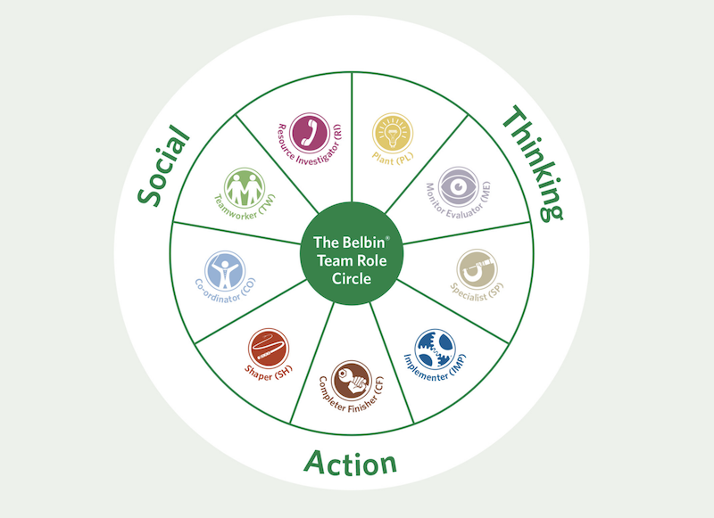
Belbin’s team roles
(https://www.linkedin.com/pulse/belbin-teams-unlocking-partnership-potential-jocelyne-daw/)
Meanwhile, my Specialist role has given me opportunities to provide expertise in specific areas. In one technical project involving data analytics, I provided expertise on data visualization tasks, critical to the success of a project.
I managed to do excellent quality work with much detail in my area of specialty while also realizing a need for communicating my insights to communicate properly and get all the help out of my expertise for everyone (Indeed, 2022).
This theory has effectively allowed me to categorize my individual strengths within a team and promoted a balanced approach to collaboration. However, it has also limitations that affected my role in a team such as overly rigid role assignments, constraining individuals, and adaptability. For instance, as a team worker, my focus on empathy caused delays in the decision-making approach when firm direction was needed. My specialist role allowed me to contribute my expertise, and the model underestimated my effectiveness in communicating technical insights to non-specialist team members. The real-world dynamic often demanded fluidity beyond the Belbin’s predefined role, and I encouraged overlapping of responsibilities for team success

2.3. Tuckman’s Stages of Team Development
Tuckman's model described the stages of team development: Forming, Storming, Norming, Performing, and Adjourning. In our university project, the journey that my team had experienced passed through all the stages of Tuckman's model. In the Forming stage, members introduced themselves and shared their goals with regard to the project. I supported the team actively by initiating a friendly and cooperative climate, which explained my strengths as a Team worker.
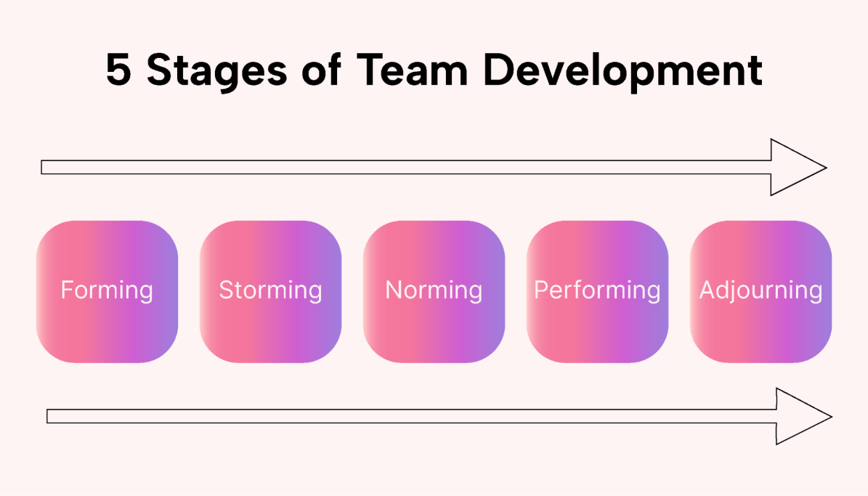
Stages of Tuckman’s Stages of Team Development
(Source- https://www.usemotion.com/blog/stages-of-team-development)
At the Norming stage, mutual trust and efficient workflows had been developed. Then, a Specialist position was taken whereby the complex task undertaken required deep expertise, but people supported each other by their roles in the other stages.
At the Performing stage, collaboration was smooth, and with group effort, a class presentation was achieved, and finally, at the Adjourning stage, the work accomplished was reviewed by all; the efforts of all members of the team were appreciated, and lessons learned as improvements for next projects were consolidated (West Chester University, 2022).
Tuckman’s stages of team development have effectively outlined the phases of teams and their experiences but oversimplified the dynamics and non-linear nature of real practices of teamwork. In my university project, while the stages were evident, my progress was not strictly sequential. For example, the storming stage re-emerged during the norming phase and when unforeseen disagreements arose over task priorities. This highlights the model's limitation in addressing cyclical challenges within the team.

2.4. Thomas-Kilmann Conflict Mode Instrument (TKI)
According to the TKI framework, my dominant conflict-handling style is Shark, characterized by assertiveness and a focus on achieving results. While this approach is effective in resolving high-stakes conflicts, it requires careful balancing to avoid overpowering others’ perspectives. In one instance, a conflict arose during a group assignment where two members disagreed on whether to prioritize creativity or adhere strictly to the project brief.
Recognizing the potential impact on team dynamics, I asserted the importance of meeting project requirements while encouraging creative input. By proposing a compromise, we integrated innovative elements without deviating from the brief, achieving a balanced and effective outcome (Pogatsnik, Beke, and Kendrovics, 2024).
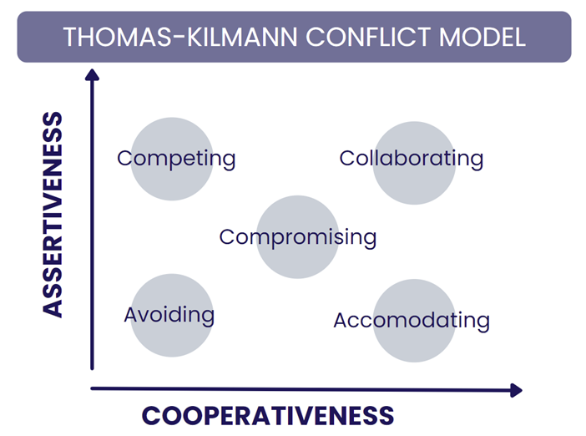
Thomas-Kilmann Conflict Mode Instrument (TKI)
(Source - https://mypd.co.uk/guide-to-the-thomas-kilmann-conflict-model/)
Although my Shark tendencies have helped me resolve conflicts quite efficiently, I have also worked on adapting my approach according to the situation. In less critical conflicts, I consciously adopted a more collaborative style that matches the strengths of the team worker, building consensus and maintaining harmony.
The Thomas-Kilmann Conflict Mode Instrument (TKI) has provided valuable insights relating to conflict resolution styles but also has limitations in the process of promoting situational flexibility. It has been categorized as quite simple factors that simplify complex interpersonal dynamics, making it more challenging to nuanced behavior in real-world scenarios. For example, reflecting on my shark tendencies, while effectiveness for resolving high-stakes, conflict can risk upon team collaboration and in group assignments, certain project requirements balanced with creative inputs yielded success, but rigid focus on the result can suppress creative ideas.

2.5. Impact on Personal Participation
Self-Awareness
I have considerably gained in self-awareness and know my contribution to teamwork with the successful application of theoretical models. Being aware of my strengths as a Team worker and Specialist has allowed me to take on roles that can help me mediate conflicts, build teamwork, and specialise in some fields.
However, I identified those areas to improve on, like balancing my Shark style in conflict with a far more collaboration style as appropriate. This self-awareness helped me go back and adjust relationships with the rest of the team to improve overall team performance (Murphy, 2024).
Behavioural Adjustments
Improve effectiveness in a team. This is achieved through deliberate behavioural changes. For example, I have adopted active listening to ensure that all voices are heard and valued. In team meetings, I deliberately step back and allow more peaceful voices to contribute, adhering to my role as a team worker.
Similarly, as a Specialist, I make myself present the technical knowledge in ways that it would be simple to act on from the team's perspective while my efforts add value without complexity overload (GeeksforGeeks, 2024).

In terms of conflict resolution, I have endeavoured to combine aspects of cooperation and compromise within the shark tendencies. It helped me balance being assertive but not the only goal-solver, hence creating a more inclusive and cooperative space.
For instance, during a recent group project, I successfully mediated a dispute between two members by actually listening to their concerns and generating a solution that resonated with both sides' perspectives.

3. CONCLUSION
This reflection provided some excellent insights about the application of theoretical models for team improvement. Being a Team worker, I excel at collaboration building, harmony preservation, and being supportive. As a Specialist, I bring unique domain expertise in the form of high-quality work to the team. My conflict style as a Shark has proved effective in battling high-stakes conflict situations, although I realize that there is a need to bring a balance between assertiveness and collaboration.
To further develop my teamwork skills, I'm intent on working on targeting emotional intelligence and active listening skills through specific training. By expanding my repertoire of conflict-handling strategies and actively pursuing opportunities to practice adaptive leadership, I look forward to becoming a more effective, versatile team member.

REFERENCES LIST
Akaki, M., Ioki, M., Mitomi, K. and Maeno, T. (2022). Best Practices of Team-Building Activities in a Project-Based Learning Class ‘Design Project’ in a Japanese Graduate School. Proceedings of the Design Society, 2, pp.2263–2272.
Behavior Modification (2023). Behavior Modification in Organizations - Organizational Behavior | OpenStax. [online] openstax.org. Available at: https://openstax.org/books/organizational-behavior/pages/4-3-behavior-modification-in-organizations.
Belbin, R.M. (2010). Management Teams. Routledge. doi:https://doi.org/10.4324/9780080963594.
Foley, O.W., Chisari, G., Curran, J. and Berkowitz, L.R. (2021). Enhancing the Interprofessional Learning Environment: an Orientation of ICU Nurses to Effective Team Building and Their Impact on the Professional Development of the Young Physician. Academic Medicine, 96(11S), pp.S183–S183.
GeeksforGeeks. (2024). Organisational Behaviour Modification: Meaning, Steps, Contribution and Criticism. [online] Available at: https://www.geeksforgeeks.org/organisational-behaviour-modification-meaning-steps-contribution-and-criticism/.
Indeed (2020). What Are Tuckman’s Five Stages of Group Development? [online] Indeed Career Guide. Available at: https://www.indeed.com/career-advice/career-development/tuckmans-stages-of-group-development.
Indeed (2022). The 9 Belbin Team Roles (With Examples and Definitions). [online] Indeed Career Guide. Available at: https://uk.indeed.com/career-advice/career-development/belbin-team-roles.
Lubis, H., Ramadhani, A. and Rasyid, M. (2022). Stres Akademik Mahasiswa dalam Melaksanakan Kuliah Daring Selama Masa Pandemi Covid 19. Maret, 10(1), pp.31–39.
Murphy, T.F. (2024). Group Development Stages (Tuckman Model). [online] Psychology Fanatic. Available at: https://psychologyfanatic.com/group-development-stages/.
Pogatsnik, M., Beke, É. and Kendrovics, R.B. (2024). Essential Teambuilding Skills for Project Work in Engineering Studies. 2024 IEEE 18th International Symposium on Applied Computational Intelligence and Informatics (SACI), pp.000121–000126.
Ranjbar Kaboutarkhani, Mostafa and Hassanpoor, A. (2020). Designing a Successful team-building Pattern in Public Sector. Public Management Researches, 13(48), pp.241–264.
Stadler, S. (2019). Conflict, Culture and Communication. Milton Park, Abingdon, Oxon ; New York, NY : Routledge, 2020.: Routledge. doi:https://doi.org/10.4324/9780429448850.
The 9 Belbin Team Roles (2023). The 9 Belbin Team Roles: Unlocking the Power of Collaboration. [online] Growth Tactics. Available at: https://www.growthtactics.net/belbin-team-roles/.
Tuckman, B.W. and Harper, B.E. (2024). Conducting Educational Research. Google Books.
West Chester University. (2022). Tuckman’s Stages of Group Development. [online] Available at: https://www.wcupa.edu/coral/tuckmanStagesGroupDelvelopment.aspx.

