Student Name:
-Andreia Dumitrascu-
Module name:
-Foreign Languages and Cultural Awareness-

PREMIER INN LONDON
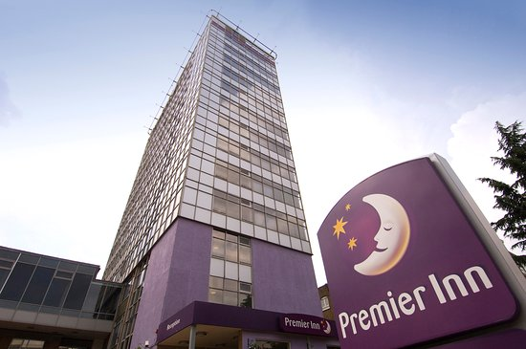
倫敦總理客棧
Name for contact: Andreia Dumitrascu
聯繫人姓名: 安德烈亞·杜米特拉斯庫
Hotel address: Queens House, 1 Leicester Square, London WC2H 7BP
(酒店地址): 倫敦萊斯特廣場1號皇后大廈WC2H 7BP
EmailAddress (電子郵件地址): Andreia_dumitrascu@yahoo.co.uk
Number phone (電話號碼): 0333 003 0025

