Joshua Peterson (P145427)
University of Wales Trinity Saint David
Submission Date: 14th May 2018
AN Evaluation of the relationship between the economy and the fitness industry

Declaration

This work has not previously been accepted in substance for any degree and is not being concurrently submitted in candidature for any degree

Signed……………………………………………

Date………………………………………………

STATEMENT 1

This dissertation is being submitted in partial fulfilment of the requirements for the degree of BA.

Signed…………………………………………….

Date………………………………………………

STATEMENT 2

This dissertation is the result of my own independent work/investigation, except where otherwise stated.

Other sources are acknowledged by footnotes giving explicit references. A bibliography is appended.

Signed……………………………………………

Date………………………………………………

STATEMENT 3

I hereby give consent for my dissertation, if accepted, to be available for photocopying and for interlibrary loan, and for the title and summary to be made available to outside organisations.

Signed………………………………………………

Date…………………………………………………

STATEMENT 4

I hereby give consent for my dissertation, if accepted, to be available on the university’s IT system to those who have consent to use the system.

Signed………………………………………………

Date…………………………………………………

Acknowledgements

I would like to thank everyone who supported me throughout writing this paper. This includes my family, friends, the dissertation Module coordinator Caroline Jawad and a very special thanks to my supervising tutor for the paper, Sandra Dettmer. A lot has happened during the development process of this paper, I do not believe this paper would have been completed if it were not for all the support I received.

Abstract
This paper had been designed to gain a deeper understanding of the relationship between the economy in the Swansea area and consumer behavior in the fitness industry within the area. For this to be achieved, the researcher had to decide on an aim. The researcher considered different economic events such as BREXIT and government investment and how they directly affected consumer behavior in the fitness industry. To meet the aim a number of objectives were set were designed to meet the researchers goal, such as;

- Provide an overview of how the local welsh economy has developed alongside relevant acceptance and uptake of ‘’paid for exercises’’, such as gyms, sports clubs and leisure centers.
- Investigate whether economic events such as the BREXIT referendum changed the exercising pattern of consumers in Swansea.
- Explore the view of the consumers in the Swansea area in regards to exercise and their price sensitivity towards the industry.
- Provide recommendations for sports facilities on how to deal with economic uncertainty and retain customers.

The researcher used secondary research to develop the literature review, identifying theories such as price elasticity to gain a better understanding of the subject. The researcher used resources such as books, websites and academic journals. A sample of 75 participants was collected when the questionnaire was distributed via survey monkey and three interviews were conducted for the researcher’s primary research. The research has identified That there is little change to overall consumer behavior towards exercise following economic events. However, some sub-categories of consumers can be become affected due to them not having funding or being considerably more price sensitive with the amount of spending in the exercise regime.

Contents
Declaration 1
Acknowledgements 3
Abstract 4
List of Figures 7
1.0 Introduction 8
2.0 Literature Review 11
2.1 Current Developments in the Fitness Industry 11
2.1.1 The Sports Industry 11
2.1.2 The Growth of Gyms 11
2.2 The Current State of the Local Economy in Swansea 12
2.2.1 Macroeconomics 12
2.2.2 Brexit 13
2.2.3 Swansea City FC 14
2.2.4 Impact of BREXIT on the Local Economy 15
2.2.5 Swansea Bay City Deal 16
2.2.6 Demographic 16
2.3 Micro-Economic Theory 17
2.3.1 Supply and Demand 17
2.3.2 Price Elasticity 18
3.0 Research Methodology 20
3.1 Definition of Research 20
3.2 Research Methods 20
3.2.1 The Research Onion 20
3.3 Research Sample 22
3.4 Questionnaire 23
3.4.1 Questionnaire Design 23
3.4.2 Piloting the Questionnaire 24
3.4.3 Distribution of the Questionnaire 24
3.5 Interview 24
3.5.1 Interview Design 24
3.5.3 Distribution of the Interview 25
3.6 Mixed Methodology 25
3.7 Reliability and Validity 25
3.8 Limitations of the Research 26
3.9 Data Analysis 26
3.10 End of Chapter Conclusion 26
4.0 Data Analysis 28
4.1 Demographics of the Sample 29
4.1.1 Age Range 29
4.1.2 Gender 29
4.1.3 Employment Status 30
4.2 Finances 30
4.3 Economy 33
4.2.1 Brexit 33
4.3.2 Recession 34
4.4 End of Chapter Conclusion 37
5.0 Concluding Discussion 38
6.0 Conclusion 40
6.1 Recommendations 40
6.2 Limitations 41
References 42
Appendices 48
Appendix A: Screenshot of Questionnaire (Part One) 48
Appendix B: Screenshot of Questionnaire (Part Two) 49
Appendix C: Screenshot of Questionnaire (Part Three) 49
Appendix D: Screenshot of Questionnaire (Part Four) 50
Appendix E: Sean Davies Interview (General Manager Swansea) 51
Appendix F: Andrew Thomas Interview (Programme Director for the sports portfolio in UWTSD) 52
Appendix G: Matthew Thomas Interview (Programme Director for the sports portfolio in UWTSD) 54

List of Figures
Figure 1: Price Elasticity of Supply (Sloman, Hinde and Garratt, 2010). 18
Figure 2: Logo for Xercise4Less (Xercise4less.com, 2018). 19
Figure 3: Research Onion (Gabriel, 2017). 21
Figure 4: Age Range 29
Figure 5: Gender of Participants 30
Figure 6: Employment Status 30
Figure 7: How much Finances influence the Consumers Exercise Regime. 31
Figure 8: Age range of Consumers who stated their Finances affected their Exercise Regime. 31
Figure 9: How much Consumer is willing to spend Monthly to Exercise. 32
Figure 10: How much Consumer is willing to spend Monthly to Exercise (Student). 33
Figure 11: Impact Brexit will have on Consumer Exercise Regime. 33
Figure 12: Consumers’ willingness to Participate in a Cheaper Sport due to Economic Reasons (Female only). 34
Figure 13: Impact a recession could have on funding for consumers exercise regime. 34
Figure 14: Essential or Luxury (Participants who stated None to impact another Recession would have on their Exercise Regime). 35
Figure 15: Impact Brexit will have on Consumers Exercise Regime (Students). 36
Figure 16: Consumers willing to Participate in a Cheaper Sport due to Economic Reason (Unemployed Only) 36

1.0 Introduction
The purpose of this research paper will be to gain a better understanding through secondary and primary research of the relationship between the current state of the economy and consumers attitude towards their exercise regime. The fitness industry is growing steadily in recent years and in 2017 it’s expected to grow by 6.3%. The UK fitness market is the biggest in Europe as going to the gym has become a major routine for some gym goers as they enjoy posting their updates on social media whilst fitness clubs receive free advertising (MarketLine, 2017). This paper will be looking at how economic events such as BREXIT can affect consumer behaviour in the fitness industry in the Swansea area. Macro-Economics can be defined as the branch of economics concerned with large-scale or general economic factors, such as international trade, unemployment, inflation rates and economic growth (Patniak, 2015).
There are many factors which are currently affecting the Swansea Economy. One aspect which will greatly affect Swansea is Brexit. BREXIT had a negative impact on the UK economy as consumer spending and consumer confidence is reduced. The people of Britain voted on the 23rd June 2016 to leave the European Union. Following the referendum, the British pound fell to its lowest value since 1985 and David Cameron resigned as Prime Minister (Foster, 2017), which has left Britons more than a little sceptical and nervous awaiting the impending departure following a transition period between 29th March 2019 and 31st December 2020 (Hunt and Wheeler, 2018). Brexit could also have a major impact on major sports teams in the Swansea area, such Swansea City FC (Benson, 2016), which could potentially affect the motivational drive for consumers in Swansea to participate in various forms of paid for and free exercise.
Following Brexit, the UK treasury has predicted that the UK could potentially enter another recession, this in turn could have a very negative impact on both consumers and businesses in the UK (Behrmann, N., 2016). A recession can be defined as two consecutive quarters of ‘’negative growth’’. For this to happen the gross domestic product (GDP) would have to contract for two quarters of the domestic year (BBC.co.uk, 2008). Despite the negativity, the government are investing £1.3 billion to be spent over the next 15 years, which is looking to improve the health and well-being in the area (BBC News, 2017).
Exercise is any activity requiring physical effort. Regular exercise provides people with many health benefits as It can reduce the risk of major illnesses, such as heart disease, type 2 diabetes and cancer by up to 50% and lower risk of an early death by up to 30% (Nhs.uk, 2018). More and more people are participating in exercise as fitness clubs are participating more in signing up in to clubs that provide weight and exercise machines, and more sports clubs are present for people to take part in various sports (MarketLine, 2017).
The aim of this paper is to identify how the current state of the economy can have an impact on the consumerism of regular gym goers. This paper will analyse how different economic factors such as BREXIT, recessions and government investments can affect how a consumer in the fitness industry spends their money. The reasoning for this is because after conducting initial research, the researcher has discovered that there is quite a lot of research carried out on how the economy affects the consumer. However, little has been developed with links between consumerism in the fitness industry and the relationship it shares with the economy. The reason that consumer behaviour in the fitness industry could be different to other industries is that fitness is being more beneficial towards the consumers health and wellbeing and may be considered an essential which will be discussed in chapters 2 and 4.
This paper will have to meet the following objectives to meet the overall aim:
- Provide an overview of how the local welsh economy has developed alongside relevant acceptance and uptake of ‘’paid for exercises’’, such as gyms, sports clubs and leisure centres.
- Investigate whether economic events such as the BREXIT referendum changed the exercising pattern of consumers in Swansea.
- Explore the view of the consumers in the Swansea area in regards to exercise and their price sensitivity towards the industry.
- Provide recommendations for sports facilities on how to deal with economic uncertainty and retain customers.
The researcher decided upon the subject of the paper due to their keen interest in fitness. The amount of people performing exercise is growing due to the various medical and social benefits exercising has. The NHS recommend that adults aged between 19-64 should perform moderate aerobic activity for 150 minutes a week (Nhs.uk, 2018). Due to this, the researcher has decided that it is necessary to gain a deeper understanding of the relationship between the economy and consumer behaviour in the fitness industry, due to how it can affect the consumers health. The paper will use a vast amount of research from various journals, books and websites.

The study will progress through the following chapters to reach the research aims and objectives:
Chapter Two - Literature Review. This chapter will deliver an insight into Macroeconomics and Microeconomic theory. This chapter will also highlight the current economic environment in Swansea and deliver a background of the fitness industry in Swansea.
Chapter Three - Research Methodology. This chapter will highlight the primary research methods that are being used to complete the study. Highlighting the pros and cons of the methods being used and the reasons why these methods best suit the study.
Chapter Four - Data Analysis. This chapter highlights the finding of the primary research carried out from the qualitative and quantitative research, demonstrating the correlation between what the research has found and the literature review in chapter 2.
Chapter Five – Conclusion and Recommendations. This chapter will draw a close to the study, providing conclusions from the research carried out. Recommendations will be provided, where the researcher will highlight aspects of the fitness industry relationship towards consumer behaviour relating to economic change, and give their recommended changes.

2.0 Literature Review
The overall purpose of this report will be to gain a better understanding of how the current economic situation has a direct effect on the fitness industry and how the fitness industry responds to the constant implications of the modern economic climate. Hence, the purpose of this chapter will be to provide a deep understanding of the literature that emphasises the link between the economy and the fitness industry. The following objectives need to be met in order to meet the overall aim;
- Provide an overview of how the local welsh economy has developed alongside relevant acceptance and uptake of ‘’paid for exercises’’, such as gyms, sports clubs and leisure centers.
- Investigate whether economic events such as the BREXIT referendum changed the exercising pattern of consumers in Swansea.
- Explore the view of the consumers in the Swansea area in regards to exercise and their price sensitivity towards the industry.
- Provide recommendations for sports facilities on how to deal with economic uncertainty and retain customers.
When considering the objectives above, the literature review will mainly focus on objectives 1 and 2 to gain a better understanding of the relationship between the economy and the fitness industry.

2.1 Current Developments in the Fitness Industry

2.1.1 The Sports Industry
Sports contribute to 450,000 jobs in the UK, over the last 5 years, sport has turned into a £20 billion industry in the UK and experts believe this is just the beginning (Critchlow, 2018).
The sports industry and sport were rarely mentioned under the same breath. Only 30 years ago, football was beset by crowd trouble, old stadiums and a lack of external funding. Fortunately for sport, business came to the rescue, identifying new opportunities, creating markets and sparking unprecedented investment in the sports that Britain loves to play (Cave, 2018).

2.1.2 The Growth of Gyms
The fitness industry has undergone an explosive growth in recent years, one beneficiary in particular are Gyms. Reasons for this boom include consumers having more leisure time on their hands and the importance of having a young looking fat-free body (Rojas, 2016).
The European gyms, health and fitness clubs market is expected to generate total revenues of $6,369.3m in 2017. Thus, representing a compound annual growth rate of 3.7% between 2013 and 2017. In comparison the French and German markets achieved a CAGR of 4.1% and 6.5% respectively (Marketline, 2017). This could be because of the major benefits involved in taking part in exercise such as less chance of obesity, a healthy lifestyle and less chance of major illnesses such as strokes and heart attacks (NHS.co.uk, 2018).

2.2 The Current State of the Local Economy in Swansea
The condition of the economy can directly affect the consumers. When the economy is in a bad state then consumers conserve their money. They stop buying non essentials and focus on saving money and getting out of debt. If the service makes the consumer feel better about themselves or help maintain the comforts of their lifestyles then they are less likely to want to give up on that service (Duff, 2018). The Swansea area can be directly affected by changes made to the UK government.
When considering the economic factors affecting business. In a strong economy all businesses grow, unemployment is low as businesses are striving, disposable income is high and consumer confidence prompts consumer to spend their money and put it back into the economy, which encourages further economic growth. However, when the economy is struggling then many small businesses face a number of challenges, consumers become worried about their job stability and as a result are forced to become more cautious with their expenditures, thus decreasing the revenue for business owners due to consumer not buying into their product or service (McQuerry, 2018).

2.2.1 Macroeconomics
To be able to understand what position the fitness industry is in, the reader will gain a level of understanding on how the industry reacts to its Macroeconomy. Macro-economics does not just consider the general prices level in a specific market but considers the overall numbers employed in the economy. Macroeconomics deals with factors such as; unemployment, inflation, economic growth and international trade. (Gillespie, 2011).

2.2.1.1 Unemployment
Unemployment in the UK has been steadily falling over the past couple of years and has now reached a four-decade low unemployment fell by 3,000 as the total figure fell to 1.44 million. Which leaves the U.K unemployment rate of 4.3% (BBC News, 2018).
As of September 2017, unemployment in the Swansea area has also steadily declined and 400 people in the Swansea area have become employed as the figure for unemployed stands at 5,800 and a change in percentage from 6.5%to 5.1% (Swansea.gov.uk, 2018).

2.2.1.2 Inflation Rate
Inflation is the annual percentage change in a price index. When the percentage change is positive, this is known as inflation. When the figure is negative, the situation is known as deflation (Krugman and Wells, 2009).
The UK consumer price inflation fell to 3% in December 2017 after a near six-year high of 3.1% in November 2017. Inflation rate in the UK averages 2.58% from 1989 until 2017 (TradingEconomics.com, 2018). This can be considered high as the target inflation rate is at 2% (Amadeo, 2018).

2.2.1.3 Economic Growth
Economic growth is where there is a rise in the capacity of an economy, where the economy can improve on the amount of goods and services which they are able to produce more than in previous periods of time (Amadeo, 2018).
The British economy has grown by 0.5% in the three months leading up to December 2017. Government and select services such as fitness industry grew by 0.4%, after a stagnant third quarter in 2017. The largest contributor towards this sector is human health activities (Tradingeconomics.com, 2018).

2.2.1.4 International Trade
If a company is exchanging capital, goods and/or services across international borders or territories then that company is performing an act of international trade.
The difference between the total value of goods and services sold overseas and services imported to Britain has widened by £1.2billion from November 2017 to £4.9billion in December 2017. While there was an increase in goods export volumes, there was not even half the amount of exports as there were imports (Partington, 2018). This is negative for the UK and in particular Wales as when there is less exports than imports this means that the UK is losing money and can be a factor of the UK economy declining.

2.2.2 Brexit
Recently a historic referendum took place on the 23rd June 2016 which ultimately lead to the departure/ Brexit of the UK from the EU (Foster, 2018). Brexit will have a major impact in the Swansea area just as it will throughout the country. Brexit will have a direct impact on consumers in the U.K, which ultimately leads to implications surrounding their fitness regime. For example, Britons living in other EU countries may have to purchase an investment visa (gives residency to someone who invest in a property or business) and with 1,800,000 Britons living abroad, then they are obviously going to insure their visas are paid for, which could mean the consumer will have to save money elsewhere which could mean that they may have to change their fitness regimes to save money as they may consider exercise to be a luxury than the mandatory investment visa (Palin and Evans, 2018).
In another example where the impact does not necessarily force the consumer but can provide a tricky obstacle in managing their funding is how Brexit will affect the exchange rates. Following Brexit, the pound has weakened and is currently worth €1.14 and $1.41 respectively (Xe.com, 2018). When comparing this to the first example, the latter provides the consumer with more of a choice when it come to their fitness regime. If the consumer decides that they need to budget then they made to choose to sacrifice some luxuries, then it depends on their personal choice is a holiday more important than keeping fit or can trading that monthly gym membership for a run across the mumbles pier help towards saving up for that holiday abroad. Also, this can have a direct impact on the macro economy as this can affect international trade as exchange rates rise the value for money for products and equipment will fall as it becomes more expensive to import them items.
Following the fall of the pound, companies have had to make amendments to maintain stability in uncertain times, a company who have failed to do so is Sports Direct. They have warned that that profits will be at least £15million lower following a belated attempt to protect itself from the fall in sterling (Vandevelde, 2018). This example can have a direct effect on a consumer in the sporting market, because the pounds worth has gone down then people are less likely to part with their money, thus lowering the demand on sports equipment and ultimately effecting the consumer sporting ambitions to a point where they may change their sport or quit altogether.
With lower profit margins and companies feeling the strain then this can cause the need for companies to start letting staff go. Following the Brexit vote employment took a slight hit and fell 0.01% from 74.5% to 74.4% (Monaghan, 2016). This can have a major effect on where consumers decide to spend the money as if the consumer loses their job then they may have to find a substitute exercise regime to save money.

2.2.3 Swansea City FC
Another major concern for Brexit is the sustainability of Swansea City FC, following their promotion to the premiership in 2011, the ‘Swans’ have increased the profile of South Wales (BBC News, 2011). Swansea City also have helped massively when it comes to increasing the amount of exercise taken place as they have many academies for youth development and recently Leon Britton made an appearance at Pontybrenin Primary School to celebrate the launch of Premier League Primary Stars (Swansacademy.co.uk, 2018). He provided the students with kit and equipment to participate in the scheme. This is just an example of the importance of having a highly recognisable premier league team in the area to influence and motivate people around Swansea to participate in exercise and sport. Considering the importance of Swansea City, it would be a real problem to see their current success threatened as Brexit approaches, there are some major implications to Swansea FC’s future business. One thing that can get pretty tricky is bringing in new transfers and keeping hold of their current foreign players, as more and more players will need visas to play in the UK following the exit of the EU, it will be tricky for Swansea to keep hold of them players and buy new ones and avoiding the drop in to the championship (Benson, 2016). Failure to adapt may result in Swansea dropping out of the Premiership, thus resulting in many complications. Firstly, Swansea will no longer be involved in the Premier League Primary Stars regime, immediately limiting the possibility of children participating in sport in the area. Also, Swansea City will have less of an influence around the area and some people may lose interest in exercise as their ‘idols’ fail to perform at the highest level.

2.2.4 Impact of BREXIT on the Local Economy
Following the results of Brexit, the UK treasury predicted that the UK could slump in to a recession. A recession would result in huge negative impacts on both the consumers and businesses alike (Behrmann, N., 2016). During a recession, consumers get very conservative with their money and an economic decline spreads across the country (Conerly, 2016). Consumers often prioritise when resources are low and most consumers tend to put homeownership and food as their priorities, whilst everything else including paid for exercises are considered a luxury and are expendable (Reed and Crawford, 2016). This could force consumers to drop any paid for exercises that they are doing such as gym membership for some free exercise routines such as running or swimming. Also, a recession can have a major effect on the businesses involved in the fitness industry such as gyms and sports clubs. Along with the potential customers it can reduce the cash flow of small gyms and leisure centres as they have to work on tight cash flows as the money comes in the money goes out. However, with a reduced demand the turnover for these companies is going to be less, which can result in staff reductions and marketing constraints as when business is tough, the company must make sacrifices and often it’s the workforce and the marketing team which pay the price as they are often expendable (Sandilands, 2018).
A recession can cause drastic unemployment around the Swansea area due to companies not achieving the same profit level as before, resulting in the company having to fire people. As an example, back in 2008 recession, unemployment was at a staggering 5% (BBC News, 2015), with unemployment in the Swansea area currently at 5.1% (Swansea.gov.uk, 2018). This can influence whether consumers continue to do the same exercise regime or do they adapt and end up taking up a new regime or stop entirely as they have lost a considerable amount of income.

2.2.5 Swansea Bay City Deal
Despite the looming Brexit, Swansea does have some positives when considering its economic stand point. Swansea has been selected to be the recipient of a £1.3 billion deal of private and public money to be spent over the next 15 years. The deal will look to improve the conditions of the internet access in the area and build more building (BBC News, 2017). One area which the government want to improve is the health and wellbeing, as they look create a state of the art sports and leisure centre which should draw in new customers and hopefully increase the level of exercise undertaken by the Swansea population. The new deal will also create 1,300 jobs in the Swansea area (Pyke, 2017). This should help lower the unemployment in the Swansea area and raise the household income for the consumer, which should raise their consumer confidence and their perspectives on certain sports and exercise which they previously considered unavailable due to their financial position such as horse riding or sailing. This also helps boost economic growth, building more leisure centres around the area provides the consumer with more services and choice available to them. They can decide between more fitness regimes and creates a wider supply for the consumer.

2.2.6 Demographic
There are many questions surrounding the demography which need to be considered. The researcher needs to consider who the main target audience is for the fitness related companies. Where are the customers likely to be located and how their product will be perceived by the target market. (Griffiths and Wall, 2011).
Considering exercise is almost a necessity for a healthy living, then most organisations in the fitness industry would like to try and market their product to a very with NHS recommending that people of all ages should be able to do some exercise and have also recommended that adults should participate in aerobic and strength exercises weekly (Nhs.uk, 2018).

2.3 Micro-Economic Theory
Microeconomics represents the study of how members in society use various resources to make choices in the marketplace. The choices referred to are the purchases of goods and services from the business providers. Businesses will look to influence the choices of consumers to spend on their various products and services (Kokemuller, 2018).

2.3.1 Supply and Demand
Economics is concerned with the production and the consumption of products. Another way of looking at this is in terms of supply and demand. The relationship between supply and demand lies at the centre of economics (Sloman, Hinde and Garratt, 2010).
Supply is any product which the seller offers up for sale. When most people think of products, they think of object. But there is more to it than selling tangible items. Another aspect could be the experience, such as a trip to Disney world, there’s no object which the buyer keeps, but rather the experience. There’s also public services such as going to the dentist and doctors which can also be considered a supply of a product (Ball and Seidman, 2012). When considering the fitness industry, it is very much a service which often does not have a tangible product. There is the obvious exception of having to pay for the equipment to participate in the required sport or exercise, which is provided by sports shops such as JD Sports, Go Outdoors and Sports Direct. However, most of the suppliers involved in the sports and fitness industry offer less tangible goods such as gym memberships, leisure centre access and pitch rental services, for example Xercise4less, LC2 and Play Football.com. Suppliers around Swansea in the fitness industry tend to allow the consumer access to their equipment and locations to allow them the freedom to carry out the exercises they wish.
The factors of demand depend on the market price. When the market price for the product is low, demand is high. When the market price is high, then the demand will fall. At a low market price many consumers will be able to purchase the product. To understand the demand of a product, the factors must be taken into consideration. Firstly, will the product fulfil the buyer’s needs, does the product represent good value for money to the customer. Then there is the possibility of the company pricing the buyer out of the sale, where the asking price is so high that the consumer refuses or is unable to pay the desired price (Whelan and Msefer, 2018). When comparing this to the sports industry, there are loads of different exercise routines which are available to the average person and the demand can vary for each of them. For example, to join The Gym, a local gym which offers 24-hour service it offers no sign-up fee and is £14.99 a month (Thegymgroup.com, 2018). To the average consumer this can be considered a good deal as demand for gyms and exercise has increased. However, in the uncertain times of Brexit and with consumers being more conservative with their money, then maybe another solution can result in similar benefits for a cheaper price. For example, someone who is already going to the gym with all the right equipment, could easily just take up running which is free and the Swansea area has many great running locations available such as the beach’s and Mumbles pier.

2.3.2 Price Elasticity
Price elasticity is a theory used to understand the relationship between price and demand. Price elasticity looks at how consumer demand can be affected by the raising or cutting of prices (Hardwick, Khan and Langmead, 1999).

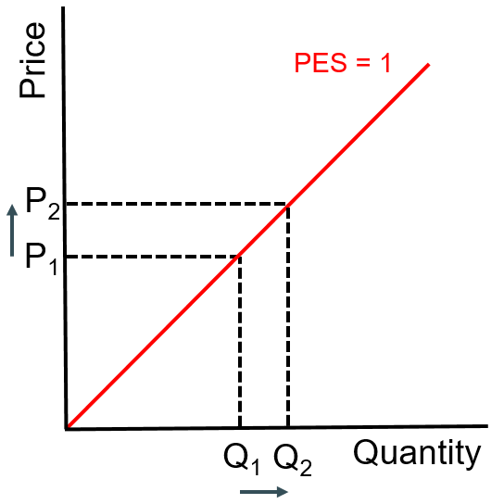

Figure 1: Price Elasticity of Supply (Sloman, Hinde and Garratt, 2010).
Placing this theory in practice it’s clear that a consumer may have varying views on the price of the requirements of their desired fitness regime. For example, when comparing the price on gyms in the Swansea area, Xercise4less offers a gym membership to adults for £12.79 a month (Xercise4less.com, 2018), compared to the £14.99 a month membership offered at The Gym (Thegymgroup.com, 2018). From a consumer’s point of view the membership offered at both gyms are reasonable prices, however if the prices were to rise to £20 a month, then the demand on the memberships may fall as the consumers may feel that at uncertain times that the price is out of reach. On the flip side if the price were to fall to £8 a month could result in more demand as more consumers will be willing to part with £8 for a gym membership every month than the previous prices, resulting in more consumers signing up, this is often defined as cross price elasticity (Stolerman and Bickel, 2010).

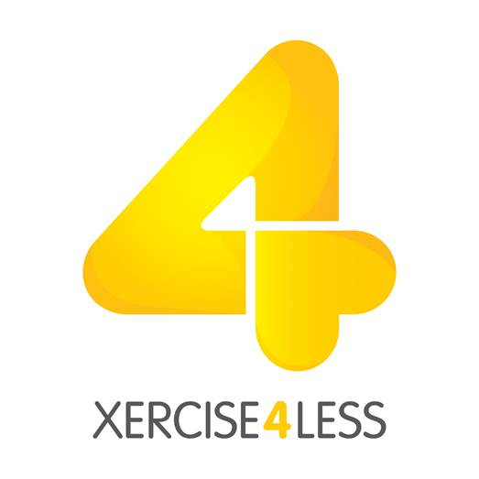

Figure 2: Logo for Xercise4Less (Xercise4less.com, 2018).

Another consideration the consumer has to make is how much they spend on their equipment. The current price for a pair of ‘‘Nike Flex Contact’’ running trainers are currently selling at £46 at sportsdirect.com (Sportsdirect.com, 2018). The consumer may feel that this is affordable and would be able to purchase this product, however the same product is being sold at JD sports for £60 (JD Sports, 2018). The consumer may feel that this price may be excessive and does not represent good value for money.
Another similar theory which can have an input in this is the elasticity of substitution, which incorporates whether the proportional change in two products/services prices results in changing what products/services the consumer ends up purchasing (Black, Hashimzade and Myles, 2012). An example of how a consumer may be subconsciously applying this theory on their fitness regime, for example taking as previously stated The Gym offer a gym membership of £14.99 a month, the consumer may feel the need to substitute if the price were to rise to £20, as a run on the beach is completely free, and the economic environment is stagnating then the consumer may feel the need to save some money and change up their exercise routine and quit their membership for a daily run across the beach.

3.0 Research Methodology
This chapter of the paper will inform the reader to a detailed analysis of the various methods that have been used to undertake the research. The research methods which will be used will help achieve the aims of the of the research and provide the reader with information regarding how consumers in the Swansea area react to the current economic state in the area. The following objectives need to be met to meet the overall aim;
- Provide an overview of how the local welsh economy has developed alongside relevant acceptance and uptake of ‘’paid for exercises’’, such as gyms, sports clubs and leisure centers.
- Investigate whether economic events such as the BREXIT referendum changed the exercising pattern of consumers in Swansea.
- Explore the view of the consumers in the Swansea area in regards to exercise and their price sensitivity towards the industry.
- Provide recommendations for sports facilities on how to deal with economic uncertainty and retain customers.
This chapter however will not be necessarily covering any of the aims above and will be looking more in detail at the research methods being used to carry out the research on the proposed area and how the data gathered will be analysed.

3.1 Definition of Research
Research can be defined as ‘’a process that people undertake in a systematic way in order to find out things, thereby increasing their knowledge’’ (Saunders, Lewis and Thornhill, 2016). Research can be split up into two categories; primary research and secondary research. Primary research is the use of ‘’qualitative and quantitative research and can include surveys, focus groups, questionnaires, and interviews.’’ (Doyle, 2011). Whereas secondary data is the use of data which has been produced by other people and therefore holds a different purpose to that of the researcher (Wilson, 2014).

3.2 Research Methods

3.2.1 The Research Onion
Saunders et al designed a process for which the researcher essentially adopts an aspect of each layer of the Research Onion to the research. The researcher should pick the method which is best suited to the question and any limitations that they may face may play a factor to their choices.
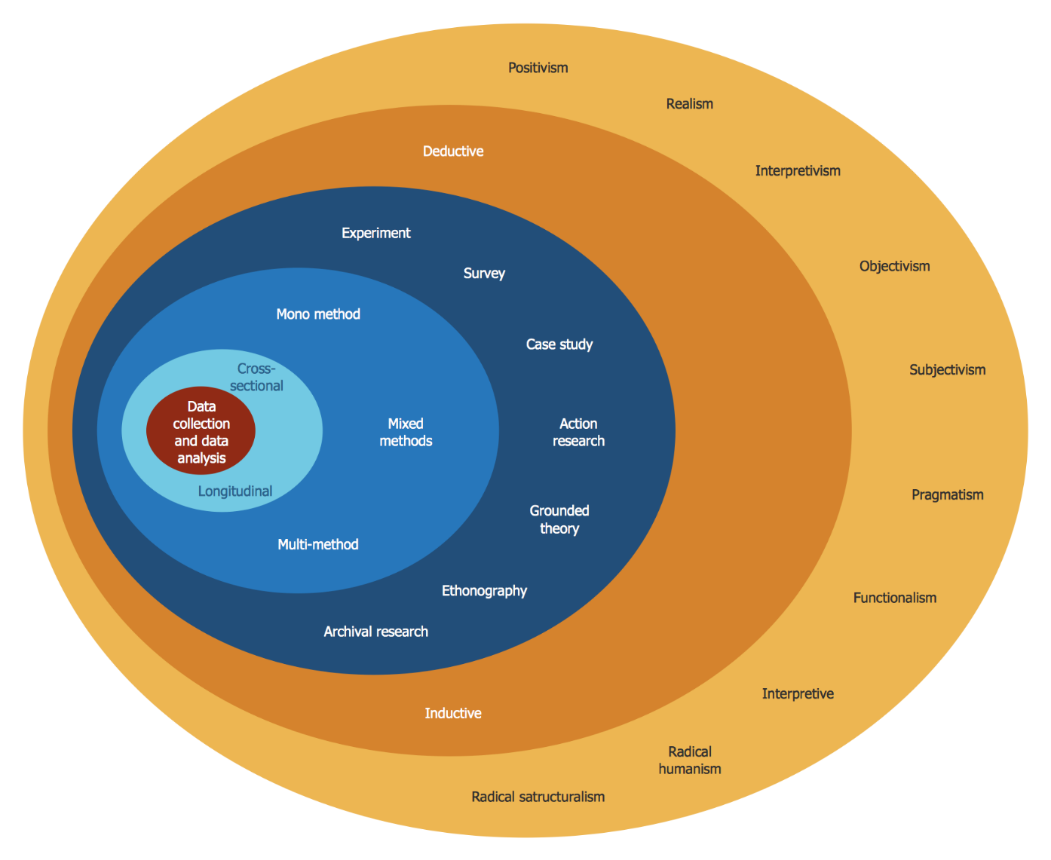

Figure 3: Research Onion (Gabriel, 2017).
The interpretivist approach can be identified as an attempt to make clear or to make sense of an object of study. This aim to bring to light an underlying coherence. This means that any subject which can be called ‘’hermeneutical’’ even in an extended sense (Young, 2009). This philosophy will explore various perspectives held to be analysed and contrasted.
The inductive research approach necessitates that the researcher must begin with a completely open mind with no preconceived idea. The aim is to generate a new theory based on the data. The nature of this approach is suitable as it allows the collection of the data to then be analysed and findings can be drawn from the results. This then allows the researcher to compare the results to previous theories (Gabriel, 2017).
Survey research offers many advantages offers many advantages, researchers can easily distribute surveys to thousands of respondents and results can be almost instantaneous and researcher can tabulate, review, and share research data as the information arrives (Kotler and Armstrong, 2017).
Qualitative research begins with assumptions and the use of interpretive/ theoretical frameworks that inform the study of research problems addressing the meaning individuals or groups ascribe to a social or a human problem. Qualitative research is carried out in a natural setting which is accustomed to the people involved (Creswell and Poth, 2017). Quantitative research will allow thorough research in to the views and perform a deeper analysis into the key perceptions from key personnel. Which should provide a deeper understanding of their attitude and behaviour towards relationship of the economy and exercise. By using both qualitative and quantitative methods, it appears that the research being carried out is mixed-method. This is term used when more than one research method is in effect (Sekeran and Bougie, 2016). This allows a broader scope of research to be collected from different perspectives.
Cross-sectional research will be used in this paper. Cross sectional analysis allows the researcher to compare different population groups and compare their reactions to different variables (Law, 2010). Cross-sectional analysis is useful when comparing primary research findings to the secondary research findings in chapter 2.

3.3 Research Sample
A sample is a portion of the target population (Hussey and Hussey, 2000). The size of the sample is made up of a fraction of the target population which is being targeted. The population which is being considered for the questionnaire are online users in the Swansea area for the questionnaire, whilst key personnel in the fitness industry in Swansea will be used for the interviews (Collis and Hussey, 2003). Due to this, it’s clear that purposive sampling has been selected, due to the researcher reaching out to an audience known to have a clear perspective on the investigation at hand (Jankowics, 2005)
It has been suggested that a sample size of 50-100 would be recommended as it will help improve the reliability of the data. The researcher will aim to gain sample size of between 65-100 responses, and in regard to the interviews a sample size of 3-4 respondent’s (Wood, M 2004). The results of the research will provide the researcher with a better insight in how consumers in the fitness industries react to the current economic conditions in the Swansea area. The sample will be selected on anonymous basis, except in the interviews when provided with consent from the interviewee. There was no specific target audience such as age or gender. However, all participant must be of the age of 18 or over. Respondents were made aware of the purpose of both the interviews and questionnaires and how their responses will be used in the study.

3.4 Questionnaire

3.4.1 Questionnaire Design
For the purpose of this study the survey will consist of 10 questions, with demographic questions such as age or gender and questions targeting how the economy can directly affect the consumer in the fitness industry. The questionnaire should be clear and understandable as the layout can have a direct effect on overall accuracy on the results, depending on the complexity of the questions asked (Gateshead.gov.uk, 2018).
The researcher has taken extra care to ensure that the respondents can understand each question clearly to enable them to provide honest answers. Also, each question was taken with a different approach in order to be able to analyse the results clearly (Pew Research Center, 2018), such as demographic questions may contain multiple answers, where some questions may just be simple yes or no responses.
The questionnaire will only consist of closed questions. This is because closed questions enable the researcher to gain demographic data, such as age or gender and also gain responses quicker (Brace, 2018). Tools such as Likert scales will enable the respondent to share their level of agreement with a statement whether they agree or disagree (Chandler and Munday, 2011). To prevent any ethical issues arising, extra precautions will be taken to ensure that the responses received are anonymous. A copy of the survey can be found in appendix of the research paper.
There are many advantages of performing a questionnaire. Performing an online questionnaire can be a quick way to collect mass amounts of data in a short space of time (Jones et al., 2008). Also, questionnaire can provide the researcher with statistical data which can provide the researcher the ability to consider demographical trends (Rada and Domínguez-Álvarez, 2013). However, there are many disadvantages to an online questionnaire, such as the researcher is unable to clarify specific questions which the participant may not understand (Fayers, 2003). Also, there is the case that due to it being an online questionnaire that it may elicit shorter answers than paper questionnaires (Hunter, 2012).

3.4.2 Piloting the Questionnaire
A pilot study will be used on a small group of participants to highlight any improvements that are needed, whether that is wording within the questions or to improve the order in which questions are asked. Due to this a pilot study has been conducted within a smaller sample of the target population. Once completed, the practice will identify whether there are any errors which need to be corrected and changes needed to keep the questionnaire flowing. Changes such as removing questions that were irrelevant and adding questions which will help improve the data being collected. Also, gathering feedback will help deciding whether more options for answers will be needed for the participants to express their opinion.

3.4.3 Distribution of the Questionnaire
Due to Survey Monkey being the service used to create the questionnaire, it was ideal for the questionnaire to be distributed online. Because of the large amounts of respondents needed for the data analysis an online questionnaire would be a great pathway to gain the responses needed. The questionnaire was sent out to potential respondents via email as it’s an easy form of distribution. The questionnaire was also distributed via face to face as the researcher stood inside Xercise4less asking for potential respondents, via both forms of distribution the interviewer was able to reach an ideal number of respondents.

3.5 Interview

3.5.1 Interview Design
For the study, the amount of questions asked in the interviews will vary depending on the interviewee in question, with questions directly involving their position in their establishment and questions regarding how the Economy can affect a consumer in the fitness industry.
The questions should be understandable and presented to the interviewee in a clear, kind and professional manner (Kessler, 2018).
The interviewee has taken extra precautions to ensure that the questions are clear and understandable so the interviewee can provide honest answers. The questions will vary for each interview depending on the participant’s position.
The interviews will consist of open questions. This will allow the interviewer to explore in greater detail the perspectives of the interviewee (Jankowicz, 2000). To prevent any ethical issues, all participants will remain anonymous unless they give permission for their names to be presented in the paper. A copy of the questions can be found in the appendix.
There are many advantages to performing an interview. An interview allows the researcher to clarify on any confusion made by the questions at hand, it also allows the researcher to ensure that the interview stays on the right track and the correct information is being collected (Braun, Clarke and Gray, 2017). Another advantage is that performing an interview allows the researcher to delve deeper into questions and gain a deeper perspective from the participant (Minichiello, 2009). However, there are disadvantages for an interview as the information being received could be anecdotal and ultimately provide the paper with false findings (Schuman et al., 1980). Also, there is the case that the interview only represents one person’s perspective of the situation and this could be a false representation of the target audience’s attitude towards the subject (Gubrium, 2006).

3.5.3 Distribution of the Interview
The interviews were carried out face to face with the various participants. The researcher took the time to reach out to the participants to confirm a date for when and where they like to meet. The interviews were recorded so that the researcher would not miss any key points made in the interview. The interview was carried out in a professional manor to ensure there is no ethical concerns and that the participant understands the questions. The questions were carried out in a flowing manner and allow opportunities for the participant to elaborate on the points that they make. The interviewees were chosen as they are key personnel in the fitness industry who can reflect a wider perspective on the issue

3.6 Mixed Methodology
Mixed methodology will be used for the research paper as it provides a greater understanding of the topic by comparing both qualitative research and quantitative research. This approach to mixed methods research occurs when the researcher cannot rely on a questionnaire or an interview alone and must buttress their findings with that of the other research method. The factor that qualitative methods such as interviews can often provide rather anecdotal findings is frequently frustrating, this is how a quantitative research such as a questionnaire can help uncover the generality of the theory (Bryman and Bell, 2007).

3.7 Reliability and Validity
A key aspect of the study is to make sure that the resources and results are credible, this is because it may make the results inaccurate. The research needs to be both reliable and validity for the research to maintain its credibility. Reliability is the ability for the researcher to produce numerous trials and gain the same results (Riley et al, 1998). In contrast with this project, this would mean that if the questionnaire was repeated numerously, then similar results would be gathered again, the reliability of the questionnaire can be tested by a pilot questionnaire on a small group of volunteers. In regards to the interviews, if similar answers were being obtained by each of the interviews then this highlights the reliability on the information being obtained.
Validity can be identified as the degree in which the data or the results of the study are correct (Ireland, 2010). The pilot questionnaire and numerous interviews would highlight any changes that would need to be made to the structure and questions. For example, what order the questions asked to increase conversation flow in the interviews, or any wording that may need to be changed in the questions for both the interviews and questionnaires.

3.8 Limitations of the Research
The main limitation of the research will be that the questionnaire and interviews are focused solely on the centre of Swansea. This could have an impact on the results, as the researcher is unavailable to gain a greater perspective from consumers in other areas of Swansea. Also time limitations may have prevented the researcher from getting enough responses to gain a broader perspective of the situation.

3.9 Data Analysis
As the researcher has gained two different forms of research in both qualitative and quantitive, the research will have various forms of analysis. For the questionnaire, due to survey monkey being used the website provides many tools to provide a detailed analysis, although Microsoft Excel will also be used to provide deeper analysis and to create charts and graphs. Also in regard to the interviews, largely descriptive analysis will be used to highlight key points made by the interviewees. After that, the results of the quantitative and qualitative will be compared to see how they differ and relate.

3.10 End of Chapter Conclusion
Within this chapter the researcher has identified the methods being used to carry out the primary research. The primary research that been identified as both qualitative and quantitative, by carrying out an online questionnaire and interviews. This chapter has highlighted the stages and concerns the researcher has addressed in the build-up of the research. The methods being used will generate accurate data if they are carried out in an understandable and professional manner.

4.0 Data Analysis
This chapter will highlight the findings from the questionnaire and the interviews which were discussed in chapter three. To ensure that the aims and objectives of the study were met, which is to identify how consumer behaviour in the fitness industry can be affected by economic uncertainty in the Swansea area. Looking at different economic concerns and how they can affect the consumers finances and ultimately their exercise regime. The research was designed and distributed needed to meet up with the following objectives;
- Provide an overview of how the local welsh economy has developed alongside relevant acceptance and uptake of ‘’paid for exercises’’, such as gyms, sports clubs and leisure centres.
- Investigate whether economic events such as the BREXIT referendum changed the exercising pattern of consumers in Swansea.
- Explore the view of the consumers in the Swansea area in regards to exercise and their price sensitivity towards the industry.
- Provide recommendations for sports facilities on how to deal with economic uncertainty and retain customers.
Based on the aims and objectives highlighted above, chapter 4 will show a detailed analysis of the data collected via the interviews and questionnaire. The researcher will then compare the two forms of research to the findings in the literature review discussed in chapter 2. To keep the analysis simple the questionnaire is where the researcher has begun their analysis and then compared the findings from the interview and the secondary resources to gain a deeper understanding of the subject. The questionnaire was split into three parts:
- Identify the participants demographic background, including their age, gender and professional background, e.g. student, unemployed or employed.
- Gain a better understanding of how much their finances play a part in changing their exercise regime and whether they are willing to participate in a cheaper sport.
- Gain an understanding of whether economic factors such as BREXIT and another recession could potentially affect the participants exercise regime.
The reader can find a copy of the questionnaire and interview questions can be found in Apendices A-G The researcher used a sample size of 3 interviews and 75 questionnaire participants.

4.1 Demographics of the Sample

4.1.1 Age Range
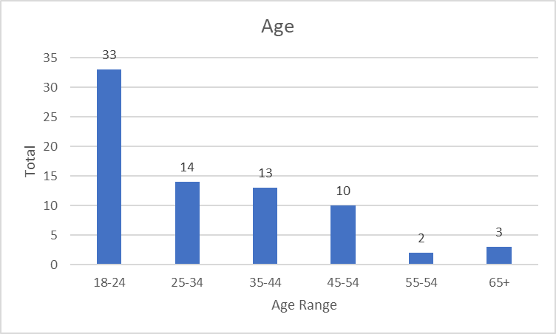

Figure 4: Age Range
Figure 4 shows the age of the respondents who participated in the questionnaire, more than a third of the people who responded to the questionnaire were aged 18-24. This may be down to the subject of the questionnaire as it discusses many fitness and sports related topics, so it can be considered that the topic targets a younger demography of respondents.
When looking at the age range of the respondents there is a clear decline with the amount of people who carry out the questionnaire as the participant getting older, with the results showing that participants aged 18-24 were most likely to answer and there have been few participants aged 55-64. Another reason as to why the demography of the respondents is so low may be due to the researcher using social media sites such as Facebook to distribute the questionnaire to the participants, which the average user is generally considered to be quite young, with the average age being 40.5 years old in 2012 (Pingdom Royal, 2012).

4.1.2 Gender
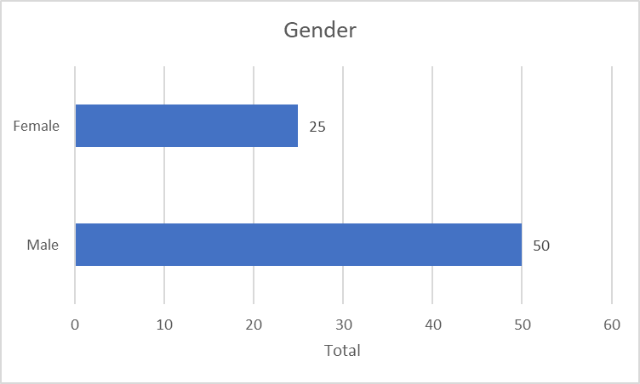

Figure 5: Gender of Participants
Figure 5 highlights that there is a significant amount more male participant’s in the questionnaire in comparison to female respondents. Although this may be unproven, this could be because of the subject being less appealing to the woman, however an article from the BBC from 2015 states that woman participating in sport and fitness in the UK is growing with 7.01 million women participating in sport at least once a week in the UK (BBC Sport, 2015).

4.1.3 Employment Status
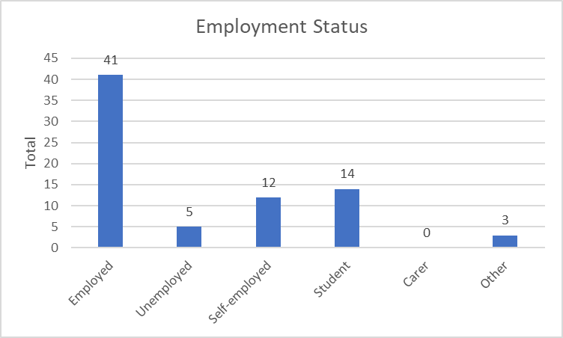

Figure 6: Employment Status
Figure 6 above shows a summary of the participants employment status. Going by the researchers statistics unemployment in the Swansea area is high when compared to the rest of the UK as unemployment at 4.3%, whereas this sample shows 6.7% of the Swansea area is currently unemployed, which could imply that economic uncertainty may be considered a concern to those in the Swansea area, due to many of the consumers not having a regular source of income. The participants who stated other may be considered either retired, disabled or may not want to say.

4.2 Finances
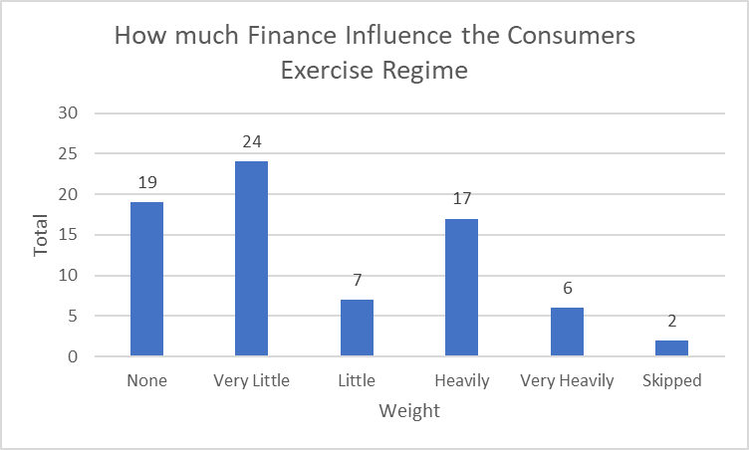

Figure 7: How much Finances influence the Consumers Exercise Regime.
Figure 7 highlights how much the participants finances influence their exercise regime, here we can see that the there are varying amounts of results with the two highest number of participants saying that their finance have none or very little impact on their exercise regime. However, not many respondents suggested that it affected their exercise regime heavily with only 6 participants choosing this option. This could give us an indication of how people would refuse to change their exercise regime even when their short on money and highlighting how the perception of exercise is being considered more of an essential rather a luxury.

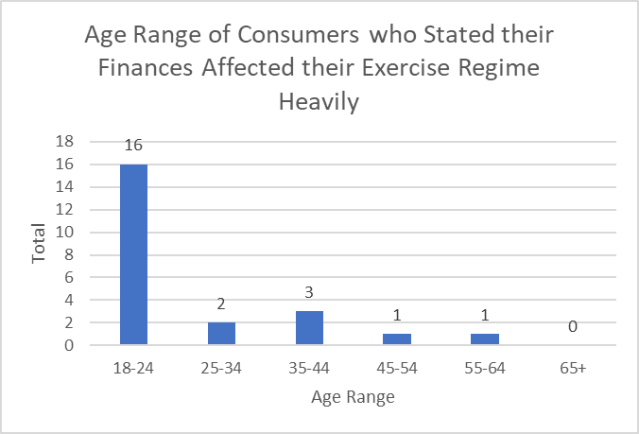

Figure 8: Age range of Consumers who stated their Finances affected their Exercise Regime.
Figure 8 looks at the age of the participants who stated that their finances affected either Heavily or Very Heavily in their exercise regime with over two thirds of them came from participants aged 18-24. Highlighting that this age group may not have as much freedom when deciding their exercise regime when compared to other age groups or maybe consider other expenditures more important. Also, only 2 of the 14 participants aged between 25-34 stated that their finance wasn’t a major concern to their exercise regime. This can show that only a small age gap can drastically change a consumer’s perception on the importance of sport and fitness.

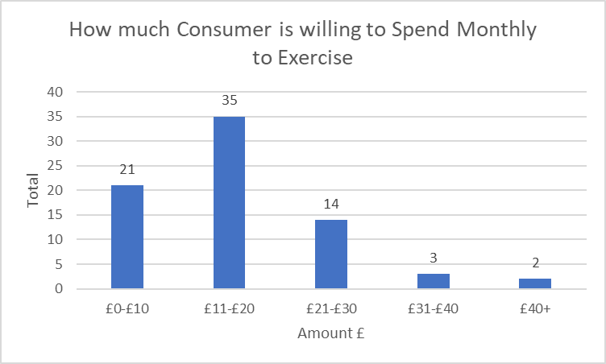

Figure 9: How much Consumer is willing to spend Monthly to Exercise.
Figure 9 shows the amount of money the participants are willing to spend to participate in a sport which they have an interest in, with 46 participants stating that they would not like to spend any more than £20 on their favoured sport a month highlighting that this is the price range that sports centres and gyms should be charging for their services, and that more premium options would be available for more. This shows that when the price is driven to high that the demand will drop from consumers participating in that form of exercise has a drastic a drastic change in elasticity once the price is raised above £20. Andrew Thomas believed that low cost gyms are taking over the fitness market as he stated that 20 years ago council gyms and gyms such as Virgin Active were priced at £20 a month at least. Thomas goes on to say that budget gyms are such as Xercise4Less are offering gym memberships for £10 a month, resulting in people leaving these pricier gyms such as Virgin Active for low budget gyms such as Xercise4Less (Thomas, A, 2018).

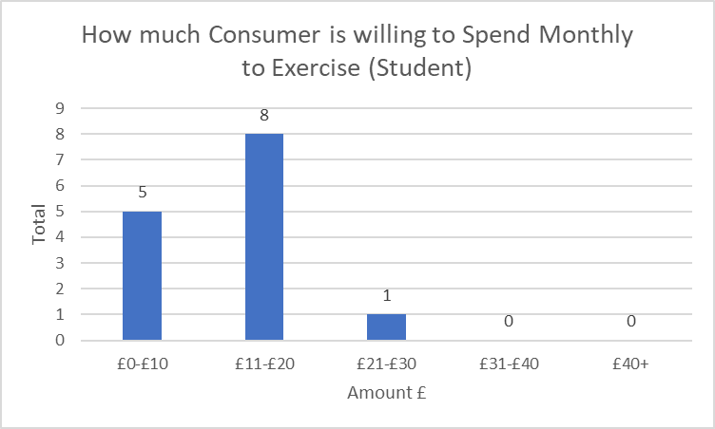

Figure 10: How much Consumer is willing to spend Monthly to Exercise (Student).
The graph above highlights that students are quite strict with the amount of money they are willing to spend on health and fitness with 13 out of the 14 student participants willing to spend their money on forms of exercise. This could be down students being unwilling to spend their money as they try to live of their ‘student budget’ as they feel that they are unable to spend their money on fitness as most tend to live of their student loans which is needed to pay for rent, food and bills and the social aspects of being a university student. Here we can see that there is consistency in the data collected as student generally tend to be aged 18-24 highlighting that there is a general tendency for younger students to be more cautious with the way they exchange their money.

4.3 Economy

4.2.1 Brexit
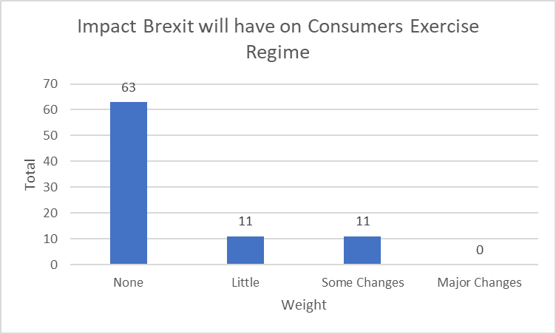

Figure 11: Impact Brexit will have on Consumer Exercise Regime.
Figure 11 highlights that despite the impending implications of BREXIT, that nearly three quarters of the participants stated that there would be no changes to their exercise regime because of the referendum. According to an article from the financial times, consumers could be drastically affected with their visas as they will require visas to stay in the country which will add more cost to consumers in the Swansea area (Palin and Evans, 2016). However, when we look at the figures above we can see that most consumers do not consider events like Brexit a concern for their fitness regime. This was further supported by Sean Davies (General Manager at Xercise4less), stating that BREXIT would only have a little impact on people going to the gym as although it could affect pricier gyms, it would only create a bigger market for budget gyms as cheaper, non-contract memberships are being offered, which entice consumers to get involved. He goes on to state that people are being more choosier with how they spend their money, deciding that going to a council gym for a higher price is not worth the benefits they have such as swimming pools and spas and budget gyms provide them with just as good service in other aspects.

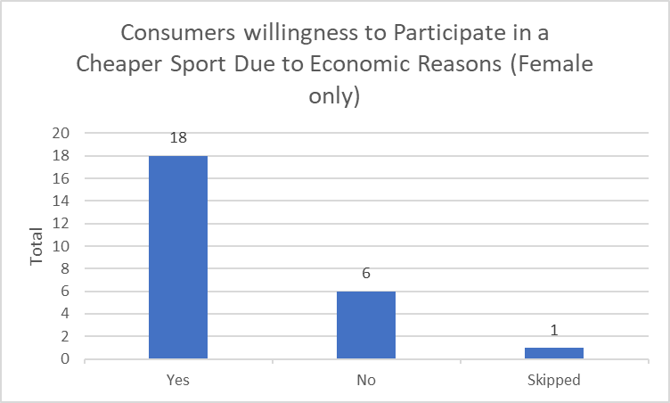

Figure 12: Consumers’ willingness to Participate in a Cheaper Sport due to Economic Reasons (Female only).
Figure 12 shows how many females are willing to participate in a cheaper sport to save money and three quarters of the woman participants suggested that they were happy to participate in a cheaper sport such as running along the beach instead of going to the gym, we can compare this to the supply and demand theory discussed in chapter 2, when there is an endless supply available for either a very little price or potentially free then the demand for the product will rise as it drives consumers away from using more expensive alternatives. Figure 12 can see that females in particular are more price sensitive.

4.3.2 Recession
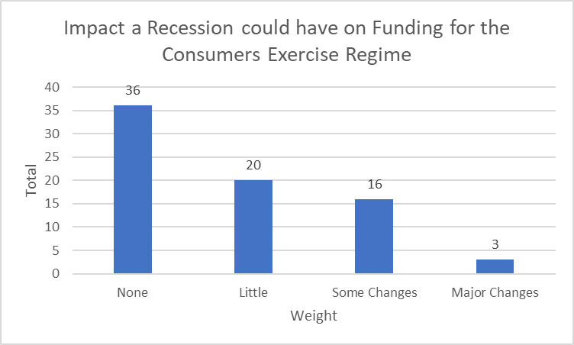

Figure 13: Impact a recession could have on funding for consumers exercise regime.
Figure 13 shows that there is a varied response on how much the participants exercise regime would be affected by another recession, however the results are similar to that of how much of an impact BREXIT would have on the consumer. Here there is another example of how economic events such as BREXIT and a recession will play little effect on the overall spending of consumers in the fitness industry.

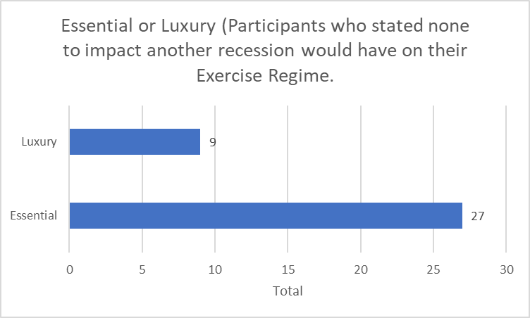

Figure 14: Essential or Luxury (Participants who stated None to impact another Recession would have on their Exercise Regime).
Figure 14 shows the participants who stated that there would be no changes if another recession occurred, a massive 75% of those participants stated that they consider exercise to be an essential as in the same category as food, bills and water rather than a luxury such as holidays or new clothes. This statistic is an indication that despite major economic concerns that the participant would still carry on participating in various forms of exercise, due to them believing exercise shares the same level of importance as food and water. This shows that the exercise orientated businesses such as gyms and sports clubs can use this to their advantage as the demand may stay the same for their service even when raising the price, it shows that exercise can be considered an inelastic service when relating the service to price elasticity.

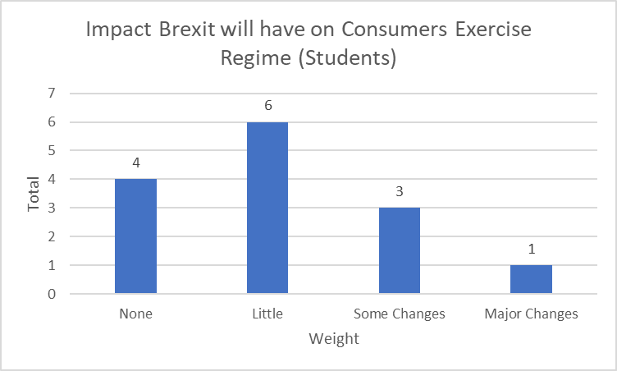

Figure 15: Impact Brexit will have on Consumers Exercise Regime (Students).
Another interesting statistic is how much more of a concern for students perceive another recession would be on their exercise regime as shown in figure 15. To gain a deeper look at this area on student participation on sports, an interview was carried out with Andrew Thomas (Programme Director for the Sport Portfolio at UWTSD). He believed that there are plenty of offers available for students which allow them to participate in their desired form of exercise at a cheaper rate than other consumers, such as the student deals on offer at Xercise4less, however he does state that if economic concerns do cause the student to change their exercise regime then they have the option of taking up running as that is free. Here it can be considered that not enough is being done to ensure that students participate in enough exercise. When considering that students may feel that they do not have enough resources to manage both university and sport it is considered that ‘’students who do well at sport tend to be good students’’ (Thomas, A, 2018).

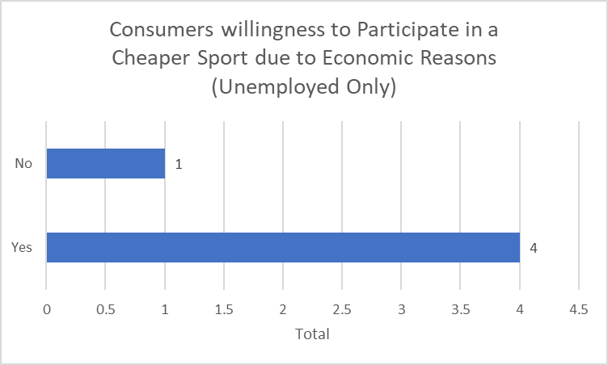

Figure 16: Consumers willing to Participate in a Cheaper Sport due to Economic Reason (Unemployed Only)
The graph above states how many unemployed participants would consider participating in a cheaper sport. 80% of the unemployed demography stated yes, highlighting that there is genuine concern from the unemployed that they may have to change their exercise regime following BREXIT and in the chance of another recession, if this statistic was to represent every person unemployed in the Swansea area, with 5,800 people currently unemployed in the area (Swansea.gov.uk, 2018), then that would mean 4,640 people in the Swansea area would have to make changes to their exercise regime.
When looking at the £1.3 Billion government investment Matthew Thomas (Swansea Stadium Management Company) believed that the investment in a new state of the art sports centre will entice consumers into participating in sport. He believed that the culture behind fitness is changing more people are concerned about fitness rather than getting big, resulting in more people wanting to participate in sport rather and taking in an interest in their health. This view was backed up by both Sean Davies and Andrew Thomas as they both believed facility development encourages consumers to spend and get involved in new sports.

4.4 End of Chapter Conclusion
After conducting the primary research, this chapter has analysed the data collected to meet the aims and objectives of the study. Although there were enough responses, there were an insufficient number of female participants, with two thirds of the participants being men. This issue will be considered more in chapter 5.

5.0 Concluding Discussion
Following the results of both the primary and secondary research, there have been some key findings following this paper.
Firstly, it’s clear that the Swansea area will be affected by economic events such as BREXIT and another recession which could potentially cause consumers to become more conservative with their money. However, following the research it may be assumed that economic events do not affect consumer buying habits in the fitness industry. This is due to consumers in the fitness industry believing their exercise regime to be an essential such as bills and food and would be unwilling to give up their exercising regime. This is highlighted with a low number of respondents saying that BREXIT and a recession will play an impact on their exercise regime.
However, it is believed that this perception has been developed, with more people becoming conscious about their health and health campaigns are asking for healthier living. This development can be compared with another modern essential such as the mobile phone. The perception that consumers can no longer do without their mobile phones for using the internet and communication with 95% of households having at least one mobile phone, stating the need to contact emergency services, family and friends (Sparkes, 2014). These are similar developments to the way consumers in the fitness industry are now perceiving exercise as they are becoming more aware of the health benefits of the service.
When we delve deeper into the findings there may be some demographs who do get affected by economic concerns. It is clear there are plenty of deals on offer for students and teens in the Swansea are (Thomas, A, 2018). However, following the results of the questionnaire, the researcher discovered that 13 of the 14 students who participants who took part of the questionnaire believed that they would not be willing to spend more than £20 for their chosen exercise regime. This shows that they have the smallest budget for exercise regimes in the Swansea area. Following on from this almost half of the participants aged between 18-24 stated that their finances could affect their exercise regime, highlighting that consideration must be made when deciding on prices for students or the younger generation as they can be considered very price sensitive.
It’s clear that consumers in the fitness industry can be price sensitive as 46 out of 75 people stating that they would pay no more than £20 to pay for their monthly exercise regime. This highlights that most people would only be willing to pay for budget gyms as they are in that price range, eliminating the possibility for consumers to pay for big budget and council gyms such as the LC2. This could potentially limit the amount of income these organisations bring in and could be further lowered via economic events such as BREXIT.
Another group of consumers who are price sensitive due to economic concerns are females, with three quarters of female participants saying they are willing to participate in a cheaper sport due to economic concerns. This may be due to females happier to participate in as females tend to be happier with participating in sports which require little or no money such as running, males however tend to take more of an interest in paid for exercises such as sports like football and weightlifting at the gym.
Another interesting finding is how willing unemployed consumers are willing to change their exercise to a cheaper alternative due to economic reason as 4 out of the 5 unemployed participants agreed. This highlights another potential target audience which are quite price sensitive highlighting that they would be willing to change exercise to save money, implying the need for sports gyms and sports centres could offer deals to get these participants involved.

6.0 Conclusion
The researcher has made an analysis of consumer behaviour and has identified interesting areas in need of development in the fitness industry. The researcher has used primary research to identify theories relating to the topic such as price elasticity. The researcher identified an approach to the research through quantitative and qualitative means and their plan was guided through the research onion. The research has met the three aims identified by the researcher at the beginning of the project. The relationship between the welsh economy and the uptake of ‘’paid for exercise’’ has been identified, the research has also identified how economic events such as Brexit would affect consumer spending in the fitness industry and explored how price sensitive consumers are towards the economy and the fitness industry.
The main findings of the research suggest that there is little price sensitivity for exercise regimes in the fitness industry as despite major economic events affecting Swansea, many consumers still wish to carry out their exercise regimes as normal and pay the same prices. However, when referring to the literature review, there is a high level of unemployment and the findings showed that this demography would be affect by economic events such and following Brexit the unemployment figures may rise again, creating a higher population having to adapt to a cheaper sport. Future research will be able to assess the impact after Brexit, as the current study was carried out before UK left the EU. Highlighting the need for further research.

6.1 Recommendations
Firstly, gyms and sports centres could provide more deals for students and younger generations as they are a price sensitive audience, however they do believe fitness to be an essential. Due to them believing that sport is important, companies can benefit from these cheaper deals to students and the younger audience as they can attract new potential customers.
However, companies in the fitness industry could raise their prices. Due to most consumers believing exercise to be an ‘’Essential’’, then these companies could potentially benefit from raising their prices as their target audience will still carry on performing their exercise regime. However, they must consider that when their prices rise over £20 then they could receive a substantial drop in consumers as 46 of the 75 participants stated that they would not pay more than £20.
When Brexit does occur and the effects take place, gyms and sports clubs may want to ensure that their female consumer do not drop as they may become cautious with their money following economic events. It may be worth them offering deals for women to ensure they carry on participating in their desired exercise regime.

6.2 Limitations
Due to the subject being a new area of research, this made it very time consuming when trying to collect resources for the literature review. Due to many of the respondents being male there was a lack of representation from female respondents, similarly many of the respondents were of a younger generation which resulted in a lack of representation for the older generation of consumers.
If the study were to be carried out again, A recommendation could be to identify what sport or exercise the participant participated in as that would provide a basis for which the researcher could identify their current amount of consumer spending. Another recommendation for further research would be to use a different form of distribution of the questionnaire. Due to the questionnaire being distributed online, many of the respondents were of the younger generation, which made it difficult to gain a deeper perspective from an older demography. Another limitation for the research was the time frame, if a larger timeframe was available this would of allowed the researcher to develop more of a background of the research and allow the researcher to conduct to a larger sample to allow a greater perspective of the Swansea area.

References
Amadeo, K. (2018). All You Need to Know About Economic Growth. [online] The Balance. Available at: https://www.thebalance.com/what-is-economic-growth-3306014 [Accessed 10 Feb. 2018].
Amadeo, K. (2018). How Fast Should the Economy Grow?. [online] The Balance. Available at: https://www.thebalance.com/what-is-the-ideal-gdp-growth-rate-3306017 [Accessed 3 May 2018].
Ball, M. and Seidman, D. (2012). Supply and demand. 1st ed. New York: Rosen Pub., p.5.
BBC.co.uk. (2008). BBC NEWS | Business | Q&A: What is a recession?. [online] Available at: http://news.bbc.co.uk/1/hi/business/7495340.stm [Accessed 30 Apr. 2018].
BBC News. (2011). Win will 'raise profile' of Wales. [online] Available at: http://www.bbc.co.uk/news/uk-wales-13595614 [Accessed 30 Jan. 2018].
BBC News. (2015). Economy tracker: Unemployment. [online] Available at: http://www.bbc.co.uk/news/10604117 [Accessed 11 Feb. 2018].
BBC News. (2017). Prime minister signs Swansea Bay deal. [online] Available at: http://www.bbc.co.uk/news/uk-wales-politics-39321953 [Accessed 31 Jan. 2018].
BBC News. (2018). UK unemployment falls to 1.44 million. [online] Available at: http://www.bbc.co.uk/news/business-42802526 [Accessed 3 Feb. 2018].
BBC Sport. (2015). Sport England: Women lead increase in sport participation. [online] Available at: https://www.bbc.co.uk/sport/35061399 [Accessed 21 Apr. 2018].
Behrmann, N., 2016, May 24. Brexit shock will cause severe unemployment, recession: UK Treasury. The Business Times.
Benson, R. (2016). How Brexit will affect Swansea, Cardiff and British football. [online] walesonline. Available at: https://www.walesonline.co.uk/sport/rugby/rugby-news/how-brexit-affect-swansea-city-11520455 [Accessed 30 Jan. 2018].
Black, J., Hashimzade, N. and Myles, G. (2012). A dictionary of economics. Oxford: Oxford University Press.
Brace, I. (2018). QUESTIONNAIRE DESIGN. [S.l.]: KOGAN PAGE.
Braun, V., Clarke, V. and Gray, D. (2017). Collecting qualitative data. Cambridge University Press.
Bryman, A. and Bell, E. (2007). Business research methods. Oxford: Oxford University Press.
Cave, A. (2018). The potential of sport: a £20 billion industry. [online] The Telegraph. Available at: http://www.telegraph.co.uk/investing/business-of-sport/potential-of-sport-20billion-industry/ [Accessed 24 Jan. 2018].
Chandler, D. and Munday, R. (2011). A dictionary of media and communication. Oxford: Oxford University Press.
Collis, J. and Hussey, R. (2003). Business Research. 2nd ed. London/Basingstoke: Palgrave Macmillan.
Conerly, B. (2016). Forbes Welcome. [online] Forbes.com. Available at: https://www.forbes.com/sites/billconerly/2016/11/29/what-is-a-recession/#14b02ecda542 [Accessed 30 Jan. 2018].
Critchlow, A. (2018). Britain's sport industry hitting top form. [online] Telegraph.co.uk. Available at: http://www.telegraph.co.uk/finance/11580773/Britains-sport-industry-hitting-top-form.html [Accessed 24 Jan. 2018].
Doyle, C. (2011). A dictionary of marketing. Oxford: Oxford University Press.
Duff, V. (2018). Consumer Behavior in the Economy. [online] Smallbusiness.chron.com. Available at: http://smallbusiness.chron.com/consumer-behavior-economy-63128.html [Accessed 24 Jan. 2018].
Fayers, P. (2003). Thinking About Answers: The Application of Cognitive Processes to Survey Methodology. Quality of Life Research., 12(6), p.719.
Foster, A. (2018). What is Brexit and what is going to happen now that Britain has voted to LEAVE the EU?. [online] Express.co.uk. Available at: https://www.express.co.uk/news/politics/645667/Brexit-EU-European-Union-Referendum-David-Cameron-Economic-Impact-UK-EU-exit-leave [Accessed 30 Jan. 2018].
Gabriel, D. (2017). Inductive and deductive approaches to research | | Dr Deborah Gabriel. [online] Deborahgabriel.com. Available at: http://deborahgabriel.com/2013/03/17/inductive-and-deductive-approaches-to-research/ [Accessed 17 Nov. 2017].
Gillespie, A. (2011). Foundations of economics. Oxford: Oxford University Press, p.11.
Griffiths, A. and Wall, S. (2011). Economics for business and management. Harlow, England: Financial Times/Prentice Hall, p.427.
Gubrium, J. (2006). Handbook of interview research. Thousand Oaks [u.a.]: Sage.
Hardwick, P., Khan, B. and Langmead, J. (1999). An Introduction to Modern Economics. Longman: New York, p.59.
Hunter, L. (2012). Challenging the reported disadvantages of e-questionnaires and addressing methodological issues of online data collection. Nurse Researcher, 20(1), pp.11-20.
Ireland, R. (2010). A dictionary of dentistry. Oxford: Oxford University Press.
Jankowicz, A. (2000). Business research projects. 3rd ed. London: Thomson Learning.
Jankowicz, A. (2005). Business research projects. 4th ed. Australia: Thomson
JD Sports. (2018). Nike Flex Contact. [online] Available at: https://www.jdsports.co.uk/product/grey-nike-flex-contact/010408/ [Accessed 11 Feb. 2018].
Jones, S., Murphy, F., Edwards, M. and James, J. (2008). Doing things differently: advantages and disadvantages of web questionnaires. Nurse Researcher, 15(4), pp.15-26.
Kessler, S. (2018). How to Conduct a Job Interview. [online] Inc.com. Available at: https://www.inc.com/guides/2010/04/conducting-job-interviews.html [Accessed 19 Apr. 2018].
Kokemuller, N. (2018). What Is the Nature of Microeconomics & Its Effect on Business?. [online] Smallbusiness.chron.com. Available at: http://smallbusiness.chron.com/nature-microeconomics-its-effect-business-66146.html [Accessed 10 Feb. 2018].
Kotler, P. and Armstrong, G. (2017). Principles of Marketing. Upper Saddle River: Pearson, pp.135-136.
Krugman, P. and Wells, R. (2009). Economics. New York: Worth Publishers, p.605.
Law, J. (2010). A dictionary of accounting. New York: Oxford University Press.
Marketline (2017). Gyms, Health & Fitness Clubs in the United Kingdom. MarketLine Industry Profile. London: Marketline
McQuerry, L. (2018). The Economy's Effects on Small Businesses. [online] Smallbusiness.chron.com. Available at: http://smallbusiness.chron.com/economys-effects-small-businesses-10269.html [Accessed 1 Feb. 2018].
Minichiello, V. (2009). Qualitative journeys: student and mentor experiences with research. California: Sage Publications.
Mona, C., Riley, M., Wilkie, E. and Wood, R. (1998). Researching and writing dissertations in hospitality and tourism. London: International Thomson, pp.129-131.
Monaghan, A. (2016). UK employment falls in months after Brexit vote. [online] the Guardian. Available at: https://www.theguardian.com/business/2016/dec/14/uk-unemployment-rate-pay-growth-jobless-ons [Accessed 10 Feb. 2018].
Nhs.uk. (2018). Benefits of exercise - Live Well - NHS Choices. [online] Available at: https://www.nhs.uk/Livewell/fitness/Pages/whybeactive.aspx [Accessed 12 Apr. 2018].
Nhs.uk. (2018). Physical activity guidelines for adults - Live Well - NHS Choices. [online] Available at: https://www.nhs.uk/Livewell/fitness/pages/physical-activity-guidelines-for-adults.aspx [Accessed 1 Feb. 2018].
Palin, A. and Evans, J. (2018). What will be Brexit’s impact on consumers?. [online] Ft.com. Available at: https://www.ft.com/content/fddc5b3c-aae8-11e4-81bc-00144feab7de [Accessed 30 Jan. 2018].
Partington, R. (2018). UK trade deficit grows as oil price rise pushes up cost of fuel imports. [online] the Guardian. Available at: https://www.theguardian.com/business/2018/feb/09/uk-trade-deficit-grows-oil-price-rise-pushes-up-cost-fuel-imports [Accessed 10 Feb. 2018].
Patniak, P. (2015). Macroeconomics. New Delhi: Oxford University Press.
Pingdom Royal. (2012). Report: Social network demographics in 2012. [online] Available at: https://royal.pingdom.com/2012/08/21/report-social-network-demographics-in-2012/ [Accessed 4 May 2018].
Rada, V. and Domínguez-Álvarez, J. (2013). Response Quality of Self-Administered Questionnaires. Social Science Computer Review, 32(2), pp.256-269.
Reed, S. and Crawford, M. (2016). How does consumer spending change during boom, recession, and recovery? : Beyond the Numbers: U.S. Bureau of Labor Statistics. [online] Bls.gov. Available at: https://www.bls.gov/opub/btn/volume-3/how-does-consumer-spending-change-during-boom-recession-and-recovery.htm [Accessed 30 Jan. 2018].
Rojas, A. (2016). I’m super-setting my life! An ethnographic comparative analysis of the growth of the gym market. Sport Science Review, 25(5-6).
Sandilands, T. (2018). Effect of Recession on Small Businesses. [online] Smallbusiness.chron.com. Available at: http://smallbusiness.chron.com/effect-recession-small-businesses-61164.html [Accessed 31 Jan. 2018].
Saunders, M., Lewis, P. and Thornhill, A. (2016). Research methods for business students. 7th ed. FT/Prentice Hall.
Schuman, H., Bradburn, N., Sudman, S., Blair, E., Locander, W., Miles, C., Singer, E. and Stocking, C. (1980). Improving Interview Method and Questionnaire Design: Response Effects to Threatening Questions in Survey Research. Social Forces, 59(1), p.325.
Sekaran, U. and Bougie, R. (2016). Research Methods For Business: A Skill Building Approach Seventh Edition. 7th ed. John Wiley & Sons, p.106.
Sloman, J., Hinde, K. and Garratt, D. (2010). Economics for business. 5th ed. Harlow: Pearson Education, p.20.
Sparkes, M. (2014). Mobile phones and internet now 'essential'. [online] Telegraph.co.uk. Available at: https://www.telegraph.co.uk/technology/news/10982388/Mobile-phones-and-internet-now-essential.html [Accessed 8 May 2018].
Sportsdirect.com. (2018). Nike | Nike Flex Contact Runners Ladies | Runners. [online] Available at: https://www.sportsdirect.com/nike-flex-contact-runners-ladies-271129?colcode=27112926 [Accessed 11 Feb. 2018].
Stolerman, I. and Bickel, W. (2010). Encyclopedia of psychopharmacology. Berlin: Springer.
Swansacademy.co.uk. (2018). Leon goes back to school to launch Premier League Primary Stars - Latest Swansea City acedemy news. [online] Available at: http://www.swansacademy.co.uk/news?news_id=624 [Accessed 30 Jan. 2018].
Swansea.gov.uk. (2018). Swansea - Labour market statistics. [online] Available at: https://www.swansea.gov.uk/labourmarketstatistics [Accessed 3 Feb. 2018].
Thegymgroup.com. (2018). The Gym Group | Pay As You Go | 24 Hour Membership. [online] Available at: https://www.thegymgroup.com/?lat=51.6291204&lng=-3.906556200000068 [Accessed 10 Feb. 2018].
Tradingeconomics.com. (2018). United Kingdom GDP Growth Rate | 1955-2018 | Data | Chart | Calendar. [online] Available at: https://tradingeconomics.com/united-kingdom/gdp-growth [Accessed 10 Feb. 2018].
Tradingeconomics.com. (2018). United Kingdom Inflation Rate | 1989-2018 | Data | Chart | Calendar. [online] Available at: https://tradingeconomics.com/united-kingdom/inflation-cpi [Accessed 3 Feb. 2018].
Vandevelde, M. (2018). Sports Direct warns on profits after slump in sterling. [online] Ft.com. Available at: https://www.ft.com/content/afe6702e-8cab-11e6-8cb7-e7ada1d123b1 [Accessed 30 Jan. 2018].
Wilson, J. (2014). Essentials of Business Research. 2nd ed. Singapore: Sage.
Whelan, J. and Msefer, K. (2018). Economics Supply and Demand. MIT, p.6.
Wood, M. (2004). Making sense of statistics. Basingstoke: Palgrave.
Xercise4less.com. (2018). Membership. [online] Available at: https://www.xercise4less.co.uk/membership/ [Accessed 10 Feb. 2018].
Xe.com. (2018). XE: Convert GBP/USD. United Kingdom Pound to United States Dollar. [online] Available at: http://www.xe.com/currencyconverter/convert/?Amount=1&From=GBP&To=USD [Accessed 30 Jan. 2018].
Young, D.C., 2009. Interpretivism and Education Law Research: A Natural Fit. Education Law Journal, 18(3), pp. 203-219.

Appendices

Appendix A: Screenshot of Questionnaire (Part One)
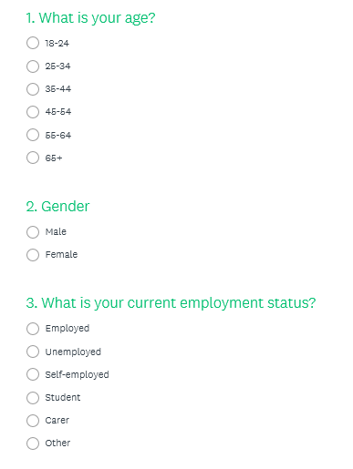

Appendix B: Screenshot of Questionnaire (Part Two)
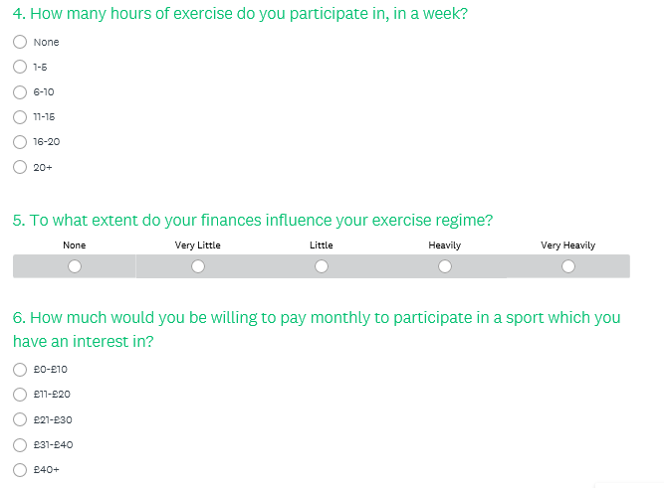

Appendix C: Screenshot of Questionnaire (Part Three)
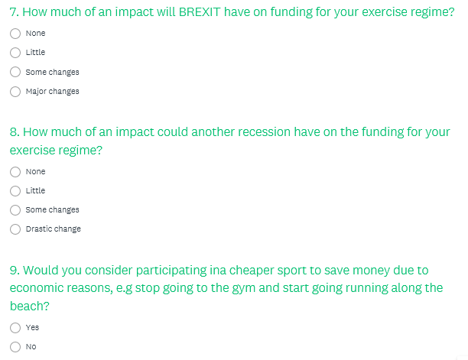

Appendix D: Screenshot of Questionnaire (Part Four)
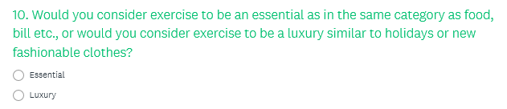

Appendix E: Sean Davies Interview (General Manager Swansea)
Question: How much of an impact do you feel gyms have on motivating people in the Swansea area?
Answer: Big impact, competitive market for gyms in Swansea, new gym opening in the Swansea area. 8,500 people just in the Swansea gym. Estimating 40-50,000 people going to gyms in the Swansea area.
Question: Considering the UK are leaving the EU, has there been a considerable drop in people going the gym?
Answer: Little change. Bigger market for budget gyms and cheaper and convenient (non-contract) memberships are being offered.
Question: Do consumers perceive exercise to be an Essential or Luxury?
Answer: Budget gyms make it more accessible for people, not much excuse to not train. People want to train but their looking after their money, other things are important such as mortgages.
Question: How do you feel a recession will affect the fitness industry in the Swansea area?
Answer: Council gyms struggling, due to having to run swimming pools, people are being choosier with how they spend their money. Deciding not to go a council gym and pay more as they don’t use the pool that they don’t use.
Question: Do gyms do enough to promote sport and fitness in the Swansea area?
Answer: Marathons are popping up working with local gyms and sports centre.
Question: The government looking to invest £1.3 billion in Swansea area and create a new state of the art sports centre?
Answer: Anything new opens, people want to try it out. More diverse selection of sports appeal to a wider audience.

Appendix F: Andrew Thomas Interview (Programme Director for the sports portfolio in UWTSD)
Question: How much of an impact do you feel that the UWTSD have on motivating people to participate in sports?
Answer: Student Union have a low impact on getting students involved in sports. No formal coaches.
Question: Are there enough various sports on offer at UWTSD?
Answer: Sport portfolio could increase dramatically through investment. Quite a lot of foreign consumers who may be interested in racket based sports, but there are no racket based sports on offer at UWTSD. Economy does not play a part. Each university decides how much it spends on sport.
Question: Could the UWTSD get non-students more involved in sport?
Answer: Every week the UWTSD get a sports hall booked at the LC for students to deliver coaching sessions to the primary students. Need own facilities to perform this at a larger scale. Again the economy doesn’t play a part in the funding for these activities.
Question: How BREXIT may impact students participating in sport?
Answer: Students who do well in sports tend to be good students. Agreed that offers for students help them fund their sport. Memberships are cheap at Xercise4less and the gym. Could run across the beach for free.
Question: How will BREXIT affect consumer behaviour in the fitness industry in the Swansea area?
Answer: More low cost gyms are taking over. Ten years ago virgin active and council gyms would have cost £20 upwards a month now you can get it for £10 upwards, highlighting how cheap gyms have become. However it may cause someone to leave the LC to go to a budget gym such as Xercise4Less.
Question: How do you feel a recession will affect consumer behaviour in the fitness industry in the Swansea area?
Answer: High cost sports such as cricket and tennis may have some depreciation in terms of the amount of consumers participating. More people run now than ever and running is free.
Question: Do consumers perceive exercise to be an Essential or Luxury?
Answer: People’s perception on luxury are changing. Gym memberships have an impact on health and well-being, something which people are becoming more aware with and people will be reluctant to give up their gym membership and rather cut down on branded food. Need more encouragement for people who do not want to participate in sport.
Question: How will the government investing £1.3 Billion into a new state of the art sports centre entice consumers to participate in new various forms of exercise?
Answer: Facility development certainly helps. They encourage participation in any environment as long as they are affordable.

Appendix G: Matthew Thomas Interview (Programme Director for the sports portfolio in UWTSD)
Question: How much of an impact do you feel Swansea City FC have on motivating people to participate in sports in the Swansea area?
Answer: Have a major impact, but may not know it. Lot of football going on in the parks. Lot of people active in Swansea, but may not be directly motivated by the football club, but they are leading Swansea, the premier league make them provide sport in the community, sport in schools, disabilities and woman’s sport.
Question: If Swansea FC were to drop out of the premier league, would this play an impact on people participating in sport as their ‘’idols’’ are not performing at the highest level?
Answer: Potentially, how many kids want to be like their idols? But the drop from premier league to championship would not have a dramatic impact. Heroes are always there such as Lee Trundle and Robbie Fowler.
Question: Do you feel that Swansea City do enough to promote sport and fitness in the Swansea area?
Answer: Could do a bit more. Tend to target those who are traditionally under targeted. Swansea have committed to leasing 5 4G pitches, and they are working with the council so that they are available to the public following the lease of the Liberty Stadium. Really successful schemes such as the Primary Stars football.
Question: How much of an impact do you feel BREXIT may have on Swansea City FC?
Answer: Will it impact VISAs and foreign players? Unsure? Swansea City will still be up there regardless. The majority of their market is their commercial income. Unsure whether BREXIT will play an impact.
Question: How do you feel a recession will affect consumer behaviour in the fitness industry in the Swansea area?
Answer: Will have an impact. Unsure how to monitor that as Swansea were not as popular in 2008. Sport is a release as people will try to relax on the weekend and get their mind their day to day problems for a couple of hours of entertainment.
Question: Do you think the recession will have an impact on demand?
Answer: Could make consumers choose cheaper options.
Question: How will the government investing £1.3 Billion into a new state of the art sports centre entice consumers to participate in new various forms of exercise?
Answer: Absolutely, new various sports will entice people to participate in new sports. Cultures changing, more about fitness rather than getting big. The countries changing, more people are interested in playing sport. People are becoming more aware for their health. Many forms of exercise unavailable such as winter Olympic sports. Societies splitting, one half want to take care of their health the other half don’t care. People have a responsibility as well could buy a Chinese and that’s the price of one month’s gym membership.

