Internet Technology and Security – ACCA4018
By Connor Ellement 1803452
Web Development
Submission date: Friday 3rd May

Contents
1) Introduction 3
2) Requirements 3
3) Implementation 4
3.1) Home Page 4
3.2) Timeline Page 5
3.3) Characters Page 6
3.4) Latest Trailers page 7
3.5) Newsletter page 8
3.6) Submitted page 8
3.7) Validation 9
3.7.1) Index.html 9
Evaluation 9

Introduction
For this assignment, the task was set to create a functioning website with a minimum of 5 (relevant and related) pages using web standards. This report will contain an overview of the website, including its purpose, its relevance, the target audience and the subject matter. It will also include screenshots from the website pages, along with validation checks on the HTML and CSS code. Finally, there will be an evaluation of the website discussing the accessibility of the website, its design and its usability (functionality).

Requirements
The website created is called the ‘Marvel Cinematic Universe Timeline’. The website was made to offer people who are fans of Marvel and watch the films information on which films to watch in order, as it can get quite confusing with the 22 (soon to be 23 and counting) films. The website lists all the Marvel Cinematic Universe films in order of the timeline within the universe itself, along with gives some information of the film, and the original trailer that went along with the film (*NOTE* The website doesn’t actually list EVERY film, as the code is all the same, and there would be no need to repeat the same code 22 times).
The website also has other pages and uses as well. On the home page there are ‘Blog Posts’ regarding upcoming news, and personal thoughts about the Marvel Cinematic Universe, along with trailers of films from the MCU. There is also a ‘Characters’ page, which gives information (Background knowledge e.g. Dead or Alive status, current partner, etc.) on the Marvel Comics’ characters that we have seen so far in the Marvel Cinematic Universe (*NOTE* The website doesn’t actually list all of the characters we have seen, only the main ones, as the code is the same and would be no need to repeat the code for all the characters). On the website, there is also a ‘Latest trailers’ page, for all of the latest Marvel Cinematic Universe film trailers to be placed for people to watch that have been uploaded to Marvels’ YouTube channel. The last page on the website is a ‘Subscribe to our newsletter” page where viewers can sign up to a weekly newsletter containing all the biggest news from the MCU in the past week. The fans of the MCU that variety in age, but to sign up to the newsletter you must be 13 and over.
The target audience for the website obviously is fans of Marvel and the Marvel Cinematic Universe films, along with anyone who may not have seen any of the films looking to learn a bit more about the universe before delving into the films.

Implementation

3.1) Home Page
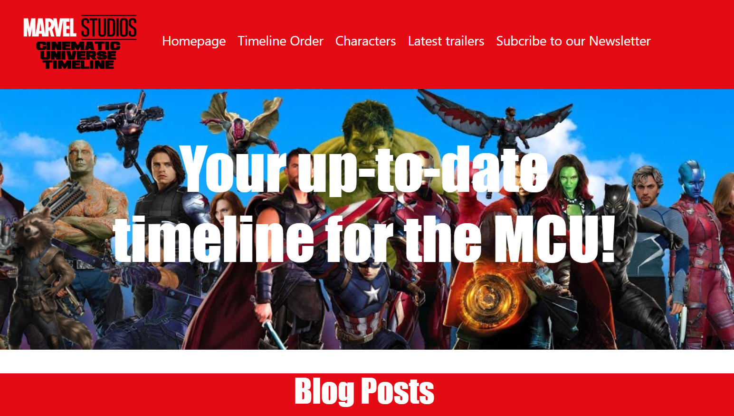
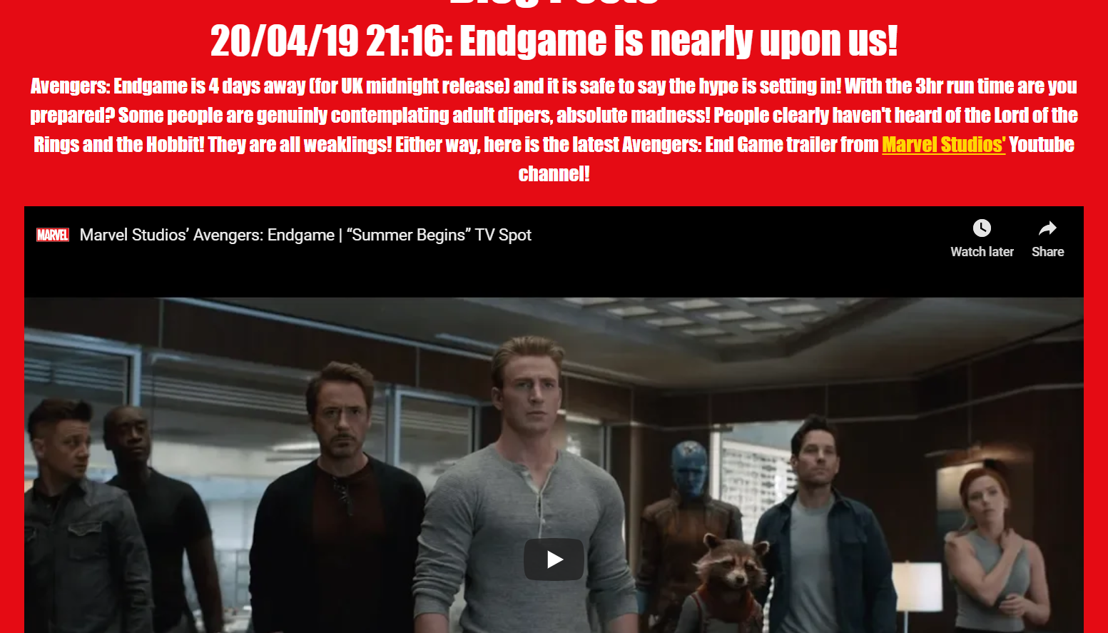

3.2) Timeline Page
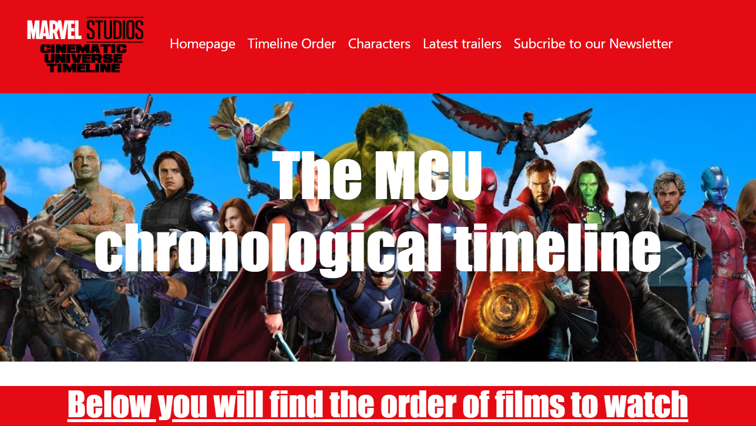
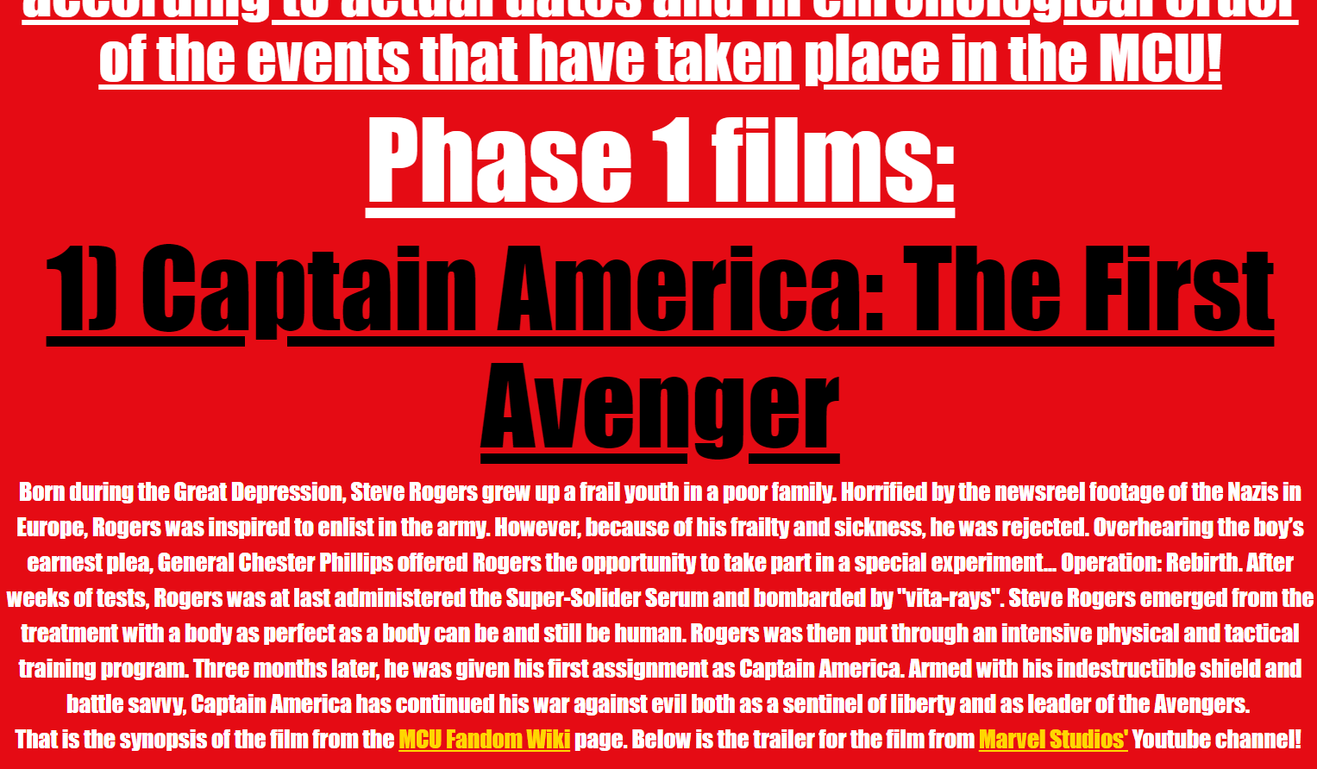

3.3) Characters Page
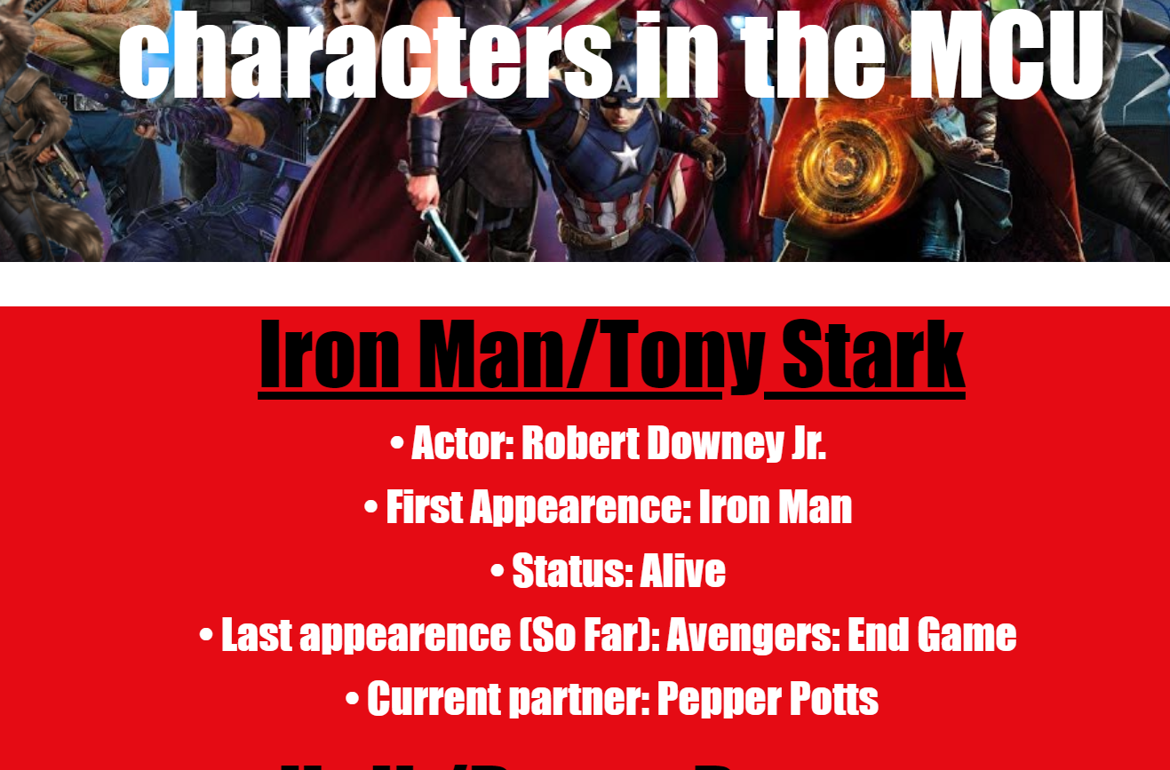
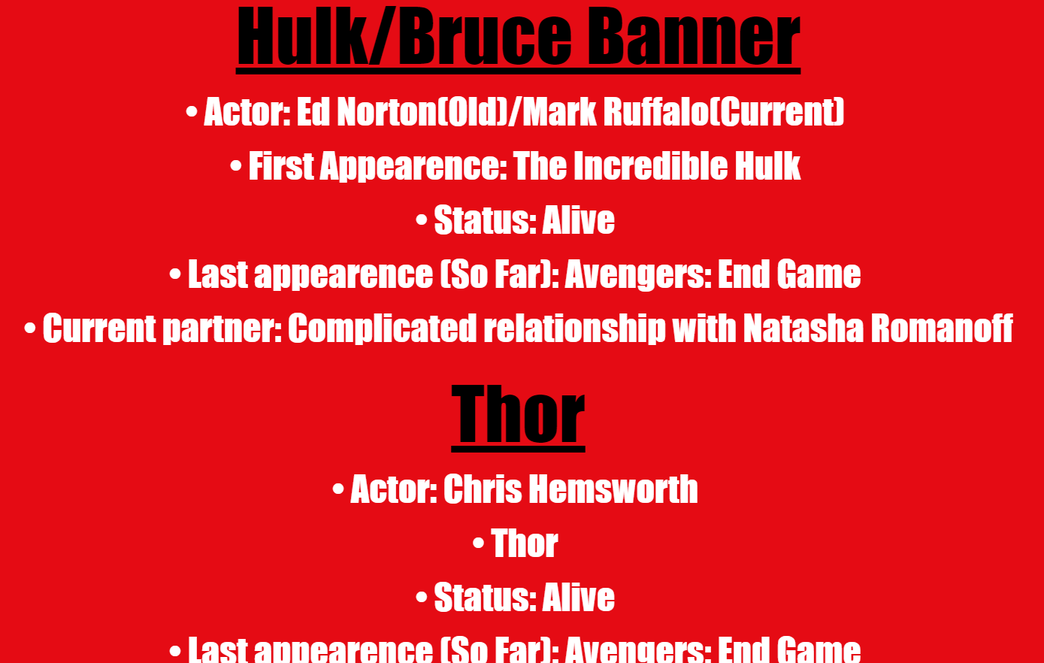

3.4) Latest Trailers page
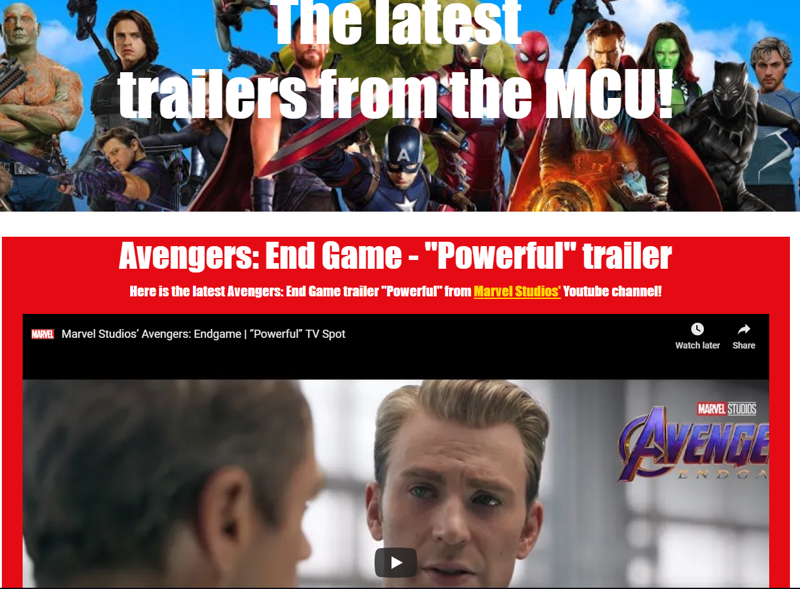
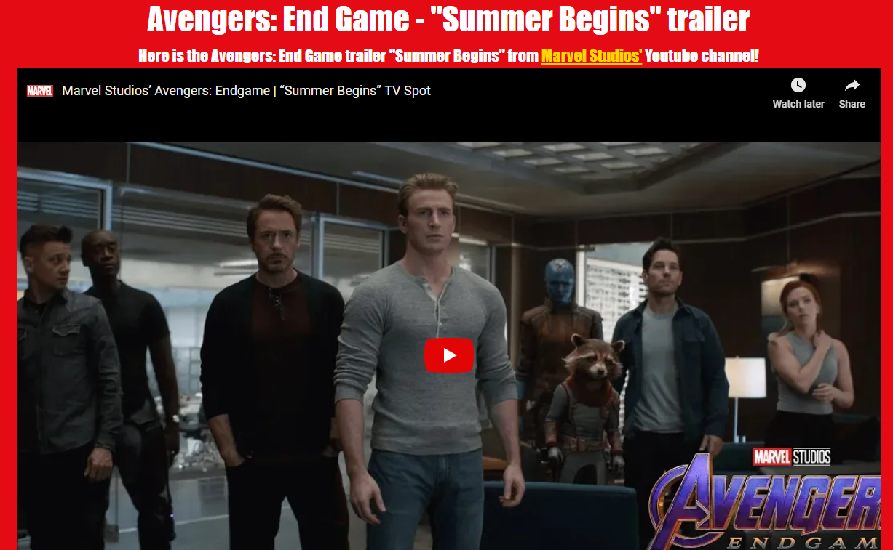

3.5) Newsletter page
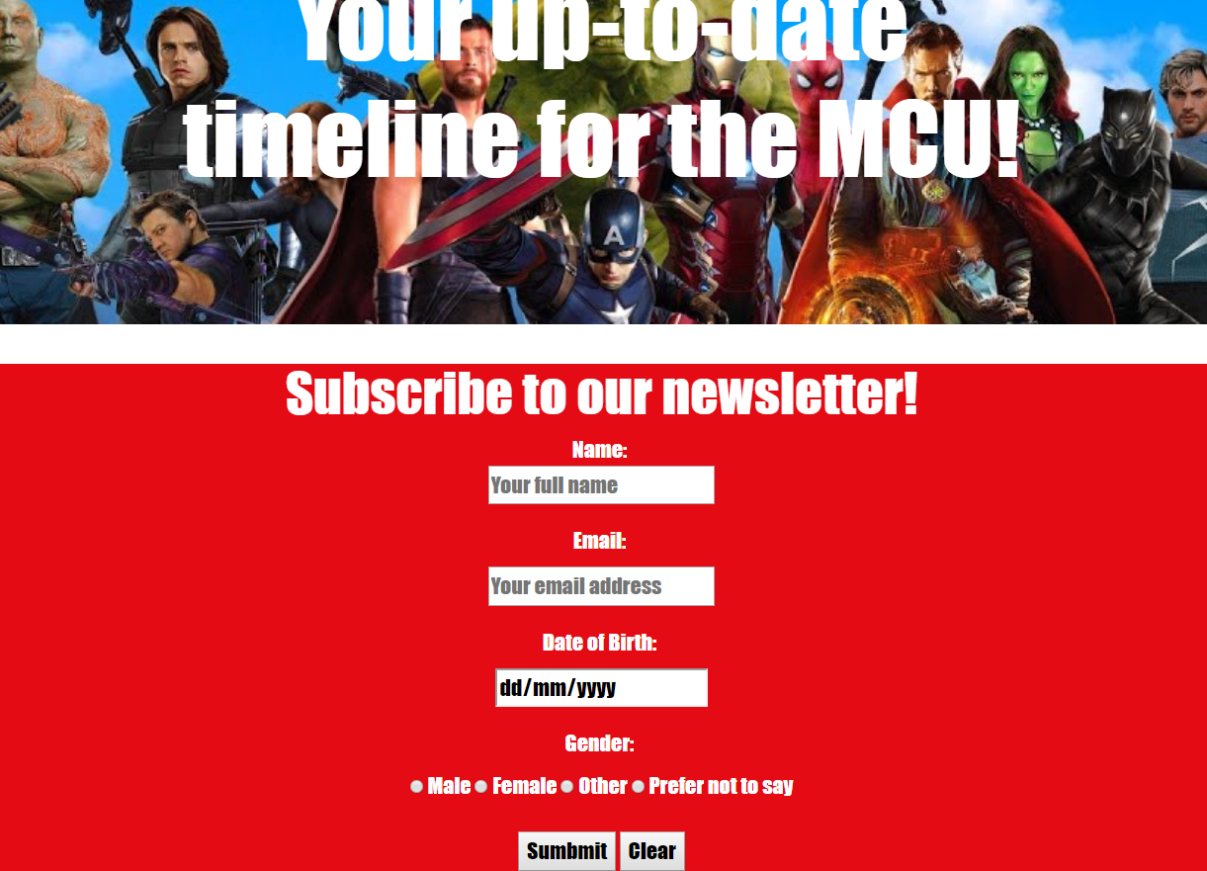

3.6) Submitted page
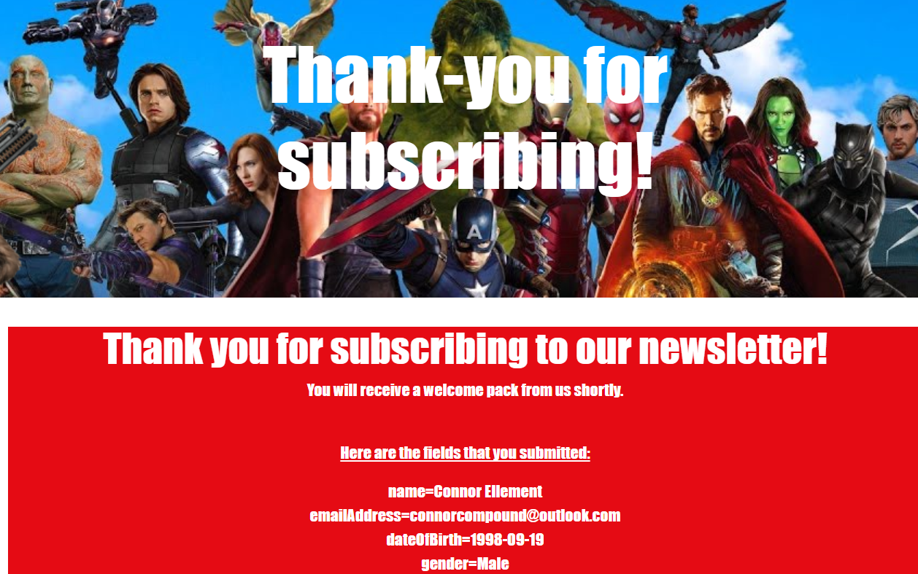

3.7) Validation

3.7.1) Index.html
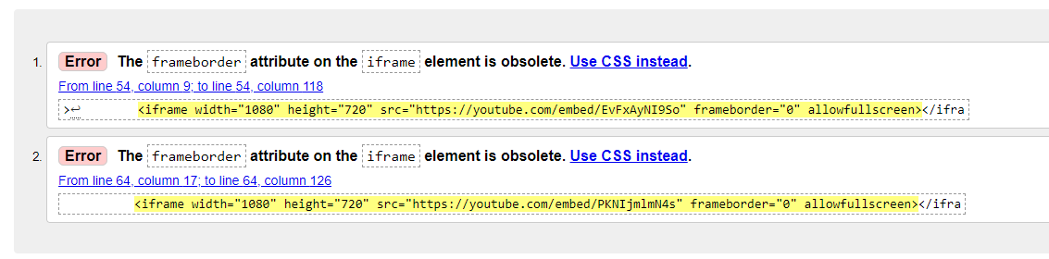
For the homepage, or index.html in visual studio, there were only two errors, both being the same error for different lines of code. The error was with the video links that were included in the ‘Blog Posts’ section. The error was saying that part of the line of code, specifically being the ‘frameborder=”0”’ part was obsolete. So, the error section of code was removed and all that changed is that there is a slight border around the video section rather than it being flush with the container background. The video section looks better this way, and the code no longer has any errors in it.

3.7.2) Timeline.html
The errors for my timeline page are as follows:
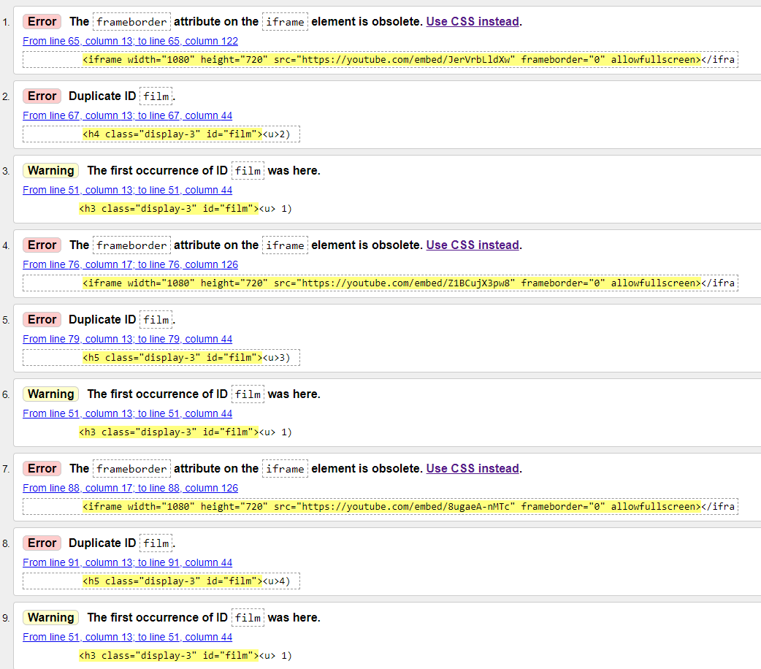
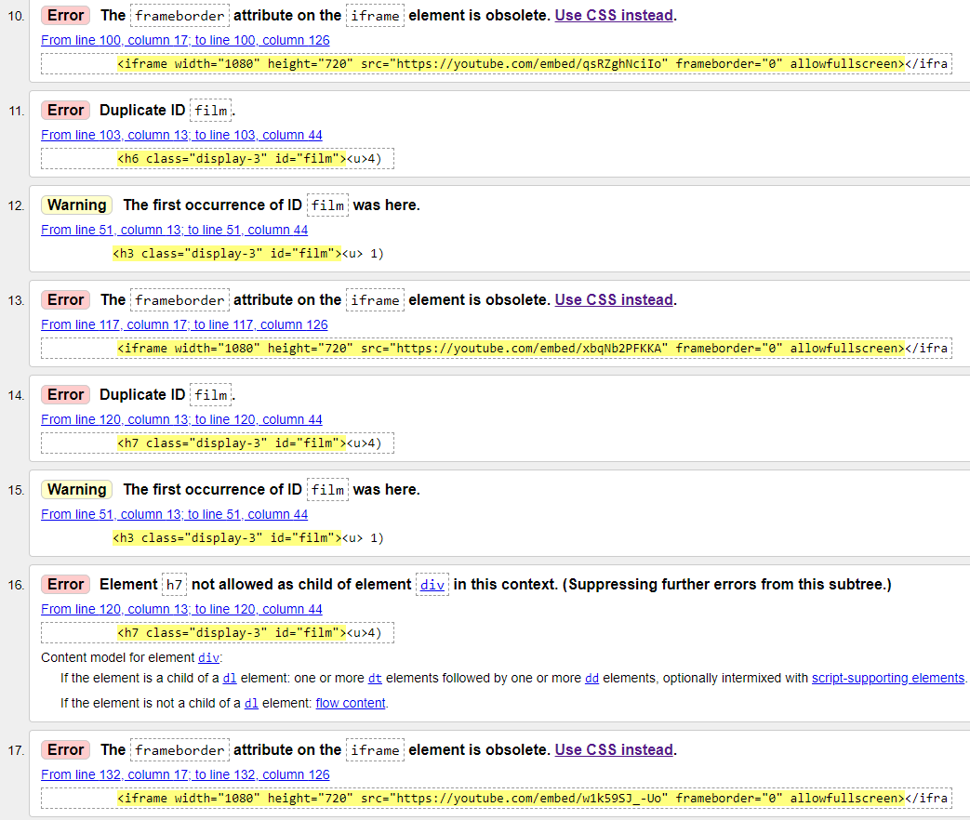
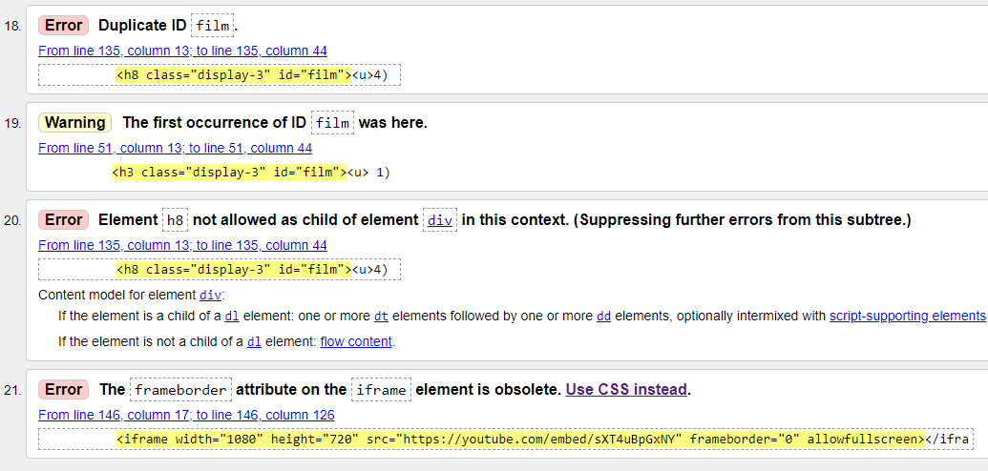
Similarly, to my index.html page, the same error in the line of code presenting the links for the trailers of the Marvel Cinematic Universe films is being flagged with the ‘frameboarder=”0”’ being deemed obsolete, so once again, that part of the code has been removed, meaning there is no longer that error. The next error to appear is one that appears a lot also, being that ‘id=”film” is duplicated. This is because I use the style I had set in my CSS sheet multiple times, so there isn’t really any harm in the id being used multiple times, as it is intended to be. The last error to occur is error 16 and 20. There is not much that can be changed to these lines of code. They are simply being used to be a heading for a film, and cannot be taken away or changed.

3.7.3) Characters.html
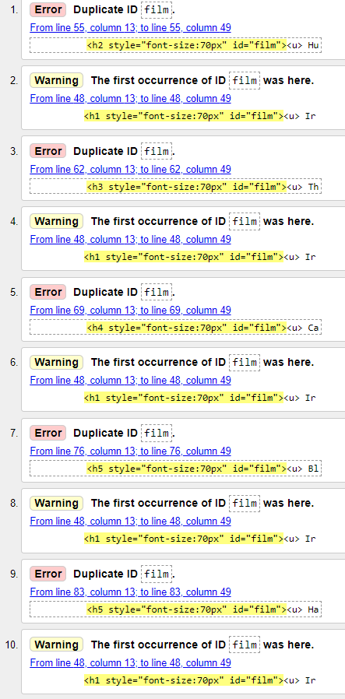
Once again, there is an error showing for the if of “film” being used more than just once. However, again the ID is intended to be used more than once, it could easily be fixed by making them id=”film1” id=”film2” etc, but the code still works either way, so it will be left as it is.

3.7.4) Latest.html
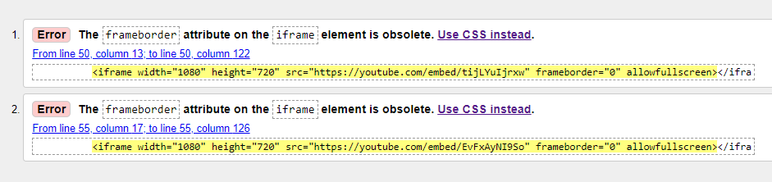
Back to the first errors that occurred back on the index.html page. The “frameborder=”0”” has been removed on both lines and now there are no errors with the code.
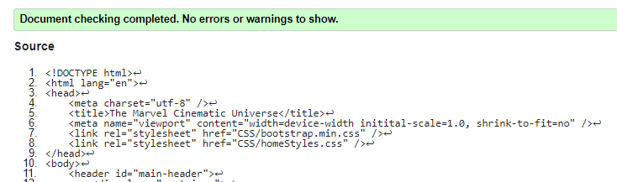

3.7.5) Newslettet.html
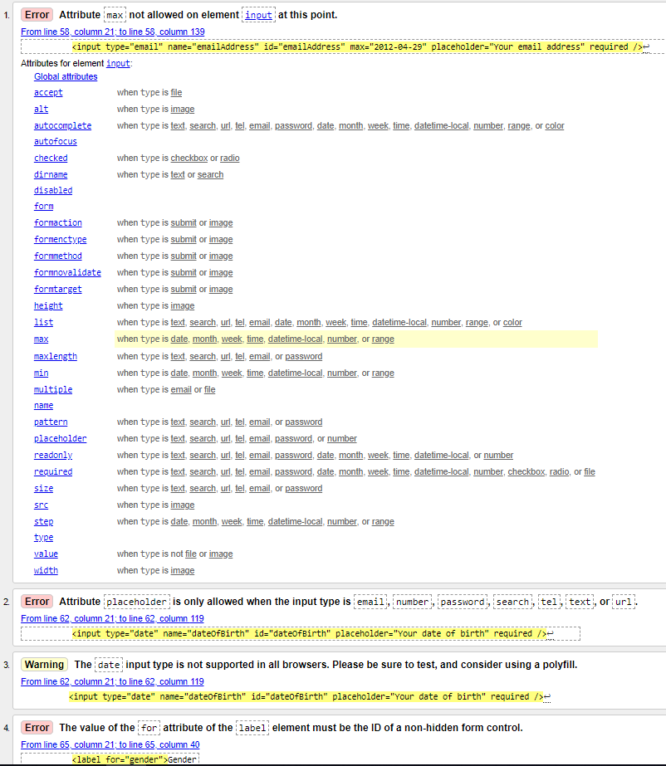
So, the first error brought to my attention is one of human error. Two lines of code have been mixed up and the “max” bit of the error shown is supposed to be in a different line of code and not that one. After adjusting the code and putting it in the correct place, the error has since disappeared.
The second error that is being shown is that the attribute of “placeholder” apparently isn’t allowed with the input type being “date”. Upon realising where the placeholder actually appears on the website (inside the text box where a date can be selected), I can see why it is not allowed. The code gives it its own placeholder in a sense of “dd/mm/yyyy”. So the placeholder I currently have of “Your date of birth” is obsolete, and I have since removed that section of code.
The third error is stating that the attribute of date may not work on all browsers. I have tested it on the browsers available to me (Mozilla Firefox, Google Chrome, Microsoft Edge and Internet Explorer), and it appears to work on all of them.
The last error I am not too sure what is it indicating at. The line of code used was recommended to me in a lecture, and I have used the knowledge from that lecture in this section of the code, and it works fine. So, I will be leaving the code as it is.

3.7.6) frmSubmit.html
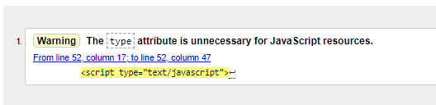
There were no errors with the code from the code used in frmSubmit.html, only a warning saying that the attribute type is unnecessary. However, as that line of code is used in all other pages on the website, I think it best to keep it as is.

3.7.7) homeStyles.css
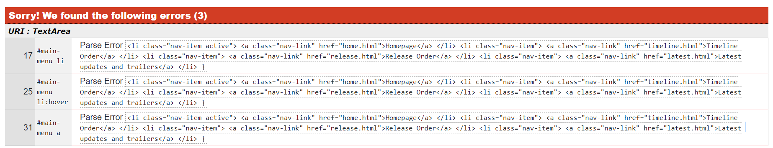
The only errors that came up with the CSS page were parse errors. I am not too sure how to correct this, as the way the code is currently parsed is the way that was taught to me in lecture and I have just gone off that knowledge. The code works as intended however, so I shall leave it as it is.

Evaluation

4.1) Design
For the design of the website, the inspiration comes from Marvel Studios and the colours associated with them as a company. The colours used primary are shades of red, white and black. The red used is specifically taken from the Marvel Studios logo as that is the most prominent colour associated with Marvel. That shade is #E50B14. The shades of black and white used are simply the shades offered by Visual Studio when entering the names “white” and black. Using the contrast checker from https://contrastchecker.com/, I was able to check how the red background vs white text looks and here are the results: 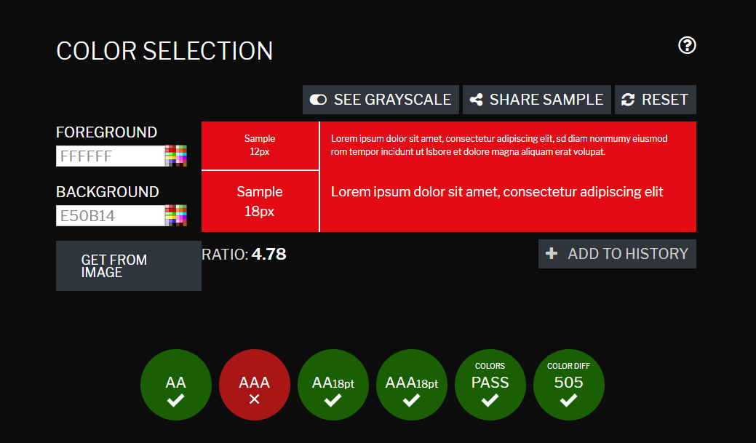
As seen above, the colour combination used passed the checker on most fronts showing that they work well together. I use the black as more of a highlight and accent colour, so there isn’t much used, but works well with the white and red all the same.

4.2) Functionality
As a whole, the website works as intended. All page’s link to each other and the logo hyperlink works to take the user back to the home page. All videos I have used and taken from YouTube work both as the standard viewer size as well as in full screen. All information displays on its intended page. All hyperlinks to external pages (links to YouTube channels and the link to the images folder) work properly and take you to the intended pages.

4.3) Content
The content of the website is all relevant to the subject matter of the website, being the Marvel Cinematic Universe. The information used, is up-to-date in terms of MCU as it stands, and at time of creating the website.

4.4) Improvements
When making a website in the future, I definitely will ask for a little bit more help and advice on the coding side of things. There were just some parts that I could not figure out how to get to work how I wanted (E.g. Active page highlight). Doing this will help streamline any future websites I create to get them up to higher standards.
Next time, I will choose a broader topic. The MCU is a relatively small subject to cover and a lot of the code ended up being the same which made the project a bit repetitive, and I would like the opportunity to use other website features.

References
No reports or journals were used for this report. However, here are the links to all the images used to make the website:
Marvel cinematic universe logo: https://www.deviantart.com/edogg8181804/art/Marvel-Cinematic-Universe-logo-FM-551368209
Marvel studios logo: http://loodibee.com/marvel/
House logo: https://www.iconfinder.com/icons/1597110/building_circle_estate_home_house_icon
MCU Wallpaper 1: https://mspoweruser.com/most-marvel-cinematic-universe-movies-discounted-in-the-microsoft-store/
MCU Wallpaper 2: https://medium.com/midday-musings/ranking-the-marvel-cinematic-universe-71da402d3669
MCU Wallpaper 3: https://www.cbr.com/video-mcu-characters-meet-avengers-endgame/
MCUCustom: Custom made using images in folder
MCUCustom2: Custom made using images in folder
customlogo: Custom made using images in folder
rocket 1: https://www.deviantart.com/davidbksandrade/art/Avengers-Infinity-War-Rocket-Raccoon-PNG-734542730
rocket 2: https://www.kisspng.com/png-rocket-raccoon-star-lord-groot-drax-the-destroyer-631796/
cinematic.png: made on cooltext.com
timeline.png: made on cooltext.com
universe.png: made on cooltext.com

