Research on 5G

1.What is 5G
So far, mobile communication has experienced four generations of development, namely 1g represented by FDMA technology in the 1980s, which makes mobile voice communication possible, and then 2G technology became popular in the 1990s. 2G technology has taken a historic step, using digital communication technology to make up for the shortcomings of analog communication technology, and 2G technology represented by TDMA. Then 3G, 3G developed in 2000 or so, because of its use of CDMA technology to significantly improve the bandwidth of mobile communication, 3G opened the era of mobile Internet, and in the next ten years, it affected people's lives. Finally, we are using 4G technology. 4G technology has gradually developed and improved in the last decade or two. With the help of OFDM, MIMO and other new technologies, mobile broadband technology has been realized, making the Internet era thoroughly penetrate into every corner of the world, bringing great convenience to our daily life. Now we can watch high-definition video, voice and video anytime and anywhere with 4G technology It seems that everything is perfect until the word 5g appears in our life. So what is 5g, why we need 5g and what 5g can do are the first questions to be answered.
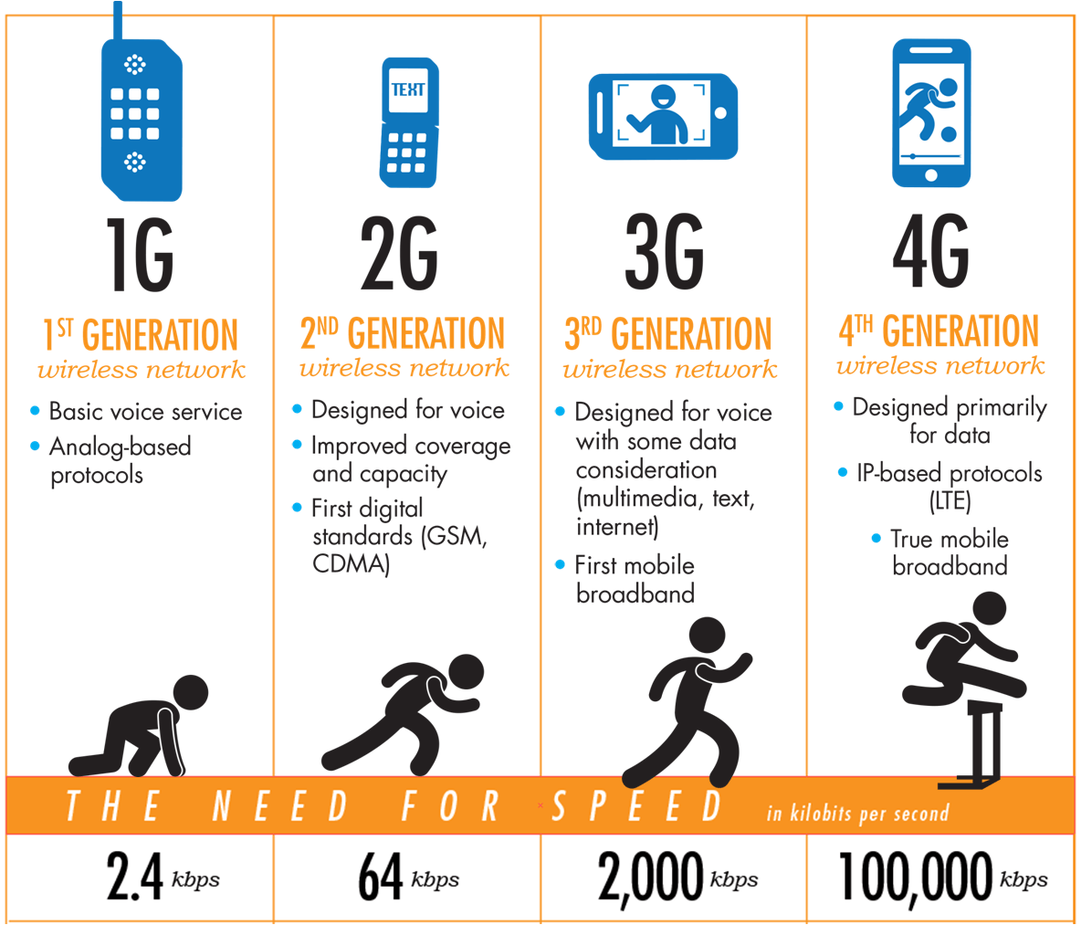
Figure 1 Development of mobile communication technology

2.Definition and technical index of 5g
5g is the 5th generation mobile communication technology. Compared with 4G, it will adopt new wireless communication technology to achieve higher technical indicators, such as higher rate, lower delay, greater bandwidth, etc., but it is not only so. Previous generations of communication technology only achieved higher performance by adopting new technology, but 5g not only achieved this point, it is also an intelligent network for business application and user experience. 5g is no longer defined by a certain business capability or a typical technical feature, it will be an advanced network of multi business and multi technology integration, and it will meet the requirements of inclusion through technological evolution and innovation The rapid development of all kinds of business of universal data and connection needs to improve the user experience. If the evolution of previous generations of communication technology is upgrading, 5g is a leap forward and subversive revolution in system architecture and key technologies, and will bring incalculable new service types, business models and derivative benefits. Now let's go back to 5g performance index and define 5g clearly with data. Figure 2 is the famous flower of 5g first proposed by China Mobile and accepted by International Telecommunication Union. This figure clearly shows nine technical indexes of 5g and compares 4G. Among them, petals represent six performance indexes of 5g, which are respectively User experienced data rate, Connections density, End to End latency, Mobility, Peak data rate, Traffic volume density. Green leaves represent three efficiency indexes of 5g, which are respectively Energy efficiency, Cost efficiency, Spectrum efficiency. And the apex of petal represents the maximum value of corresponding index
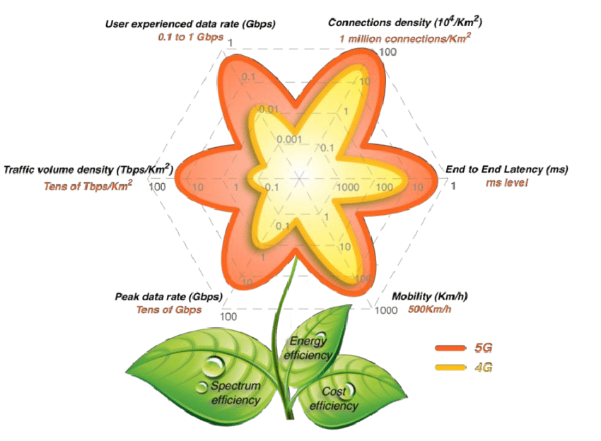
Figure 2 5G flower
From this figure, it can be clearly seen that 5g is greatly improved in performance compared with 4G, and 5g is also greatly improved in efficiency compared with 4G. 5g's spectrum efficiency is required to be 3-5 times higher than 4G, and the energy efficiency and cost efficiency per unit bit are also greatly reduced compared with 4G, which reflects the sustainable development that 5g decided to achieve at the beginning of design and proposal. 3.Why 5g is needed
So why do we need 5g? So far, many people still think that 4G is very fast, and 4G can meet almost all our needs. In fact, 4G has been widely used in the world for only five or six years, and there are still many potentials not explored. On the other hand, the research and development of 5g technology and the construction of 5g infrastructure will cost much more human and material resources than the previous communication technology, especially 4G technology is now very mature, and its infrastructure is even under construction. There are three ways to answer this question. First of all, from the perspective of the most macro national strategy, countries have seen the great benefits 4G brings to the country, including the explosion of scientific and technological innovation, full employment creation, economic growth and so on. In fact, the Internet economy is now the most important component of the world economy, and the growth rate of the Internet economy in the United States is four times that of GDP. It can be said that the new communication technology Technology will be an important engine to drive national development, 5g will have a profound impact on the future economic performance of all countries. In addition, just as 4G technology brings the technological explosion to Silicon Valley, leading 5g technology can control the initiative of future technological development, which is an indisputable place for all countries. Today, 5g has been called the strategic commanding point to win the long-term competitive advantage of the country. Countries have increased the development of 5g to national occupation, and accelerated the introduction of a number of incentive policies and measures to take the lead in the development of 5g. The most representative example of the importance of 5g to the country is the friction between the United States and Huawei. In order to curb the development of 5g in China, the United States is willing to use national forces to sanction Huawei, a private enterprise in China, and force countries not to use Huawei's 5g technology and equipment, which proves that 5g has become an important battlefield between countries. On the other hand, from the perspective of company and market, as mentioned above, 5g technology can bring incalculable benefits, not only market revenue but also technology leading advantages. Therefore, each technology company is trying to promote 5g development and market, so as to open up new business market, compete for customer resources, and make 5g progress much faster than previous communication technologies Into our lives. It took 12 years for 3G technology to be commercially used in Japan for the first time in 2000 and replaced by 4G in a large scale in 2012. However, it only takes eight to ten years for 4G to be replaced by 5g. Looking at the mobile phone market this year, we can see that 5g technology has been used in all new mobile phones, even though 5g infrastructure has not been completed in various countries. It is every company that can benefit from 5g that spare no effort to promote, making 5g a demand, not just that we really need 5g. Finally, from the perspective of users, we really need 5g. First of all, 4G itself has been faced with increasing challenges, such as the huge increase in the number of users, the prosperity of over the top business, etc., which make 4G technology unable to bear. In order to bring better experience to users, 4G will inevitably be replaced by 5g. Secondly, with the accumulation of various technologies in the 4G era, the capabilities of display, computing and cloud computing have been continuously improved in recent years, prompting many new applications and demands, such as VR / AR, Internet of things, intelligent transportation, driverless, telemedicine and so on. These new applications and demands put forward higher requirements for wireless communication technology, such as Internet of things technology needs more extensive and higher Efficient connection technology, driverless driving needs ten times less delay than now, VR needs extremely high data rate and so on. Finally, Internet technology develops rapidly driven by 4G, which in turn cannot meet the needs of Internet development, such as realizing the consistency experience of users across cellular sites, realizing the network connection on the train, establishing intelligent adaptive signaling and control mechanism, etc. To sum up, the demand of users is also growing day by day, and technology is creating more demand for users, so that users can bring new experience, which makes our real need 5g.

4.What can 5g do
The last question is what 5g can do. Let's imagine a day in the 5g era when William got up in the morning and said "I'm up" to the voice assistant at the bedside. Then the curtain in the room opened automatically, the night light turned off and the light in the toilet turned on. The coffee machine in the kitchen began to make its own coffee. After William finished his breakfast, he went out. After the door was closed, the sweeper at home began to work. William's car automatically drove to William's side from the garage. William got on the car and started to drive automatically. In the car, William took out his mobile phone to watch the football match being held 4000 kilometers away. Thanks to the super-high definition of 8K, William could even see the sweat on the players. After arriving at the company, William took part in the morning meeting. William sat in his office, put on VR glasses, and went to the meeting with colleagues from all over the world. Although everyone was in different countries, they seemed to be sitting in the same office through VR glasses without any delay. At noon, William solved a mechanical problem in another city by using remote control technology. After work, William got on the auto driving car and went home. Even during the rush hour, there was no traffic jam. Thanks to the smart city technology, each road would automatically adjust the traffic indicator light of the intersection according to the traffic flow. In the high-speed car, William and a friend living in another city had a video call. The voice was clear and the video did not shake. This may be the day of 5g era, in which 5g technology has brought great convenience to William's life. Thanks to the low power and high density link characteristics of 5G, the Internet of things has become possible. All the devices in the family seem to have life to communicate with each other and work together. 5G's low latency and high mobility enable William to watch videos and make high-quality video calls on high-speed self driving cars. The 5g's ultra-high speed enables William to watch shocking 8K resolution online video and conduct VR teleconferencing. This is what people expect from 5g and what they want to do with 5g.

5.The key technologies of 5g
The realization of such revolutionary 5g communication requires a lot of new technical support. Here, the key technologies of 5g are introduced from the two main aspects of wireless network technology: wireless network and core network.

5.1 Key technologies of wireless network
Facing the diversified business requirements, 5g wireless network has been designed completely, with four key technical features: new architecture, new design, new frequency band and new antenna.
The first is the new architecture. The architecture of wireless system has undergone a series of changes in 3G, 4G and 5g. In 3G, the core network controls the base station through the RNC (wireless network controller) node. In 4G, in order to reduce the delay, the RNC node is removed and the base station is directly connected to the core network. Due to the new networking requirements in 5g era, including multi base station cooperation, network capacity opening, ultra-low delay transmission, etc., cu-du network architecture is introduced in 5g，as shown in figure 3.
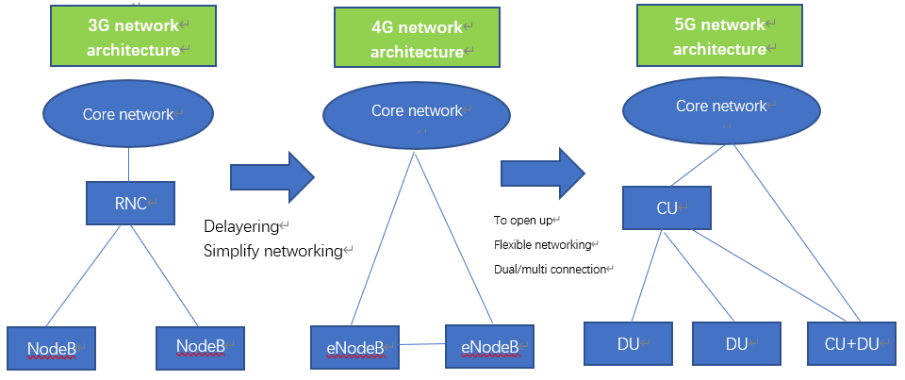
Figure 3 Evolution of wireless network architecture
Then there's the new design. Another new change of 5g wireless network is the introduction of flexible frame structure, using a unified air port design to meet the needs of different frequency bands (medium and low frequency and millimeter wave), different scenes (embB and ullc), and different duplex modes (TDD and FDD). Compared with the fixed frame structure of 4G, 5g frame structure can adopt a variety of parameters (uplink and downlink ratio, subcarrier bandwidth, system bandwidth, etc.) to adapt to different requirements flexibly. In terms of system bandwidth, the maximum bandwidth of 4G single carrier is 20MHz, while 5g introduces a larger system bandwidth. In the medium and low frequency systems below 6GHz, the maximum system bandwidth of 5g is 100MHz; in the millimeter wave band, the maximum system bandwidth of 5g is 400MHz. The increase of system bandwidth can effectively deal with the scenarios with large general bandwidth in 5g band, such as the 3.5G carrier frequency has 200MHz bandwidth, and the millimeter wave band often has gigahertz bandwidth, avoiding unnecessary excessive carrier aggregation. In terms of subcarrier bandwidth, 4G adopts fixed 15khzw subcarrier bandwidth. In 5g system, there are multiple subcarrier bandwidth options: in low and medium frequency systems below 6GHz, subcarrier bandwidth of 15KHz, 30kHz and 60KHZ can be selected for data transmission; in millimeter wave system, subcarrier bandwidth of 60KHZ and 120kHz can be selected for data transmission. In terms of frame structure, 4G adopts static frame structure and 5g adopts configurable static or semi-static frame structure. Furthermore, some subframes in 5g system can also be configured as flexible subframes. When the actual data arrives, it can be semi-static or dynamic configured as specific uplink or downlink subframes, which can effectively improve the spectral efficiency and reduce the delay. In terms of subframe length, in 5g system, due to the motivation of ultra-low delay transmission in medium and low frequency and effective utilization of time-domain fragmentation resources in millimeter wave band, 5g introduces shorter subframe design compared with LTE subframe length of 1 ms, and the shortest length can be reduced to 1 / 7 of LTE. Short frame is not only a necessary technical means to meet the 1-millisecond user interface delay demand of ITU, but also one of the essential technical means in the subsequent application of the Internet of vehicles and industrial Internet.
Then there's the new band. Multi band collaboration mainly includes three aspects: first, the joint networking of high, medium and low frequency; second, the interaction between 5g and 4G bands, namely SA and NSA; third, the use of multi band joint transmission to ensure uplink coverage. For the high, medium and low frequency joint networking, 5g ecosystem covers the carrier frequency range from hundreds of megahertz (MHz) to dozens of gigahertz, which have different characteristics and are suitable for different scenarios.
The last is the new antenna. Large scale antenna is an important feature of 5g system. Compared with the design of 2-8 antennas in 4G system, the devices with 16, 32, 64 channels in 5g become the mainstream in the medium frequency band. In the millimeter wave band, more antennas are the mainstream design. Considering the cost problem, the simulator such as phase shifter should be used to reduce the number of channels in order to control the cost. In 5g system design, there are three major optimizations for large-scale antennas. The first one is the initial access channel shaping. 5g system introduces the function of multi beam initial access, so that the initial access and data transmission can reach a relatively balanced coverage，as shown in figure 4。
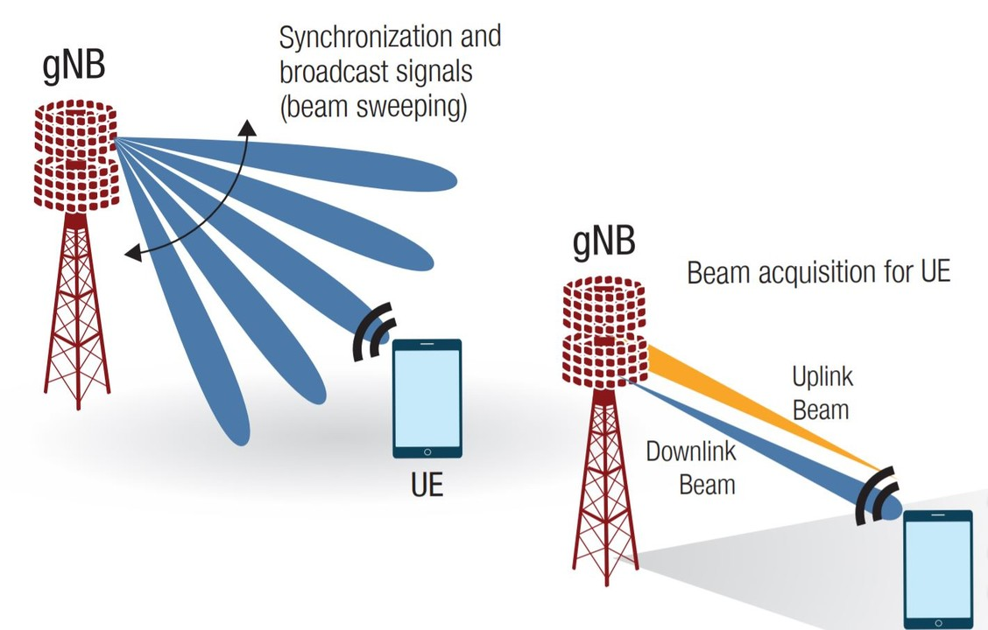
Figure 4 5G Beam
The second optimization is the hybrid operation mode of MIMO (multiple input and multiple output). The third optimization is the new design of the reference signal. CRS (common reference signal) is the most important reference signal in 4G system, which undertakes most of the system functions of reference signal, including fine synchronization, demodulation, feedback and measurement, and is the core design of 4G system. However, with the increase of the number of antennas and the introduction of heterogeneous network topology, the defects of CRS gradually appear, including the overhead of multiple antennas, neighbor cell interference, forward compatibility difficulties and so on. In view of this, at the beginning of the design, the reference signal of 5g system is intentionally removed from CRS, and the functions it carries are allocated to a number of other reference signals, including tracking reference signals, demodulation reference signals, channel information feedback reference signals, etc. Through the flexible combination and configuration of multiple independent reference signals, 5g system can achieve the optimal balance of overhead and performance.

5.2 Key technologies of core network
The main sign of 5g network architecture reform is the change of core network architecture. Compared with 4G, 5g core network has achieved revolutionary changes in architecture, platform, function, protocol and other fields. It supports 5g to realize network personalization, service, large capacity, high performance and low cost.
In order to realize the 5g business development in the next 10 years, the design of 5g network architecture takes the future oriented technology into account, and SBA (Service Architecture) emerges as the times require. It is a consensus in the industry that 5g's control surface is deployed based on cloud computing. Therefore, it is necessary to define the control surface of 5g core network for "cloud native". Based on the control surface of microservice reconfiguration, it is one of the driving forces of the design of service architecture to make the upper layer network function conform to the lower layer cloud computing infrastructure. The service architecture decouples the complex "single network element" into modular services, so as to realize independent upgrade and gray-scale release, thus greatly improving the network agility. This means that each individual network function is composed of several services. The customization and introduction of network functions are like building blocks, making small service modules form a systematic network architecture on demand. These service modules divide the business logic of mobile communication network according to three principles: self-contained, reusable and independent life cycle management.
A feature of 5g core network is the use of software architecture. Nfv and SDN promote the transformation of traditional communication network based on integrated hardware and software equipment. 5g core network will be realized based on the software architecture of general equipment, cloud infrastructure and virtualized (containerized) network elements. The network between 5g network elements will be opened and configured quickly based on Sdn. Nfv is the core technology to realize the decoupling of hardware and software in communication network. Through the general server and virtualization technology, nfv decouples the functions of hardware and network element completely. The function of network element exists in the form of software, which supports rapid creation, dynamic migration, flexible expansion and contraction, and greatly improves the flexibility of network. Through the combination of big data and artificial intelligence, the software network will further move towards intelligence. SDN realizes the separation of network equipment's transfer control and centralized construction of control surface, and becomes the brain of the next generation network. The transfer surface is scattered and the network traffic can be unloaded flexibly and quickly. SDN architecture provides the open ability of network connection, improves the flexibility of network connection and forwarding, and provides the technical basis for network connection optimization and resource dynamic adjustment. Nfv and SDN technology have completely subverted the traditional communication network. The physical architecture of 5g network will be based on standardized data center nodes. Its logical architecture is hardware and software decoupled. The software 5g network elements are hosted on a unified cloud infrastructure, and the infrastructure resources can be fully shared.
5g core network also realizes the separation of control surface and user surface. In the traditional mobile network, the network element has the ability of control surface and user surface at the same time. In recent years, with the rise of SDN technology, when designing 5g architecture, the design of architecture function has been re examined. As the core concept of SDN, the separation of control surface and user surface makes 5g network have certain advantages in two aspects: centralized deployment of control surface, centralized management and control, optimization and reorganization, and simplified, flexible deployment and efficient forwarding of user surface functions. The function separation of control surface and user surface makes the function of control surface and user surface recombine optimally. The more flat architecture brings shorter path, lower delay and higher efficiency to the network.
Network slicing is also an important feature of 5G core network. Network slicing is to provide end-to-end logical or physical "private network" based on unified infrastructure and unified network resources. This enables 4G to be converted from one network multi-purpose to 5g multi network dedicated. In the age of 5g, network slicing can virtualize a network into many different networks to realize multi network private use. Network slicing is a landmark technology that 5g is different from 4G. As the key to realize end-to-end slicing and the "end-to-end" management center, the core network combines different network functions on demand and flexibly constructs core network slicing.
5g core network also supports edge computing. The traditional 2G, 3G and 4G networks have single services, single service objects, relatively single architecture, centralized control and data gateway, which lead to the failure to meet the requirements of large traffic, ultra-low delay and flexible service deployment. One of the core capabilities supporting 5g for edge computing. This requires that the traffic can be shunted and routed near the user in the network.

6.The future
Finally, let's talk about the future of 5g, including its development trend and problems in development.
As mentioned above, 5g will bring significant benefits to countries, companies and all users, which makes 5g popular and widely supported all over the world. As of April 2020, 5g has reached the global number of commercial 5g users in the United Kingdom, the United States, Switzerland, China and South Korea. According to the forecast, as shown in the figure below, 5g users will explode in the next few years, and reach an amazing growth in 2025. According to the report provided by strategy analytics, a well-known global market research organization, in the first quarter of 2020, the global 5g smart phone shipments reached 24.1 million units, an increase of nearly 29% over the 19.7 million units shipped in 2019. All of these show that 5g has been used on a large scale all over the world, and the era of 5g is coming.
At present, it is the early stage of 5g development. The use and development of 5g are mainly led by several world powers and powerful countries, including the United States, South Korea, Japan, European countries and China. It can be predicted that 5g will be used in these countries first in the next few years. Therefore, to study and predict the development trend of 5g in the next few years, it is necessary to study the development trend of 5g in these countries China's national conditions are quite different, and 5g development also presents different trends in these countries.
First of all, the United States has paid great attention to the arrival of 5g era. The U.S. has always been market-oriented in economic development, and the government and the country do not participate in the R & D and application of technology, but when the age of 5g comes, the U.S. government has shown an unusual emphasis on 5g. The U.S. government believes that 5g is not only a new generation of communication technology, but also the key to win national interests and strategic disputes, especially with China's technology Competition. The United States held 5g summit in the White House at the end of 2018. At the summit, the United States raised 5g to a high level of national competitiveness and encouraged private enterprises to deploy 5g as soon as possible. The summit proposed a comprehensive strategy - "5g fast" plan to promote the U.S. advantages in 5g, which has three key components: forward-looking spectrum policy, modern infrastructure policy and market-based network regulation. In terms of spectrum policy, we are adding additional radio spectrum for 5g, aiming to push more spectrum of medium and low level and without permission to the commercial market. In terms of infrastructure, the FCC will update its infrastructure policy and simplify the approval process to accelerate 5g infrastructure construction. In the aspect of network supervision, we should abolish the rule of network neutrality. These policies aim to reduce the investment cost of enterprises in 5g and relax the regulation of telecommunication industry, so as to accelerate the development and innovation of 5g. The United States is expected to build a 5g network covering the whole country by 2022, and wants to grasp the latest technological development trend and occupy the leading position as before, so as to maintain the strong economic system and technology of the United States.
Then there is South Korea, which has always been a powerful country in communication technology, and the figure of South Korea is bound to be indispensable in the development of 5g. In recent years, South Korea's GDP keeps low growth and unemployment rate is high, which makes South Korea hope to use 5g to get rid of the long-term dependence on manufacturing, turn to service industry, and revive exports, so as to improve economic growth rate and maintain national competitiveness. As early as 2013, South Korea established 5g Forum promotion group 5g forum, and put forward 5g national strategy and long-term development plan. At the end of 2013, MSIP issued 5g mobile communication leading strategy and said it would invest 500 billion won in R &amp; D, standardization, infrastructure and other fields in the next seven years. At the beginning of 2014, the Korean government determined the "future development strategy of mobile communication industry" with 5g development master plan as the main content, decided to launch a comprehensive 5g commercial service in 2020, and invested 1.6 trillion won in 5g core technology research and development. In 2016, the Ministry of science, information and communication technology of South Korea launched the "future growth engine implementation plan" and "Pingchang Winter Olympics k-ict (Korea ICT) implementation plan" to make Pingchang Winter Olympics the first 5g Olympic Games in the world, and launched the "5g mobile communication industry development plan" and "k-ict spectrum plan", which established the goal of becoming the first 5g commercial country in the world 。 In 2017, the Ministry of science, information and communication technology of South Korea established the 5g Strategy Promotion Committee, which was chaired by the minister himself, and initiated the formulation of national 5g standards in South Korea. South Korea's 5g strategy has set clear goals for the development of South Korea's 5g from four aspects of service, technology, standard and Ecology: first, to achieve 5g commercial use in the service field and lead the 5g market in 2019; second, to become the best in the world in the technology field, the first in the world in the terminal field, and to obtain 15% market share in the equipment field; third, to establish safety standards in the standard field and introduce them The fourth is to create 1.6 million jobs by 2020 and another 1.5 million by 2026. South Korea has now gained a leading edge in 5g development, and will continue to vigorously develop 5g construction.
Japan also hopes 5g to solve a series of domestic problems that hinder social and economic development, trying to seize the opportunity of 5g development, build a super intelligent society, stimulate economic vitality, and reshape national innovation. In September 2013, relying on Japan Radio Industry and Enterprise Association, Japan first established 5g Ad Hoc Working Group "2020 &amp; Beyond ad hoc" (20b ah), which actively promoted 5g research and standardization in Japan. At the beginning of 2014, NTT DoCoMo, Japan's largest operator, jointly carried out 5g experiments with a number of enterprises. In July 2014, NTT DoCoMo took the lead in releasing 5g white paper "5g wireless access: needs, concepts and technologies", which elaborated key technologies related to 5g. In October of the same year, Japan Radio Industry and Enterprise Association also released its 5g white paper "mobile communication system in 2020 and beyond", which describes the possible socio-economic and environmental impacts of 5g, including market and user trends, traffic trends, cost and spectrum impacts, and summarizes the 5g framework and capabilities. Driven by the industry, in 2014, the Ministry of the interior and communications of Japan established the radio policy vision group, which also became the actual leader of Japan's 5g national strategic planning. In September, the Ministry of the interior and communications of Japan established 5GMF (5g mobile promotion forum), which took over the functions and research results of Japan Radio Industry and Enterprise Association and became the actual promotion organization of 5g development in Japan. 5GMF further determined the direction of 5g R &amp; D and standardization, and set up four groups to promote international cooperation, R &amp; D and standardization, application and 5g network architecture. Japan has accumulated a lot of technology in 3G and 4G era, and has led the development of communication technology. In 5g competition, Japan is a huge force that can not be ignored.
In the 2G era, Europe once led the development of global mobile communication, and thus successfully built a large number of well-known communication and electronic information technology enterprises such as Ericsson, Nokia, Siemens, Alcatel, etc. However, Europe's deployment of 3G and 4G is relatively weak, lagging behind other countries or regions as a whole. Facing the coming 5g era, the EU has formulated a series of strategic plans to support the development of 5g, hoping to copy the experience of 2G era, catch up in 5g era and return to the first camp. Under the seventh framework plan of EU research and development plan, the EU launched the "5g now" research project as early as September 2012, which was jointly undertaken by six research institutions from Germany, France, Poland and Hungary, and mainly focused on 5g physical layer technology. In November of the same year, the EU invested 27 million euros to officially launch the 5g R&D project "Metis", so it became the pioneer of 5g R &amp; D in the world, which was jointly undertaken by more than 30 members led by Ericsson, aiming to cope with the social challenges of mobile network in 2020 and the future by building 5g cornerstone. In January 2014, the EU replaced the original eighth framework plan with horizon 2020, and set up 5g PPP (5g public private partnership) project. 5g is planned to be developed by 2020 and officially put into commercial use by 2022. The total budget of the plan is 1.4 billion euros, and the government and private enterprises invest 700 million euros each. The members of the plan include communication equipment manufacturers, network operators, telecommunication operators and research institutes. In March 2015, 5g PPP released EU 5g vision, aiming to ensure Europe's voice in the next generation of global standards for mobile technology. The 5g vision describes in detail the progress and plans of EU 5g in terms of driving factors, disruptive capabilities, system design principles, core key technologies, wireless spectrum resources, promotion schedule, etc. In September 2016, the European Commission launched the "5g action plan", which aims to promote 5g in a major city of each member state by 2020, cover major urban areas and transport lines by 2025, and develop a clear road map for public and private investment in 5g infrastructure in the EU. In the same year, the European Commission proposed the development of the EU electronic communication code to replace the updated EU Telecommunications Regulations in 2009. The EU electronic communication specification was passed in June 2018. The EU has made provisions on 5g spectrum distribution in the new law case to ensure that 5g spectrum will be in place before 2020, and the validity period of spectrum is not less than 20 years, laying a legal foundation for ensuring 5g development. The EU electronic communication standard came into force in early 2019, and Member States will have two years to translate it into domestic laws, which will vigorously promote the development of 5g and the whole high-speed broadband network.
Finally, China, the black horse of 5g era. In the process of 5g development, China has accelerated the exploration of 5g R &amp; D and application in standard formulation, product R&D, network design, industrial chain construction, experimental verification and application promotion. China has developed from a follower in the 3G era to a parallel runner in the 4G era, actively seeking breakthroughs in the 5g era and leading global development. On June 6, 2019, the Ministry of industry and information technology issued 5g commercial license to China Telecom, China Mobile, China Unicom, and China Radio and television, making China the fifth official 5g commercial country after South Korea, the United States, Switzerland and the United Kingdom. 5g is of great significance to China, which is far more than other countries. This is the first time that China has kept pace with and even led the traditional technological powers in the competition of science and technology. This is not only the result of China's vigorous development of science and technology and economy in recent decades, but also the proof of China's strong growth. The Chinese government has invested unprecedented enthusiasm in 5g. By the end of March 2020, there have been 188000 5g base stations in China, with more than 50 million package users. 5g has been promoted at a faster pace. On April 30, China Mobile opened 5g base stations in the 6500 meter forward camp of Everest, with 5g signals covering the summit of Everest, which is the highest 5g base station in the world China's 5g signal "flutters" at the world's highest peak. At present, China is the country with the fastest development of 5g, and is leading the development trend of 5g. 5g era is a historic opportunity for China. China has the most mobile network user groups. The government has invested a huge amount of money to speed up the coverage of 5g facilities. China will enhance the voice of scientific and technological competition and promote the transformation and upgrading of national industries in 5g era.
In a word, 5g has been paid attention to globally. All countries are trying their best to promote 5g development, and they want to solve social problems and promote economic and technological development with the help of 5g. However, the development trend of 5g is not smooth, and there are still many problems to be solved. First of all, 5g's security, second, 5g's spectrum resource is also an important factor hindering the development of 5g, in addition, 5g's development is hindered by political factors. Finally, in 2020, when 5g is developing rapidly, a new crown epidemic has disrupted all the rhythms, which has greatly hindered the development of 5g.

