  Problem Solving and Decision making | The University of Wales Trinity and Saint David  Problem Solving and Decision Making  BMSW 4004  Certificate of Higher Education in Skills for the Workplace  Neli Miteva (2113297)  Chijioke Uba

Contents
1. Introduction 1
2. Understanding the nature and impact of the problem of staff absenteeism 2
a. Nature of the problem of staff absenteeism 2
b. Scope of the problem of staff absenteeism 3
c. Impact of the problem of staff absenteeism 3
3. A PESTLE analysis of the macro-environmental factors contributing to the complex problem. 5
a. Political factor 5
b. Social 6
3.3 Environment factor 6
4. Fishbone diagram 7
5. Possible solutions 8
a. One-on-one 8
b. Support staff members and their wellbeing 8
c. Encourage good attendance 9
d. Flexible schedule 9
e. Penalties 9
6. Plan for implementing the solution, Monitoring and Evaluation 10
6.1 Action plan 10
6.2 Monitoring 11
6.3 Evaluation 11
7. Conclusion 12
8. Reference list: 13

Introduction

Every person or organization occasionally faces different problems, no matter if they are connected to their personal or professional life. According to the Oxford dictionary, a problem is a matter or situation regarded as unwelcome or harmful and needs to be dealt with and overcome. And problem-solving is the process of finding solutions to difficult or complex issues (Oxford dictionary). To resolve a problem there must be a decision making of possible solutions, the action or process of making important decisions (Oxford dictionary). As part of life, every person needs to make many different decisions every day. Decisions like: What to wear? To go or not go to work. To meet friends and family or spend the day quiet? What to eat? According to Gelatt (1962), the decision-making process required evaluating potential results, assessing the value of those outcomes, and selecting an effective approach. It is necessary to understand how decisions are made and how our decision-making processes are influenced in order to think critically and solve problems creatively.
Like many other medium-sized district general hospital trusts, Mid Cheshire Hospitals NHS Foundation Trust (MCHT), has experienced a staff absenteeism problem. Despite being comfortably under the objective of 4.51 percent previously established by clinical commissioning groups (CCGs) and NHS Northwest, the Trust's rolling average significantly grew from 2007 to 2012.

Understanding the nature and impact of the problem of staff absenteeism

Nature of the problem of staff absenteeism

Absenteeism is described as a "habitual failure to appear, especially for work or other regular responsibility" by Dictionary.com. Is also defined as a habitual practice of missing a responsibility or commitment. Absenteeism has traditionally been considered a sign of poor personal performance and also a violation of an implied agreement among workers and employers; it became presented as a financial or quasi-economic problem. It is observed from the perspective of human resources management that work absences are a significant issue.
As an organization's staff practices gain prominence, each employee's function and the consequences of their absence become increasingly important. According to research, more than a trillion dollars are wasted yearly leads to significant shortfalls caused by chronic absenteeism related to health, so a greater emphasis on preventive health might lower those expenses.
There are two types of absenteeism; 1. Planned absenteeism such as annual leave, holidays, long-term absence, maternity, any medical treatment that has been planned, etc. 2. Unplanned absenteeism such as short-term absence, emergency absence, unpredicted absence, etc.
The staff absenteeism problem Mid Cheshire Hospital is facing is a complex one and is a long-term problem. Despite being comfortably under the prior target of 4.51 percent established by clinical commissioning groups (CCGs) and NHS Northwest, the Trust's rolling average significantly grew from 2007 to 2012. According to NHS Absence rates in October 2021, England's overall sickness absence rate was 5.7%. This is higher than September 2021 (5.4%) and higher than October 2020 (4.5%) which shows that the problem of absenteeism is significantly rising.

Scope of the problem of staff absenteeism

Staff absenteeism problem is faced in Mid Cheshire Hospital, every other hospital in the entire United Kingdom, and in all economic industries. Absenteeism has a detrimental impact on profits for small and medium-sized firms in the United Kingdom. Across businesses and industries in Britain, absenteeism has been defined as the biggest cause of low efficiency of work, and that short-term absences and anxiety are primarily caused by minor illnesses, and those absences of over a month are usually caused by mental health issues (CIPD Survey, 2005). According to the Office for National Statistics – Labour Force Survey, employees in the UK take an average of 4.4 sick days a year. Westfield Health claims that absenteeism cost the UK economy £14 billion last year. According to reports, this expenditure would rise to £26 billion in 2030.

Impact of the problem of staff absenteeism

Absenteeism has a negative impact on the whole company as well as on their employees, colleagues, and also their families. Across all industries, absenteeism is deemed problematic since employee absences negatively affect labor output. Consequently, there is a shortage of employees, which impacts output quantitatively and qualitatively. Furthermore, absenteeism has financial implications, including expenses involved with the individual such as benefits, and salary; expenses involved with managing the issues triggered by absences; costs of employing people with extra hours, employing replacements; and costs associated with reducing the volume or work quality. Employees who choose to come to work while feeling unwell have a propensity to endanger their colleagues who are otherwise healthy. A sick staff causes the organization money in the form of missed earnings because once exposed to hazardous pollutants, newly infected employees will choose to treat their condition through absenteeism or presenteeism. Steers and Rhodes (1978) expressed questions about the effects of working while sick, implying that although some absenteeism can be beneficial to a company, relying too heavily on absence numbers as a part of performance management can be counter-productive, with bad effects for both employers and staff. Absence from work can have a direct (sick pay, overtime so the absence can be covered, benefits that have to be paid, etc) or indirect (administration cost, time managers have to spend on paperwork, low productivity, etc) impact on the company, but it is not only organizations that have to bear the costs of absences through health-related productivity losses incurred by absences, employee income, loss of skills, recruitment, retraining, but also the public who are charged with the costs of medical care (estimated at £5-11 billion) and the government, which is responsible for government benefits (£29 billion) and lost taxes on those off sick (£28-$36 billion). An increase in temporary and agency staffing caused a drop in quality of service in part due to high absenteeism rates. It is estimated that the Trust loses over £1 million every year per percentage point of absenteeism which has a massive impact on the hospital`s budget. Unruh (2007) investigated the direct association between absenteeism and quality of care, finding that absence combined with a strong workload appears to result in a considerable increase in unfavourable occurrences. According to Teng (2010) when staff burnout and workload are connected patients’ safety suffers significantly. It is proven that when staff is overworked or burnout their performance has a significant impact on patients’ satisfaction.
To try to solve the problem of staff absenteeism PESTEL framework has been used to identify the main causes.

A PESTLE analysis of the macro-environmental factors contributing to the complex problem.

PESTEL framework is first traced back to Francis Aguilar in 1967. It is an acronym and stands for Political, Economic, Social, Technological, Environment, Legal. PESTEL framework analysis only the external and macro-environmental factors causing the problem in the organization which can be very difficult or even impossible for organizations to control. Using PESTEL analysis three main factors have been identified in this problem of staff absenteeism in MCHT: Political, Social, and Environment.

Political factor

The actions and legislation made by governments that have an influence on your business are examples of political factors. This can include, change in taxes, government policy, corruption, political stability, and instability, labor law, foreign trade policy, etc. In this case, the focus is on Government policy due to Covid 19. A worldwide outbreak of COVID-19, which started in China in 2019, has greatly impacted the lives, health, and livelihood of people around the globe. All countries have put in place many different social restrictions. On 23 March 2020 in the United Kingdom took place the first restrictions such as the national lookdown, social distancing, face covering, etc. All non-essential businesses and shops were closed, people had to stay home and were advised to go out only for essentials shopping, or to visit a doctor. Only vital personnel, such as NHS staff, were permitted to go to work. All schools, nurseries, and universities were closed, only the children of the key workers were allowed to go, and the rest of the parents had to combine working from home with online learning. Many people lost their jobs, some of their businesses, and for a very short period everyone’s life was upside down. All changes, isolating whole families, remotely working, etc. have brought symptoms like stress from working distantly, anxiety, and worries due to Covid 19 which led to low productivity and higher absence in the workplace. NHS England published figures showing a 5% rise in absences from work for health-related reasons in the past week. According to NHS England's latest "winter sitreps" statistics, the number of staff days lost to Covid throughout the NHS in England reached 124,855 last week, a 38 percent increase over the previous week's total of 90,277. The overall amount of personnel absenteeism for whichever medical purpose – such as a cold, flu, or mental health condition (the maximum of 29.6 percent in 2015-2016) – also climbed, but less dramatically, from 416,995 to 457,135, a 10% increase. Figures indicate that the majority of NHS employees absent due to Covid is growing dramatically, raising further concerns about hospitals' capacity to react to any spike driven by Omicron of patients in need of treatment.

Social

The social factor comprises consumers’ knowledge, public views, and personal cloud-based service usage patterns. Illness is a major disruptor of the individual's life over the course of his or her life. In the latest days, the involvement of psychological and social variables in the emergence of a range of health problems has been explored. In many sectors of employment, job security is low during a pandemic, and thus workplace health impacts employee well-being. Vaccine reluctance is a substantial health hazard, according to scientific research. Health awareness has increased in the past years especially due to Covid. Health promotion and prevention at the workplace are examined in studies that have since been made available, particularly from the USA. Costs associated with illness and absenteeism are where companies save the most money.
A significant study has been conducted on the relationship between absenteeism from work and employment attitudes including job satisfaction and performance. According to Hanisch and Hulin (1991), absence, as well as other burnout (such as tardiness, turnovers), indicate "invisible" attitudes like work discontent, poor work engagement, or a desire to leave, they also suggested that employment-related attitudes and intentions have been identified as drivers of absent behaviour. Accordingly, low company responsibility, missing job satisfaction, and desire to leave your job imply a higher rate of absenteeism. Absences from work taken willingly rather than unwillingly could lead to dissatisfaction with their jobs and a lack of commitment to their employers. It is, therefore, reasonable to predict a negative correlation between work attitudes and voluntary absences than between compulsory absences.

3.3 Environment factor

By analyzing the environment, a company can develop a strategic plan, detect possibilities and dangers, and create collaborations with other businesses. Terrible weather such as snow, and storms can cause transport difficulties that will cause many employees to arrive late at work or to be absent. Absent from work due to bad weather has a negative impact on employees as well as on employers. In February 2010 estimated 800 or 4.8 percent of employees did not attend work due to bad weather (US Department of Labor).
To understand the problem of staff absenteeism even better Fishbone diagram has been applied.

Fishbone diagram

The fishbone diagram is also known as the "Ishikawa Diagram" after Kaoru Ishikawa 1976 a Japanese quality control statistician who conceived and implemented it. Is a method for assessing the efficacy of business operations. Because of its structural aspect and appearance, it is referred to as a fishbone. An important part of problem-solving is to identify many possible causes for any effect using a graphical tool like the FISHBONE Diagram. It is also known as a cause-and-effect diagram because it is used to investigate all the possible or actual causes that lead to a particular result.
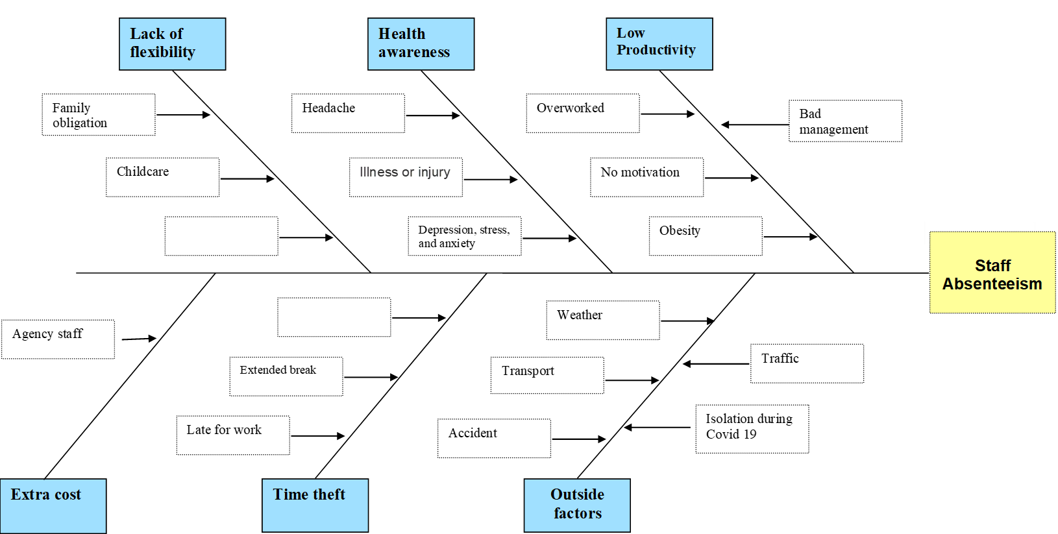

"Family difficulties" have become the most commonly mentioned cause for unexpected absenteeism among US employees in 1998. According to Rhodes and Steers (1976), family duties are a barrier to attending to work. Women were shown to have greater absence rates than males in general, most of them due to children-related reasons especially those with kids up to five years old. Studies have also shown that younger employees are more likely to be absent and those who have just started a new job compared to the ones who have more and longer experience in the company. Approximately 4.5 hours are stolen from employers weekly by the average employee, according to another study, they are also called “time theft”. People with migraines are more likely to take short-term absences since migraines usually last between 4 and 72 hours.
In the United Kingdom often practiced is in the case of staff absence to hire a temporary or “agency” staff which cost the company more financially. Despite doing the same function, temporary personnel, such as health care professionals provided by agencies, cost on average 20% more than those provided by the NHS's own employees.
According to the Mid Cheshire Hospital report (2018/2019)
“During the year, the Trust employed an average of 4,165 full-time equivalent staff, an increase of 168 on the previous year. The average staff cost increased from £40,625 to £42,098, an increase of 3.6%. Average wage awards were at 3.4% however the average wage has seen a larger increase due to the increased use of higher-cost agency staff.” pp. 27

Possible solutions

One-on-one

These meetings are between employees and their supervisors to discuss their work, professional growth, and development. Engaging one-on-one with team members is essential to teams' retention and engagement.

Support staff members and their wellbeing

Working as a health professional can be very stressful and overwhelming but by creating programs to support their own staff, their mental health, and wellbeing, MCHT can help not just their employees, but also significantly reduce staff absenteeism.

Encourage good attendance

Acknowledging good attendance by offering bonuses or simply by encouraging the staff for being on time can have a positive impact on absenteeism in the hospital.

Flexible schedule

Offering a flexible schedule such as adaptable days and hours, working from home, and opportunities to share vacancies or simply letting employees arrive late or finish early work could reduce absenteeism significantly.

Penalties

Penalties such as reducing a salary amount and cutting down benefits, and bonuses can have a positive effect. They may encourage the employees to attend more to work. Although it has to approach very carefully, especially with employees who have a sensible reason to be absent as penalties can push employees to find another job.
To help find the most appropriate solution to reduce staff absenteeism in MCHT all solutions have been evaluated with the GRIT analysis.

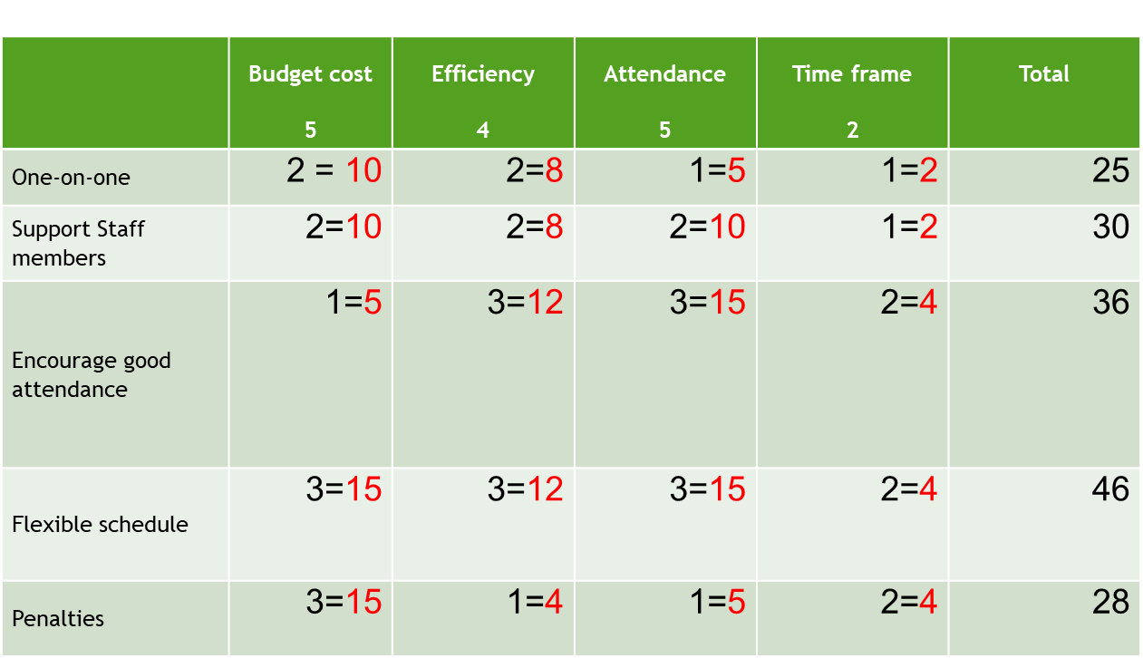
From the GRIT score table Flexible schedule has the higher score which proposes this is the most appropriate solution for the problem of staff absenteeism in MCHT. The next step is to implement an action plan.

Plan for implementing the solution, Monitoring and Evaluation

6.1 Action plan
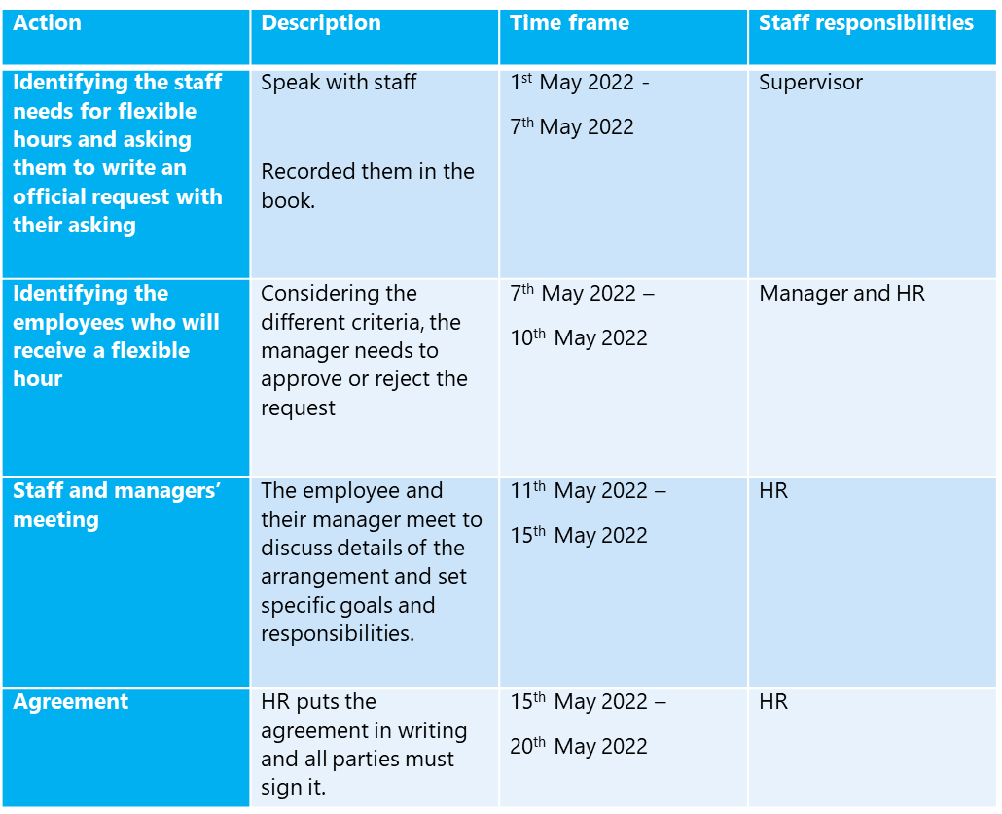

6.2 Monitoring
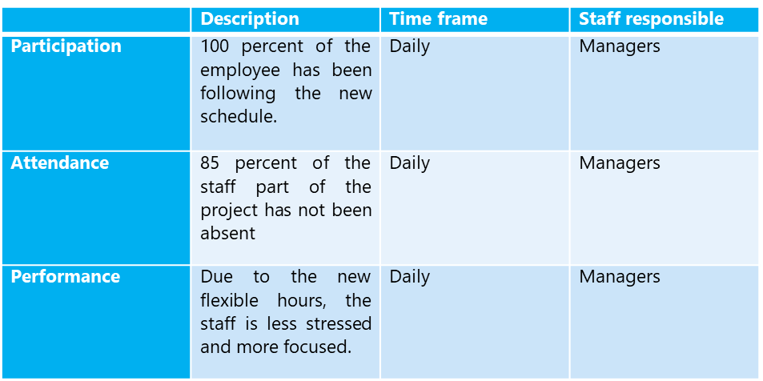

6.3 Evaluation

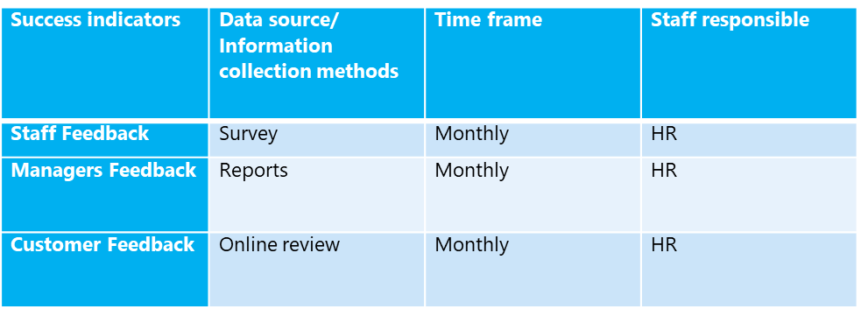

Conclusion

Trying to solve the problem MHCT hospital is facing we used the PESTEL framework and Fishbone to identify the main causes. We found three factors from the PESTEL analysis: Political, Social, and Environment. But to understand the problem better we used the Fishbone diagram where we discover the problems that are inside the hospital.
After identifying the main causes, we address a few possible solutions but to choose the best one we used the GRID table. From the table, we can see that a Flexible schedule with 46 points is the dominant solution.
Evaluation of the action plan has shown that using a flexible schedule has reduced staff absenteeism in Mid Cheshire Hospital significantly.

Reference list:

Baker‐McClearn, D., Greasley, K., Dale, J. and Griffith, F., 2010. Absence management and presenteeism: The pressures on employees to attend work and the impact of attendance on performance. Human Resource Management Journal, 20(3), pp.311-328.
Bose, T.K., 2012. Application of fishbone analysis for evaluating supply chain and business process-a case study on the St James Hospital. International Journal of Managing Value and Supply Chains (IJMVSC), 3(2), pp.17-24.
Burton WN, Conti DJ, Chen CY, Schultz AB, Edington DW (1999). ‘The role of health risk factors and disease on worker productivity’. Journal of occupational and environmental medicine/American College of Occupational and Environmental Medicine. 1999 Oct;41(10):863–877
CIPD Survey (2005). Absence Management, http://www.cipd.co.uk, accessed 18 November 2009. Dew, K., Keefe, V. and Small, K. (2005). ‘ “Choosing” to work when sick: workplace presenteeism’. Social Science and Medicine, 60: 2273–2282.
Der Feltz-Cornelis, V., Maria, C., Varley, D., Allgar, V.L. and de Beurs, E., 2020. Workplace stress, presenteeism, absenteeism, and resilience amongst university staff and students in the COVID-19 lockdown. Frontiers in Psychiatry, p.1284.
Duclay, E., Hardouin, J.B., Sébille, V., Anthoine, E. and Moret, L., 2015. Exploring the impact of staff absenteeism on patient satisfaction using routine databases in a university hospital. Journal of nursing management, 23(7), pp.833-841.
Erickson, R.J., Nichols, L. and Ritter, C., 2000. Family influences on absenteeism: Testing an expanded process model. Journal of Vocational Behavior, 57(2), pp.246-272.
European Union Programme (2020), Occupational health and safety risks in the healthcare sector [online] Available from: https://www.ilo.org/dyn/travail/docs/1965/osh.pdf (Accessed 07 April 2022)
eWIN (2014), Case Study: Reducing Long-term Absenteeism [online] Available from: eWIN Case Study - Reducing Long-term Absenteeism.pdf (Accessed 05 April 2022)
Gelatt, H. B. (1962). ‘Decision making: A conceptual frame of reference for counseling’. Journal of Counseling Psychology, 9, 240-245.
Hanisch, K. A., & Hulin, C. L. (1991). General attitudes and organizational withdrawal: An evaluation of causal model. Journal of Vocational Behavior, 39, 110–128.
Issa, T. and Issa, T., 2014. Sustainable business strategies and PESTEL framework. GSTF Journal on Computing (JoC), 1(1), pp. 73-80
Li, S.S. and Lee, L.C., 2011. Using fishbone analysis to improve the quality of proposals for science and technology programs. Research Evaluation, 20(4), pp.275-282.
Marques, D.D.O., Pereira, M.S., Souza, A.C.S., Vila, V.D.S.C., Almeida, C.C.O.D.F. and Oliveira, E.C.D., 2015. Absenteeism–illness of the nursing staff of a university hospital. Revista Brasileira de Enfermagem, 68, pp.876-882.
NHS (2019), Mid Cheshire Hospitals NHS Foundation Trust Annual Report and Accounts 2018 to 2019 [Online] Available from: https://www.mcht.nhs.uk/application/files/2016/4734/8884/Annual_Report_and_Accounts_-_201819_.pdf (Accessed 08 April 2022)
NHS (2022) NHS Sickness Absence Rates, November 2021, Provisional Statistics [online] Available from: NHS Sickness Absence Rates, November 2021, Provisional Statistics - NHS Digital (Accessed 05 April 2022)
NHS England (2022) Urgent and emergency care daily situation reports 2021-22. [Online] Available from: https://www.england.nhs.uk/statistics/statistical-work-areas/uec-sitrep/urgent-and-emergency-care-daily-situation-reports-2021-22. (Accessed 07 April 2022)
ONS (2019), Sickness absence in the UK labour market: 2018 [online] Available from: Sickness absence in the UK labour market - Office for National Statistics (ons.gov.uk) (Accessed 05 April 2022)
Pennebaker, J.W., Hendler, C.S., Durrett, M.E. and Richards, P., 1981. Social factors influencing absenteeism due to illness in nursery school children. Child Development, pp.692-700.
Sagie, A., 1998. Employee absenteeism, organizational commitment, and job satisfaction: Another look. Journal of vocational behavior, 52(2), pp.156-171.
Saravi, B.M., Kabirzadeh, A., Rezazadeh, E., Khariki, M.F., Asgari, Z., Farahabadi, E.B., Motamed, N. and Siamian, H., (2013). Prevalence and causes of medical absenteeism among staff (case study at mazandaran university of medical sciences: 2009-2010)’. Materia Socio-médica, 25(4), p.233.
Shacham, M., Greenblatt-Kimron, L., Hamama-Raz, Y., Martin, L.R., Peleg, O., Ben-Ezra, M. and Mijiritsky, E., 2021. Increased COVID-19 vaccination hesitancy and health awareness amid COVID-19 vaccinations programs in Israel. International journal of environmental research and public health, 18(7), p.3804.
Steers, R. and Rhodes, S. (1978). ‘Major influences on employee attendance: a process model’. Journal of Applied Psychology, 63: 391–407.
Teng C.I., Shyu Y.I., Chiou W.K., Fan H.C. & Lam S.M. (2010) Interactive effects of nurse-experienced time pressure and burnout on patient safety: a cross-sectional survey. International Journal of Nursing Studies 47 (11), 1442–1450.
Unruh L., Joseph L. & Strickland M. (2007) Nurse absenteeism and workload: negative effect on restraint use, incident reports and mortality. Journal of Advanced Nursing 60 (6), 673–681.
West, M. and Dawson, J., 2012. Employee engagement and NHS performance. London: King's Fund.
Williams, SW (2001), ‘Making Better Business Decisions: Understanding and Improving Critical Thinking and Problem Solving Skills’, SAGE Publications, Thousand Oaks. Available from: ProQuest Ebook Central. [7 March 2022]. Created from trinity on 2022-03-07 10:08:51
Yüksel, I., 2012. Developing a multi-criteria decision making model for PESTEL analysis. International Journal of Business and Management, 7(24), p.52.

