

Programme: | BSc Health and Social Care
Module: | Changemakers: Building your Personal Brand for Sustainable Employment
Module code: | BMHP5015
Lecturer:  Student:  ID: | Musab Shah  2411894 | Internal Verifier: | Dr Eleni Koutsogeorgou-Andreou
Assignment Title: | Component 1: Online Portfolio of Set Exercises | Word count: | 2022

1. Introduction
This online portfolio presents the completed BMHP5015 set exercises and shows my development of employability skills for health and social care. It includes personal branding, networking, communication, equality and diversity, wellbeing, project planning, change management and reflection. The portfolio demonstrates how these activities have helped me identify strengths, development needs and practical career actions.

2. Completed Portfolio Tasks

Task 1: Personal Brand
My personal brand is the professional image that I want employers, colleagues and service users to have of me; calm, respectful, reliable and willing to learn. This brand is not just a statement in health and social care, it is demonstrated by being on time, keeping things confidential, communicating with compassion and behaving safely. Personal branding is useful as it facilitates communication of a value proposition (Gorbatov, et al. 2018). Another reason for the importance of professional identity is that care workers need to understand the values and responsibilities of the care worker role (Fitzgerald, 2020).
My weaknesses now are listening, patience, cultural awareness and accepting feedback. These attributes enable me to pursue my goal of working in adult social care/community support. My brand, however, is still lacking in evidence. I must demonstrate practical experience, team working skills, reflective learning and confidence in interviews. I will ensure that I have a CPD folder, keep examples of volunteering or placement to improve, update my CV monthly and develop a professional LinkedIn profile. Also, I will be practicing answers to the questions with the STAR method to ensure that my strengths are backed up by evidence not just general claims. Feedback, certificates and short reflective notes will be collected as evidence of progress.
Being more employable will be a benefit as I will be able to communicate my values, skills and career direction to employers when developing my personal brand. To be seen as a safe, inclusive and reflective future care professional.

Task 2: Network Map and Rationale
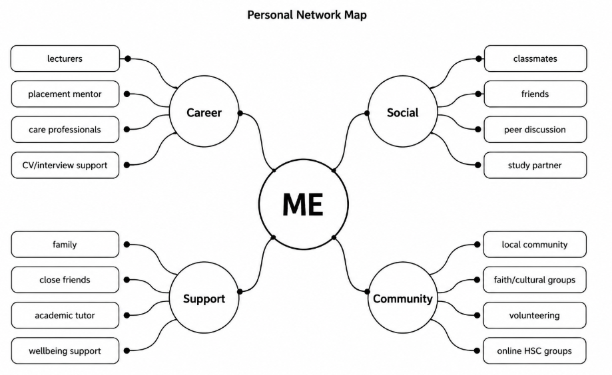
My network is hybrid – it includes close personal support and study-based relationships, community connections and some early career contacts. Social capital is the strongest aspect. I have family, close friends and trusted classmates who support, encourage, and assist me emotionally, practically, and otherwise. This is important as social capital can provide access to information and support that individuals may not be able to obtain on their own (Coleman, 1988). If I only use people who have similar experiences, however, then I may be restricting myself in bonding capital.
Bridging social capital is being built with classmates, peer discussion groups, and community groups. These connections open me up to other backgrounds and perspectives which are important in health and social care as inclusive practice involves understanding people outside of my social circle. Bridging capital is a means of bridging between larger groups and can increase opportunities for people, according to Putnam (2000). The area I'm not as strong at is social capital. I don't know enough managers, employers, placement supervisors or professional bodies to provide me with career guidance or work-related opportunities.
To improve I will attend careers sessions, speak to placement mentors, speak to lecturers about employability routes, join online groups relating to health and social care and look for volunteering opportunities. I will also keep in touch with you professionally after meetings. This will enable me to have a more balanced network and shift from informal to more employability-related networks. Skills are not always enough; often, it requires access to trusted information as well as skills in order to capitalize on future opportunities.

Task 3: Blog
Digital Inclusion in Health and Social Care: Why Access Still Matters
Target audience: service users and family carers.
Digital health services can help to make care faster and simpler. Use of online appointments, patient apps, electronic prescriptions and text reminders can help to reduce travel and manage appointments. But the success of digital healthcare is only partial if people don't have the skills, confidence and resources to utilize it. Digital inclusion is the situation in which nobody is at a disadvantage due to a lack of Internet access, devices, confidence, language support or information.
This is important as health and social care already provides support for people who may have barriers, such as older people, disabled people, people on low incomes and those whose first language is not English. Without support, services transitioning online could make it more difficult for those who need them most to access them. NHS England (2023a) associate inclusion with fairer experience and better outcomes and Skills for Care (2025) indicates that adult social care is still under staffing pressure, highlighting the need for effective communication and accessible systems.
For instance, someone might not be able to read a text message, or they may not have enough money for mobile data, or they are afraid of using an unfamiliar app, for an online appointment. This can make it worse, even if the service itself is efficient, as it can increase inequality. Thus, digital inclusion must be considered as a care quality issue rather than just a technology issue.
Digital inclusion is not the same as ensuring that all are forced to use technology. It involves giving options and assistance. Support can be provided by having a telephone and face-to-face option, giving clear instructions, using simple language, providing translated information and assisting carers to help service users safely. Staff should also be trained to be able to patiently talk about digital tools and to identify when someone is being excluded.
Families and carers can help with digital inclusion by verifying that service users are aware of what appointment messages mean, assisting them to navigate to trusted NHS websites and by encouraging them to seek alternative means of communication if necessary. It is also important for care providers to seek the service users' preferred method of communication.
It's a straightforward message: digital care shouldn't be a barrier to care; it should make it easier. Technology must be used in a way that is respectful to dignity, choice and equality in a person-cantered service. Digital tools can enhance, not detract from inclusive care when used in conjunction with human assistance.

Task 4: Equality and Diversity Quiz
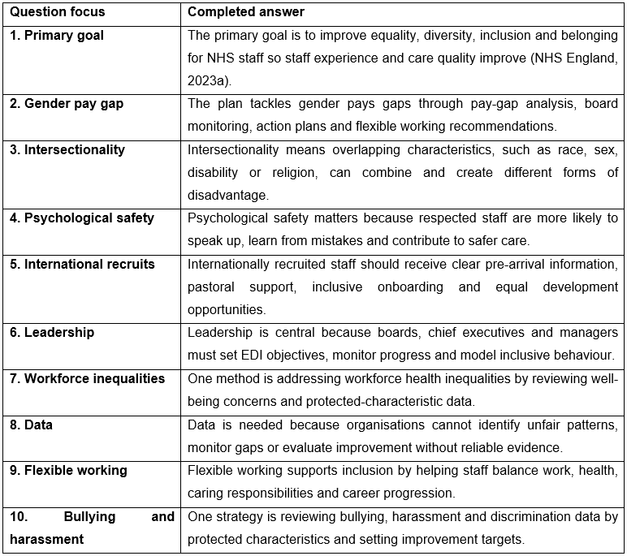

Task 5: A Letter to Yourself
Dear younger me,
I am contacting you when you are feeling bad and are working to keep your stress level down. You may think that being strong means that you hold things in, but that is not the case. Strength also involves identifying feelings, seeking assistance and taking baby steps before things get too stressful.
It's important to be aware that emotional intelligence would have enabled you to have known your emotions rather than blamed yourself. Goleman (1995) explains emotional intelligence as recognising and managing emotions in ourselves and others. Knowing this earlier would have allowed you to take a moment before you responded, to be able to talk about your concerns clearly and to have been aware when stress was impacting your confidence. You did not have to be weak, you were learning how to deal with challenging emotions.
Resilience would have been helpful, but not the kind that is commonly thought of. Being resilient does not mean that one should ignore or suppress issues or pretend things are okay. It involves recovery, learning and utilizing support. Resilience is a key consideration in health and social care as workers could find themselves in emotional scenarios and still manage to communicate in a calm manner and maintain their own wellbeing. The module assisted me in developing an understanding of the habits required for resilience – sleep, routine, reflection, boundaries, trusted support.
I want you to treat yourself better. Discuss feelings of being overwhelmed with someone. Don't be afraid to take breaks. Make sure to record what went well, not just what went wrong. Reflecting on the mistakes honestly can make them learn. These experiences will help you to be more empathetic towards others one day.
The hard time will not be a part of you. It can be a professional asset as it will instil in your patience, compassion and wellbeing.
From your future self.

Task 6: SMART Goal and Gantt Chart
SMART goal: By 30th September 2026, I will have completed my Level 5 portfolio, updated my CV, attended one Careers/employability session, applied for 2 volunteering/placement opportunities and prepared 3 STAR interview examples to help to improve my employability for an adult social care support role.
The Gantt chart below breaks down this goal into activities with time. The first two are Coursework and Skills Review as they serve as evidence for applications. CV Development is parallel to Networking, Volunteering and Search/Interview preparation, to ensure that I am building confidence and evidence of employability before the deadline.
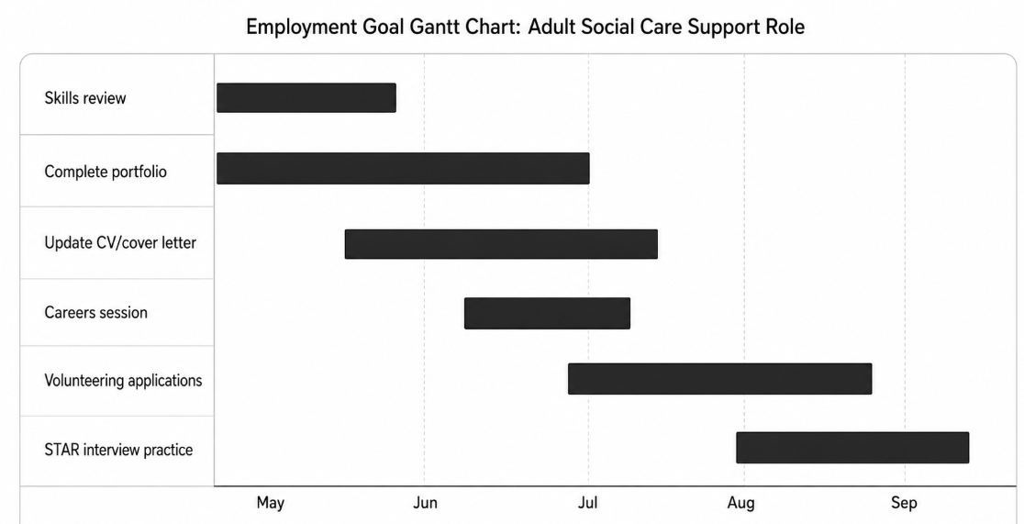

Task 7: Care Home Change Management Plan
As a care home manager, I would implement a daily handover and care task recording system using digital means. The change is required as paper notes can be delayed, unclear or hard to share between shifts. A digital system might enhance the communication, minimise information loss and aid in safer person-centred care.
I would employ Lewin's change model. I would first unfreeze by giving staff an awareness of risks of bad handover and how improved recording helps to protect residents. I would then test it out in one unit for four weeks and then roll it out in other units. Staff would be given short training, and printed guidance and support during the change stage from two digital champions. During the refreezing part of the process I would go over the mistakes, staff comments and resident results to make the new process a routine. According to Lewin (1947) the process of change requires preparation, movement and stabilisation.
My key skills are communication, active listening, emotional intelligence, planning and risk assessment and conflict resolution. Building urgency and shared vision, not just giving instructions from management is another important part of change leadership (Kotter, 2012).
Challenges may include resistance from staff, less digital confidence, time pressures and fear of technology taking the place of personal care. I would tackle resistance by engaging staff early, listen to their concerns and let them know that the system isn't intended to take the place of judgement. Staff who require additional support would receive further training which would be practical. A paper backup would be a temporary solution to minimize risk during the pilot. I would also keep an eye on workload as adult social care is already staffed and has staffing and vacancy issues (Skills for Care, 2025).
This change should enhance the timeliness, accountability and staff confidence. Should be assessed using handover quality, unmet care needs, staff stress and resident feedback after 3 months. The intent is not the technology itself, but for safer and more reliable care. If the pilot is becoming more stressed or confused, I would change the training and schedule prior to full implementation.

Task 8: Reflective Practice and Professional Growth
Upon completion of the portfolio activities, I was made aware that employability is not just about gaining a qualification. I must demonstrate my values, communicate professionally, develop networks, adapt to change and reflect on practice. I used Gibbs' reflective cycle to help me think about what I learned and what I will do differently next as I was describing the activities (Gibbs, 1988).
The greatest development for me has been to understand how personal branding relates to real-life examples: CV examples, network contacts, inclusive communication, wellbeing habits and career planning. I am less confident with presenting achievements. My CPD plan is to maintain a monthly record of CPD, update CV following each new experience, ask for feedback from tutors/supervisors and complete short reflections after volunteering/placement. This will help to reinforce my professional identity both in credibility and sustainability.

3. Conclusion
The reflective and employable health and social care professional that I am developing in this portfolio is through my work and learning. I have recognised strengths, gaps and practical actions through personal branding, networking, inclusion, wellbeing and planning and change management tasks. My next step is to establish evidence via volunteering, feedback, CPD records and confident professional communication to demonstrate my readiness for practice to my employers.

Reference List
Bourdieu, P. (1986). The forms of capital. In. Richardson, JG (ed.) Handbook of theory and research for the sociology of education (pp. 241-258).
Care Quality Commission (2024) The state of health care and adult social care in England 2023/24. Available at: https://www.cqc.org.uk/publications/major-report/state-care/2023-2024
Coleman, J. S. (1988). Social capital in the creation of human capital. American journal of sociology, 94, S95-S120.
Fitzgerald, A. (2020, July). Professional identity: A concept analysis. In Nursing forum (Vol. 55, No. 3, pp. 447-472).
Gibbs, G. (1988). Learning by doing: A guide to teaching and learning methods. Further Education Unit.
Goleman, D. (1995). Emotional Intelligence, New York, NY, England.
Gorbatov, S., Khapova, S. N., & Lysova, E. I. (2018). Personal branding: Interdisciplinary systematic review and research agenda. Frontiers in psychology, 9, 2238.
Kotter, J. P. (2012). Leading change. Harvard business press.
Lewin, K. (1947). Frontiers in group dynamics: Concept, method and reality in social science; social equilibria and social change. Human relations, 1(1), 5-41.
NHS England (2023a) NHS equality, diversity, and inclusion improvement plan. Available at: https://www.england.nhs.uk/publication/nhs-edi-improvement-plan/
Putnam, R. D. (2000). Bowling alone: The collapse and revival of American community. Simon and schuster.
Skills for Care (2025) The size and structure of the adult social care sector and workforce in England: Workforce supply and demand trends 2024/25. Leeds: Skills for Care. Available at: https://www.skillsforcare.org.uk/Adult-Social-Care-Workforce-Data/workforceintelligence/resources/Reports/National/The-size-and-structure-of-the-adult-social-care-sector-and-workforce-in-England-2025.pdf

