Evaluation of Emotional
Intelligence in Workplace Context

Module title: Developing Emotional Intelligence Skills for the Workplace
Module code: BMSW6106
Student name: Ovidiu Ionel Badea
Student ID number: 2021298
Lecturer: Md Ashikul Khan

University of Wales Trinity Saint David, Birmingham 2024
Table of Contents
Introduction 2
Investigating role of EI in the workplace particularly on FAYE Inc 2
Discussing two models with potential to enhance Clarke’s abilities 4
Critically explaining words that Clarke told during his EI session 7
Role of organisational culture in Understanding EI and Employees’ mindfulness 9
Organisational Culture and Emotional Intelligence 9
Fostering Mindfulness in the Workplace 10
Influence on EI and Mindfulness 11
Broder Implications in Organisational Culture 11
Ways FAYE Inc. Harnessing Benefits of EI and Mindfulness of Employees 12
Building a Supportive Organisational Culture 12
Offering Emotional Intelligence Training and Workshops 12
Integrating Mindfulness Practices 13
Encouraging Mindful Leadership 13
Promoting a Collaborative and Empathetic Work Environment 13
Conclusion 14
References 15
Appendix………………………………………………………………………………………………....18

Introduction
The individual report evaluates the role of Emotional Intelligence (EI) in the workplace with a focus on the case study organisation FAYE Inc. In addition, a theoretical overview of concepts and core insight of the models of EI reflects the components of EI that contribute to managing the wide range of employee base through understanding their emotional states and mindfulness. The following report assesses Clarke’s capability to work on a strict schedule and manage the employees in this new organisational system. The importance of organisational culture in manifesting EI in relevance to understanding employees’ emotions and boosting their productive growth needs to be elucidated in this report.

Investigating role of EI in the workplace particularly on FAYE Inc
EI plays a crucial role in enhancing employees’ performance growth, guides the leaders and management in understanding employees' emotions and suggests reliable suggestions to overcome emotional chaos. In the workplace, EI facilitates employees by increasing the level of empathy, resilience capability and adaptability. As opined by Arar and Öneren (2021), workplace happiness is positively influenced by EI and contributes to encouraging employees to enrich their work-life balance. Following the case study, it has been evaluated that under the supervision of Clarke, female employees felt discomfort while referring to them as “my love”. This greeting has not been accepted by the ladies as it hurts their emotional states and affects work performance simultaneously. Clarke, the new supervisor of FAYE Inc. was informed about the disagreements of female employees’ and advised to change the interaction patterns by the hands of EI. In this context, Clarke communicated with the Chinese teams to suggest interaction patterns that could be comfortable for the ladies to communicate with Clarke. As stated by Samanta and Kallou (2020), EI has a positive correlation with job satisfaction and enriching the work behaviour of employees. This contributes to improved performance and facilitates the employees in bridging the skill gap that could aid them in performing best.
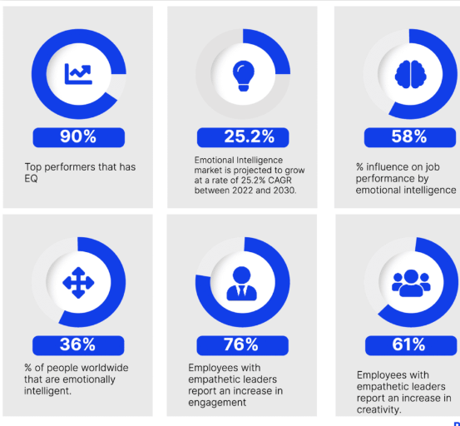
Figure 1: Statistical evidence shows the impact of EI on workplace
(Source: Okoronkwo, 2022)
The key role of EI lies in enhancing personal awareness about emotions, expressions, behaviour and emotional control for realising own emotions and understanding others. EI facilitates the individual in idealising the mistakes and identifying the ways of accepting the changes for resolving the key hindrances. As suggested by Okoronkwo (2022), a report has been published and it has been acknowledged that around 90% of top performers have a high “Emotional Quotient (EQ)” that leads to high EI. In addition, the work performance of 58% of employees has been influenced by EI and EI increases the empathetic leadership capability of around 61% of individuals. Employees' encouragement to enrich work-life balance has been influenced by emotional intelligence, which contributes to workplace happiness and encourages the leaders to suggest reliable suggestions regarding work-life balance. In accordance, EI plays a vital role in enhancing the job performance of individuals and around 58% of employees are motivated by sharing their expressions and emotions with others (Okoronkwo, 2022). It has been reflected in the case study that Clarke’s approach to calling the female employees affected their emotional states and they rejected the greetings. Disagreement with the new system designed by Clarke is the main reason for decreasing the performance efficiency and demotivating the female employees to perform best.
In the workplace of FAYE Inc., Clarke understood that EI signifies the aspects of employee wellbeing, employee behaviour and workplace culture that led to increased employee performance growth. However, Clarke realised the fact that leaders must understand the feelings of others to manage them and idealise the unreasonable expectations for career improvement. As opined by Ouakouak, Zaitouni and Arya (2020), ethical leadership emphasises the leaders assessing the components of emotions and enriching employee motivation to increase employees’ job performance. Employee motivation strategies and practices facilitate the leaders and management in reducing job-quitting tendencies and strengthening leaders-employee relationships. Moreover, organisations that cultivate EI through fostering training and development programs often see a reduction in employee turnover rates and eliminate employees' workplace stress radically (Zeidan, 2020). EI has not only enhanced individual performance growth but also aids the leaders and management in developing a cohesive relationship with employees that leads to encouraging the employees to share emotional expressions such as anxiety, fear of loss, burnout feelings and depression with colleagues. This is put forth in encouraging the employees to perform best and enhancing individual skills simultaneously.

Discussing two models with potential to enhance Clarke’s abilities
The Mayer-Salovey model of EI
“The Mayer-Salovey model of EI” is a model that describes the developmental stages through the lens of certain abilities such as “perceived emotions”, “understanding emotions”, “managing emotions” and “use emotions by facilitating thought process”. John D. Mayer and Peter Salovey established this model based on the idea that EI is made up of certain mental abilities that allow people to express, appraise and regulate emotions. As referred to by Craig (2019), the theoretical explanation of the “Mayer-Salovey EI model” states that personal intelligence has been associated with the feelings of emotions and this helps an individual conceptualise the core patterns of EI. The “Mayer-Salovey model” expresses that EI is an ability to foster perceived emotions and increase an individual's capability to understand the emotions of others through facilitating thoughts and manifesting the emotions into actions. In accordance to increase Clarke’s ability, it has been evaluated that manifestation of thoughts emphasises Clarke's understanding of others' feelings and revises the structural practices for retaining skilled employees while valuing their emotions. As suggested by Hughes et al. (2020), personality traits and emotional regulation influenced leadership qualities in adopting regulatory tactics and reforming organisational practices to embrace changes for structural improvements and enhancing employee relations.
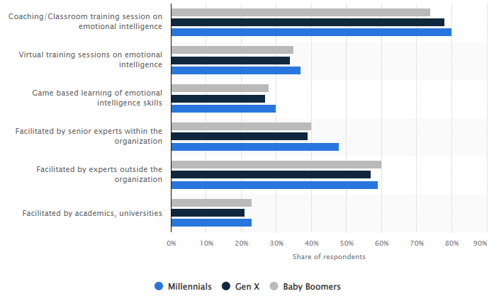
Figure 2: Effectiveness of training method in improving EI skills of leaders
(Source: Bohne, 2022)
As suggested by Bohne (2022), coaching and training sessions on EI is effective for the Millennial in enhancing their compatibility by 80%. In addition, through training programs, employees can obtain real-time experiences about the utilisation technique of EI in regard to improve individual performance. In relevance, EI has been associated with the capability of people in understanding, assessing and controlling emotions to improve the quality of interpersonal coordination. It would be effective for Clarke in enhancing the potential and skill sets for managing the employees and integrating the changes for organisational improvements and enhancing individuals and organisational performance.
Goleman model of EI
Daniel Goleman established a model that describes EI as a collection of competencies and skills that can be fostered and steered to improve performance efficiency. The theoretical overview of the “Goleman EI model” states that five constructs such as “self-awareness”, “self-regulation”, “social skills”, “empathy” and “motivation” influenced the credibility of leaders’ EI in relevance to improve employees’ performance. As stated by Tritsch (2021), self-awareness is the ability of an individual that state the current mood and its reasons and facilitates the individuals in identifying their own emotions. Additionally, motivation is the inner courage that drives individuals to explore creative ideas and integrate innovativeness in actions for performance betterment. Following the case study context, Clarke’s abilities could be increased by applying the core insights of “Goleman’s EI model” in actions and being aware about own emotions, expressions and emotional behaviour for understanding others’ emotions simultaneously. This could benefit the supervisor by revising the management systems and prioritising the use of EI for idealising the emotions of others and respecting their emotional states. As opined by Aamir (2023), the Goleman model of EI facilitates organisations and leaders for enriching organisational commitments and improving social awareness of leaders for enhancing employees’ performance growth and enriching organisational productivity effectively.
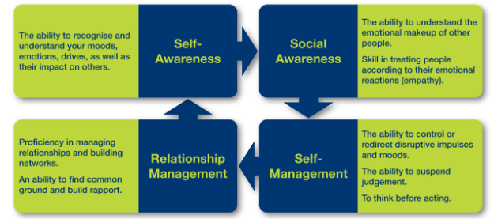
Figure 3: Goleman model of EI
(Source: Tritsch, 2021)
The application of the “Goleman EI model” in improving an individual’s effectiveness and skill development lies in encouraging the individuals to improve self-awareness potential, strengthening social skills and enriching empathy for understanding others. As suggested by Steffens et al. (2021), personal and collective self-awareness potential enriches authentic leadership styles and endorses leadership capabilities that contribute to improving employee relations, behaviour and engagement. This leads to enriching employees’ job satisfaction and employee morale. In relevance to the case study, the EI model of Goleman helps Clarke form an idea of EI and its components, which contributes to increasing the capabilities to respect others’ emotions and understanding emotional control for maintaining a good relationship with employees. Clarke, the new supervisor of FAYE Inc., can understand the reasonable expectations that employees foster in relevance to improving skill sets. Self-awareness, empathy, social awareness, motivation and self-regulation, the five components of the EI model, facilitate Clarke in fostering the EI skills to manage the employees while understanding their emotions.

Critically explaining words that Clarke told during his EI session
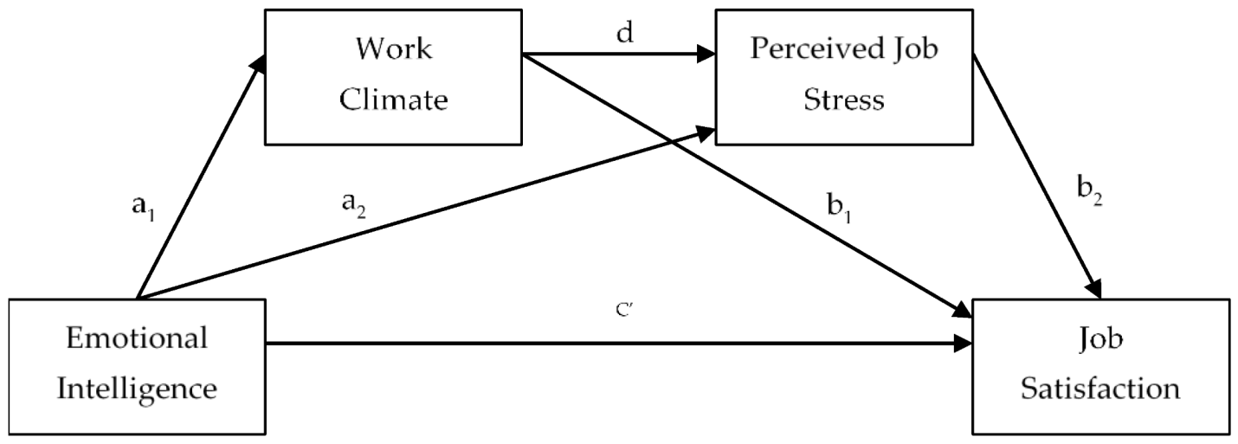
Figure 4: Relation of work climate and job stress
(Source: Castillo-López and Domínguez, 2024)
The female employees at FAYE Inc. expressed discomfort with being addressed as "my love” by the new supervisor Clarke. This greeting was not well-accepted by the women as it caused emotional distress and harmed their work performance. By analysing the female employees' concerns, Clarke, the new supervisor, was recommended to modify the way they interacted through the use of emotional intelligence. In this context, Clarke discussed the fact in an “EI session” that leaders often hurt employees’ feelings by insensitive attitudes, inflexible practices and unreasonable expectations. This realisation emphasises Clarke in discussing the issues with the Chinese team to obtain reliable suggestions from them to resolve the issues raised in FAYE Inc. As suggested by Sembiring et al. (2020), EI has a positive relationship between job satisfaction, organisational justice and forming a caring climate of an organisation. EI influenced employees' performance and enriched their job satisfaction. Following the case study, it has been seen that Clarke realises that EI plays a vital role in enhancing employees’ job satisfaction, employee’s wellbeing and reshaping employees’ behaviour that put forth in enhancing employees’ job performance. However, Clarke told in EI sessions that poorly managed change would not be effective for both the organisation and employees in relevance to improving organisational and employee performance.
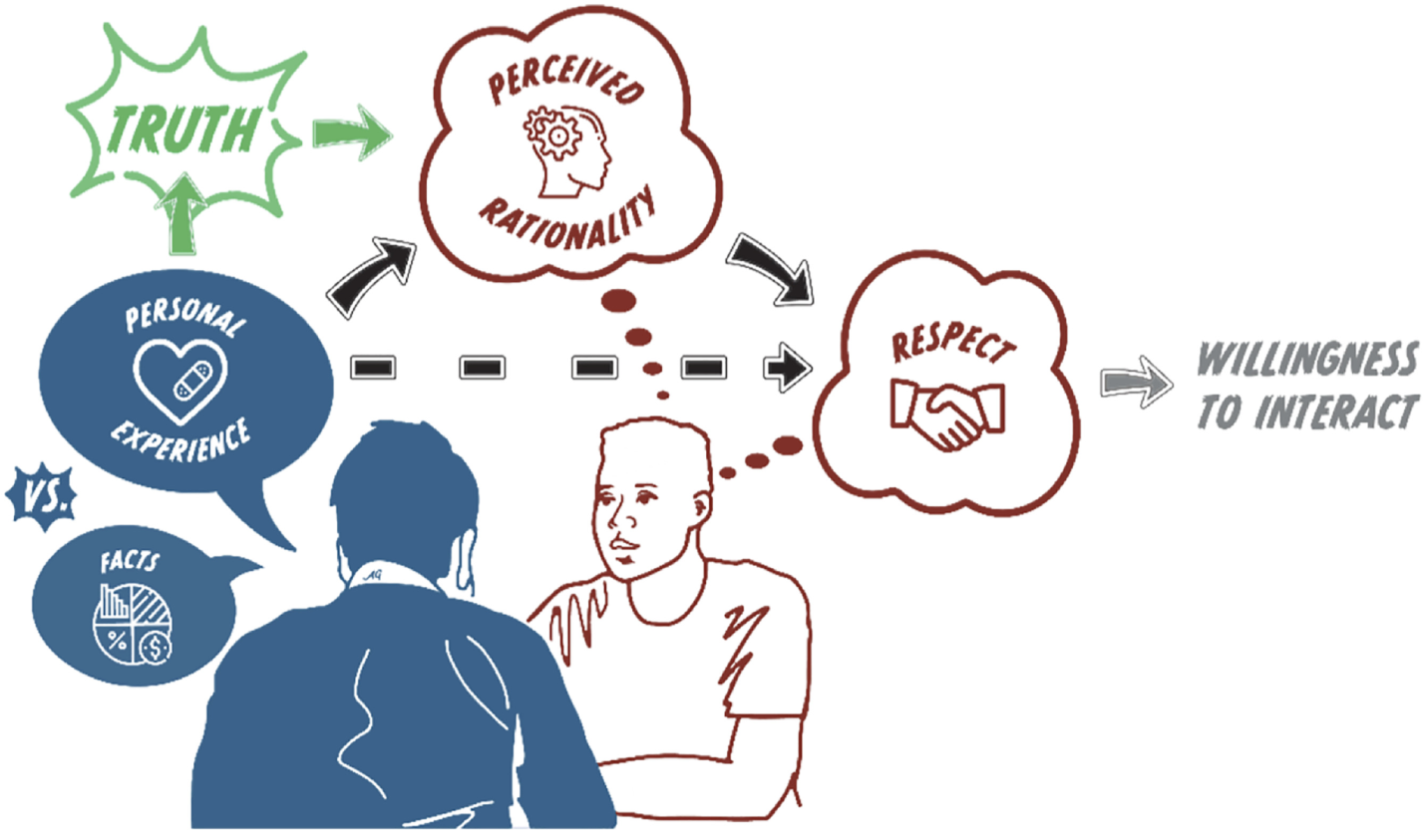
Figure 5: Linking personal experience with the willingness to interact
(Source: Kubin et al., 2021)
Clarke admitted that he saw the light on how the approaches to communication and organisational culture differ in different parts of the world. He said he breaks his words mindfully bearing in mind how his words will be interpreted by the various members facing FAYE Inc. as a diverse organisation. He said his manner of greeting the employees has adversely influenced the morale of some of the workers and assured the committee that he would have to modify his language to conform to courtesy and decorum in compliance with diversity. Clarke was aware that EI encompasses not only being able to identify feelings within oneself but also being in a position to comprehend the emotions and viewpoints of others as well. This indicates the characteristics of a person to respect people’s opinions as to cultural disparities and work on himself to be more sensitive to everybody’s needs (Kubin et al., 2021). This applies to Clarke to make all employees feel respected and welcome at work. Applying the fundamental principles of "Goleman's EI model" in enhancing Clarke's skills, it has been noted that it would be reliable in understanding one's own emotions, expressions and emotional behaviour to better understand the emotions of others.

Role of organisational culture in Understanding EI and Employees’ mindfulness

Organisational Culture and Emotional Intelligence
Organisational culture can be defined as the working characteristics of a firm relating to the external and internal environment of the business (Oh and Han, 2020). The positive, inclusive and emotionally intelligent culture allows employees to value, support and motivate them. They are encouraged to put into practice aspects of EI to include self-awareness, empathy and social competence. The company had laid the groundwork that employees could attend EI training sessions and managers would demonstrate emotionally intelligent training. This culture enables Clarke to think over his feelings and identify himself during the pressure moments. By engaging in this kind of reflection Clarke helped him achieve the EI component, which is self-awareness. He learned how to control his emotional response to a particular stimulus and avoided frustration or conflict that was associated with the trigger. In team meetings, Clarke had earlier been so aggressive that he would interrupt people or just rubbish their ideas. Subsequently, he was able to cultivate his EI and began to take a moment before talking, listen better and think before reacting. This benefited him directly in his relations and led to other better relations throughout the workplace.

Fostering Mindfulness in the Workplace
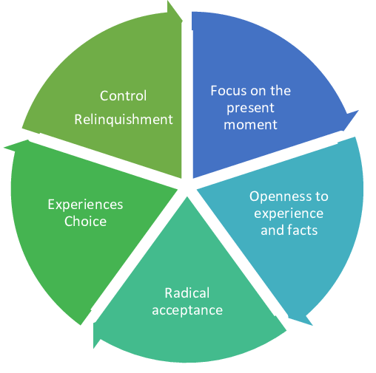
Figure 6: Components of “Mindfulness”
(Source: Islas, 2024)
One of the EI components is mindfulness, which presupposes the conscious presence of a person and focuses on inner experiences (Hattingh, 2023). Mindfulness assists workers in handling stress, enhancing concentration and developing self-regulation (Islas, 2024). It is a result of a mindful organisational culture that enables its employees to engage in self-reflection, work calmly and have better communication. In FAYE Inc. organisation, a range of activities in the organisation included mindfulness as part of their wellness activities. The company offered mindful workshops and promoted such practices as break with mindfulness and even meditation. These practices assisted most employees to gain higher self-awareness by improving their emotional intelligence as seen by Clarke. The observations from the case study highlighted that Clarke's mindfulness enabled the management of emotions in the actual realm.
In terms of exercising mindfulness practices, it is effective to control frustration or stress by watching the reflection of emotions (Izhar et al., 2022). For instance, when there is a tight schedule for completing a project, Clarke realised that he and his team are stressed. Instead of acting out of the anger, he was able to stop for a second, take several breaths and calmly observe the issue at hand. This enabled him to offer solutions that were clear and helpful instead of complicating stressful issues. However, Clarke also saw that the advantages of mindfulness were not soloistic; they included positive enhancements of other performers as well. After some of the employees in FAYE Inc. adopted mindfulness, the organisation was able to overcome the high levels of stress, augmented concentration, and all-around unity among workers. Employees were more capable of managing adversity, integrating information proficiently and sustaining positive attitudes regarding difficulties. Thus, mindfulness was integrated into the affective-emotional component of the company’s organisational culture.

Influence on EI and Mindfulness
Indeed, organisational culture lays the basis for the development of both emotional intelligence and mindfulness. For FAYE Inc., the culture encouraged people to be more open, to learn, and to grow emotionally; this paved the way for them to embody some of the most vital skills of EI including mindfulness. Such a culture as that of FAYE Inc. fosters openness of emotions, self-awareness and good self-management skills among employees. It offers the means for mindfulness training to maintain the ability of employees to be attentive, receptive and relaxed when managing challenges at work (Konte, 2023). This culture allows employees to engage each other better and handle conflict in ways that are more emotionally sound. According to Clarke, organisational culture played the biggest part in his EI growth. Those aspects made him a better person with a positive outlook on life: The company has instilled in him emotional intelligence. Clarke profited from the growth in these aspects not just for personal benefit, but, crucially, for the benefit of his team. Controlling emotions and staying mindful enhanced the working environment hence improving the organisation's overall performance.

Broder Implications in Organisational Culture
Experience of Clarke at FAYE Inc. gives an example of where theories related to emotional intelligence and Mindfulness can be implemented within organisations. The aspects that are given priority when guessing are as follows help a company to have a more committed and productive organisational culture staff. The rationale on how emotions affect stressing, communicating and interacting with others shows that emotionally smart employee will be more productive and satisfied in their duties. Businesses giving value to EI and mindfulness programs empower employees and boost the health of those organisations (Paul, 2022). As people all over the world are provided with compressed schedules and high stress working conditions, salvaging employee well-being has been more necessary than ever.

Ways FAYE Inc. Harnessing Benefits of EI and Mindfulness of Employees

Building a Supportive Organisational Culture
FAYE Inc. as a company practice the culture of emotional intelligence and mindfulness in its workplace. One of the company’s core values includes valuing and communicating openly, growing as individuals and becoming lifelong learners: this practice fosters employees’ self-awareness and awareness of others, as well as attentiveness to context. This healthy culture ensures that people are in a position to embrace reflective modes of emotional self-awareness for healthy interactions and conflict solutions (Yang and Gao, 2020). The liberality in displaying emotions has ensured that workers such as Clarke have low awareness. The company encourages its workers to take EI training during which they can learn about the regulation of emotions, about causes of emotions and sympathy or empathy. It provides the atmosphere through which the employees can freely express themselves, and effectively address the stress issues that are inherent with organisational life.

Offering Emotional Intelligence Training and Workshops
FAYE Inc. has established and sponsored frequent EI training programs with the view of enhancing the scores of emotional intelligence competencies of its employees. These workshops define the elements of EI as self-awareness, self-regulation, motivation, empathy, and relationship management. Employees learn about their feelings and how they should handle them, especially at times of pressure or stress (Gabriel and Aguinis, 2021). For instance, Clarke can experience positive development, such as improved management of moods from the said sessions. Before the training, he had a problem controlling aggression in a team meeting; he would interrupt people or even reject ideas. From the training, Clarke was able to recognise anger learn how to count to 10 and regain his composure before responding, which allowed him to greatly improve his people skills with his team.

Integrating Mindfulness Practices
Mindfulness is one of the critical aspects that define FAYE Inc.’s strategy towards promoting emotional intelligence. In addition to those options, the company facilitates mindfulness programmes such as meditation, breathing exercises and mindful intervals to enable employees to undertake organisational changes, stress and manage advancements in stress. Good et al. (2015) opined that mindfulness allows employees to maintain focus on feelings with no distractions lowering stress levels and enhancing decision-making. All these were new to Clarke and included deep breathing and practising meditation. These practices enabled him to keep patience while facing angry people thus enhancing positive management of emotional reactions.

Encouraging Mindful Leadership
Each manager at FAYE Inc. follows awareness of EI and mindfulness and is supported in practising mindfulness in leadership, to support these ideas. FAYE Inc. teaches their leadership tactical methods to identify, respond and appreciate or respect their team’s feelings. The leaders listen to and facilitate to encourage positive attitudes at the workplace and model healthy ways of handling feelings. It has made the workforce more proactive and productive since this approach of leadership makes employees more enthusiastic. Rožman and Štrukelj (2020) highlighted that workers perceive their managers as supportive and receptive to their ideas, concerns and needs, to maintain a healthier organisational climate. Additionally, mindful leaders manage workplace relationships more effectively, thus translating to well-managed conflicts or challenges, so important in any organisation.

Promoting a Collaborative and Empathetic Work Environment
FAYE Inc. engages co-workers culturally to work together by practising the value of emotional recognition down to the main official level. Frank and courteous behaviour is promoted among employees, and that enhances team spirit and relations too. It was done by integrating EI alongside mindfulness which transformed the working environment so that they could freely share, propose, and contribute toward the company’s goals (Olawade et al., 2024). FAYE Inc. has made the organisation full of emotionally intelligent employees with the implementation of emotional intelligence and mindfulness into the company’s culture. Employees become more productive, less stressed, and better equipped to meet the demands of the new world of work as organisational performance is improved significantly to positive results.

Conclusion
In the new dynamic world of business, EI and Mindfulness are the two new emerging competencies, essential for improving the human asset, leadership, and organisational success. FAYE Inc.’s case and Clarke’s EI session give a valuable understanding of how organisational culture affects the perception and usage of EI and mindfulness in a company. Thus, the present work examines the contribution of the organisational culture to the process of EI development, mindfulness cultivation, and enhancement of organisational relations and performance. Clarke's experience in his EI session showed how culture in an organisation influences the level of empathy and understanding in a person. At the beginning of the regime, Clarke was similar such as many other workers who failed to grasp the relevance of emotion regulation for organisational effectiveness. Nonetheless, FAYE Inc. cultivating the individual’s personality, self-improvement, training, and emotional expressiveness supported him.

References
Aamir, A. (2023) ‘Emotional Intelligence and Organizational Commitment - Application of the Goleman’s Model of Emotional Intelligence’, International Journal of Intellectual Human Resource Management (IJIHRM), 4(1). Available at: https://doi.org/10.46988/IJIHRM.04.01.2023.001.
Arar, T. and Öneren, M. (2021) ‘Role of Emotional Intelligence and Work-Life Balance in Relationship between Workplace Happiness and Perceived Performance in Academic Setting’, Ege Akademik Bakis (Ege Academic Review), 21(4), pp. 391–406. Available at: https://doi.org/10.21121/eab.1015653.
Bohne, R. (2022) Training methods most helpful to learn emotional intelligence skills worldwide by generation 2019, Statista. Available at: https://www.statista.com/statistics/1074280/most-helpful-training-methods-emotional-intelligence-generation-worldwide.
Castillo-López, Á.G. del and Domínguez, M.P. (2024) ‘Employees’ Emotional Intelligence and Job Satisfaction: The Mediating Role of Work Climate and Job Stress’, Administrative Sciences, 14(9), p. 205. Available at: https://doi.org/10.3390/admsci14090205.
Craig, H. (2019) The Theories of Emotional Intelligence Explained, PositivePsychology.com. Available at: https://positivepsychology.com/emotional-intelligence-theories.
Gabriel, K. and Aguinis, H. (2021) ‘How to prevent and combat employee burnout and create healthier workplaces during crises and beyond’, Business Horizons, 65(2), pp. 183–192. Available at: https://doi.org/10.1016/j.bushor.2021.02.037.
Good, D.J. et al. (2015) ‘Contemplating Mindfulness at Work: An Integrative Review’, Journal of Management, 42(1), pp. 114–142. Available at: https://doi.org/10.1177/0149206315617003.
Hattingh, A. (2023) The influence of emotional intelligence and mindfulness on self-leadership among graduates in the early career stage, Ufs.ac.za. University of the Free State. Available at: https://scholar.ufs.ac.za/items/5f1fa5f2-6421-4ddc-82ee-d0489ee539c8.
Hughes, D.J. et al. (2020) ‘Personality traits and emotion regulation: A targeted review and recommendations.’, Emotion, 20(1), pp. 63–67. Available at: https://doi.org/10.1037/emo0000644.
Islas, T.B. (2024) ‘Contextual therapies for the intervention of anxiety and depression in adults’, Mexican Journal of Medical Research ICSA, 12(24), pp. 78–88. Available at: https://doi.org/10.29057/mjmr.v12i24.12426.
Izhar, L.I. et al. (2022) ‘Emotion Self-Regulation in Neurotic Students: A Pilot Mindfulness-Based Intervention to Assess Its Effectiveness through Brain Signals and Behavioral Data’, Sensors, 22(7), p. 2703. Available at: https://doi.org/10.3390/s22072703.
Konte, A.G. (2023) ‘Mindfulness in Organizations: The Concept of Mindful Leadership’, IntechOpen eBooks [Preprint]. Available at: https://doi.org/10.5772/intechopen.108322.
Kubin, E. et al. (2021) ‘Personal experiences bridge moral and political divides better than facts’, Proceedings of the National Academy of Sciences, 118(6). Available at: https://doi.org/10.1073/pnas.2008389118.
Oh, S. and Han, H. (2020) ‘Facilitating organisational learning activities: Types of organisational culture and their influence on organisational learning and performance’, Knowledge Management Research & Practice, 18(1), pp. 1–15. Available at: https://doi.org/10.1080/14778238.2018.1538668.
Okoronkwo, V. (2022) 39 Best Emotional Intelligence Statistics To Know In 2022, Passive Secrets. Available at: https://passivesecrets.com/emotional-intelligence-statistics.
Olawade, D.B. et al. (2024) ‘Enhancing Mental Health with Artificial Intelligence: Current Trends and Future Prospects’, Journal of medicine, surgery, and public health, 3(3), pp. 100099–100099. Available at: https://doi.org/10.1016/j.glmedi.2024.100099.
Ouakouak, M.L., Zaitouni, M.G. and Arya, B. (2020) ‘Ethical leadership, emotional leadership, and quitting intentions in public organizations’, Leadership & Organization Development Journal, 41(2), pp. 257–279. Available at: https://doi.org/10.1108/lodj-05-2019-0206.
Paul, D. (2022) ‘Mindfulness–based positive transformative leadership development for health organisations’, Leadership in Health Services, 36(1). Available at: https://doi.org/10.1108/lhs-04-2022-0044.
Rožman, M. and Štrukelj, T. (2020) ‘Organisational climate components and their impact on work engagement of employees in medium-sized organisations’, Economic Research-Ekonomska Istraživanja, 34(1), pp. 1–32. Available at: https://doi.org/10.1080/1331677x.2020.1804967.
Samanta, I. and Kallou, S. (2020) ‘The Role of Emotional Intelligence in Counterproductive Work Behavior’, European Business & Management, 6(2), p. 20. Available at: https://doi.org/10.11648/j.ebm.20200602.11.
Sembiring, N. et al. (2020) ‘The effects of emotional intelligence and organizational justice on job satisfaction, caring climate, and criminal investigation officers’ performance’, International Journal of Organizational Analysis, 28(5), pp. 1113–1130. Available at: https://doi.org/10.1108/ijoa-10-2019-1908.
Steffens, N.K. et al. (2021) ‘Knowing me, knowing us: Personal and collective self-awareness enhances authentic leadership and leader endorsement’, The Leadership Quarterly, 32(6), p. 101498. Available at: https://doi.org/10.1016/j.leaqua.2021.101498.
Tritsch, E. (2021) What is Goleman’s Theory of Emotional Intelligence?, Fairborn Digital Academy. Available at: https://fairborndigital.us/2021/10/14/what-is-golemans-theory-of-emotional-intelligence.
Yang, R. and Gao, C.Y. (2020) ‘Rethinking Cultural Competence Education in the Global Era: Insights from Fei Xiaotong’s Theory of Cultural Self-Awareness’, Frontiers of Education in China, 15(4), pp. 539–563. Available at: https://doi.org/10.1007/s11516-020-0026-4.
Zeidan, S. (2020) ‘Empirical Investigation of the Relationship between Emotional Intelligence, Organisational Commitment and Turnover Intentions’, Journal of Information & Knowledge Management, 19(2), p. 2050012. Available at: https://doi.org/10.1142/s0219649220500124.

Individual poster presentation


