
Skills for the Workplace
Module Assignment Submission
Student Name: | Jahed Ahmed
Student Number: | 1708625
Module No: | BMSK4002
Module Title: | Effective team working and communication

Statement of Confirmation of Authenticity
By the act of making this submission, the student declares that this is the work of the student named above. The work has not, in whole or in part, beeni knowingly presented elsewhere for assessment, or where assessment has been built on a previous assessment, this has been identified. Where materials have been used from other sources it has been properly acknowledged. If this statement is untrue, the student acknowledges that an assessment offence has been committed.
Attention is drawn to the plagiarism and unfair practice policies of both the University and of ILM.

Table of Contents

Introduction 1
Importance of Communication (Real Life Experiences) 1-3
Conflicts in Workplace 3-5
Relevent Theories to Communication to Workplace 5-7
Inter-personal Communication 7-9
Written Communication: Formats & Structures 9-10
Conclusion 10
References 11-13

Introduction
Teamwork plays vital role in any organization. It helps a team to work creatively and efficiently. Business sometimes ask employees to as a team so that they can understand the benefit of working together including making new friendship, sharing knowledge, creativity and also responsibilities of work. On the other hand, teamwork also may cause stress and tension among the member because of the lack of communication. Right communication makes people happy and bring more productivity while working as a team. .In this report we will discuss about the effective team wok of a real life employee (My friend), importance of effective teamwork, some conflicts in workplace, and some relative theories of effective employment and communication styles. (Effective Communication & Team Work)

Importance of Communication (Real Life Experiences)
One is better than one that means a team is better than one person. A group of five can do more things than an individual. But it’s only happen when group of five works together to achieve one goal. The importance of communication in teamwork are given below with real life example: (7 Stories That Prove The Importance of Teamwork)
- Motivation: Sometimes good communication works as motivation tools for the employee. My friend works in Apple Corporation where they maintain a good communication with the lower level employee. He was there as a junior marketing and sells executive for few months. As a marketer of the company, he has to inform the condition of the product and sell to the upper level employee. And as there was no barrier for the lower level employee he can directly contact to the superior to tell the condition of the product. And he was motivated because of the good commination. So every company should practice good communication among the employees.

- Work place Diversity: Effective communication in the workplace is very important in organizations those who have workplace diversity. One of my friends works in Google and everyday he has to deal with different countries people who has different culture and different language. Sometimes he faced problem and it crates a barrier among the employee. After completing the training on that company, now he is able to adjust with everyone in the company. He understood that, for a company it is really important for employee to have a good communication skill. Based on that real life experience of my friend, we can say it is important for a company to practice good communication skills in the early career of the employee if they have diversity in the workplace. (What Are the Benefits of Effective Communication in the Workplace?)

- Clear Direction: One of my friend’s works in a Bank. He worked with so many companies but he didn’t stay there. Because there was lack of communication in the organization where he didn’t get the clean direction of the work. Employees always appreciate good form the upper level management. And it creates healthy environment in the organization. My friends wanted this from his job too. And finally he is very satisfied with his new job where good direction is given to the employee. At the point when workers are happy with their employments, they can effectively play out their obligations with an inspirational demeanour. Neglecting to convey successfully in a working environment prompts disappointment and perplexity among representatives. Be that as it may, directors can mitigate such issues by keeping the lines of correspondence open. So based another real life experience, we conclude that for a good direction we need good communication. (What Are the Benefits of Effective Communication in the Workplace?)

Conflicts in Workplace

Lack of communication creates conflicts among the employees. Its not only ruin the relationship but also harm the organization in so many way. Some of them are given below:
- Poor Communication: Poor communication is the main reason of conflict in the organization. For example: A lower level employee wants to communicate with upper level employee for business purpose if it takes so long to communicate with them, employee gets demotivated. Sometimes this type of demotivated employee conflict with other employees.

- Creating Uncertainty: Uncertainty occurs due to lack of communication, which brings tensions and conflict. For example: One doctor may waiting for his colleague to finish the blood test for a sick person. If the colleague does wrong test or react in wrong way then the doctor will be in trouble and the patient. Whole team might struggle. (How Does a Lack of Communication Cause Conflict in the Workplace?)

- Sharing Resources: Companies who has limited resources may face conflict. For example: Office gear, may encounter strife if labourers don't impart their requirements for the assets. For instance, a labour who neglects to advise others ahead of time that she should utilize the solitary office PC for a whole day to finish an undertaking may get under the skin of whatever is left of the staff who may likewise need to utilize the machine. (How Does a Lack of Communication Cause Conflict in the Workplace?)

- Non-responsiveness: Another wellspring of contention is non-responsiveness from associates or chiefs to a demand for data, elucidation or assessment. The representative anticipating a reaction may feel the other party is by and large deliberately non-communicative and meddling with her capacity to play out her own particular activity. This can make a harmful, no collaborative condition, regardless of whether the no responsiveness is because of an oversight or other favourable reason. (How Does a Lack of Communication Cause Conflict in the Workplace?)

- Different Communication Styles: Sometimes different communication style creates conflict among the employees. For example: some people like face-to-face communication where others may prefer communicate via electric media like email. So sometimes it creates conflicts when employee shares data among them. (How Does a Lack of Communication Cause Conflict in the Workplace?)

Relevant Theories of Communication to Workplace

Weber’s Classic Organizational Theory: Weberian hypothesis holds that there is no degree for complexity in the messages being sent from the best and he also said that there should be full working capacity for the employee. And there will be some rules and the employee should follow regulations. The organization have to set the goals very clearly so that employee can achieve it. (Popular Theories of Organizational Communication)

- Tompkins and Cheney’s Organizational Control Theory: According to this theory, there are four kinds of control that determine how organizations exercise power within and they are-
- Simple control.
- Technical control.
- Bureaucratic.
- Concertive control.
According to this theory, supervisor assigns work to the employee and they also oversee it. Basically this type of depends on the relationship with the supervisor and employee. And it works in small organization perfectly. This theory also says that its really important to see whether the employee in the organization are happy or not about the job. And this theory also teaches an organization to practice teamwork in the workplace so that they can share knowledge and ideas among themselves.
(Popular Theories of Organizational Communication)

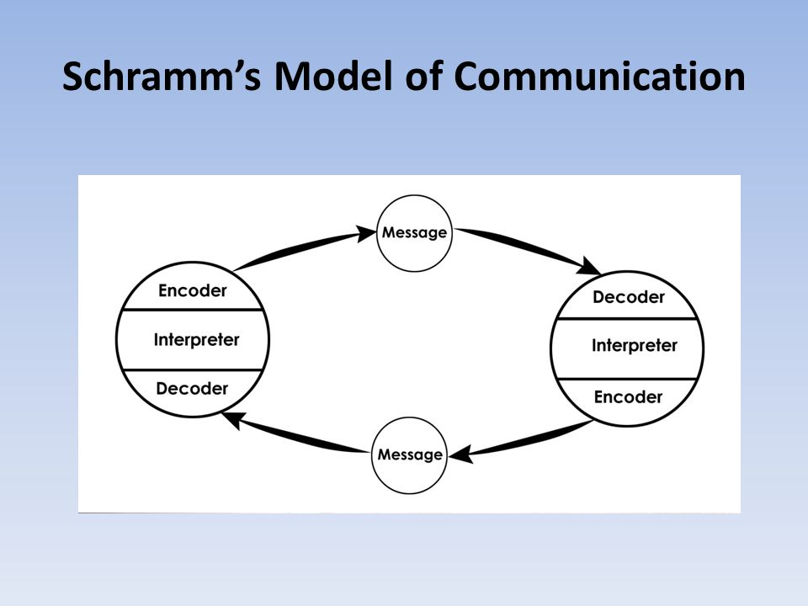
- Schramm's Model of Communication: In 1954, Wilbur Schramm said that there would be two sides for communication. One is sender and another one is receiver. Basically it’s a two way communication process. There are some components too. These are-
1. Sender
2. Encoder
3. Decoder
4. Interpreter
5. Receiver
6. Message
7. Feedback
8. Medium
9. Noise.
(Slideplayer.com)
Inter-personal Communication

Interpersonal Communication is a process where people share their feelings, thought, and mainly information in through verbal and non-verbal way. And it is very important for any employees to understand the Inter- Personal Communication. But it should be face-to-face communication. Some of interpersonal communications are-
- Body Language
- Active listening
- Personal Presentation
- Context Awareness.

Body Language: Basically it’s a non- verbal and face-to-face communication process. It opposes physical behaviour to words to convey messages. Such behaviour includes facial expressions, body posture, gestures, eye movement, touch and the use of space. In organization, body language includes actions and way of behaviour. And maintaining eye contact with supervisor explains employee’s honesty, Interest, attention and confidence. And it varies form country to country. For example: In UK shaking chair in a meeting can be normal but in some countries may not be normal. So employee should learn this knowledge and practice it in the organisation according to the situation. (How Body Language Is Used in the Workplace)


Active Listening: When a listener gives full concentration on what other people saying is called active listening. Active listening plays a very important role in any organization. The skills in the workplace can increase the productivity and performance. If an employee listen actively what his/her supervisor is saying, he/she can perform well and it also helps them to prevent mistakes and avoid misunderstanding. A leader also should know what he/she is saying and whether the employees are listening or not.


Personal Presentation: Personal presentation is the skill of a specific person. Basically it shows how an employee smartly handles any difficult or normal situation. It also shows employees overall dress, gesture and presentation skills. Organization nowadays spent lots of money marketing to promote any brand or any product or the organization itself. So when it comes to any organization reputation, staff in associations should realize that all that they do is promoting for the association, each email they send, each telephone call they take, each time they interface with a customer or client. Associations likewise invest a great deal of energy and cash selecting and preparing the correct sort of individuals to extend the correct sort of picture. (Personal Presentation Skills | SkillsYouNeed)

Context Awareness: Maintaining awareness in the working context so that fellow workers can do their job successfully. Sometimes employees are assigned to do some works where context should be focus rather than focusing on other things. Sometimes technology also uses to do such jobs.

Written Communication: Formats and Structures
Business commonly uses different types of communication format to reach the target audiences. And different format costs are different. Letters, memo, email, telegram, sales latter are used as a communication tools by the organization. And the structure of the communication tools are now varies from organization to organization. But when it comes to communicate with upper level management, employee use completely formal format of communication. With the same level employee or lower level employee they use normal or semi- formal communication format. Nowadays employee also uses social media for normal communication and uses letter for business contract or built good relationship with other organization. Memos are basically internal communication format used as a internal communication tools to communicate with managers and other employees. For meeting, employee use personal format in the organization. Basically this personal format is used to set meeting with business owners, the directors or managers of the company, who often meet to discuss major business ideas before making a decision. And email is the most popular tools of communication process. Email is used to communicate with inside the organization and outside the organization.
But many organizations nowadays have developed the format or email to maintain the professionalism.
Conclusion
Nowadays, communication is the essential element of any organization if we want to maintain a good relationship inside the organization or outside the organization. Though communication has different format or media, we use for the same purpose. For any business organization, effective communication is really important because it gives employees a clear understanding about their tasks. This report also shows the importance of communication, some theories and some formats of communication so that we can understand how communication effect our life in positive way in personal life as well as professional life.

References
- Certificate in Higher Education: Skills for the Workplace Student Yearbook | SAGE India. 2017. Certificate in Higher Education: Skills for the Workplace Student Yearbook | SAGE India. [ONLINE] Available at: https://in.sagepub.com/en-in/sas/certificate-in-higher-education-skills-for-the-workplace-student-yearbook/book260960
- (c) Copyright skillsyouneed.com 2011-2017. 2017. Personal Presentation Skills | SkillsYouNeed. [ONLINE] Available at:https://www.skillsyouneed.com/ps/personal-presentation.html
- Effective Communication & Team Work | Chron.com. 2017. Effective Communication & Team Work | Chron.com. [ONLINE] Available at: http://smallbusiness.chron.com/effective-communication-team-work-3167.html
- How Does a Lack of Communication Cause Conflict in the Workplace? | Chron.com. 2017. How Does a Lack of Communication Cause Conflict in the Workplace? | Chron.com. [ONLINE] Available at: http://smallbusiness.chron.com/lack-communication-cause-conflict-workplace-10470.html
- How Does a Lack of Communication Cause Conflict in the Workplace? | Your Business. 2017. How Does a Lack of Communication Cause Conflict in the Workplace? | Your Business. [ONLINE] Available at: https://yourbusiness.azcentral.com/lack-communication-cause-conflict-workplace-9430.html
- How Body Language Is Used in the Workplace | Chron.com. 2017. How Body Language Is Used in the Workplace | Chron.com. [ONLINE] Available at: http://smallbusiness.chron.com/body-language-used-workplace-11773.html
- Popular Theories of Organizational Communication. 2017. Popular Theories of Organizational Communication. [ONLINE] Available at: http://www.managementstudyguide.com/theories-of-organizational-communication.htm
- Scoro. 2017. 7 Stories That Prove The Importance of Teamwork | Scoro. [ONLINE] Available at: https://www.scoro.com/blog/teamwork-stories-importance-of-teamwork/
- Slideplayer.com. 2017. Slideplayer.com. [ONLINE] Available at: http://slideplayer.com/slide/9483638/29/images/15/Schramm%E2%80%99s+Model+of+Communication.jpg
- The Business Student's Guide to Study and Employability | SAGE India. 2017. The Business Student's Guide to Study and Employability | SAGE India. [ONLINE] Available at: https://in.sagepub.com/en-in/sas/the-business-students-guide-to-study-and-employability/book241260
- What Are the Benefits of Effective Communication in the Workplace? | Chron.com. 2017. What Are the Benefits of Effective Communication in the Workplace? | Chron.com. [ONLINE] Available at: http://smallbusiness.chron.com/benefits-effective-communication-workplace-20198.html

