assignment 2: Professional development plan (pdp)
Learning in the Digital Area
Student name: Vivian Nnadozie (2541945)
Student Number: 2541945

​
Contents
Task 1: Self Evaluation 1
Task 2: Personal development Plan (PDP) 2
The link to the PDP file 3
Screen shots of my goal progress 3
Task 3: Becoming a lifelong learner (summary) 7
Bouncing forward 7
Task 4: Video Presentation 8
Referencing 9
Referencing for the PDP table 9

​
​
​
​
​
​
​
​
​
​
​
​
​
​

Task 1: Self Evaluation

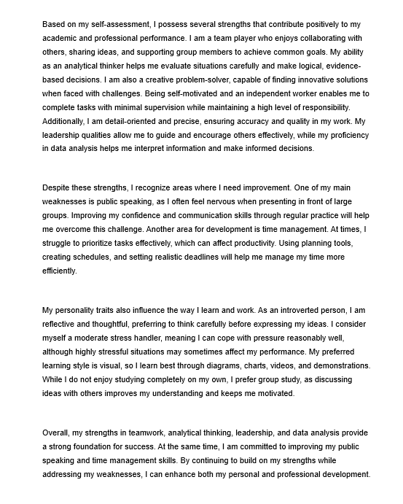

Task 2: Personal development Plan (PDP)

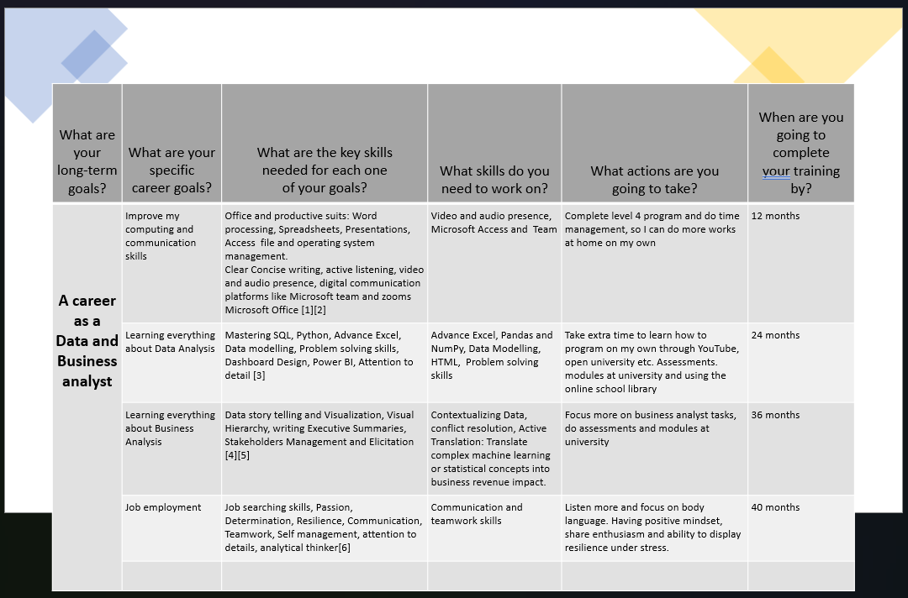
A screen shot of my personal development plan

The link to the PDP file

personal development plan assingment.pptx

Screen shots of my goal progress

SQL:
SQL (Structured Query Language) is a programming language used to manage, query, and manipulate data stored in relational databases. It enables users to retrieve, filter, update, and analyse large datasets efficiently using commands such as SELECT, INSERT, UPDATE, and DELETE. SQL is an essential skill for data and business analysts because it supports data extraction, reporting, and decision-making.

Excel Macros and VBA:
Excel Macros and Visual Basic for Applications (VBA) are automation tools used to simplify repetitive tasks and improve productivity in Microsoft Excel. Macros record a sequence of actions that can be replayed automatically, while VBA allows users to write custom code to create advanced functions, automate data processing, generate reports, and develop interactive spreadsheets. These tools help save time, reduce errors, and increase efficiency in data analysis and business operations.

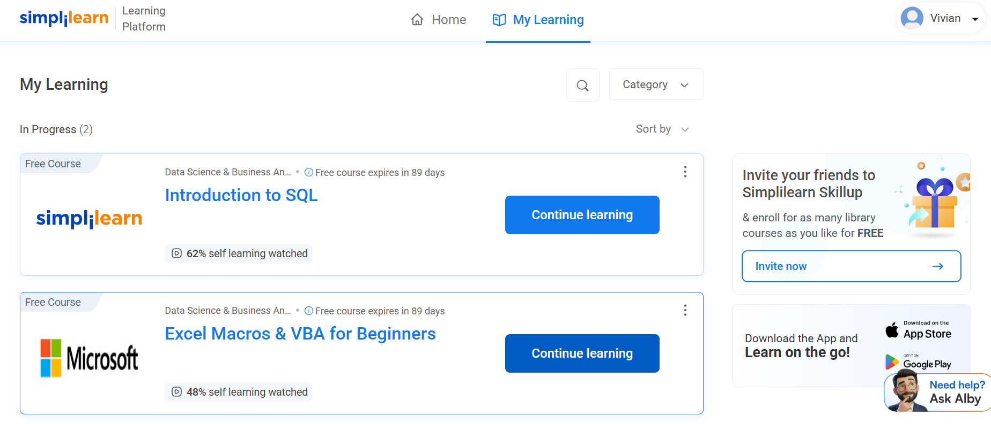
A screen shot of my learning progress with simpleilearn learning platform

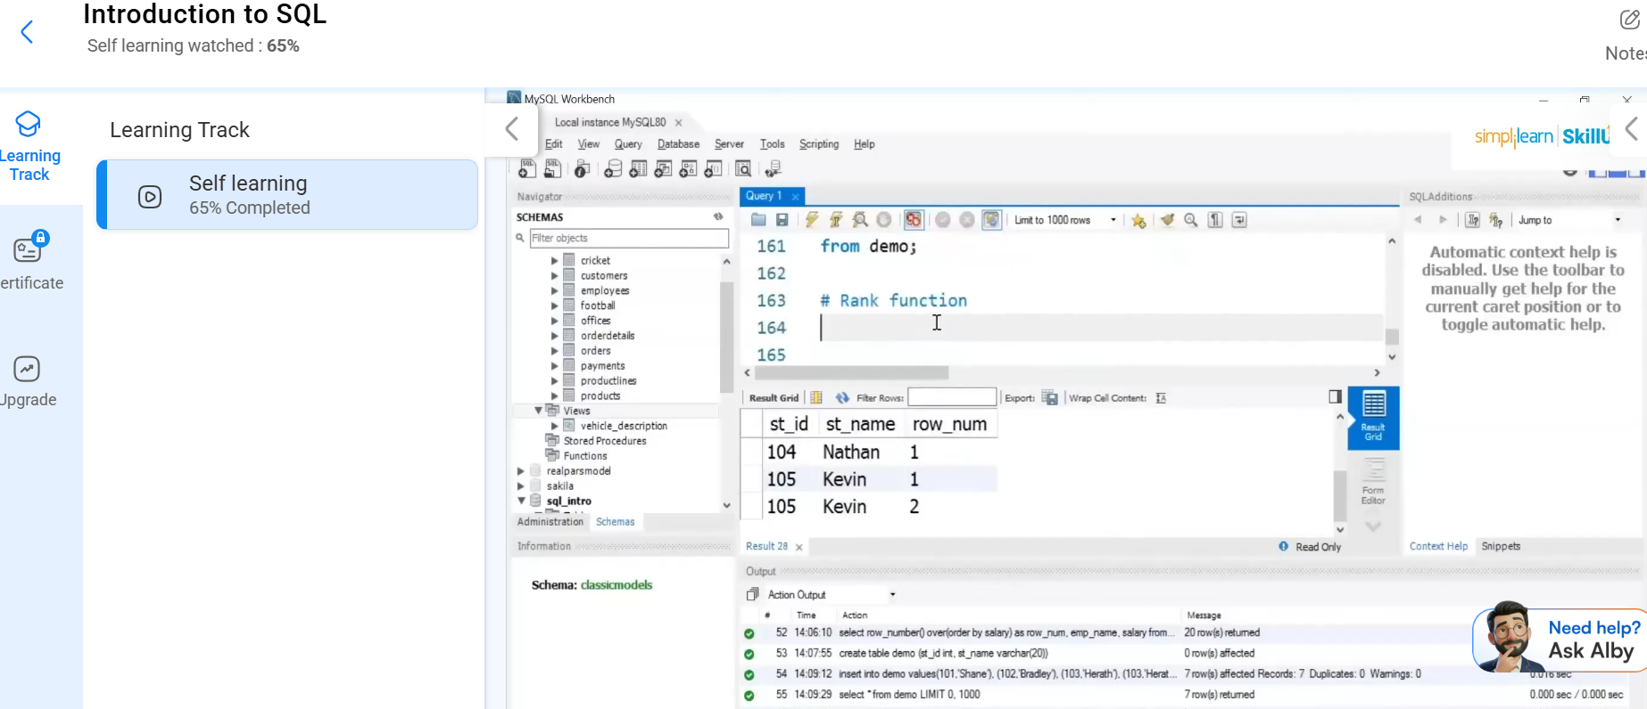
A screen shot showing my progress @68% completion of the introduction to SQL

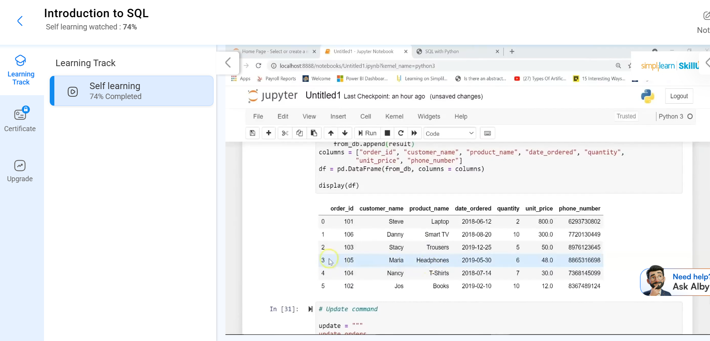

A screen shot showing my progress @74%

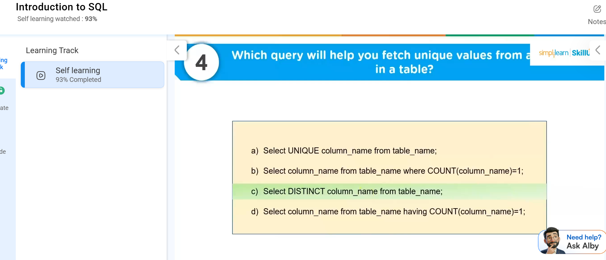completion of the introduction to SQL
A screenshot @93%
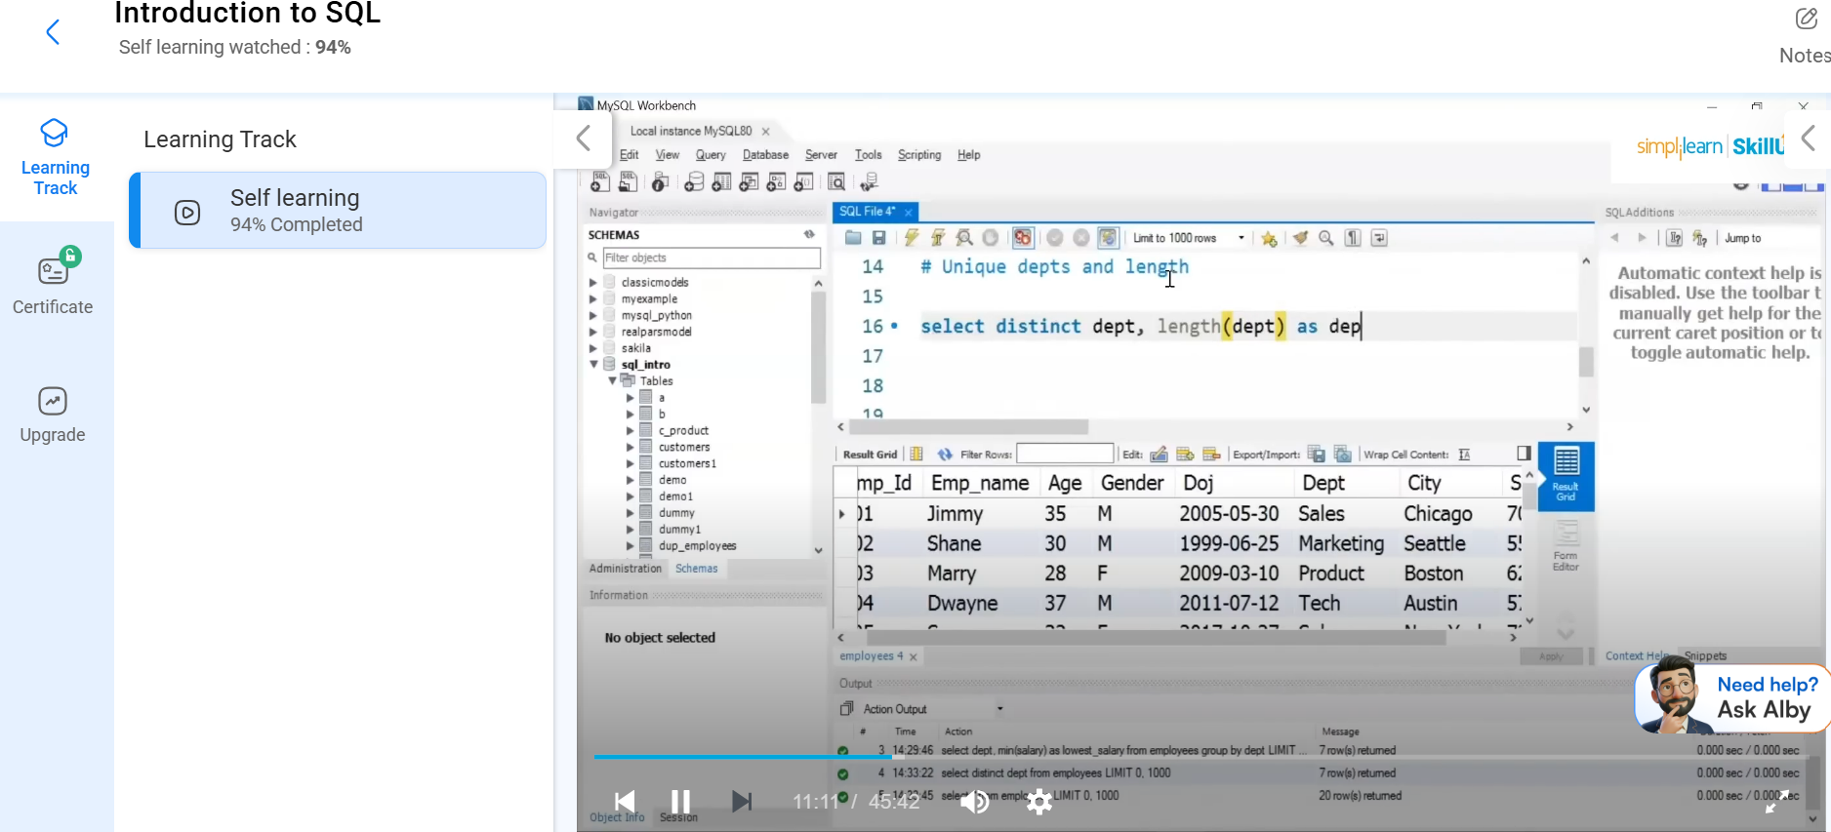
A screenshot @94%

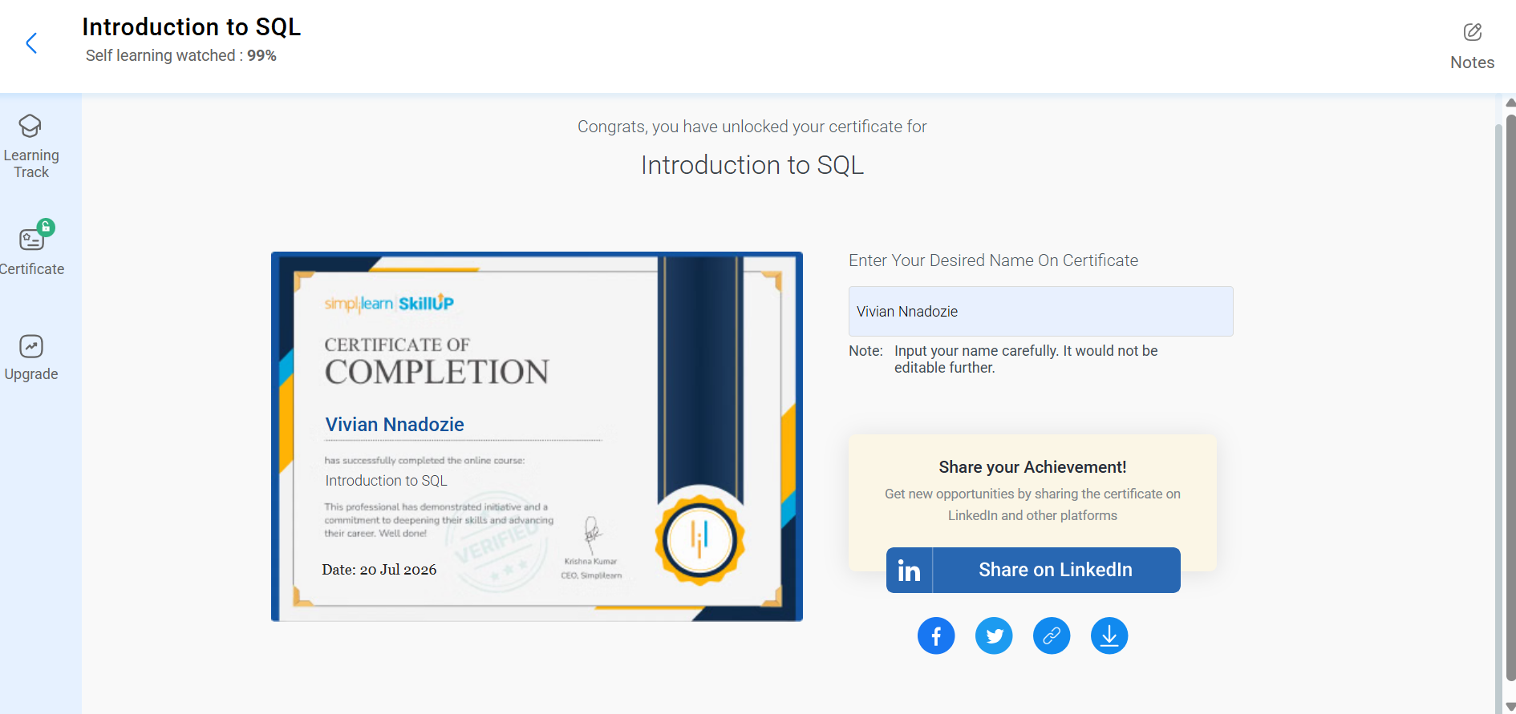

Task 3: Becoming a lifelong learner (summary)

Bouncing forward

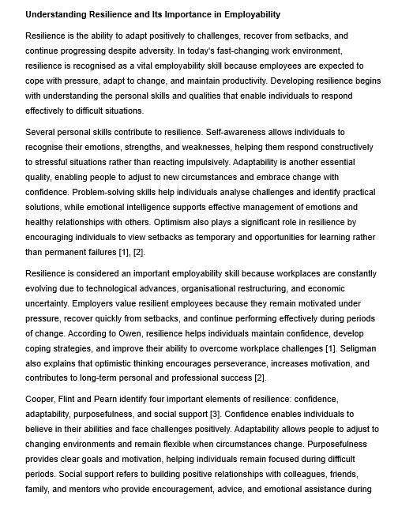

Task 4: Video Presentation
Presentation (Assisgnment.pptx

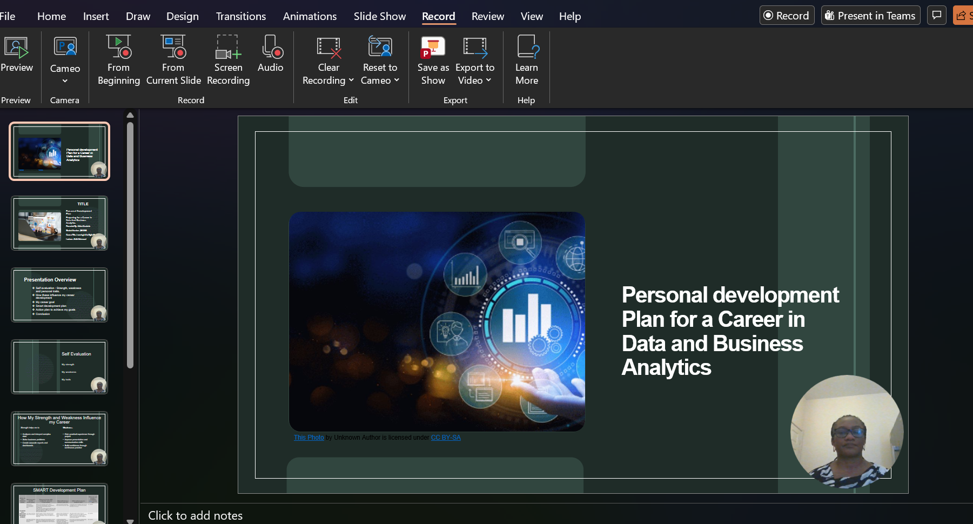
A screenshot of one of the video presentation slide

Presentation (Assisgnment.mp4

Referencing

[1] J. Owen, Resilience: How to Build a Personal Strategy for Success, 2020.
[2] M. E. P. Seligman, Flourish: A Visionary New Understanding of Happiness and Well-being. New York, NY, USA: Atria Books, 2013.
[3] C. Cooper, L. Flint, and M. Pearn, Building Resilience for Success: A Resource for Managers and Organisations. Basingstoke, U.K.: Palgrave Macmillan, 2013.
[4] C. Crow, The Resilience Toolkit: Practical Skills for Handling Stress and Change, 2020.
[5] J. Fisher, "The Personal Transition Curve," 2012.

Figure
Fig 1: Fisher’s Personal Transition Curve

Referencing for the PDP table

[1] Microsoft, Microsoft 365 Documentation. [Online]. Available: https://learn.microsoft.com/microsoft-365/. [Accessed: 20-Jul-2026].
[2] S. Robbins and T. Judge, Organizational Behavior, 19th ed. Harlow, U.K.: Pearson, 2023.
[3] F. Provost and T. Fawcett, Data Science for Business: What You Need to Know about Data Mining and Data-Analytic Thinking, 2nd ed. Sebastopol, CA, USA: O'Reilly Media, 2023.
[4] B. Nussbaumer Knaflic, Storytelling with Data: A Data Visualization Guide for Business Professionals. Hoboken, NJ, USA: Wiley, 2015.
[5] International Institute of Business Analysis (IIBA), A Guide to the Business Analysis Body of Knowledge (BABOK Guide), Version 3. Toronto, ON, Canada: IIBA, 2015.
[6] S. Robbins and T. Judge, Organizational Behaviour, 19th ed. Harlow, U.K.: Pearson, 2023

